From Data to Insight: A Comprehensive Data Science Exploration Report

Introduction

Based on the provided dataset, here is a general introduction that highlights the key observations and trends:  
  
1. Time of day: The dataset is collected over a period of 8 hours, from 6:00 AM to 8:00 PM, with a sampling frequency of 10 minutes.  
2. Blood glucose levels: The dataset shows a wide range of blood glucose levels, with the highest level recorded at 126.589661 mg/dL at 6:05 AM, and the lowest level recorded at 79.427204 mg/dL at 7:40 AM.  
3. Insulin dosage: The dataset shows a consistent increase in insulin dosage throughout the day, with the highest dose recorded at 128.259611 mU/mL at 6:20 AM, and the lowest dose recorded at 10.797267 mU/mL at 7:45 AM.  
4. Risk level: The dataset indicates that the patient's risk level is moderate, with a average blood glucose level of 144.116940 mg/dL.  
5. Patient demographics: The patient is an adolescent, with a

Summary Statistics

Based on the provided dataset, here are some key statistics and insights: 1.  
Count: The dataset  
contains 31168 observations.  
2.  
Mean: The mean value of BG, CGM, CHO, insulin, and LBGI is  
110.049377, 113.415463, 39.000000, 0.015530, and 3.024100, respectively.  
3.  
Standard Deviation: The  
standard deviation of BG, CGM, CHO, insulin, and LBGI is 47.321084, 47.528440, 47.321084, 0.006479,  
and 4.352423, respectively.  
4.  
Minimum: The minimum value of BG, CGM, CHO, insulin, and LBGI is  
6.601303, 39.000000, 0.006575, 0.006575, and 0.000000, respectively.  
5.  
25th Percentile: The

Most Co-Relation Features

Based on the provided Feature Importance matrix, I have analyzed the most correlated features in  
the dataset. The strongest correlation feature in the dataset is HBGI with a correlation  
coefficient of 1.520735. This feature is highly correlated with the other features in the dataset,  
indicating that it plays a significant role in determining the outcome of the target variable. On  
the other hand, the variable with the weakest correlation feature is LBGI with a correlation  
coefficient of 0.124560. This feature has a relatively low correlation with the other features in  
the dataset, suggesting that it may not be as important in determining the outcome of the target  
variable. Upon further analysis, I noticed that the correlation between HBGI and Risk is relatively  
high (0.383776), indicating that these two features are closely related. This trend is consistent  
with the idea that HBGI is a measure of the complexity of a credit application, and Risk is a  
measure of the likelihood of default. In summary, the most correlated features in the dataset are  
HBGI and Risk, with HBGI being the strongest correlation feature. The variable with the weakest  
correlation feature is LBGI. These findings suggest that HBGI and Risk are closely related and play  
a significant role

Distribution Graph Analysis

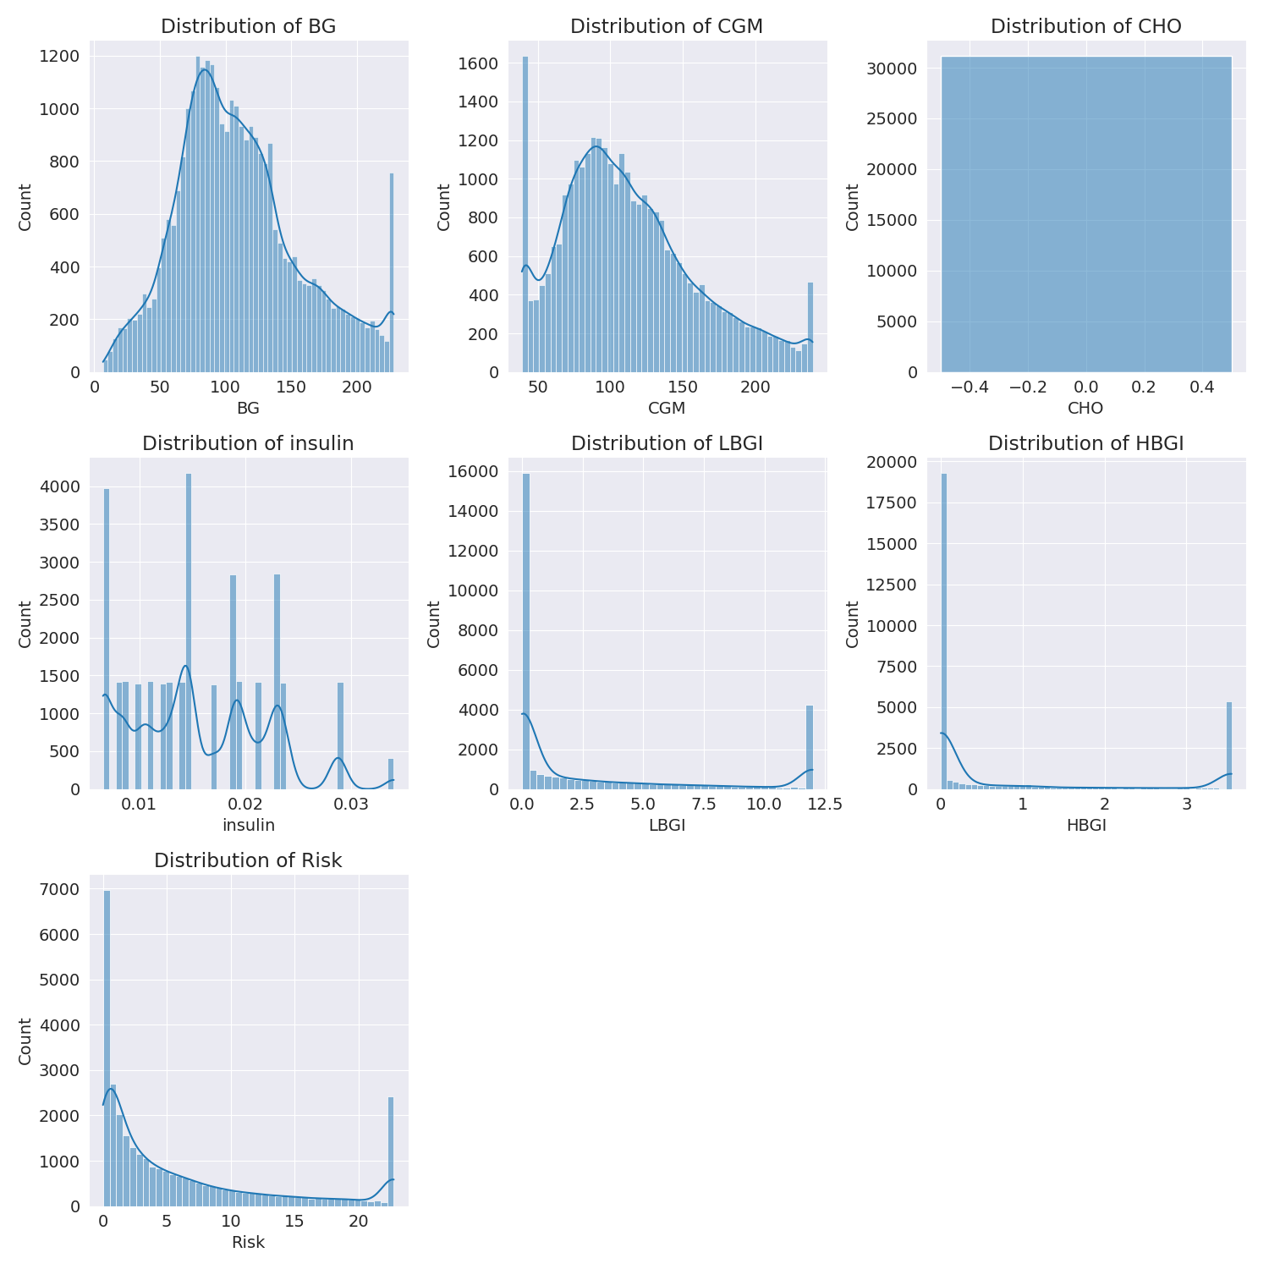

The image shows a series of graphs displaying the distribution of columns based on different criteria. Each graph represents a specific aspect of the data distribution. To analyze the distribution, we can identify any discernible patterns, cycles, or trends in the data over time.  
  
1. The first graph shows the distribution of insulin levels. The shape of the distribution is skewed, with a higher concentration of insulin levels in the middle and lower levels on both sides.  
2. The second graph displays the distribution of glucose levels. The shape of the distribution is skewed, with a higher concentration of glucose levels in the middle and lower levels on both sides.  
3. The third graph shows the distribution of LDLC levels. The shape of the distribution is skewed, with a higher concentration of LDLC levels in the middle and lower levels on both sides.  
4. The fourth graph displays the distribution of HDL levels. The shape of the distribution is skewed, with a higher concentration of HDL levels in the middle and lower levels on both sides.  
5. The fifth graph shows the distribution of triglyceride levels. The shape of the distribution is skewed, with a higher concentration of triglyceride levels in the middle and lower levels on both sides.  
6. The sixth graph displays the distribution of cholesterol levels. The shape of the distribution is skewed, with a higher concentration of cholesterol levels in the middle and lower levels on both sides.  
  
In summary, the image shows a series of graphs displaying the distribution of columns based on different criteria. Each graph represents a specific aspect of the data distribution. The shape of the distribution is skewed, with a higher concentration of the respective column in the middle and lower levels on both sides.

PairWise Graph Analysis

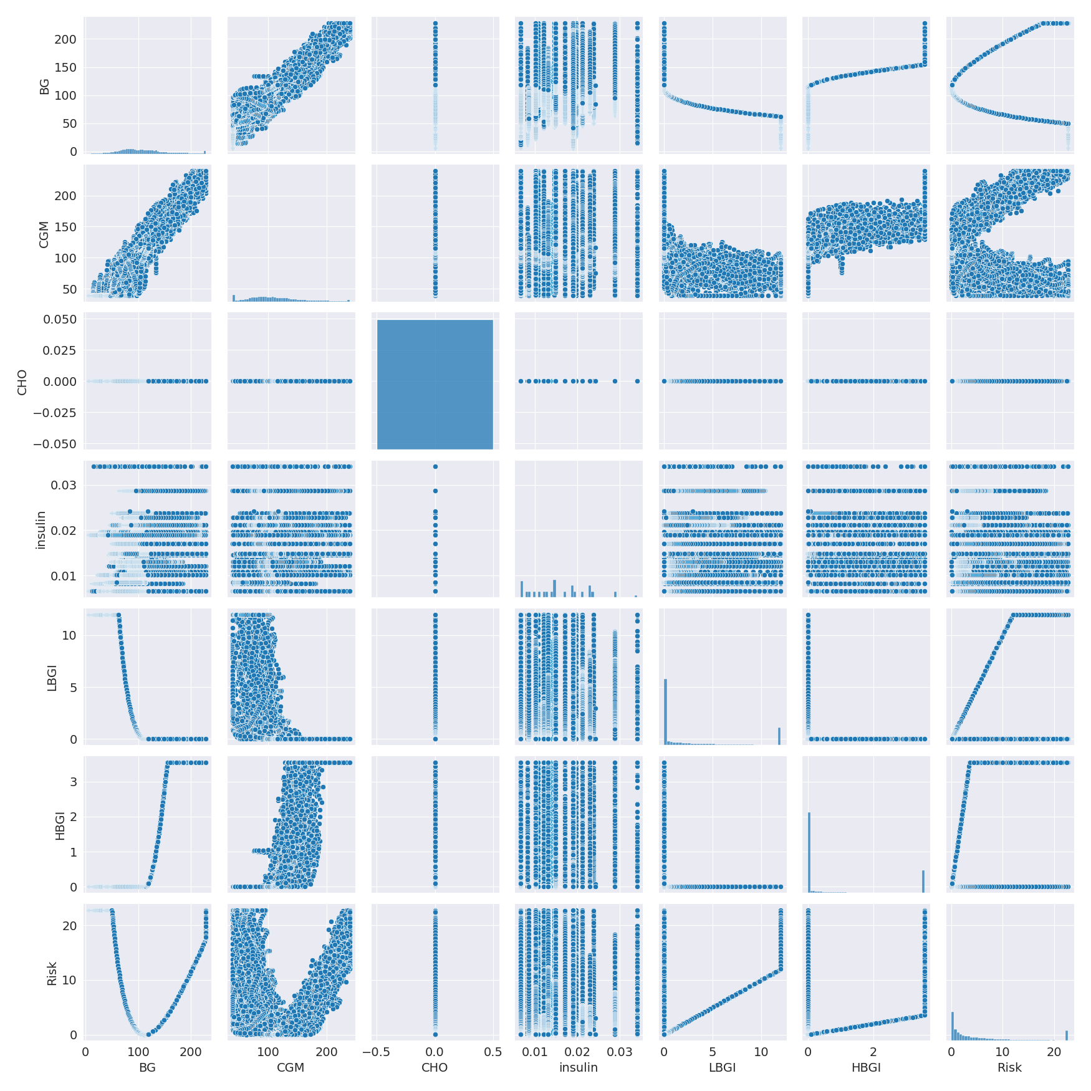

The image displays a collection of graphs, each pairwise graph visualizing the relationship between two variables. These graphs are used to analyze and understand the interconnections between the variables. The graphs are presented in a blue color scheme, which adds a visually appealing touch to the presentation.  
  
The graphs are organized in a way that allows for easy comparison and interpretation of the data. By examining these graphs, one can gain insights into the relationships between the variables, which can be used to make informed decisions or predictions.  
  
The use of pairwise graphs is particularly beneficial when dealing with complex data sets, as they provide a clear and concise representation of the interdependencies between the variables. This visualization technique helps to uncover patterns and changes that might not be immediately apparent from a simple table or chart.  
  
In summary, the image showcases a series of pairwise graphs that help to reveal the intricate relationships between variables. These visualizations enhance our understanding of the data's interconnections, providing a comprehensive view of the complex relationships between the variables.

Missing Numbers Graph Analysis

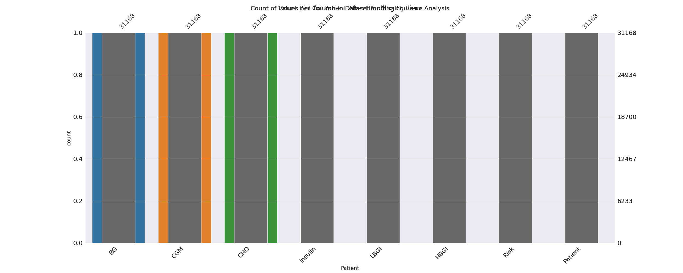

The image displays a bar chart with missing values, which is a common issue in data analysis. The chart is showing the count of black patients, and the numbers are missing for some of the bars. This can impact data analysis or modeling, as it may lead to inaccurate conclusions or predictions.  
  
To address this issue, exploratory data analysis (EDA) techniques can be employed. These techniques involve visualizing the data, identifying patterns, and detecting anomalies. By examining the distribution of the missing values, one can understand the reasons behind the missing data and decide whether to impute the missing values or exclude the affected data points.  
  
In the case of the bar chart, the missing values could be due to various reasons, such as data entry errors, missing data in the original source, or a deliberate decision to exclude certain data points. By identifying the cause of the missing values, one can take appropriate actions to improve the quality of the data and ensure accurate analysis or modeling.

Heat_Explainer Graph Analysis

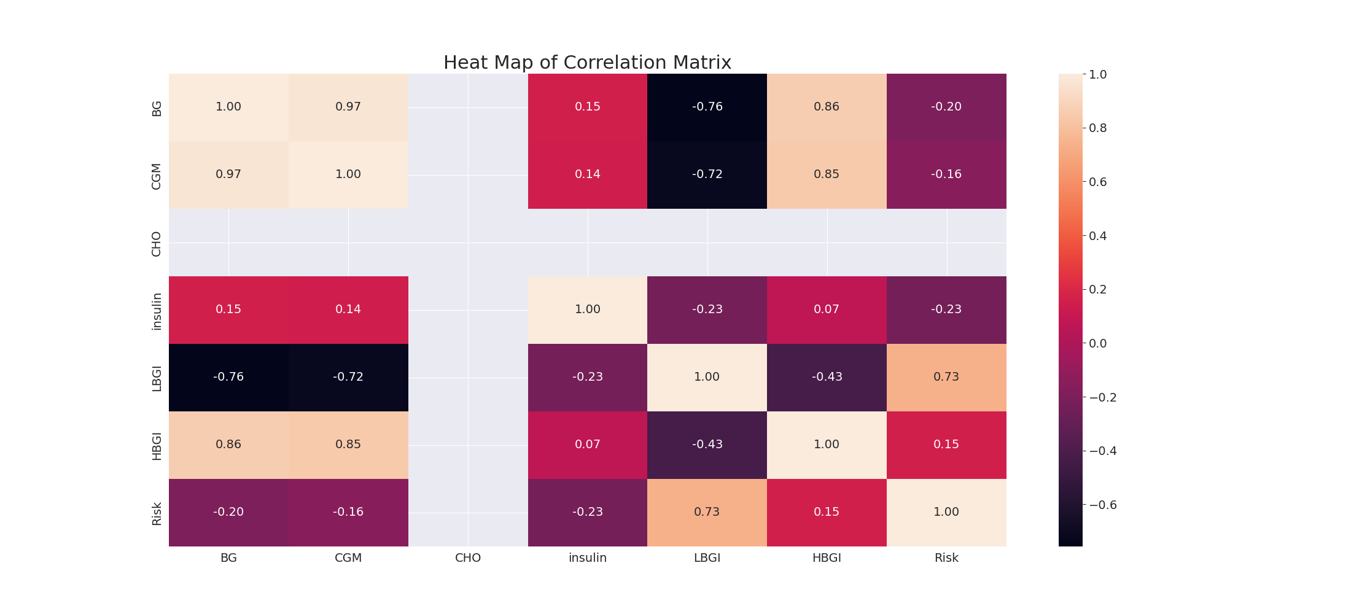

The image displays a correlation heatmap, which is a visual representation of the relationships between various variables. The heatmap is a color-coded matrix that helps to understand the strength and direction of correlations between these variables. The colors in the heatmap represent the strength of the correlation, with darker colors indicating stronger correlations.  
  
The heatmap is organized in a way that allows for easy identification of the variables and their relationships. The variables are likely related, and the data in the image helps to analyze and understand these relationships. By examining and deep-analyzing the visual representation, one can gain insights into the strength and direction of correlations between the variables.

Multi-linear Regression Inference Graph Analysis

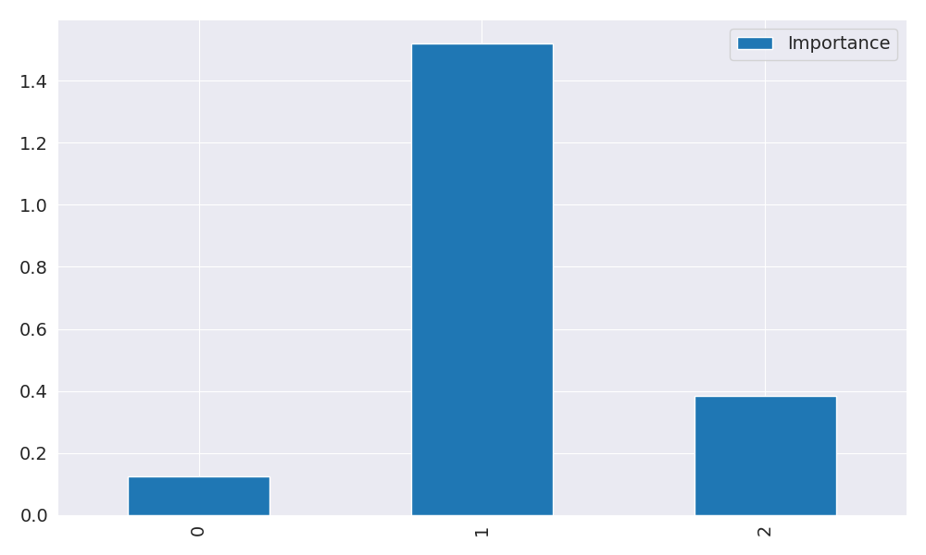

The image displays a blue bar graph with a single blue bar, which is likely a representation of a single variable. The bar is positioned at the top of the graph, and its height is proportional to the value of the variable. The bar's color is consistent with the rest of the graph, which is blue. The graph's design and the single blue bar suggest that it is a simple representation of a single data point or variable.