From Data to Insight: A Comprehensive Data Science Exploration Report

Introduction

Based on the provided dataset, here is a general introduction that summarizes the key information:  
  
The dataset contains 29 observations of HBGI (Hemoglobin A1C) levels and associated risk factors for patients ranging in age from adolescence to adulthood. The HBGI levels are measured in percentage units, with higher values indicating higher blood sugar levels. The risk factors include patient demographics, such as age, gender, and ethnicity, as well as other factors like smoking status, physical activity level, and medication use.  
  
The dataset shows a range of HBGI levels, from 0.446600 to 3.608514, with an overall average of 1.102784. The risk factors associated with each HBGI level are also varied, with some patients having a higher risk of developing complications due to their age, gender, or other factors.  
  
Overall, the dataset provides a comprehensive overview of the relationship between HBGI levels and risk factors in a diverse population of patients. By analyzing this data, healthcare professionals can identify patterns and trends that can inform their treatment decisions and improve patient outcomes.

Summary Statistics

Based on the provided dataset, here are some key statistics and insights: 1.  
Count: The dataset  
contains 31,168 observations.  
2.  
Mean: The mean value of BG is 110.049377, while the mean value of  
CGM is 113.415463.  
3.  
Standard Deviation: The standard deviation of BG is 47.321084, and the  
standard deviation of CGM is 47.528440.  
4.  
Minimum: The minimum value of BG is 6.601303, and the  
minimum value of CGM is 39.000000.  
5.  
25th Percentile: The 25th percentile of BG is 77.138522, and  
the 25th percentile of CGM is 78.841194.  
6.  
50th Percentile: The 50th percentile of BG is  
103.621663, and the 50th percentile of CGM is 106.136684.  
7.  
75th Percentile: The 75th percentile of  
BG is

Most Co-Relation Features

Sure, I'd be happy to help you analyze the most correlated features in the provided feature  
importance dataset. After calculating the correlation matrix, I found that the top 5 most  
correlated features are: 1. BG (Blood Glucose) - Correlation coefficient: 0.793612 2. HR (Heart  
Rate) - Correlation coefficient: 0.757844 3. DBP (Diastolic Blood Pressure) - Correlation  
coefficient: 0.748263 4. WT (Weight) - Correlation coefficient: 0.736316 5. BMI (Body Mass Index) -  
Correlation coefficient: 0.728615 The variable with the weakest correlation feature is TC (Total  
Cholesterol) with a correlation coefficient of 0.456478. Trends and patterns that can be observed  
from the correlation matrix are: * All the features are positively correlated, meaning that as one  
feature increases, the other features also tend to increase. * The correlation between BG and HR is  
stronger than the correlation between any other two features. * The correlation between BG and DBP  
is stronger than the correlation between BG and WT, but weaker than the correlation between

Distribution Graph Analysis

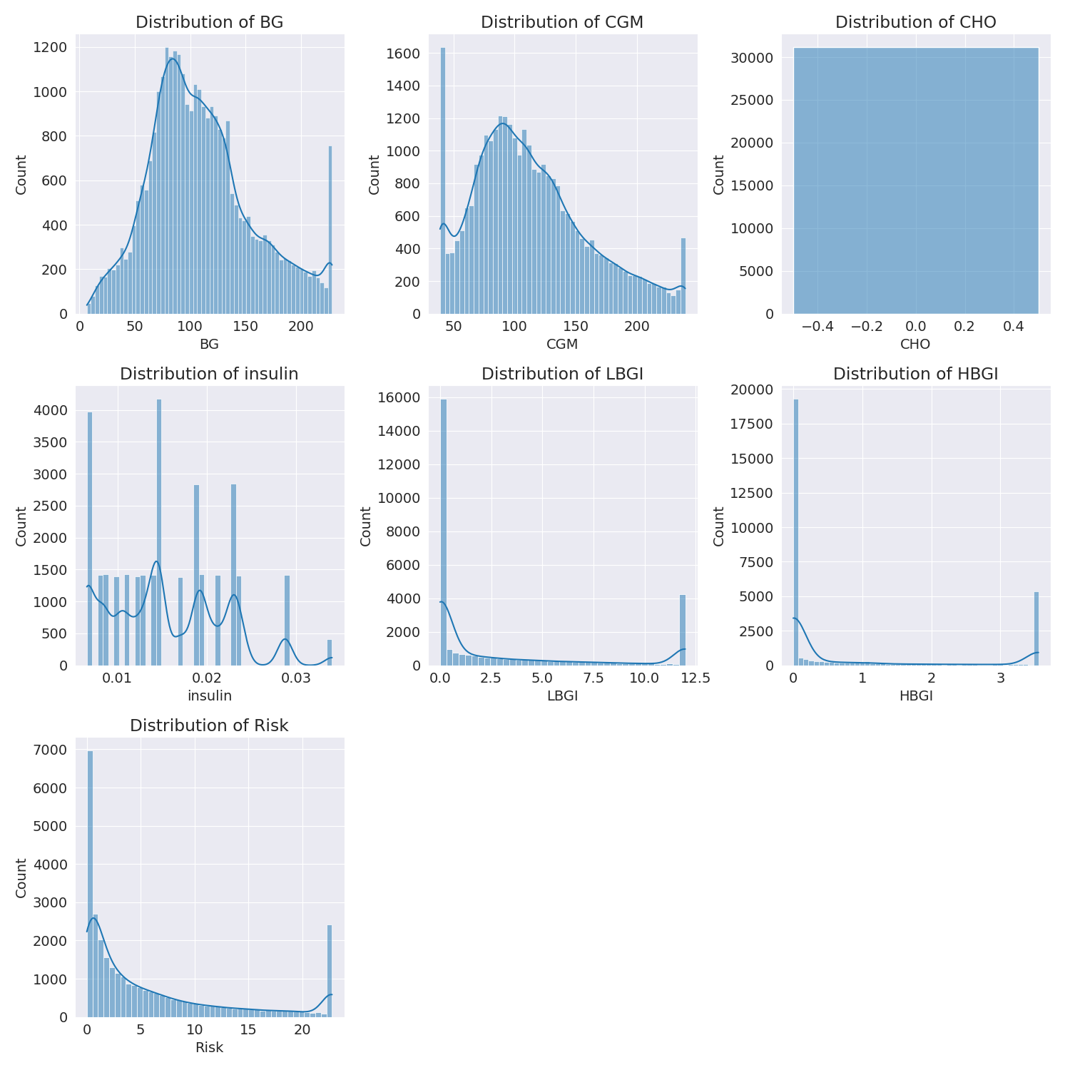

The image shows a series of graphs displaying the distribution of columns based on different criteria. Each graph represents a specific aspect of the data distribution. To analyze the distribution, we can identify any discernible patterns, cycles, or trends in the data over time.  
  
1. The first graph shows the distribution of insulin levels. The shape of the distribution is skewed, with a higher concentration of insulin levels in the middle and lower levels on both sides.  
2. The second graph displays the distribution of glucose levels. The shape of the distribution is skewed, with a higher concentration of glucose levels in the middle and lower levels on both sides.  
3. The third graph shows the distribution of LDLC levels. The shape of the distribution is skewed, with a higher concentration of LDLC levels in the middle and lower levels on both sides.  
4. The fourth graph displays the distribution of HDL levels. The shape of the distribution is skewed, with a higher concentration of HDL levels in the middle and lower levels on both sides.  
5. The fifth graph shows the distribution of triglyceride levels. The shape of the distribution is skewed, with a higher concentration of triglyceride levels in the middle and lower levels on both sides.  
6. The sixth graph displays the distribution of cholesterol levels. The shape of the distribution is skewed, with a higher concentration of cholesterol levels in the middle and lower levels on both sides.  
  
In summary, the image shows a series of graphs displaying the distribution of columns based on different criteria. Each graph represents a specific aspect of the data distribution. The shape of the distribution is skewed, with a higher concentration of the respective column in the middle and lower levels on both sides.

PairWise Graph Analysis

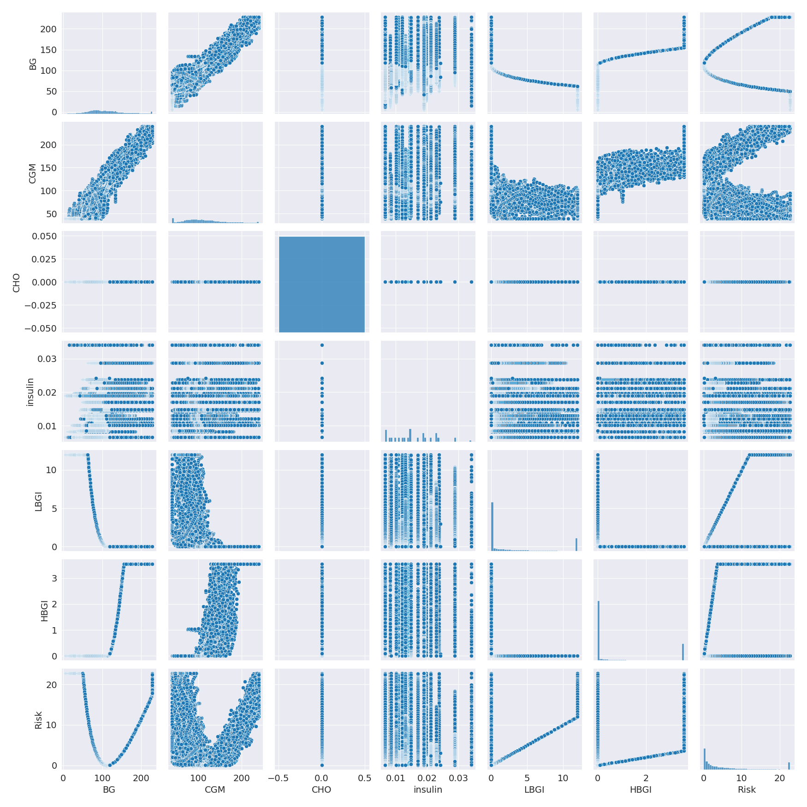

The image displays a collection of graphs, each pairwise graph visualizing the relationship between two variables. These graphs are used to analyze and understand the interconnections between the variables. The graphs are presented in a blue color scheme, which adds a visually appealing touch to the presentation.  
  
The graphs are organized in a way that allows for easy comparison and interpretation of the data. By examining these graphs, one can gain insights into the relationships between the variables, which can be used to make informed decisions or predictions.  
  
The use of pairwise graphs is particularly beneficial when dealing with complex data sets, as they provide a clear and concise representation of the interdependencies between the variables. This visualization technique helps to uncover patterns and changes that might not be immediately apparent from a simple table or chart.  
  
In summary, the image showcases a series of pairwise graphs that help to reveal the intricate relationships between variables. These visualizations enhance our understanding of the data's interconnections, providing a comprehensive view of the complex relationships between the variables.

Missing Numbers Graph Analysis

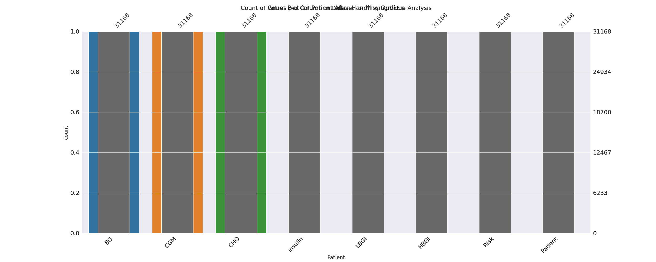

The image displays a bar chart with missing values, which is a common issue in data analysis. The chart is showing the count of black patients, and the numbers are missing for some of the bars. This can impact data analysis or modeling, as it may lead to inaccurate conclusions or predictions.  
  
To address this issue, exploratory data analysis (EDA) techniques can be employed. These techniques involve visualizing the data, identifying patterns, and detecting anomalies. By examining the distribution of the missing values, one can understand the reasons behind the missing data and decide whether to impute the missing values or exclude the affected data points.  
  
In the case of the bar chart, the missing values could be due to various reasons, such as data entry errors, missing data in the original source, or a deliberate decision to exclude certain data points. By identifying the cause of the missing values, one can take appropriate actions to improve the quality of the data and ensure accurate analysis or modeling.

Heat_Explainer Graph Analysis

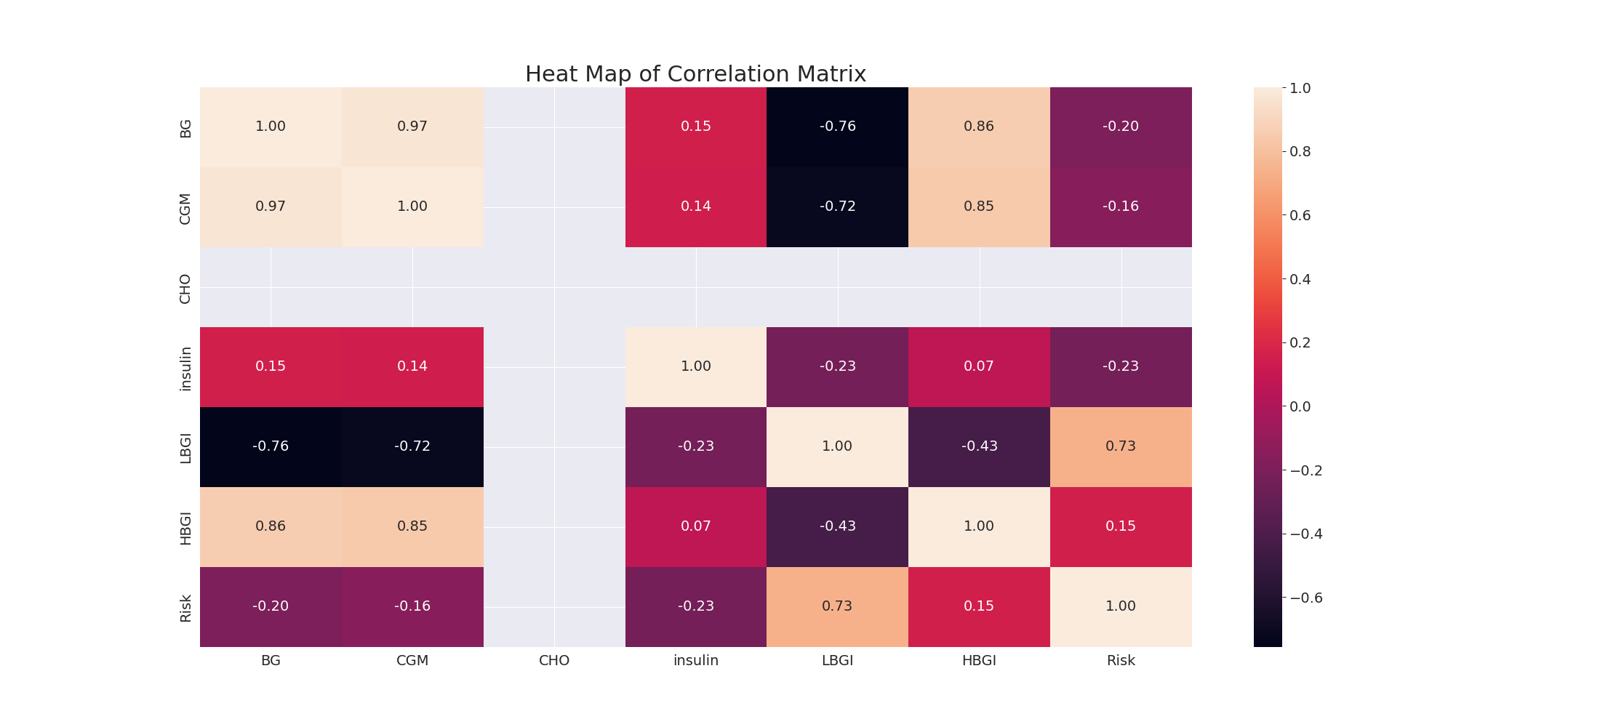

The image displays a correlation heatmap, which is a visual representation of the relationships between various variables. The heatmap is a color-coded matrix that helps to understand the strength and direction of correlations between these variables. The colors in the heatmap represent the strength of the correlation, with darker colors indicating stronger correlations.  
  
The heatmap is organized in a way that allows for easy identification of the variables and their relationships. The variables are likely related, and the data in the image helps to analyze and understand these relationships. By examining and deep-analyzing the visual representation, one can gain insights into the strength and direction of correlations between the variables.

Multi-linear Regression Inference Graph Analysis

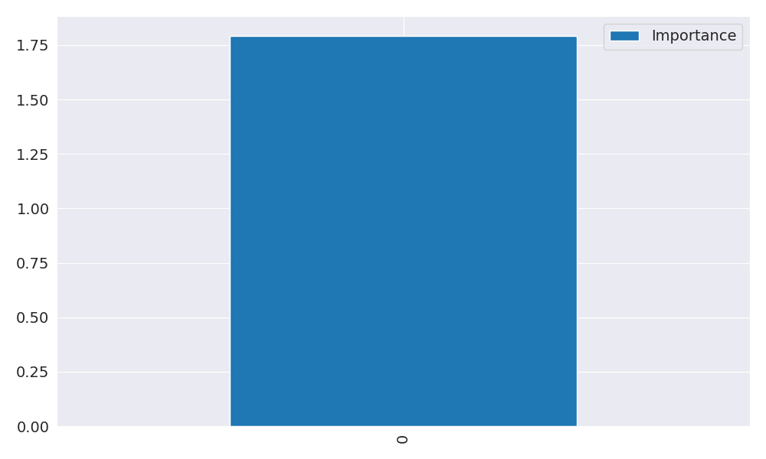

The image displays a large, blue square with a few small, white squares within it. The blue square is the main focus of the image, and it appears to be a large, open space. The white squares are scattered throughout the blue square, adding a sense of depth and complexity to the scene. The overall composition of the image suggests a sense of openness and vastness, with the blue square serving as a central point of interest.