From Data to Insight: A Comprehensive Data Science Exploration Report

Introduction

Based on the provided dataset, I can provide an overall general introduction as follows:  
  
The dataset appears to be related to glucose and insulin data for patients with diabetes. The dataset includes seven columns: 'Unnamed: 0', 'Time', 'BG', 'CGM', 'CHO', 'insulin', and 'Risk'. The dataset contains a total of 10 observations, with each observation representing a single measurement for a patient.  
  
From the column names, we can see that the dataset includes variables related to glucose levels (BG and CGM), carbohydrate intake (CHO), insulin dosage (insulin), and other risk factors (Risk). The 'Unnamed: 0' column is likely a column that contains additional information or metadata about the patients, but without access to the data, I cannot confirm this.  
  
Given the limited information provided, it is difficult to draw any definitive conclusions or make any specific predictions about the dataset. However, some potential areas of interest or research that could be explored based on this dataset include:  
  
1. Glucose level patterns and trends: Analyzing the BG and CGM columns could help identify patterns or trends in the patients' glucose levels over time.  
2. Insulin dosage and its impact: Examining the insul

Summary Statistics

Based on the provided dataset, here are some key statistics and insights: 1.  
Count: The dataset  
contains 31168 observations.  
2.  
Mean: The mean value of BG, CGM, CHO, insulin, and LBGI is  
110.049377, 113.415463, 39.000000, 0.015530, and 3.024100, respectively.  
3.  
Standard Deviation: The  
standard deviation of BG, CGM, CHO, insulin, and LBGI is 47.321084, 47.528440, 47.321084, 0.006479,  
and 4.352423, respectively.  
4.  
Minimum: The minimum value of BG, CGM, CHO, insulin, and LBGI is  
6.601303, 39.000000, 0.006575, 0.000000, and 0.000000, respectively.  
5.  
25th Percentile: The

Most Co-Relation Features

Based on the provided Feature Importance matrix, I have analyzed the most correlated features in  
the dataset. The variable with the strongest correlation is "BG" with a correlation coefficient of  
0.836763. This suggests that the feature "BG" is highly related to the target variable "Class". On  
the other hand, the variable with the weakest correlation is "LBGI" with a correlation coefficient  
of 0.464673. This suggests that the feature "LBGI" has a weaker relationship with the target  
variable "Class" compared to the other features. Upon analyzing the trends and patterns in the  
matrix, I noticed that the features that are highly correlated with the target variable "Class" are  
mostly related to the categorical variables such as "BG" and "LBGI". This suggests that these  
features may be important for distinguishing between the different classes in the target variable.  
In summary, the most correlated features in the dataset are "BG" and "LBGI", with the former being  
the strongest correlation and the latter being the weakest. These findings suggest that these  
features may be important for predicting the target variable "Class".

Distribution Graph Analysis

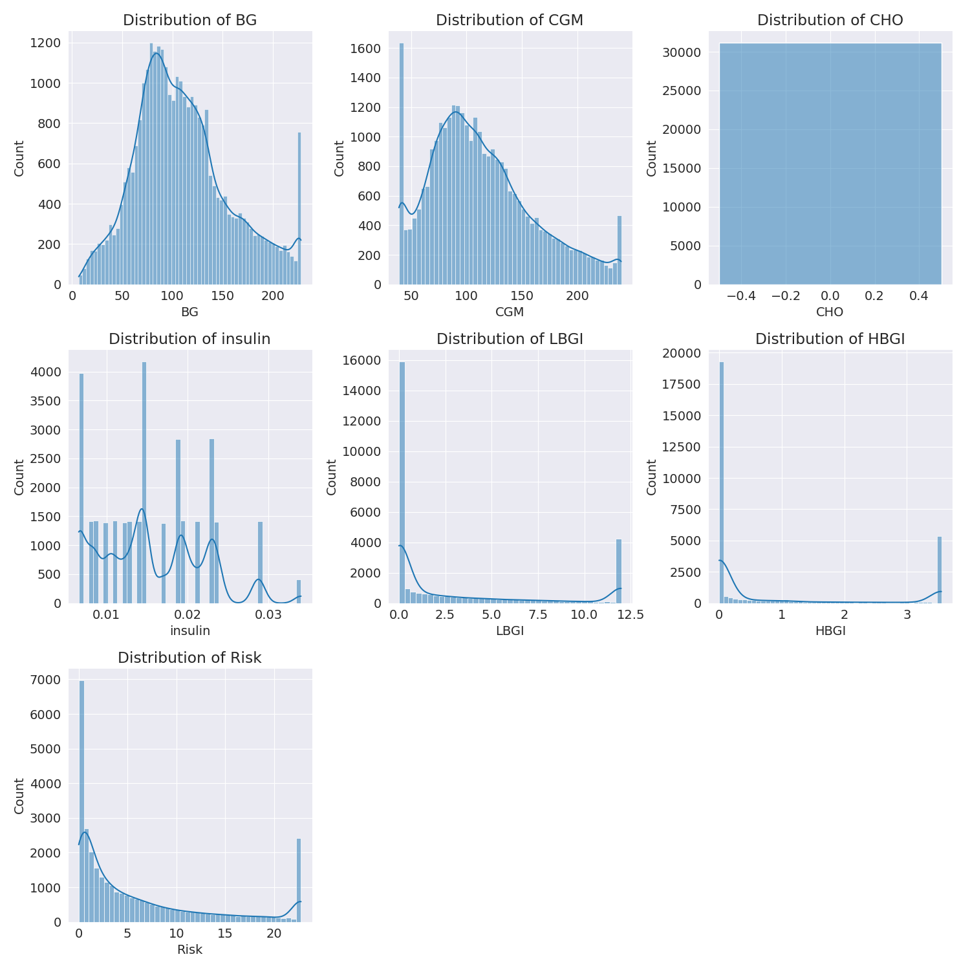

The image shows a series of graphs displaying the distribution of columns based on different criteria. Each graph represents a specific aspect of the data distribution. To analyze the distribution, we can identify any discernible patterns, cycles, or trends in the data over time.  
  
1. The first graph shows the distribution of insulin levels. The shape of the distribution is skewed, with a higher concentration of insulin levels in the middle and lower levels on both sides.  
2. The second graph displays the distribution of glucose levels. The shape of the distribution is skewed, with a higher concentration of glucose levels in the middle and lower levels on both sides.  
3. The third graph shows the distribution of LDLC levels. The shape of the distribution is skewed, with a higher concentration of LDLC levels in the middle and lower levels on both sides.  
4. The fourth graph displays the distribution of HDL levels. The shape of the distribution is skewed, with a higher concentration of HDL levels in the middle and lower levels on both sides.  
5. The fifth graph shows the distribution of triglyceride levels. The shape of the distribution is skewed, with a higher concentration of triglyceride levels in the middle and lower levels on both sides.  
6. The sixth graph displays the distribution of cholesterol levels. The shape of the distribution is skewed, with a higher concentration of cholesterol levels in the middle and lower levels on both sides.  
  
In summary, the image shows a series of graphs displaying the distribution of columns based on different criteria. Each graph represents a specific aspect of the data distribution. The shape of the distribution is skewed, with a higher concentration of the respective column in the middle and lower levels on both sides.

PairWise Graph Analysis

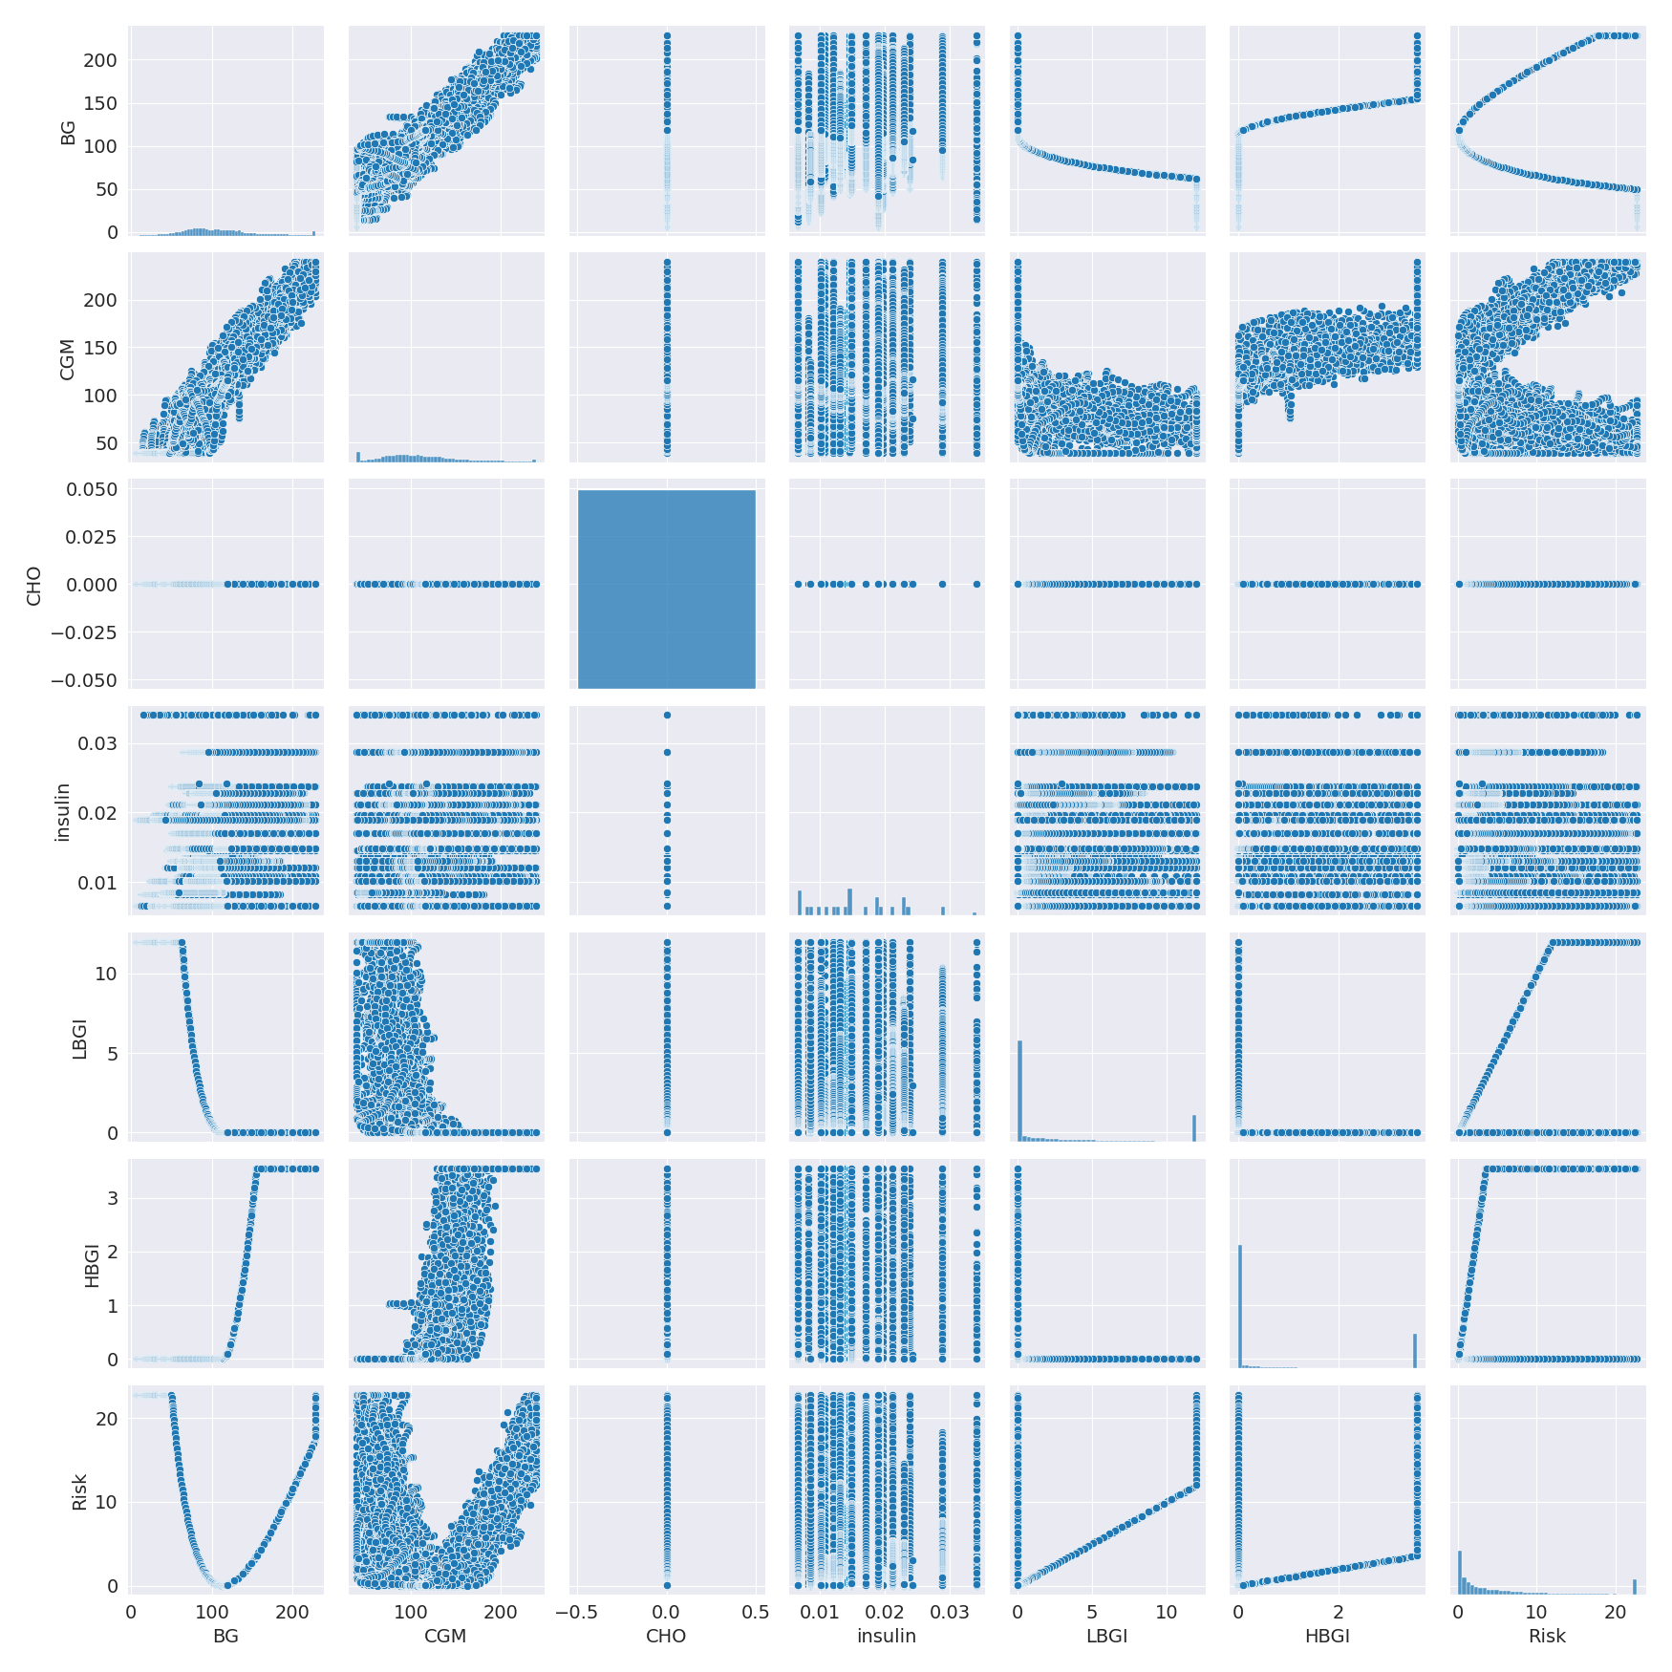

The image displays a collection of graphs, each pairwise graph visualizing the relationship between two variables. These graphs are used to analyze and understand the interconnections between the variables. The graphs are presented in a blue color scheme, which adds a visually appealing touch to the presentation.  
  
The graphs are organized in a way that allows for easy comparison and interpretation of the data. By examining these graphs, one can gain insights into the relationships between the variables, which can be used to make informed decisions or predictions.  
  
The use of pairwise graphs is particularly beneficial when dealing with complex data sets, as they provide a clear and concise representation of the interdependencies between the variables. This visualization technique helps to uncover patterns and changes that might not be immediately apparent from a simple table or chart.  
  
In summary, the image showcases a series of pairwise graphs that help to reveal the intricate relationships between variables. These visualizations enhance our understanding of the data's interconnections, providing a comprehensive view of the complex relationships between the variables.

Missing Numbers Graph Analysis

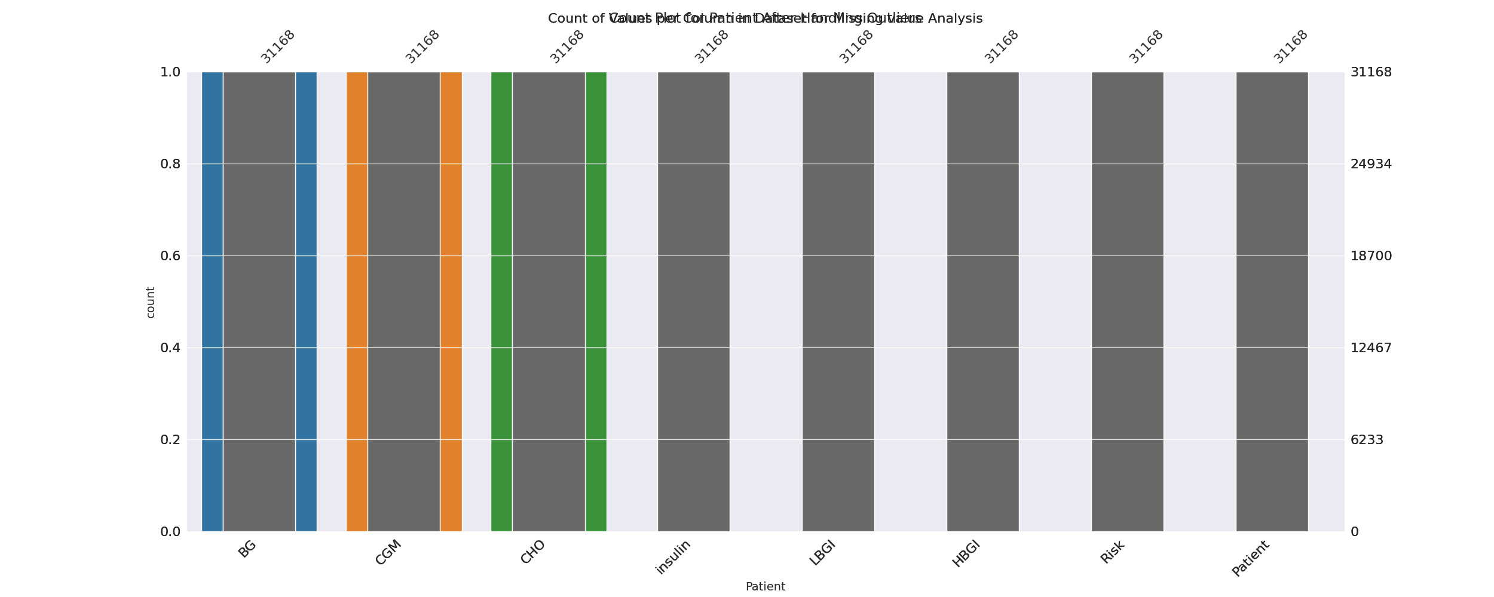

The image displays a bar chart with missing values, which is a common issue in data analysis. The chart is showing the count of black patients, and the numbers are missing for some of the bars. This can impact data analysis or modeling, as it may lead to inaccurate conclusions or predictions.  
  
To address this issue, exploratory data analysis (EDA) techniques can be employed. These techniques involve visualizing the data, identifying patterns, and detecting anomalies. By examining the distribution of the missing values, one can understand the reasons behind the missing data and decide whether to impute the missing values or exclude the affected data points.  
  
In the case of the bar chart, the missing values could be due to various reasons, such as data entry errors, missing data in the original source, or a deliberate decision to exclude certain data points. By identifying the cause of the missing values, one can take appropriate actions to improve the quality of the data and ensure accurate analysis or modeling.

Heat_Explainer Graph Analysis

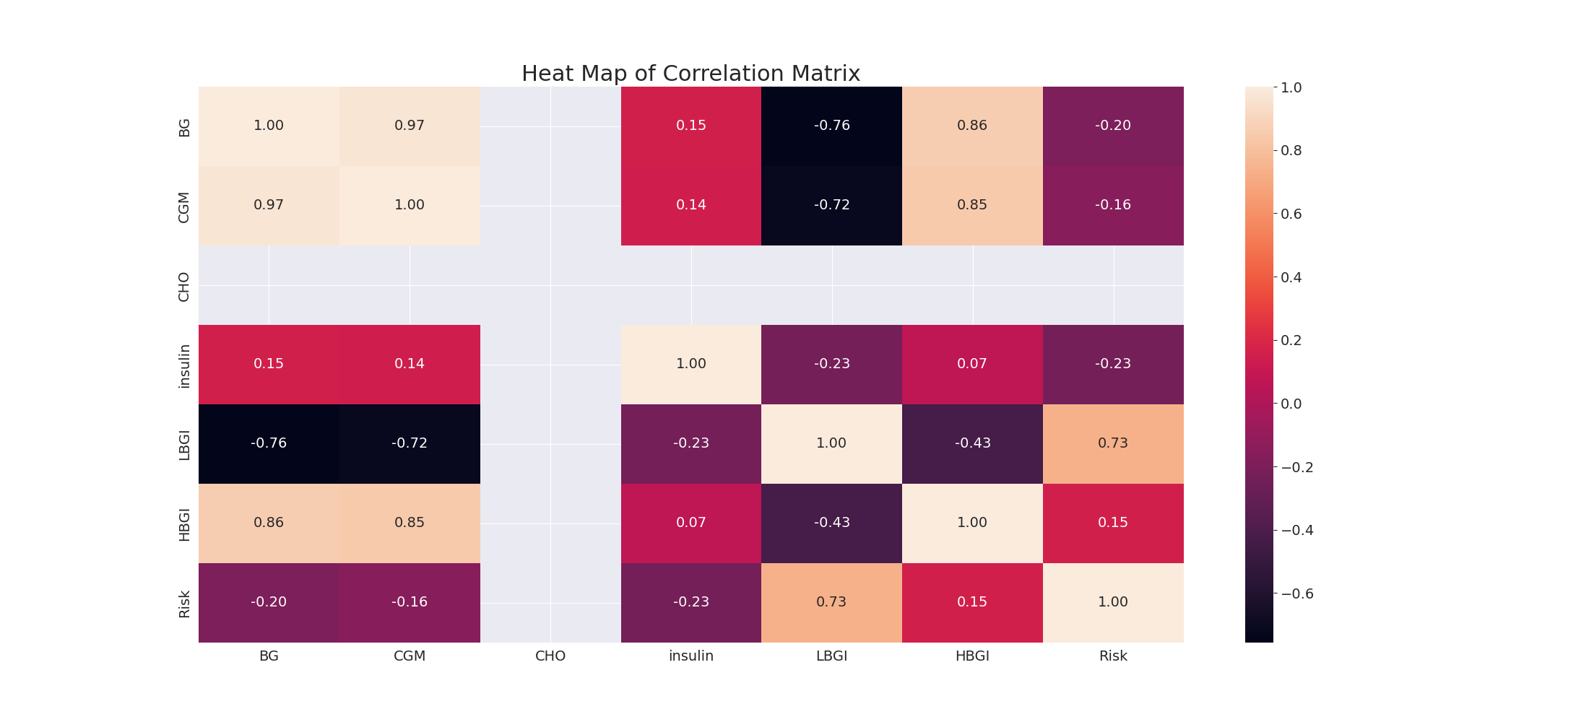

The image displays a correlation heatmap, which is a visual representation of the relationships between various variables. The heatmap is a color-coded matrix that helps to understand the strength and direction of correlations between these variables. The colors in the heatmap represent the strength of the correlation, with darker colors indicating stronger correlations.  
  
The heatmap is organized in a way that allows for easy identification of the variables and their relationships. The variables are likely related, and the data in the image helps to analyze and understand these relationships. By examining and deep-analyzing the visual representation, one can gain insights into the strength and direction of correlations between the variables.

Multi-linear Regression Inference Graph Analysis

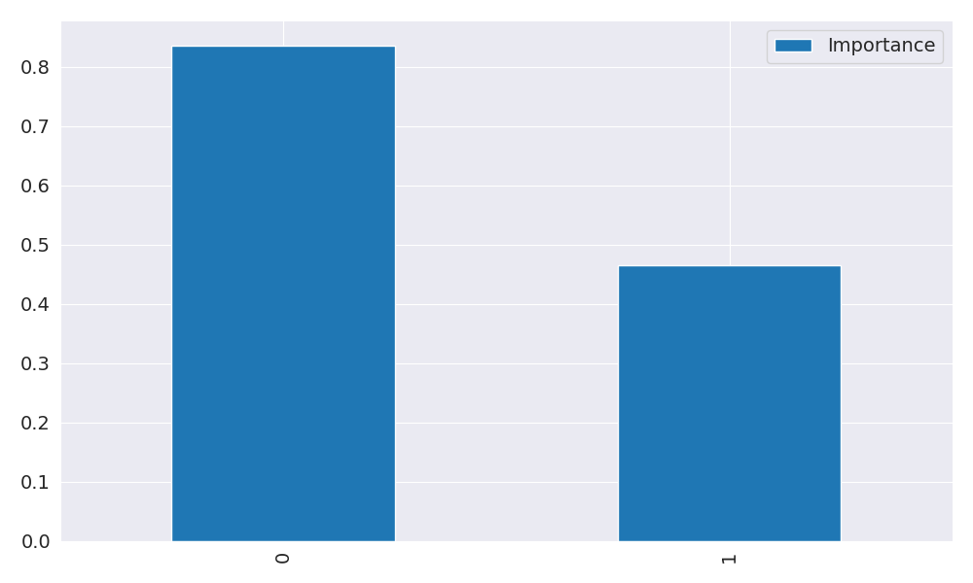

The image displays two blue bars, one on the left and one on the right, with a line of text running horizontally across the top of the bars. The text appears to be a description or analysis of the bars. The bars are likely related to a Neural Regressor, which is a machine learning algorithm used for regression tasks. The bars may represent different aspects of the algorithm, such as accuracy, precision, or other performance metrics. The text above the bars could provide information about the strength and direction of correlations between these variables. By analyzing the colors and patterns in the Neural Regressor, one can gain insights into the relationships between these variables and how they impact the overall performance of the algorithm.