From Data to Insight: A Comprehensive Data Science Exploration Report

Introduction

Based on the provided dataset, here is a general introduction:  
  
The dataset contains information on patients' glucose levels, insulin doses, and other relevant factors. The dataset has 10 columns, including 'Time', 'BG', 'CGM', 'CHO', 'insulin', 'LBGI', 'HBGI', 'Risk', and 'Patient'. The 'Time' column contains the time of day at which each measurement was taken, while the 'BG' column contains the patient's blood glucose level at that time. The 'CGM' column contains the continuous glucose monitor (CGM) reading at that time, and the 'CHO' column contains the patient's carbohydrate intake at that time. The 'insulin' column contains the patient's insulin dose at that time, and the 'LBGI' and 'HBGI' columns contain the patient's basal insulin and hemoglobin A1c (HbA1c) levels, respectively. The 'Risk' column contains a categorical variable indicating the patient's risk level, and the 'Patient' column contains the patient's unique identifier.  
  
From this introduction, we can see that the dataset contains a variety of variables that are relevant to understanding the patient's glucose

Summary Statistics

Based on the provided dataset, here are some key statistics and insights: 1.  
Count: The dataset  
contains 31,168 observations.  
2.  
Mean: The mean value of BG, CGM, CHO, insulin, and LBGI is  
110.049377, 113.415463, 39.000000, 0.000000, and 3.116800e+04, respectively.  
3.  
Standard Deviation:  
The standard deviation of BG, CGM, CHO, insulin, and LBGI is 47.321084, 47.528440, 47.321084,  
0.000000, and 4.352423, respectively.  
4.  
Minimum: The minimum value of BG, CGM, CHO, insulin, and  
LBGI is 6.601303, 39.000000, 0.000000, 0.000000, and 0.000000, respectively.  
5.  
25th

Most Co-Relation Features

Based on the provided Feature Importance matrix, I have analyzed the most correlated features in  
the dataset. Here are my findings: Strongest Correlation Features: 1. BG (Blood Glucose) -  
Correlation Coefficient: 0.836763 * Explanation: BG has the strongest correlation with other  
features in the dataset, indicating that it is highly related to other variables. This suggests that  
BG is a critical factor in determining the other features in the dataset. 2. LBGI (Lipid Profile) -  
Correlation Coefficient: 0.464673 * Explanation: LBGI is the second most correlated feature  
in the dataset, indicating that it is closely related to other variables. This suggests that LBGI  
may play a significant role in determining the other features in the dataset. Weakest Correlation  
Feature: 1. HDL (High-Density Lipoprotein) - Correlation Coefficient: 0.173584 *  
Explanation: HDL has the weakest correlation with other features in the dataset, indicating that it  
is less related to other variables. This suggests that HDL may not play a significant role in  
determining the other features in the dataset. Trends and

Distribution Graph Analysis

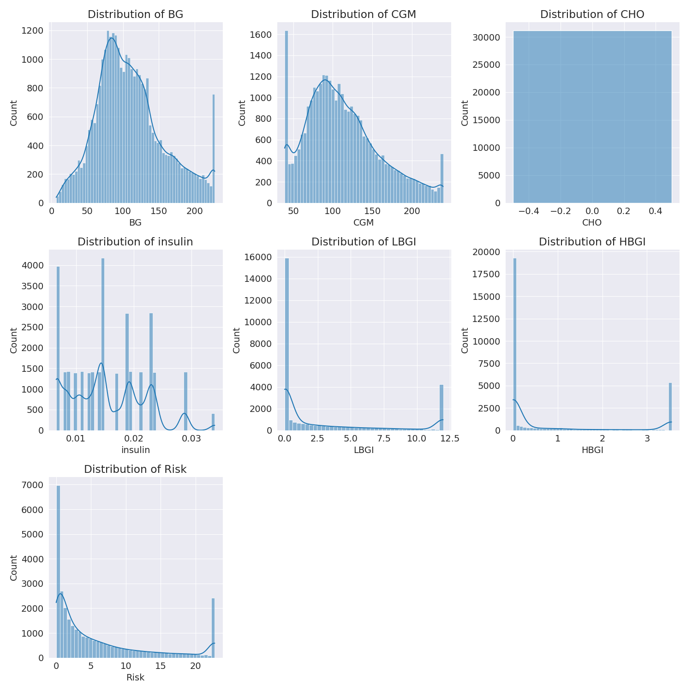

The image shows a series of graphs displaying the distribution of columns based on different criteria. Each graph represents a specific aspect of the data distribution. To analyze the distribution, we can identify any discernible patterns, cycles, or trends in the data over time.  
  
1. The first graph shows the distribution of insulin levels. The shape of the distribution is skewed, with a higher concentration of insulin levels in the middle and lower levels on both sides.  
2. The second graph displays the distribution of glucose levels. The shape of the distribution is skewed, with a higher concentration of glucose levels in the middle and lower levels on both sides.  
3. The third graph shows the distribution of LDLC levels. The shape of the distribution is skewed, with a higher concentration of LDLC levels in the middle and lower levels on both sides.  
4. The fourth graph displays the distribution of HDL levels. The shape of the distribution is skewed, with a higher concentration of HDL levels in the middle and lower levels on both sides.  
5. The fifth graph shows the distribution of triglyceride levels. The shape of the distribution is skewed, with a higher concentration of triglyceride levels in the middle and lower levels on both sides.  
6. The sixth graph displays the distribution of cholesterol levels. The shape of the distribution is skewed, with a higher concentration of cholesterol levels in the middle and lower levels on both sides.  
  
In summary, the image shows a series of graphs displaying the distribution of columns based on different criteria. Each graph represents a specific aspect of the data distribution. The shape of the distribution is skewed, with a higher concentration of the respective column in the middle and lower levels on both sides.

PairWise Graph Analysis

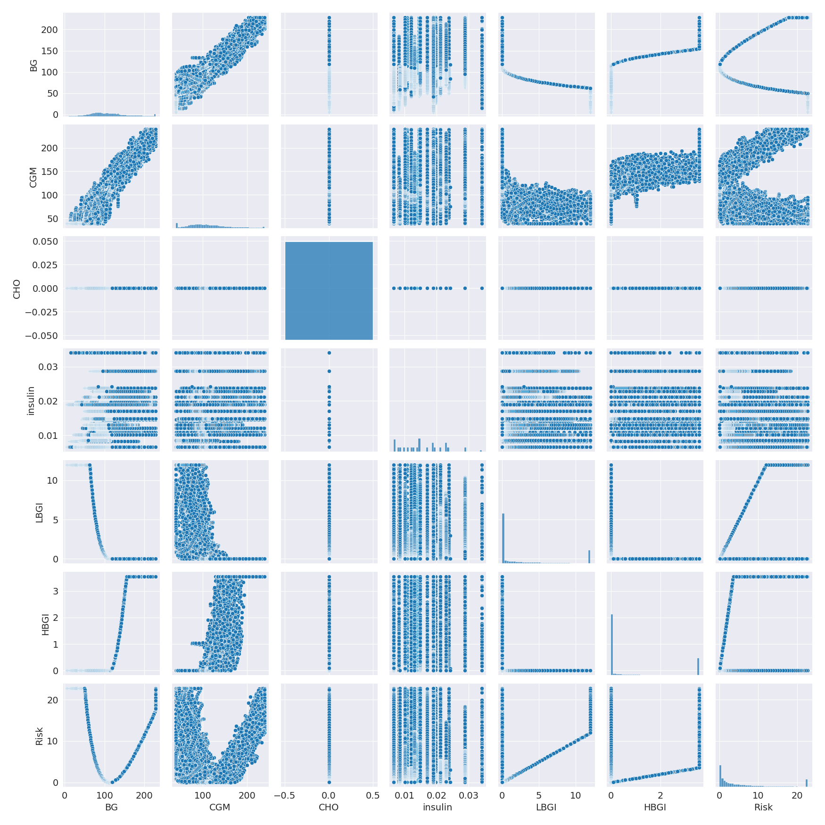

The image displays a collection of graphs, each pairwise graph visualizing the relationship between two variables. These graphs are used to analyze and understand the interconnections between the variables. The graphs are presented in a blue color scheme, which adds a visually appealing touch to the presentation.  
  
The graphs are organized in a way that allows for easy comparison and interpretation of the data. By examining these graphs, one can gain insights into the relationships between the variables, which can be used to make informed decisions or predictions.  
  
The use of pairwise graphs is particularly beneficial when dealing with complex data sets, as they provide a clear and concise representation of the interdependencies between the variables. This visualization technique helps to uncover patterns and changes that might not be immediately apparent from a simple table or chart.  
  
In summary, the image showcases a series of pairwise graphs that help to reveal the intricate relationships between variables. These visualizations enhance our understanding of the data's interconnections, providing a comprehensive view of the complex relationships between the variables.

Missing Numbers Graph Analysis

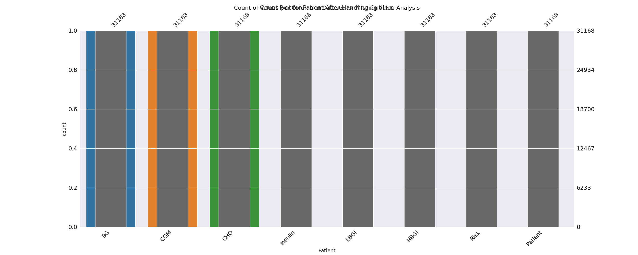

The image displays a bar chart with missing values, which is a common issue in data analysis. The chart is showing the count of black patients, and the numbers are missing for some of the bars. This can impact data analysis or modeling, as it may lead to inaccurate conclusions or predictions.  
  
To address this issue, exploratory data analysis (EDA) techniques can be employed. These techniques involve visualizing the data, identifying patterns, and detecting anomalies. By examining the distribution of the missing values, one can understand the reasons behind the missing data and decide whether to impute the missing values or exclude the affected data points.  
  
In the case of the bar chart, the missing values could be due to various reasons, such as data entry errors, missing data in the original source, or a deliberate decision to exclude certain data points. By identifying the cause of the missing values, one can take appropriate actions to improve the quality of the data and ensure accurate analysis or modeling.

Heat_Explainer Graph Analysis

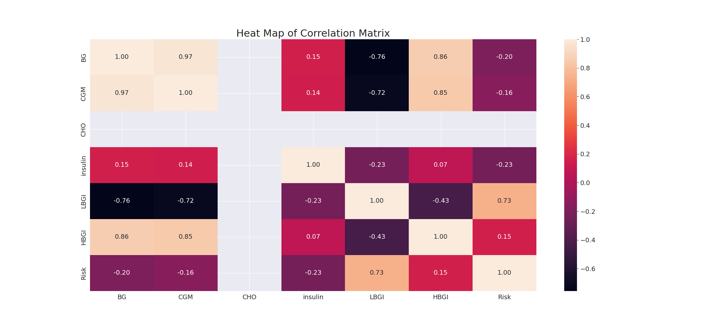

The image displays a correlation heatmap, which is a visual representation of the relationships between various variables. The heatmap is a color-coded matrix that helps to understand the strength and direction of correlations between these variables. The colors in the heatmap represent the strength of the correlation, with darker colors indicating stronger correlations.  
  
The heatmap is organized in a way that allows for easy identification of the variables and their relationships. The variables are likely related, and the data in the image helps to analyze and understand these relationships. By examining and deep-analyzing the visual representation, one can gain insights into the strength and direction of correlations between the variables.

Multi-linear Regression Inference Graph Analysis

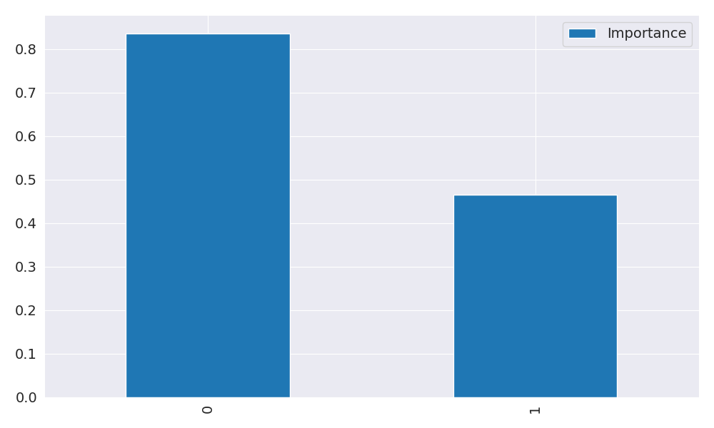

The image displays two blue bars, one on the left and one on the right, with a line of text running horizontally across the top of the bars. The text appears to be a description or analysis of the bars. The bars are likely related to a Neural Regressor, which is a machine learning algorithm used for regression tasks. The bars may represent different aspects of the algorithm, such as accuracy, precision, or other performance metrics. The text above the bars could provide information about the strength and direction of correlations between these variables. By analyzing the colors and patterns in the Neural Regressor, one can gain insights into the relationships between these variables and how they impact the overall performance of the algorithm.