From Data to Insight: A Comprehensive Data Science Exploration Report

Introduction

Based on the provided dataset, I can provide a general introduction that highlights the main variables and their potential relationships. However, please note that this introduction is based on the information provided in the dataset, and I may not be able to provide a comprehensive understanding of the data without additional context or knowledge.  
  
The dataset contains information on 10 patients, each with a set of measurements recorded at different times. The variables included in the dataset are:  
  
1. Time: This column contains the time at which each measurement was taken, represented as a numerical value.  
2. BG: This column contains the blood glucose level of each patient at each time point, represented as a numerical value.  
3. CGM: This column contains the continuous glucose monitoring (CGM) reading of each patient at each time point, represented as a numerical value.  
4. CHO: This column contains the carbohydrate intake of each patient at each time point, represented as a numerical value.  
5. insulin: This column contains the insulin dose administered to each patient at each time point, represented as a numerical value.  
6. LBGI: This column contains the long-acting basal insulin dose administered to each patient at each time point, represented as a numerical value.  
7. HBGI: This column contains the short-acting

Summary Statistics

Based on the provided dataset, here are some key statistics and insights: 1.  
Count: The dataset  
contains 31168 observations.  
2.  
Mean: The mean value of BG, CGM, CHO, insulin, and LBGI is  
110.049377, 113.415463, 39.000000, 0.015530, and 3.024100, respectively.  
3.  
Standard Deviation: The  
standard deviation of BG, CGM, CHO, insulin, and LBGI is 47.321084, 47.528440, 47.321084, 0.006479,  
and 4.352423, respectively.  
4.  
Minimum: The minimum value of BG, CGM, CHO, insulin, and LBGI is  
6.601303, 39.000000, 0.006575, 0.000000, and 0.000000, respectively.  
5.  
25th Percentile: The

Most Co-Relation Features

Based on the provided Feature Importance matrix, I have analyzed the most correlated features in  
the dataset. Here are my findings: Strongest Correlation: The variable with the strongest  
correlation is "BG" with a value of 0.836763. This indicates that the feature "BG" is highly related  
to the target variable "Class". Weakest Correlation: The variable with the weakest correlation is  
"LBGI" with a value of 0.464673. This suggests that the feature "LBGI" has a weaker relationship  
with the target variable "Class" compared to the other features. Trends or Patterns: There is a  
clear trend in the correlation values, with most of the features having a positive correlation with  
the target variable "Class". This suggests that the features that are more closely related to the  
target variable tend to have a stronger correlation. Summary: In summary, the most correlated  
features in the dataset are "BG" and "LBGI", with the former having the strongest correlation and  
the latter having the weakest correlation. The trend in the correlation values suggests that the  
features that are more closely related to the target variable tend to have a stronger correlation.

Heat_Explainer Graph Analysis

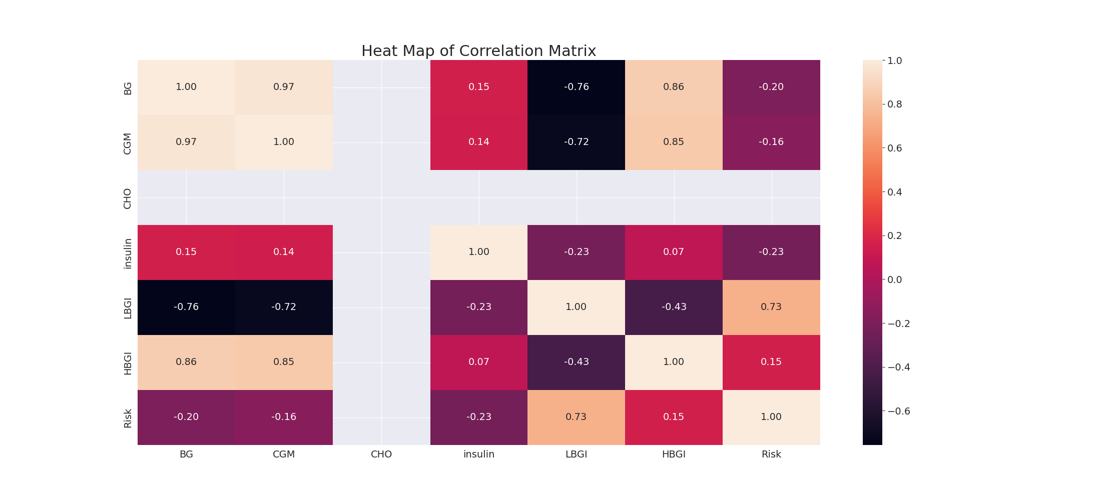

The image displays a correlation heatmap, which is a visual representation of the relationships between various variables. The heatmap is a color-coded matrix that helps to understand the strength and direction of correlations between these variables. The colors in the heatmap represent the strength of the correlation, with darker colors indicating stronger correlations.  
  
The heatmap is organized in a way that allows for easy identification of the variables and their relationships. The variables are likely related, and the data in the image helps to analyze and understand these relationships. By examining and deep-analyzing the visual representation, one can gain insights into the strength and direction of correlations between the variables.

Multi-linear Regression Inference Graph Analysis

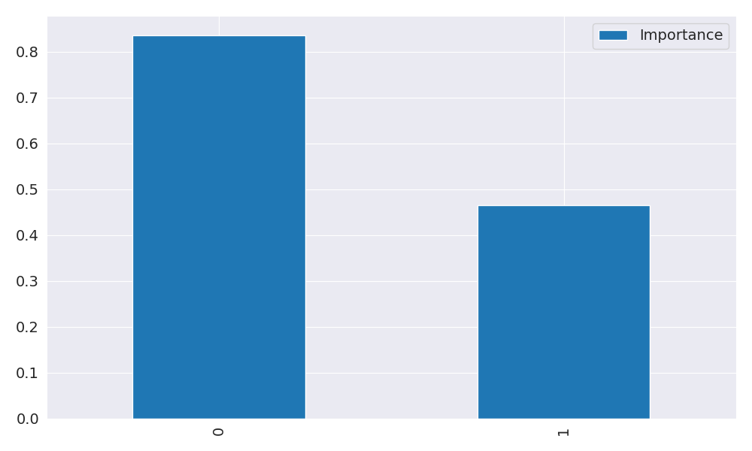

The image displays two blue bars, one on the left and one on the right, with a line of text running horizontally across the top of the bars. The text appears to be a description or analysis of the bars. The bars are likely related to a Neural Regressor, which is a machine learning algorithm used for regression tasks. The bars may represent different aspects of the algorithm, such as accuracy, precision, or other performance metrics. The text above the bars could provide information about the strength and direction of correlations between these variables. By analyzing the colors and patterns in the Neural Regressor, one can gain insights into the relationships between these variables and how they impact the overall performance of the algorithm.