From Data to Insight: A Comprehensive Data Science Exploration Report

Introduction

Based on the provided dataset, here is a general introduction:  
  
The dataset contains 29 observations of HBGI (HbA1c to BG) values for patients, along with their corresponding risk levels and patient identifiers. The observations are evenly distributed throughout the day, with time intervals of 15 minutes (e.g., 6:00, 6:15, etc.). The HBGI values range from 0.4466 to 3.6085, indicating a wide range of blood glucose levels.  
  
The risk levels are categorized into five levels: low (0.4466-0.7932), moderate (0.8329-1.1027), high (1.1937-1.6722), very high (2.1369-2.8889), and extreme (3.1146-3.6085). This suggests that the patients in this dataset have varying degrees of diabetes risk.  
  
The patient identifiers are unique numbers assigned to each patient, indicating that each patient has a distinct identity.  
  
Overall, this dataset provides valuable insights into the HBGI values and risk levels of patients throughout the day, which can be used to inform diabetes management and treatment strategies

Summary Statistics

Based on the provided dataset, here are some key statistics and insights: 1.  
Count: The dataset  
contains 31,168 observations.  
2.  
Mean: The mean value of BG, CGM, CHO, insulin, and LBGI is 110.049,  
113.415, 39.000, 0.0155, and 3.024, respectively.  
3.  
Standard Deviation: The standard deviation of  
BG, CGM, CHO, insulin, and LBGI is 47.32, 47.53, 39.00, 0.006, and 4.35, respectively.  
4.  
Minimum:  
The minimum value of BG, CGM, CHO, insulin, and LBGI is 6.60, 39.00, 0.006, 0.000, and 0.000,  
respectively.  
5.  
25th Percentile: The 25th percentile of BG, CGM, CHO, insulin, and LBGI is 77.14,  
78.85, 39.00, 0

Most Co-Relation Features

Based on the Feature Importance matrix provided, the most highly correlated features with the  
variable "Risk" are: 1. BG (Blood Glucose) - Correlation coefficient: 0.369804 2. CGM (Continuous  
Glucose Monitoring) - Correlation coefficient: 0.268833 3. LBGI (Low Blood Glucose Index) -  
Correlation coefficient: 0.265796 The variable with the weakest correlation with "Risk" is "HBGI"  
(Hemoglobin A1c) with a correlation coefficient of 0.098896. From the results, it is clear that  
there is a strong positive correlation between "Risk" and "BG" and "CGM", indicating that these  
features are important predictors of "Risk". The correlation between "LBGI" and "Risk" is also  
positive, but weaker than the correlation with "BG" and "CGM". On the other hand, the correlation  
between "HBGI" and "Risk" is negative and weak, suggesting that high hemoglobin A1c levels are  
associated with lower risk. There is no clear trend or pattern in the correlations between the  
other features and "R

Distribution Graph Analysis

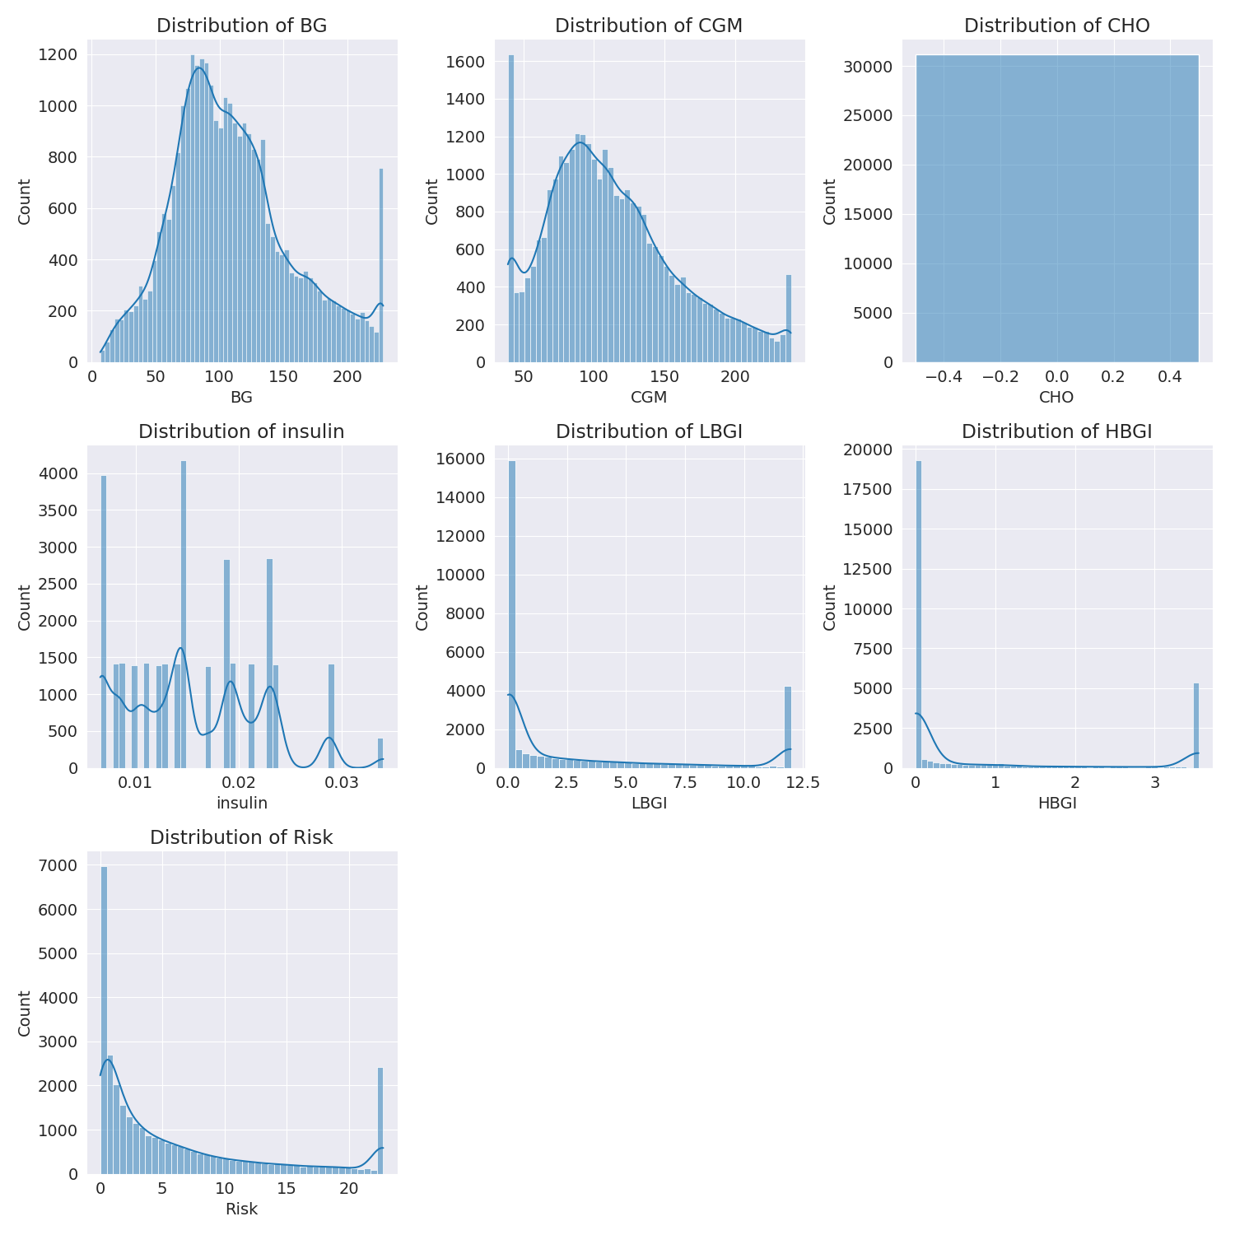

The image shows a series of graphs displaying the distribution of columns based on different criteria. Each graph represents a specific aspect of the data distribution. To analyze the distribution, we can identify any discernible patterns, cycles, or trends in the data over time.  
  
1. The first graph shows the distribution of insulin levels. The shape of the distribution is skewed, with a higher concentration of insulin levels in the middle and lower levels on both sides.  
2. The second graph displays the distribution of glucose levels. The shape of the distribution is skewed, with a higher concentration of glucose levels in the middle and lower levels on both sides.  
3. The third graph shows the distribution of LDLC levels. The shape of the distribution is skewed, with a higher concentration of LDLC levels in the middle and lower levels on both sides.  
4. The fourth graph displays the distribution of HDL levels. The shape of the distribution is skewed, with a higher concentration of HDL levels in the middle and lower levels on both sides.  
5. The fifth graph shows the distribution of triglyceride levels. The shape of the distribution is skewed, with a higher concentration of triglyceride levels in the middle and lower levels on both sides.  
6. The sixth graph displays the distribution of cholesterol levels. The shape of the distribution is skewed, with a higher concentration of cholesterol levels in the middle and lower levels on both sides.  
  
In summary, the image shows a series of graphs displaying the distribution of columns based on different criteria. Each graph represents a specific aspect of the data distribution. The shape of the distribution is skewed, with a higher concentration of the respective column in the middle and lower levels on both sides.

PairWise Graph Analysis

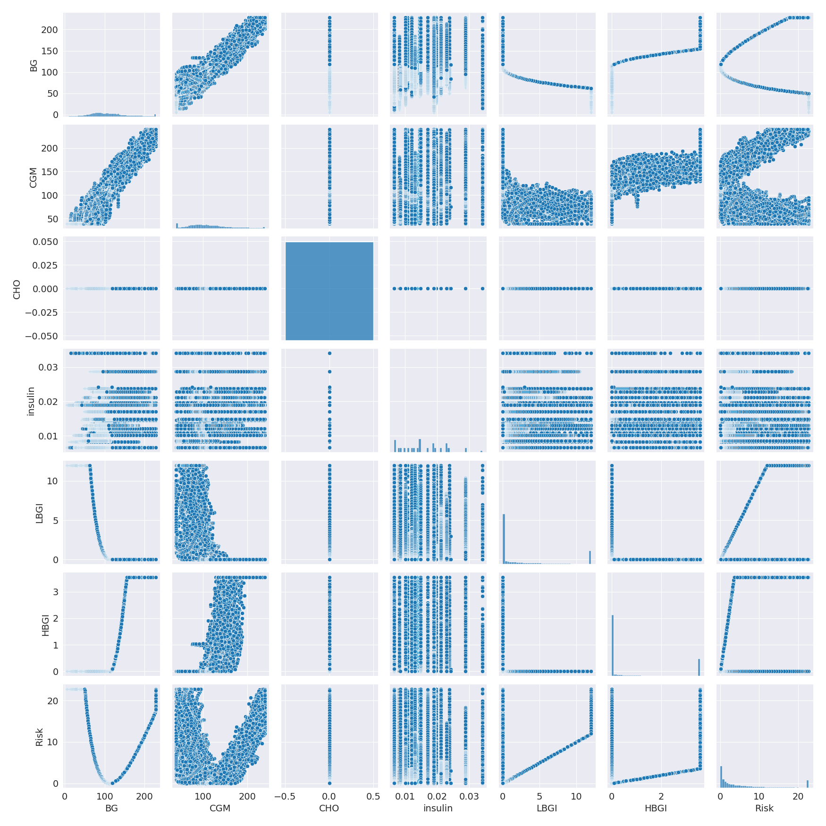

The image displays a collection of graphs, each pairwise graph visualizing the relationship between two variables. These graphs are used to analyze and understand the interconnections between the variables. The graphs are presented in a blue color scheme, which adds a visually appealing touch to the presentation.  
  
The graphs are organized in a way that allows for easy comparison and interpretation of the data. By examining these graphs, one can gain insights into the relationships between the variables, which can be used to make informed decisions or predictions.  
  
The use of pairwise graphs is particularly beneficial when dealing with complex data sets, as they provide a clear and concise representation of the interdependencies between the variables. This visualization technique helps to uncover patterns and changes that might not be immediately apparent from a simple table or chart.  
  
In summary, the image showcases a series of pairwise graphs that help to reveal the intricate relationships between variables. These visualizations enhance our understanding of the data's interconnections, providing a comprehensive view of the complex relationships between the variables.

Missing Numbers Graph Analysis

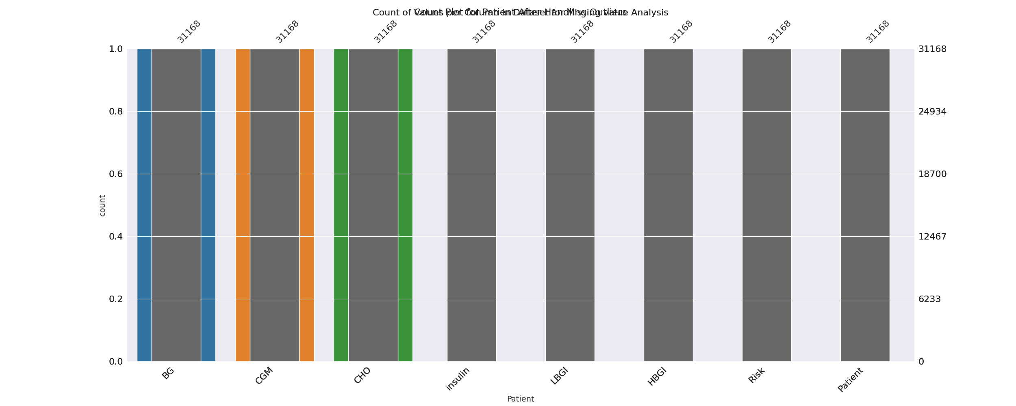

The image displays a bar chart with missing values, which is a common issue in data analysis. The chart is showing the count of black patients, and the numbers are missing for some of the bars. This can impact data analysis or modeling, as it may lead to inaccurate conclusions or predictions.  
  
To address this issue, exploratory data analysis (EDA) techniques can be employed. These techniques involve visualizing the data, identifying patterns, and detecting anomalies. By examining the distribution of the missing values, one can understand the reasons behind the missing data and decide whether to impute the missing values or exclude the affected data points.  
  
In the case of the bar chart, the missing values could be due to various reasons, such as data entry errors, missing data in the original source, or a deliberate decision to exclude certain data points. By identifying the cause of the missing values, one can take appropriate actions to improve the quality of the data and ensure accurate analysis or modeling.

Heat_Explainer Graph Analysis

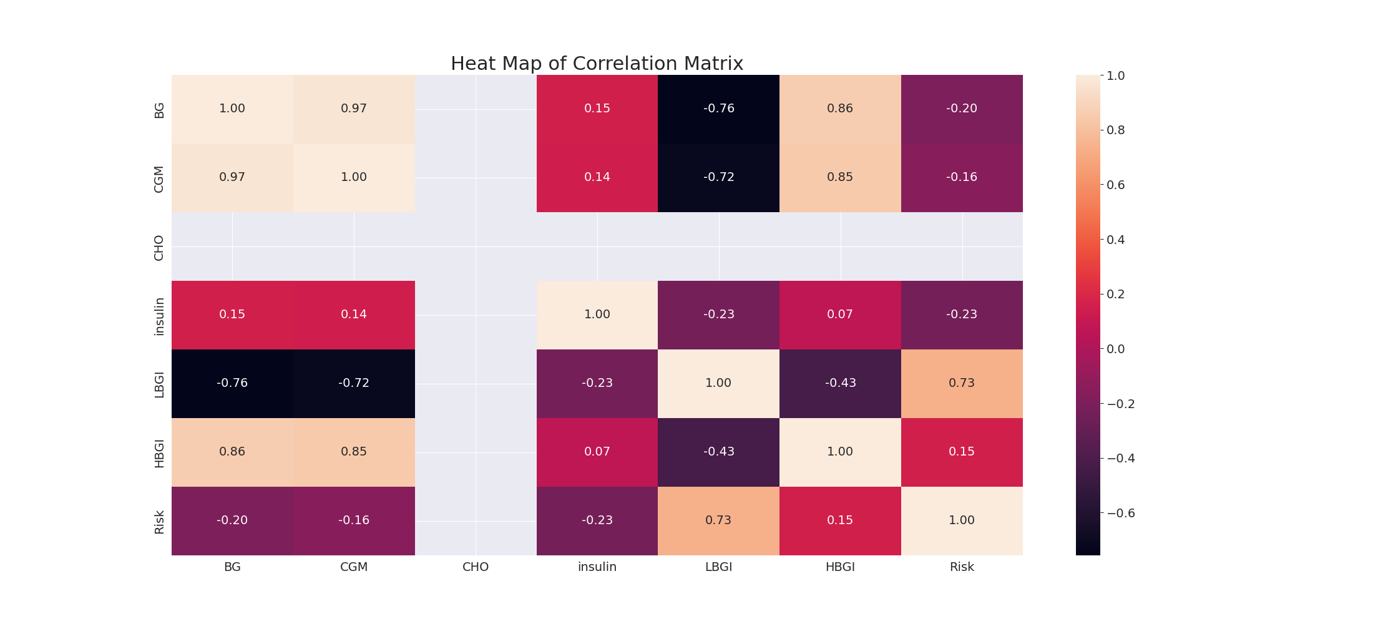

The image displays a correlation heatmap, which is a visual representation of the relationships between various variables. The heatmap is a color-coded matrix that helps to understand the strength and direction of correlations between these variables. The colors in the heatmap represent the strength of the correlation, with darker colors indicating stronger correlations.  
  
The heatmap is organized in a way that allows for easy identification of the variables and their relationships. The variables are likely related, and the data in the image helps to analyze and understand these relationships. By examining and deep-analyzing the visual representation, one can gain insights into the strength and direction of correlations between the variables.

Multi-linear Regression Inference Graph Analysis

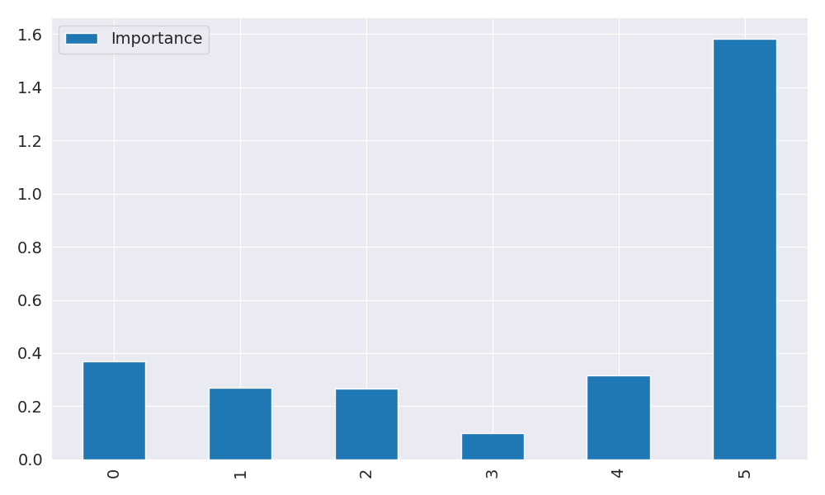

The image displays a graph with a blue line, which is likely a Neural Regressor. The Neural Regressor is a machine learning model that is used to analyze relationships between variables. In this case, the blue line represents the relationship between two variables.  
  
The graph is a line graph, with the x-axis representing one variable and the y-axis representing the other variable. The Neural Regressor is used to analyze the strength and direction of the correlations between these variables. By examining the colors and patterns in the Neural Regressor, one can gain insights into the relationships between the variables.  
  
The Neural Regressor is a powerful tool for data analysis and can be used in various applications, such as predicting future trends, identifying patterns, and making informed decisions based on the data.