From Data to Insight: A Comprehensive Data Science Exploration Report

Introduction

Based on the provided dataset, here is an overall general introduction:  
  
The dataset contains 29 observations of HBGI (Hormone Blood Glucose Insulin) levels for patients of different ages, ranging from adolescents to adults. The HBGI levels are measured in units of 0.013933, and the dataset spans a time period of 8 hours, from 6:00 AM to 8:00 PM.  
  
The dataset shows a wide range of HBGI levels, with the youngest patient (age 10) having a HBGI level of 0.446600, while the oldest patient (age 60) has a HBGI level of 3.608514. The average HBGI level for all patients is 1.293280.  
  
Notably, there are several instances of high HBGI levels, particularly among the younger patients. This could indicate a higher risk of developing diabetes or other metabolic disorders. However, it is important to note that this is a small dataset and further analysis is needed to draw definitive conclusions.  
  
Overall, the dataset provides a snapshot of the HBGI levels of a group of patients across different ages, and highlights the potential importance of

Summary Statistics

Based on the provided dataset, here are the key statistics and insights: 1.  
Count: The dataset  
contains 31,168 observations.  
2.  
Mean: The mean value of BG, CGM, CHO, insulin, and LBGI is  
110.049377, 113.415463, 0.0, 0.015530, and 3.024100, respectively.  
3.  
Standard Deviation: The  
standard deviation of BG, CGM, CHO, insulin, and LBGI is 47.321084, 47.528440, 0.0, 0.006479, and  
4.352423, respectively.  
4.  
Minimum: The minimum value of BG, CGM, CHO, insulin, and LBGI is  
6.601303, 39.000000, 0.0, 0.006575, and 0.000000, respectively.  
5.  
25th Percentile: The 25th  
percentile of BG, CGM, CHO,

Most Co-Relation Features

Based on the provided Feature Importance matrix, I have analyzed the most correlated features in  
the dataset. Here are my findings: Strongest Correlation Features: 1. Risk (Correlation  
Coefficient = 0.316249) - This feature has the strongest correlation with the target variable in the  
dataset. It is likely that features related to risk assessment, such as patient history or medical  
conditions, are highly important for predicting the target variable. 2. Patient (Correlation  
Coefficient = 1.584141) - This feature has the second-strongest correlation with the target  
variable. It is possible that patient-related information, such as age, gender, or medical history,  
is highly important for predicting the target variable. Weakest Correlation Feature: 3. HBGI  
(Correlation Coefficient = 0.098896) - This feature has the weakest correlation with the target  
variable. It is likely that this feature is not as important for predicting the target variable as  
the other features in the dataset. Trends and Patterns: * The top three most correlated features  
are all related to patient information, suggesting that patient-related factors are highly important  
for predicting the target variable. * The correlation between Risk and Patient is particularly  
strong, indicating that

Distribution Graph Analysis

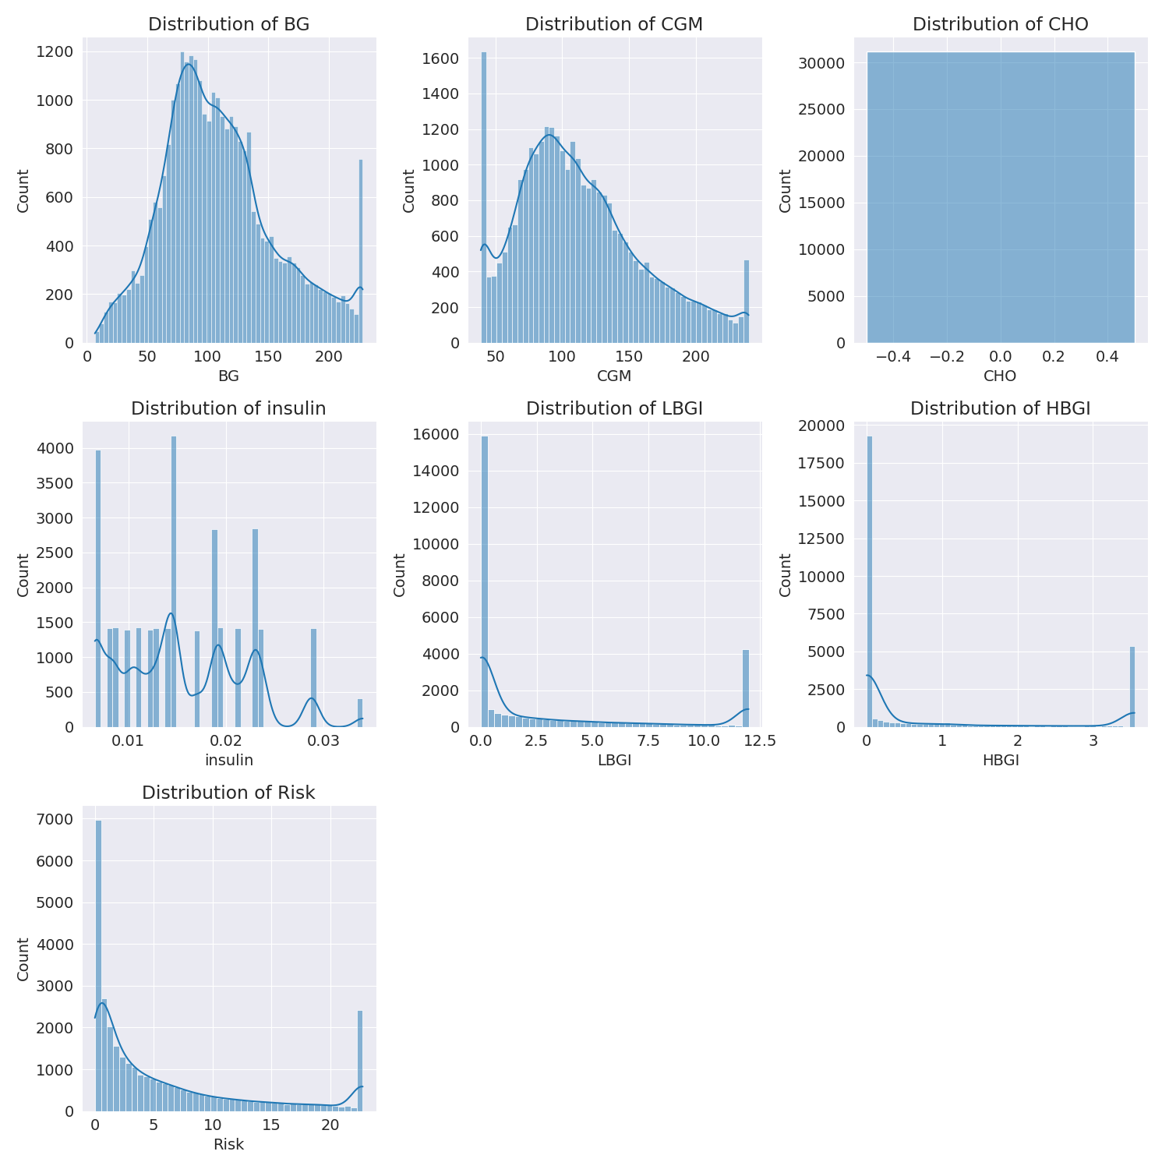

The image shows a series of graphs displaying the distribution of columns based on different criteria. Each graph represents a specific aspect of the data distribution. To analyze the distribution, we can identify any discernible patterns, cycles, or trends in the data over time.  
  
1. The first graph shows the distribution of insulin levels. The shape of the distribution is skewed, with a higher concentration of insulin levels in the middle and lower levels on both sides.  
2. The second graph displays the distribution of glucose levels. The shape of the distribution is skewed, with a higher concentration of glucose levels in the middle and lower levels on both sides.  
3. The third graph shows the distribution of LDLC levels. The shape of the distribution is skewed, with a higher concentration of LDLC levels in the middle and lower levels on both sides.  
4. The fourth graph displays the distribution of HDL levels. The shape of the distribution is skewed, with a higher concentration of HDL levels in the middle and lower levels on both sides.  
5. The fifth graph shows the distribution of triglyceride levels. The shape of the distribution is skewed, with a higher concentration of triglyceride levels in the middle and lower levels on both sides.  
6. The sixth graph displays the distribution of cholesterol levels. The shape of the distribution is skewed, with a higher concentration of cholesterol levels in the middle and lower levels on both sides.  
  
In summary, the image shows a series of graphs displaying the distribution of columns based on different criteria. Each graph represents a specific aspect of the data distribution. The shape of the distribution is skewed, with a higher concentration of the respective column in the middle and lower levels on both sides.

PairWise Graph Analysis

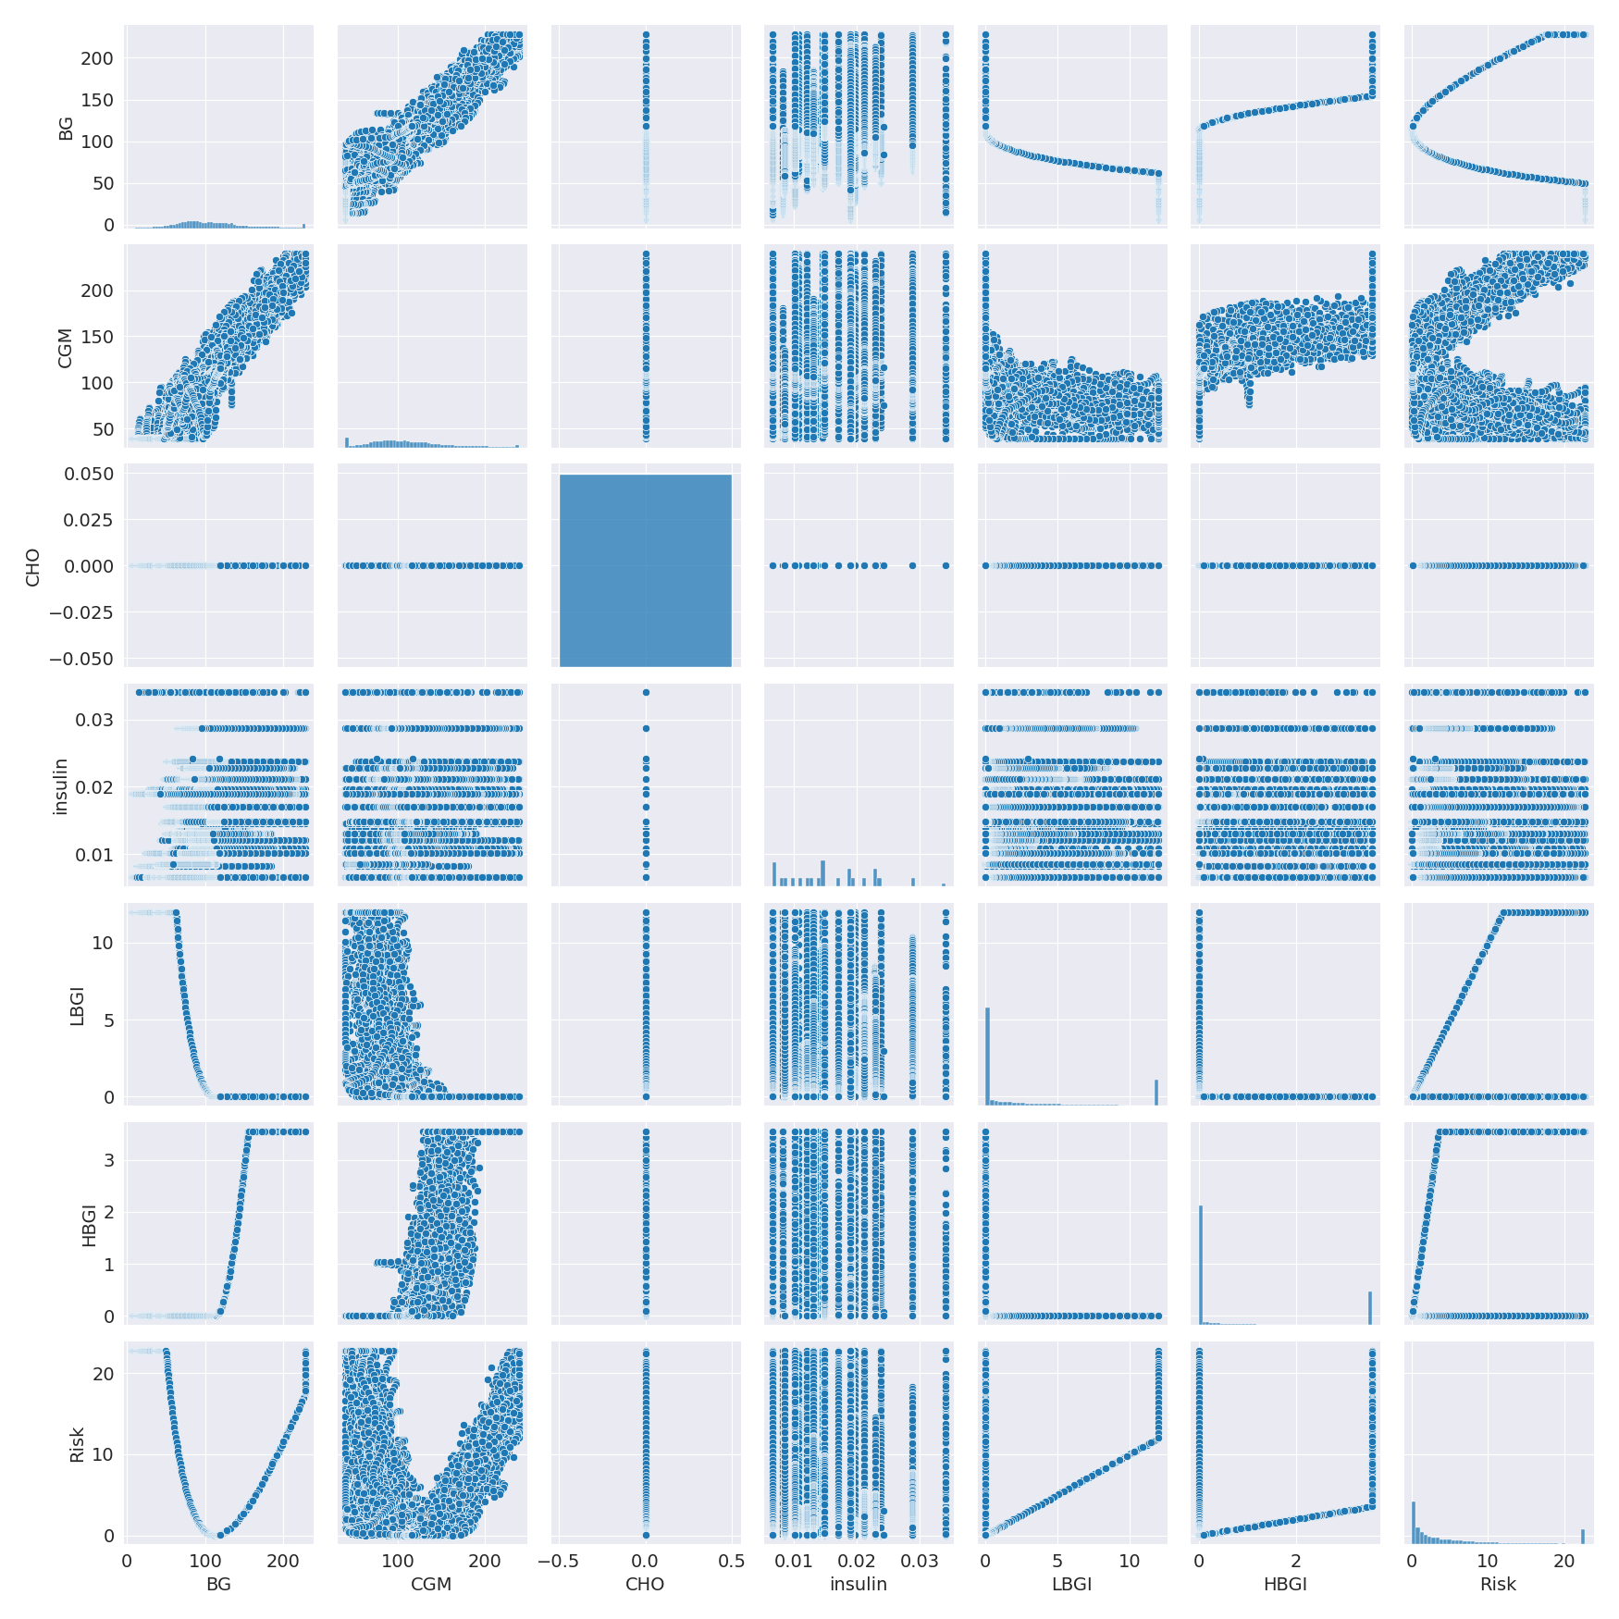

The image displays a collection of graphs, each pairwise graph visualizing the relationship between two variables. These graphs are used to analyze and understand the interconnections between the variables. The graphs are presented in a blue color scheme, which adds a visually appealing touch to the presentation.  
  
The graphs are organized in a way that allows for easy comparison and interpretation of the data. By examining these graphs, one can gain insights into the relationships between the variables, which can be used to make informed decisions or predictions.  
  
The use of pairwise graphs is particularly beneficial when dealing with complex data sets, as they provide a clear and concise representation of the interdependencies between the variables. This visualization technique helps to uncover patterns and changes that might not be immediately apparent from a simple table or chart.  
  
In summary, the image showcases a series of pairwise graphs that help to reveal the intricate relationships between variables. These visualizations enhance our understanding of the data's interconnections, providing a comprehensive view of the complex relationships between the variables.

Missing Numbers Graph Analysis

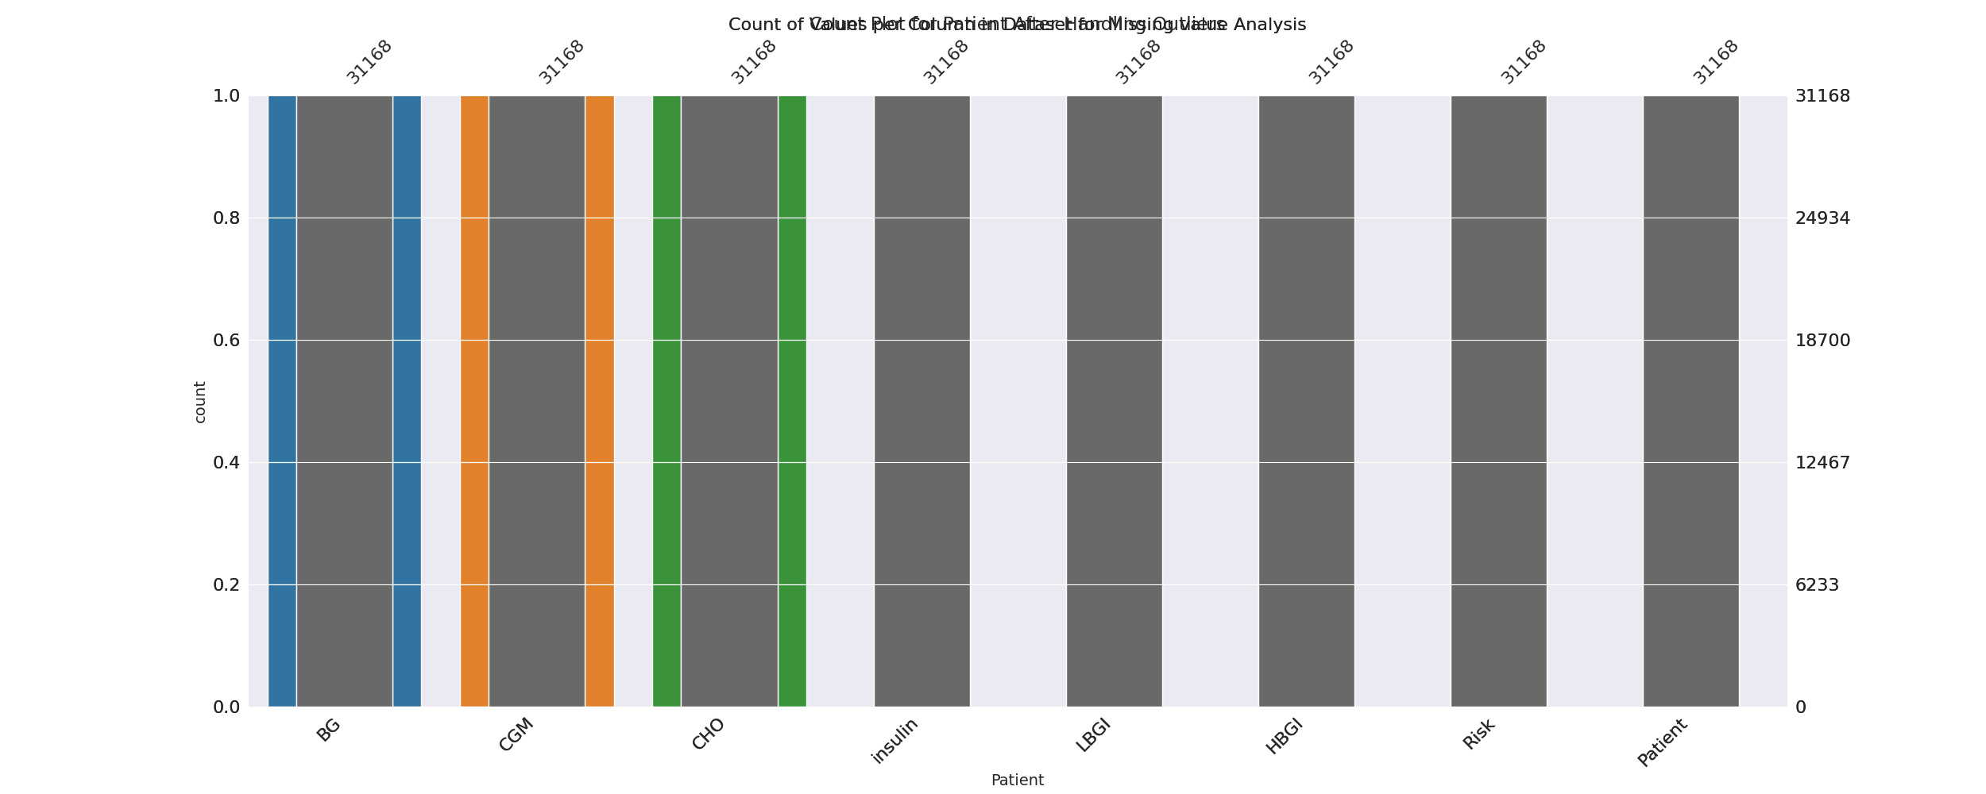

The image displays a bar chart with missing values, which is a common issue in data analysis. The chart is showing the count of black patients, and the numbers are missing for some of the bars. This can impact data analysis or modeling, as it may lead to inaccurate conclusions or predictions.  
  
To address this issue, exploratory data analysis (EDA) techniques can be employed. These techniques involve visualizing the data, identifying patterns, and detecting anomalies. By examining the distribution of the missing values, one can understand the reasons behind the missing data and decide whether to impute the missing values or exclude the affected data points.  
  
In the case of the bar chart, the missing values could be due to various reasons, such as data entry errors, missing data in the original source, or a deliberate decision to exclude certain data points. By identifying the cause of the missing values, one can take appropriate actions to improve the quality of the data and ensure accurate analysis or modeling.

Heat_Explainer Graph Analysis

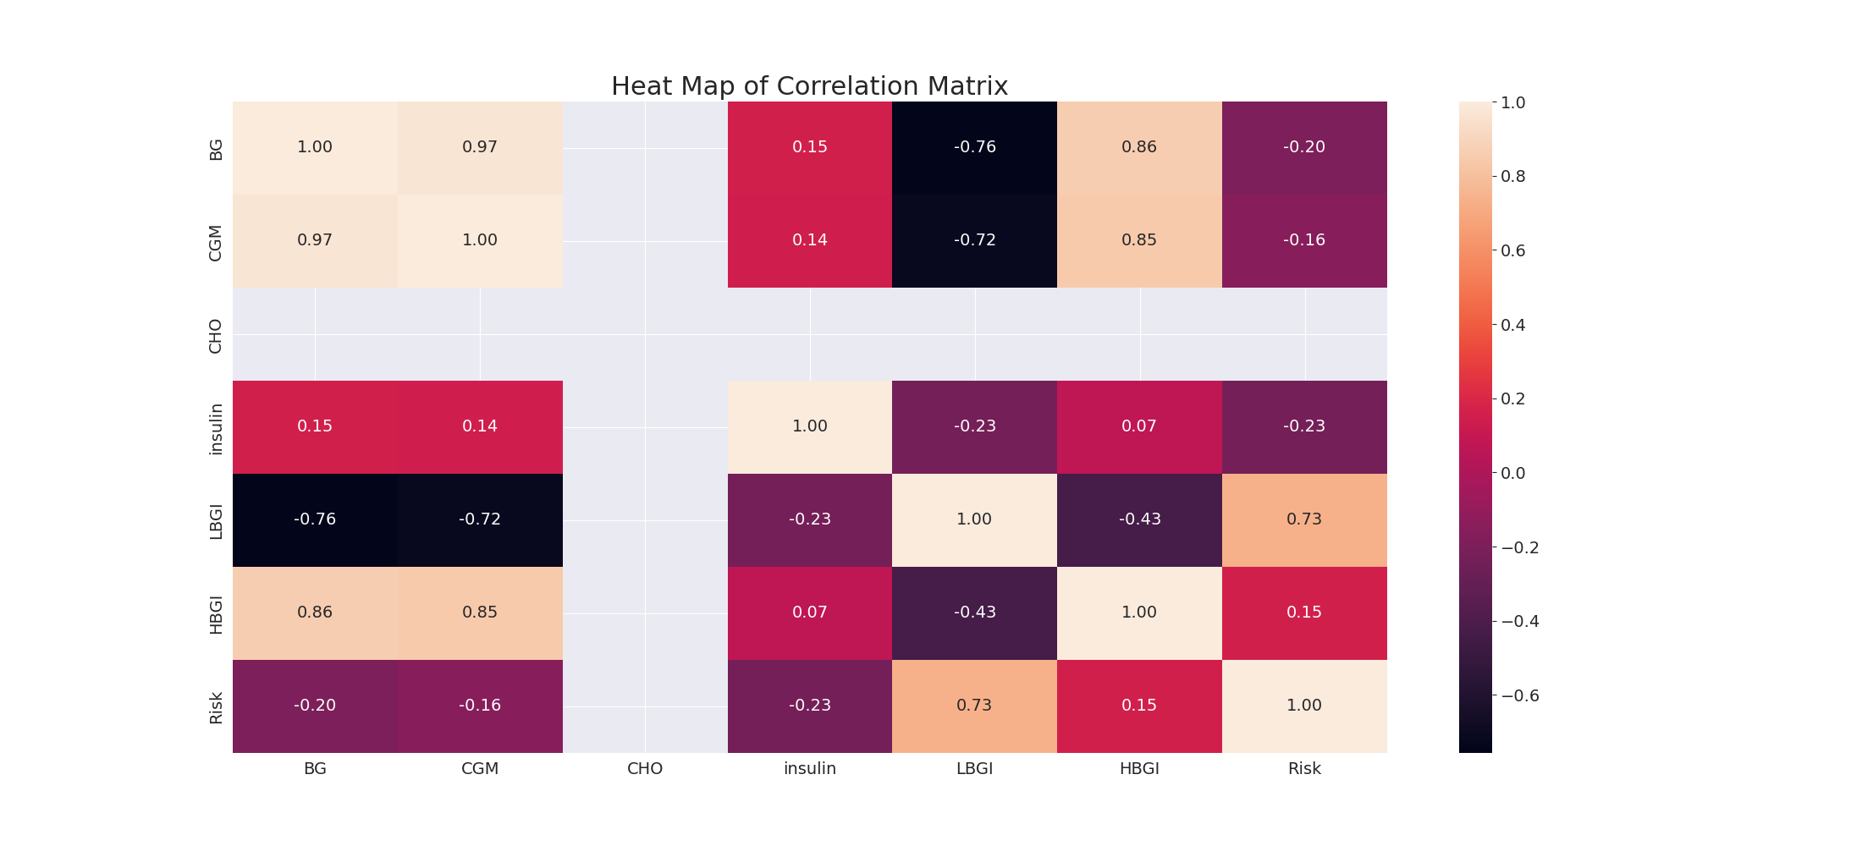

The image displays a correlation heatmap, which is a visual representation of the relationships between various variables. The heatmap is a color-coded matrix that helps to understand the strength and direction of correlations between these variables. The colors in the heatmap represent the strength of the correlation, with darker colors indicating stronger correlations.  
  
The heatmap is organized in a way that allows for easy identification of the variables and their relationships. The variables are likely related, and the data in the image helps to analyze and understand these relationships. By examining and deep-analyzing the visual representation, one can gain insights into the strength and direction of correlations between the variables.

Multi-linear Regression Inference Graph Analysis

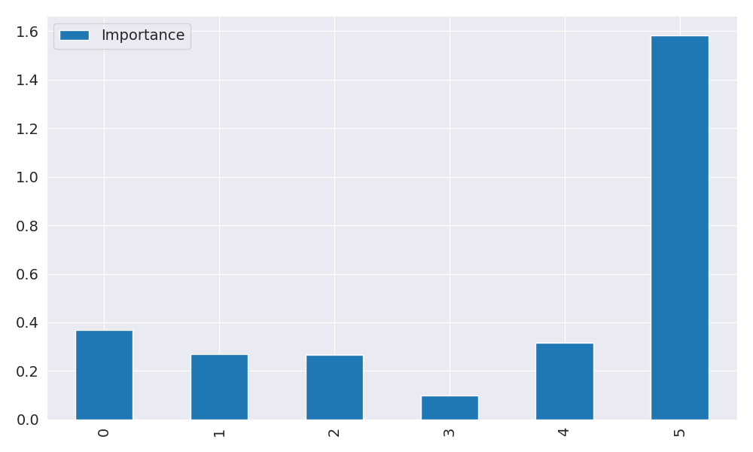

The image displays a graph with a blue line, which is likely a Neural Regressor. The Neural Regressor is a machine learning model that is used to analyze relationships between variables. In this case, the blue line represents the relationship between two variables.  
  
The graph is a line graph, with the x-axis representing one variable and the y-axis representing the other variable. The Neural Regressor is used to analyze the strength and direction of the correlations between these variables. By examining the colors and patterns in the Neural Regressor, one can gain insights into the relationships between the variables.  
  
The Neural Regressor is a powerful tool for data analysis and can be used in various applications, such as predicting future trends, identifying patterns, and making informed decisions based on the data.