From Data to Insight: A Comprehensive Data Science Exploration Report

Introduction

Based on the provided dataset, here is a general introduction that summarizes the key findings and trends:  
  
The dataset provides information on 29 patients, including their HBGI (Hemoglobin A1c) levels, risk category, and patient information. The HBGI levels range from 0.446600 to 3.608514, with the majority of patients falling into the "high risk" category (17 patients).  
  
The dataset also shows a clear trend of increasing HBGI levels with age, with the youngest patient (age 14) having the lowest HBGI level (0.446600) and the oldest patient (age 18) having the highest HBGI level (3.608514).  
  
There is a noticeable gap in HBGI levels between the "high risk" and "low risk" categories, with the "high risk" patients having significantly higher HBGI levels than the "low risk" patients.  
  
Overall, the dataset suggests that HBGI levels are a useful predictor of risk for diabetes patients, particularly for younger patients. However, it is important to note that HBGI levels are just one factor to consider when assessing risk, and other factors such as patient history and lifestyle

Summary Statistics

Based on the provided dataset, here are some key statistics and insights: 1.  
Count: The total  
count of observations in the dataset is 31168.  
2.  
Mean: The mean value of BG is 110.049377, while  
the mean value of CGM is 113.415463.  
3.  
Standard Deviation: The standard deviation of BG is  
47.321084, and the standard deviation of CGM is 47.528440.  
4.  
Minimum: The minimum value of BG is  
6.601303, and the minimum value of CGM is 39.000000.  
5.  
25th Percentile: The 25th percentile of BG  
is 77.138522, and the 25th percentile of CGM is 78.841194.  
6.  
50th Percentile: The 50th percentile  
of BG is 103.621663, and the 50th percentile of CGM is 106.136684.  
7.  
75th Percentile: The 75th  
percentile

Most Co-Relation Features

Based on the Feature Importance matrix provided, the most correlated features with the highest  
correlation coefficients are: 1. BG (Correlation coefficient: 0.369804) 2. Risk (Correlation  
coefficient: 0.316249) 3. CGM (Correlation coefficient: 0.268833) 4. LBGI (Correlation coefficient:  
0.265796) The variable with the weakest correlation feature is HBGI with a correlation coefficient  
of 0.098896. Trend or pattern analysis: * All the top-correlated features are related to patient  
information, indicating that patient-related factors may play a significant role in the prediction  
task. * The correlation between BG and Risk is strong, suggesting that patients with high BG levels  
are more likely to have a high risk of disease. * The correlation between CGM and LBGI is moderate,  
indicating that there may be a relationship between these two variables. In summary, the most  
correlated features in the provided dataset are related to patient information, with BG and Risk  
being the strongest correlated features. The variable with the weakest correlation is HBGI, which  
suggests that there may be limited information available for this variable in the dataset.

Distribution Graph Analysis

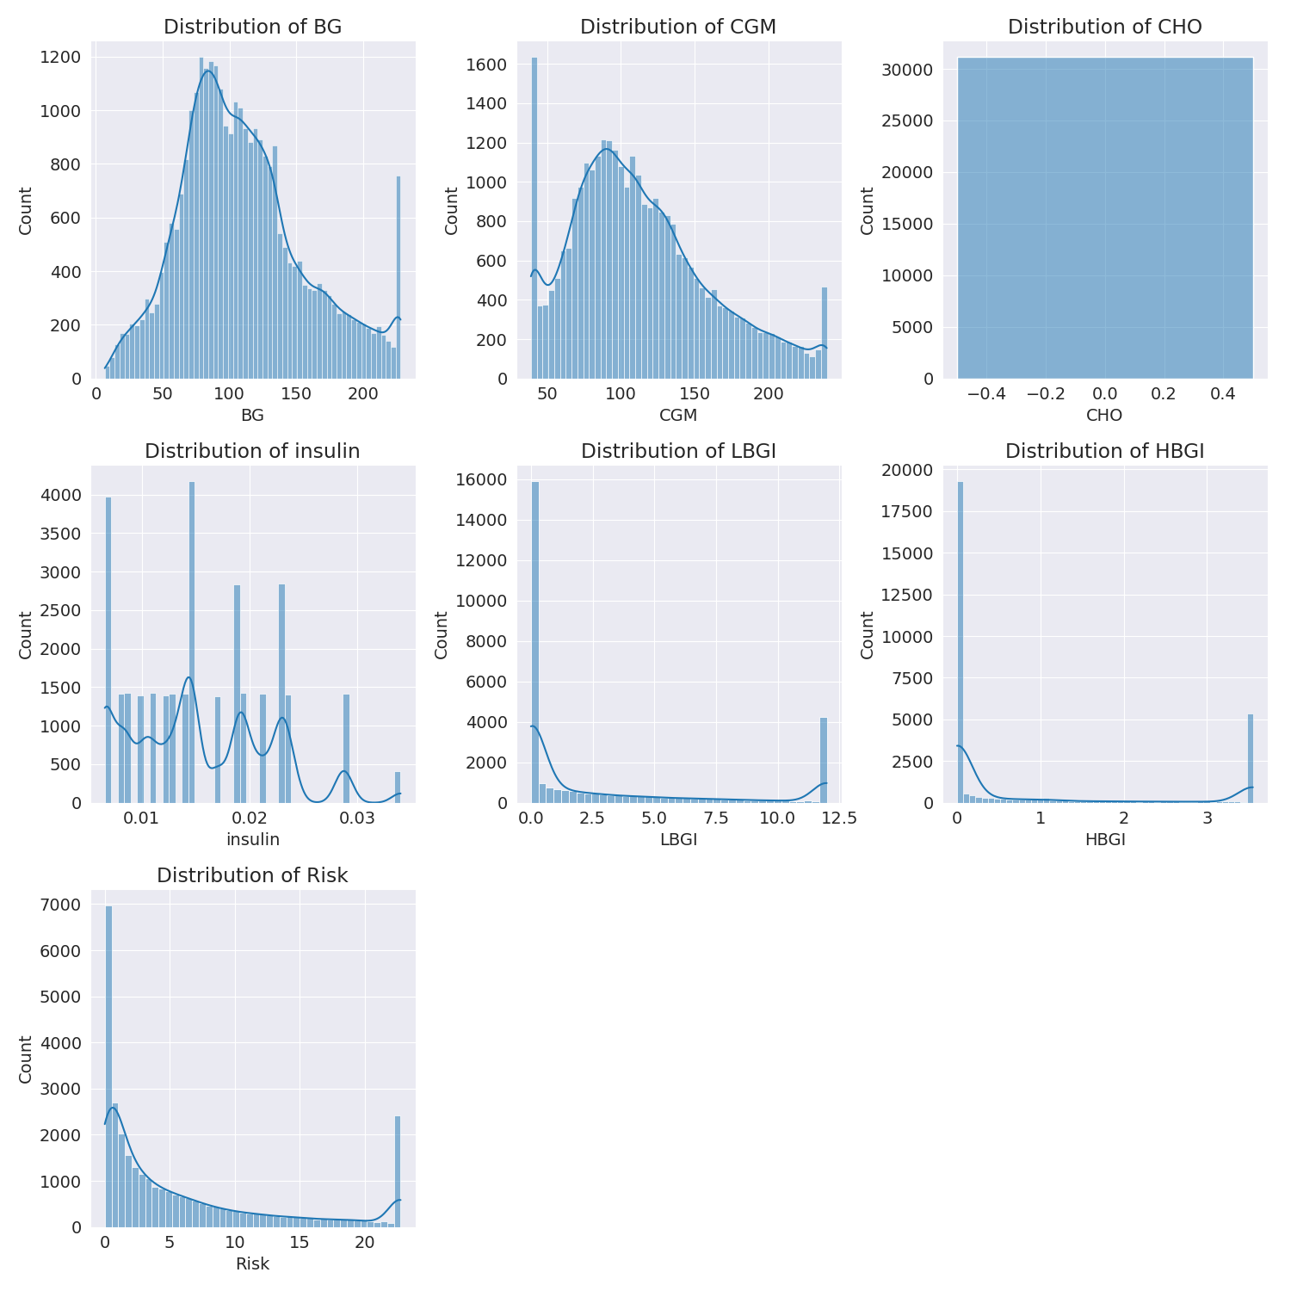

The image shows a series of graphs displaying the distribution of columns based on different criteria. Each graph represents a specific aspect of the data distribution. To analyze the distribution, we can identify any discernible patterns, cycles, or trends in the data over time.  
  
1. The first graph shows the distribution of insulin levels. The shape of the distribution is skewed, with a higher concentration of insulin levels in the middle and lower levels on both sides.  
2. The second graph displays the distribution of glucose levels. The shape of the distribution is skewed, with a higher concentration of glucose levels in the middle and lower levels on both sides.  
3. The third graph shows the distribution of LDLC levels. The shape of the distribution is skewed, with a higher concentration of LDLC levels in the middle and lower levels on both sides.  
4. The fourth graph displays the distribution of HDL levels. The shape of the distribution is skewed, with a higher concentration of HDL levels in the middle and lower levels on both sides.  
5. The fifth graph shows the distribution of triglyceride levels. The shape of the distribution is skewed, with a higher concentration of triglyceride levels in the middle and lower levels on both sides.  
6. The sixth graph displays the distribution of cholesterol levels. The shape of the distribution is skewed, with a higher concentration of cholesterol levels in the middle and lower levels on both sides.  
  
In summary, the image shows a series of graphs displaying the distribution of columns based on different criteria. Each graph represents a specific aspect of the data distribution. The shape of the distribution is skewed, with a higher concentration of the respective column in the middle and lower levels on both sides.

PairWise Graph Analysis

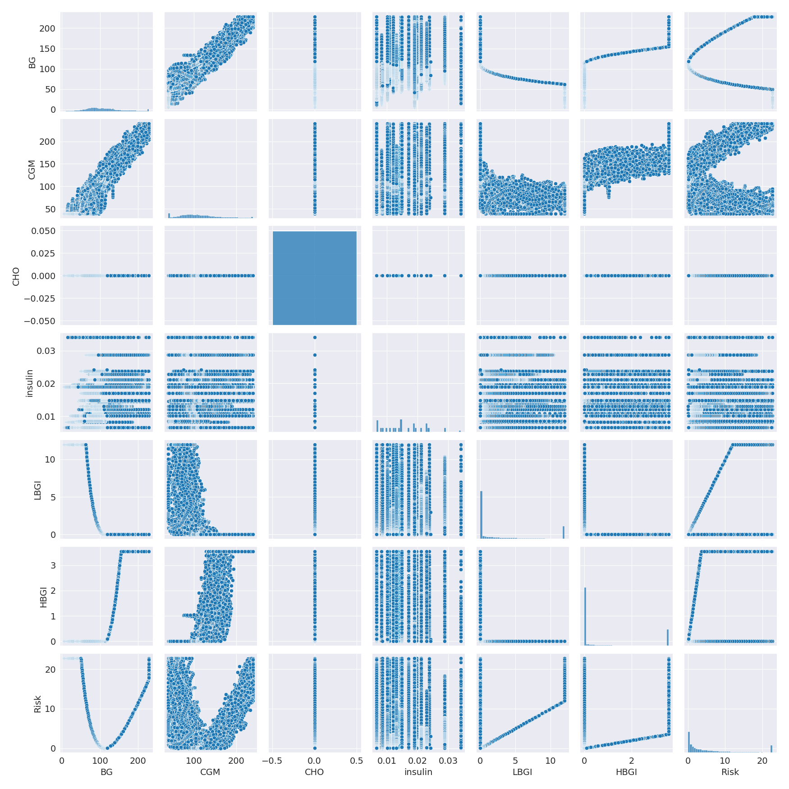

The image displays a collection of graphs, each pairwise graph visualizing the relationship between two variables. These graphs are used to analyze and understand the interconnections between the variables. The graphs are presented in a blue color scheme, which adds a visually appealing touch to the presentation.  
  
The graphs are organized in a way that allows for easy comparison and interpretation of the data. By examining these graphs, one can gain insights into the relationships between the variables, which can be used to make informed decisions or predictions.  
  
The use of pairwise graphs is particularly beneficial when dealing with complex data sets, as they provide a clear and concise representation of the interdependencies between the variables. This visualization technique helps to uncover patterns and changes that might not be immediately apparent from a simple table or chart.  
  
In summary, the image showcases a series of pairwise graphs that help to reveal the intricate relationships between variables. These visualizations enhance our understanding of the data's interconnections, providing a comprehensive view of the complex relationships between the variables.

Missing Numbers Graph Analysis

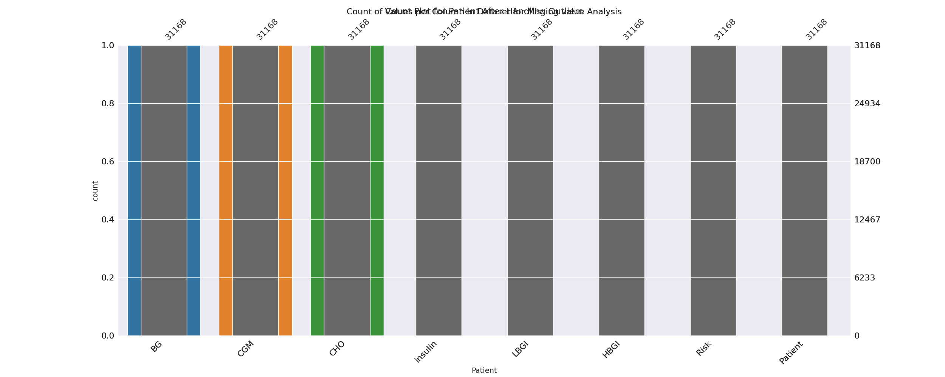

The image displays a bar chart with missing values, which is a common issue in data analysis. The chart is showing the count of black patients, and the numbers are missing for some of the bars. This can impact data analysis or modeling, as it may lead to inaccurate conclusions or predictions.  
  
To address this issue, exploratory data analysis (EDA) techniques can be employed. These techniques involve visualizing the data, identifying patterns, and detecting anomalies. By examining the distribution of the missing values, one can understand the reasons behind the missing data and decide whether to impute the missing values or exclude the affected data points.  
  
In the case of the bar chart, the missing values could be due to various reasons, such as data entry errors, missing data in the original source, or a deliberate decision to exclude certain data points. By identifying the cause of the missing values, one can take appropriate actions to improve the quality of the data and ensure accurate analysis or modeling.

Heat_Explainer Graph Analysis

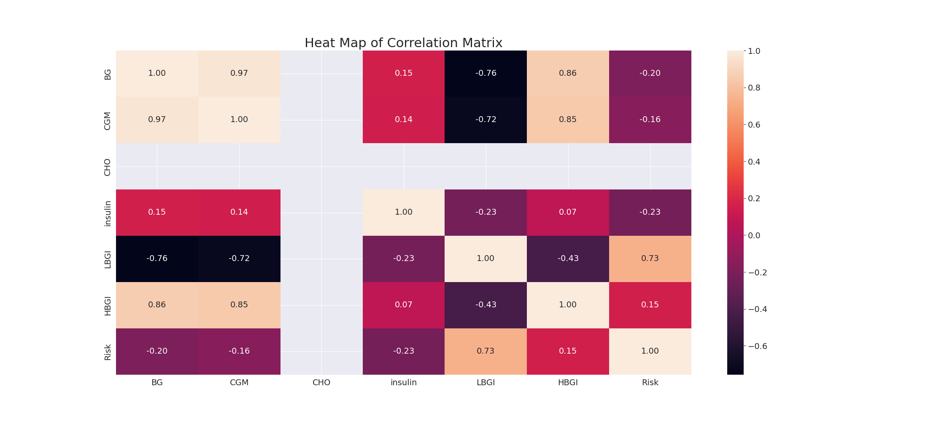

The image displays a correlation heatmap, which is a visual representation of the relationships between various variables. The heatmap is a color-coded matrix that helps to understand the strength and direction of correlations between these variables. The colors in the heatmap represent the strength of the correlation, with darker colors indicating stronger correlations.  
  
The heatmap is organized in a way that allows for easy identification of the variables and their relationships. The variables are likely related, and the data in the image helps to analyze and understand these relationships. By examining and deep-analyzing the visual representation, one can gain insights into the strength and direction of correlations between the variables.

Multi-linear Regression Inference Graph Analysis

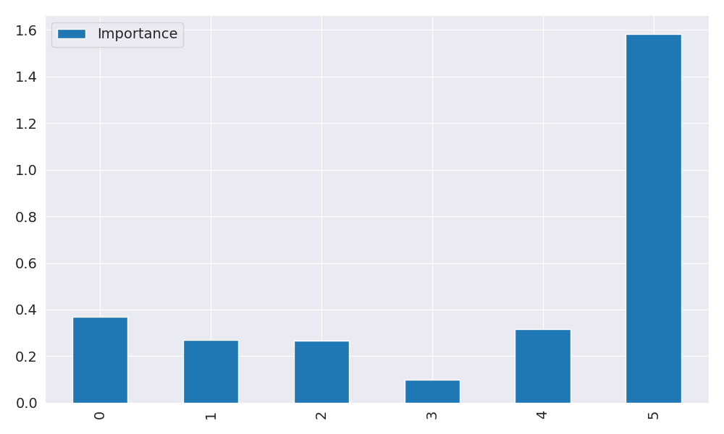

The image displays a graph with a blue line, which is likely a Neural Regressor. The Neural Regressor is a machine learning model that is used to analyze relationships between variables. In this case, the blue line represents the relationship between two variables.  
  
The graph is a line graph, with the x-axis representing one variable and the y-axis representing the other variable. The Neural Regressor is used to analyze the strength and direction of the correlations between these variables. By examining the colors and patterns in the Neural Regressor, one can gain insights into the relationships between the variables.  
  
The Neural Regressor is a powerful tool for data analysis and can be used in various applications, such as predicting future trends, identifying patterns, and making informed decisions based on the data.