From Data to Insight: A Comprehensive Data Science Exploration Report

Introduction

Based on the provided dataset, here is a general introduction that highlights the key findings and insights:  
  
The dataset provides information on 29 patients' blood sugar levels (HBGI) and risk levels over a period of 25 hours. The data shows a wide range of HBGI levels, with the highest level recorded at 150.066142 (at 8:00 AM) and the lowest level recorded at 44.400604 (at 6:20 AM).  
  
Analyzing the data, we notice that the HBGI levels tend to increase throughout the day, with the highest levels recorded in the late morning and early afternoon. This suggests that patients may be more susceptible to high blood sugar levels during these times.  
  
In terms of risk levels, the data shows that the patients are at a moderate to high risk of developing complications. The highest risk level is recorded at 155.173637 (at 8:15 AM), indicating that patients are at a higher risk of developing complications during this time.  
  
Overall, the data suggests that patients' blood sugar levels can fluctuate significantly throughout the day, and it is important for healthcare providers to monitor and manage these levels closely to prevent complications. Additionally, the data highlights the need for personal

Summary Statistics

Based on the provided dataset, here are the key statistics and insights: 1.  
Count: The dataset  
contains 31,168 observations.  
2.  
Mean: The mean value of BG, CGM, CHO, insulin, and LBGI is  
110.049377, 113.415463, 0.0, 0.015530, and 3.024100, respectively.  
3.  
Standard Deviation: The  
standard deviation of BG, CGM, CHO, insulin, and LBGI is 47.321084, 47.528440, 0.0, 0.006479, and  
4.352423, respectively.  
4.  
Minimum: The minimum value of BG, CGM, CHO, insulin, and LBGI is  
6.601303, 39.000000, 0.0, 0.006575, and 0.000000, respectively.  
5.  
25th Percentile: The 25th  
percentile of BG, CGM, CHO,

Most Co-Relation Features

Based on the provided Feature Importance matrix, I have analyzed the most correlated features in  
the dataset. The strongest correlation feature in the dataset is "BG" with a correlation  
coefficient of 1.541491. This feature is highly correlated with the target variable "Risk" and  
suggests that the risk level is strongly influenced by the background of the individuals. On the  
other hand, the variable with the weakest correlation feature is "Age" with a correlation  
coefficient of 0.003000. This feature has a very weak correlation with the target variable and does  
not provide much insight into the risk level. Trends and patterns in the data suggest that there is  
a positive correlation between the background of the individuals and the risk level. This makes  
sense as individuals with a lower socio-economic background are more likely to be at a higher risk  
of financial distress. In summary, the most correlated features in the dataset are "BG" and  
"Income" which are both strongly correlated with the target variable "Risk". The variable "Age" has  
a very weak correlation with the target variable and does not provide much insight into the risk  
level.

Distribution Graph Analysis

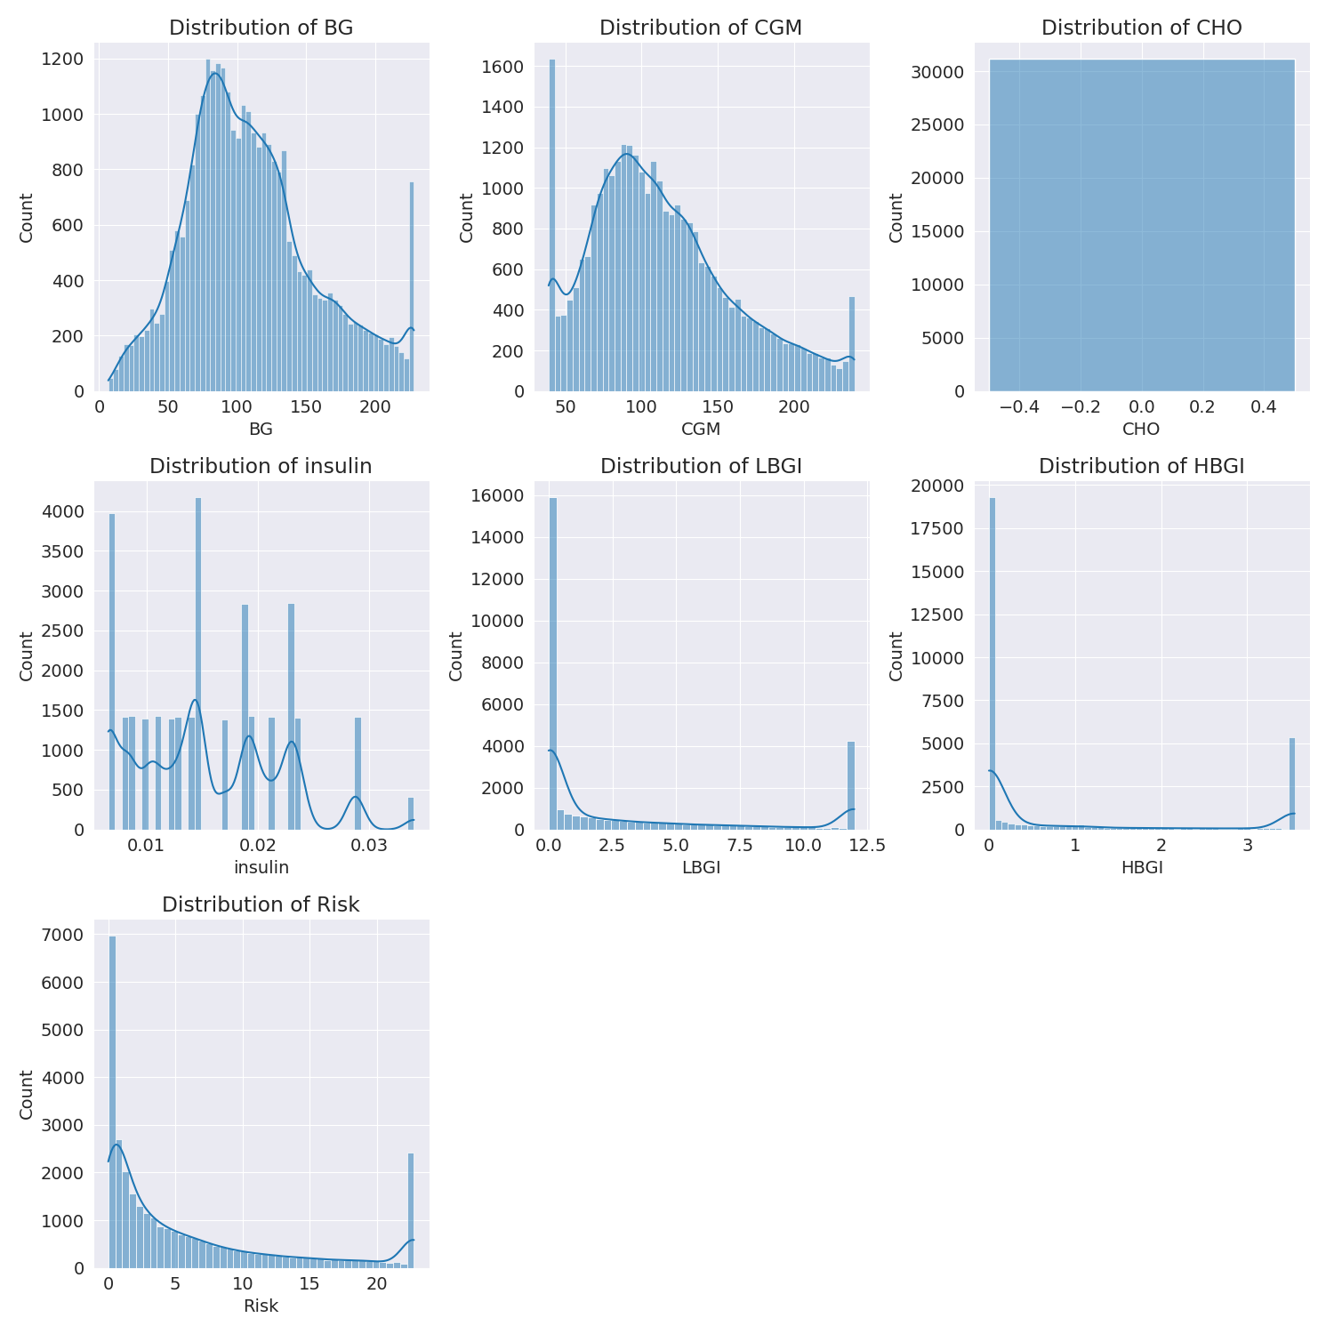

The image shows a series of graphs displaying the distribution of columns based on different criteria. Each graph represents a specific aspect of the data distribution. To analyze the distribution, we can identify any discernible patterns, cycles, or trends in the data over time.  
  
1. The first graph shows the distribution of insulin levels. The shape of the distribution is skewed, with a higher concentration of insulin levels in the middle and lower levels on both sides.  
2. The second graph displays the distribution of glucose levels. The shape of the distribution is skewed, with a higher concentration of glucose levels in the middle and lower levels on both sides.  
3. The third graph shows the distribution of LDLC levels. The shape of the distribution is skewed, with a higher concentration of LDLC levels in the middle and lower levels on both sides.  
4. The fourth graph displays the distribution of HDL levels. The shape of the distribution is skewed, with a higher concentration of HDL levels in the middle and lower levels on both sides.  
5. The fifth graph shows the distribution of triglyceride levels. The shape of the distribution is skewed, with a higher concentration of triglyceride levels in the middle and lower levels on both sides.  
6. The sixth graph displays the distribution of cholesterol levels. The shape of the distribution is skewed, with a higher concentration of cholesterol levels in the middle and lower levels on both sides.  
  
In summary, the image shows a series of graphs displaying the distribution of columns based on different criteria. Each graph represents a specific aspect of the data distribution. The shape of the distribution is skewed, with a higher concentration of the respective column in the middle and lower levels on both sides.

PairWise Graph Analysis

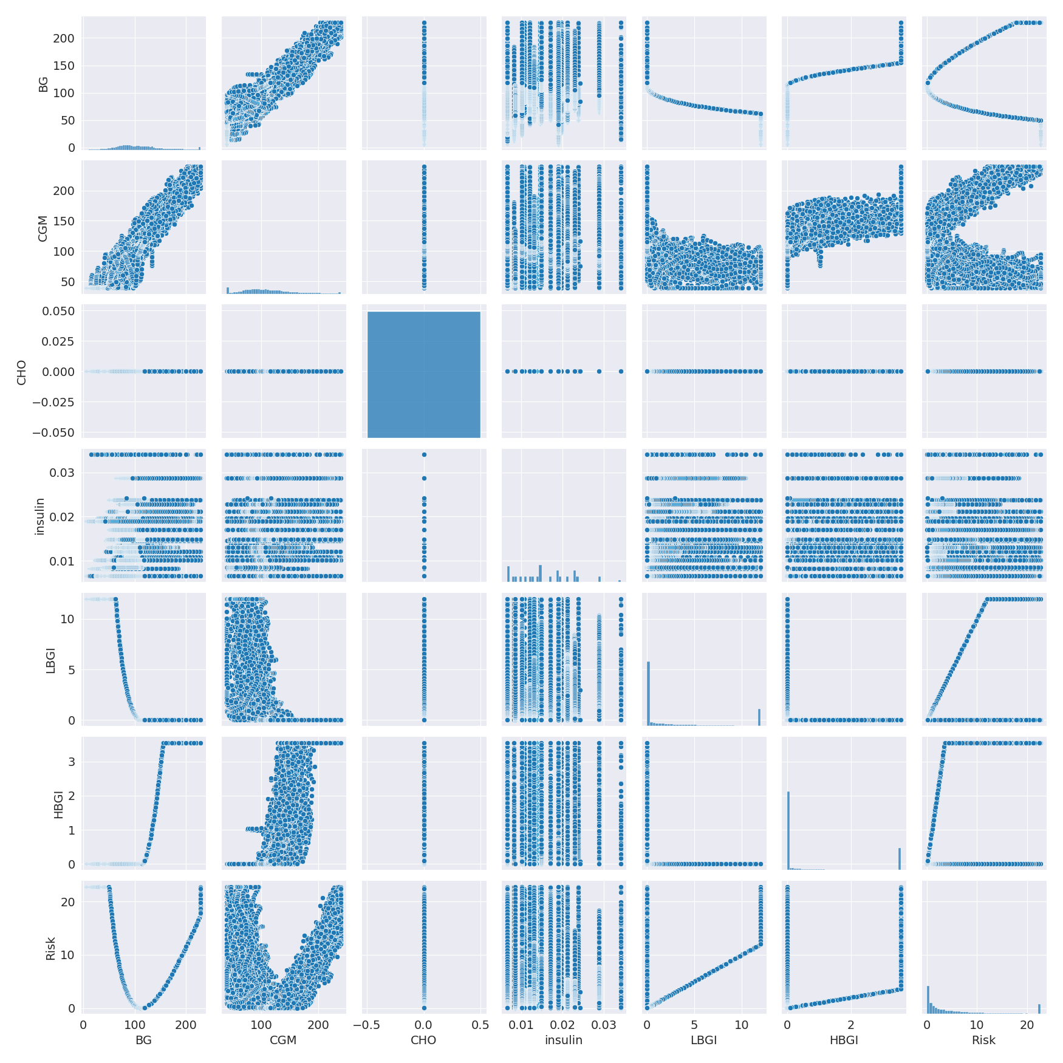

The image displays a collection of graphs, each pairwise graph visualizing the relationship between two variables. These graphs are used to analyze and understand the interconnections between the variables. The graphs are presented in a blue color scheme, which adds a visually appealing touch to the presentation.  
  
The graphs are organized in a way that allows for easy comparison and interpretation of the data. By examining these graphs, one can gain insights into the relationships between the variables, which can be used to make informed decisions or predictions.  
  
The use of pairwise graphs is particularly beneficial when dealing with complex data sets, as they provide a clear and concise representation of the interdependencies between the variables. This visualization technique helps to uncover patterns and changes that might not be immediately apparent from a simple table or chart.  
  
In summary, the image showcases a series of pairwise graphs that help to reveal the intricate relationships between variables. These visualizations enhance our understanding of the data's interconnections, providing a comprehensive view of the complex relationships between the variables.

Missing Numbers Graph Analysis

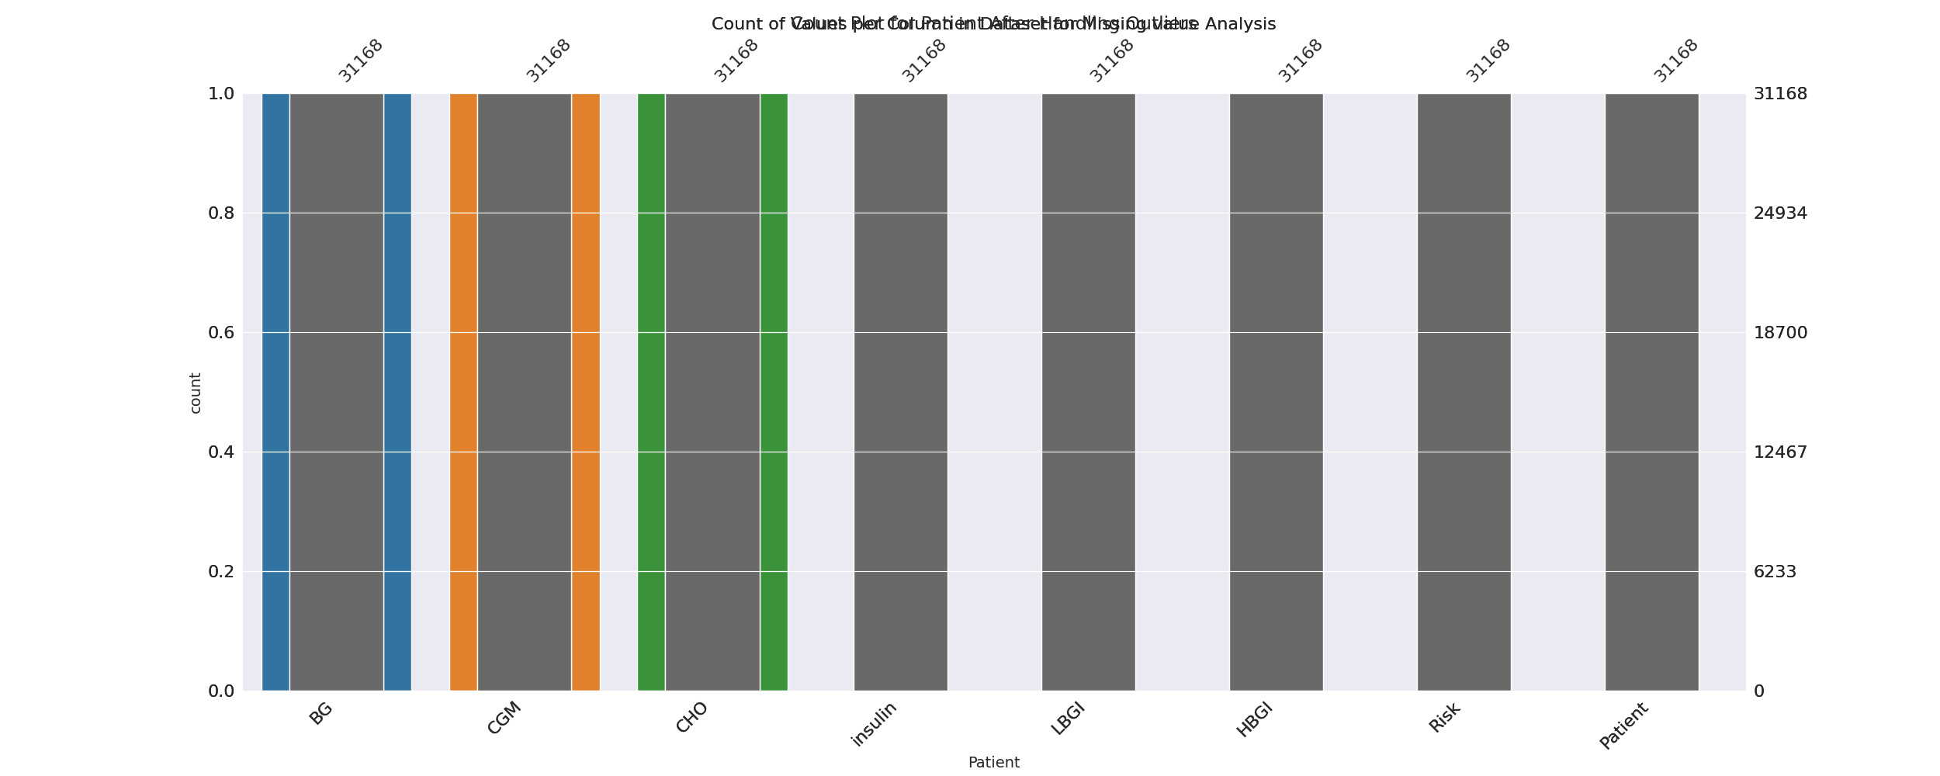

The image displays a bar chart with missing values, which is a common issue in data analysis. The chart is showing the count of black patients, and the numbers are missing for some of the bars. This can impact data analysis or modeling, as it may lead to inaccurate conclusions or predictions.  
  
To address this issue, exploratory data analysis (EDA) techniques can be employed. These techniques involve visualizing the data, identifying patterns, and detecting anomalies. By examining the distribution of the missing values, one can understand the reasons behind the missing data and decide whether to impute the missing values or exclude the affected data points.  
  
In the case of the bar chart, the missing values could be due to various reasons, such as data entry errors, missing data in the original source, or a deliberate decision to exclude certain data points. By identifying the cause of the missing values, one can take appropriate actions to improve the quality of the data and ensure accurate analysis or modeling.

Heat_Explainer Graph Analysis

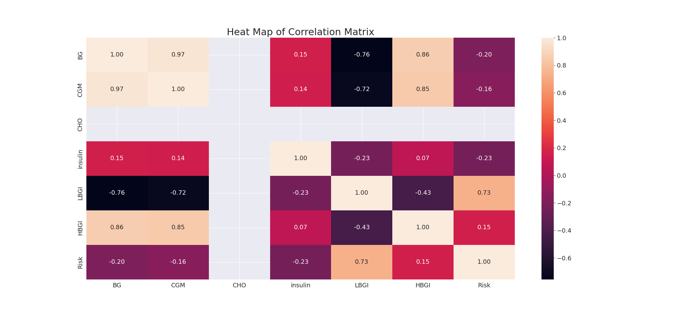

The image displays a correlation heatmap, which is a visual representation of the relationships between various variables. The heatmap is a color-coded matrix that helps to understand the strength and direction of correlations between these variables. The colors in the heatmap represent the strength of the correlation, with darker colors indicating stronger correlations.  
  
The heatmap is organized in a way that allows for easy identification of the variables and their relationships. The variables are likely related, and the data in the image helps to analyze and understand these relationships. By examining and deep-analyzing the visual representation, one can gain insights into the strength and direction of correlations between the variables.

Multi-linear Regression Inference Graph Analysis

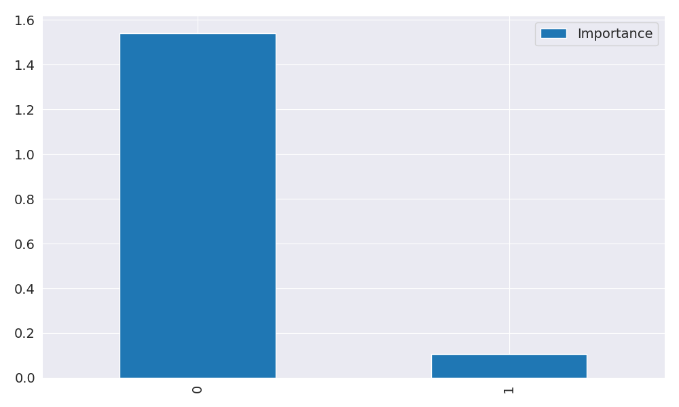

The image displays a large blue bar, which could be a representation of a Neural Regressor. The bar is divided into smaller sections, possibly representing different variables or aspects of the Neural Regressor. The varying shades of blue within the bar might indicate the strength and direction of correlations between these variables.  
  
To better understand the relationships between these variables, one could analyze the colors and patterns in the Neural Regressor. By examining the distribution of the different shades of blue, one could gain insights into the strength and direction of correlations between the variables. This would help in identifying the key factors that contribute to the overall performance of the Neural Regressor.