**DATA ENTRY FORM**

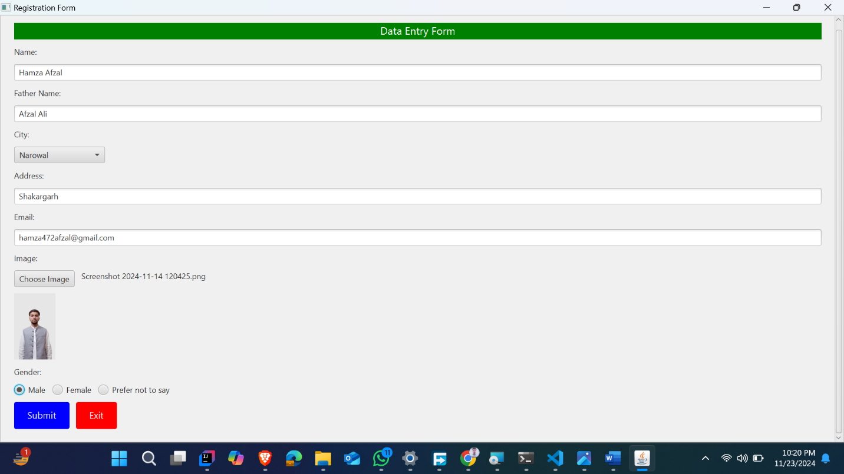

**FORM AFTER SUBMISSION**

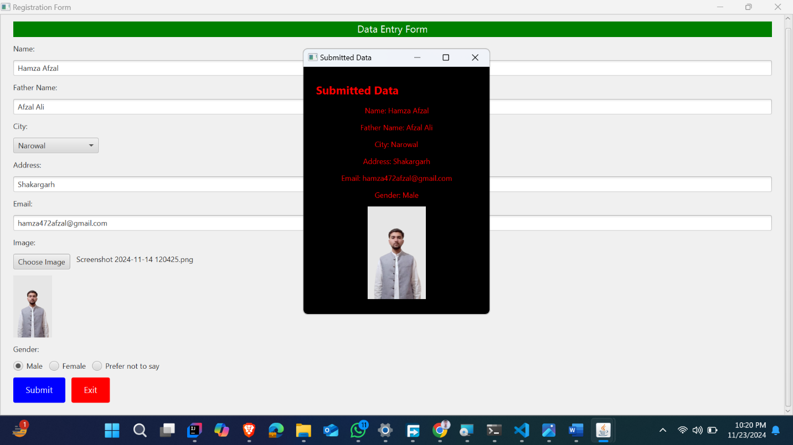

**SECOND WINDOW DISPLAYING INFORMATION**

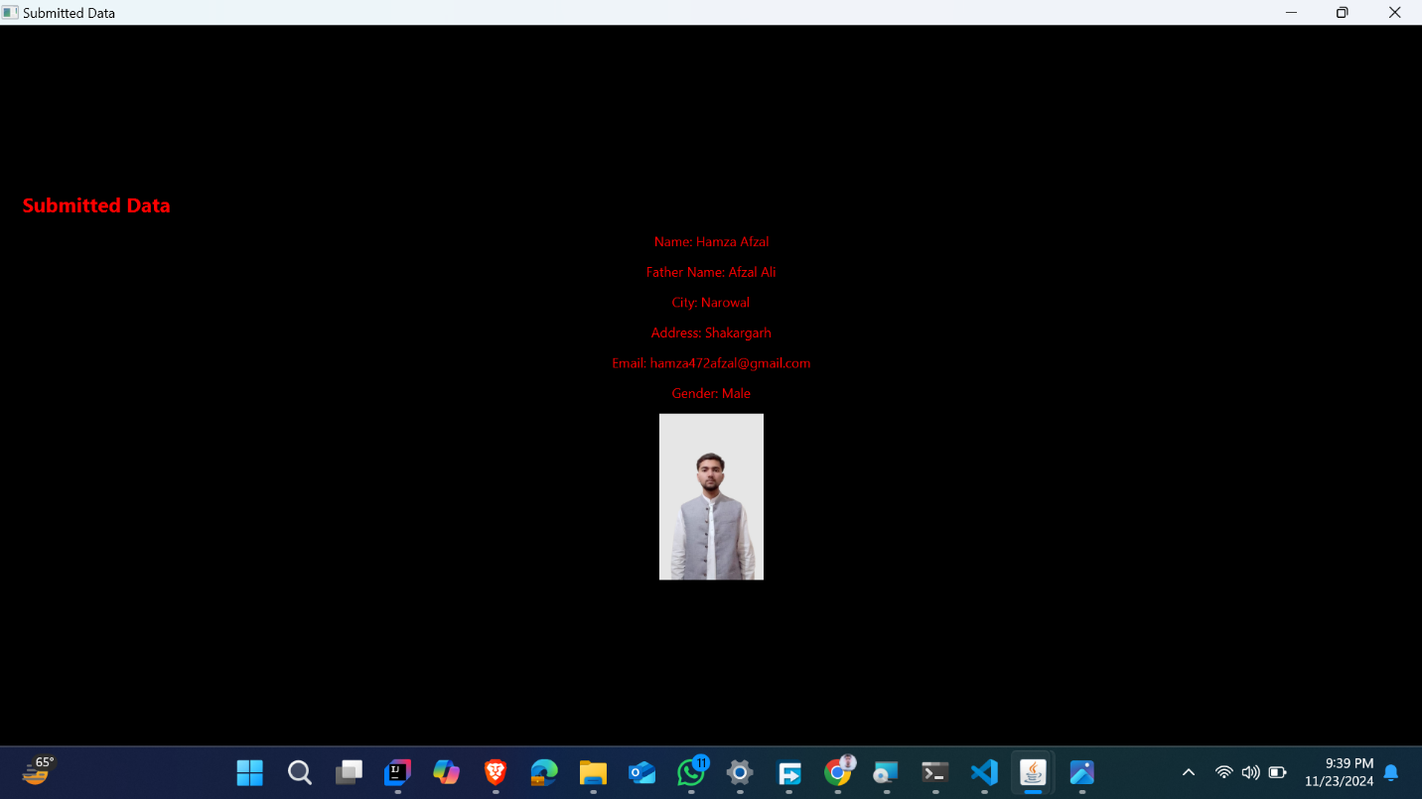

**INFORMATION PRINTED ON CONSOLE**

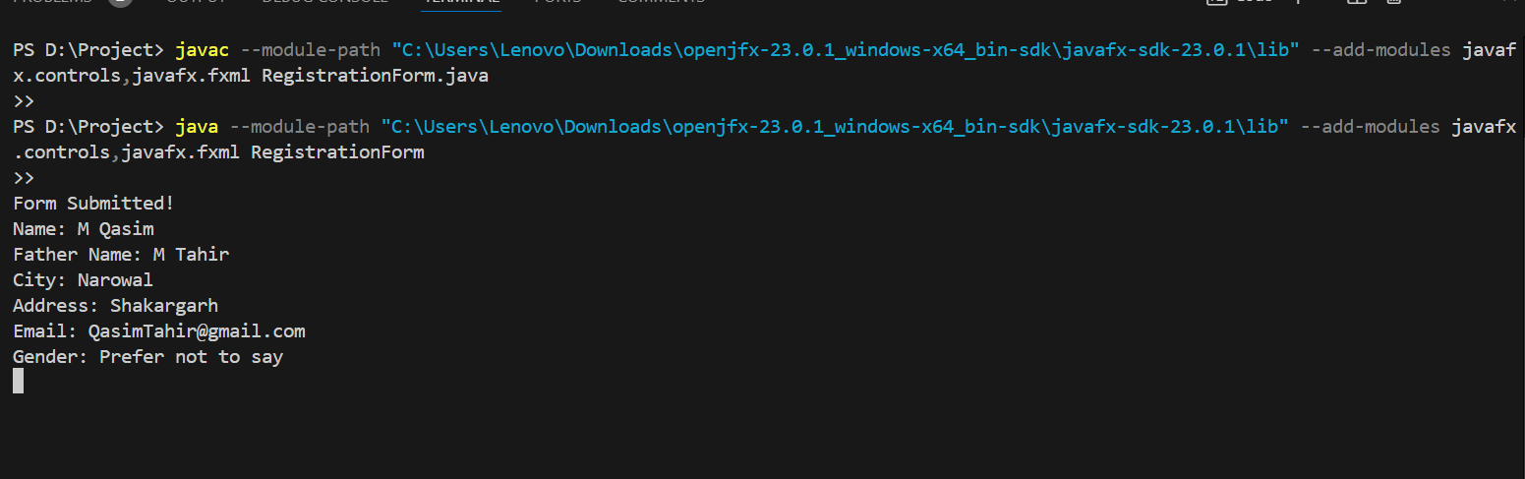

**CODE OF DATA ENTRY FORM**

import javafx.application.Application;

import javafx.scene.Scene;

import javafx.scene.control.*;

import javafx.scene.image.Image;

import javafx.scene.image.ImageView;

import javafx.scene.layout.*;

import javafx.stage.FileChooser;

import javafx.stage.Stage;

import java.io.File;

import java.util.ArrayList;

public class RegistrationForm extends Application {

    // ArrayList to store form data

    private final ArrayList<String> dataList = new ArrayList<>();

    @Override

    public void start(Stage primaryStage) {

        // Root layout for the form

        VBox root = new VBox(10);

        root.setStyle("-fx-padding: 20; -fx-background-color: #f0f0f0;");

        // Banner (Label at the top)

        Label banner = new Label("Data Entry Form");

        banner.setStyle("-fx-background-color: green; -fx-text-fill: white; -fx-font-size: 16; -fx-alignment: center;");

        banner.setMaxWidth(Double.MAX_VALUE);

        // Form fields

        TextField nameField = new TextField();

        nameField.setPromptText("Name");

        TextField fatherNameField = new TextField();

        fatherNameField.setPromptText("Father Name");

        ComboBox<String> cityComboBox = new ComboBox<>();

        cityComboBox.getItems().addAll("Lahore", "Gujranwala", "Sialkot", "Narowal", "Faisalabad", "Jehlum", "Gujrat", "Mandibahauddin");

        cityComboBox.setPromptText("Select City");

        TextField addressField = new TextField();

        addressField.setPromptText("Address");

        TextField emailField = new TextField();

        emailField.setPromptText("Email");

        // File chooser for image

        Button fileChooserButton = new Button("Choose Image");

        Label imageLabel = new Label("No file chosen");

        ImageView imageView = new ImageView();

        imageView.setFitWidth(100);

        imageView.setFitHeight(100);

        imageView.setPreserveRatio(true);

        fileChooserButton.setOnAction(e -> {

            FileChooser fileChooser = new FileChooser();

            File file = fileChooser.showOpenDialog(primaryStage);

            if (file != null) {

                imageLabel.setText(file.getName());

                imageView.setImage(new Image(file.toURI().toString())); // Display selected image

            }

        });

        // Radio buttons for gender

        ToggleGroup genderGroup = new ToggleGroup();

        RadioButton maleButton = new RadioButton("Male");

        maleButton.setToggleGroup(genderGroup);

        RadioButton femaleButton = new RadioButton("Female");

        femaleButton.setToggleGroup(genderGroup);

        RadioButton preferNotToSay = new RadioButton("Prefer not to say");

        preferNotToSay.setToggleGroup(genderGroup);

        HBox genderBox = new HBox(10, maleButton, femaleButton, preferNotToSay);

        // Submit button

        Button submitButton = new Button("Submit");

        submitButton.setStyle("-fx-background-color: blue; -fx-text-fill: white; -fx-font-size: 14; -fx-padding: 10 20 10 20;");

        submitButton.setOnAction(e -> {

            // Collect data

            String name = nameField.getText();

            String fatherName = fatherNameField.getText();

            String city = cityComboBox.getValue();

            String address = addressField.getText();

            String email = emailField.getText();

            RadioButton selectedGender = (RadioButton) genderGroup.getSelectedToggle();

            String gender = selectedGender != null ? selectedGender.getText() : "Not selected";

            // Add to ArrayList

            dataList.clear(); // Clear previous data if needed

            dataList.add("Name: " + name);

            dataList.add("Father Name: " + fatherName);

            dataList.add("City: " + city);

            dataList.add("Address: " + address);

            dataList.add("Email: " + email);

            dataList.add("Gender: " + gender);

            // Print data to console

            System.out.println("Form Submitted!");

            dataList.forEach(System.out::println);

            // Show data in a new window

            showDataWindow(name, fatherName, city, address, email, gender, imageView.getImage());

        });

        // Exit button

        Button exitButton = new Button("Exit");

        exitButton.setStyle("-fx-background-color: red; -fx-text-fill: white; -fx-font-size: 14; -fx-padding: 10 20 10 20;");

        exitButton.setOnAction(e -> {

            // Print message and close the application

            System.out.println("Form Did Not Submit. Exiting...");

            primaryStage.close();

        });

        // HBox for buttons (Submit and Exit)

        HBox buttonBox = new HBox(10, submitButton, exitButton);

        // Add all elements to the root layout

        root.getChildren().addAll(

                banner,

                new Label("Name:"), nameField,

                new Label("Father Name:"), fatherNameField,

                new Label("City:"), cityComboBox,

                new Label("Address:"), addressField,

                new Label("Email:"), emailField,

                new Label("Image:"), new HBox(10, fileChooserButton, imageLabel),

                imageView, // Display the selected image

                new Label("Gender:"), genderBox,

                buttonBox // Add the button box containing Submit and Exit buttons

        );

        // Add the root layout to a ScrollPane for scrollable content

        ScrollPane scrollPane = new ScrollPane(root);

        scrollPane.setFitToWidth(true); // Ensure the content fits the width of the scroll pane

        // Set the scene and show the stage

        Scene scene = new Scene(scrollPane, 400, 500); // Adjust scene height to allow scrolling

        primaryStage.setTitle("Registration Form");

        primaryStage.setScene(scene);

        primaryStage.show();

    }

    private void showDataWindow(String name, String fatherName, String city, String address, String email, String gender, Image image) {

        // Create a new stage (window)

        Stage dataStage = new Stage();

        VBox dataRoot = new VBox(10);

        dataRoot.setStyle("-fx-padding: 20; -fx-background-color: black; -fx-alignment: center;");

        // Title banner for the new window

        Label title = new Label("Submitted Data");

        title.setStyle("-fx-font-size: 18; -fx-text-fill: red; -fx-font-weight: bold;");

        title.setMaxWidth(Double.MAX_VALUE);

        // Display the submitted data with green text

        Label nameLabel = new Label("Name: " + name);

        Label fatherNameLabel = new Label("Father Name: " + fatherName);

        Label cityLabel = new Label("City: " + city);

        Label addressLabel = new Label("Address: " + address);

        Label emailLabel = new Label("Email: " + email);

        Label genderLabel = new Label("Gender: " + gender);

        nameLabel.setStyle("-fx-text-fill: red;");

        fatherNameLabel.setStyle("-fx-text-fill: red;");

        cityLabel.setStyle("-fx-text-fill: red;");

        addressLabel.setStyle("-fx-text-fill: red;");

        emailLabel.setStyle("-fx-text-fill: red;");

        genderLabel.setStyle("-fx-text-fill: red;");

        // Display the image if available

        ImageView displayImageView = new ImageView(image);

        if (image != null) {

            displayImageView.setFitWidth(150);

            displayImageView.setFitHeight(150);

            displayImageView.setPreserveRatio(true);

        }

        // Add all elements to the VBox

        dataRoot.getChildren().addAll(

                title,

                nameLabel,

                fatherNameLabel,

                cityLabel,

                addressLabel,

                emailLabel,

                genderLabel,

                displayImageView

        );

        // Set the scene and show the stage

        Scene dataScene = new Scene(dataRoot, 300, 400);

        dataStage.setTitle("Submitted Data");

        dataStage.setScene(dataScene);

        dataStage.show();

    }

    public static void main(String[] args) {

        launch(args);

    }

}