Lab 05 Implementation Report
Hamza Afzal | Roll number 2430-0176 | 20 October 2026
The Lab 04 website was extended with a feedback validator, migrated from jQuery to native JavaScript, and converted to strict TypeScript. Browser behavior, compiler error handling and keyboard booking were tested. Lighthouse accessibility scored 100 in light and dark mode; the visible error state also passed all 29 applicable snapshot checks in each theme.

Tasks 1 through 4 Legacy code and native port
The form keeps required attributes and adds novalidate so the script can display its own messages. A pinned jQuery 3.7.1 baseline was loaded from the CDN and tested with an empty form and a valid name/email. The Network request list confirms that version was downloaded. The legacy baseline is preserved in Git commit 82aa9ae.
jQuery offered concise, consistent APIs across older browsers. Native querySelector, classList, fetch and CSS transitions now cover many of those needs. Maintenance work still requires reading deployed jQuery code and preserving its behavior during migration.

Six native translations
$(document).ready(fn) becomes a module script or DOMContentLoaded listener.
$("#name").val() becomes the value property of a checked HTMLInputElement.
.after(html) becomes createElement, textContent and input.after(error).
$(".error").remove() becomes querySelectorAll followed by forEach and remove().
.text(message).hide().fadeIn(400) becomes textContent assignment; the fade is dropped as allowed by the lab.
$form[0].reset() becomes form.reset() on an HTMLFormElement.

Legacy smells and behavior
The legacy script uses function-scoped var, library-specific $.trim, HTML strings for error messages, and indexOf for membership tests. The port uses const/let, native trim, created elements with textContent, and includes. It removes old messages and aria-invalid markers before each validation attempt.
Both versions trim name and email, require a nonempty name, accept an email containing @, show matching messages, then reset on success. This intentionally preserves the handout’s simple rule, not full email verification. No feedback is sent or stored. The Message textarea retains required in markup but is not checked by the supplied custom validator.

TypeScript Implementation

Tasks 5 and 6 Compiler setup and first errors
TypeScript is installed as a development dependency. npm run build runs tsc; npm run typecheck runs tsc --noEmit. tsconfig.json enables strict and noEmitOnError, targets ES2022 modules, reads src and emits browser JavaScript into public. All five browser scripts, including greeting and navigation from earlier labs, were converted to TypeScript.
"strict": true,
"rootDir": "src",
"outDir": "public",
"noEmitOnError": true
The first untyped conversion produced TS18047 because form could be null and TS7006 because input/message/ms parameters implicitly had any type. There were also errors for using value on Element and closest on EventTarget. The feedback file initially lacked imports, so its global status conflicted with a DOM declaration. Importing getRequired made it a module.

Tasks 7 and 8 Types and structural typing
interface Slot {
day: string; start: string; end: string; room: string;
}
delay(ms: number): Promise<void>
makeCounter(): () => number
getRequired<T extends Element>(selector: string,
root: ParentNode = document): T
describeSlot(slot: Slot): string
getRequired checks the querySelector result and throws a clear error if it is null. Its generic type is a compile-time expectation, not a runtime tag check. A Slot interface requires the four named properties. A variable containing those properties plus id was accepted. Passing only { day: "Monday" } was rejected with TS2739 because start, end and room were absent.

Tasks 9 and 10 Safe DOM use
main.ts narrows event.target with instanceof Element, checks closest results for null and checks find results for undefined. The Slot array includes Monday, Wednesday and Friday with the existing visible times and locations. Buttons maintain selected styling and aria-pressed; the counter reports the number booked out of three.
feedback.ts uses getRequired<HTMLFormElement> and getRequired<HTMLInputElement>. Helpers have typed parameters and void returns; the listener receives SubmitEvent. Its feedback live region is #form-status, leaving booking messages in #status. The earlier form handler was removed to avoid duplicate submissions. The error token uses light-dark and oklch; alert messages and invalid borders use that token.
Interfaces, annotations and generic arguments are erased during compilation. The browser loads public/*.js modules, while src/*.ts contains the maintained source. Existing .js module import paths are retained for browser compatibility.

Compiler and Browser Verification

Task 11 Deliberate errors and recovery
The following are exact diagnostic messages from actual compiler runs. Both temporary errors were removed before the final successful build.
error TS2739: Type '{ day: string; }' is missing the
following properties from type 'Slot': start, end, room
error TS2345: Argument of type 'string' is not
assignable to parameter of type 'number'.
The second error was caused by delay("1000"). SHA-256 hashes of public/main.js before and after the failed build matched, confirming noEmitOnError prevented replacement. Restoring delay(1000) made build and typecheck pass. Exact initial, deliberate-error and final compiler transcripts are included in the repository evidence.

Task 12 Verification results
Empty native submit produced two role=alert messages and two aria-invalid markers. An invalid email produced one error. A trimmed valid name/email produced thanks, removed errors and reset the form.
The final browser request list contained the page, CSS and five native modules; no jQuery request was present. The legacy request list recorded jquery-3.7.1.min.js.
Keyboard-only Tab navigation reached Friday. Enter booked it, and Space cancelled it. A focus-return fix preserves keyboard use after the pending operation; it does not move focus away from another control the user has reached.
Desktop 1440 × 1100 and mobile 390 × 844 were checked in Chrome. Mobile had one form column and no page-level horizontal overflow. No page JavaScript errors were recorded.
Standard Lighthouse accessibility audits scored 100 in both emulated themes. With two validation messages visible, snapshot audits passed 29 of 29 applicable checks in both themes. These automated checks do not cover every accessibility issue.
Final typecheck, build, the existing greeting unit test, ESLint and Prettier checks passed. getRequired was also tested for a missing element, and independent counters returned 1, 2 and 1.

Repository and assistance disclosure
Repository: https://github.com/HamzaAfzal5054/web-engineering-lab
Source: src/*.ts Browser output: public/*.js
Notes: LEGACY-NOTES.md Evidence: evidence/lab-05
Based on the supplied Lab 05 Statement and the existing repository. Prepared with Codex assistance for implementation, explanations and automated verification. The handout states that AI coding assistants are not permitted for this lab; the assistance is disclosed here and this report does not claim independent completion.

Legacy and Native Validation Evidence
The same empty-submit messages appear in the tested jQuery baseline and the native port. These are cropped browser captures; original full-page images are retained in the evidence folder.
Figure 1 jQuery 3.7.1 baseline
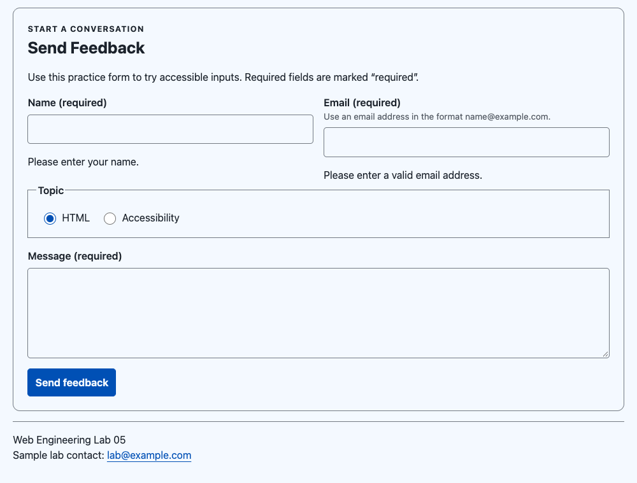
Figure 2 Native validator in light mode
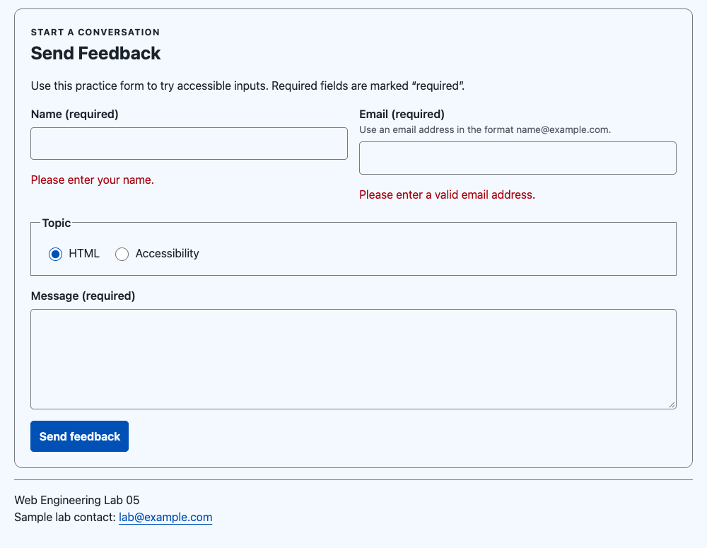

Feedback and Booking Evidence
Figure 3 Valid feedback resets the form and displays thanks
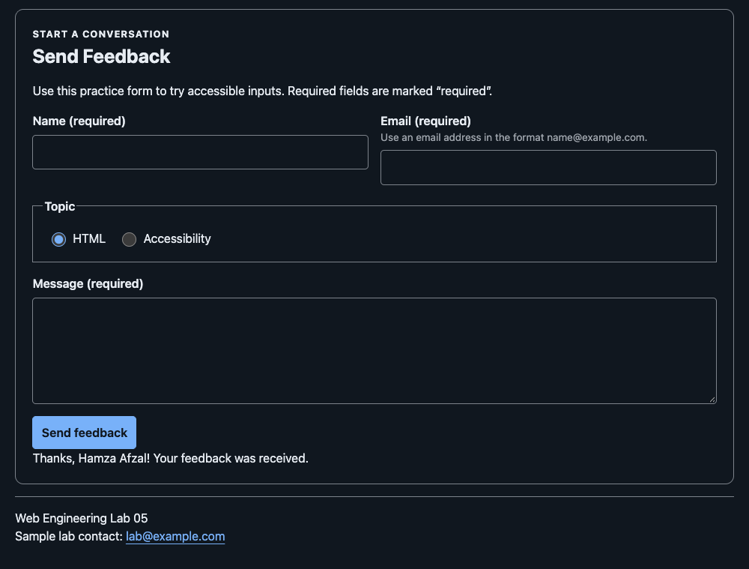
Figure 4 Friday booked using Tab and Enter
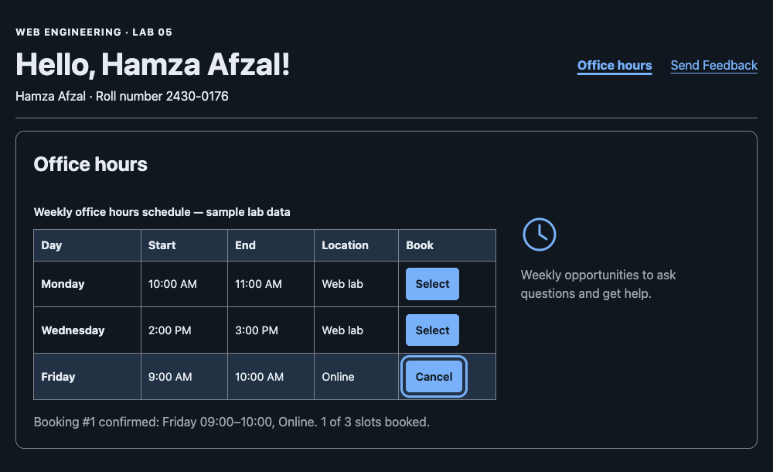
The subsequent Space key cancelled Friday and restored the selected count to zero. The form and schedule keep separate live regions.

Mobile and Dark Theme Evidence
Figure 5 Mobile validation at 390 CSS pixels. The two panels show the upper and lower halves of the same full-page capture in reading order.
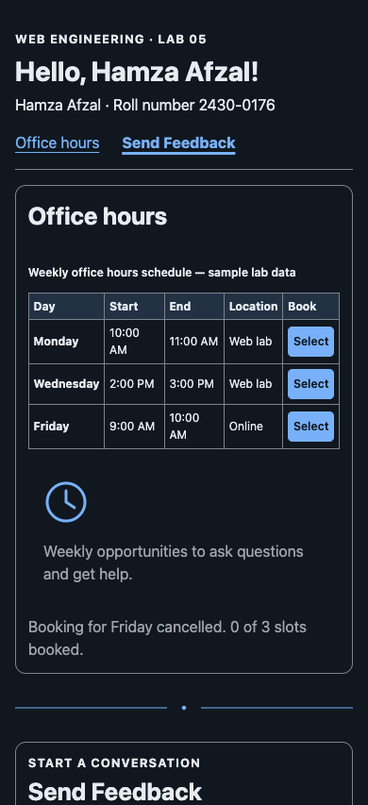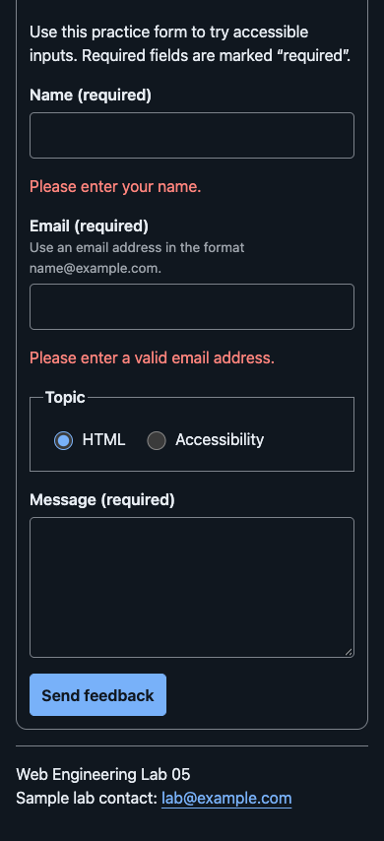

Light Theme Accessibility Audit
Figure 6 Standard Lighthouse accessibility score 100 in the emulated light theme. The separate error-state audit also passed all 29 applicable checks with both validation messages visible.
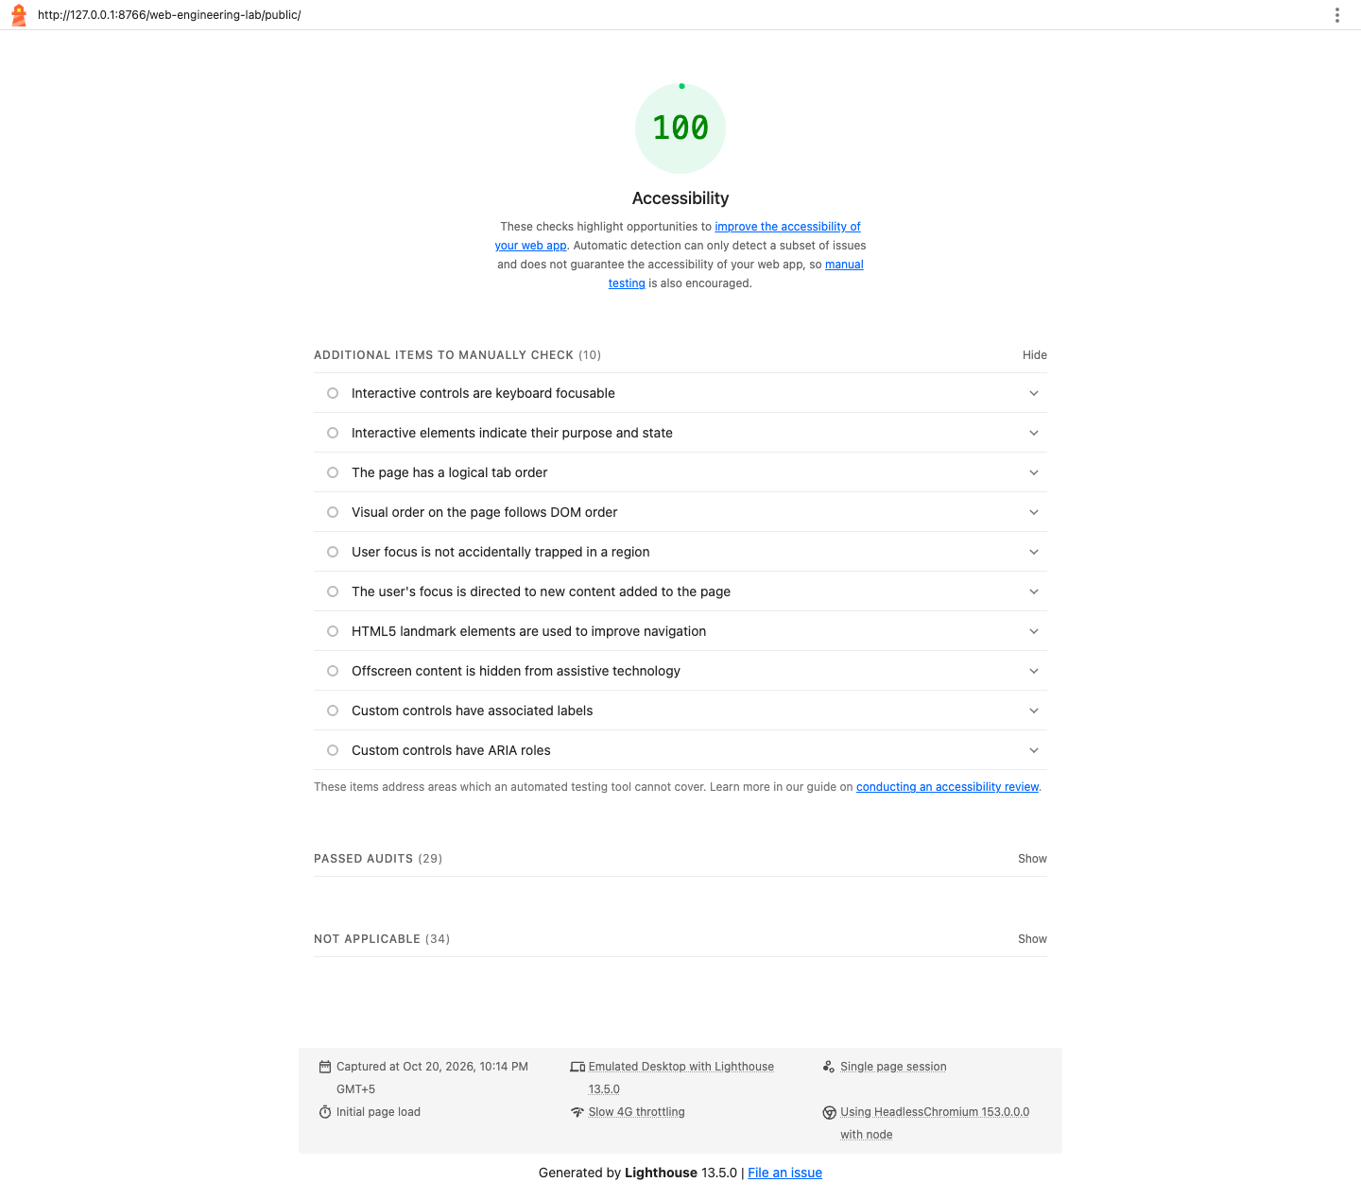

Dark Theme Accessibility Audit
Figure 7 Standard Lighthouse accessibility score 100 in the emulated dark theme. The separate error-state audit also passed all 29 applicable checks with both validation messages visible.

