Data Communications – Assignment 1

Hamza Bhatti (21223241)

Contents

[Introduction 2](#_Toc413248020)

[Element 1: Internet Speeds 2](#_Toc413248021)

[University of West London Internet 2](#_Toc413248022)

[Virgin Media Internet 3](#_Toc413248023)

[TalkTalk Internet 4](#_Toc413248024)

[Bar Chart 5](#_Toc413248025)

[Conclusion 5](#_Toc413248026)

[Element 2: Ethernet Cabling 6](#_Toc413248027)

[Making an Ethernet Cable 6](#_Toc413248028)

[Other Physical Layered Technologies 8](#_Toc413248029)

[Element 3: Switches and Routers 9](#_Toc413248030)

[Switches 9](#_Toc413248031)

[Routers 9](#_Toc413248032)

[Their Differences 9](#_Toc413248033)

[Element 4: Network Diagram 10](#_Toc413248034)

[The Diagram 10](#_Toc413248035)

[The Equipment 11](#_Toc413248036)

[Overview Of The Layout 12](#_Toc413248037)

[Bibliography 13](#_Toc413248038)

# Introduction

In this logbook, a variety of basic networking activities will be completed. The purpose of the logbook is to have an introduction to networking and learn the basics of the subject. Each element in this logbook is a brief introduction into different areas of the subject.

# Element 1: Internet Speeds

In this first section of the logbook, Internet speeds where tests and then compared to one another. This practical exercise helps identify different trends in Internets. Results for this element are provided on the excel spreadsheet.

The speeds of the internets that where tested where provided by <http://www.speedtest.net/>. Wired networking was tested using Ethernet, along with Wi-Fi connection to the internet. A laptop was used for the wired internet speed tests and a mobile phone was used to test the Wi-Fi.

Three internets where tested for this element. The internets tested where, University of West London, Virgin media and TalkTalk. The tests were carried out 10 times, allowing anomalous results to be identified along with easily identifiable trends in results. Each test was carried out one minute after the other.

The results on the spreadsheet shows the results for each test, along with the mean average for ping, download and upload speeds. Along with this, the standard deviation was also calculated, showing the spread of the results in each category.

## University of West London Internet

**Wi-Fi**

When testing UWL Wi-Fi using a mobile, there were generally stable results for the ping, but varied results were found for download and uploads speeds. Ping (how fast a message was sent and received from the server) was fairly consistent with a standard deviation of 1.20. The lowest value being 15ms (milliseconds) and the highest value being 19ms. The two most common values that were found for ping where 17.00ms and 18.00ms, both occurring 3 times. The average value that was found for the ping was 17.10ms.

The download speed (megabytes per second) had very fluctuating results. The highest download speed being 7.48mbps and lowest being 4.00mbps, were the average speed was 6.11mbps. The upload speed was much lower than the download, averaging at 3.49mbps. The results showed that the lowest upload speed was found in test 2 and was 1.92mbps.

**Wired**

When testing the internet using an Ethernet cable, the results found where drastically different from that of the Wi-Fi. The ping of the wired network gave an average of 8.50ms. The ping latency that was found only gave two different values, these being 8ms and 9ms both occurring 5 times each. This was more consistent that the WIFI counterpart. This resulted in a low standard deviation of the results.

The highest value found for the download speed was 93.34mbps and the lowest was found to be 91.96mbps. The mean average of the download results where 93.10mbps, also giving a low standard deviation.

Following the same trend as the download speed, upload speed was also high. The results were in the high 90’s, with an average throughput of 94.88mbps.

**Comparison of UWL Wi-Fi and Wired Networking**

Generally, the Wi-Fi tests provided very low scores than that of the wired internet speeds. This could be because more students that were present at the university would be using a wide variety of devices, such as laptops, tablets and mobile phones to access the internet through Wi-Fi. Students present may be downloading files on their laptop or viewing videos online which could cause latency issues and reduced download speeds.

Related to the above statement, less students may have been using the workstations provided by the university to access the internet, thus results in a better experience when using the internet.

The wired networking gave more symmetric results than of the Wi-Fi, meaning that the download and upload speeds of the wired network gave roughly the same speeds.

## Virgin Media Internet

**Wi-Fi**

The ping latency for the Wi-Fi was very consistent and low, giving a small result for the standard deviation. The only two values that were found in the test was 7.00ms and 8.00ms, 8ms being the most common value. The average ping because of these results was 7.80ms which is acceptable for home use.

The download and upload speed was also very consistent. The average result for the download on this network was 30.64mbps. The only result that did not fit the trend of 30mpbs and above was in test 5, where the download dropped 29.04mbps. As this only occurred once during testing, this would not be found as an issue.

After finding very good results for the ping and download, the upload speed of data was fairly disappointing. The results ranged from 1.96mbps to 2.02mbps.

**Wired**

The ping found for the wired networking averaged at 6.30mbps, and gave a standard deviation of 0.48. Download was also very fast, where the average download speed was 31.16mbps. Upload speed was largely lower than the download speed, which gave results varying from 1.97mbps to 2.02mbps.

**Comparison of Virgin Media Wi-Fi and Wired Networks**

The ping and download results were very consistent with each other on Wi-Fi and on the wired network. Having a consistent ping and download speed would help retrieving data from servers.

The upload speed however was very puzzling. The lower speeds of uploading data could be because of the equipment that is used in the local area. Wires connecting phone lines together could be in need of replacing causing very slow uploading of data to host servers.

The internet provided by Virgin was asymmetric, where the download speed was much higher than the upload.

## TalkTalk Internet

**Wi-Fi**

The rate at which a message was sent to and back from the server was generally slow. The ping value for the TalkTalk WIFI was an average of 36.60ms which is very slow. The fastest latency speed was 27.00ms, but this only occurred once in test 6. The results for the ping varied a great deal, giving a standard deviation of 7.33.

The download speed was also very slow ranging from 6.96mbps to 7.03 mbps. This can be seen as a very low download rate. The upload speed was drastically lower than that of the download and gave an average of 0.63mbps. The download and upload speeds stayed consistent and gave standard deviation of 0.02 and 0.01 respectively.

**Wired**

The average ping that was found for the wired network was 41.8ms, and gave a very high standard deviation of 7.33.

The download speed and upload speeds of the wired network where 7.00mbps and 0.63mbps respectively.

**Comparison TalkTalk Wi-Fi and Wired Networks**

The WIFI and wired network connection to the internet was very similar. The only difference was the ping for Wi-Fi, which was slightly lower than that of the wired network speed tests.

Download and upload results were found to be asymmetric, where the download speed was greater than the upload.

## Bar Chart

The bar chart below was produced in excel, showing the average results from the internet speed tests.

The bar chart shows that the UWL wired network was vastly superior to all the other ISPs. For the home networking, Virgin can be seen as being more reliable than TalkTalk, but has a very low upload speed. Virgin is also consistent for internet for Wi-Fi and wired internet access.

## Conclusion

From the results that were gathered, the wired internet provided by University of West London gave the highest upload and download speed than that of the Virgin and TalkTalk. This may be the case because of the vast amount of students at the university who will need the internet to access blackboard, download slides or watch lecture videos. However the Download speed for the Wi-Fi was surprisingly lower than that of the Wired networking available at the university. The Wi-Fi could have been used by a very large number of students at the university, causing a slower experience on mobile devices.

Virgin media gave very consistent results for both upload and download speeds for both Wi-Fi and wired networking. For a consistent experience on both methods of accessing the internet, Virgin would be found to the most reliable download speeds only. However, the University of West London’s Wired Internet is still faster than that of virgin, but only by this method.

Out of all three internet providers, TalkTalk can be seen as being very slow for today’s standards and would not be recommended for general everyday use and can be seen as being unreliable compared to Virgin as home networks.

# Element 2: Ethernet Cabling

In this element, the production of an Ethernet cable, along with example of other physical layer technologies are presented.

## Making an Ethernet Cable

The type of Ethernet cable that was produced was a “Straight Through” Ethernet cable which is widely used. The tools used to produce the Ethernet cable where:

* A length of Ethernet cable
* RJ45 Head
* Wire cutter and stripper
* Rj45 head crimper
* Ethernet cable tester

First, a short piece of wire was cut from a bulk line of Ethernet cabling. The wire was stripped on both ends to reveal the twisted pair wires, which can be seen below.

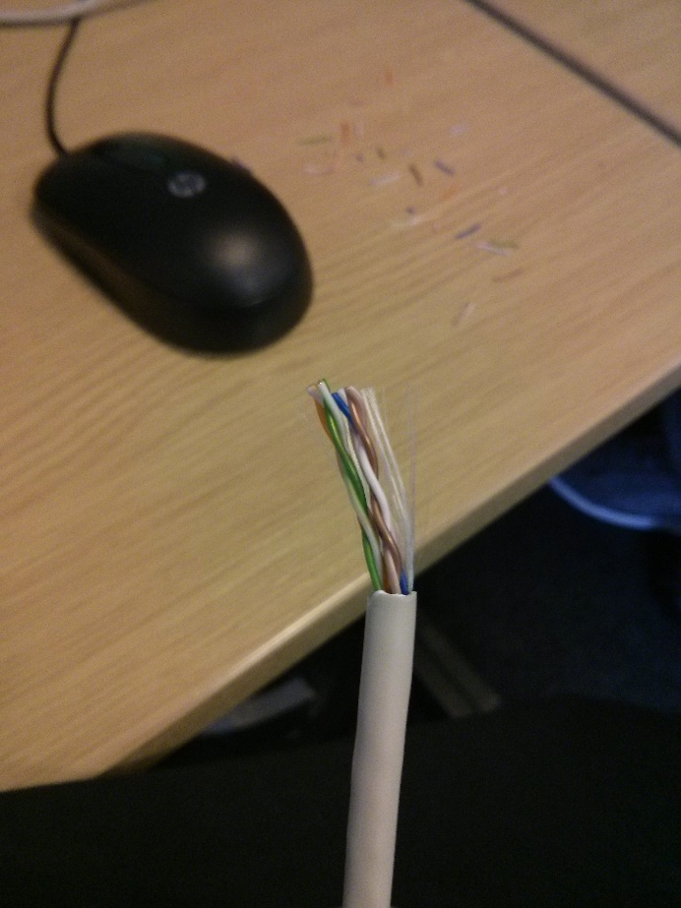

The wires where then untwisted and straightened to reveal the different coloured wires. The wires that where revealed are listed below along with an image of the coloured wires.

* Orange and White Orange
* Blue and White Blue
* Green and White Green
* Brown and White Brown.

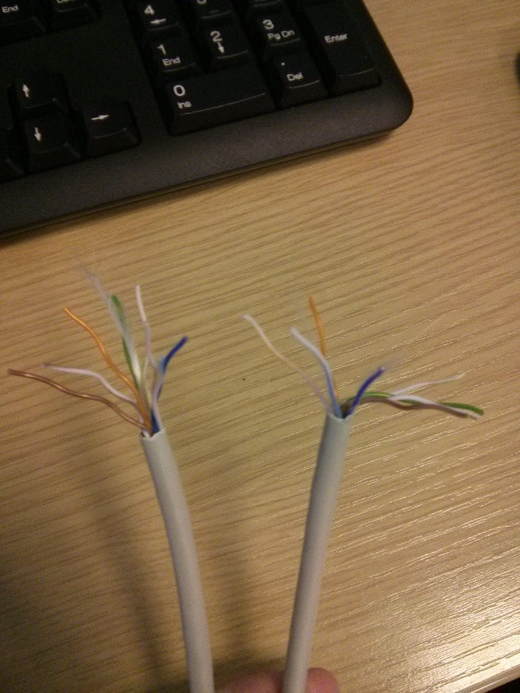

The wires where then arranged in a Straight through fashion, which is most commonly used Ethernet cable arrangement. The arrangement is as follows:

* White Orange
* Orange
* White Green
* Blue
* White Blue
* Green
* White Brown
* Brown

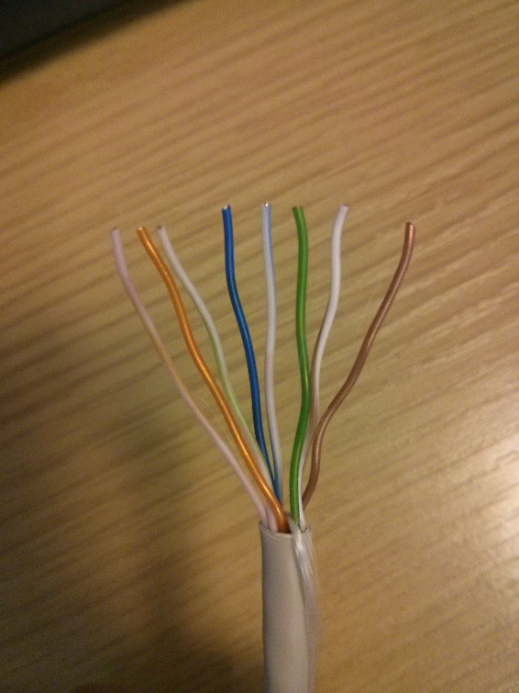

The wires where then straightened further and then slotted in the RJ45 head. The head was then crimped using an RJ45 crimping tool. This was done on both sides of the Ethernet cable. The finished wire can be seen below.

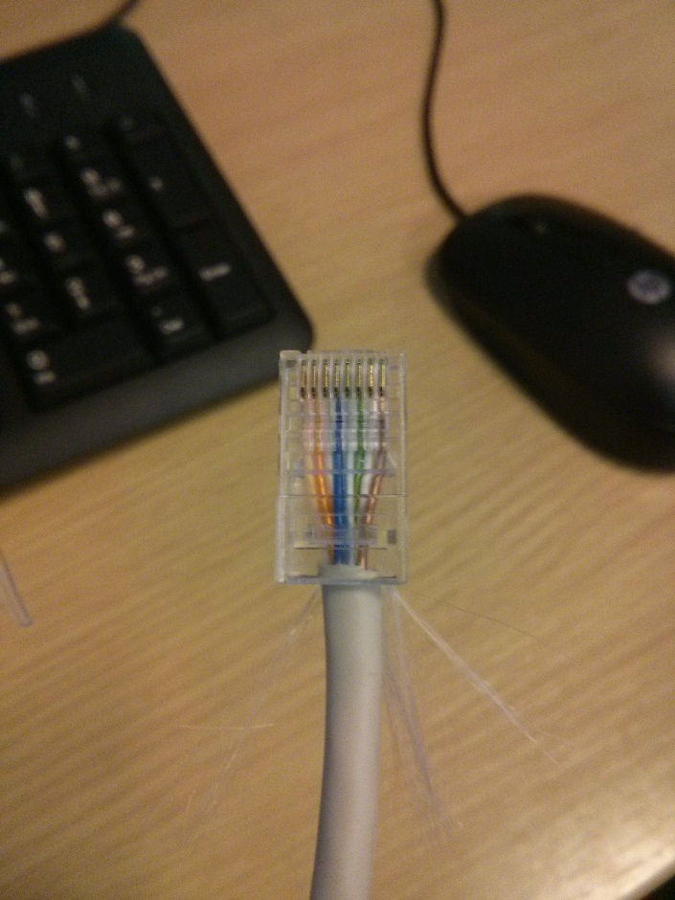

The Ethernet cable was then tested using a wire mapping tester.

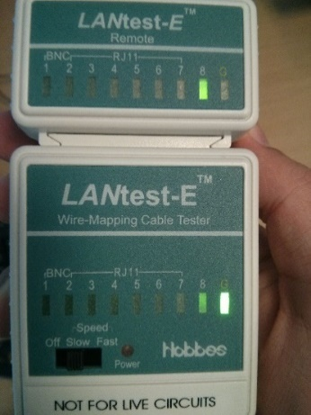

## Other Physical Layered Technologies

The physical layer of networking is the first layer of the networking model and uses hardware to successfully transmit data. The following is a brief list of the different physical layer technologies:

* Bluetooth
* Universal Serial Bus
* Digital Subscriber Line
* Integrated Services Digital Network (Janssen, Cory 2015)

Bluetooth

“The Bluetooth RF (physical layer) operates in the unlicensed ISM band at 2.4GHz. The system employs a frequency hop transceiver to combat interference and fading” (Bluetooth 2015). With this technology, battling interference is key. Bluetooth is now found in every modern mobile phone along with laptops and PCs to allow data transfer to different destination. These could be to other mobile phone or computers.

Universal Serial Bus

“USB is a system for connecting a wide range of peripherals to a computer, including pointing devices, displays, and data storage and communications products “(Knagge, Geoff 2015). USBs are widely used by many individuals. The devices are mainly used for data transfer, whether it be transferring music files to another computer or using it as a backup facility. USB is implemented in mobile phones to allow this data transfer to occur on that platform also.

Digital Subscriber Line

This is a technology that makes use of the twisted pair cable used for telephone lines. It transports data in different forms, such as video and music to subscribers. (Cisco 2015) Streaming services such as Netflix can provide their services which makes use of DSL. The video that is streamed can be viewed directly on an individual’s TV.

Integrated Services Digital Network

“ISDN is a network technology that supports digital transfer of simultaneous voice and data traffic. Similar to [DSL](http://compnetworking.about.com/library/glossary/bldef-dsl.htm) in this respect, an ISDN Internet service works over ordinary telephone lines” (Mitchel, Bradley 2015). This technology has also been used in America as an alternative to satellite internet. ISDN has a very low availability.

# Element 3: Switches and Routers

In this section of the logbook Switches and Routers uses will be identified, along with their differences

## Switches

Switches operate on the second layer of networking. The technology is used to filter and send packets of data between LAN segments. LANs that use switches to join together are called Switched LANs. These are called Switched Ethernet LANs when Ethernet is used. (Pacchiano, Ron 2014)

## Routers

Routers are devices that forward packets of data along networks. The router is connected to a minimum of two networks, this can be Local Area or Wide Area Networks. The routers are found at the gateways where two or more networks are connected (Pacchiano, Ron 2014).

## Their Differences

A Router is a more complex device than that of a switch. A router serves as an intermediate destination for network traffic. They receive IP packets, check them for identification of the IP of which it came and the IP of its destination. This can be used over LAN or WAN. Switches join computers together within a LAN and are unable to join multiple networks together (Diffen 2014).

Routers have the ability to join home networks to the internet for connection sharing. Switches are incapable of doing so. If a switch is part of the network, there must be a computer that is set as a gateway to the internet. Routers allow direct access to the internet. Computers that are connected to the routers are peers and the router handles connection (Mitchell, Bradley 2015).

When a switch accepts a message from a computer, it can learn where that message or frame of data came from and remember that origin. The switch will send the message to all ports. A router can do this same task but does not send to all ports, but instead sends the messages only to the computer that is was intended for (Notenboom, Leo 2005).

# Element 4: Network Diagram

In this section of the logbook, a network diagram is presented to solve a scenario that was provided.

## The Diagram

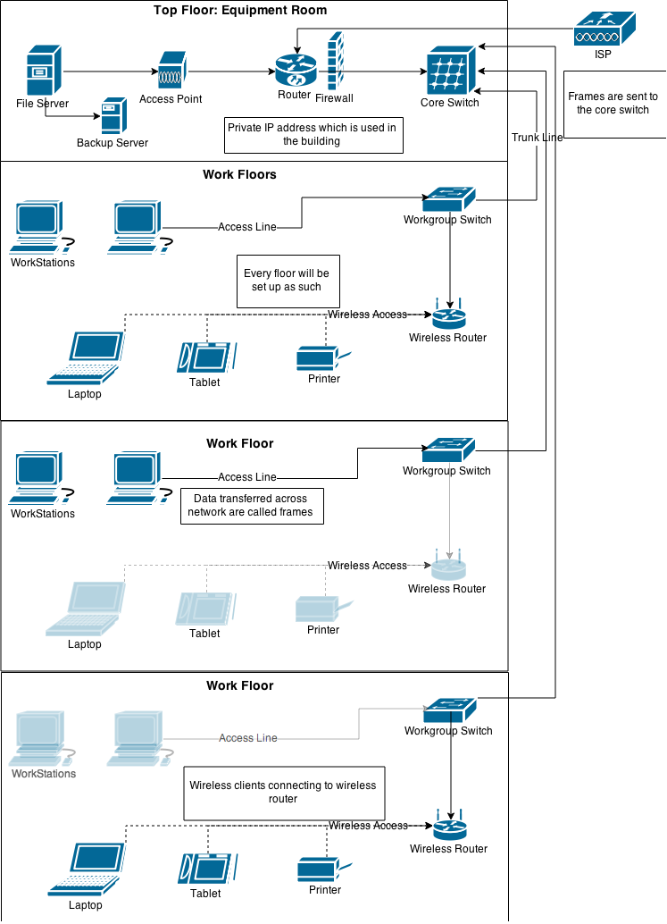

## The Equipment

Server

Name: HP StorageWorks 4400 Scalable NAS for Windows File Services.

Cost: £538.61

Reason for purchase: The server comes equipped with 12TB of data storage space which is a very large amount of space for all the files that will likely be produced by the company. Should the company need, the storage data can be easily upgraded. This server is also highly reliable and will unlikely suffer any downtime (Transparent 2015).

Workgroup Switches

Name: Netgear ProSafe JGS524 24-port Gigabit Rackmount Switch.

Cost: £300.12 total (£100.04 for one)

Reason for purchase: The workgroup switch comes equipped with 24 ports, allowing a large quantity of workstations to be connected to the switch. Connectivity between each of the switches and the internet will be at 48 Gbps of bandwidth which will allow frames to be transferred across the network at high speeds (eBuyer 2015).

Printers

Name: SAMSUNG Xpress SL-C410W Colour Wireless Laser Printer.

Cost: £449.97 total (£149.99 for one)

Reason for purchase: The printer enables printing over wired and wireless networking. This will enable workstation and client who bring a laptop or tablet to print out documents by any of the two means. The printer also comes equipped with NFC. Mobile devices that have NFC can simple tap the printer with their device to print out documents (Currys 2015).

Core switch

Name: WS-C6506 - Cisco Catalyst 6506 chassis – switch.

Cost: £2,700.00

Reason for purchase: The core switch comes equipped with a gigabit data transfer around the network. This will allow the files to be transferred around the building quickly with relatively no delay. The core switch will work well with the chosen workgroup switches stated above (digital devices 2015).

Wireless Router

Name: NETGEAR WNDR3700 Simultaneous Dual-Band Wi-Fi Fibre Broadband Router (600Mbps N)

Cost: £272.85 total (£90.95 for one)

Reason for purchase: This router comes equipped with Gigabit internet connectivity. This will prove beneficial to allow files created on laptops and tablets to be sent to the rooter then to the workgroup switch quickly for fast sharing of files. (broadband buyer 2015)

Internet Service Provider

Name: Virgin Media Business Managed Internet Access

Cost: £325 per month (Can be altered).

Reason for purchase: The ISP provides a scalable payment meaning that the company will only pay for the band witch they use. Virgin will also provide installation of the router and infrastructure. They will also provide 24/7 support along with monitoring to check when errors in the network occur (Virgin 2015).

## Overview Of The Layout

The diagram showing the potential layout of the network is based on a switch network for the multi-storey building.

The top floor will be the equipment room. This room will contain the server which will serve as a means of storing data that has been created by the employees. The router and core switch will also be on this floor. As all the vital equipment which allows internet access and a localised area to save data produced will be on the top floor, this will keep the equipment safe from flooding. A backup server is also present and can be used if the main server is down for maintenance. Files that are backed up can be saved on external hard drives and the backup server.

Three floors will be used as work floors. Each floor will contain a series of workstations for the employees of the company. Wireless devices brought by clients can also be used on any of the floors and can connect to the wireless routers.

Each of the three work floors will be equipped with a workgroup switch and a wireless router which are connected together. A wireless router is supplied on each of the floors to allow no loss in download and upload speeds. The routers on each floor will allow speeds to stay high. The workstations provided will be connected to the floors workgroup switch via an Access Line. The work group switches on each floor will be connect to a unique port of the core switch located on the top floor with a cord called a Trunk Line.

Data transferred to the server on the top floor will be in the form of frames. When employees using the network wish to save something on the server or communicate with another floor, the data will be converted into frames and be passed through the work group switch. This can be done through wired or wireless. The frames will be passed up to the Core switch through the trunk line. The Core switch will read the address of the frames and then send it to intended destination.

# Bibliography

Bluetooth (2015) *Architecture - Overview of Operations* [Online]. Available at: <https://developer.bluetooth.org/TechnologyOverview/Pages/OverviewOfOperations.aspx> [Accessed: 01/03/2015].

Broadband buyer (2015) *NETGEAR WNDR3700 Simultaneous Dual-Band WiFi Fibre Broadband Router (600Mbps N)* [Online]. Available at: <http://www.broadbandbuyer.co.uk/products/10617-netgear-wndr3700-100uks/?gclid=CMKp2Omgh8QCFTPKtAodoGYAPQ> [Accessed: 01/03/2015].

Cisco (2015) *Digital Subscriber Line* [Online]. Available at: <http://www.cisco.com/c/en/us/td/docs/net_mgmt/active_network_abstraction/3-7/reference/guide/ANARefGuide37/dsl.pdf> [Accessed: 02/03/2015].

Cisco (2015) *What is a Network Switch vs. a Router?* [Online]. Available at:[http://www.cisco.com/cisco/web/solutions/small\_business/resource\_center/articles/connect\_employees\_and\_offices/what\_is\_a\_network\_switch/index.html?referring\_site=smartnavRD](http://www.cisco.com/cisco/web/solutions/small_business/resource_center/articles/connect_employees_and_offices/what_is_a_network_switch/index.html?referring_site=smartnavRD" \t "_blank) [Accessed: 26/02/2015].

Currys (2015) *SAMSUNG Xpress SL-C410W Colour Wireless Laser Printer* [Online]. Available at: <http://www.pcworld.co.uk/gbuk/printers-ink/printers-scanners/laser-printers/samsung-xpress-sl-c410w-colour-wireless-laser-printer-21650991-pdt.html#cat-0> [Accessed: 28/02/2015].

Diffen (2014) *Router vs. Switch* [Online]. Available at: <http://www.diffen.com/difference/Router_vs_Switch> [Accessed: 03/03/2015].

Digital devices (2015) *WS-C6506 - Cisco Catalyst 6506 chassis - switch* [Online]. Available at: <http://www.digitaldevicesonline.com/cisco/cisco-switches/ws-c6506-e.php?gclid=CIOOgeOMh8QCFWfKtAodnVsAjw>[Accessed: 01/03/2015].

eBuyer (2015) *Netgear ProSafe JGS524 24-port Gigabit Rackmount Switch* [Online]. Available at: <http://www.ebuyer.com/80236-netgear-prosafe-jgs524-24-port-gigabit-rackmount-switch-jgs524-200eus?utm_source=google&utm_medium=products&gclid=CIm8ip6PhcQCFVDHtAodGXgAyA> [Accessed: 28/02/2015].

Islam, A.K.M.N. & Gojobo, J. (2015) *Bluetooth: Overview of architecture, PHY and MAC* [Online]. Available at: <http://www.cs.tut.fi/kurssit/TLT-6556/Slides/2-Bluetooth.pdf> [Accessed: 01/03/2015].

Janssen, C. (2015) *Physical Layer* [Online]. Available at: <http://www.techopedia.com/definition/8866/physical-layer> [Accessed: 21/02/2015].

Knagge, G. (2015) *The Universal Serial Bus : How it Works and What it Does* [Online]. Available at: <http://www.geoffknagge.com/uni/elec101/essay.shtml> [Accessed: 02/03/2015].

Mitchel, B. (2015) *ISDN - Integrated Services Digital Network* [Online]. Available at: <http://compnetworking.about.com/od/internetaccessbestuses/g/bldef_isdn.htm> [Accessed: 02/03/2015].

Mitchell, B. (2015) *What is the Difference Between Routers and Switches (and Hubs)?* [Online]. Available at: <http://compnetworking.about.com/od/homenetworkhardware/f/routervsswitch.htm> [Accessed: 26/02/2015].

Notenboom, L. (2005) *What’s the difference between a hub, a switch, and a router?* [Online]. Available at: <https://askleo.com/whats_the_difference_between_a_hub_a_switch_and_a_router/> [Accessed: 03/03/2015].

Pacchiano, R. (2014) *The Difference Between Hubs, Switches and Routers* [Online]. Available at: <http://www.webopedia.com/DidYouKnow/Hardware_Software/router_switch_hub.asp> [Accessed: 26/02/2015].

Transparent (2015) *HP StorageWorks 4400 Scalable NAS for Windows File Services* [Online]. Available at: <http://transparent-uk.com/hp-storageworks-4400-scalable-nas-for-windows-file-services.html?utm_source=google_shopping&gclid=CLixkPWNhcQCFQLMtAodBFgAhA> [Accessed: 2015].

Virgin (2015) *Managed Internet Access* [Online]. Available at: <http://www.virginmediabusiness.co.uk/Products-and-solutions/Broadband-and-Internet-Services/Managed-Internet-Access/> [Accessed: 28/02/2015].