SOFTWARE ENGINEERING — CHAPTER 3
Design and Methodology — Lab Session

LAB 5
Practical Session: Designing Your Own Project's Architecture
Team: Hamza Ben Labiedh, Ali Chamakh, Mohamed Krid · Project: FoodGO — pre-order lunch for Lac 3 / Zone Industrielle Le Kram · Filled in: 1 Nov 2026
How we did this session. Lab 4 produced our full design document before any code existed. We did Lab 5 after building the midterm MVP, so every table below describes the design as built. The changes since Lab 4 are marked (new): the AI forecast (ADR-0004) and the single service area, Lac 3 / Zone Industrielle Le Kram (ADR-0007). Every choice traces to a requirement (FR/BR) or a decision (D-xx, ADR).
Honest notes. This worksheet was prepared by Hamza with Claude, and the other two members review it at the team meeting on 2 Nov. Step 6's peer review comes from an independent AI reviewer, because no other team was available; its rows are labelled as such, and a row is left for the peer team in class. The instructor checkpoints have not been signed yet.

Field | Details
Session type | Hands-on lab (team work)
Duration | ≈ 2 hours 30 minutes
Prerequisite | Lab 4 — Design and Methodology (lecture session) + your completed SRS (Lab 2/3)
Team size | 3–4 students, same as your course/capstone project team
Deliverable | Draft architecture, class, and sequence designs for your own project (not a case study)

Table of Contents

1. Purpose of This Session
Lab 4 walked through the design steps using the shared case study (the Campus Library Management System). This session is the hands-on companion: you will apply the exact same steps, but to your own course/capstone project, working live in your team with instructor checkpoints along the way.
Key difference from Lab 4
There is no case study here — every table and template in this document is meant to be filled in with real design decisions for YOUR project, on the spot, during the session. Bring your finished SRS from Lab 2/3: every design choice should trace back to a requirement.
2. Session Logistics
Item | Details
Team size | 3–4 students (your assigned project team)
Duration | ≈ 2h30, timeboxed per step (see agenda below)
Materials needed | Laptop, your completed SRS, this document (digital or printed), whiteboard/sticky notes for diagrams
Instructor role | Circulates, answers questions, signs off at each checkpoint
2.1 Pre-Session Checklist
Complete before arriving:
☑ Bring your completed SRS / final requirements list from Lab 2/3 — Lab 3 specification: docs/lab3-specification
☑ Re-read Lab 4 (methodology options and the design pattern cheat sheet) as a refresher — Lab 4 SDD §2.1 and §7.1 reused
☑ Have a diagramming tool ready (draw.io, Lucidchart) or paper and pens — Mermaid (sources in docs/uml)
☑ Agree as a team on your target programming language/platform — it affects design choices — Node.js 22 + Express + SQLite (ADR-0002)

3. Session Agenda
Time | Step | Activity
0:00 – 0:10 | Kickoff | Confirm team, project scope, and design goals with instructor
0:10 – 0:30 | Step 1 | Choose your methodology and architectural style
0:30 – 1:00 | Step 2 | High-level component design
1:00 – 1:30 | Step 3 | Class modeling
1:30 – 1:55 | Step 4 | Sequence diagrams for key use cases
1:55 – 2:10 | Step 5 | Apply design patterns
2:10 – 2:30 | Step 6 | Peer review & assemble SDD skeleton

Checkpoints
At the end of each step, raise your hand or flag the instructor before moving to the next step. This keeps every team calibrated and catches issues early.

Step 1 — Choose Methodology & Architecture for Your Project (20 min)
Reminder: pick the methodology and style that best fit your domain and your team's tech stack.
In-session activity
- Discuss as a team: is your system data-heavy, real-time, or made of several independent services?
- Compare at least 2 architecture styles from the Lab 4 cheat sheet against your project's needs.
- Agree as a team on one methodology and one architectural style.
Team discussion. FoodGO is data-centric (orders, menus, memberships, payments must always agree). It is lightly real-time: live order status, but nothing needs sub-second guarantees. It is not made of independent services: one team, one database, one area, and a short morning ordering peak.

Fill in: Methodology & Architecture Decision
Option Considered | Pros for Your Project | Cons for Your Project | Chosen?
Layered architecture (presentation → business → data access) | Access rules (BR-09, BR-15), the deadline (BR-01) and the service area (BR-17) hold on every request because no screen can reach the database without a business component. Easy to test layer by layer. | One process and one database; scaling means scaling the whole app. | ✅ Primary style
Microservices | Independent scaling and deployment per component. | One team, one area, no independent scaling need. Splitting components that share orders turns each order into a distributed transaction and adds network failures to our hardest requirement (one correct order). | ❌ Deferred (revisit conditions in SDD §2.1.4)
Event-driven | Status changes reach customer, restaurant and courier without the order code knowing them (FR-15, FR-24). | Hard to follow; an event handler must never roll back a committed order. | ✅ Only for notifications, sent after commit (D-08)
Client–server | Four client roles against one central record. | — | ✅ Communication model (REST JSON + SSE)
Object-Oriented Design (methodology) | The domain is entity-rich; rules are invariants on objects (an order's status, a menu item's availability). | Needs care to keep classes small. | ✅ Domain model
Component-Oriented Design (methodology) | The specification's functional areas map one-to-one to components with narrow interfaces. | Interfaces must be designed up front. | ✅ System structure

Justification. FoodGO's hardest requirement is correctness, not scale. A layered monolith makes the access rules, the ordering deadline and the service-area rule structural, while one team serving one area has no reason to pay the cost of microservices. Components are already separated by responsibility, so a later split would be a packaging change. Process: Scrum with one-week sprints (proposal §6).
☐ Checkpoint: explain your choice to the instructor in one minute — to be signed by the instructor in class

Step 2 — High-Level Component Design (30 min)
Reminder: break your system into components, each with a single clear responsibility.
In-session activity
- List your system's major components or subsystems.
- Sketch a component/architecture diagram (whiteboard, paper, or a tool) showing how they interact.
- Mark any external systems your project integrates with.

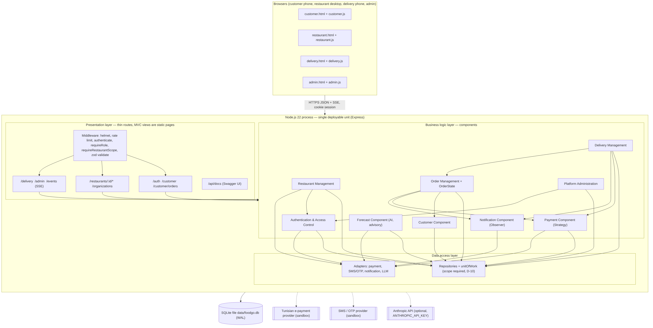
Figure 1 — Component and deployment diagram (source: docs/uml/component-deployment.mmd). Revised after the peer review: Platform Administration and four missing dependencies added.

External systems (dashed in the diagram): Tunisian e-payment provider, SMS/OTP provider, Anthropic API (optional). The restaurant's kitchen and its delivery people's transport are outside the software boundary (BR-06, BR-07).

Fill in: Component Responsibility Table
Component | Responsibility | Talks To
Presentation (4 UIs + routes + middleware) | Validate input (zod), authenticate, check role and restaurant scope, call one component, return JSON / SSE | Business components; browsers
Authentication & Access Control | Password sign-in (staff, delivery, admin), SMS one-time code (customers), sessions, staff provisioning (FR-01, FR-29) | Repositories; SMS adapter
Customer | A customer's restaurants, menus and profile; membership check (BR-04, BR-16) | Repositories
Restaurant Management | Menu and availability, deadline and payment settings, in-person registration, workplaces with their zone (new, FR-32), delivery team (FR-30) | Repositories
Order Management (+ OrderState) | Only creator/changer of orders: service-area check (new, BR-17), deadline gate, totals, status changes (BR-01, BR-14) | Customer, Payment, Notification, Repositories
Delivery Management | Assign to the restaurant's own staff, delivery info, start, confirm (BR-08, BR-10, BR-11) | Order Management, Payment, Notification, Repositories
Payment | Strategy per method; owns payment status (FR-25–FR-28) | Payment adapter, Repositories
Notification | Events after commit; who may see what (BR-15) | Notification adapter; SSE stream
Forecast (new, FR-31) | Advisory prep forecast from past orders; optional LLM note, no customer data | Repositories; LLM adapter
Repositories + unit of work | All SQL; restaurant scope is a required argument; transactions T1–T3 | SQLite
Adapters | Payment, SMS/OTP, notification, LLM behind narrow interfaces | External providers
☐ Checkpoint: show your diagram and table to the instructor — to be signed by the instructor in class

Step 3 — Class Modeling (30 min)
Reminder: identify classes, attributes, and operations from your requirements and use cases.
In-session activity
- As a team, list at least 5 candidate classes from your domain.
- For each class, list 2–3 key attributes and 2–3 key operations.
- Sketch relationships (associations, inheritance) between your classes.

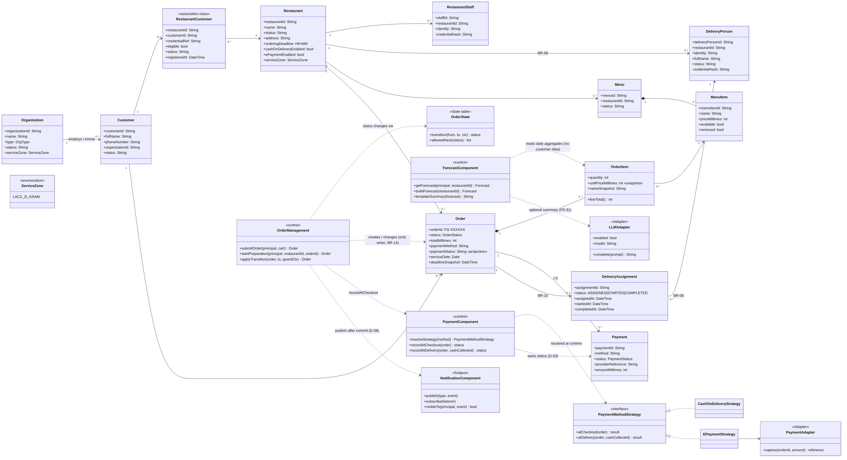
Figure 2 — Class diagram (source: docs/uml/class-diagram.mmd). Revised after the peer review: control classes carry the behaviour; forecast classes added; attributes synced with the schema.

Fill in: Class Design Table
Class | Attributes | Operations | Related Classes
Restaurant | name, status, orderingDeadline (HH:MM), serviceZone (new), payment flags | isOrderingOpen(now), paymentMethods(), updateSettings() | Menu (1..*), RestaurantStaff, DeliveryPerson (BR-06), RestaurantCustomer, Order
Organization (workplace) | name, type, serviceZone (new) | create(name, type, zone), isInServiceArea() (new) | Customer (1..*)
Customer | fullName, phoneNumber, organizationId | signInWithCode(), listMyRestaurants(), placeOrder() | Organization, RestaurantCustomer, Order
RestaurantCustomer (membership, association class) | eligible, status, credentialRef | register(), setEligibility(), assertActive() | Restaurant, Customer
MenuItem | name, priceMillimes, available | setAvailable(), edit(), remove() (soft) | Menu (composition), OrderItem
Order | orderId (FG-XXXXXX), status, totalMillimes, paymentStatus (projection), deadlineSnapshot, serviceDate | total() (sum of its lines); a record otherwise — only OrderManagement creates or changes it | Customer, Restaurant, OrderItem (composition), Payment, DeliveryAssignment
OrderItem | quantity, unitPriceMillimes (snapshot), nameSnapshot | lineTotal() | Order, MenuItem
Payment | method, status, amountMillimes, providerReference | a record — written only by PaymentComponent, which also projects the status onto Order (D-03) | Order, PaymentComponent
DeliveryAssignment | status (ASSIGNED/STARTED/COMPLETED), assignedAt, completedAt | assign(), start(), confirm() | Order (0..1), DeliveryPerson
OrderManagement «control» | dependencies (repos, payments, notifications, clock) | submitOrder(principal, cart), startPreparation(), applyTransition(order, to, guardCtx) | Order, OrderState, PaymentComponent, NotificationComponent
PaymentComponent «control» | strategy registry | resolveStrategy(method), recordAtCheckout(order), recordAtDelivery(order, cashCollected) | Payment, PaymentMethodStrategy
ForecastComponent «control» (new, FR-31) | LLM adapter, clock | getForecast(principal, restaurantId), buildForecast(), templateSummary() | OrderItem (daily aggregates), LLMAdapter
OrderState (state table) | the transition table and guards | transition(from, to, ctx), allowedNext(status) | OrderManagement
PaymentMethodStrategy (interface) | — | atCheckout(order), atDelivery(order, cashCollected) | CashOnDeliveryStrategy, EPaymentStrategy, PaymentAdapter
Cohesion check (two classes for the instructor).
- OrderManagement is the only writer of orders. It does not know who must be told when an order changes (that is Notification) or how money is taken (that is Payment).
- DeliveryAssignment only links one order to one of the restaurant's own couriers and tracks that link. It has no vehicle, shift or salary attributes on purpose (BR-07).
☐ Checkpoint: instructor reviews at least 2 classes for cohesion and single responsibility — to be signed by the instructor in class

Step 4 — Sequence Diagrams (25 min)
Reminder: sequence diagrams show how objects collaborate, in order, to complete a use case.
In-session activity
- Pick your top 2 “Must have” use cases from your SRS.
- For each, list the sequence of messages between objects using the template below.

Fill in: Sequence Diagram Template
Sequence for Use Case: UC-01 — Place a morning pre-order (US-11, FR-09–FR-14, BR-01, BR-17)
Actors/Objects involved: Customer, Customer UI, Order route, Auth middleware, Order Management, Customer Component, Payment Component, Repositories, Notification.
1. Customer → Customer UI : choose dishes, quantities, payment method
2. Customer UI → Order route : POST /customer/orders + Idempotency-Key
3. Order route → Auth middleware : authenticate, require role CUSTOMER
4. Order route → Order route : validate body (zod) — else VAL-001
5. Order route → Order Management : submitOrder(principal, cart)
6. Order Management → Repositories : idempotency lookup (a retry returns the first order)
7. Order Management → Customer Component : assertMembership (BR-04, BR-16) — begins transaction T1
8. Order Management → Repositories : read restaurant and deadline; restaurant must be ACTIVE — else ORDER-003
9. Order Management → Order Management : assertInServiceArea (new, BR-17) — else ORDER-003
10. Order Management → Order Management : evaluateDeadline (BR-01) — else ORDER-001
11. Order Management → Payment Component : assertMethodAvailable (FR-25, FR-26)
12. Order Management → Repositories : read item availability (BR-02) — else ORDER-002
13. Order Management → Repositories : insert order (total, deadline snapshot D-04) and items (price snapshot D-02)
14. Order Management → Payment Component : recordAtCheckout → Repositories : insert payment row and project its status onto the order (D-03) — commit T1
15. Order Management → Notification : OrderSubmitted, OrderConfirmed (after commit, D-08)
16. Notification → Restaurant UI / Customer UI : live update (BR-15: only this restaurant and this customer)
17. Order route → Customer UI : 201 Created, order FG-XXXXXX
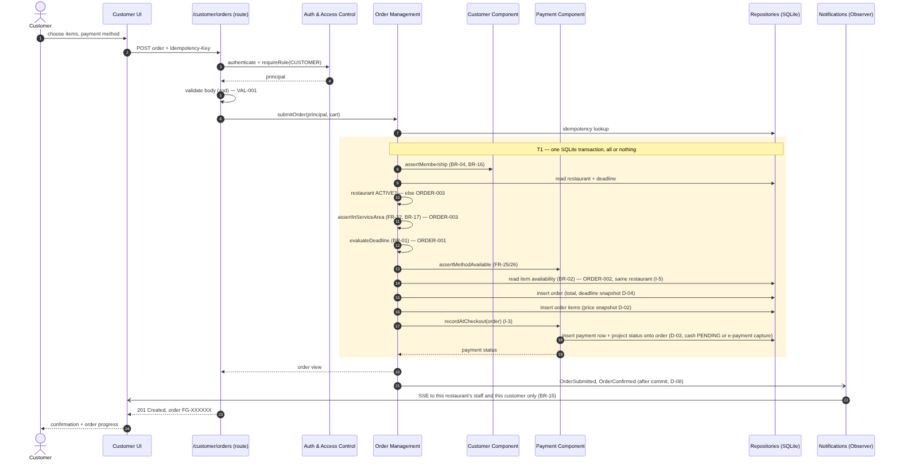
Sequence for Use Case: UC-02 — Assign a delivery person and complete the delivery (US-16, US-18, FR-19–FR-23, BR-10, BR-11)
Actors/Objects involved: Restaurant staff, Delivery person, Customer, Delivery Management, Order Management (OrderState), Payment Component, Repositories, Notification.
1. Restaurant staff → Delivery Management : assignOrder(orderId, deliveryPersonId)
2. Delivery Management → Repositories : check the person belongs to the order's restaurant (I-8, BR-06) and the order is not already assigned
3. Delivery Management → Repositories : insert assignment before dispatch (BR-10) — begins T2
4. Delivery Management → Order Management : applyTransition(→ ASSIGNED) — commit T2
5. Delivery Management → Notification : DeliveryAssigned → Delivery person sees it (own assignments only, BR-08)
6. Delivery person → Delivery Management : startDelivery(assignmentId)
7. Delivery Management → Order Management : applyTransition(→ OUT_FOR_DELIVERY); Notification → Customer : "On the way"
8. Delivery person → Delivery Management : confirmDelivery(assignmentId, cashCollected) — begins T3
9. Delivery Management → Order Management : applyTransition(→ DELIVERED), guard: actor is the assignee (BR-11)
10. Delivery Management → Repositories : complete assignment
11. Delivery Management → Payment Component : recordAtDelivery (cash marked paid) — commit T3
12. Delivery Management → Notification : OrderStatusChanged, PaymentStatusChanged → Customer : "Delivered"
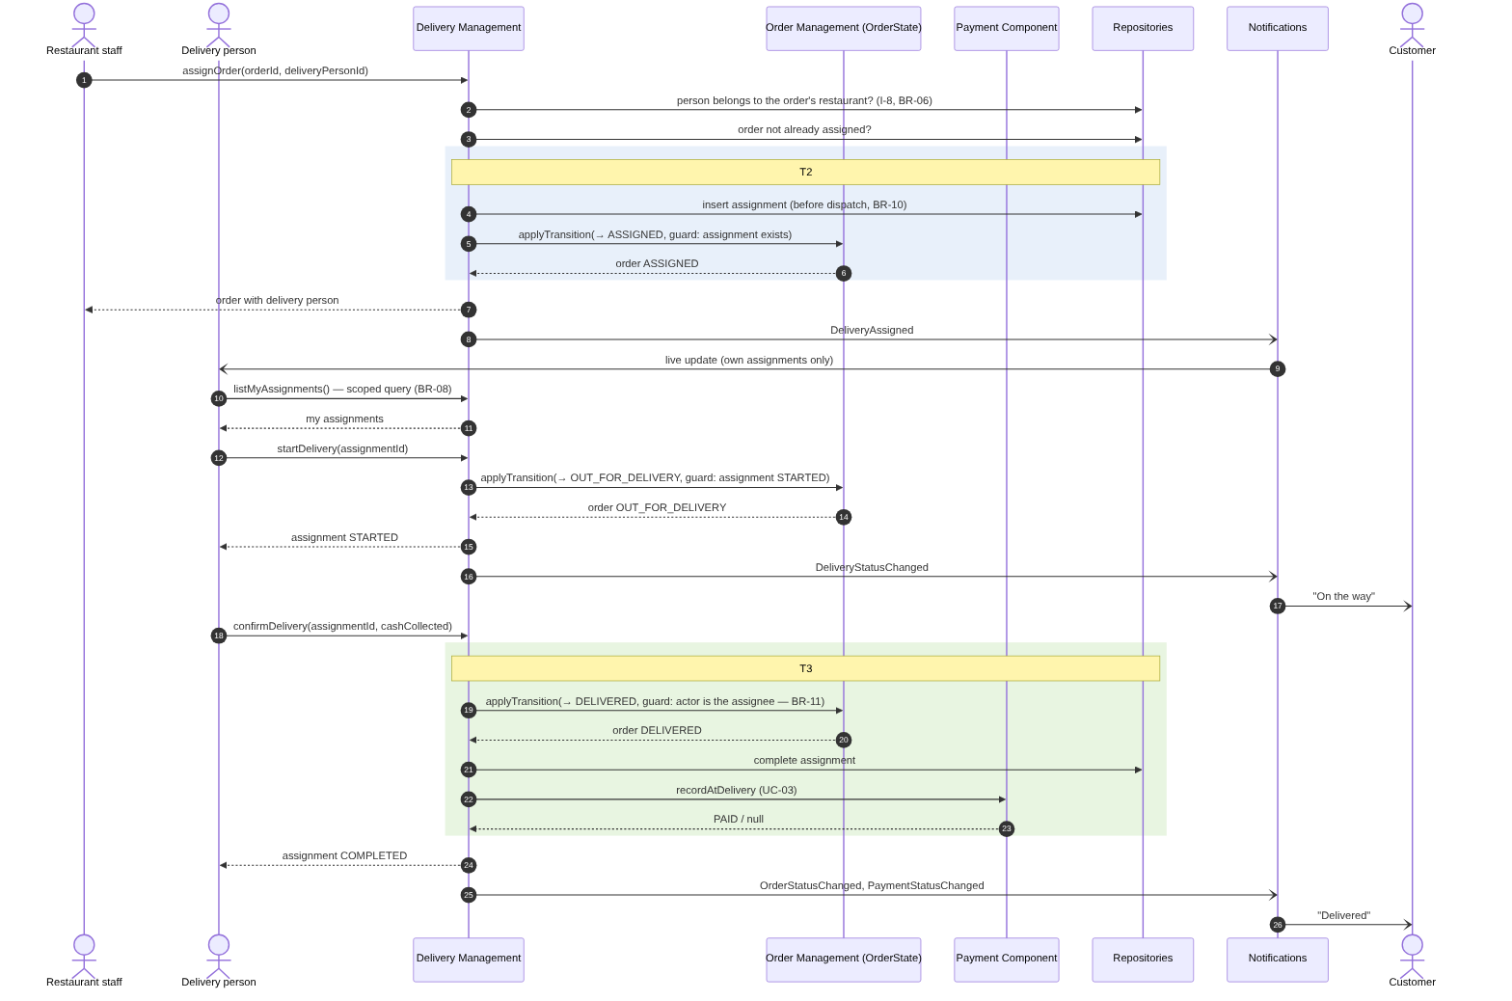
Extra, added after the peer review: UC-15, the AI prep forecast (FR-31): aggregates only, optional LLM call with a template fallback, audited. Diagram. (docs/uml/sequence-uc15-forecast.png)
☐ Checkpoint: show your 2 sequence diagrams to the instructor — to be signed by the instructor in class

Step 5 — Apply Design Patterns (15 min)
Reminder: reuse proven solutions rather than inventing new ones — see the Lab 4 pattern cheat sheet.
In-session activity
- Review the design you've built so far as a team.
- Identify at least 2 design problems that match a known pattern from Lab 4.

Fill in: Design Pattern Table
Pattern | Problem Solved | Where Applied
State (table-driven variant) | BR-14 needs one coherent order status with illegal transitions impossible, while the failure states (cancel, reject, fail) are still undecided. A closed if chain would scatter the rule; a transition table with guards encodes the happy path once and lets a new state be added in one place. We use a table, not one class per state (honest wording after the peer review). | src/domain/orderState.js (transition, allowedNext); only Order Management calls it
Strategy | Payment methods are per-restaurant and open-ended, and no provider is chosen (Q-22). Without Strategy the ordering code would branch on every method. | src/components/paymentComponent.js: CashOnDeliveryStrategy, EPaymentStrategy, resolveStrategy()
Adapter | Payment, SMS, notification and LLM providers are third parties we don't control; business code must be testable without them. | src/adapters/ (payment, SMS/OTP, notification, LLM); sandboxes today
Observer | One status change must reach customer, restaurant and courier, each seeing only what BR-15 allows, without Order Management knowing them. | src/components/notificationComponent.js (publish, subscribe, visibleTo); events after commit; SSE stream
Repository + Unit of Work | Every restaurant-owned query must be scoped (BR-09), and multi-row writes must be all-or-nothing (T1–T3). | src/repositories/ (requireScope, unitOfWork)
Patterns deliberately not used: Singleton (a global connection is a testing liability; the DB is injected), Decorator (its only candidate, delivery fees, has no requirement, Q-31).

Step 6 — Peer Review & Assemble SDD Skeleton (20 min)
Reminder: validation catches weak cohesion, tight coupling, and requirements the design missed.
In-session activity
- Swap your architecture diagram, class diagram, and sequence diagrams with another team.
- Using the Lab 4 design quality checklist, find at least 3 issues in their design.
- Return the feedback, receive your own team's feedback, and revise for the remaining time.
- Create your SDD skeleton (Sections 1–2 from the Lab 4 template) using today's work.
Reviewing team. No other team was available for the swap, so we used an independent AI reviewer: a fresh Claude agent that knew nothing about the project, read only the repository, and applied a design-quality checklist (cohesion, coupling, requirement coverage, diagram–code consistency, UML notation, patterns). It changed nothing. Every issue below was checked against the code before we accepted it. A peer team's review is still to be added in class.

Fill in: Peer Feedback Received
Reviewing Team | Issue Found | Our Fix
Independent AI reviewer | Order Management wrote the payment status, breaking D-03 ("only Payment writes it"), and the e-payment row was written twice. | Fixed in code. recordAtCheckout now inserts the payment row and projects its status in one call (insertPaymentAndProject); the extra write in submitOrder is gone. Unit test added.
Independent AI reviewer | Component diagrams were incomplete: no Platform Administration component, and the Delivery→Payment, Order→Customer, Restaurant Management→Auth and →adapters dependencies were missing. | Fixed. Both component diagrams (component-deployment.mmd, architecture.md) redrawn with the Admin component and all four dependencies.
Independent AI reviewer | The AI forecast (FR-31) only appeared at component level; no class or sequence diagram covered it, and the Observer subject was not shown. | Fixed. ForecastComponent, LLMAdapter «Adapter» and NotificationComponent «Subject» added to the class diagram; new sequence diagram UC-15 with the LLM-failure branch.
Independent AI reviewer | The class diagram put behaviour on passive records (Order ..> OrderState, Payment ..> Strategy) and missed attributes (Restaurant.status, address; DeliveryPerson.status, fullName). | Fixed. Control classes OrderManagement and PaymentComponent now carry those dependencies; attributes synced with the schema; RestaurantCustomer marked as an association class.
Independent AI reviewer | Sequence notation errors: resolveStrategy drawn as a message to the strategy, a reply skipping the Payment lifeline, UC-02 checks drawn inside T2, and no return messages. | Fixed. UC-03 uses a self-call and returns through the caller; UC-02 shows the checks before T2, with return messages; UC-01 shows the restaurant-status guard.
Independent AI reviewer | State guards trust a context built by the caller (applyTransition is public), and the "State" is really a transition table. | Partly fixed. Wording corrected everywhere to "table-driven state machine". The refactor (intention-revealing markAssigned / dispatch / markDelivered) is backlog story US-33 for Sprint 2.
Independent AI reviewer (low) | assertInServiceArea checks that both places are in a served area, not that they are in the *same* area; adding a second area would silently allow cross-area orders. | Recorded. ADR-0007 now says the ADR that adds an area must decide cross-area ordering. No code change while there is one area.
_Peer team (in class)_ | _to fill in_ | _to fill in_
What the reviewer said we do well: clean layering with one composition root, repositories that require the restaurant scope, events published after commit, and real (not decorative) Strategy and Adapter implementations.
SDD skeleton: Sections 1–2 are at the end of this document (also docs/lab5-design/SDD_SKELETON_SECTIONS_1-2.md).

Instructor sign-off
Show your architecture diagram, class diagram, and at least one sequence diagram to the instructor before the session ends. This is your official checkpoint for today's deliverable.

Draft SDD skeleton — Sections 1–2 (Step 6)
Lab 5, Step 6 deliverable. These are Sections 1–2 of the Lab 4 template (IEEE 1016), rewritten after building the midterm MVP. The full Lab 4 SDD is ../lab4-sdd/FoodGO_Software_Design_Document.pdf. This skeleton records what changed since then: the AI forecast (ADR-0004), the single service area (ADR-0007), and the design as actually built.
1. Introduction
1.1 Purpose
This document describes how FoodGO is designed: its architecture, components, classes, behaviour and the reasons behind each choice. Every design element traces back to a requirement in the Lab 3 specification (FR-xx, BR-xx) or to a later team decision recorded as an ADR.
Readers: the three team members, the course instructor, and anyone maintaining the code later.
1.2 Scope
FoodGO is a pre-order lunch platform for one area of Tunis: Lac 3 / Zone Industrielle Le Kram (one area, known by both names). Traffic there gets heavy at lunchtime because employees leave work at the same moment to get food. FoodGO moves ordering to the morning: an employee orders before a deadline the restaurant sets, the kitchen cooks exactly what was ordered, and the restaurant's own delivery staff bring lunch at noon. The platform coordinates; the restaurant delivers.
In scope:
- In-person customer registration and SMS-code sign-in (FR-01–FR-04, BR-05, BR-16)
- Menus and item availability (FR-05–FR-08, BR-03)
- Morning pre-orders with a restaurant deadline (FR-09–FR-15, BR-01, BR-02)
- Customer verification and per-restaurant eligibility (FR-16, FR-17, BR-04)
- The restaurant's own delivery team: assignment, start, confirmation (FR-18–FR-24, BR-06–BR-11)
- Cash on delivery and Tunisian e-payment status (FR-25–FR-28, BR-12, BR-13)
- Account provisioning (FR-29, FR-30) and administrator monitoring
- An advisory AI prep forecast for restaurants (FR-31, ADR-0004)
- The service area: restaurants and workplaces must be inside Lac 3 / Zone Industrielle Le Kram; restaurants outside it cannot join (FR-32, BR-17, ADR-0007)
Out of scope until stakeholders decide: other areas, order cancellation, restaurant rejection, failed delivery, refunds, delivery fees, GPS tracking, self-registration, a named payment provider, staggered delivery windows.
1.3 Definitions, acronyms and abbreviations
Term | Meaning
FR / BR | Functional requirement / business rule. FR-01…FR-30 and BR-01…BR-16 come from the Lab 3 specification; FR-31, FR-32 and BR-17 were added later by team decision (ADRs).
UC-xx | Use case, derived in the Lab 4 SDD (Appendix A)
D-xx | Design decision from the Lab 4 SDD register
ADR | Architecture Decision Record, in docs/decisions/
Service area / zone | Lac 3 / Zone Industrielle Le Kram, code LAC3_ZI_KRAM, the only place FoodGO operates
Ordering deadline | Restaurant-local time after which today's orders are refused
Membership | The record that a restaurant registered a customer, with an eligibility flag
Millimes | 1/1000 of a Tunisian dinar; all money is stored as whole millimes
SSE | Server-Sent Events, used for live status updates
PROPOSED / UNRESOLVED | A design position we took to make the system buildable / a business decision left to stakeholders
1.4 References
Document | Used for
Lab 3 Software Specification (docs/lab3-specification/) | All requirements, business rules and open questions
Lab 4 Software Design Document (docs/lab4-sdd/) | The original design, decision register, traceability
ADRs 0001–0007 (docs/decisions/) | Decisions taken after Lab 4, notably 0004 (AI forecast) and 0007 (service area)
Living architecture summary (docs/architecture.md) | The design as built, kept in sync with the code
Lab 5 worksheet (LAB5_DESIGN_WORKSHEET.md) | Steps 1–6 of this session
IEEE Std 1016 | Section structure
2. System Architecture
2.1 Design methodology and architectural style
- Design methodology: Object-Oriented Design for the domain model (orders, menu items, assignments and payments are objects whose state must stay consistent), combined with Component-Oriented Design for the system's structure: one component per functional area, each with a narrow interface.
- Architectural style: a layered monolith (presentation → business components → data access), with client–server communication, MVC limited to the presentation layer, and events only for notifications (sent after the database commit).
- Process: Scrum with one-week sprints (see the proposal).
Why: FoodGO's hardest requirement is correctness, not scale. Access rules (BR-09, BR-15), the deadline (BR-01) and the service area (BR-17) must hold on every request, and layering makes that structural: no screen can reach the database without passing through a business component. One team, one area and a short morning peak do not justify microservices, and splitting the components would turn every order into a distributed transaction. The components are already separated, so moving to services later would be a packaging change.
2.2 Component diagram
Component diagram: see Step 2 above (docs/uml/component-deployment.png).
2.3 Component descriptions
Component | Layer | Responsibility | Traces to
Customer, Restaurant, Delivery and Admin interfaces | Presentation | Static pages plus thin routes: validate input, check role and restaurant scope, call one component, return JSON | FR-05–FR-10, FR-16–FR-24, FR-29
Authentication & Access Control | Business | Password and SMS-code sign-in, sessions, roles, restaurant scope, staff provisioning | FR-01, FR-29, BR-05, BR-08, BR-09
Customer | Business | The customer's restaurants, menus and profile; membership check | FR-05, FR-06, BR-04, BR-16
Restaurant Management | Business | Menu and availability, deadline and payment settings, in-person registration, workplaces, delivery team | FR-01–FR-08, FR-16–FR-18, FR-30, FR-32
Order Management | Business | The only component that creates or changes an order: service-area check, deadline gate, totals, status changes | FR-09–FR-15, BR-01, BR-02, BR-14, BR-17
Delivery Management | Business | Assignment to the restaurant's own staff, delivery information, start and confirmation | FR-19–FR-23, BR-06, BR-08, BR-10, BR-11
Payment | Business | One strategy per payment method; owns the payment status and writes the order's projection of it (D-03) | FR-25–FR-28, BR-12, BR-13
Notification | Business | Publishes events after commit; decides who may see each event | FR-14, FR-15, FR-24, BR-15
Forecast | Business | Advisory prep forecast from past orders; optional LLM note with no customer data | FR-31
Platform Administration | Business | Restaurants, staff accounts, read-only monitoring and audit trail | FR-29, BG-09
Repositories + unit of work | Data access | All SQL; the restaurant scope is a required argument; transactions T1–T3 | BR-09, BR-15, D-10
Adapters | Data access | Payment, SMS/OTP, notification and LLM providers behind narrow interfaces | FR-27, BR-13, Q-22
2.4 Architectural constraints and layer rules
- A route contains no business rule: it validates, calls one component and responds.
- Only repositories issue SQL; a component never names a table.
- Every restaurant-owned query takes the restaurant scope as a required argument (D-10).
- Authentication and authorisation run in middleware, before any component.
- Only Order Management creates or changes an order, and only through the OrderState transition table (BR-14). Only Payment writes a payment status (D-03).
- Third parties are reached only through adapters.
- The AI forecast is advice only: it never accepts orders, changes payments, eligibility or the menu.
- No component employs, schedules or equips a delivery person (BR-06, BR-07).
- Every restaurant and workplace is inside the service area; the zone list exists only in src/domain/serviceArea.js and migration 003 (FR-32, BR-17).
4. End-of-Session Submission Checklist
☑ Methodology & architecture decision with justification
☑ Component/architecture diagram + responsibility table
☑ Class diagram + class design table
☑ 2 sequence diagrams for key use cases
☑ Design pattern justification table
☑ Peer review feedback log and revisions made (independent AI reviewer; a peer team's review still to add)
☑ Draft SDD skeleton (Sections 1–2 completed)
☐ Instructor sign-off obtained at each checkpoint — not yet obtained
5. Participation & Deliverable Rubric
Criterion | Weight
Team participation & discussion quality | 10%
Architecture/component design quality | 20%
Class diagram correctness | 20%
Sequence diagram correctness | 20%
Design pattern justification | 10%
Peer review quality & SDD skeleton | 20%

