Insertion Sort for Linked List
Overview
This project implements the insertion sort algorithm for a linked list data structure. The code is based on the original array-based insertion sort algorithm but adapted to work with linked lists.

Code Structure
Header File (LinkedListSort.h)
- Contains the Node structure definition
- Function declarations for insertion sort and helper functions
- Include guards to prevent multiple inclusions
Implementation File (LinkedListSort.cpp)
- insertion_sort(Node*& head): Main sorting function that implements insertion sort algorithm
- insert(Node*& head, int value): Helper function to insert elements at the end of the list
- display(Node* head): Function to display the linked list
- clear(Node*& head): Function to deallocate memory
- main(): Test function that demonstrates the sorting algorithm

Algorithm Explanation
The insertion sort algorithm works by:
- Starting from the second element (first element is considered sorted)
- For each element, find its correct position in the sorted portion
- Insert the element at that position
- Repeat until all elements are processed
Key Features:
- Time Complexity: O(n²) in worst case, O(n) in best case
- Space Complexity: O(1) - sorts in place
- Stable: Maintains relative order of equal elements
- Adaptive: Efficient for small datasets and nearly sorted data
Expected Output:
Before sorting: 20 65 30 10
After sorting: 10 20 30 65
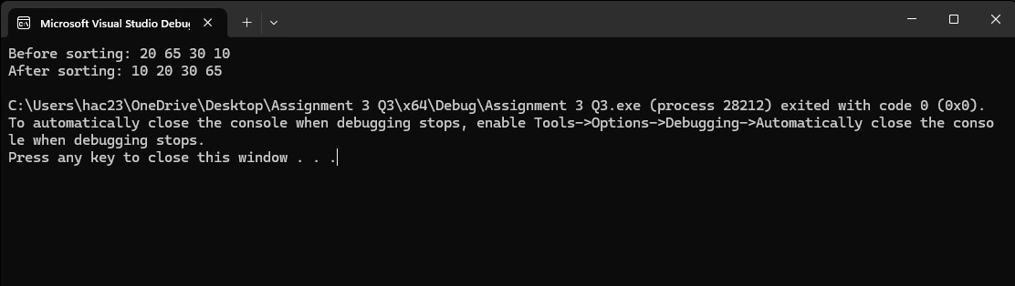
Step-by-step execution:
- Initial: 20 → 65 → 30 → 10
- After processing 65: 20 → 65 → 30 → 10 (no change needed)
- After processing 30: 20 → 30 → 65 → 10 (30 inserted before 65)
- After processing 10: 10 → 20 → 30 → 65 (10 inserted at beginning)

