Stack of Integers Using Vector
Overview
This project implements a simple stack of integers using C++ vector. The program allows the user to:
- Add integers to the stack (push)
- Remove elements from either the top or bottom of the stack
- View the current top element
- Calculate the average of the stack elements
- Check if the stack is empty
It demonstrates the basic use of dynamic data structures using a class with clean user interaction.
Features
Create a stack object
Check whether the stack is empty
Push integer values onto the stack
Remove an element from the top or bottom of the stack
View the top element
Calculate the average of the stack elements
Display the stack from top to bottom after each operation

Files Required
1. main.cpp - Contains the main() function and handles user interaction
2. Stack.h - Contains the Stack class definition and method implementations
Input Instructions
During execution, the program will prompt you to:
1. Enter how many integers to push onto the stack
2. Input the integers (one after another or space-separated)
3. Choose whether to remove an element:
- Type 't' to remove from top
- Type 'b' to remove from bottom
- Type 'n' to skip removal
The program will then display:
- Stack contents
- Top element
- Average of elements
Sample Output
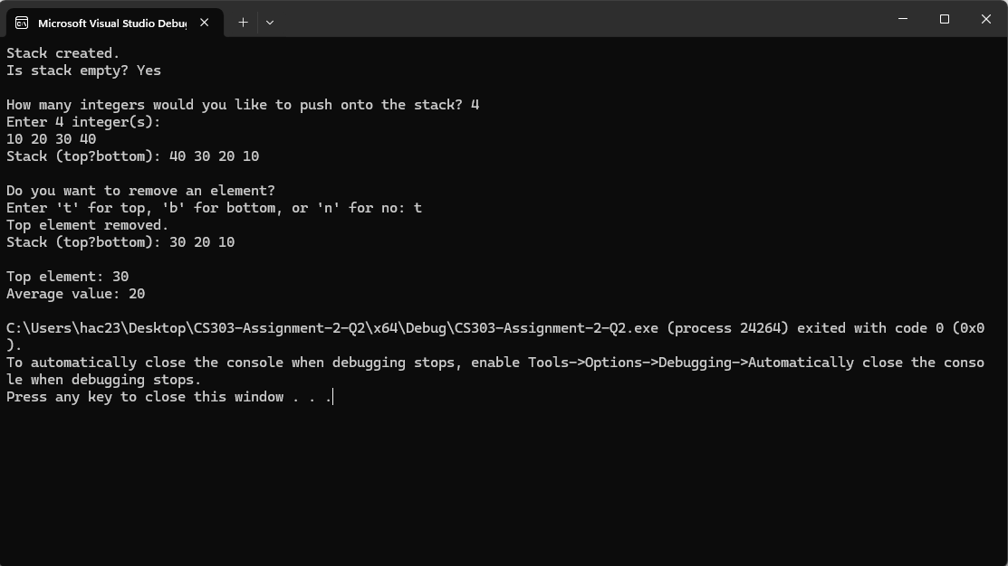
Notes
- All functionalities are implemented inside the Stack class in Stack.h
- Separate .cpp file for the class — everything is included in line for simplicity
- Designed to demonstrate class structure, vector use, and stack behavior

