Database Management system



Group members
Areeza Maryam | 01-135232-013
Rubab Hanif | 01-135232-082
Hamza Masood | 01-135232-023

Project Proposal
Real Estate Management System

Database Design
Entities:
- Property
- Property_Type
- Agent
- Agency
- Client
- Listing
- Transaction
- Payment
- Contract
- Location
- Inspection
- Feedback
Attributes:
- Property
property_id, title, price, size, status, type_id, agent_id, location_id
- Property_Type
type_id, type_name, description
- Agent
agent_id, name, contact, email, agency_id, commission_rate
- Agency
agency_id, agency_name, address, contact, license_no
- Client
client_id, name, email, phone, client_type (Buyer/Seller/Renter)
- Listing
listing_id, property_id, agent_id, listing_date, expiry_date, status
- Transaction
transaction_id, property_id, date, price, payment_id, contract_id
- Payment
payment_id, transaction_id, amount, date, method, status
- Contract
contract_id, transaction_id, start_date, end_date, terms
- Location
location_id, city, area, address, postal_code
- Inspection
inspection_id, property_id, client_id, agent_id, date, remarks
- Feedback
feedback_id, client_id, agent_id, rating, comment, date
Relationships:
- One Agency has many Agents.
- One Agent creates many Listings.
- One Listing is for one Property.
- One Property_Type defines many Properties.
- One Property belongs to one Location.
- One Client can have many Inspections.
- One Property can be inspected by many Clients.
- One Transaction is linked to one Contract.
- One Transaction can have many Payments.
- One Client can give many Feedbacks to Agents.
- One Agent can handle many Transactions.
- One Property can have many Feedbacks

ERD:

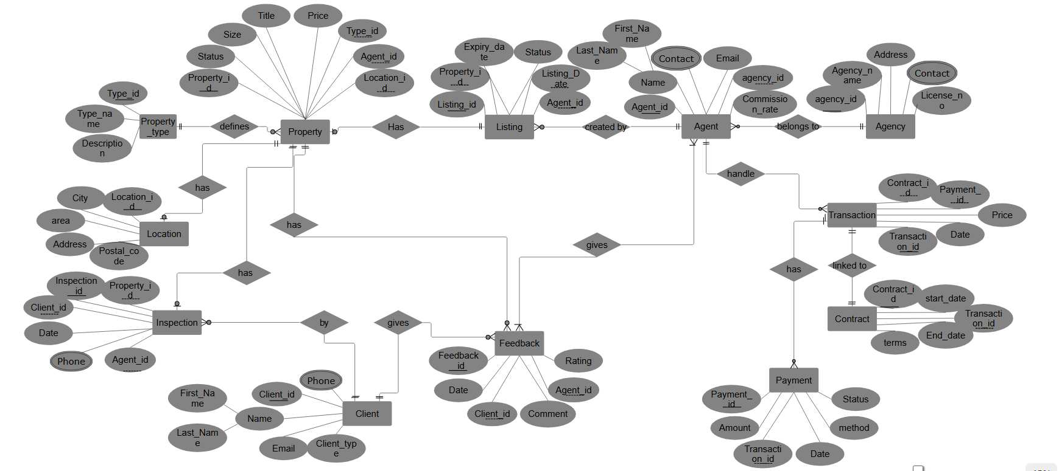

~Real Estate Management System

RDM
Following is the Relational data model for Real estate Management system.
- Property(
property_id [PK, NOT NULL],
title [NOT NULL],
price [NOT NULL, CHECK price > 0],
size [NOT NULL, CHECK size > 0],
status [NOT NULL, CHECK status IN ('Available','Sold','Rented')],
type_id [FK → Property_Type(type_id), NOT NULL],
agent_id [FK → Agent(agent_id), NOT NULL],
location_id [FK → Location(location_id), NOT NULL]
)
- Property_Type(
type_id [PK, NOT NULL],
type_name [NOT NULL, UNIQUE],
description
)

- Agent(
agent_id [PK, NOT NULL],
name [NOT NULL],
contact [NOT NULL],
email [NOT NULL, UNIQUE],
agency_id [FK → Agency(agency_id), NOT NULL],
commission_rate [CHECK commission_rate >= 0]
)
- Agency(
agency_id [PK, NOT NULL],
agency_name [NOT NULL],
address [NOT NULL],
contact [NOT NULL],
license_no [NOT NULL, UNIQUE]
)
- Client(
client_id [PK, NOT NULL],
name [NOT NULL],
email [NOT NULL, UNIQUE],
phone [NOT NULL],
client_type [NOT NULL, CHECK client_type IN ('Buyer','Seller','Renter')]
)
- Listing(
listing_id [PK, NOT NULL],
property_id [FK → Property(property_id), NOT NULL],
agent_id [FK → Agent(agent_id), NOT NULL],
listing_date [NOT NULL],
expiry_date [NOT NULL],
status [NOT NULL, CHECK status IN ('Active','Expired')]
)
- Transaction(
transaction_id [PK, NOT NULL],
property_id [FK → Property(property_id), NOT NULL],
payment_id [FK → Payment(payment_id)],
contract_id [FK → Contract(contract_id)],
date [NOT NULL],
price [NOT NULL, CHECK price > 0]
)
- Payment(
payment_id [PK, NOT NULL],
transaction_id [FK → Transaction(transaction_id), NOT NULL],
amount [NOT NULL, CHECK amount > 0],
date [NOT NULL],
method [NOT NULL, CHECK method IN ('Cash','Bank Transfer','Online')],
status [NOT NULL, CHECK status IN ('Pending','Completed','Failed')]
)
- Contract(
contract_id [PK, NOT NULL],
transaction_id [FK → Transaction(transaction_id), NOT NULL],
start_date [NOT NULL],
end_date [NOT NULL],
terms [NOT NULL]
)
- Location(
location_id [PK, NOT NULL],
city [NOT NULL],
area [NOT NULL],
address [NOT NULL],
postal_code [NOT NULL]
)
- Inspection(
inspection_id [PK, NOT NULL],
property_id [FK → Property(property_id), NOT NULL],
client_id [FK → Client(client_id), NOT NULL],
agent_id [FK → Agent(agent_id), NOT NULL],
date [NOT NULL],
remarks
)
- Feedback(
feedback_id [PK, NOT NULL],
client_id [FK → Client(client_id), NOT NULL],
agent_id [FK → Agent(agent_id), NOT NULL],
property_id [FK → Property(property_id)],
rating [NOT NULL, CHECK rating BETWEEN 1 AND 5],
comment,
date [NOT NULL]
)

Normalization
Unnormalized form
Unnormalized form contains repeating groups, multi-valued attributes, and no strict structure.
Problems in UNF:
- Repeating values for agents, clients, payments, inspections
- All data stored in one large table.
- Same property duplicated across multiple rows
- No primary keys
- Multivalued attributes and non-atomic attributes (e.g., multiple inspections or feedback items for the same property)
First normal form:
- Removed repeating groups and multivalued attributes.
- Made all values atomic.
- Assigned primary keys.
- Split data into separate basic entities:
Property, Property_Type, Agent, Agency, Client, Listing, Transaction, Payment, Contract, Location, Inspection, Feedback.

1NF TABLES
Property
(property_id, title, price, size, status, type_id, agent_id, location_id)
Property_Type
(type_id, type_name, description)
Agent
(agent_id, name, contact, email, agency_id, commission_rate)
Agency
(agency_id, agency_name, address, contact, license_no)
Client
(client_id, name, email, phone, client_type)
Listing
(listing_id, property_id, agent_id, listing_date, expiry_date, status)
Transaction
(transaction_id, property_id, payment_id, contract_id, date, price)
Payment
(payment_id, transaction_id, amount, date, method, status)
Contract
(contract_id, transaction_id, start_date, end_date, terms)
Location
(location_id, city, area, address, postal_code)
Inspection
(inspection_id, property_id, client_id, agent_id, date, remarks)
Feedback
(feedback_id, client_id, agent_id, property_id, rating, comment, date)

After 1NF:
- All repeating groups removed
- All attributes atomic
- Each table has a primary key

Second Normal form:
- Already satisfied because all tables use single-column primary keys.
- Removed attributes not fully dependent on the primary key.
- Separated related information into new tables:
- Agency split from Agent
- Property_Type split from Property
- Location split from Property
- Payment & Contract split from Transaction

2NF tables:
Adjustments made for 2NF
- Agent → Agency separation
- Agency details removed from Agent table
- Prevents partial redundancy
- Property → Property_Type and Location separated
- Property type and location stored in separate tables
- Transaction → Payment and Contract separated
- Prevents storing repeated contract or payment info in the same row

After 2NF:
- All non-key attributes depend entirely on the primary key
- No unrelated attributes stored in a table

Third Normal Form:
- Must be in 2NF
- Remove transitive dependency
- Non-key attributes must not depend on other non-key attributes

3NF Tables
Property
(property_id, title, price, size, status, type_id, agent_id, location_id)
Property_Type
(type_id, type_name, description)
Agent
(agent_id, name, contact, email, agency_id, commission_rate)
Agency
(agency_id, agency_name, address, contact, license_no)
Client
(client_id, name, email, phone, client_type)
Listing
(listing_id, property_id, agent_id, listing_date, expiry_date, status)
Transaction
(transaction_id, property_id, payment_id, contract_id, date, price)
Payment
(payment_id, transaction_id, amount, date, method, status)
Contract
(contract_id, transaction_id, start_date, end_date, terms)
Location
(location_id, city, area, address, postal_code)
Inspection
(inspection_id, property_id, client_id, agent_id, date, remarks)
Feedback
(feedback_id, client_id, agent_id, property_id, rating, comment, date)

Explanation of Removed Redundancies
- Agency details removed from Agent table
prevents multiple agents repeating same agency data
- Property type separated
prevents repeating “House”, “Plot”, “Apartment” descriptions
- Location separated
prevents repeating city, area, address for same location
- Payments moved out of Transaction
prevents multiple payment rows per transaction
- Contracts separated
stores terms logically outside transaction
- Inspections & Feedback moved to separate tables
prevents repeating inspection/feedback details inside Property

