Algonquin College Logo

# SCHOOL OF ADVANCED TECHNOLOGY

### ICT - Applications & Programming

### Computer Engineering Technology – Computing Science



A11

Computer Science Challenge

Lab Professor / Lab Session:

[Paulo Sousa / 302]

Team:

[Hamza El Sousi] - Id: [040982818] / [Mansi Joshi] - Id: [041091664]

CS Challenge 1: Connect 4 UI Design

***The use of this template is not required, but should help guide your responses***

|  |  |
| --- | --- |
| **Part**  **1** | **Implementing the UI** |

**Note 1: Read Specification**

*This is only a suggested template. Please check instructions in the A11 specification.*

*If you do use this document, put some care into it. You won't be marked on format, but leaving unneeded or example elements will lead to confusion and risk costing you marks.*

* 1. **Intended UI.**

**What should your UI look like?**

Include a sketch of your UI.

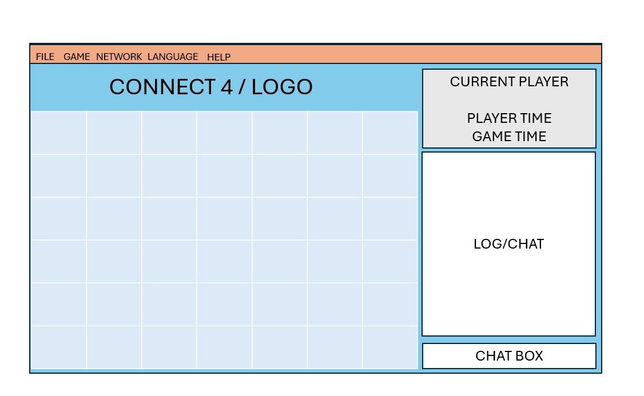

* 1. **UI Sizing and Colours**

**How is it all put together?**

A breakdown of your UI by component sizes and colours. See section 1.2 in the A11 Specification document.

We will use a three-tone color display of light blue, gray, and white.

GUI will be resizable.

Chat box will be (20, 30)

* 1. **Language**

English and Hindi

**1.4. Visual Components**

*What components are required for your UI? List each component, where it goes in the UI, and what it's meant to do. A table is helpful. (Consider annotating a diagram of your UI if that helps make things clearer.)*

We will be using javax.swing.*; and java.awt.*; along with some event and action listeners.

The UI components are composed of JFrame, JMenuBar, JMenu, JPanel, JButton, JTextField, GridLayout, and BorderLayout

**FINAL SUGGESTIONS**

*Here some ideas to think about your implementation....*

* *Try to create a application whose execution can be very intuitive (easy to be played).*
* *Remember that this game will be in fact implemented only in the next assignment. NO CODE IS REQUIRED.*

**References**

|  |  |
| --- | --- |
|  | * ***NOTE****: Even if you use any AI tool (ex: ChatGPT), report here, including the references used.* |

Algonquin College

Winter, 2024