Setup (DDL and INSERT):

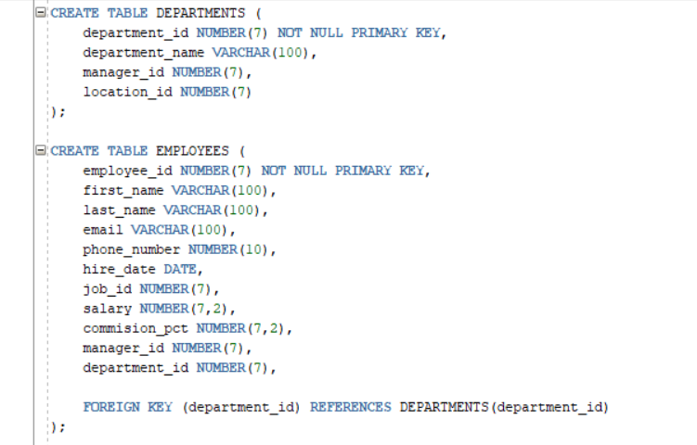

Exercise 1:

Exercise 2:

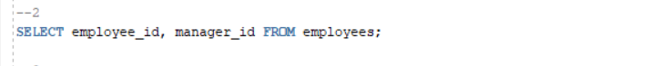

Exercise 3:

Exercise 4:

Insert row:



Update row:



Delete row:



Exercise 5:

