Setup (DDL and INSERT):

Exercise 1:

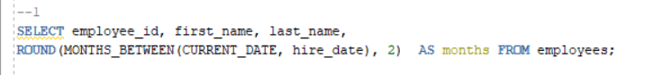

Exercise 2:

Exercise 3:

Exercise 4:

Exercise 5:

After updating and deleting:

After truncation:

