Dataset

As dateset we used the digit one from sklearn (which can be found here). It is composed by 180 images per digit, and each image has a shape of 8*8, and each pixel can have a values in the range [0, 16].
To use it, we flatten each image to form a vector with 64 features, and we standardize each feature to be into the range [0, 1], dividing each one by 16.

ANN and training

We implement the ANN from scratch. For the experiments we used a model composed by 3 Linear layers, with a Tanh activation function between consecutive layers (and no activation function after the last one). The output dimensions of the layers are 32, 20, 10.
We trained the model using the 80% of the dataset, and the remaining portion is used as test set. We trained the model using a batch size of 4, and a learning rate of 0.01. In the following image the mean loss for each epoch is shown.

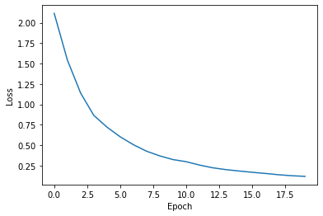
The model obtained a score of 99.44% on train set and 91.90% on test set.

Pixels swap
To evaluate how the model behaves when we modify the images, we performed different experiments. For each image, we swapped randomly a number of pixels, and we evaluate the score on it. The next image shows the results obtained
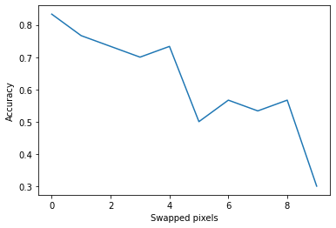
We see that the score is high when no pixels are swapped, but drastically drops when more are changes, leading to catastrophic results when more than 8 are swapped.

