Umar Qureshi - 100591742

Hamza Farhat - 100657374

Fadi Salback - 100649987

Abdul Zainul-Abedin - 100617275

Date: March 13th, 2020

Lab 3- Sudoku

This is a sudoku validator where we used 11 threads to check if the solutions are correct. Please refer to code documentation. The code begins with setting the global variables and reading the file for the sudoku puzzle. After that it converts each character to an int and creates the 11 threads. Then, the threads are called in their manner to check each row, column and the 9 grids to validate solution.

These are two examples of the valid and invalid solution. You can also see how the file was compiled:

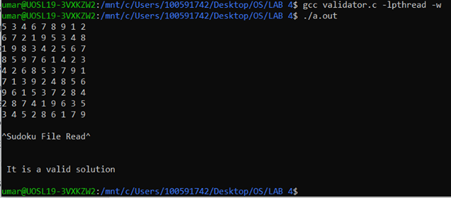

Invalid Solution:

