pep8 Learning

Usage
- pycodestyle --first FILE-NAME
- pycodestyle --show-source --show-pep8 FILE-NAME

Indentation
- User 4 spaces for indentation. Spaces are often better but if you find tabs already implemented then stick with it. Python doesn’t allow mixing tabs and spaces.
- When you write a big expression, it is best to keep the expression vertically aligned. When you do this, you'll create a "hanging indent". The examples of hanging indent are:

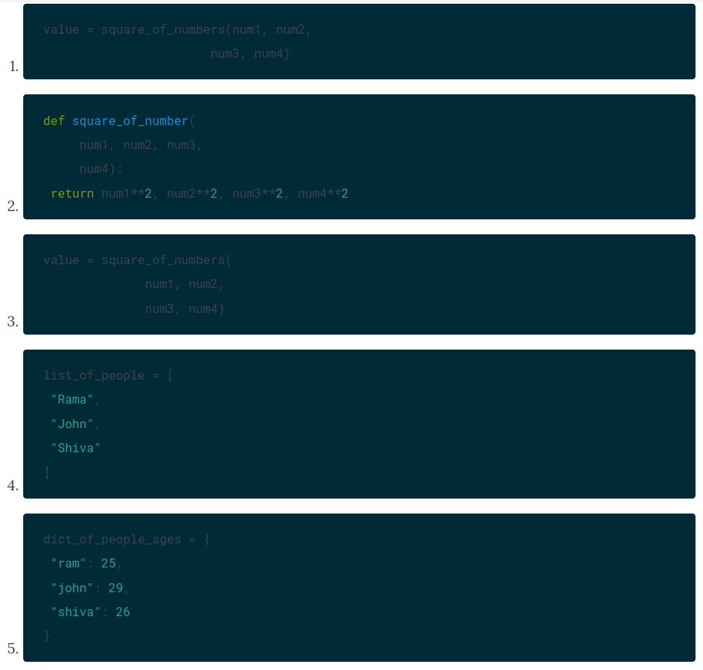
Maximum Line Length
- Generally, it’s good to aim for a line length of 79 characters in Python code.
- Comments should have 72 characters of line length.
- While using + operator, you can better use proper line break. Example is below
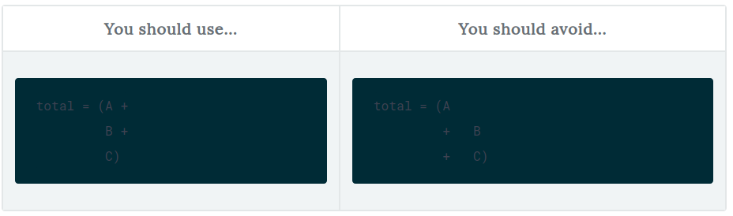

Blank Lines
- In Python scripts, top-level function and classes are separated by two blank lines.
- Method definitions inside classes should be separated by one blank line.
- Example:
class SwapTestSuite(unittest.TestCase):
"""
Swap Operation Test Case
"""
def setUp(self):
self.a = 1
self.b = 2

def test_swap_operations(self):
instance = Swap(self.a,self.b)
value1, value2 =instance.get_swap_values()
self.assertEqual(self.a, value2)
self.assertEqual(self.b, value1)

class OddOrEvenTestSuite(unittest.TestCase):
"""
This is the Odd or Even Test case Suite
"""
def setUp(self):
self.value1 = 1
self.value2 = 2

def test_odd_even_operations(self):
instance1 = OddOrEven(self.value1)
instance2 = OddOrEven(self.value2)
message1 = instance1.get_odd_or_even()
message2 = instance2.get_odd_or_even()
self.assertEqual(message1, 'Odd')
self.assertEqual(message2, 'Even')

Whitespaces in Expressions and Statements
- No white-space with assign op while writing things in arguments. Example
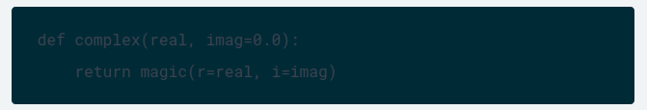
- White-space around -> operator. Example
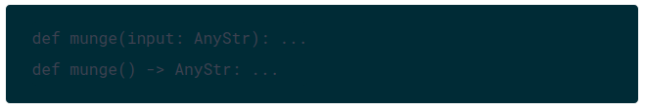
- User parenthesis for readability. Example
- Example of function call

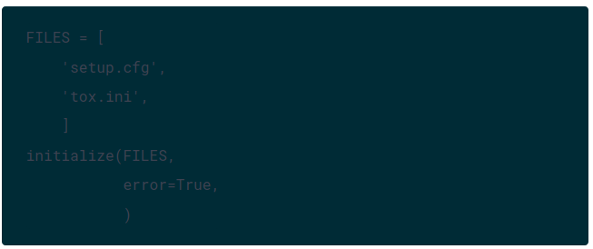
Source File Encoding
- The American Standard Code for Information Interchange (ASCII) is the most common format for text files in computers and on the Internet. It is a 7-bit character set.
- Unicode Worldwide Character Standard, or Unicode in short, is a system for "the interchange, processing, and display of the written texts of the diverse languages of the modern world".
  - UTF-16 is a Unicode encoding that is variable-length: code points are encoded with one or two 16-bit code units.
  - UTF-8 is another type of Unicode variable-length encoding, using one to four 8-bit bytes. In Python 3, UTF-8 is the default source encoding.
  - UTF-32 is a fixed-length encoding that uses exactly 32 bits per Unicode code point.
- you can make use of the .encode() and .decode() string methods. The former returns an 8-bit string version of the Unicode string, encoded in the requested encoding, while the latter interprets the string using the given encoding.

Imports
- If you do many imports, you should make sure to state each import on a single line. Example
DO
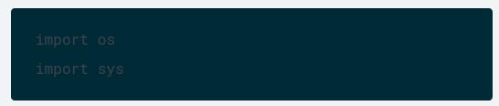
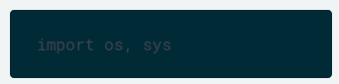
DON’T

- In general, you can follow this order:
  - Standard library imports.
  - Related third-party imports.
  - Local application/library specific imports.

Absolute and Relative Imports
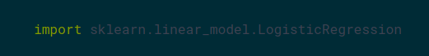
- Absolute imports are preferred in Python, as it adds up more readability. An absolute import is an import that uses the absolute path of the function or class, separated by .. For example,

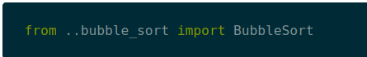
- A relative import is an import that is relative to the current position where your Python file exists. You could use this type of import if your project structure is growing, as it will make your project more readable.

- you should try to avoid wildcard imports, because they do not add to the readability; You have no view on which classes, methods or variables you are using from your module, for example:
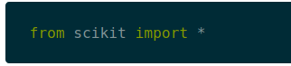

Comments
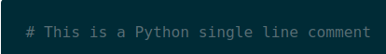
- omments are used for in-code documentation in Python. Comments start with the # symbol.

- Comments should have 72 characters of line length!
- There are three types of comments:
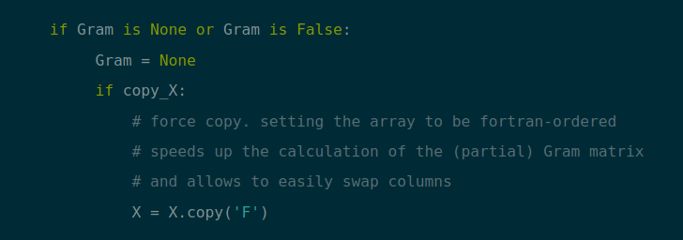
  - You use block comments to explain code that is more complex or unfamiliar to others. Block comments are indented at the same level as the code.
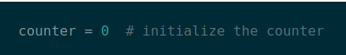
  - You should use inline comments sparingly, even though they can be effective when you need to explain some parts of your code.

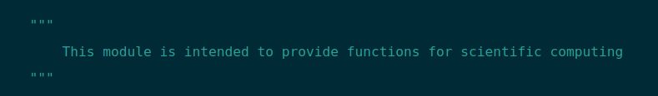
  - You write documentation strings or docstrings at the start of public modules, files, classes and methods. These type of comments start with """ and end with """:

Python modules and Packages
- A module is a single Python file
- a package is a directory of Python modules containing an additional __init__.py file

Module Level dunder Names
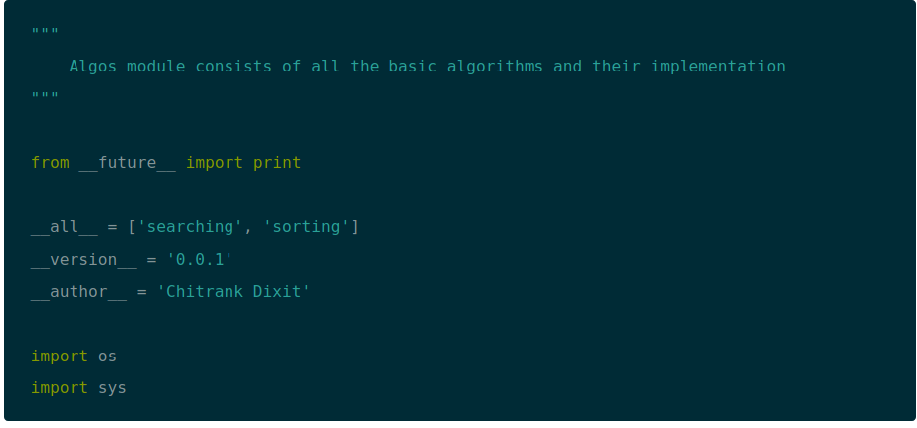
- A module level dunder like (__all__, __author__, __version__) should be placed at the module main docstring and should be before all the import statements. You should define the from __future__ imports before any other code, except the docstrings.

Naming Conventions
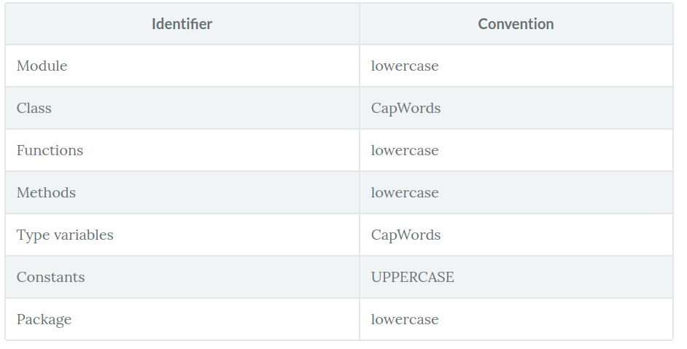
- Do not use 'l', 'O' or 'I' as a single variable name: these characters look similar to zero (0) and (1) in some fonts.
- Generally, it's good to use short names if possible. In some cases, you can use underscores to improve readability.

