# ***Task***

## **B)** *Explore and implement GitHub software for Configuration management from the given****link****and paste screen captures by each member in a separate word file githubExplore.doc.*

### **Member 01:**

### **Name: Hamza Khalid (Group Leader)**

### **Student ID: 64170**

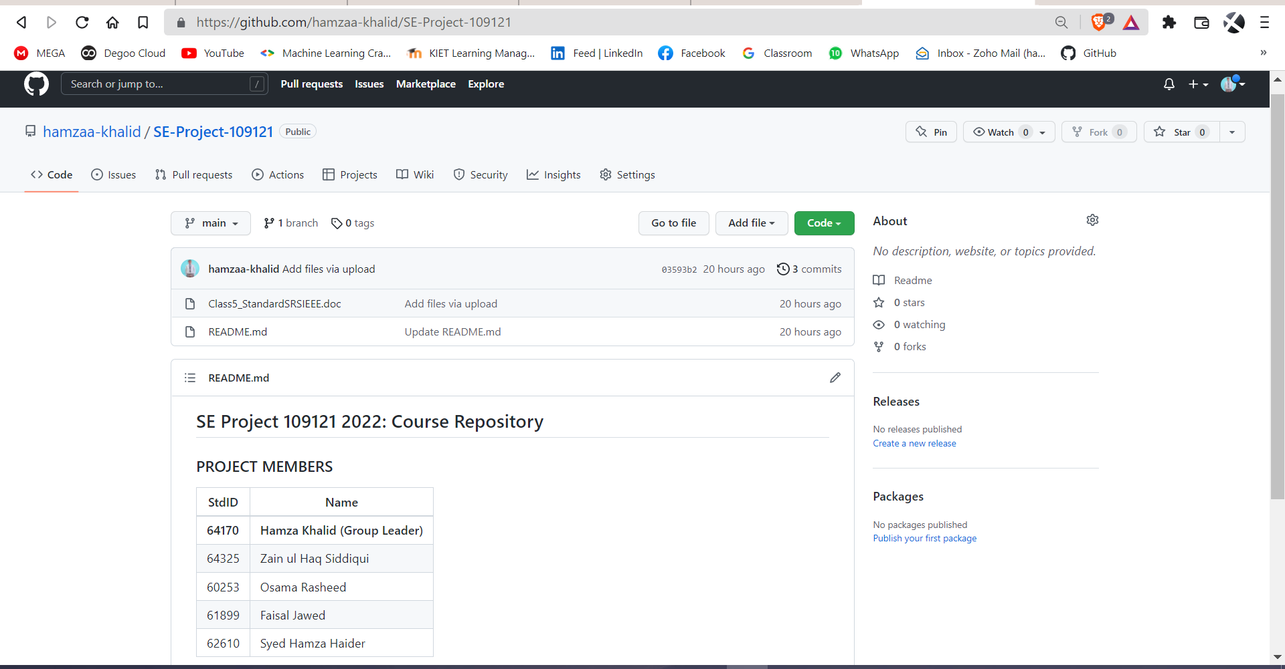

### **Member 02:**

### **Name: Faisal Jawed**

### **Student ID: 61899**

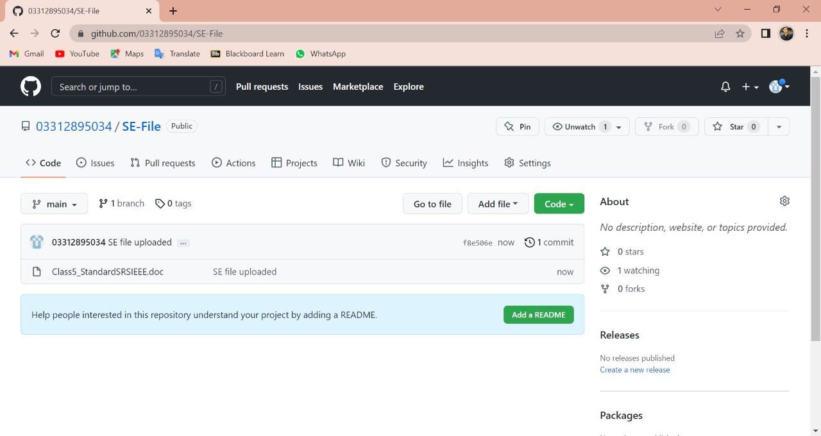

### **Member 03:**

### **Name: Osama Rasheed**

### **Student ID: 60253**

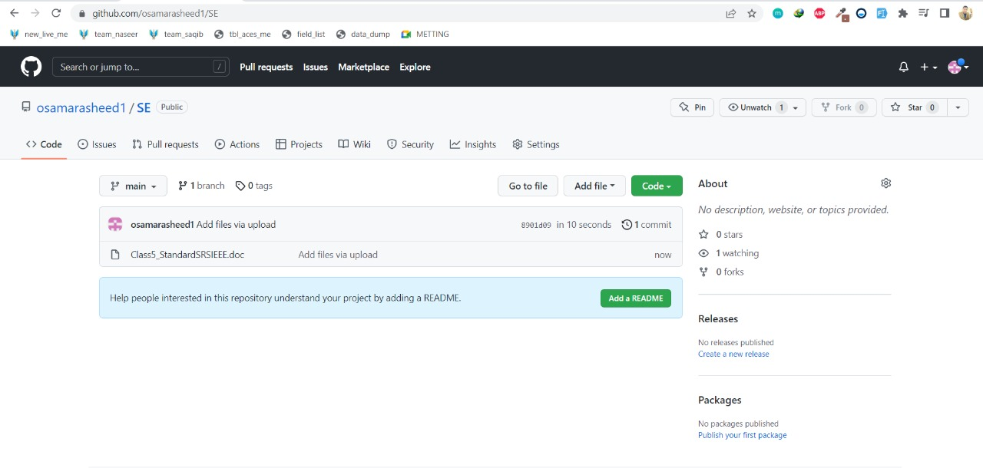

### **Member 04:**

### **Name: Zain ul haq Siddiqui**

### **Student ID: 64325**

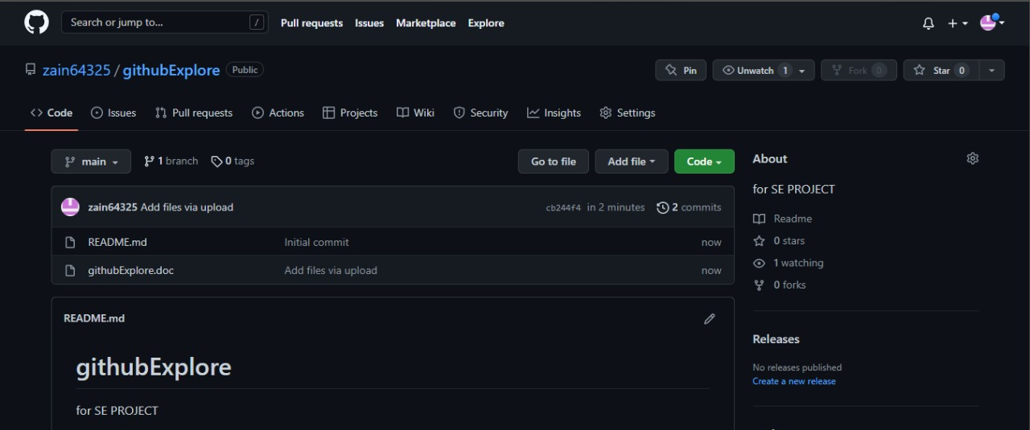

### **Member 05:**

### **Name: Syed Hamza Haider**

### **Student ID: 62610**

Note: Due To Some personal issues Syed Hamza Haider will submit the GitHub SS by himself.