**Data Analytics And Visualization**

**Table Of Contents**

**Province wise deaths 3**

**Province wise Injuries 4**

**Trend of Deaths with respect to time 5**

**Correlation between Deaths and Injuries 6**

**Province wise Deaths (Male/Female separated) 7**

**Province wise Injuries (Male/Female separated) 8**

**Houses Destroyed Province wise 9**

**Number of Houses Destroyed (Fully/Partially) in each Province 10**

**Number of Roads/Shops/Bridges/Livestock destroyed (Province wise) 11**

**Correlation Matrix for Infrastructure destroyed 12**

# Province wise deaths

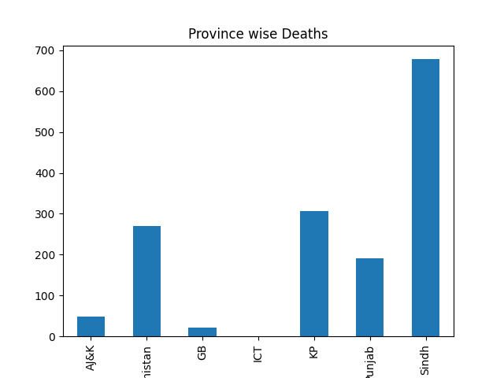

Reporting of Plots:

X variable: Name of Provinces

Y variable: Number of Deaths

The Bar Graph show number of Total Deaths in each province

Analysis and reporting:

The plot will show in which provinces the floods were more deadly and took more lives and where it wasn’t.

As seen in this visualization, Flood mostly killed people from 4 major provinces of Pakistan. Highest in Sindh, followed by KP, Balochistan and then Punjab. There were minor losses in AJ&K, GB and ICT

# Province wise Injuries

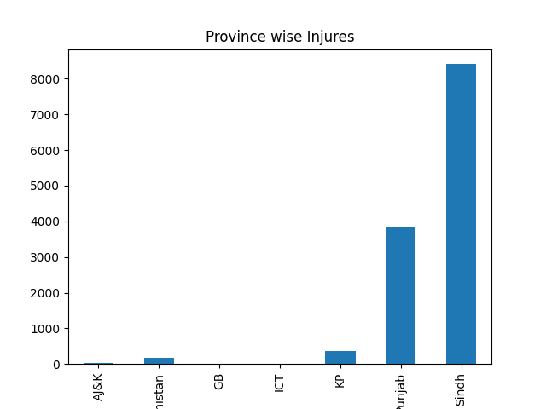

Reporting of Plots:

X variable: Name of Provinces

Y variable: Number of Injuries

The Bar Graph show number of Total Injured in each province

Analysis and reporting:

The plot will show in which provinces the floods left more people injured. This will also show that whether the same trend as the number of deaths in each province.

The trend in injuries is different from that of deaths. Sindh has highest followed by Punjab. Balochistan and KP has very low injuries as compare to other 2 major provinces No injuries are seen in AJ&K, GB and ICT

# Trend of Deaths with respect to time

Reporting of Plots: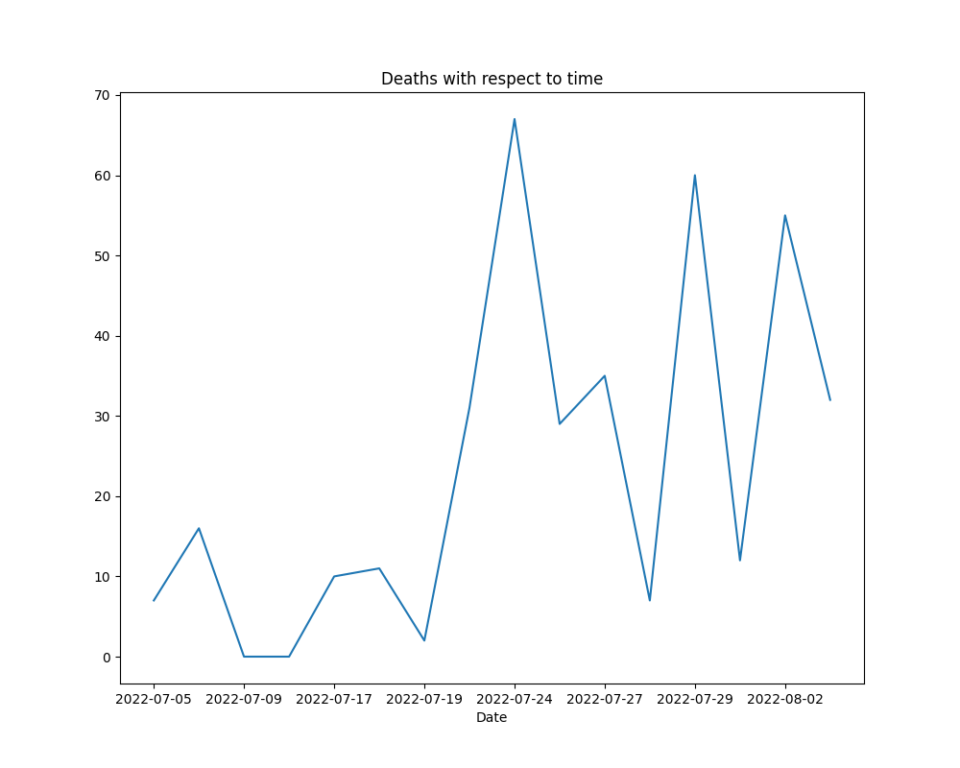

X variable: Dates

Y variable: Number of Deaths

The Line Graph shows number of Deaths for each day

Analysis and reporting:

The plot will show the trend of death over the passing days, whether increasing or decreasing.

As seen in this line graph, there is no fixed trend as death rate fluctuates with respect to time. But an overall increase can be observed.

# Correlation between Deaths and Injuries

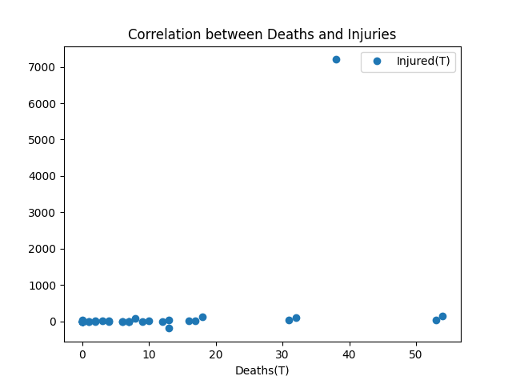

Reporting of Plots:

X variable: Deaths

Y variable: Injuries

The Scatter Plot will plot Deaths and Injuries for a particular day

Analysis and reporting:

The plot will show whether relationship between death and injuries exists or not. (or how strong or weak it is.)

As seen from graph, there seems to be negligible correlation between deaths and injuries

# Province wise Deaths (Male/Female separated)

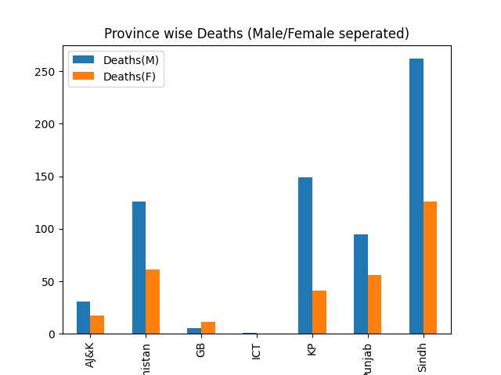

Reporting of Plots:

X variable: Provinces

Y variable: Deaths

The Bar Graph will show Male and Female Deaths for each province

Analysis and reporting:

The plot will not only show deaths with respect to province, but we can also compare deaths of Male and Female for a single province or even other provinces.

except for GB, number of deaths of male is higher than female in all territories. In AJ&K, Balochistan, Punjab and Sindh, death of Males in almost twice that of Female. In KP, approximately 3 times more Males have died as compared to Females.

# Province wise Injuries (Male/Female separated)

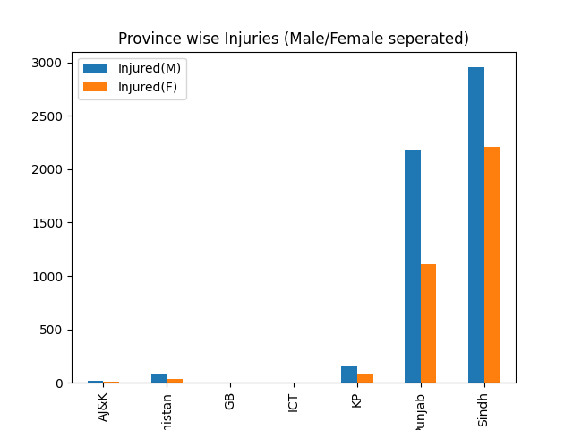

Reporting of Plots:

X variable: Provinces

Y variable: Injuries

The Bar Graph will show Male and Female Injuries for each province

Analysis and reporting:

The plot will not only show injuries with respect to province, but we can also compare deaths of Male and Female for a single province or even other provinces.

The injured people mostly belong to Punjab and Sindh. In both provinces, there are more Males injured as compared to Female. The percentage of Female injured is greater in Sindh as compared to Punjab (the actual number of Female injured in is even greater than Male injured in Punjab)

# Houses Destroyed Province wise

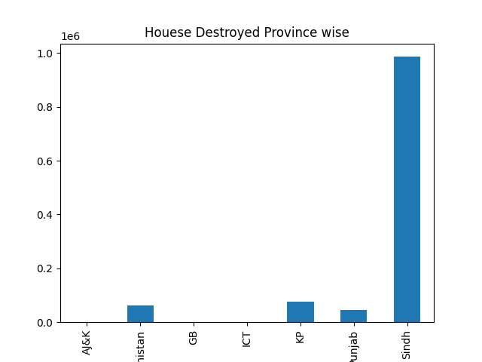

Reporting of Plots:

X variable: Provinces

Y variable: Number of Houses Destroyed

The Bar Graph will show total number of houses destroyed for each province

Analysis and reporting:

The plot will show territories where more houses are destroyed and where there is more settlement issues.

Number of houses destroyed in Sindh is way above as compared to any other territory (around 1 million). Number of houses destroyed in other territories is less than 100,000. Out of these Balochistan, KP and Punjab numbers are significant.

# Number of Houses Destroyed (Fully/Partially) in each Province

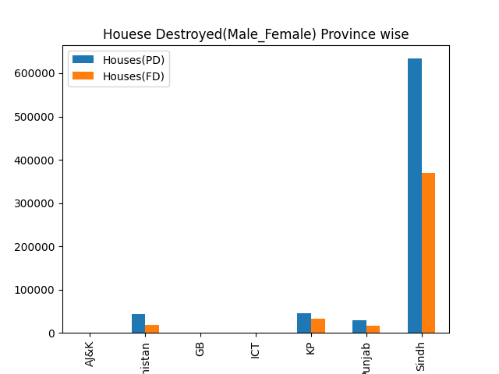

Reporting of Plots:

X variable: Provinces

Y variable: Number of Houses Destroyed

The Bar Graph will show total number of houses destroyed, whether partially or fully, for each province

Analysis and reporting:

The plot will show territories where more houses are destroyed and where there are more settlement issues. Additionally, we can also compare houses that are fully or partially destroyed within a province or even with other provinces.

Number of houses partially destroyed is greater than Number of houses fully destroyed in all cases. In KP, there seems to be less in difference is houses fully destroyed and houses partially destroyed.

# Number of Roads/Shops/Bridges/Livestock destroyed (Province wise)

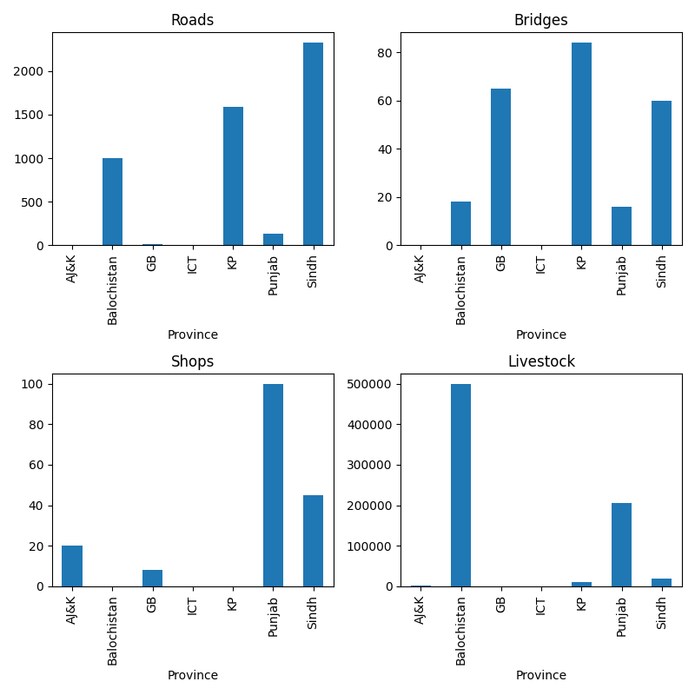

Reporting of Plots:

X variable: Provinces

Y variable: Number of Infrastructure destroyed (Roads/Bridges/Shops/Livestock)

The Bar Graph will show total number specific infrastructure destroyed for each province in each of the 4 cases.

Analysis and reporting:

Which type of infrastructure destroyed is more, varies from province to province. In ICT, no type of infrastructure is destroyed. In GB, mainly Bridges are affected (which are greater than 60 in number) In AJ&K, around 20 shops are destroyed Balochistan, Livestock (500,000), Roads (1000) and Bridges (less than 20) are destroyed. No shops are destroyed. In KP, Bridges (80+) are Roads (2000+) are severely are affected. Sindh and Punjab are only provinces where all types of infrastructure in affected. In Punjab, Shops and livestock are mainly hit. In Sindh, Roads, Bridges and Shops are destroyed in great number. The livestock however, not so much.

# Correlation Matrix for Infrastructure destroyed

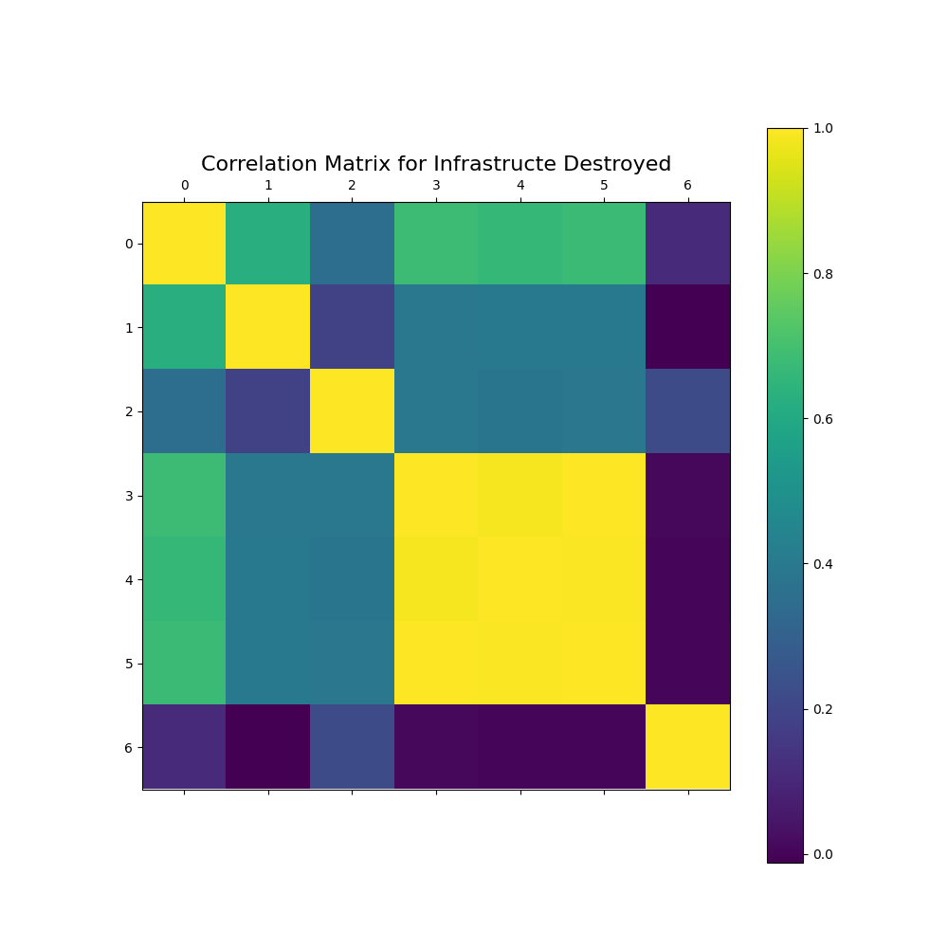

Reporting of Plots:

X variable: Roads, Bridges, Shops, Houses (PD), Houses (FD), Houses (Total), Livestock

Y variable: Roads, Bridges, Shops, Houses (PD), Houses (FD), Houses (Total), Livestock

This Correlation matrix will show all possible correlations between the given attributes.

Analysis and reporting:

The correlation matrix will help us to discover potential correlations between attributes.

There seems to be moderate correlation between Roads destroyed and Bridges or Houses destroyed(partially/fully). Houses Partially and Fully destroyed are also strongly correlated to one another.