Deep Learning Project Proposal

Names:

Hamza Khan (20i-0583)

Huzaifa Ehsan (20i-2651)

Teacher:

Hassan Raza

Table of Contents

Title 3

Explanation 3

Methodology 3

Data Collection and Preparation 3

Model Building 3

Regression model 4

Classification model 4

Model Evaluation 4

Improvement and Iteration 4

Contribution 4

# Title

Predicting Weights using images of Fruit Boxes

# Explanation

Image-Based Weight Estimation involves training a neural network using images of fruit boxes, where each image contains multiple fruits with associated weights in CSV file. The network will learn to extract essential features from these images, such as colors, textures, and spatial arrangements of fruits, through convolutional layers, and associate these features with corresponding fruit weights via fully connected layers. The goal is to create a model capable of accurately predicting the weights of fruits within boxes based solely on the visual information provided by the images.

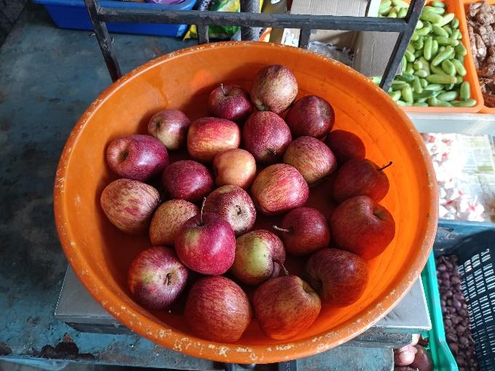

# Methodology

## Data Collection and Preparation

* Dataset Collection: We have taken a dataset from kaggle containing a large amount of images and its corresponding weight are stored in a CSV. (<https://www.kaggle.com/datasets/mirlab/fruitbox>)
* Data Preprocessing:
  + Resize images to a uniform size and normalize pixel values.
* Data Preparation:
  + Divide the dataset into Train, Validation and Test sets.

## Model Building

* Neural Network Architecture: We will design a neural network architecture for classification as well as regression task. We see compare which model performs better. A Convolutional Neural Network (CNN) will also be used for image-related tasks due to its ability to capture spatial features.

### Regression model

The regression model will contain 1 neuron in output layer which will try to predict weights in continuous values.

### Classification model

The classification model will contain more than 1 neuron in the output layer as we will categorize our results into classes. For example, if we have 4 neurons, then each will signify: less than 1 kg, around 1 kg, around 2kg, greater than 2kg. Furthermore, we will also vary the number of neurons in the output layer to see where the model gives optimal results.

* Input and Output Layers: The input layer will be the image data, and the output layer will contain 1 neuron for the regression model and varying number of neurons for the classification model (as mentioned above).
* Training: We will split the dataset into 70% training, 20% validation, and 10% test sets. Train the model using the training set, validate it using the validation set to prevent overfitting, and adjust hyperparameters accordingly.
* Loss Function: MSE los for Regression model and CE Loss for Classification.
* Optimizer: AdamW optimizer.

## Model Evaluation

Evaluation will be done through testing dataset.

## Improvement and Iteration

* Run for more epochs.
* Hyperparameter tuning.
* Change the number of neurons in hidden layers.
* Regularization Techniques: Explore techniques such as dropout, batch normalization, or early release to prevent overfitting.

# Contribution

In recent years, there have been studies and research exploring aspects related to object detection as well as classification. The most common example of this is the YOLO (You Only Look Once) model. However, models targeting fruit weight estimation within boxes using neural networks have not been explored until now.