Deep Learning Project Proposal

Names:

Hamza Khan (20i-0583)

Huzaifa Ehsan

Table of Contents

Title 3

Explanation 3

Methodology 3

Data Collection and Preparation 3

Model Building 3

Regression model 4

Classification model 4

Model Evaluation 4

Improvement and Iteration 4

Contribution 4

# Title

Predicting Weights using images of Fruit Boxes

# Explanation

Image-Based Weight Estimation involves training a neural network using annotated images of fruit boxes, where each image contains multiple fruits with associated weights. The network learns to extract essential features from these images, such as colors, textures, and spatial arrangements of fruits, through convolutional layers, and associates these features with corresponding fruit weights via fully connected layers. The goal is to create a model capable of accurately predicting the weights of fruits within boxes based solely on the visual information provided by the images. Challenges include accounting for variations in lighting, handling diverse fruit types, and ensuring the model's generalization to unseen scenarios, impacting sectors like agriculture and retail for improved inventory management and quality control. Sample image for the dataset which we will be using in our project is shown below:

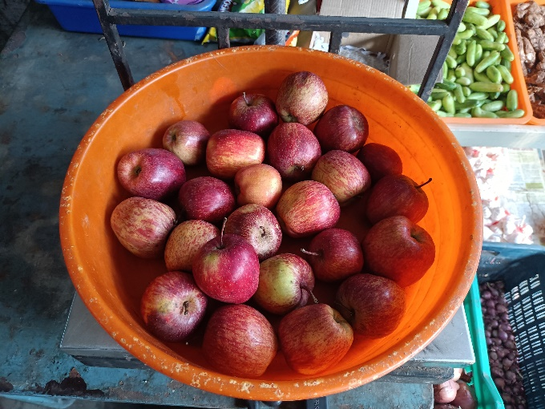

# Methodology

## Data Collection and Preparation

* Dataset Collection: Gather a dataset of fruit box images with corresponding weights. Ensure that the images are labeled correctly with their respective weights.
* Data Preprocessing: Resize images to a uniform size, normalize pixel values, and consider augmentation techniques to increase dataset variability.

## Model Building

* Neural Network Architecture: We will design a neural network architecture for classification as well as regression task. A Convolutional Neural Network (CNN) will also be used for image-related tasks due to its ability to capture spatial features.

### Regression model

The regression model will contain the 1 neuron in output layer which will try to predict weights in continuous values.

### Classification model

The classification model will contain more than 1 neuron in the output layer. For example, if we have 4 neurons, then each will signify: less than 1 kg, 1 kg, 2kg, greater than 2kg. Furthermore, we will also vary the number of neurons in the output layer to see where the model gives optimal results.

* Input and Output Layers: The input layer will be the image data, and the output layer will contain 1 neuron for the regression model and varying number of neurons for the classification model (as mentioned above).
* Training: We will split the dataset into 70% training, 20% validation, and 10% test sets. Train the model using the training set, validate it using the validation set to prevent overfitting, and adjust hyperparameters accordingly.
* Loss Function: MSE loss.
* Optimizer: AdamW optimizer

## Model Evaluation

Evaluation will be done through testing dataset.

## Improvement and Iteration

* Fine-tuning: If the model performance is not satisfactory, consider fine-tuning the architecture, adjusting hyperparameters, or increasing the dataset size.
* Regularization Techniques: Implement techniques like dropout, batch normalization, or early stopping to prevent overfitting and enhance generalization.
* Challenges and Considerations
* Data Quality: Ensure high-quality, labeled data to improve model accuracy.
* Balanced Dataset: Aim for a balanced dataset that represents different fruit types and weights to avoid bias.
* Complexity: The model might struggle if the dataset is small or if the relationships between images and weights are complex.

# Contribution

In recent years, there have been studies and research exploring aspects related to object detection as well as classification. The most common example of this is the YOLO (You Only Look Once) model. However, models targeting fruit weight estimation within boxes using neural networks have not been explored until now.