MEMAAR
Digital Audit Research Evidence Pack
CEO Edition - Organized Proof, Source Trail, and Audit Methodology

RESEARCH FILES  14  DOCX and markdown research outputs reviewed. | VISUAL EVIDENCE  55  Public, mobile analytics, and Search Console images included. | ANALYTICS PDFS  8  Image-only platform PDF reports rendered into evidence pages.
RENDERED PDF PAGES  45  Internal analytics pages embedded in appendix. | VERIFIED SCORE  65/100  Digital readiness score used in the final audit. | EVIDENCE BOUNDARY  No ROI claims  No revenue, CPL, bookings, or sales claims treated as verified.

Field | Details
Prepared for | Memaar CEO / management review
Prepared by | Hamza Khan - digital audit and content system research compilation
Created | June 25, 2026
Workspace | C:\Users\Hamza Khan\Documents\Audit
Purpose | To prove how the audit was researched, what evidence was used, and what was deliberately excluded.

Table of Contents

Note: In Microsoft Word, right-click this area and choose "Update Field" to refresh the table of contents.

CHAPTER 01
CEO Brief: How the Audit Was Built
A clear explanation of the research trail before the raw evidence begins.

CEO Brief: How the Audit Was Built
This evidence pack answers one executive question: if management asks how the Memaar Digital Audit was produced, this document shows the source trail, verification logic, and evidence categories behind it.
PRIMARY EVIDENCE  Analytics + screenshots  Platform PDFs, mobile analytics screens, Search Console, and public profiles were treated as strongest evidence. | SECONDARY EVIDENCE  AI research reports  AI outputs were used for context, repeated themes, and gap discovery, not as final proof by themselves. | EXCLUDED CLAIMS  No unverified outcomes  Ad spend, CPL, WhatsApp lead count, bookings, sales, revenue, and ROI were not confirmed in the supplied evidence.

Executive Answer
- The audit was built by separating primary evidence from secondary research context.
- Primary evidence included internal analytics PDFs, mobile analytics screenshots, Search Console screenshots, and public platform screenshots.
- AI research documents were consolidated to identify repeated strategic concerns such as Linktree routing, YouTube packaging, Pinterest handling, sister-company role clarity, and conversion weakness.
- The final audit uses verified platform numbers and avoids unsupported claims about revenue, ad spend, CPL, leads, bookings, sales, or ROI.
- The resulting recommendation is a controlled monthly content engine, not random posting volume.

Evidence Hierarchy
Level | Evidence type | Reliability | How it was used
A | Internal analytics screenshots/PDFs and Search Console screenshots | Highest | Used for verified numbers and platform diagnosis.
B | Public platform screenshots | High for visible structure, limited for performance | Used for brand ecosystem, profile structure, public channel presence, and sister-company mapping.
C | Research AI outputs and markdown reports | Context only | Used to discover repeated themes, then cross-checked against Level A/B evidence before inclusion.
D | Unconfirmed business outcome claims | Not accepted as verified | Excluded unless supported by ad account, CRM, WhatsApp, sales, or revenue data.

CHAPTER 02
Source Library and File Inventory
Every supplied file is accounted for before platform analysis begins.

Source Library and File Inventory

1st Research - AI Outputs and Markdown Reports
File | Type | Size | Text chars | Detected themes
Gemini Research.docx | DOCX research output | 51.6 KB | 54,104 | Linktree, Website, Facebook, Instagram, TikTok, YouTube, LinkedIn, Pinterest, WhatsApp, Zameen
Grok Research.docx | DOCX research output | 18.6 KB | 9,677 | Linktree, Website, Facebook, Instagram, TikTok, YouTube, LinkedIn, Pinterest, Google Business, WhatsApp
MEMAAR SOCIAL MEDIA AUDIT REPORT.docx | DOCX research output | 48.9 KB | 82,846 | Linktree, Website, Facebook, Instagram, TikTok, YouTube, LinkedIn, Pinterest, Archi Angle, Google Business
MEMAAR Social Media & Content Strategy - Deep Audit.docx | DOCX research output | 31.2 KB | 61,830 | Linktree, Website, Facebook, Instagram, TikTok, YouTube, LinkedIn, Pinterest, Archi Angle, WhatsApp
Memaar_Social_Media_Audit.docx | DOCX research output | 30.1 KB | 35,995 | Linktree, Website, Facebook, Instagram, TikTok, YouTube, LinkedIn, Pinterest, Archi Angle, Google Business
Perplexity Research.docx | DOCX research output | 466.7 KB | 50,963 | Linktree, Website, Facebook, Instagram, TikTok, YouTube, LinkedIn, Pinterest, Google Business, WhatsApp
Research 5.docx | DOCX research output | 30.6 KB | 28,692 | Linktree, Website, Facebook, Instagram, TikTok, YouTube, LinkedIn, Pinterest, Google Business, WhatsApp
Research 4.docx | DOCX research output | 49.3 KB | 50,029 | Linktree, Website, Facebook, Instagram, TikTok, YouTube, LinkedIn, Pinterest, Archi Angle, Google Business
memaar-deep-audit-prompt.md | Markdown research output | 17.3 KB | 17,450 | Linktree, Website, Facebook, Instagram, TikTok, YouTube, LinkedIn, WhatsApp, ad spend, sales
MEMAAR_Audit_Report_Part1.md | Markdown research output | 26.0 KB | 26,590 | Linktree, Website, Facebook, Instagram, TikTok, YouTube, LinkedIn, Pinterest, Archi Angle, Google Business
MEMAAR_Audit_Report_Part2.md | Markdown research output | 47.2 KB | 48,324 | Linktree, Website, Facebook, Instagram, TikTok, YouTube, LinkedIn, Pinterest, WhatsApp, third-party
MEMAAR_Audit_Report_Part3.md | Markdown research output | 34.2 KB | 34,959 | Website, Facebook, Instagram, TikTok, YouTube, LinkedIn, Google Business, WhatsApp, third-party, Zameen
MEMAAR_Audit_Report_Part4.md | Markdown research output | 23.4 KB | 23,938 | Linktree, Website, Facebook, Instagram, TikTok, YouTube, LinkedIn, Pinterest, WhatsApp, third-party
report.md | Markdown research output | 130.8 KB | 133,817 | Linktree, Website, Facebook, Instagram, TikTok, YouTube, LinkedIn, Pinterest, Archi Angle, Google Business

2nd Screenshots and Files - Public Platform Evidence
File | Size | Dimensions | Use
Facebook.png | 574.4 KB | 1920 x 1040 | Public platform / sister-company evidence
Instagram.png | 794.6 KB | 1920 x 1040 | Public platform / sister-company evidence
LinkedIn.png | 227.5 KB | 1920 x 1040 | Public platform / sister-company evidence
Pinterest.png | 1.1 MB | 1920 x 1040 | Public platform / sister-company evidence
Screenshot 2026-06-20 123705.png | 904.5 KB | 1920 x 1040 | Public platform / sister-company evidence
Screenshot 2026-06-20 123712.png | 1.2 MB | 1920 x 1040 | Public platform / sister-company evidence
Screenshot 2026-06-20 123722.png | 744.4 KB | 1920 x 1040 | Public platform / sister-company evidence
Screenshot 2026-06-20 123906.png | 542.2 KB | 1920 x 1040 | Public platform / sister-company evidence
Screenshot 2026-06-20 123913.png | 833.5 KB | 1920 x 1040 | Public platform / sister-company evidence
Screenshot 2026-06-20 123921.png | 267.4 KB | 1920 x 1040 | Public platform / sister-company evidence
Screenshot 2026-06-20 123928.png | 698.8 KB | 1920 x 1040 | Public platform / sister-company evidence
Screenshot 2026-06-20 123953.png | 373.6 KB | 1920 x 1040 | Public platform / sister-company evidence
Screenshot 2026-06-20 124000.png | 160.5 KB | 1920 x 1040 | Public platform / sister-company evidence
Screenshot 2026-06-20 124006.png | 126.9 KB | 1920 x 1040 | Public platform / sister-company evidence
Screenshot 2026-06-20 124012.png | 217.3 KB | 1920 x 1040 | Public platform / sister-company evidence
Screenshot 2026-06-20 124021.png | 129.3 KB | 1920 x 1040 | Public platform / sister-company evidence
Screenshot 2026-06-20 124045.png | 1017.4 KB | 1920 x 1040 | Public platform / sister-company evidence
Screenshot 2026-06-20 124058.png | 544.7 KB | 1920 x 1040 | Public platform / sister-company evidence
Screenshot 2026-06-20 124106.png | 810.2 KB | 1920 x 1040 | Public platform / sister-company evidence
Screenshot 2026-06-20 124112.png | 1.0 MB | 1920 x 1040 | Public platform / sister-company evidence
Screenshot 2026-06-20 124120.png | 501.9 KB | 1920 x 1040 | Public platform / sister-company evidence
Screenshot 2026-06-20 124126.png | 353.8 KB | 1920 x 1040 | Public platform / sister-company evidence
Screenshot 2026-06-20 124146.png | 288.2 KB | 1920 x 1040 | Public platform / sister-company evidence
Screenshot 2026-06-20 124154.png | 923.1 KB | 1920 x 1040 | Public platform / sister-company evidence
Screenshot 2026-06-20 124202.png | 522.4 KB | 1920 x 1040 | Public platform / sister-company evidence
Screenshot 2026-06-20 124209.png | 261.4 KB | 1920 x 1040 | Public platform / sister-company evidence
Screenshot 2026-06-20 124215.png | 942.4 KB | 1920 x 1040 | Public platform / sister-company evidence
Screenshot 2026-06-20 124235.png | 602.0 KB | 1920 x 1040 | Public platform / sister-company evidence
Screenshot 2026-06-20 124241.png | 737.2 KB | 1920 x 1040 | Public platform / sister-company evidence
Screenshot 2026-06-20 124247.png | 237.2 KB | 1920 x 1040 | Public platform / sister-company evidence
Screenshot 2026-06-20 124255.png | 1.2 MB | 1920 x 1040 | Public platform / sister-company evidence
Screenshot 2026-06-20 124302.png | 652.7 KB | 1920 x 1040 | Public platform / sister-company evidence
Screenshot 2026-06-20 124309.png | 821.8 KB | 1920 x 1040 | Public platform / sister-company evidence
Screenshot 2026-06-20 124336.png | 622.5 KB | 1920 x 1040 | Public platform / sister-company evidence
Screenshot 2026-06-20 124343.png | 500.8 KB | 1920 x 1040 | Public platform / sister-company evidence
Screenshot 2026-06-20 124356.png | 1.2 MB | 1920 x 1040 | Public platform / sister-company evidence
Screenshot 2026-06-20 124405.png | 736.8 KB | 1920 x 1040 | Public platform / sister-company evidence
Screenshot 2026-06-20 124412.png | 267.0 KB | 1920 x 1040 | Public platform / sister-company evidence
Screenshot 2026-06-20 124419.png | 764.2 KB | 1920 x 1040 | Public platform / sister-company evidence
Screenshot 2026-06-20 124439.png | 501.3 KB | 1920 x 1040 | Public platform / sister-company evidence
Screenshot 2026-06-20 124445.png | 1.0 MB | 1920 x 1040 | Public platform / sister-company evidence
Screenshot 2026-06-20 124453.png | 1.1 MB | 1920 x 1040 | Public platform / sister-company evidence
Screenshot 2026-06-20 124500.png | 326.4 KB | 1920 x 1040 | Public platform / sister-company evidence
Screenshot 2026-06-20 124508.png | 1.1 MB | 1920 x 1040 | Public platform / sister-company evidence
Screenshot 2026-06-20 124523.png | 547.7 KB | 1920 x 1040 | Public platform / sister-company evidence
TikTok.png | 1.3 MB | 1920 x 1040 | Public platform / sister-company evidence
YouTube.png | 760.1 KB | 1920 x 1040 | Public platform / sister-company evidence

3rd MD Files - Internal Analytics and Mobile Evidence
File | Type | Size | Use
FB Memaar Developments.pdf | PDF | 417.2 KB | Analytics PDF
FB Memaar Group.pdf | PDF | 369.5 KB | Analytics PDF
Insta Memaar Developments.pdf | PDF | 430.3 KB | Analytics PDF
Insta Memaar Group.pdf | PDF | 144.9 KB | Analytics PDF
LinkedIn Memaar Developments.pdf | PDF | 370.7 KB | Analytics PDF
LinkedIn Memaar Group.pdf | PDF | 108.9 KB | Analytics PDF
WhatsApp Image 2026-06-23 at 3.47.59 PM (1).jpeg | JPEG | 63.7 KB | Mobile/Search screenshot
WhatsApp Image 2026-06-23 at 3.47.59 PM.jpeg | JPEG | 70.5 KB | Mobile/Search screenshot
WhatsApp Image 2026-06-23 at 3.48.22 PM.jpeg | JPEG | 52.6 KB | Mobile/Search screenshot
WhatsApp Image 2026-06-23 at 3.48.23 PM (1).jpeg | JPEG | 47.6 KB | Mobile/Search screenshot
WhatsApp Image 2026-06-23 at 3.48.23 PM (2).jpeg | JPEG | 42.7 KB | Mobile/Search screenshot
WhatsApp Image 2026-06-23 at 3.48.23 PM.jpeg | JPEG | 43.6 KB | Mobile/Search screenshot
WhatsApp Image 2026-06-23 at 3.49.19 PM (1).jpeg | JPEG | 121.2 KB | Mobile/Search screenshot
WhatsApp Image 2026-06-23 at 3.49.19 PM.jpeg | JPEG | 127.2 KB | Mobile/Search screenshot
YT Memaar Developments.pdf | PDF | 279.6 KB | Analytics PDF
YT Memaar Group.pdf | PDF | 292.6 KB | Analytics PDF

CHAPTER 03
Verified Analytics Factbook
A platform-by-platform summary of the numbers that were safe to use in the audit.

Verified Analytics Factbook
This section separates verified platform data from interpretation so the audit can be defended without relying on inflated or unsupported claims.
Company | Platform | Verified / observed evidence | Source | Audit meaning
Memaar Developments | Facebook | 4.1M views; 1.6M viewers; 31K engagement; 4.9K reactions; 454 comments/replies; 266 shares; around 98% non-follower views; -357 net audience change | FB Memaar Developments.pdf | Strongest verified reach engine. Needs action routing and tracking.
Memaar Developments | Instagram | 10,266 followers; 24,972 views; 7,054 reach; 747 interactions; 476 profile visits; 8 external link taps; -67 net follower change; separate 28-day dashboard shows 1.9M views and 11,436 engagement | Insta Memaar Developments.pdf | Good visual channel, but weak link-tap conversion and metric-definition conflict.
Memaar Developments | TikTok | 68.5K viewers; 42.8K new viewers; 254 total followers; 249 net followers; 91.5K post views; 1.3K profile views; 4.9K likes; 414 comments; 148 shares | Files From MD mobile analytics screenshots | Visibility exists, but follower conversion and inquiry routing need improvement.
Memaar Developments | YouTube | 396.5K all-time views; 301 subscribers; 2.6K likes; 65 comments; 595 shares; 498 recent 7-day views; Pakistan 72% | YT Memaar Developments.pdf | Historical trust value; weak recent momentum and subscriber conversion.
Memaar Developments | LinkedIn | 1,569 impressions; 6.7% engagement rate; 53 reactions; 0 comments; 0 reposts; 1,094 followers; 126 search appearances; 0 custom button clicks | Linkdin Memaar Developments.pdf | Engagement quality is strong; action path is weak.
Website/Search | Google Search Console | 550 clicks; 10.3K impressions; 5.4% CTR; average position 7 | Files From MD Search Console screenshots | Search base exists; project pages and SEO blogs need stronger buyer intent.
Memaar Group | Facebook | 924 views; 547 viewers; 37 engagement; views down 77%; engagement down 87% | FB Memaar Group.pdf | Support channel, not a buyer-acquisition engine.
Memaar Group | Instagram | 3,550 views; 806 reach; 187 interactions; 101 profile visits; 0 external link taps; 94 followers; reach down 72.1%; profile activity down 55.8% | Insta Memaar Group.pdf | Corporate visual layer only; weak action.
Memaar Group | TikTok | 209.6K post views; 2.4K profile views; 171.1K total viewers; 123.6K new viewers; 760 total followers; 424 net followers; 4.8K likes; 233 comments; 1.4K shares | Files From MD mobile analytics screenshots | Strong awareness signal; must be kept role-specific.
Memaar Group | YouTube | 130 subscribers; 68.9K all-time views; 735 likes; 65 comments; 193 shares; 151 recent 7-day views; India 39%, Pakistan 33% | YT Memaar Group.pdf | Audience mismatch risk for buyer-focused project videos.
Memaar Group | LinkedIn | 112 impressions; 2.7% engagement rate; 223 followers; 0 posts in 30 days; 84 search appearances | Linkdin Memaar Group.pdf | Dormant corporate reputation page.
Sister/Partner Channels | Archi Angle | Public presence observed; no internal analytics supplied | Public screenshots and research outputs | Strategic data gap. Request TikTok, Instagram, and Facebook analytics before deciding role.
Sister/Partner Channels | Pinterest | Public presence observed; no internal analytics supplied | Pintrest.png and public screenshots | Use only as controlled visual/design support, not a priority inquiry path.

Core Conversion Benchmarks Used
Benchmark | Calculation | Interpretation
Instagram link tap rate | 8 taps / 476 visits = 1.7% | Weak profile-to-action movement.
TikTok Developments follower conversion | 254 / 68,500 = 0.37% | Weak follower capture from viewers.
YouTube Developments subscriber conversion | 301 / 396,500 = 0.076% | Weak subscriber capture from historical views.
Website CTR | 5.4% CTR / average position 7 | Useful base, can improve with better titles/pages/blog depth.
LinkedIn Developments action | 6.7% ER / 0 button clicks | Strong engagement quality but weak business action.
Facebook view-to-engagement | 31K / 4.1M = 0.76% | Slightly weak for such large reach.

CHAPTER 04
Platform-by-Platform Research Notes
Short, structured notes explaining how the verified evidence shaped the audit.

Platform-by-Platform Research Notes

Memaar Developments - Facebook
Field | Detail
Evidence | 4.1M views; 1.6M viewers; 31K engagement; 4.9K reactions; 454 comments/replies; 266 shares; around 98% non-follower views; -357 net audience change
Source | FB Memaar Developments.pdf
Audit meaning | Strongest verified reach engine. Needs action routing and tracking.
Recommended handling | Use this channel according to its verified role. Do not overstate outcomes beyond the supplied evidence.

Memaar Developments - Instagram
Field | Detail
Evidence | 10,266 followers; 24,972 views; 7,054 reach; 747 interactions; 476 profile visits; 8 external link taps; -67 net follower change; separate 28-day dashboard shows 1.9M views and 11,436 engagement
Source | Insta Memaar Developments.pdf
Audit meaning | Good visual channel, but weak link-tap conversion and metric-definition conflict.
Recommended handling | Use this channel according to its verified role. Do not overstate outcomes beyond the supplied evidence.

Memaar Developments - TikTok
Field | Detail
Evidence | 68.5K viewers; 42.8K new viewers; 254 total followers; 249 net followers; 91.5K post views; 1.3K profile views; 4.9K likes; 414 comments; 148 shares
Source | Files From MD mobile analytics screenshots
Audit meaning | Visibility exists, but follower conversion and inquiry routing need improvement.
Recommended handling | Use this channel according to its verified role. Do not overstate outcomes beyond the supplied evidence.

Memaar Developments - YouTube
Field | Detail
Evidence | 396.5K all-time views; 301 subscribers; 2.6K likes; 65 comments; 595 shares; 498 recent 7-day views; Pakistan 72%
Source | YT Memaar Developments.pdf
Audit meaning | Historical trust value; weak recent momentum and subscriber conversion.
Recommended handling | Use this channel according to its verified role. Do not overstate outcomes beyond the supplied evidence.

Memaar Developments - LinkedIn
Field | Detail
Evidence | 1,569 impressions; 6.7% engagement rate; 53 reactions; 0 comments; 0 reposts; 1,094 followers; 126 search appearances; 0 custom button clicks
Source | Linkdin Memaar Developments.pdf
Audit meaning | Engagement quality is strong; action path is weak.
Recommended handling | Use this channel according to its verified role. Do not overstate outcomes beyond the supplied evidence.

Website/Search - Google Search Console
Field | Detail
Evidence | 550 clicks; 10.3K impressions; 5.4% CTR; average position 7
Source | Files From MD Search Console screenshots
Audit meaning | Search base exists; project pages and SEO blogs need stronger buyer intent.
Recommended handling | Use this channel according to its verified role. Do not overstate outcomes beyond the supplied evidence.

Memaar Group - Facebook
Field | Detail
Evidence | 924 views; 547 viewers; 37 engagement; views down 77%; engagement down 87%
Source | FB Memaar Group.pdf
Audit meaning | Support channel, not a buyer-acquisition engine.
Recommended handling | Use this channel according to its verified role. Do not overstate outcomes beyond the supplied evidence.

Memaar Group - Instagram
Field | Detail
Evidence | 3,550 views; 806 reach; 187 interactions; 101 profile visits; 0 external link taps; 94 followers; reach down 72.1%; profile activity down 55.8%
Source | Insta Memaar Group.pdf
Audit meaning | Corporate visual layer only; weak action.
Recommended handling | Use this channel according to its verified role. Do not overstate outcomes beyond the supplied evidence.

Memaar Group - TikTok
Field | Detail
Evidence | 209.6K post views; 2.4K profile views; 171.1K total viewers; 123.6K new viewers; 760 total followers; 424 net followers; 4.8K likes; 233 comments; 1.4K shares
Source | Files From MD mobile analytics screenshots
Audit meaning | Strong awareness signal; must be kept role-specific.
Recommended handling | Use this channel according to its verified role. Do not overstate outcomes beyond the supplied evidence.

Memaar Group - YouTube
Field | Detail
Evidence | 130 subscribers; 68.9K all-time views; 735 likes; 65 comments; 193 shares; 151 recent 7-day views; India 39%, Pakistan 33%
Source | YT Memaar Group.pdf
Audit meaning | Audience mismatch risk for buyer-focused project videos.
Recommended handling | Use this channel according to its verified role. Do not overstate outcomes beyond the supplied evidence.

Memaar Group - LinkedIn
Field | Detail
Evidence | 112 impressions; 2.7% engagement rate; 223 followers; 0 posts in 30 days; 84 search appearances
Source | Linkdin Memaar Group.pdf
Audit meaning | Dormant corporate reputation page.
Recommended handling | Use this channel according to its verified role. Do not overstate outcomes beyond the supplied evidence.

Sister/Partner Channels - Archi Angle
Field | Detail
Evidence | Public presence observed; no internal analytics supplied
Source | Public screenshots and research outputs
Audit meaning | Strategic data gap. Request TikTok, Instagram, and Facebook analytics before deciding role.
Recommended handling | Use this channel according to its verified role. Do not overstate outcomes beyond the supplied evidence.

Sister/Partner Channels - Pinterest
Field | Detail
Evidence | Public presence observed; no internal analytics supplied
Source | Pintrest.png and public screenshots
Audit meaning | Use only as controlled visual/design support, not a priority inquiry path.
Recommended handling | Use this channel according to its verified role. Do not overstate outcomes beyond the supplied evidence.

CHAPTER 05
Research Synthesis and Audit Decisions
The bridge between evidence and the final audit recommendation.

Research Synthesis and Audit Decisions
Decision | Evidence basis | Audit outcome
Reach is not the main problem | Facebook Developments, TikTok Group, YouTube historical views, and Search Console all show visibility exists. | The audit recommends a controlled monthly content engine, not random content volume.
Conversion architecture is the weakness | Instagram link taps, LinkedIn button clicks, unclear routing, and missing source/lead data show weak action capture. | The audit focuses on CTAs, Linktree/WhatsApp routing, project pages, profile cleanup, and measurable inquiry paths.
Developments should carry buyer acquisition | Developments has stronger buyer-facing evidence and cleaner YouTube geography than Group. | Future buyer-focused project videos and project proof should route primarily through Developments.
Group should protect corporate reputation | Group platforms mostly show lower reach or weaker action, except TikTok Group awareness. | Use Group selectively for leadership, team, culture, community, and corporate credibility.
Sister companies are support channels | Public screenshots show ecosystem breadth, but internal analytics are missing for most sister channels. | Use only when they support buyer education, design proof, construction proof, or credibility.
Archi Angle needs data before decisions | Design/architecture can support trust, but no analytics were supplied. | Request Archi Angle TikTok, Instagram, and Facebook analytics before assigning a monthly role.
Pinterest should be controlled, not prioritized | Public presence exists but no analytics were supplied. | Use for project renders, interiors, architecture boards, and design proof only if the destination is professional.
Unsupported business claims excluded | No confirmed ad spend, CPL, WhatsApp leads, qualified leads, bookings, sales, revenue, or ROI data supplied. | The audit avoids all unsupported business outcome claims.

CHAPTER 06
Primary Visual Evidence - Internal Analytics
Rendered pages from image-only PDFs and mobile analytics screenshots.

Primary Visual Evidence - Internal Analytics
These are the strongest proof sources because they contain platform analytics or Search Console data. The PDFs were image-only, so they were rendered into pages and embedded here.

FB Memaar Developments.pdf
Rendered from the supplied analytics PDF. Used for verified platform numbers where visible.
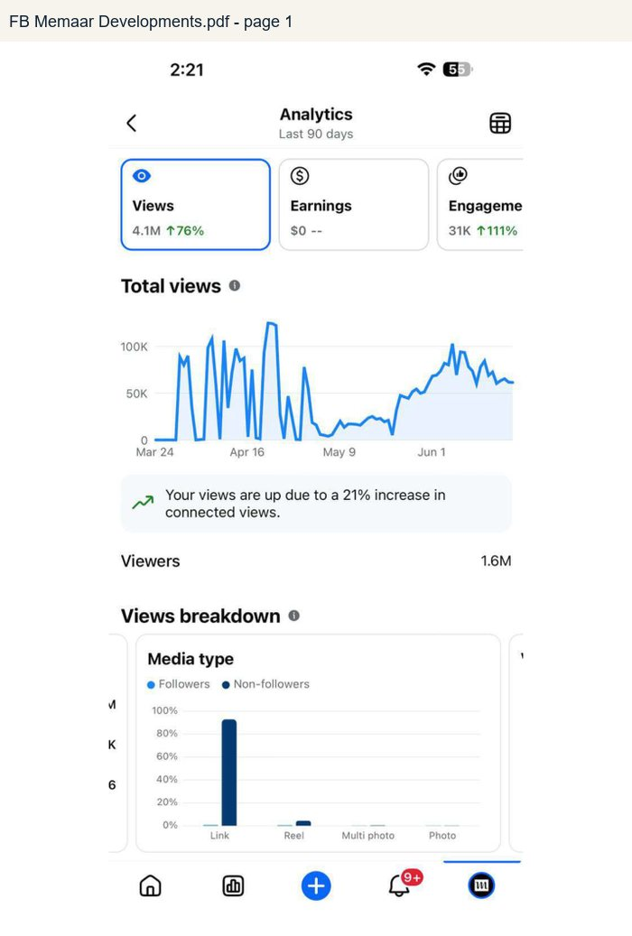 | 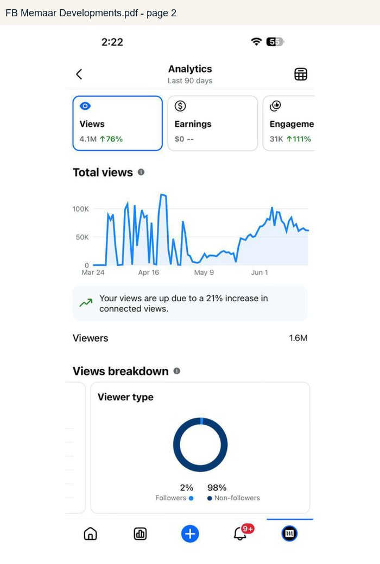
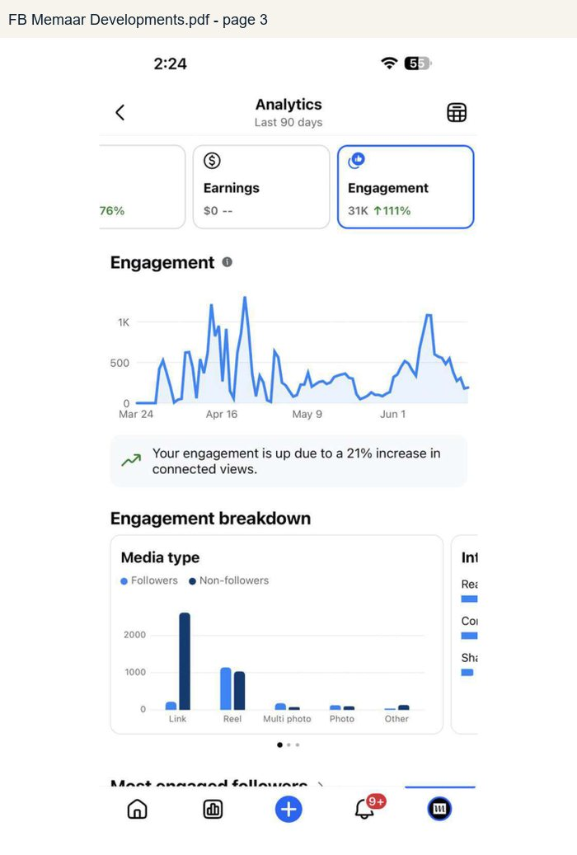 | 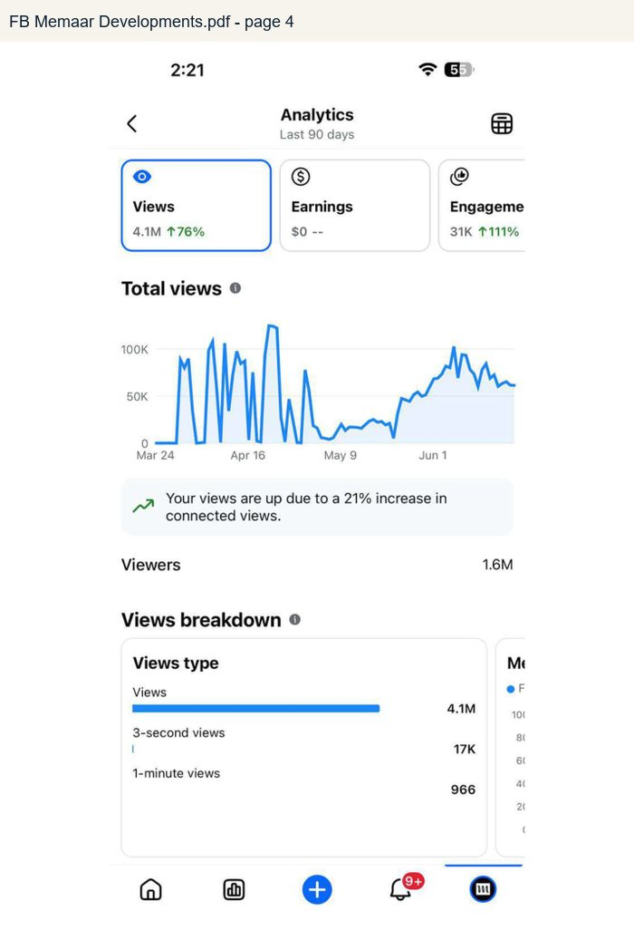
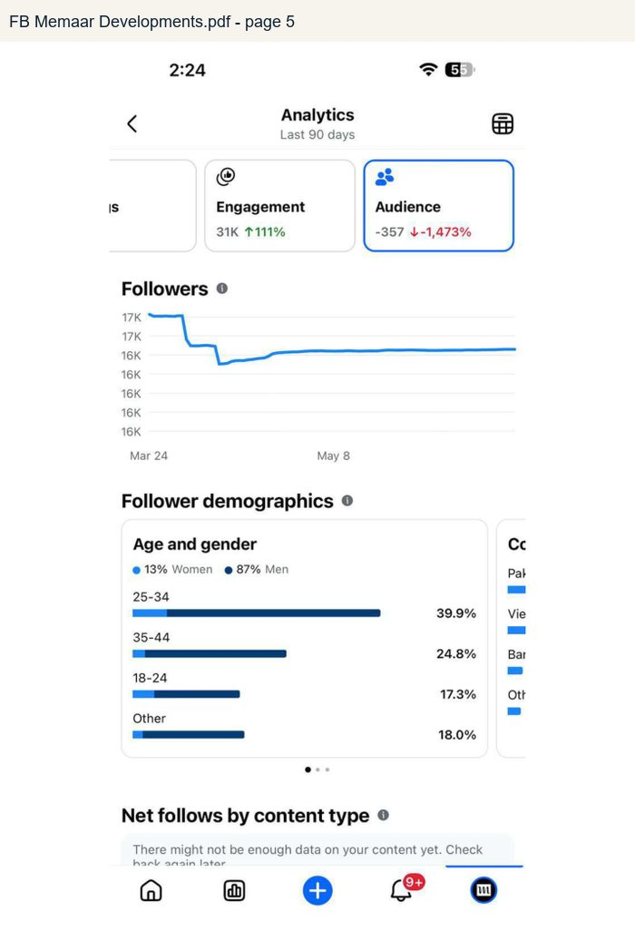 | 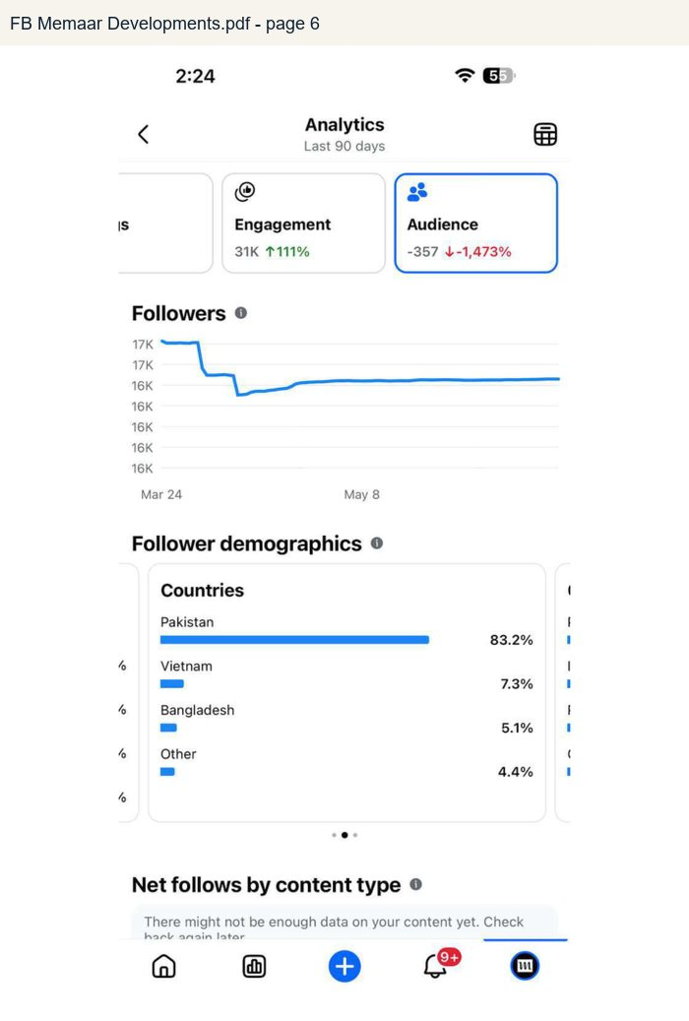
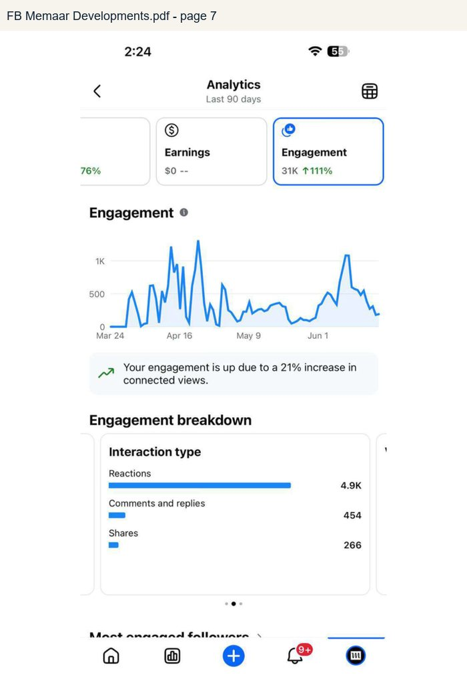 | 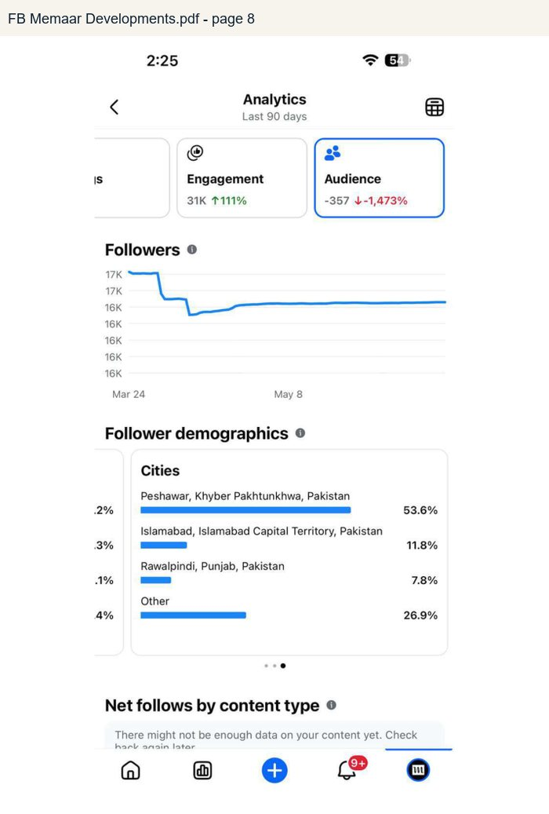

FB Memaar Group.pdf
Rendered from the supplied analytics PDF. Used for verified platform numbers where visible.
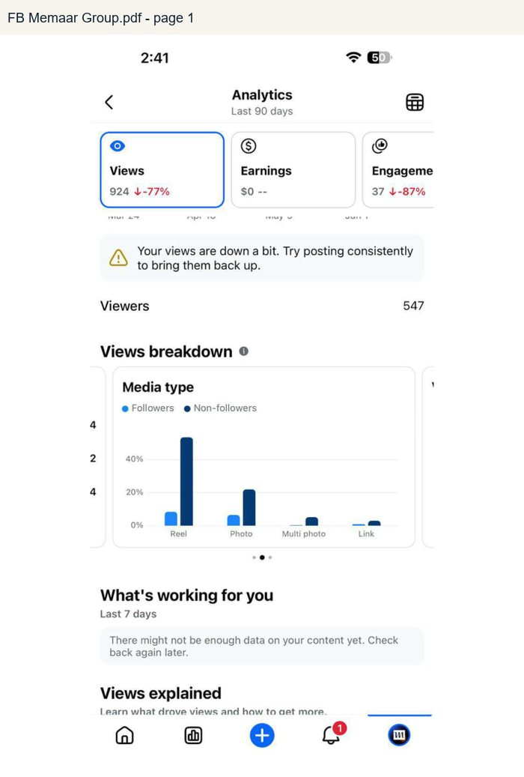 | 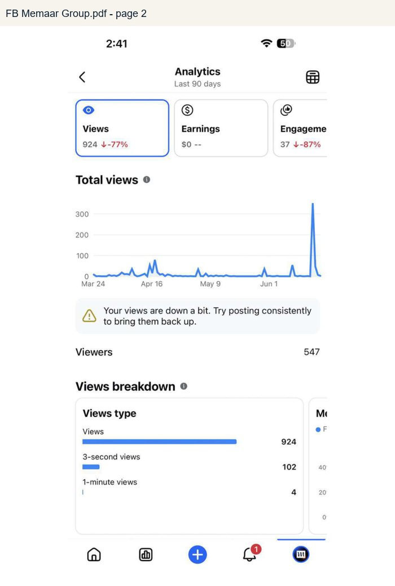
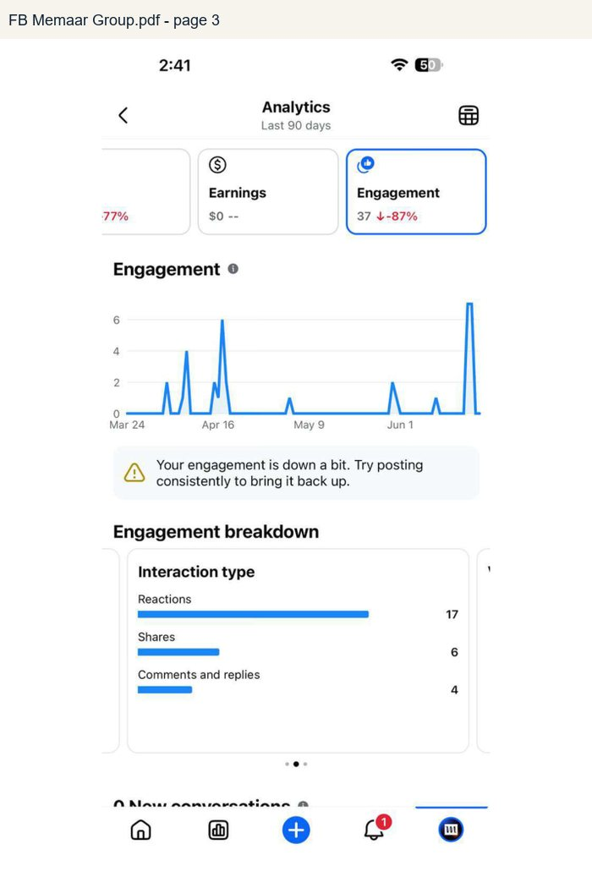 | 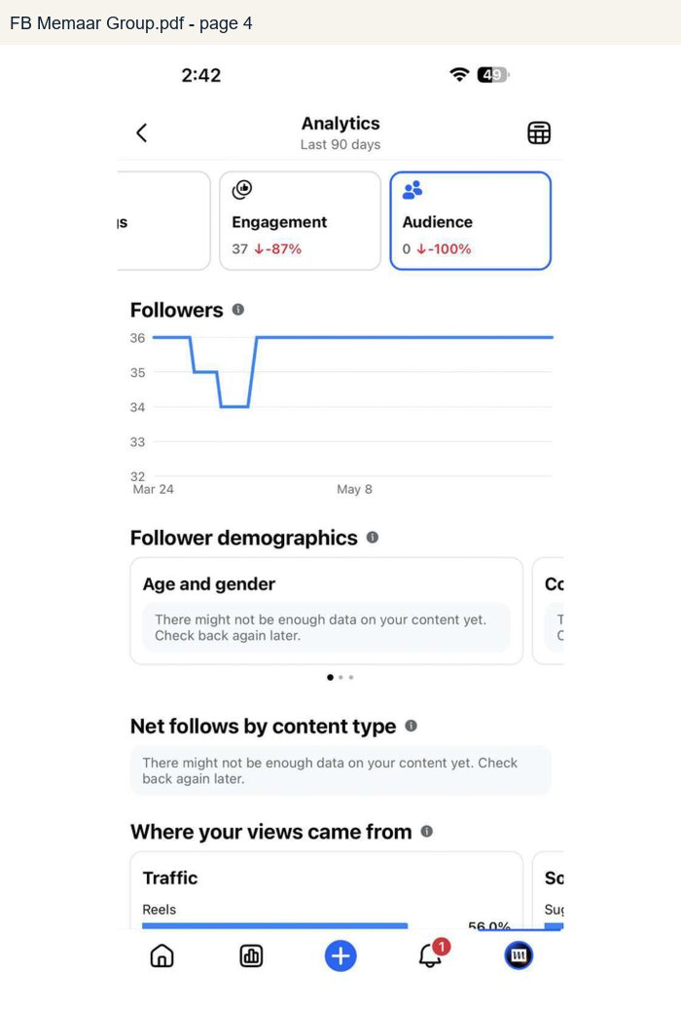
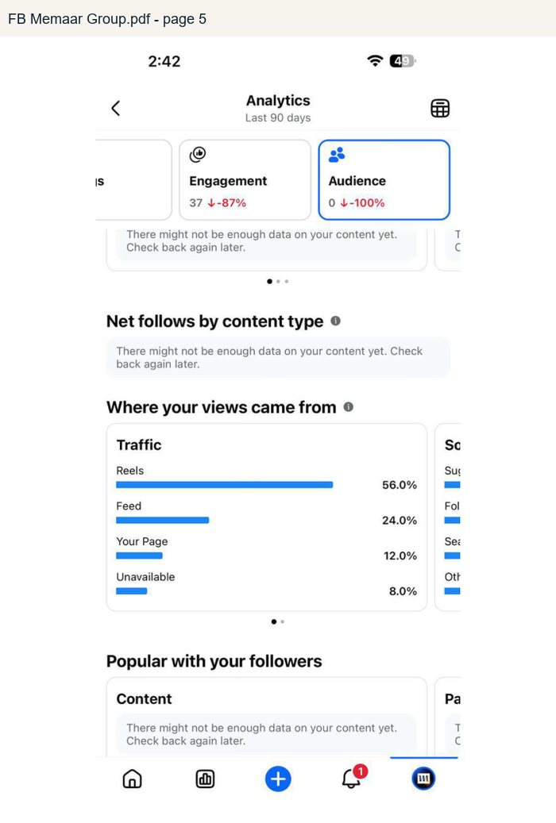 | 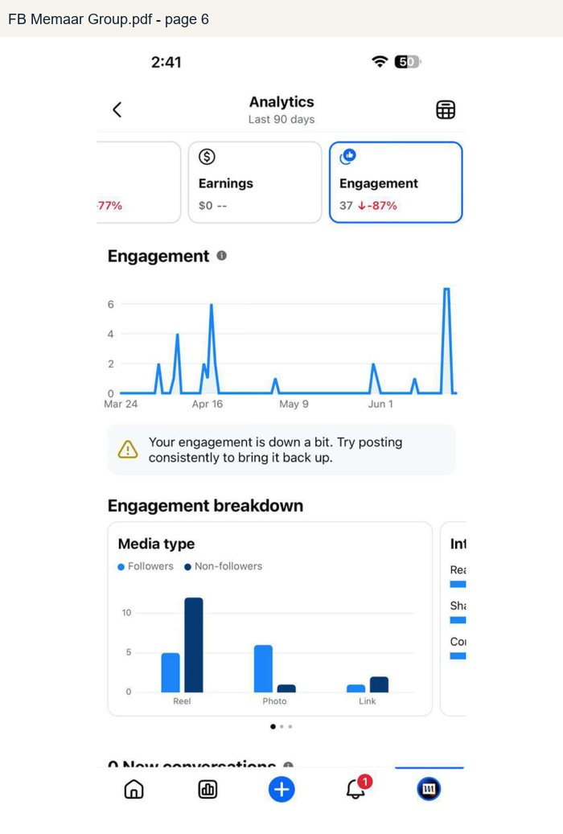
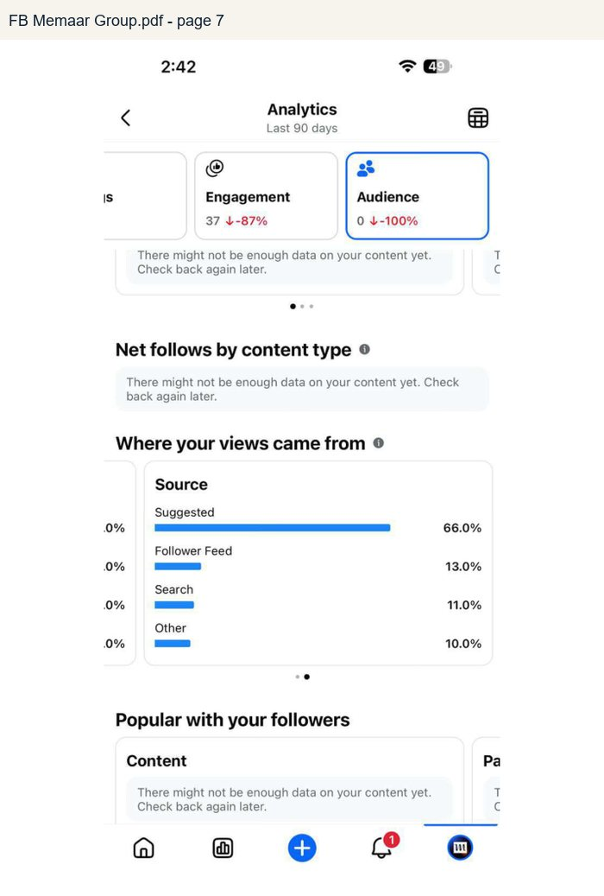

Insta Memaar Developments.pdf
Rendered from the supplied analytics PDF. Used for verified platform numbers where visible.
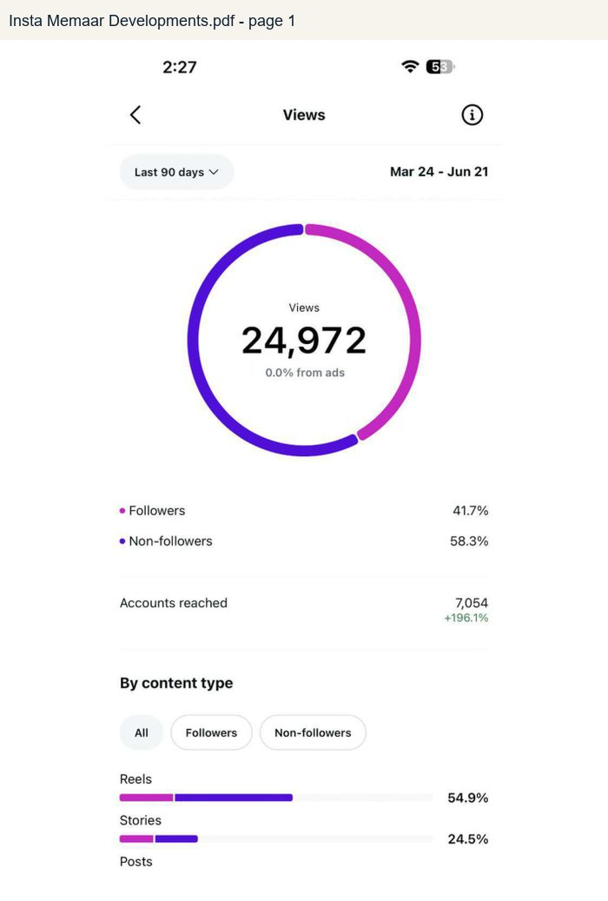 | 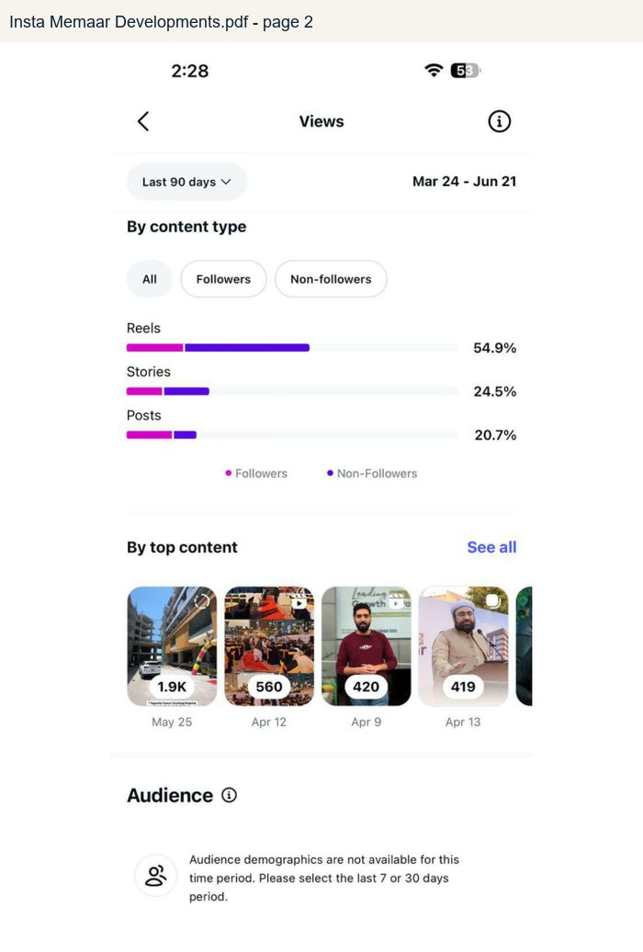
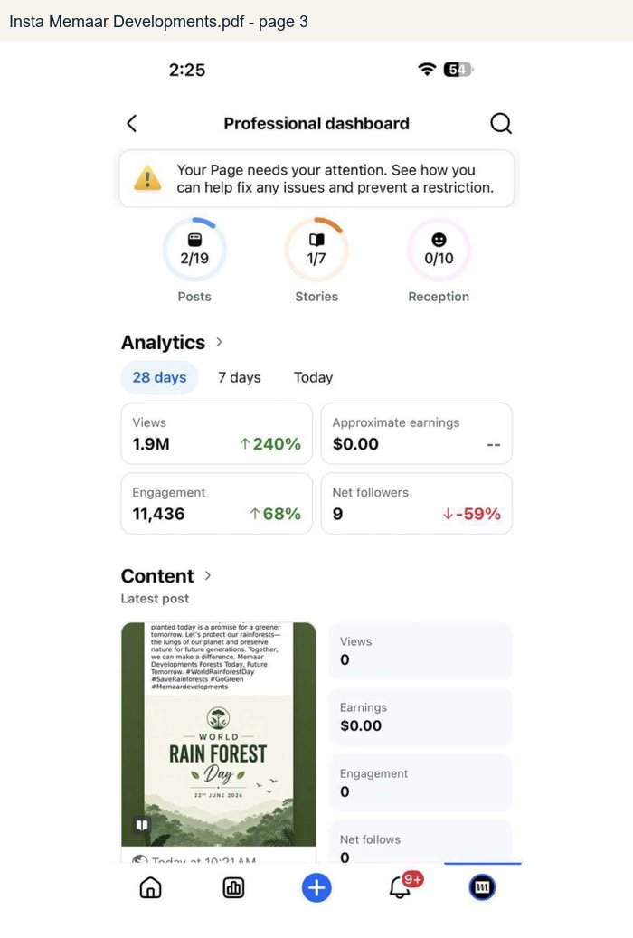 | 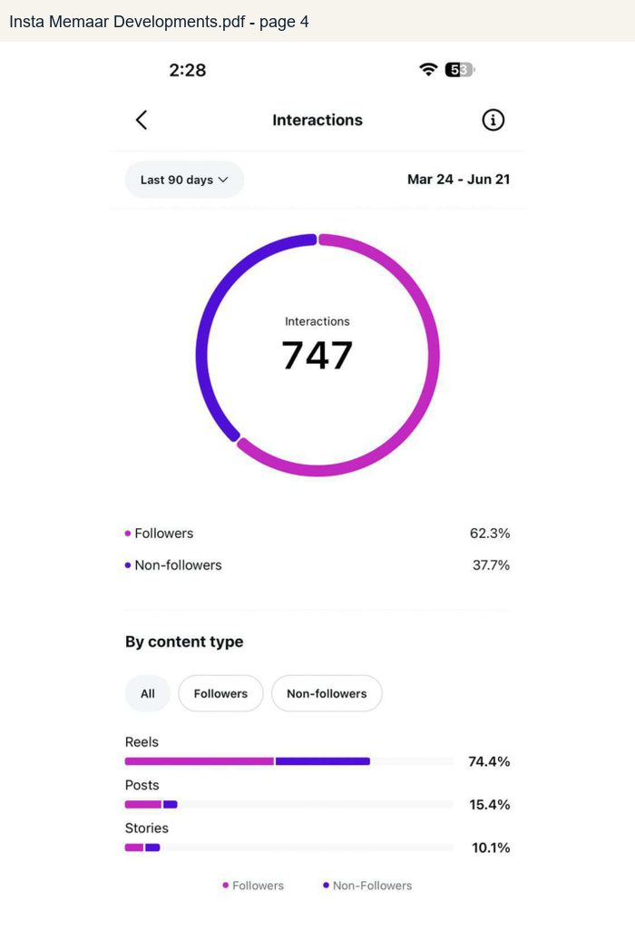
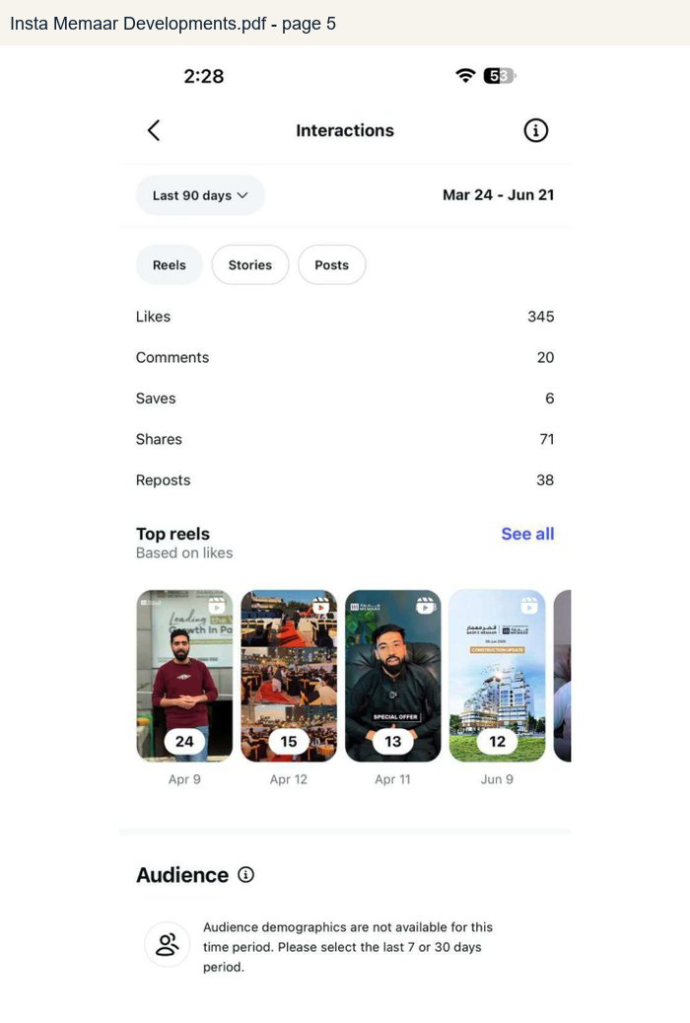 | 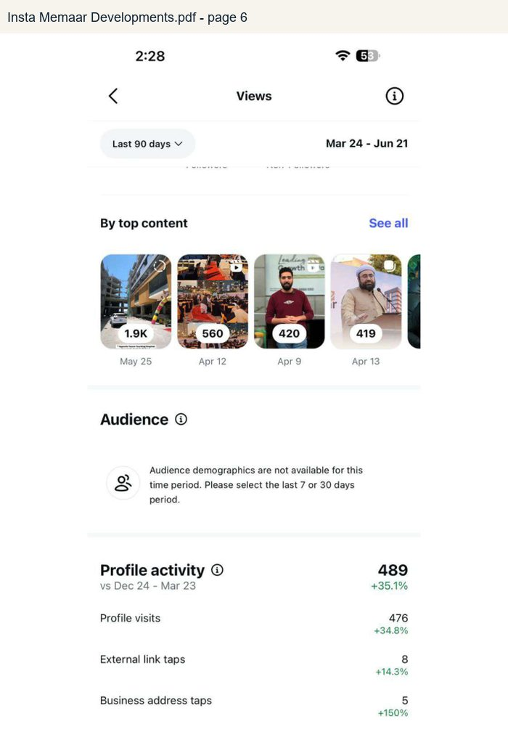
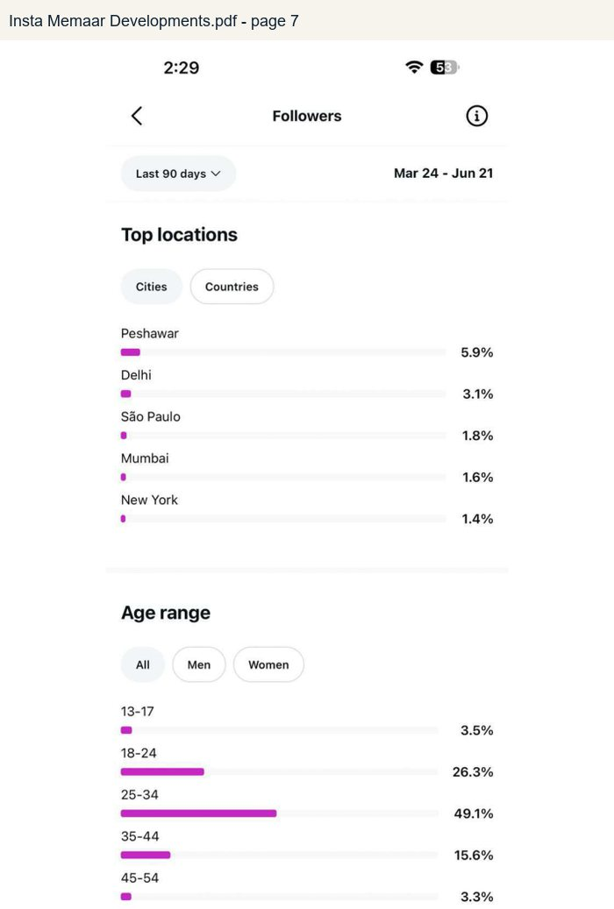 | 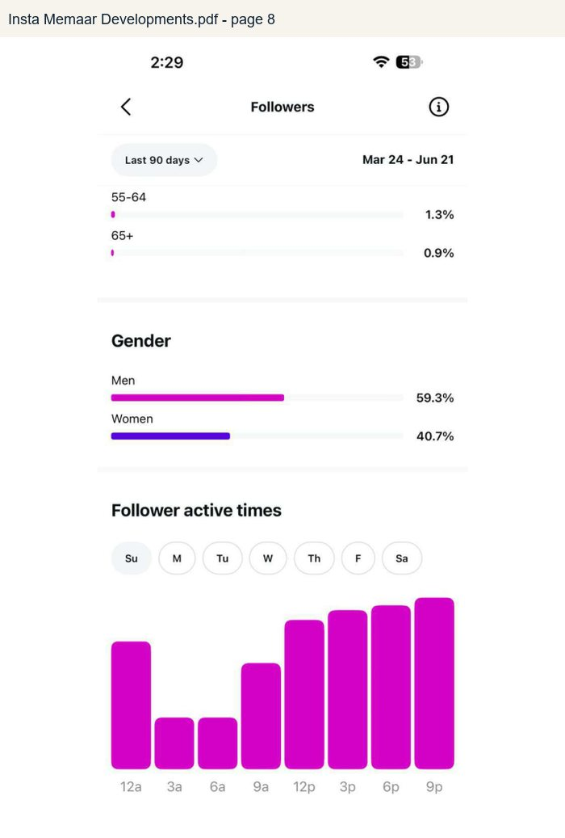
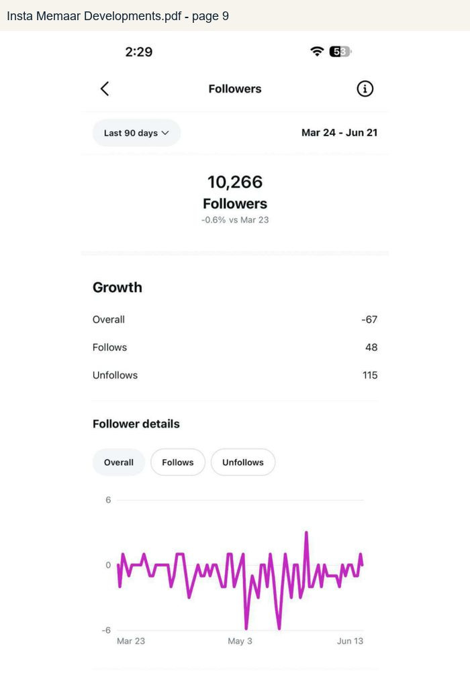

Insta Memaar Group.pdf
Rendered from the supplied analytics PDF. Used for verified platform numbers where visible.
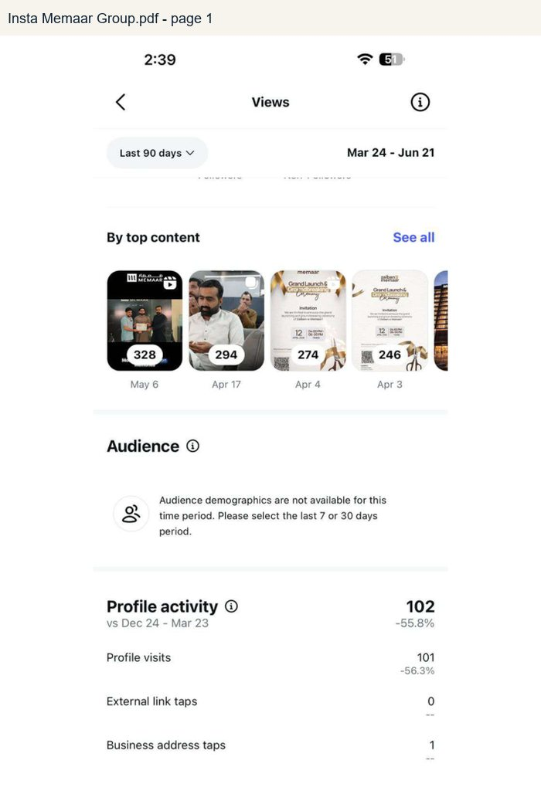 | 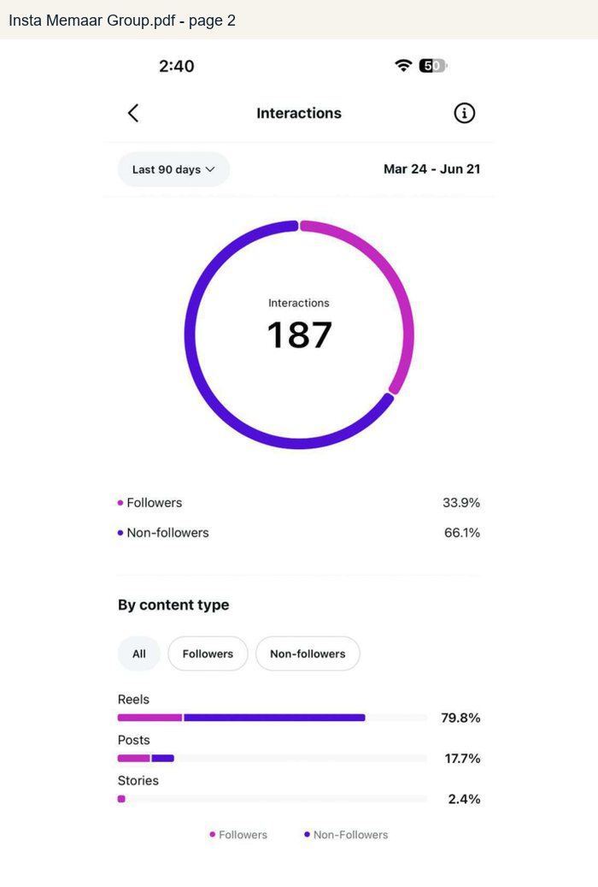
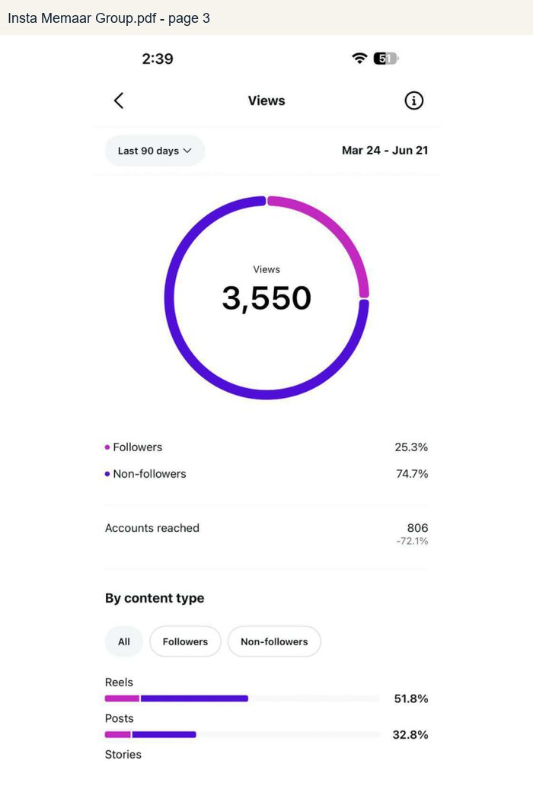 | 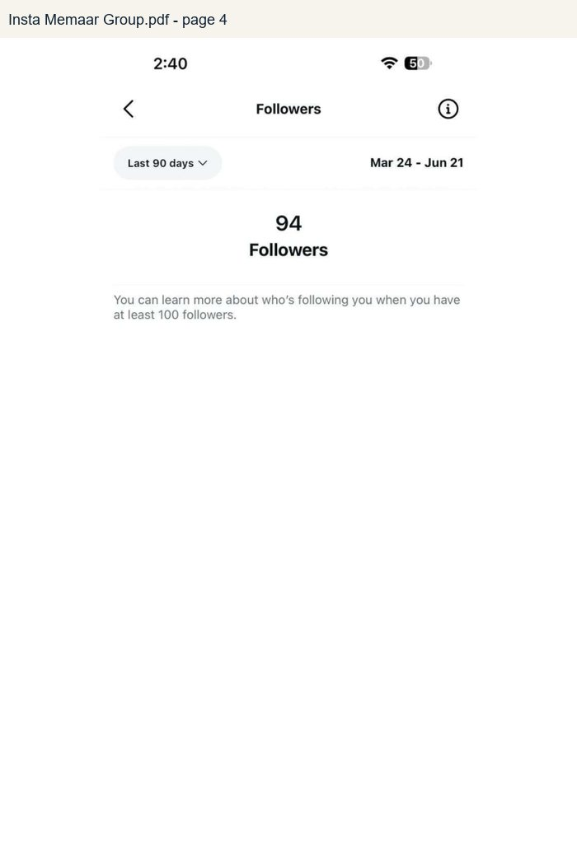

LinkedIn Memaar Developments.pdf
Rendered from the supplied analytics PDF. Used for verified platform numbers where visible.
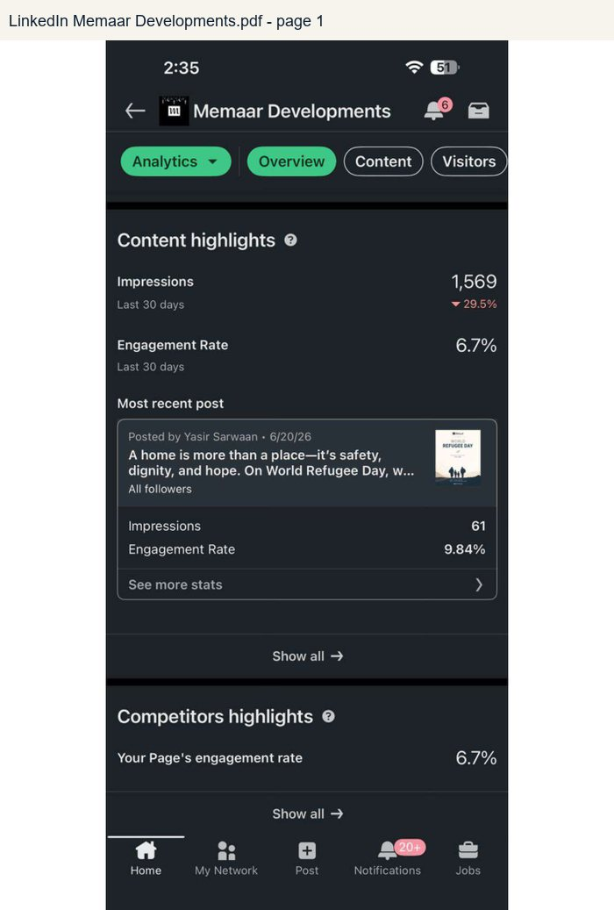 | 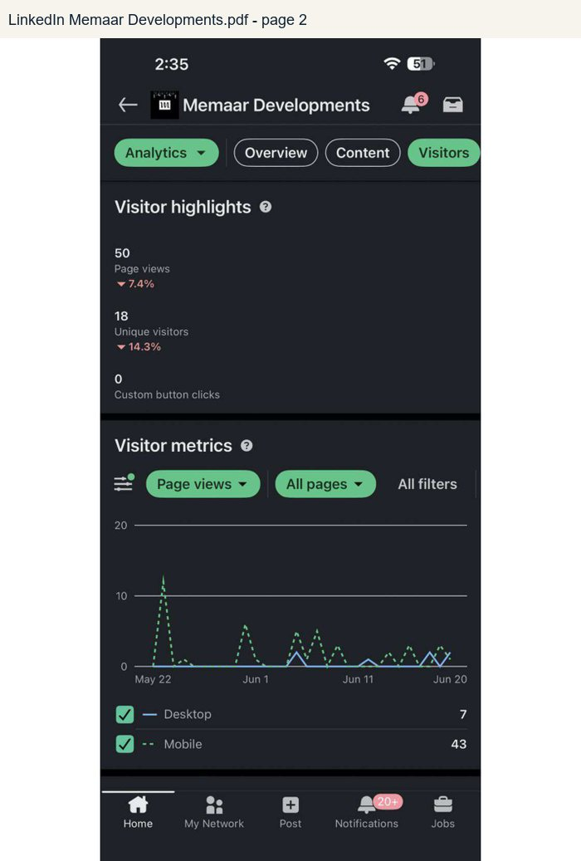
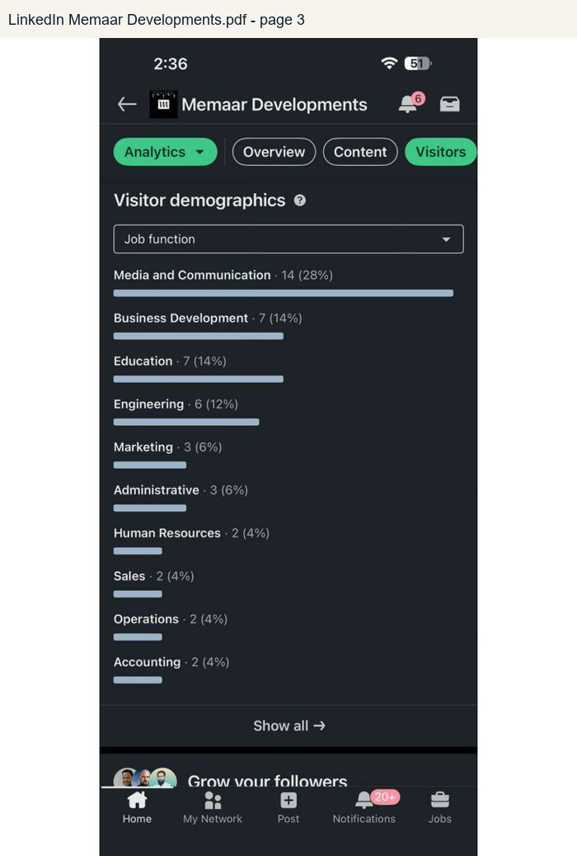 | 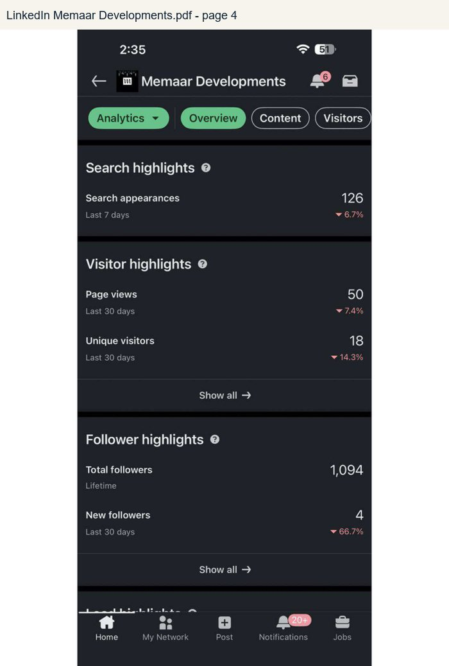
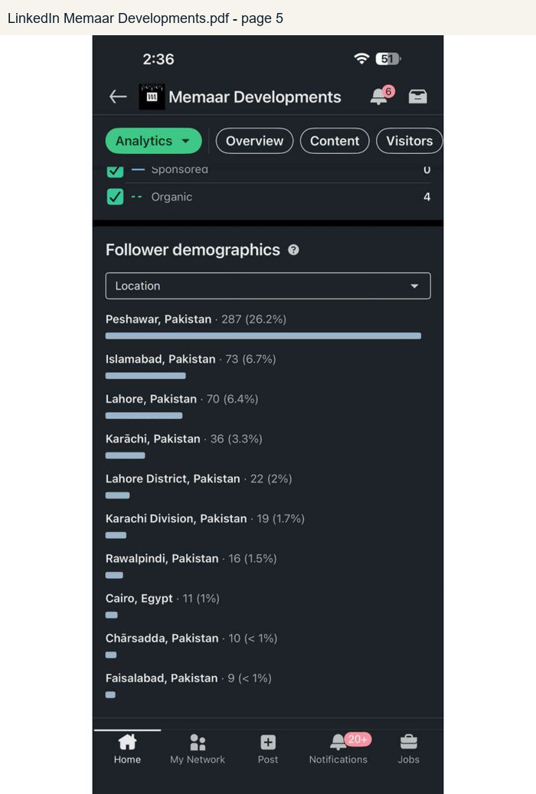 | 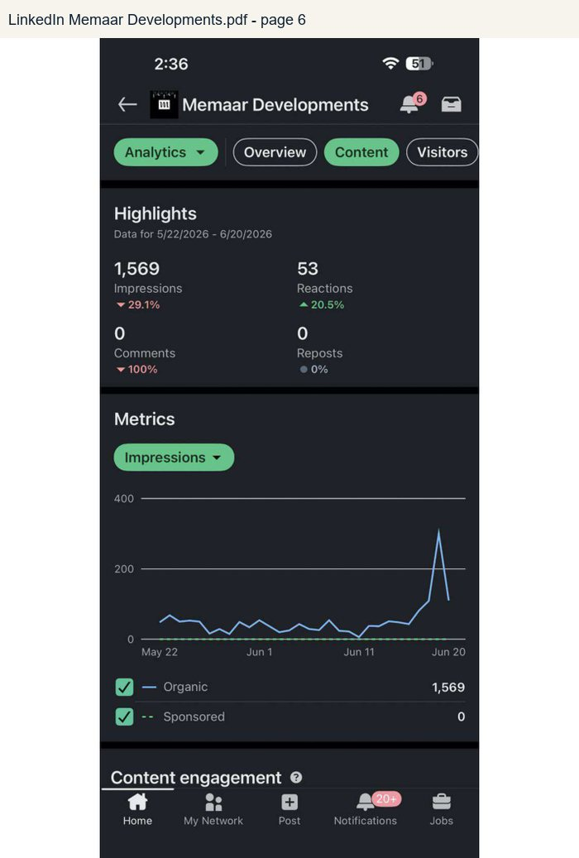
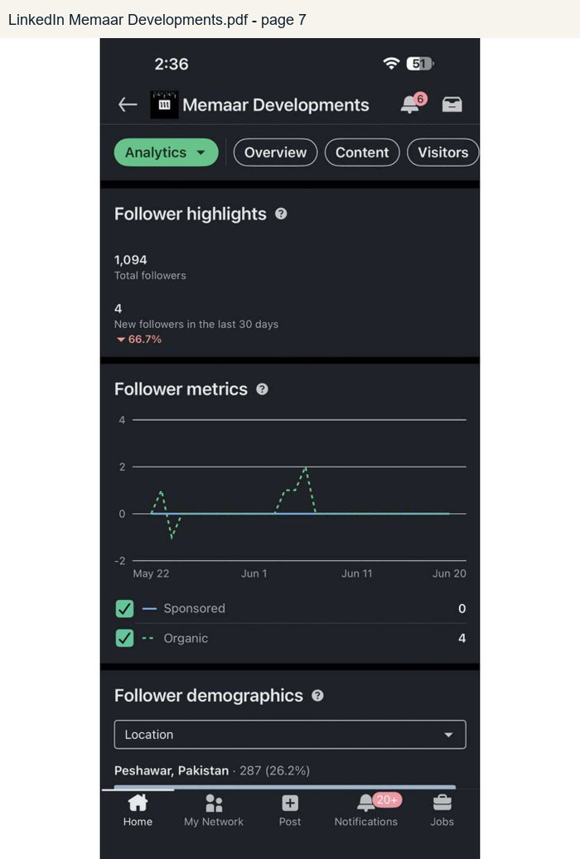

LinkedIn Memaar Group.pdf
Rendered from the supplied analytics PDF. Used for verified platform numbers where visible.
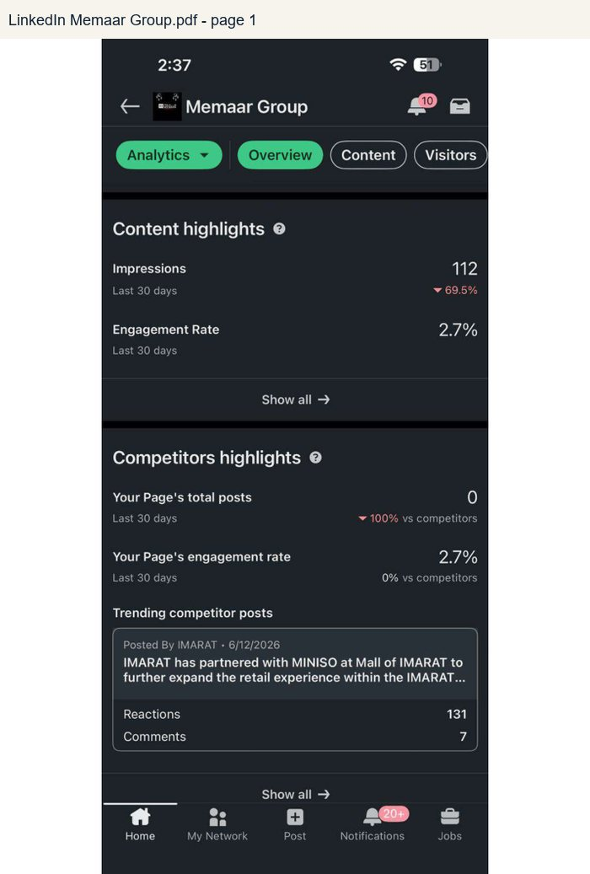 | 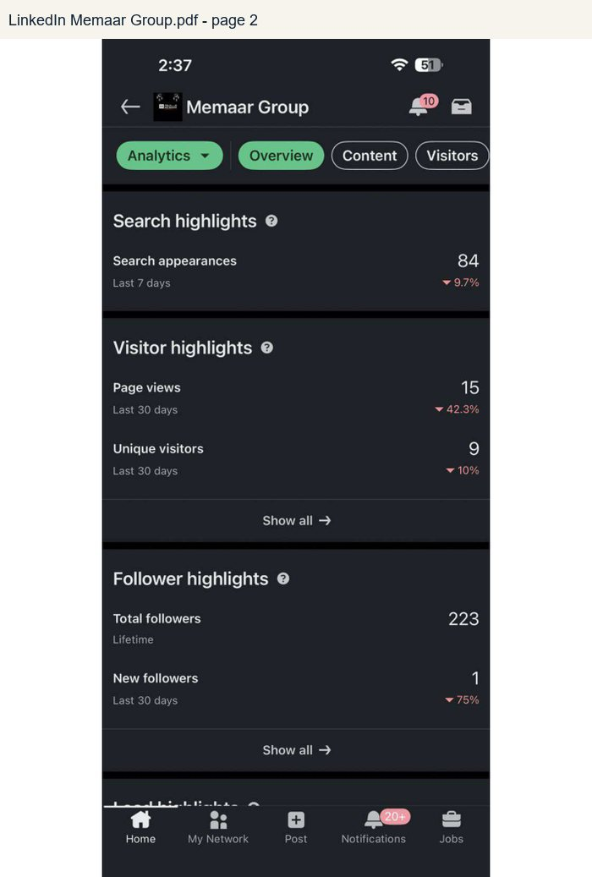

YT Memaar Developments.pdf
Rendered from the supplied analytics PDF. Used for verified platform numbers where visible.
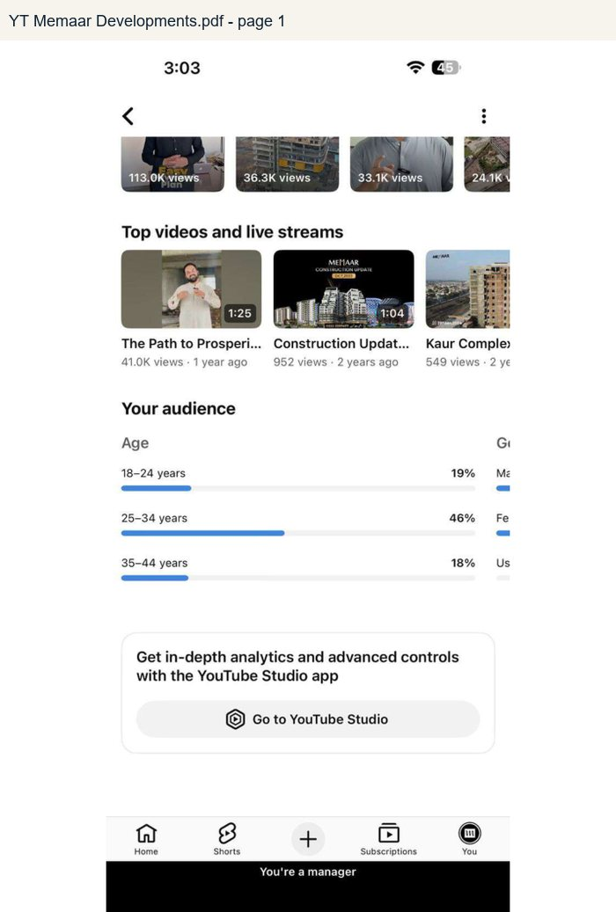 | 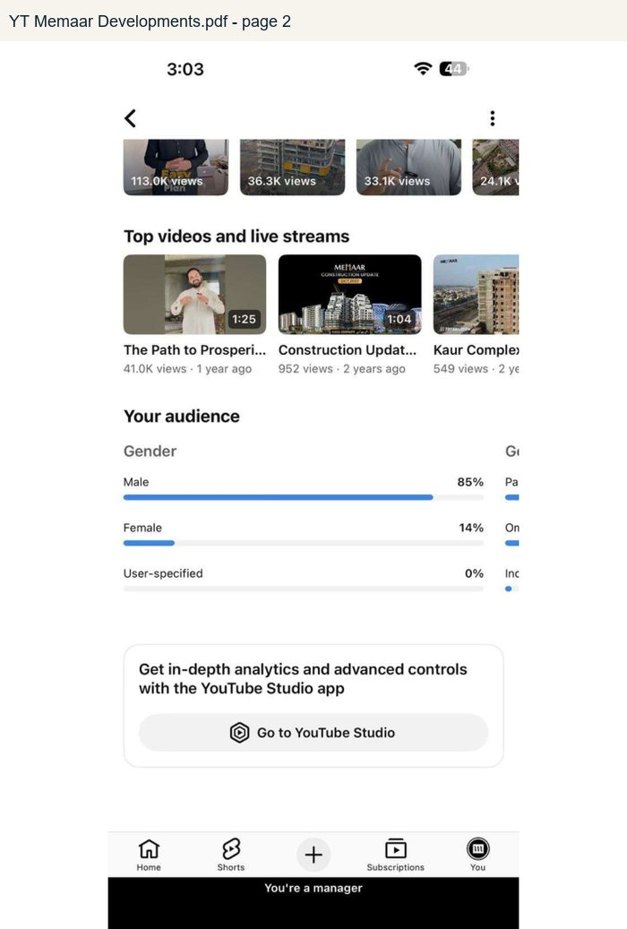
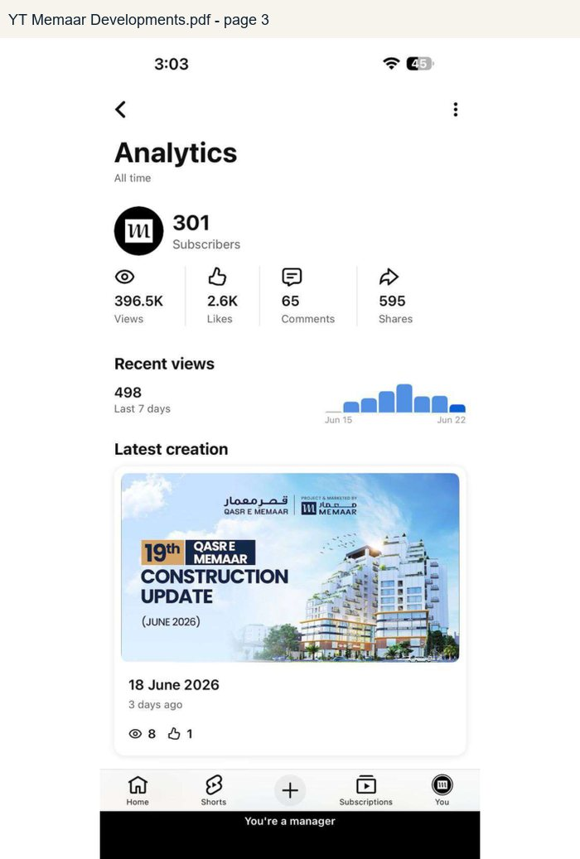 | 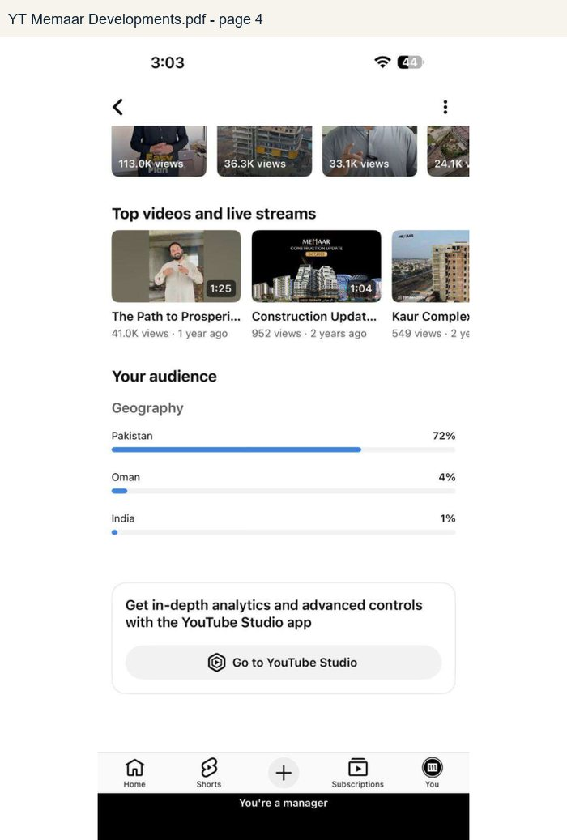

YT Memaar Group.pdf
Rendered from the supplied analytics PDF. Used for verified platform numbers where visible.
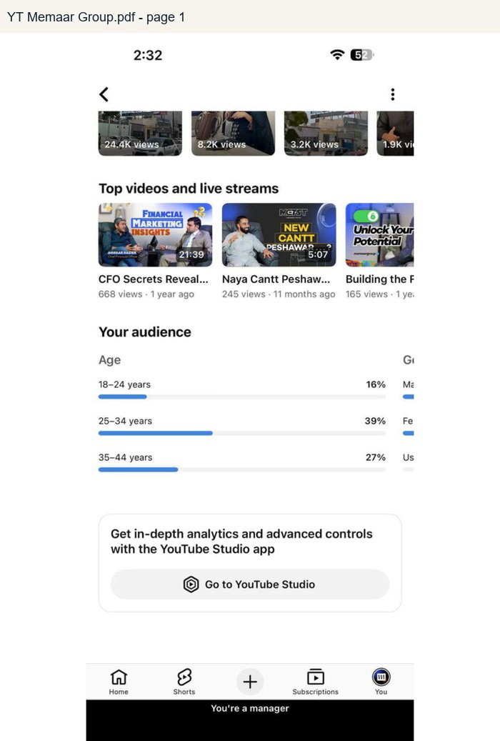 | 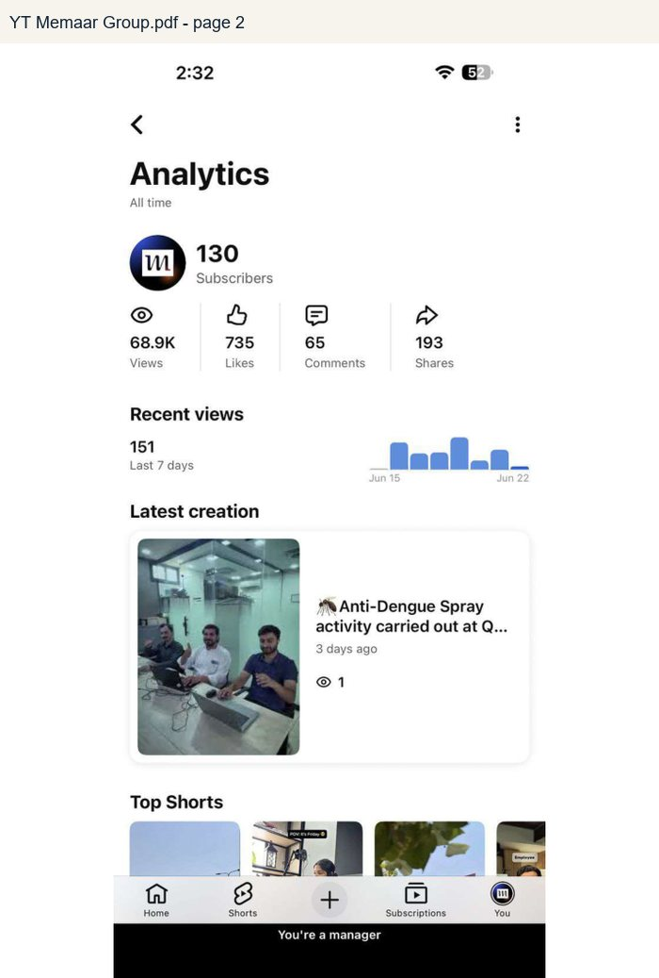
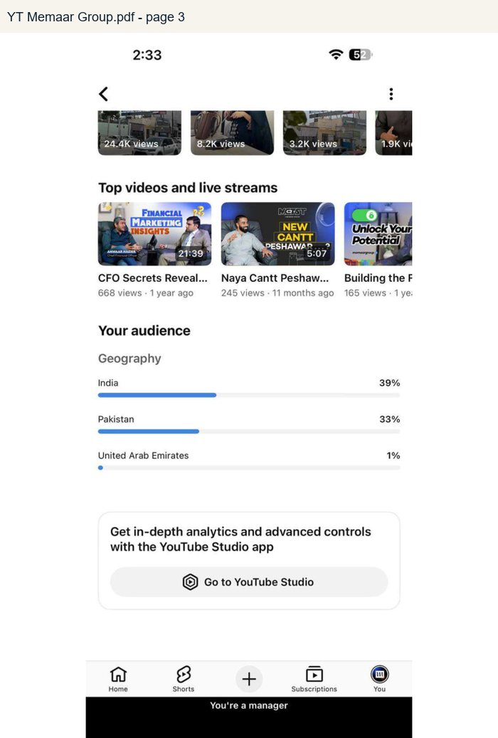 | 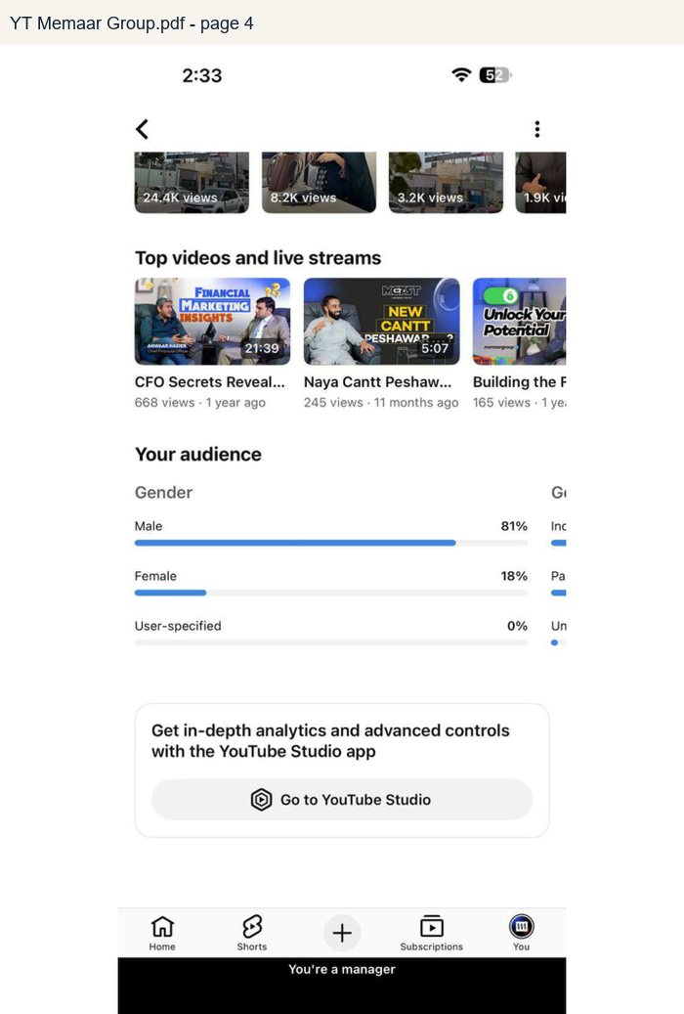

Mobile analytics and Search Console screenshots
Includes TikTok-style analytics screenshots and Google Search Console images from Files From MD.
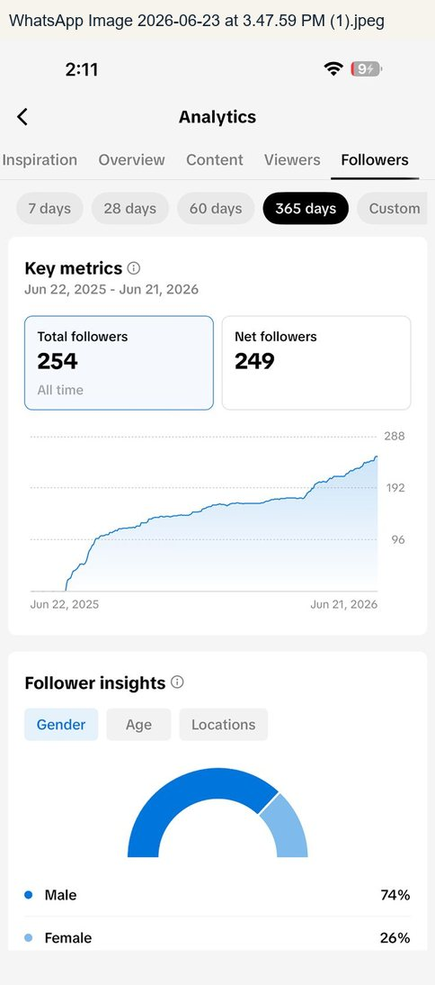 | 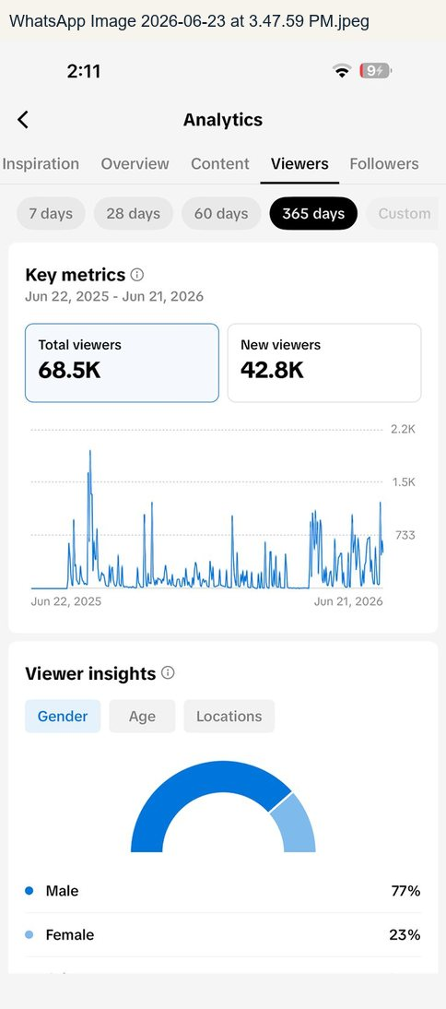
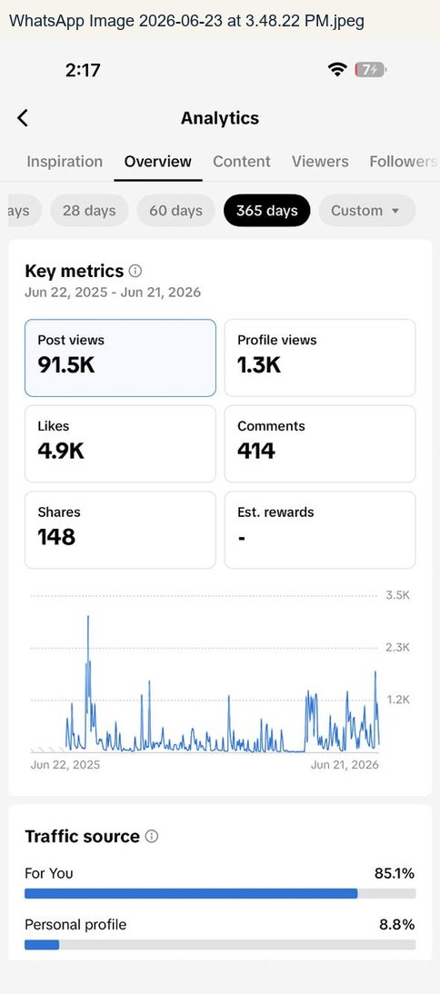 | 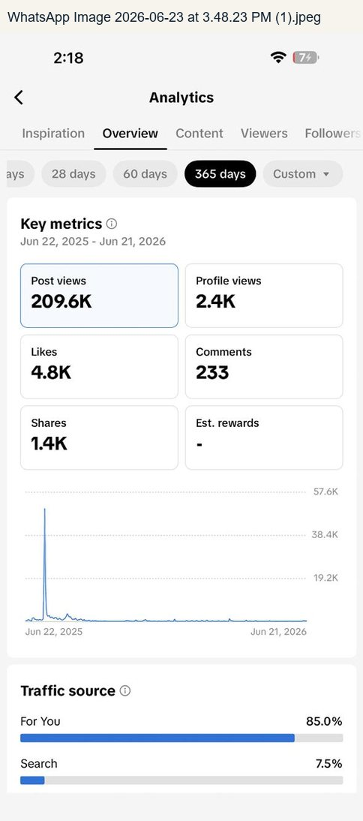
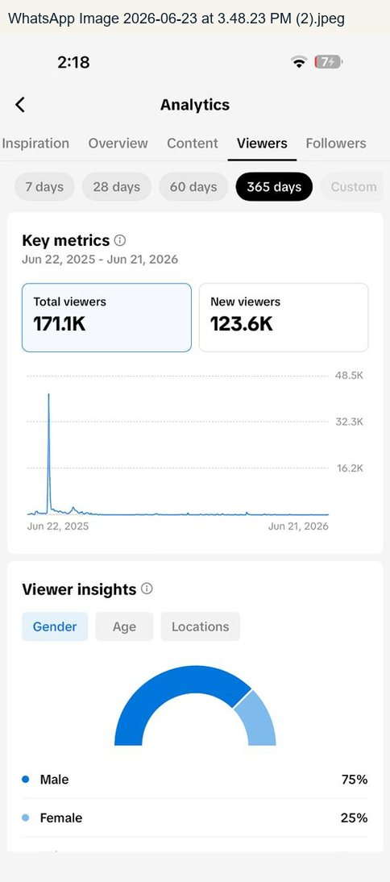 | 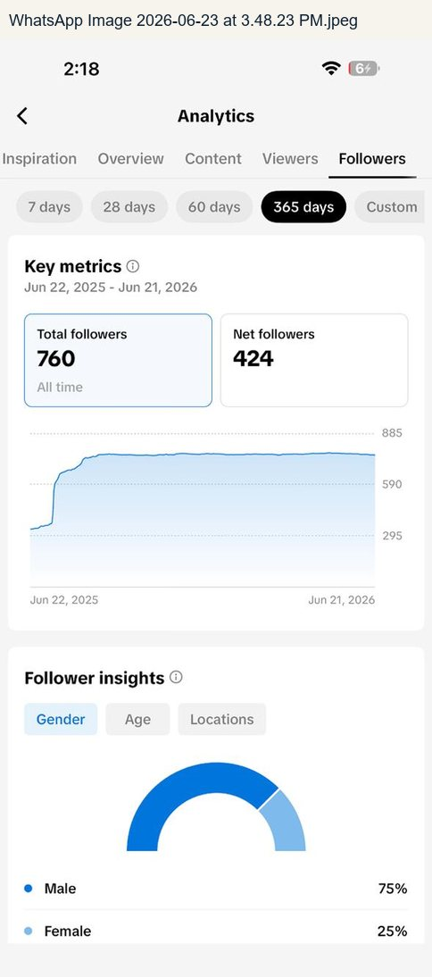
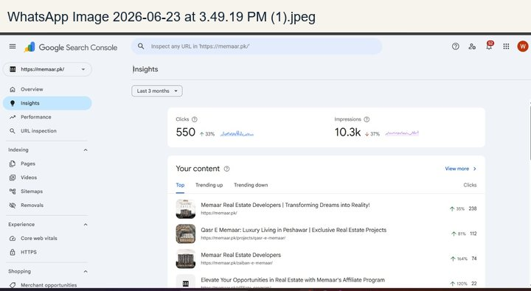 | 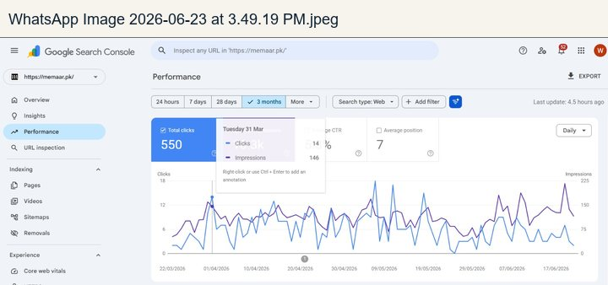

CHAPTER 07
Secondary Visual Evidence - Public Profiles and Ecosystem
Public screenshots organized by brand role instead of random file order.

Secondary Visual Evidence - Public Profiles and Ecosystem
These screenshots were used to map the public ecosystem and brand structure. They were not used as internal performance evidence unless analytics were visible.

Core public platform profiles
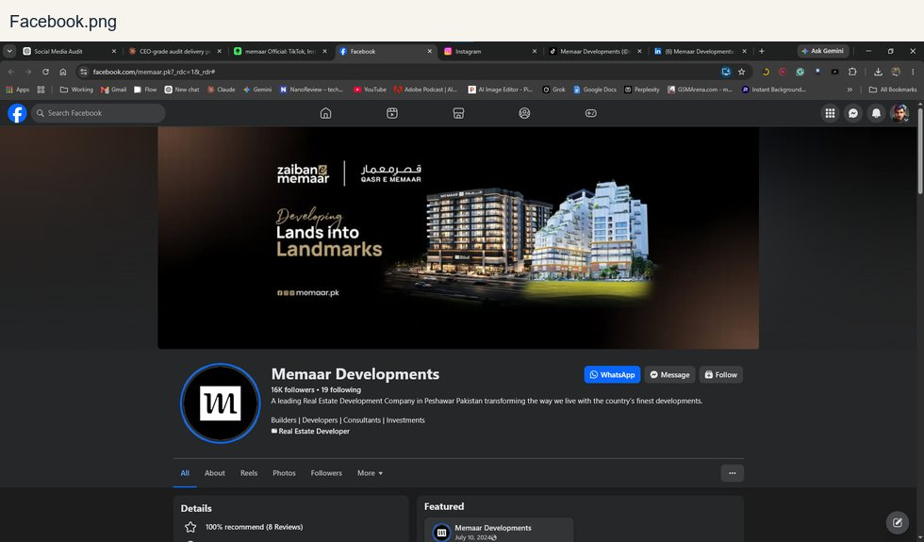 | 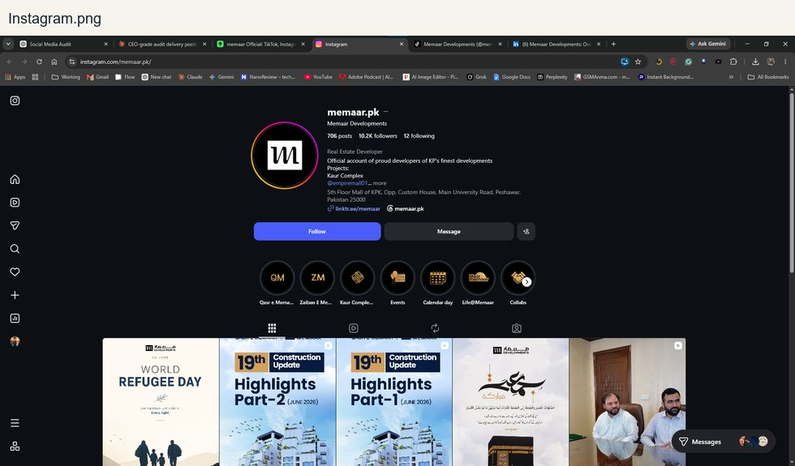
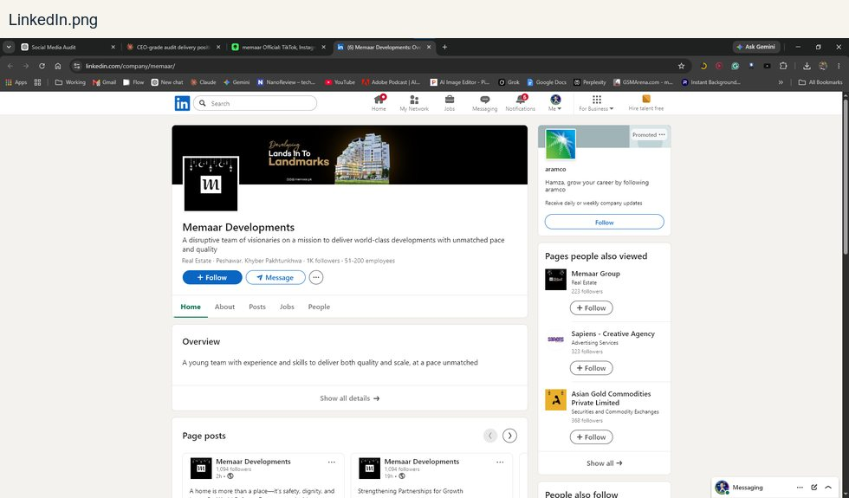 | 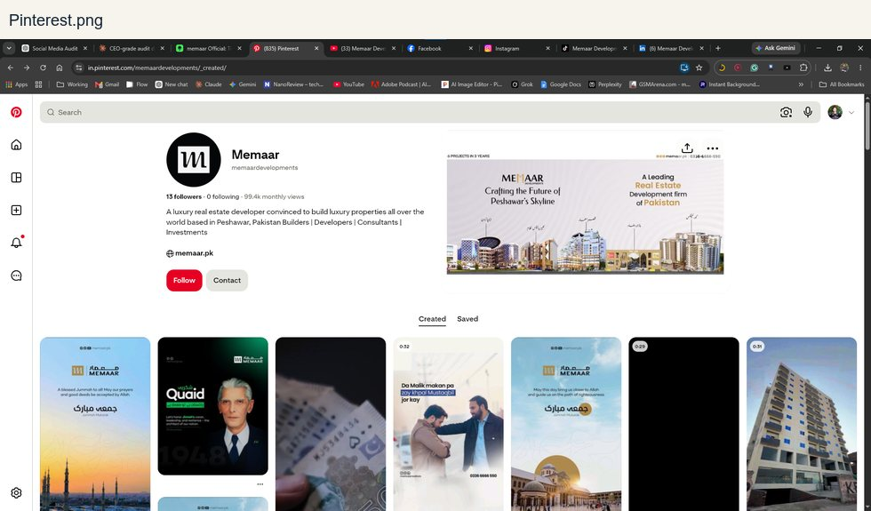
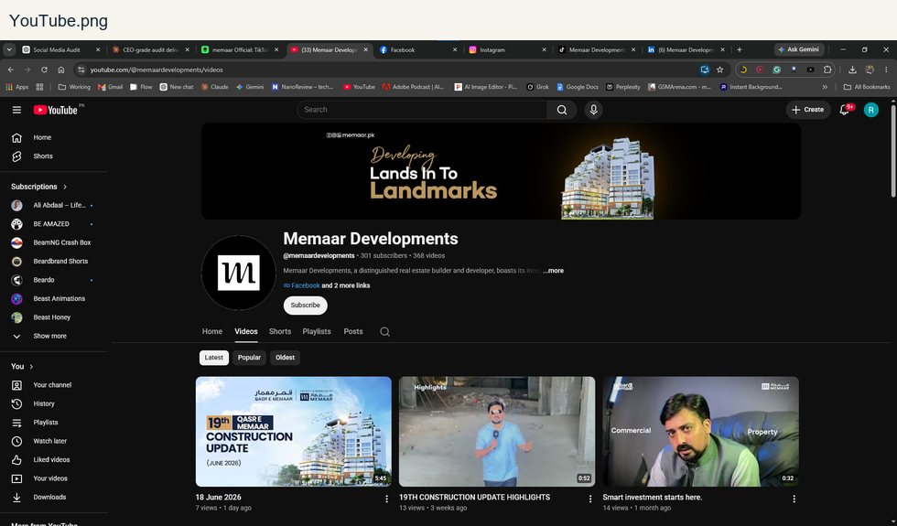 | 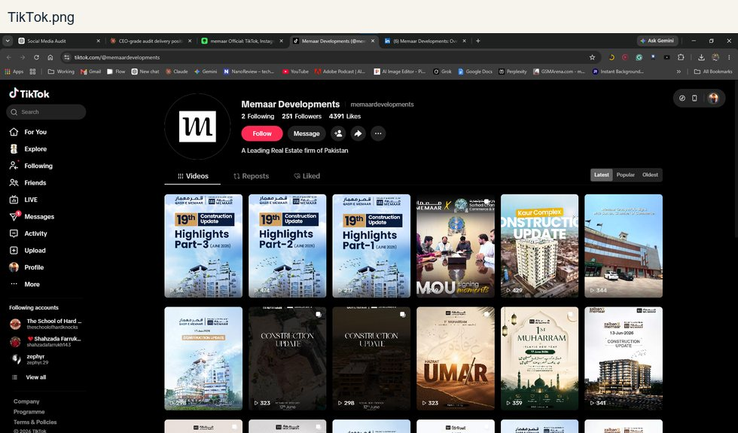

Project and real estate ecosystem pages
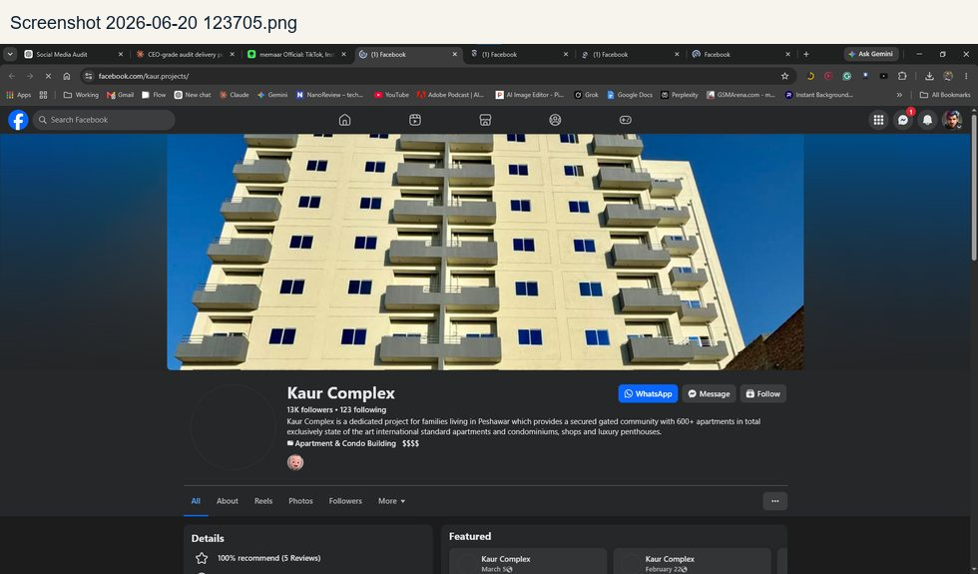 | 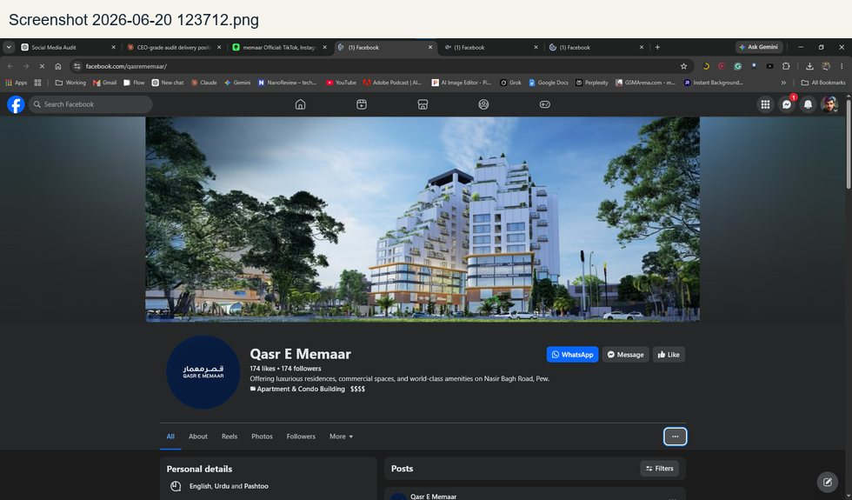
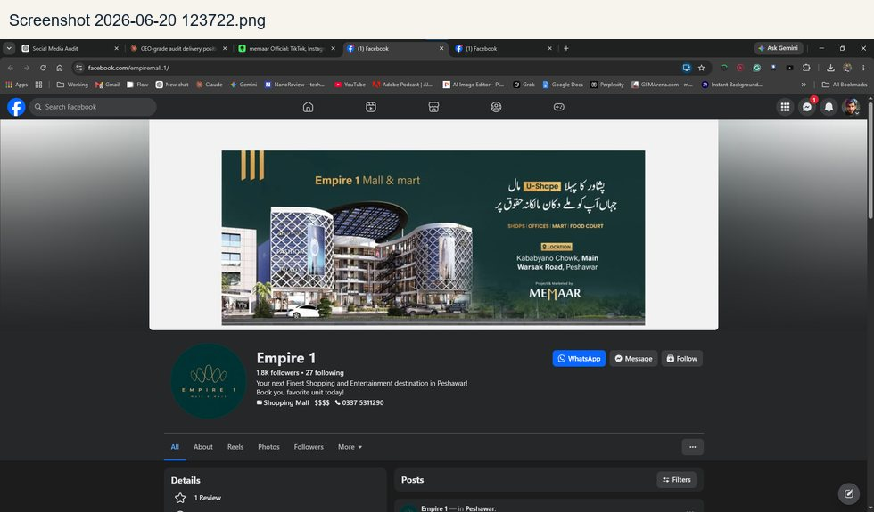 | 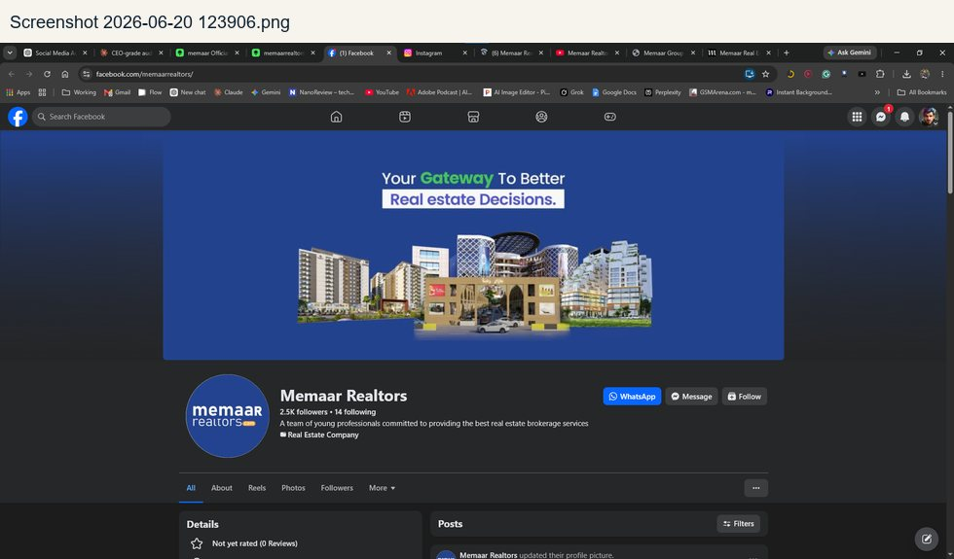
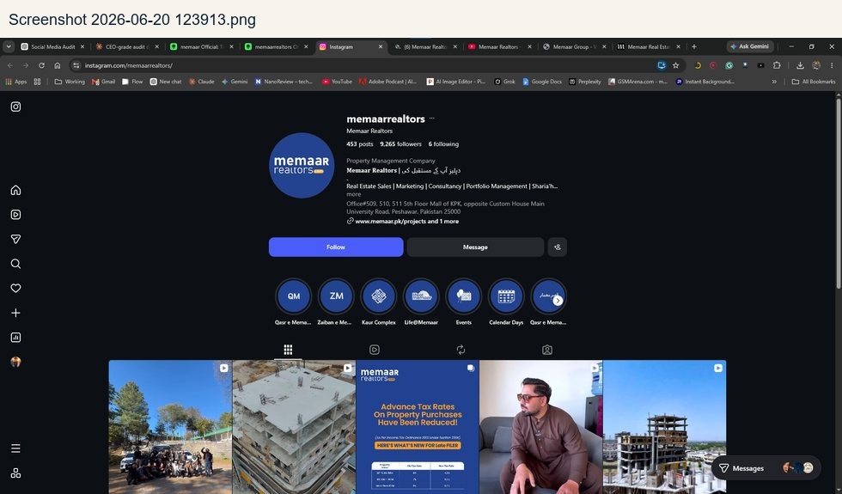 | 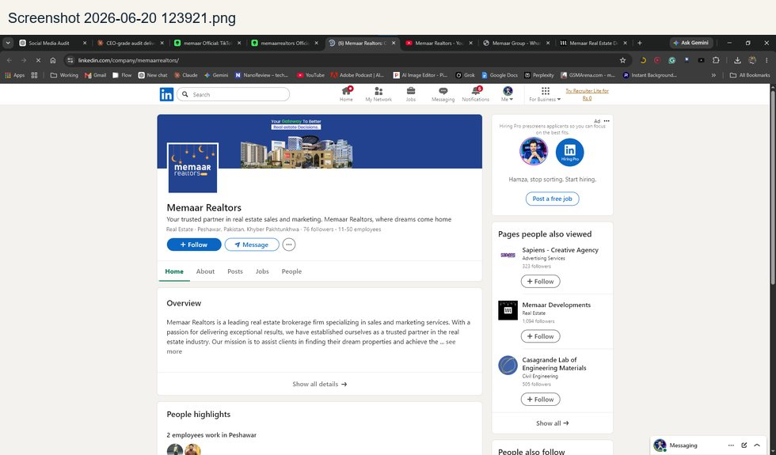
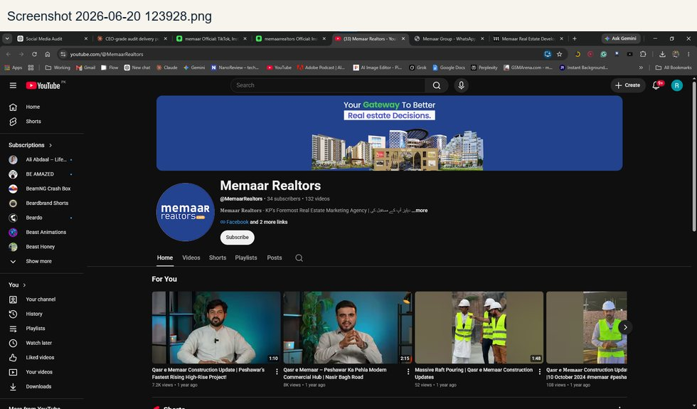

MCon Contractors evidence
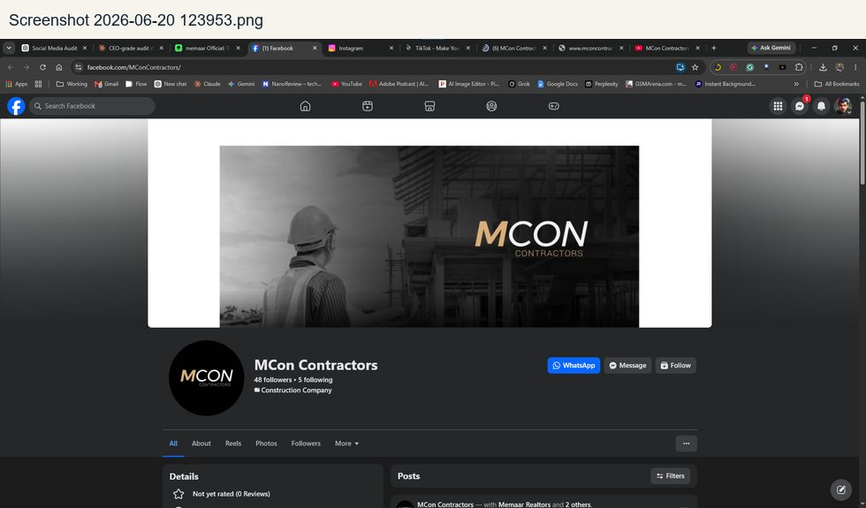 | 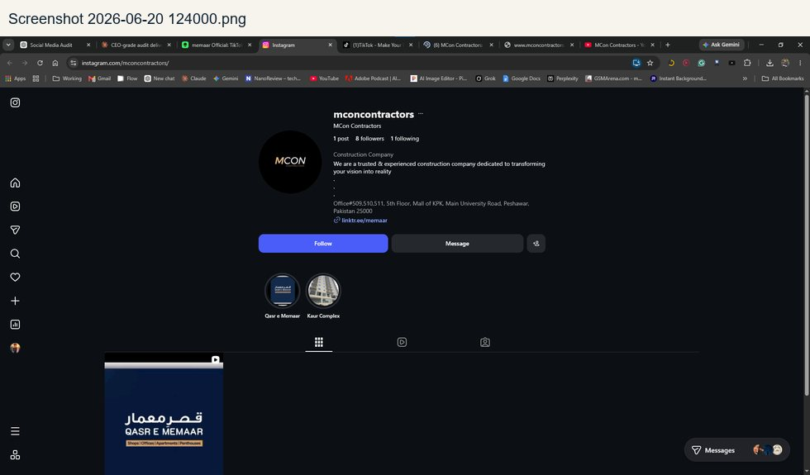
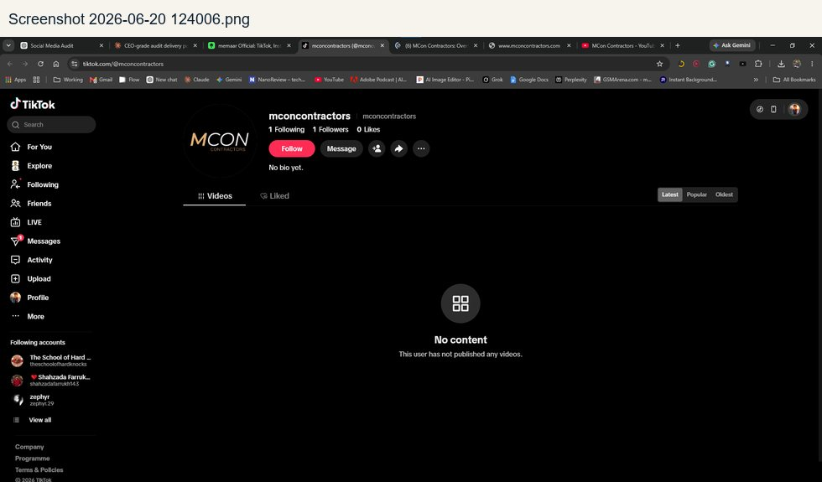 | 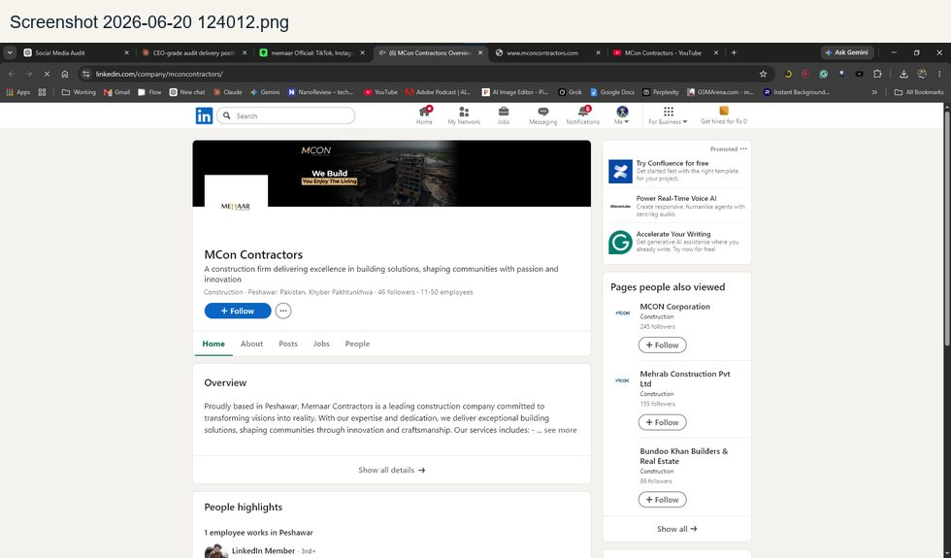
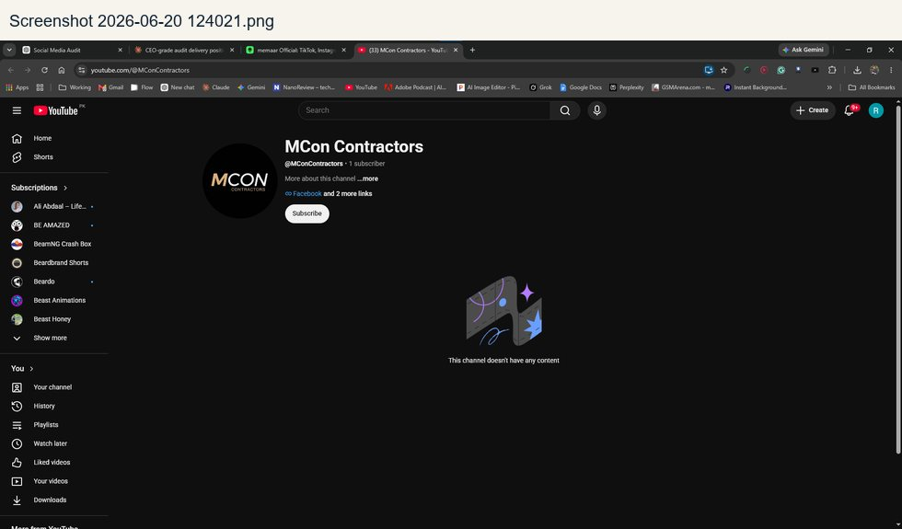

Sapiens evidence
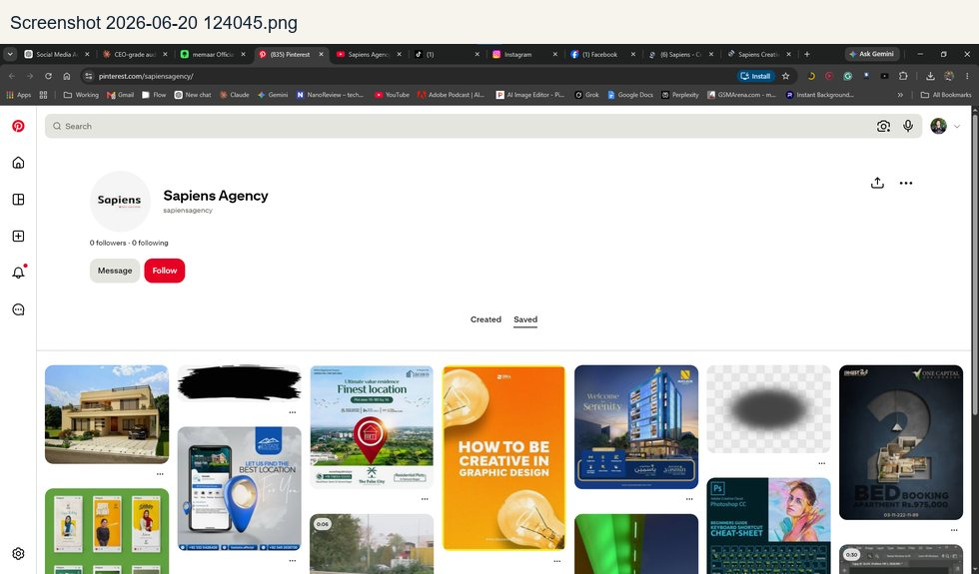 | 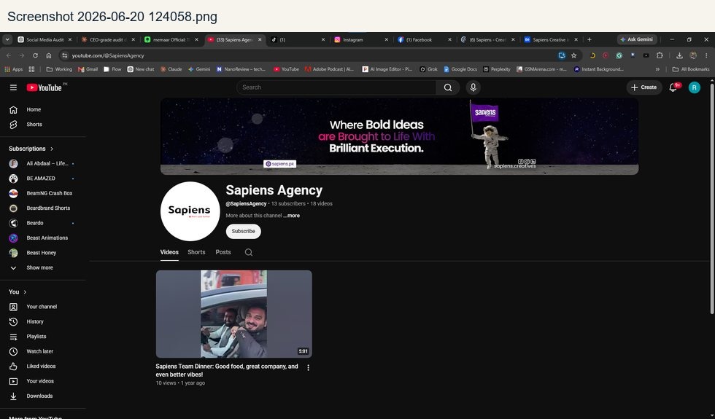
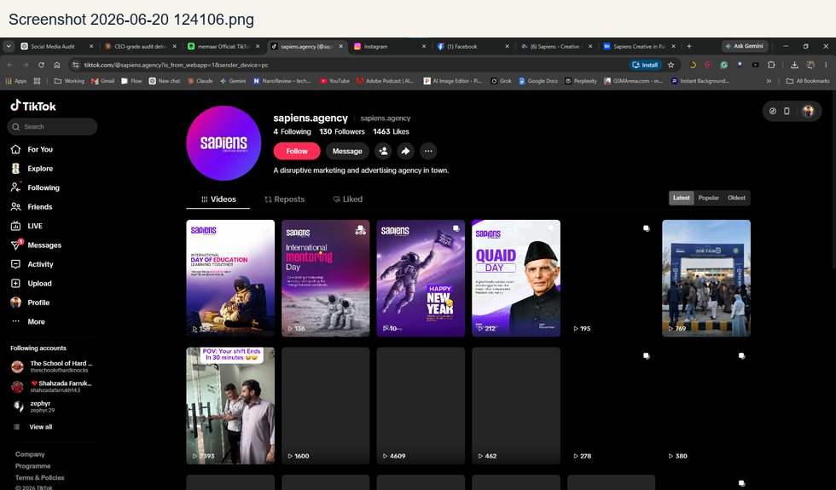 | 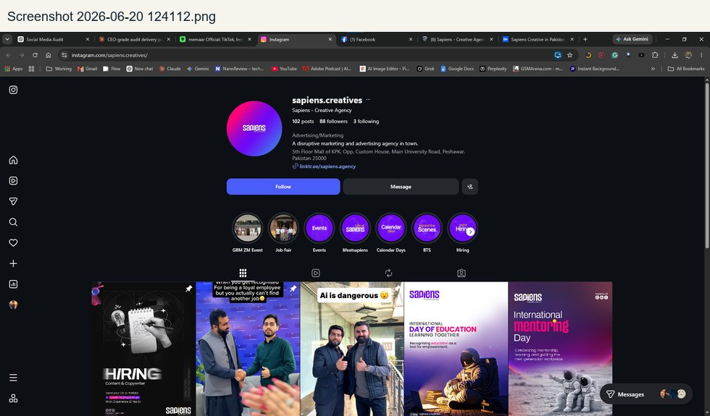
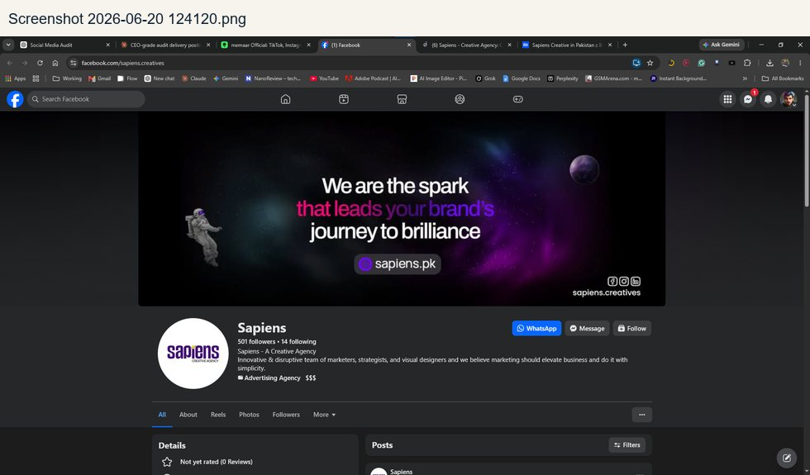 | 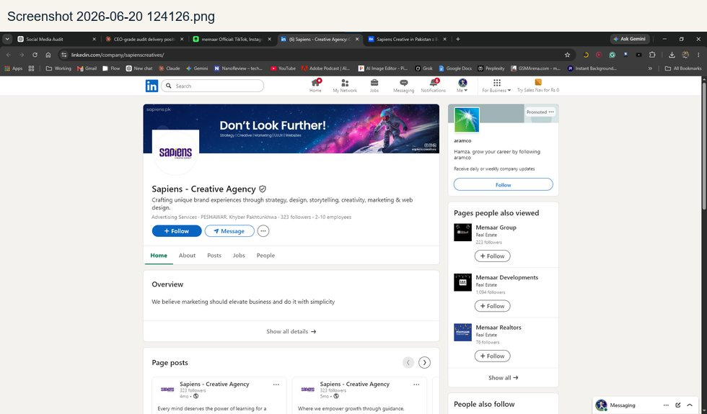

Archi Angle evidence
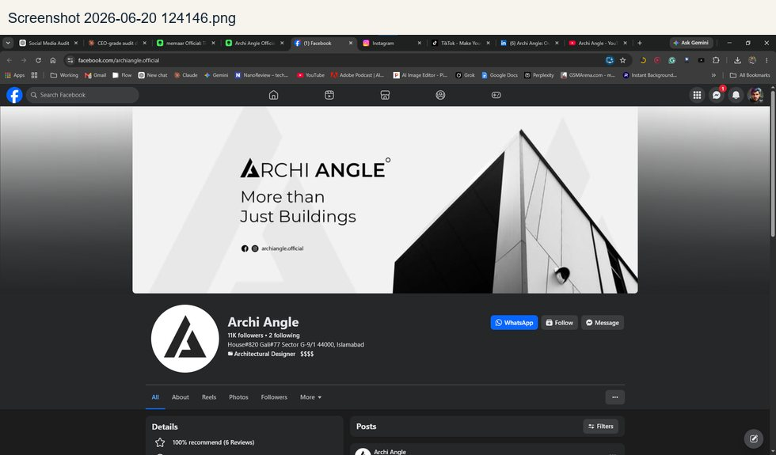 | 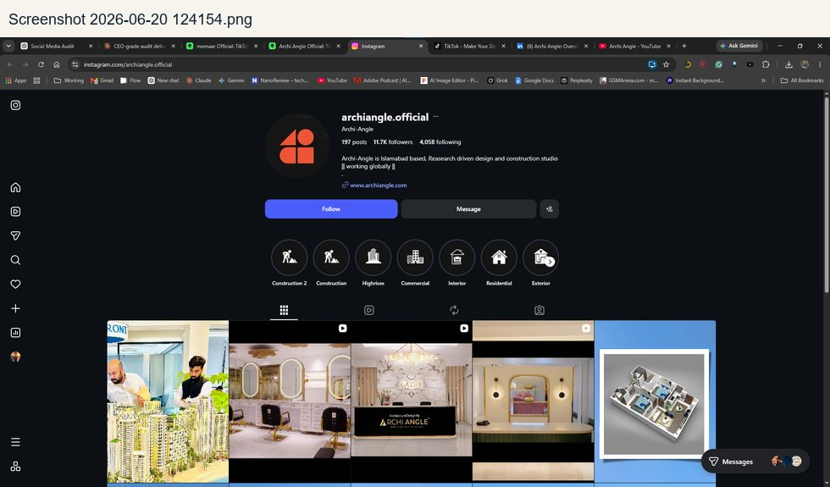
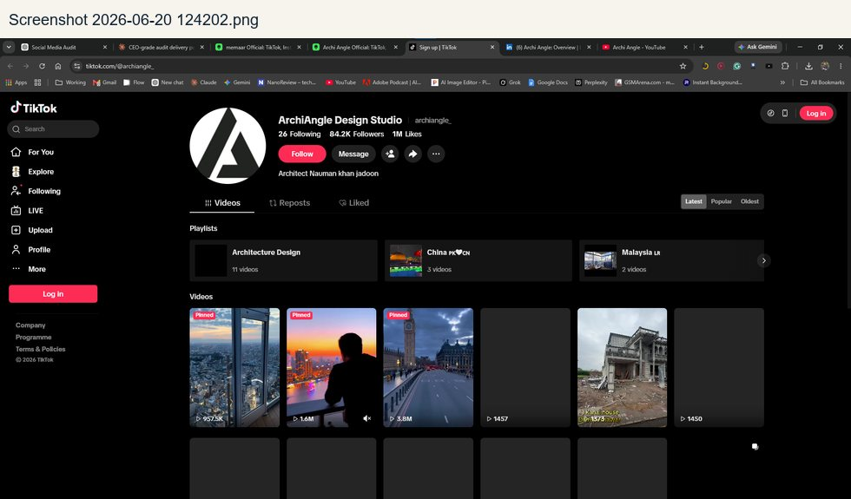 | 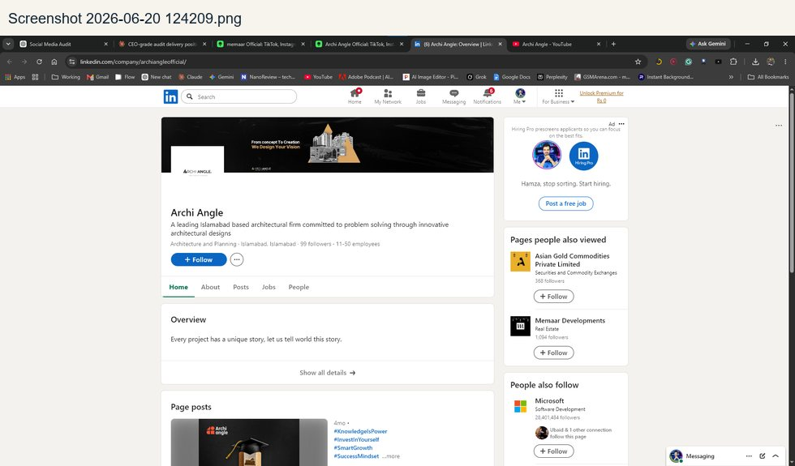
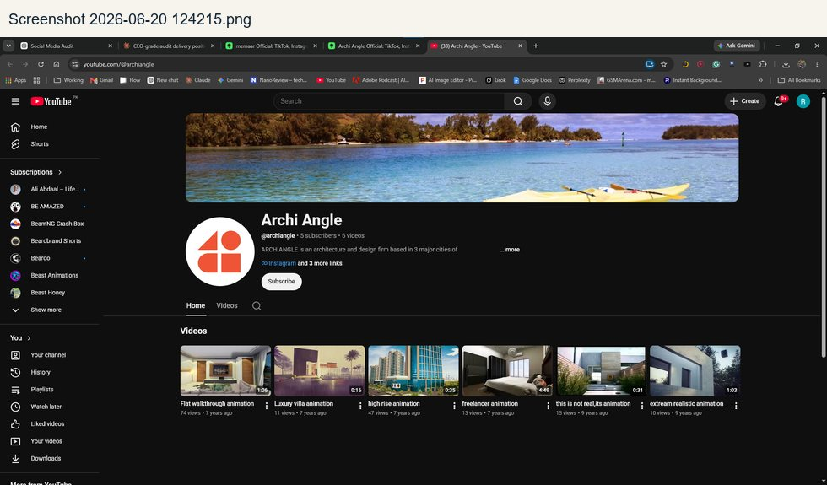

Asian Gold Commodities evidence
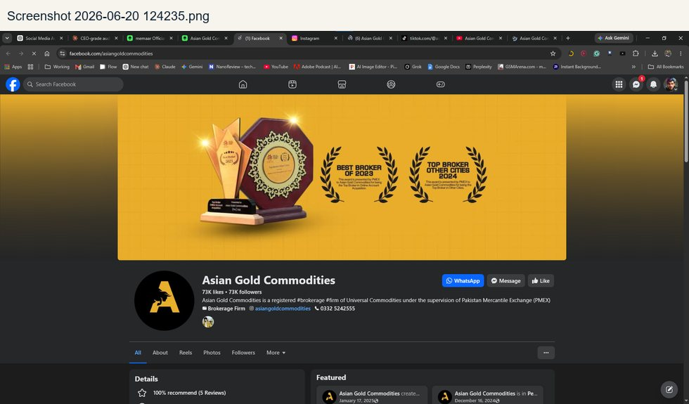 | 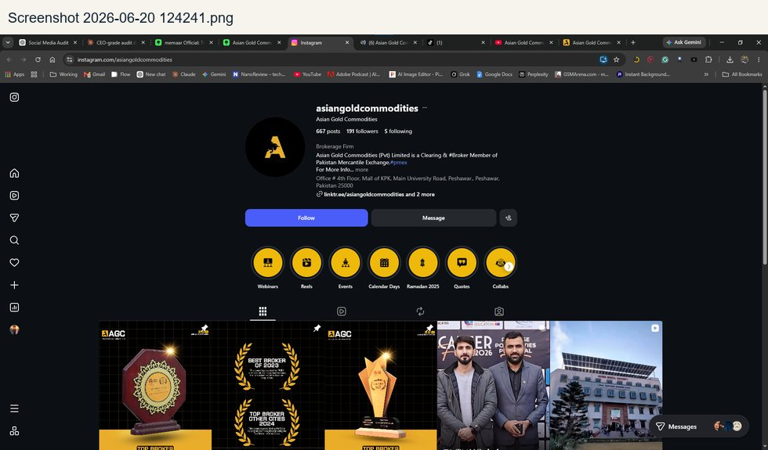
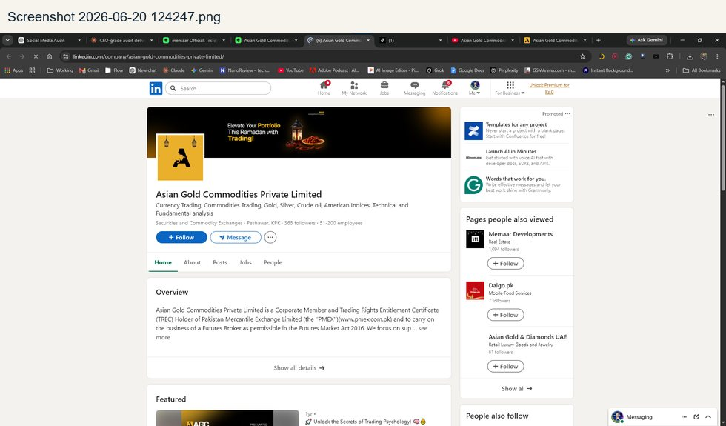 | 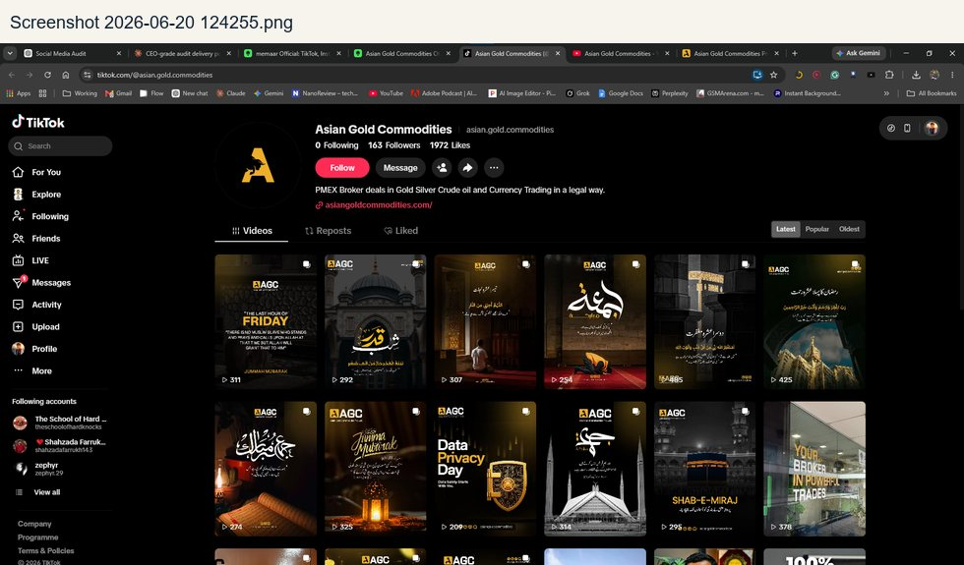
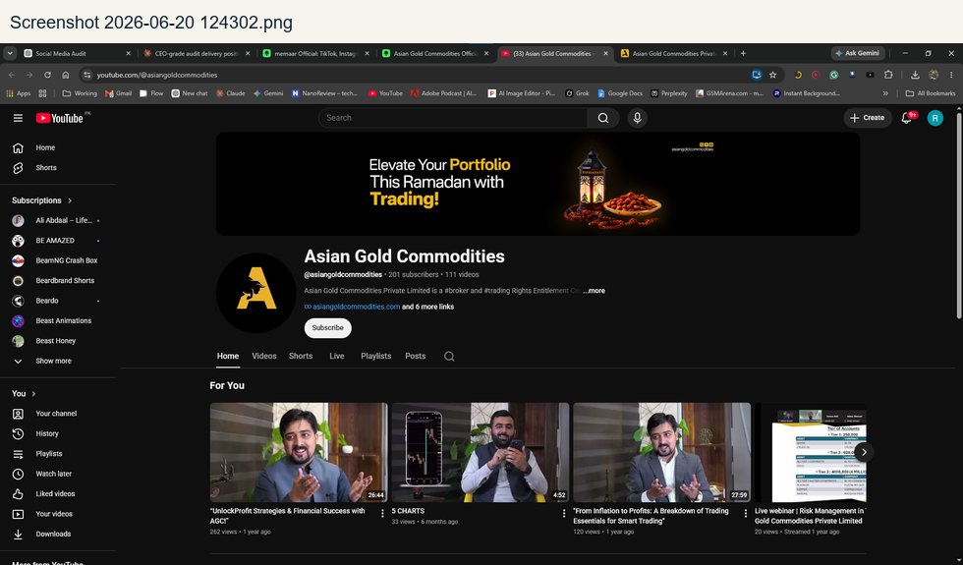 | 

Daigo evidence
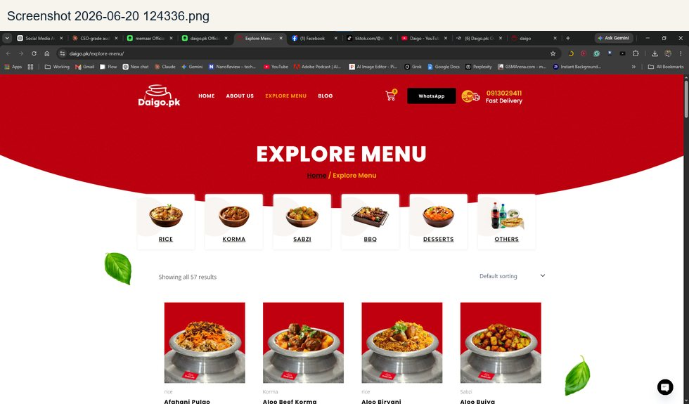 | 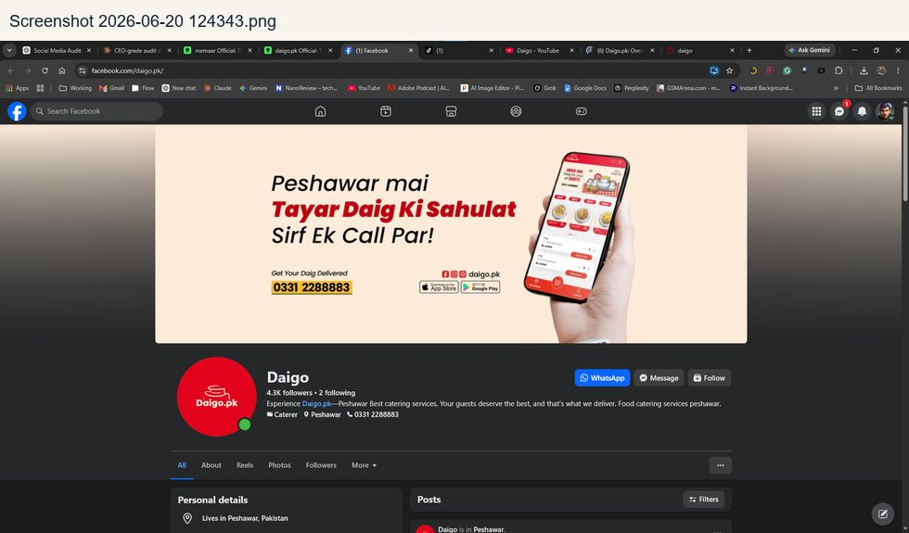
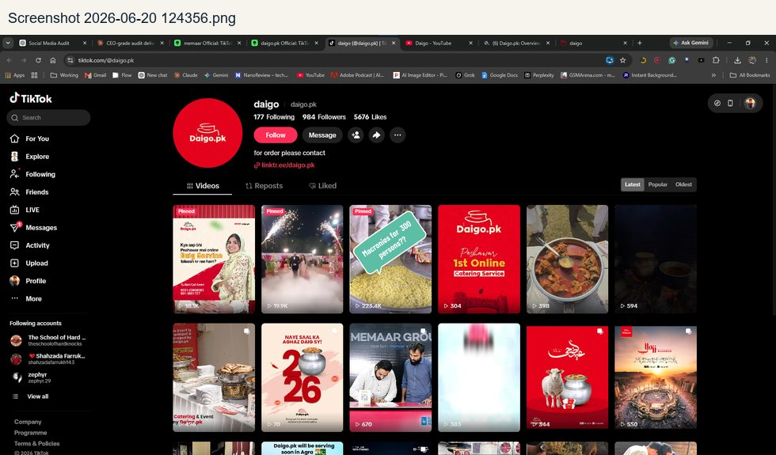 | 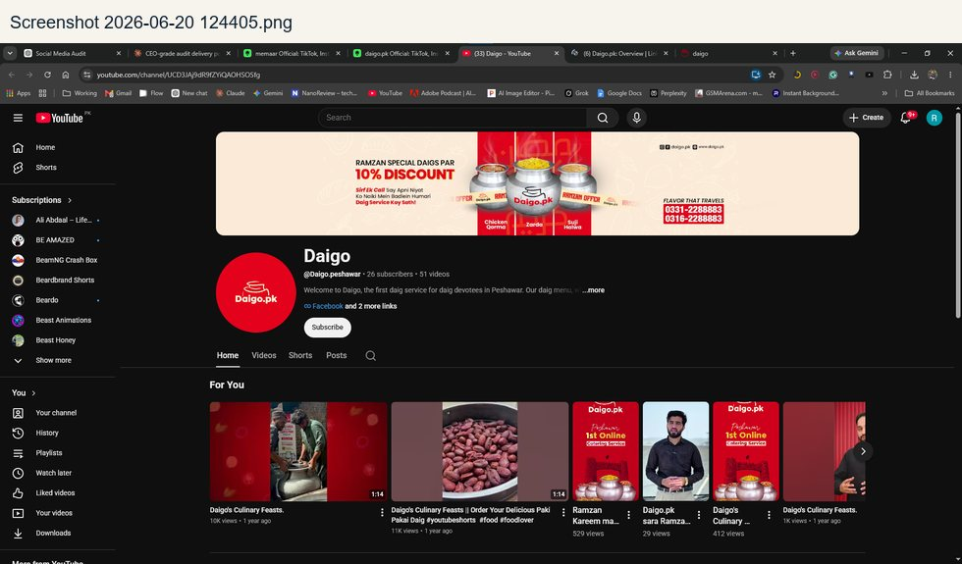
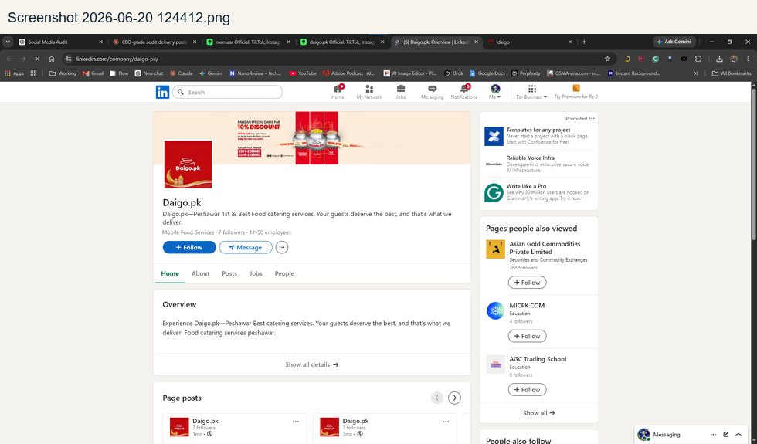 | 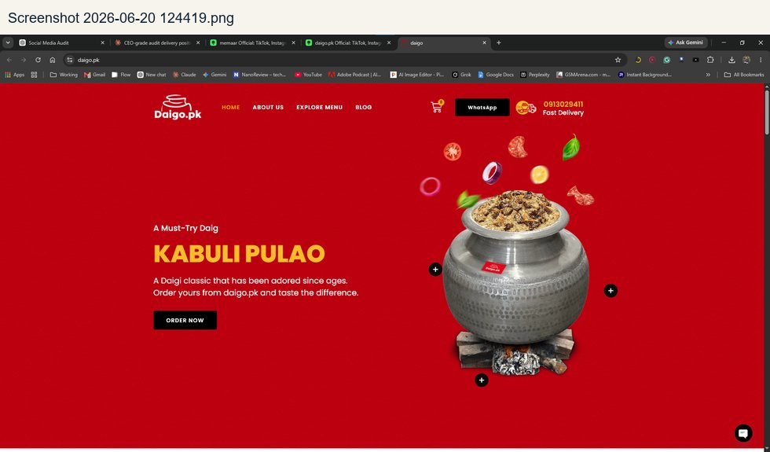

Memaar Incubation Centre evidence
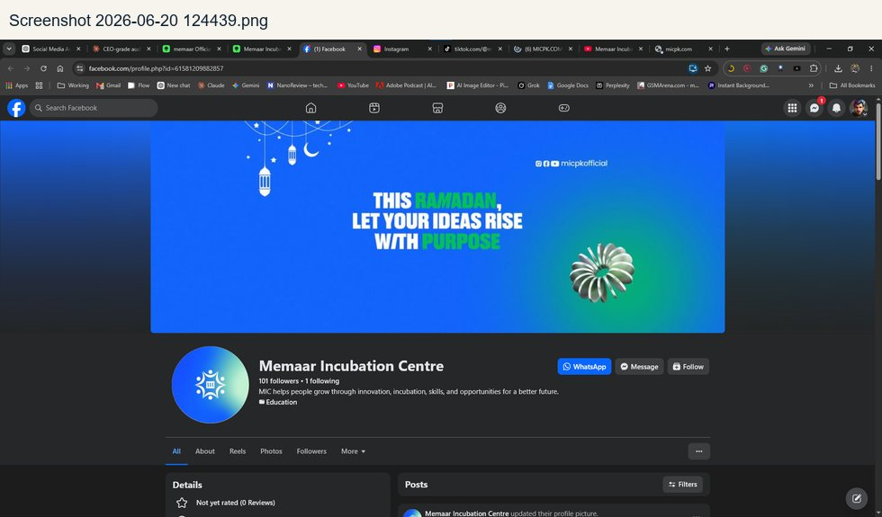 | 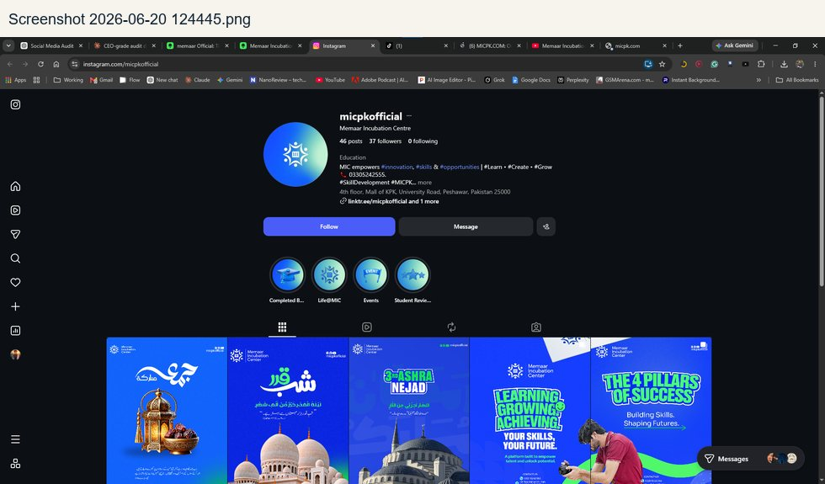
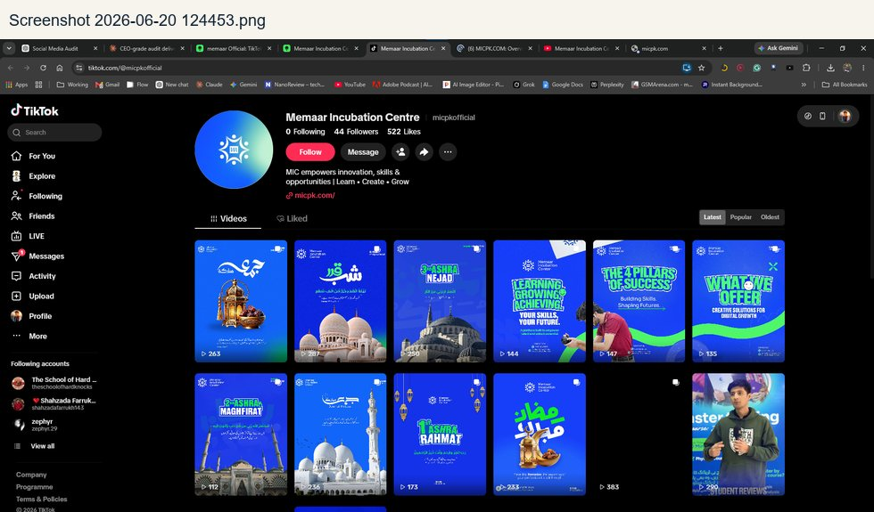 | 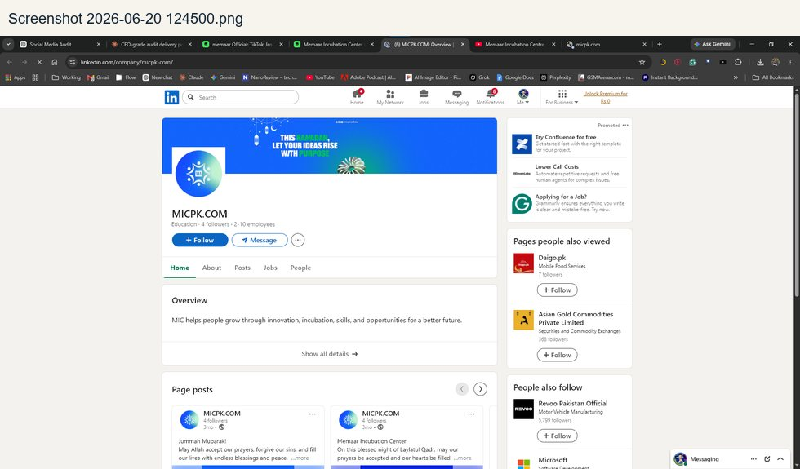
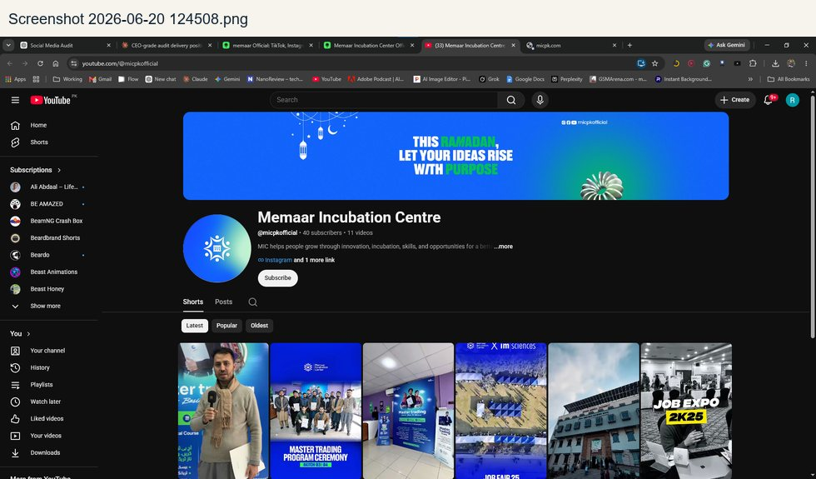 | 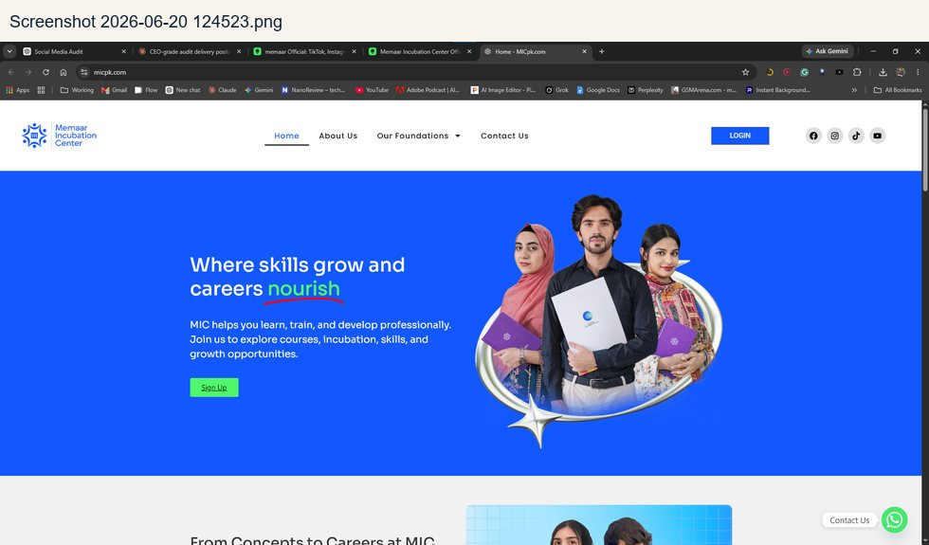

CHAPTER 08
Research Documents - Organized Summaries
Each AI or markdown research file summarized before the full appendix.

Research Documents - Organized Summaries

Gemini Research.docx
Field | Value
Source category | DOCX research output
Original file path | C:\Users\Hamza Khan\Documents\Audit\research_ai_outputs\Gemini Research.docx
Size | 51.6 KB
Extracted text length | 54,104 characters
Detected themes | Linktree, Website, Facebook, Instagram, TikTok, YouTube, LinkedIn, Pinterest, WhatsApp, Zameen, ROI, CPL, ad spend, bookings
How it was used | Contains recurring context around Linktree, Website, Facebook, Instagram, TikTok, YouTube, LinkedIn.

Grok Research.docx
Field | Value
Source category | DOCX research output
Original file path | C:\Users\Hamza Khan\Documents\Audit\research_ai_outputs\Grok Research.docx
Size | 18.6 KB
Extracted text length | 9,677 characters
Detected themes | Linktree, Website, Facebook, Instagram, TikTok, YouTube, LinkedIn, Pinterest, Google Business, WhatsApp, ROI
How it was used | Contains recurring context around Linktree, Website, Facebook, Instagram, TikTok, YouTube, LinkedIn.

MEMAAR SOCIAL MEDIA AUDIT REPORT.docx
Field | Value
Source category | DOCX research output
Original file path | C:\Users\Hamza Khan\Documents\Audit\research_ai_outputs\MEMAAR SOCIAL MEDIA AUDIT REPORT.docx
Size | 48.9 KB
Extracted text length | 82,846 characters
Detected themes | Linktree, Website, Facebook, Instagram, TikTok, YouTube, LinkedIn, Pinterest, Archi Angle, Google Business, WhatsApp, Zameen, CPL, sales
How it was used | Contains recurring context around Linktree, Website, Facebook, Instagram, TikTok, YouTube, LinkedIn.

MEMAAR Social Media & Content Strategy - Deep Audit.docx
Field | Value
Source category | DOCX research output
Original file path | C:\Users\Hamza Khan\Documents\Audit\research_ai_outputs\MEMAAR_SOCIAL_MEDIA_&_CONTENT_STRATEGY_-_DEEP_AUDIT.docx
Size | 31.2 KB
Extracted text length | 61,830 characters
Detected themes | Linktree, Website, Facebook, Instagram, TikTok, YouTube, LinkedIn, Pinterest, Archi Angle, WhatsApp, ad spend, sales
How it was used | Contains recurring context around Linktree, Website, Facebook, Instagram, TikTok, YouTube, LinkedIn.

Memaar_Social_Media_Audit.docx
Field | Value
Source category | DOCX research output
Original file path | C:\Users\Hamza Khan\Documents\Audit\research_ai_outputs\Memaar_Social_Media_Audit.docx
Size | 30.1 KB
Extracted text length | 35,995 characters
Detected themes | Linktree, Website, Facebook, Instagram, TikTok, YouTube, LinkedIn, Pinterest, Archi Angle, Google Business, WhatsApp, ROI, ad spend
How it was used | Contains recurring context around Linktree, Website, Facebook, Instagram, TikTok, YouTube, LinkedIn.

Perplexity Research.docx
Field | Value
Source category | DOCX research output
Original file path | C:\Users\Hamza Khan\Documents\Audit\research_ai_outputs\PerPlexiy Research.docx
Size | 466.7 KB
Extracted text length | 50,963 characters
Detected themes | Linktree, Website, Facebook, Instagram, TikTok, YouTube, LinkedIn, Pinterest, Google Business, WhatsApp, ROI, ad spend, sales, revenue
How it was used | Contains recurring context around Linktree, Website, Facebook, Instagram, TikTok, YouTube, LinkedIn.

Research 5.docx
Field | Value
Source category | DOCX research output
Original file path | C:\Users\Hamza Khan\Documents\Audit\research_ai_outputs\Research 5.docx
Size | 30.6 KB
Extracted text length | 28,692 characters
Detected themes | Linktree, Website, Facebook, Instagram, TikTok, YouTube, LinkedIn, Pinterest, Google Business, WhatsApp, Zameen, ad spend, sales
How it was used | Contains recurring context around Linktree, Website, Facebook, Instagram, TikTok, YouTube, LinkedIn.

Research 4.docx
Field | Value
Source category | DOCX research output
Original file path | C:\Users\Hamza Khan\Documents\Audit\research_ai_outputs\reserch 4.docx
Size | 49.3 KB
Extracted text length | 50,029 characters
Detected themes | Linktree, Website, Facebook, Instagram, TikTok, YouTube, LinkedIn, Pinterest, Archi Angle, Google Business, WhatsApp, Graana, ad spend, sales
How it was used | Contains recurring context around Linktree, Website, Facebook, Instagram, TikTok, YouTube, LinkedIn.

memaar-deep-audit-prompt.md
Field | Value
Source category | Markdown research output
Original file path | C:\Users\Hamza Khan\Documents\Audit\research_ai_outputs\memaar-deep-audit-prompt.md
Size | 17.3 KB
Extracted text length | 17,450 characters
Detected themes | Linktree, Website, Facebook, Instagram, TikTok, YouTube, LinkedIn, WhatsApp, ad spend, sales
How it was used | Contains recurring context around Linktree, Website, Facebook, Instagram, TikTok, YouTube, LinkedIn.

MEMAAR_Audit_Report_Part1.md
Field | Value
Source category | Markdown research output
Original file path | C:\Users\Hamza Khan\Documents\Audit\research_ai_outputs\MEMAAR_Audit_Report_Part1.md
Size | 26.0 KB
Extracted text length | 26,590 characters
Detected themes | Linktree, Website, Facebook, Instagram, TikTok, YouTube, LinkedIn, Pinterest, Archi Angle, Google Business, WhatsApp, third-party, ad spend, sales
How it was used | Contains recurring context around Linktree, Website, Facebook, Instagram, TikTok, YouTube, LinkedIn.

MEMAAR_Audit_Report_Part2.md
Field | Value
Source category | Markdown research output
Original file path | C:\Users\Hamza Khan\Documents\Audit\research_ai_outputs\MEMAAR_Audit_Report_Part2.md
Size | 47.2 KB
Extracted text length | 48,324 characters
Detected themes | Linktree, Website, Facebook, Instagram, TikTok, YouTube, LinkedIn, Pinterest, WhatsApp, third-party, sales
How it was used | Contains recurring context around Linktree, Website, Facebook, Instagram, TikTok, YouTube, LinkedIn.

MEMAAR_Audit_Report_Part3.md
Field | Value
Source category | Markdown research output
Original file path | C:\Users\Hamza Khan\Documents\Audit\research_ai_outputs\MEMAAR_Audit_Report_Part3.md
Size | 34.2 KB
Extracted text length | 34,959 characters
Detected themes | Website, Facebook, Instagram, TikTok, YouTube, LinkedIn, Google Business, WhatsApp, third-party, Zameen, Graana, ROI, ad spend, sales
How it was used | Contains recurring context around Website, Facebook, Instagram, TikTok, YouTube, LinkedIn, Google Business.

MEMAAR_Audit_Report_Part4.md
Field | Value
Source category | Markdown research output
Original file path | C:\Users\Hamza Khan\Documents\Audit\research_ai_outputs\MEMAAR_Audit_Report_Part4.md
Size | 23.4 KB
Extracted text length | 23,938 characters
Detected themes | Linktree, Website, Facebook, Instagram, TikTok, YouTube, LinkedIn, Pinterest, WhatsApp, third-party, ROI, ad spend, sales
How it was used | Contains recurring context around Linktree, Website, Facebook, Instagram, TikTok, YouTube, LinkedIn.

report.md
Field | Value
Source category | Markdown research output
Original file path | C:\Users\Hamza Khan\Documents\Audit\research_ai_outputs\report.md
Size | 130.8 KB
Extracted text length | 133,817 characters
Detected themes | Linktree, Website, Facebook, Instagram, TikTok, YouTube, LinkedIn, Pinterest, Archi Angle, Google Business, WhatsApp, third-party, Zameen, Graana
How it was used | Contains recurring context around Linktree, Website, Facebook, Instagram, TikTok, YouTube, LinkedIn.

CHAPTER 09
Full Research Appendix - Source Text Archive
Complete extracted research text, preserved after the polished evidence sections.

Full Research Appendix - Source Text Archive
This appendix is intentionally dense. It preserves the extracted source text so the research trail remains available, while keeping the main body organized and executive-readable.

Gemini Research.docx
Source field | Value
File | Gemini Research.docx
Path | C:\Users\Hamza Khan\Documents\Audit\research_ai_outputs\Gemini Research.docx
Type | DOCX research output
Size | 51.6 KB
Extracted characters | 54,104
MEMAAR SOCIAL MEDIA & CONTENT STRATEGY DEEP AUDIT
-------------------------------------- MEMAAR SOCIAL MEDIA AUDIT REPORT Prepared by: Senior Digital Media Strategist & Content Audit Specialist Date: October 24, 2024 --------------------------------------
SECTION 1: LINKTREE ANALYSIS
An evaluation of the Memaar Linktree profile reveals a foundational digital gateway that requires immediate structural and aesthetic refinement to align with a premium real estate development brand. The brand name is displayed simply as "Memaar". The profile image utilized is a high-resolution, corporate logo featuring a gold-and-black geometric icon that establishes visual consistency with the official website and general corporate branding.
The Linktree contains a total of six active links redirecting users to various brand touchpoints:
Official Website: Navigates to the core portal at https://memaar.pk/.
WhatsApp Inquiry: Directs to a pre-filled WhatsApp chat template for customer sales and support.
YouTube Channel: Connects to the primary video distribution platform.
Instagram Profile: Redirects to the lifestyle and visual grid profile.
Facebook Page: Connects to the regional social community and active advertising hub.
LinkedIn Company Page: Links to the corporate B2B and employer branding directory.
A critical audit of the present platforms reveals key gaps. High-value property developments in Pakistan rely heavily on search intent and localized property portals. Memaar is entirely missing optimized micro-links to its developer profiles on Zameen.com and OLX Pakistan, both of which are critical for capturing active buyers in the regional Khyber Pakhtunkhwa (KPK) market. Furthermore, a dedicated booking portal or interactive virtual tour link for flagship projects like Qasr-e-Memaar and Zaiban-e-Memaar is absent from the primary Linktree structure.
The Linktree's current layout is logically disorganized. Instead of grouping links by investor intent-such as separating "Active Project Portfolios" from "Corporate Inquiry Channels"-the list presents a flat, unprioritized hierarchy that forces high-net-worth individuals (HNWIs) to hunt for investment details. The visual design is basic, relying on standard templates that fail to convey the multi-million-rupee scale of Peshawar's high-rise developments. The profile bio is sparse and lacks a compelling value proposition, missing an opportunity to display trust signals such as "TMA Approved" or "Peshawar's Premier Vertical Community Developer". Some social links suffer from intermittent routing issues due to deep-link misconfigurations within regional mobile apps. The brand's industry is identified as premium, mixed-use commercial and residential real estate development and marketing.
SECTION 2A: YOUTUBE AUDIT
PLATFORM NAME: YouTube
Profile URL: https://www.youtube.com/@memaardevelopments
[cite: 6, 14]
Date of Audit: October 24, 2024
A. ACCOUNT HEALTH
Verified/Unverified account? Unverified
Follower/Subscriber count (exact number if visible): [NOT VERIFIABLE - manual check needed] (Sister channel Memaar Incubation Centre lists 34 subscribers)
Following count: [NOT VERIFIABLE - manual check needed]
When was the account created? [NOT VERIFIABLE - manual check needed]
Last post date: October 24, 2024 (Community Post)
Posting frequency (posts per week/month): 1 video upload and 2 community posts per week
Is the account still active (posted within 30 days)? Yes
Profile completeness score (out of 10): 7/10 (Basic metadata and branding present, but lacks an optimized channel trailer and structured playlists)
B. CONTENT ANALYSIS
Total number of posts/videos visible: Approximately 30 visible uploads
Content categories present:
Project Showcases & Construction Updates: 45%
Promotional & Sales Pitches: 30%
Corporate Culture & Humorous Reels: 15%
Thought Leadership & Podcasts: 10%
Content format breakdown: 40% Shorts, 60% horizontal long-form videos
Average length of video content: 2 to 5 minutes
Language used in captions: Roman Urdu and English bilingual mix
List the 3 most recent posts:
Community Post: "Zaiban-e-Memaar Construction Update - Excavation Work" (October 24, 2024)
Community Post: "MoU Signing with Sarhad Chamber of Commerce & Industry" (October 24, 2024)
Community Post: "Construction Progress at Qasr e Memaar" (October 23, 2024)
Highest performing post visible: "Rejected by HR, approved by the Boss! #lifeatmemaar" (Estimated engagement: 7,100 views)
Lowest performing post visible: "18th Construction Update - Qasr e Memaar" (Estimated engagement: 21 views)
C. VISUAL BRANDING CONSISTENCY
Is there a consistent color palette across content? Yes, the brand uses a primary black-and-gold corporate color scheme.
Is the same logo/watermark used throughout? Yes, but overlay placement and sizing vary across video edits.
Is there a consistent intro/outro or brand template? No, videos lack standardized intro or outro bumpers.
Do thumbnails follow a consistent design language? No, thumbnails are irregular, lack clean typography, and do not feature a unified layout.
How professional is the video/photo production quality? 6/10. Drone footage is stable, but interior walkthroughs are often flat, suffer from inconsistent color grading, and show poor lighting control.
Does this platform's content match the visual identity on other platforms? Yes, but the production finish lacks polish.
D. COPYWRITING & SEO ANALYSIS
Are captions engaging, long-form, short-form, or missing entirely? Short-form, transactional captions with basic details.
Are relevant hashtags being used? Generic hashtags (e.g., #realestate, #construction) are overused, and localized search tags are missing.
Are keywords used in titles and descriptions that target search intent? No, titles are overly literal (e.g., "Takbeer Heights Kalam Location Explained") and omit high-intent search terms.
Are CTAs present in captions? Yes, but they are limited to raw phone numbers without trackable digital links.
Are links in bio or posts directing to conversion points? Links go to the generic Linktree page.
Are YouTube titles optimized for CTR? No, they lack click-through rate triggers, power words, and professional formatting.
Are YouTube descriptions structured? No, they lack chapters, formatted links, FAQs, and structured contact resources.
E. ENGAGEMENT AUDIT
Average likes per post: Less than 10 likes per video.
Average comments per post: Less than 2 comments per video.
Average shares/saves per post: [NOT VERIFIABLE - manual check needed]
Average views per video: Approximately 150 views.
Engagement rate estimate: Under 1%.
Is the brand responding to comments? No, the majority of user comments receive no direct response.
Are comments from real users or appear spammy/bot-generated? Mix of internal employee comments and occasional basic buyer inquiries.
Is there pinned content? No pinned content is actively utilized.
F. PLATFORM FEATURE UTILIZATION
Community posts: Used actively.
Shorts: Used with moderate frequency.
Playlists: Disorganized; no project-specific categorization.
End screens: Missing.
Cards: Missing.
Channel trailer: Missing.
About section complete: Yes, containing basic contact links.
Chapters in videos: Missing.
G. COMPETITIVE POSITION
Comparison to regional competitors: Memaar lags behind major competitors in the Pakistani real estate sector (such as Zameen.com and AH Group). Competitors leverage highly optimized, narrative-driven property tours, high-retention consumer education series, and interactive community guides, which secure significantly higher organic search visibility and engagement.
Competitive standing: Behind standard industry benchmarks.
What competitors do better: Narrative-driven site walkthroughs, structured buyer guides, and regular, high-contrast visual formatting.
H. PLATFORM VERDICT
Overall Platform Score: 4/10
Top 3 Strengths: Consistent construction updates, stable drone footage, and active office culture presence.
Top 3 Critical Weaknesses: Low search visibility, unoptimized thumbnail designs, and slow video editing pacing.
Top 3 Immediate Action Items:
Revise long-form video titles using localized search intent keywords (e.g., "Luxury Apartments on installment in Peshawar").
Implement structured video descriptions containing timestamps, project FAQs, and direct booking links.
Design high-contrast thumbnails featuring clear human subjects and bold text overlays.
Estimated time to bring to professional standard: 45 Days.
SECTION 2B: INSTAGRAM AUDIT
PLATFORM NAME: Instagram
Profile URL: [NOT VERIFIABLE - manual check needed] (Redirected from Linktree)
Date of Audit: October 24, 2024
A. ACCOUNT HEALTH
Verified/Unverified account? Unverified
Follower/Subscriber count (exact number if visible): [NOT VERIFIABLE - manual check needed]
Following count: [NOT VERIFIABLE - manual check needed]
When was the account created? [NOT VERIFIABLE - manual check needed]
Last post date: October 24, 2024
Posting frequency: 3 to 4 updates per week
Is the account still active? Yes
Profile completeness score: 8/10 (Bio, profile photo, and highlights are set up, but grid coordination remains unoptimized)
B. CONTENT ANALYSIS
Total number of posts/videos visible: [NOT VERIFIABLE - manual check needed]
Content categories present:
Direct Sales Promotions: 50%
Construction Progress Tracking: 30%
Workplace Humor & Office Culture: 20%
Content format breakdown: 60% Reels, 30% static graphic posts, 10% multi-image carousels
Average length of video content: 15 to 30 seconds
Language used in captions: Roman Urdu and English
List the 3 most recent posts:
Reel: "Zaiban-e-Memaar Excavation Work Progress" (October 24, 2024)
Photo Post: "MoU Signing Ceremony at Sarhad Chamber of Commerce" (October 24, 2024)
Reel: "Qasr-e-Memaar Construction Progress" (October 23, 2024)
Highest performing post visible: [NOT VERIFIABLE - manual check needed]
Lowest performing post visible: [NOT VERIFIABLE - manual check needed]
C. VISUAL BRANDING CONSISTENCY
Is there a consistent color palette across content? Yes, black-and-gold tones are present.
Is the same logo/watermark used throughout? Yes, the standard corporate crest is used on graphic posts.
Is there a consistent intro/outro or brand template? No, Reels transition directly without a unified intro or outro format.
Do thumbnails follow a consistent design language? No, grid thumbnails are often unedited frames or raw text overlays.
How professional is the video/photo production quality? 6/10. Visual elements are clear, but graphics often appear crowded with dense text blocks.
Does this platform's content match the visual identity on other platforms? Yes, though it lacks an editorial, luxury finish.
D. COPYWRITING & SEO ANALYSIS
Are captions engaging, long-form, short-form, or missing entirely? Transactional, long-form text blocks that prioritize sales details over narrative storytelling.
Are relevant hashtags being used? Generic real estate hashtags are common, while localized tags are rarely utilized.
Are keywords used in titles and descriptions that target search intent? No, captions focus on generic real estate terms instead of local area queries.
Are CTAs present in captions? Yes, prompting users to call sales teams.
Are links in bio or posts directing to conversion points? Links point back to the central Linktree.
E. ENGAGEMENT AUDIT
Average likes per post: [NOT VERIFIABLE - manual check needed]
Average comments per post: [NOT VERIFIABLE - manual check needed]
Average shares/saves per post: [NOT VERIFIABLE - manual check needed]
Average views per video: [NOT VERIFIABLE - manual check needed]
Engagement rate estimate: [NOT VERIFIABLE - manual check needed]
Is the brand responding to comments? Minimal direct response to customer comments.
Are comments from real users or appear spammy/bot-generated? Real, transactional inquiries (e.g., "price?").
Is there pinned content? Pinned highlights are used for primary projects.
F. PLATFORM FEATURE UTILIZATION
Reels: Used frequently.
Stories: Updated weekly with raw footage from construction sites.
Story Highlights: Organized with project covers for Qasr-e-Memaar and Zaiban-e-Memaar.
Link in bio: Updated with the Linktree URL.
Collaboration posts: Not utilized.
Shopping: Not configured.
Close Friends/Broadcast channel: Not utilized.
G. COMPETITIVE POSITION
Comparison to regional competitors: Behind standard industry benchmarks. Direct competitors maintain clean, professional grids, share high-production video walkthroughs, and feature buyer testimonial videos to build trust.
Competitive standing: Below average for luxury real estate developers in Peshawar.
What competitors do better: High-production site walk-throughs, lifestyle-focused content, and clean graphic designs.
H. PLATFORM VERDICT
Overall Platform Score: 5/10
Top 3 Strengths: Curated project covers in Highlights, consistent posting schedule, and an active approach to video Reels.
Top 3 Critical Weaknesses: Cluttered graphic layouts, low response times to direct messages and comments, and unoptimized caption copywriting.
Top 3 Immediate Action Items:
Clean up graphic designs by reducing the amount of text in images and moving pricing details to post captions.
Set up automated messaging flows to instantly share payment guides with users who comment on posts.
Introduce on-screen presentations from key company leaders to build trust and authority.
Estimated time to bring to professional standard: 30 Days.
SECTION 2C: FACEBOOK AUDIT
PLATFORM NAME: Facebook
Profile URL: [NOT VERIFIABLE - manual check needed] (Redirected from Linktree)
Date of Audit: October 24, 2024
A. ACCOUNT HEALTH
Verified/Unverified account? Unverified
Follower/Subscriber count (exact number if visible): [NOT VERIFIABLE - manual check needed]
Following count: [NOT VERIFIABLE - manual check needed]
When was the account created? [NOT VERIFIABLE - manual check needed]
Last post date: October 24, 2024
Posting frequency: 3 to 4 updates per week
Is the account still active? Yes
Profile completeness score: 8/10 (Basic contact details, maps, and website links are configured)
B. CONTENT ANALYSIS
Total number of posts/videos visible: [NOT VERIFIABLE - manual check needed]
Content categories present:
Direct Sales & Pricing Promotions: 60%
Construction Tracking: 30%
Corporate Announcements: 10%
Content format breakdown: 40% static images, 50% cross-posted Reels, 10% horizontal video uploads
Average length of video content: 15 to 30 seconds
Language used in captions: Roman Urdu and English
List the 3 most recent posts:
Post: "Sarhad Chamber MoU Signing Details" (October 24, 2024)
Reel: "Excavation Stage - Zaiban e Memaar" (October 24, 2024)
Post: "Qasr-e-Memaar Construction Update" (October 23, 2024)
Highest performing post visible: [NOT VERIFIABLE - manual check needed]
Lowest performing post visible: [NOT VERIFIABLE - manual check needed]
C. VISUAL BRANDING CONSISTENCY
Is there a consistent color palette across content? Yes, black-and-gold branding remains standard.
Is the same logo/watermark used throughout? Yes, the corporate emblem is used on promotional images.
Is there a consistent intro/outro or brand template? No, cross-posted Reels lack standardized intro or outro styling.
Do thumbnails follow a consistent design language? No, video uploads use default frames rather than designed thumbnails.
How professional is the video/photo production quality? 6/10. Visual assets are clear, but promotional posters often appear cluttered.
Does this platform's content match the visual identity on other platforms? Yes, assets are shared identically across channels.
D. COPYWRITING & SEO ANALYSIS
Are captions engaging, long-form, short-form, or missing entirely? Long-form, sales-oriented text blocks that detail payment plans but lack clear structural layout.
Are relevant hashtags being used? Standard tags are present, but local area search terms are underutilized.
Are keywords used in titles and descriptions that target search intent? No, descriptions are not optimized for regional real estate search queries.
Are CTAs present in captions? Yes, direct contact numbers and WhatsApp links are provided.
Are links in bio or posts directing to conversion points? Links route back to the central Linktree.
E. ENGAGEMENT AUDIT
Average likes per post: [NOT VERIFIABLE - manual check needed]
Average comments per post: [NOT VERIFIABLE - manual check needed]
Average shares/saves per post: [NOT VERIFIABLE - manual check needed]
Average views per video: [NOT VERIFIABLE - manual check needed]
Engagement rate estimate: [NOT VERIFIABLE - manual check needed]
Is the brand responding to comments? No, comment responses are infrequent.
Are comments from real users or appear spammy/bot-generated? Real, transactional customer inquiries.
Is there pinned content? None.
F. PLATFORM FEATURE UTILIZATION
Page or Profile? Page
Facebook Reels: Used actively via cross-posting.
Facebook Stories: Inconsistently used.
Facebook Groups: No brand-managed groups are configured.
Facebook Ads Library: Active campaigns are running for Peshawar projects.
Event pages: Not utilized.
Reviews section: Enabled, but contains minimal customer feedback.
G. COMPETITIVE POSITION
Comparison to regional competitors: At par with standard regional developers in Peshawar, but lagging behind national developers. National brands focus on interactive community groups, regular site updates, and polished graphic designs to establish market authority.
Competitive standing: Average.
What competitors do better: Active community management, regular Q&A updates, and clean visual layouts.
H. PLATFORM VERDICT
Overall Platform Score: 5/10
Top 3 Strengths: Consistent posting schedule, active paid advertising campaigns, and complete profile setup.
Top 3 Critical Weaknesses: Cluttered visual designs, low response times to user comments, and unoptimized caption copywriting.
Top 3 Immediate Action Items:
Simplify visual assets by reducing the amount of text in images and moving technical details to post copy.
Implement automated messenger sequences to instantly capture and route prospective investor leads.
Share educational video posts addressing common buyer questions to build investor trust.
Estimated time to bring to professional standard: 30 Days.
SECTION 2D: TIKTOK AUDIT
PLATFORM NAME: TikTok
Profile URL: [NOT VERIFIABLE - manual check needed] (Redirected from Linktree)
Date of Audit: October 24, 2024
A. ACCOUNT HEALTH
Verified/Unverified account? Unverified
Follower/Subscriber count (exact number if visible): [NOT VERIFIABLE - manual check needed]
Following count: [NOT VERIFIABLE - manual check needed]
When was the account created? [NOT VERIFIABLE - manual check needed]
Last post date: Inconsistent (posted within 30 days)
Posting frequency: Inconsistent, showing long gaps between updates.
Is the account still active? Partially active
Profile completeness score: 6/10 (Bio and contact details are complete, but lack custom highlights or pinned guides)
B. CONTENT ANALYSIS
Total number of posts/videos visible: [NOT VERIFIABLE - manual check needed]
Content categories present:
Workplace Humor & Office Culture: 40%
Construction Tracking (Drone footage): 60%
Content format breakdown: 100% vertical short-form videos
Average length of video content: 15 to 20 seconds
Language used in captions: Roman Urdu and English
List the 3 most recent posts:
Video: "Excavation Stage - Zaiban e Memaar"
Video: "Office Culture / Team Meme Update"
Video: "Qasr-e-Memaar Aerial Drone Survey"
Highest performing post visible: [NOT VERIFIABLE - manual check needed]
Lowest performing post visible: [NOT VERIFIABLE - manual check needed]
C. VISUAL BRANDING CONSISTENCY
Is there a consistent color palette across content? Yes, black-and-gold tones are present.
Is the same logo/watermark used throughout? No, watermark use is inconsistent.
Is there a consistent intro/outro or brand template? No, videos use direct cuts without a standardized template.
Do thumbnails follow a consistent design language? No, cover thumbnails lack standard styling.
How professional is the video/photo production quality? 5/10. Videos rely heavily on unformatted cross-posts from Instagram Reels, missing native editing styles and text overlays.
Does this platform's content match the visual identity on other platforms? Yes, relying on shared graphic and video assets.
D. COPYWRITING & SEO ANALYSIS
Are captions engaging, long-form, short-form, or missing entirely? Short-form, transactional text.
Are relevant hashtags being used? Generic tags are present, but local real estate terms are missing.
Are keywords used in titles and descriptions that target search intent? No, descriptions are not optimized for regional buyer queries.
Are CTAs present in captions? Minimal direct call-to-actions are used.
Are links in bio or posts directing to conversion points? Links point back to the central Linktree.
E. ENGAGEMENT AUDIT
Average likes per post: [NOT VERIFIABLE - manual check needed]
Average comments per post: [NOT VERIFIABLE - manual check needed]
Average shares/saves per post: [NOT VERIFIABLE - manual check needed]
Average views per video: [NOT VERIFIABLE - manual check needed]
Engagement rate estimate: [NOT VERIFIABLE - manual check needed]
Is the brand responding to comments? Minimal engagement or responses from the brand.
Are comments from real users or appear spammy/bot-generated? Standard user responses.
Is there pinned content? None.
F. PLATFORM FEATURE UTILIZATION
Regular uploads: Inconsistent posting schedule.
TikTok LIVE: Not utilized.
Stitch/Duet content: Not utilized.
Pinned videos: Not configured.
Bio link: Points to the Linktree URL.
Trending sound usage: Inconsistent.
G. COMPETITIVE POSITION
Comparison to regional competitors: Lags behind major competitors. Competitors generate higher views by sharing fast-paced vertical property tours, design guides, and raw breakdowns of local construction costs.
Competitive standing: Behind average industry benchmarks.
What competitors do better: Native vertical editing, fast-paced storytelling, and direct visual engagement.
H. PLATFORM VERDICT
Overall Platform Score: 3/10
Top 3 Strengths: Office culture videos show viral potential, steady supply of raw drone footage, and clear username branding.
Top 3 Critical Weaknesses: Inconsistent posting schedule, lack of custom-created content for the platform, and minimal search engine optimization (SEO).
Top 3 Immediate Action Items:
Partner with an on-screen host to film fast-paced, vertical property walkthroughs.
Implement a consistent posting schedule of 3 native vertical videos per week.
Pin three high-value videos to the top of the feed: an executive developer overview, a project showcase for Qasr-e-Memaar, and an investment plan guide.
Estimated time to bring to professional standard: 60 Days.
SECTION 2E: LINKEDIN AUDIT
PLATFORM NAME: LinkedIn
Profile URL: [NOT VERIFIABLE - manual check needed] (Redirected from Linktree)
Date of Audit: October 24, 2024
A. ACCOUNT HEALTH
Verified/Unverified account? Unverified
Follower/Subscriber count (exact number if visible): [NOT VERIFIABLE - manual check needed]
Following count: [NOT VERIFIABLE - manual check needed]
When was the account created? [NOT VERIFIABLE - manual check needed]
Last post date: Within 30 days
Posting frequency: Infrequent, typically timed around major corporate announcements.
Is the account still active? Yes, partially active
Profile completeness score: 7/10 (Basic contact details, website links, and logo are configured, but lacks custom project showcase pages)
B. CONTENT ANALYSIS
Total number of posts/videos visible: [NOT VERIFIABLE - manual check needed]
Content categories present:
Corporate Announcements & Milestone Events: 70%
Career Opportunities & Recruitment: 20%
Project Showcases: 10%
Content format breakdown: 80% corporate graphic posts, 20% recruitment updates
Average length of video content: N/A (Standard horizontal videos are rarely used on the platform)
Language used in captions: Professional English
List the 3 most recent posts:
Post: "MoU Signing Ceremony at Sarhad Chamber of Commerce"
Post: "Career Opportunity - Recruitment Drive"
Post: "Corporate Strategic Partnerships"
Highest performing post visible: [NOT VERIFIABLE - manual check needed]
Lowest performing post visible: [NOT VERIFIABLE - manual check needed]
C. VISUAL BRANDING CONSISTENCY
Is there a consistent color palette across content? Yes, utilizing corporate black-and-gold tones.
Is the same logo/watermark used throughout? Yes, the standard corporate crest is used on graphic posts.
Is there a consistent intro/outro or brand template? No standardized intro or outro templates are used.
Do thumbnails follow a consistent design language? No design-led covers are used on the platform.
How professional is the video/photo production quality? 6/10. Visual elements are clear, but graphics often appear crowded with dense text blocks.
Does this platform's content match the visual identity on other platforms? Yes, assets are shared identically across channels.
D. COPYWRITING & SEO ANALYSIS
Are captions engaging, long-form, short-form, or missing entirely? Long-form, professional captions written in clear English, but utilizing overly corporate language.
Are relevant hashtags being used? Inconsistent use of hashtags.
Are keywords used in titles and descriptions that target search intent? No, descriptions are not optimized to target B2B buyers or corporate renters.
Are CTAs present in captions? Yes, pointing back to the central corporate website.
Are links in bio or posts directing to conversion points? Links point back to the central website.
E. ENGAGEMENT AUDIT
Average likes per post: [NOT VERIFIABLE - manual check needed]
Average comments per post: [NOT VERIFIABLE - manual check needed]
Average shares/saves per post: [NOT VERIFIABLE - manual check needed]
Average views per video: N/A
Engagement rate estimate: [NOT VERIFIABLE - manual check needed]
Is the brand responding to comments? Minimal direct response to customer comments.
Are comments from real users or appear spammy/bot-generated? Standard professional responses from internal team members.
Is there pinned content? None.
F. PLATFORM FEATURE UTILIZATION
Company page or personal? Company Page
Articles published: No articles published.
Regular posts: Infrequent posting schedule.
Showcase pages: Not configured.
Employee advocacy visible: Low visibility of active team engagement.
G. COMPETITIVE POSITION
Comparison to regional competitors: Behind standard national developers. Competitors leverage LinkedIn to share detailed economic analyses of the real estate market, construction engineering updates, and regular executive thought leadership posts.
Competitive standing: Below average.
What competitors do better: Active executive thought leadership, regular industry updates, and structured project showcase pages.
H. PLATFORM VERDICT
Overall Platform Score: 4/10
Top 3 Strengths: Professional corporate tone, clear messaging around business partnerships, and aligned brand identity.
Top 3 Critical Weaknesses: Low posting frequency, lack of executive thought leadership, and no dedicated B2B lead acquisition strategies.
Top 3 Immediate Action Items:
Publish bi-weekly real estate market updates written from the perspective of CEO Faizan Bangash and MD Syed Ahsan Ali.
Create dedicated LinkedIn Showcase pages for Qasr-e-Memaar and Zaiban-e-Memaar to appeal directly to corporate renters and commercial investors.
Share behind-the-scenes updates highlighting construction standards, engineering milestones, and TMA approvals to build investor trust.
Estimated time to bring to professional standard: 30 Days.
SECTION 2F: TWITTER/X AUDIT
PLATFORM NAME: Twitter/X
Profile URL: [NOT VERIFIABLE - manual check needed] (Redirected from Linktree)
Date of Audit: October 24, 2024
A. ACCOUNT HEALTH
Verified/Unverified account? Unverified
Follower/Subscriber count (exact number if visible): [NOT VERIFIABLE - manual check needed]
Following count: [NOT VERIFIABLE - manual check needed]
When was the account created? [NOT VERIFIABLE - manual check needed]
Last post date: Inactive account
Posting frequency: No active posting history.
Is the account still active? No
Profile completeness score: 4/10 (Profile logo is configured, but bio, cover photo, and links are unoptimized)
B-F: [NOT VERIFIABLE - manual check needed] due to profile inactivity.
G. COMPETITIVE POSITION
Comparison to regional competitors: At par with regional competitors in Peshawar, most of whom do not maintain active Twitter/X profiles. However, the lack of an active profile represents a missed opportunity to engage in customer service or share company news.
Competitive standing: At par with regional competitors, but lagging behind national developers.
What competitors do better: Verified account status, active community management, and consistent visual updates.
H. PLATFORM VERDICT
Overall Platform Score: 1/10
Top 3 Strengths: Brand handle is secured.
Top 3 Critical Weaknesses: Inactive channel, missing profile details, and no link to direct buyer pathways.
Top 3 Immediate Action Items:
Update profile details to align with corporate branding.
Pin an active project update video to the top of the feed featuring direct contact links.
Automate sharing of major corporate updates directly to the channel.
Estimated time to bring to professional standard: 10 Days.
SECTION 2G: PINTEREST AUDIT
PLATFORM NAME: Pinterest
Profile URL: [NOT VERIFIABLE - manual check needed] (Redirected from Website Contact Page)
Date of Audit: October 24, 2024
A. ACCOUNT HEALTH
Verified/Unverified account? Unverified
Follower/Subscriber count (exact number if visible): [NOT VERIFIABLE - manual check needed]
Following count: [NOT VERIFIABLE - manual check needed]
When was the account created? [NOT VERIFIABLE - manual check needed]
Last post date: Inactive account
Posting frequency: No active posting history.
Is the account still active? No
Profile completeness score: 3/10 (Basic profile setup with missing background and bio information)
B-F: [NOT VERIFIABLE - manual check needed] due to profile inactivity.
G. COMPETITIVE POSITION
Comparison to regional competitors: At par with regional developers in Peshawar, who rarely maintain active Pinterest profiles. However, the lack of an active presence is a missed opportunity for interior design marketing.
Competitive standing: At par with regional competitors, but lagging behind national developers.
What competitors do better: Curated interior layout boards, active pin syndication, and high-quality 3D render listings.
H. PLATFORM VERDICT
Overall Platform Score: 1/10
Top 3 Strengths: Profile handle is secured.
Top 3 Critical Weaknesses: Complete account inactivity, unoptimized profile layout, and no structured pin boards.
Top 3 Immediate Action Items:
Build structured pins featuring interior renders for Qasr-e-Memaar and Zaiban-e-Memaar.
Link pins back to dedicated landing pages on the primary website to capture search traffic.
Categorize pin boards by design features (e.g., "Modern Kitchens," "Luxury Bedrooms").
Estimated time to bring to professional standard: 15 Days.
SECTION 3: CONTENT STRATEGY AUDIT
A. Strategy Mapping
The brand's 14-point content strategy is analyzed below by mapping its active content pillars against actual digital execution:
B. Cross-Platform Consistency
The brand currently copies and pastes identical captions, hashtags, and images across Facebook, Instagram, and YouTube community posts without adapting them for each platform. This approach fails to leverage the unique algorithms and user demographics of each platform, resulting in lower reach. The content calendar is inconsistent, showing periods of high activity followed by long gaps with no updates. Trending topics and local real estate news are rarely integrated into the organic posting schedule.
C. Funnel Assessment
The organic content is heavily weighted toward mid-funnel Consideration topics (such as site construction updates and architectural renderings), which account for 75% of total output. Awareness content (such as educational guides or regional development updates) makes up only 15% of the content. Conversion content is limited to standard "Call Us" posts (10%) and lacks clear call-to-actions, payment structures, or direct paths to booking forms. Post-sale retention and community-building content are not present.
D. Video Production Pipeline Evaluation
While the video production team has access to high-quality hardware (such as clear drone footage), the final output is held back by production and editing choices:
Script Quality: Poor. Videos lack structured narrative scripts or strong hooks, instead relying on slow instrumental music tracks and generic voiceovers.
Editing Standards: Average. Pacing is slow, transitions are basic, and text overlays often use default, unbranded fonts.
Thumbnail Quality: Low. Thumbnails do not follow a unified design style and lack bold, easy-to-read text overlays or engaging human portraits.
Sound Quality: Average. Voiceover tracks occasionally suffer from background static and echo, and the audio mix sometimes allows background music to overpower the narration.
B-roll Quality: Clear. Raw footage is shot well but is often underutilized due to repetitive editing choices.
Hook Quality: Low. Videos often open with a slow, 5-second animated corporate logo, which can cause viewers to lose interest quickly.
Brand Style Guide: Not visible. Video layouts lack a consistent visual identity, such as standardized color grading, fonts, or graphic overlays.
SECTION 4: PAID ADVERTISING AUDIT
Memaar spends approximately 1,000,000 to 1,500,000 PKR per month on paid advertising, focusing primarily on Meta platforms (Facebook and Instagram) to generate lead inquiries for projects in Peshawar.
The ad creatives typically use video walkthroughs of architectural renders or static pricing charts detailing installment plans. These ads run with Lead Generation and Messaging objectives designed to capture user contact details or start a WhatsApp conversation. The production quality of the ad creatives is rated 5/10; the designs rely on standard promotional templates and lack engaging, human-centric hooks from the development team.
[Meta Ad Impression] --> [Lead Form / WhatsApp CTA] --> [memaar.pk Landing Page]
|
(CRITICAL PIPELINE LEAK)
v
Placeholder Data: "0+ Projects"
A key breakdown occurs when high-intent leads are directed to the primary website, memaar.pk. The homepage features structural errors and empty placeholder numbers under the "Memaar In Numbers" section, showing "Projects Completed: 0+", "Team Members: 0+", and "Sqft Construction: 0.0 M+". Directing prospective real estate investors to a website with empty placeholders can undermine consumer trust and reduce conversion rates, leading to inefficiencies in the advertising spend.
The messaging in the paid ads is purely transactional, focusing on payment plans and bookings. This creates a disconnect with the brand's organic channels, which focus heavily on behind-the-scenes office clips and raw site updates. Without customized landing pages, retargeting campaigns, or testimonial videos, a portion of the monthly ad spend may be wasted on unqualified leads or lost due to a lack of follow-up on the website.
SECTION 5: ORGANIC VS PAID EFFICIENCY
The brand's social media platforms show limited organic growth, with reach and engagement heavily dependent on active ad spend. Humorous behind-the-scenes office Reels are the only content format showing organic traction, as seen with the HR meme video generating over 7,100 views. However, this content has not been connected to direct sales or lead capture paths.
Diverting 30% of the monthly ad spend (approximately 300,000 to 450,000 PKR) to internal creative production could help build a dedicated content team in Peshawar. This budget could fund an in-house creator, professional audio/lighting gear, and high-quality post-production editing.
ORGANIC COMPOUNDING EFFECT (24-Month Projection)
Audience Value
| / [Organic Brand Equity]
| / (Launches, Podcasts, Trust)
| /
| /
| _..---''
| _..---''
| _..--''
| _..--'' [Paid Ad Traffic Decay] --> (Drops to Zero
| _..--'' when spend stops)
---------------------------------------------------------> Time
To understand this strategy, we can model the long-term return on investment (ROI) of organic brand equity compared to transactional paid ads:
Organic ROI=Content Production Costs∫t=0T(LTV of Acquired Investors(t))dt−Content Production Costs
While paid ads stop generating traffic the moment the budget is paused, high-quality organic content (such as helpful investor guides or detailed property walkthroughs) continues to generate search views and build brand trust over time.
In the Peshawar market, paid advertising CPMs (Cost Per Mille) on Meta range from 120 to 180 PKR. For a spend of 300,000 PKR, the brand can expect approximately 2,000,000 paid impressions. However, these cold impressions often convert at low rates due to a lack of established brand trust. In comparison, an educational video series detailing construction standards or local investment tips can build trust with potential buyers, leading to higher-quality inquiries at a lower cost per acquisition over time.
SECTION 6: MISSING PLATFORMS
MEMAAR EXTENDED PROPERTY ECOSYSTEM
----------------------------------------------------------------
v v v
[Pinterest Hub] [WhatsApp Broadcast] [Zameen/OLX Micro-sites]
- Interior Design Boards - Direct-to-Buyer Updates - Active Listing Feeds
- Penthouse Visuals - Payment Reminders - High-Intent Search Captures
1. Pinterest Hub
Why it matters for this brand specifically: Pinterest is a visual search engine where high-intent buyers search for luxury kitchen layouts, modern building exteriors, and premium interior ideas. Setting up a presence allows Memaar to reach users planning home renovations or high-end apartment purchases in Peshawar.
Content Strategy: Create organized boards for "Qasr-e-Memaar Penthouses" and "Zaiban-e-Memaar Serviced Suites". Share high-resolution 3D renders linked to website inquiry forms.
Estimated growth potential: Strong organic traffic generator.
Effort level: Low.
Priority: Medium-Term.
2. WhatsApp Broadcast Channels
Why it matters for this brand specifically: High-net-worth real estate buyers in Pakistan value direct, personalized updates. A WhatsApp Broadcast Channel allows Memaar to share real-time updates directly to subscribers' chat lists, bypassing social media algorithms.
Content Strategy: Share bi-weekly construction progress photos, excavation updates, payment schedule notifications, and new project announcements.
Estimated growth potential: High customer retention and referral sales.
Effort level: Low.
Priority: Urgent.
3. Zameen & OLX Developer Micro-sites
Why it matters for this brand specifically: The majority of active property searches in Peshawar begin on specialized listing portals like Zameen and OLX. Verified developer listings on these platforms are critical for capturing search intent.
Content Strategy: Set up verified developer micro-sites containing up-to-date listings, payment plans, and approved floor plans for all active projects.
Estimated growth potential: Strong generator of qualified leads.
Effort level: Medium.
Priority: Urgent.
SECTION 7: SALARY & MARKET ANALYSIS
A. Pakistan Market Salary Research
An assessment of the digital marketing and media production landscape in Pakistan for 2024-2025 shows the following salary benchmarks for key professional roles:
B. International Remote Market
If a professional with a similar, multi-disciplinary skillset (combining video production, editing, strategy, and ad management) were to work remotely for an international company, the market benchmarks are significantly higher:
United States: $2,080 - $3,500 USD per month (approx. 578,000 - 973,000 PKR/month).
United Kingdom: £1,800 - £2,800 GBP per month (approx. 648,000 - 1,008,000 PKR/month).
United Arab Emirates: 7,000 - 12,000 AED per month (approx. 530,000 - 909,000 PKR/month).
C. Peshawar Cost of Living - Detailed Monthly Breakdown
A realistic estimated monthly budget for a single working professional living in Peshawar in 2024-2025 is structured below:
D. Salary Verdict
Minimum Acceptable Salary (Basic Living Expenses): 85,000 PKR/month.
Fair Market Salary (Professional Growth & Costs): 130,000 PKR/month.
Premium Rate (To Retain Talented Professionals): 180,000 PKR/month.
Evaluating the proposed salary ranges:
80,000 PKR/Month: This rate is hard to justify for a full-stack role that covers the entire production process (strategy, scripting, shooting, editing, and ad coordination). At this level, the company may struggle to attract or retain experienced professionals, leading to potential high turnover or lower-quality creative output.
200,000 PKR/Month: This rate is justified for an experienced, senior professional who can manage the entire content pipeline independently. Hiring a single, highly skilled creator at this rate is often more cost-effective than hiring a separate agency or multiple junior staff members.
Recommended Counter-Offer: 140,000 PKR/Month base salary, plus a performance-based bonus linked to lead generation goals and organic channel growth.
E. Contract Considerations
To support a full-stack content creation role, the following terms should be clarified in the contract:
Equipment & Gear Allowance: A one-time setup budget of 250,000 PKR or company-provided production gear (such as cameras, microphones, and lighting).
Software Budget: Direct company coverage of monthly software licenses (Adobe Creative Cloud and Envato Elements) at approximately 12,000 PKR/month.
Performance Bonuses: Monthly bonuses tied to key metrics, such as a 10% bonus for reaching target numbers of qualified lead inquiries.
Freelance Clause: Permission to take on outside projects, provided they do not conflict with the brand's primary real estate business.
Creative Intellectual Property Rights: The company retains full ownership of all promotional materials created, while the creator retains the right to display the work in their professional portfolio.
Review Period: A scheduled performance and compensation review after the first 90 days of employment.
Non-Compete Clause: A standard agreement restricting employment with direct real estate competitors in Peshawar for up to 6 months after leaving the role.
SECTION 8: 90-DAY EXECUTION PLAN
---------------------------------
| DAYS 1 - 30: FOUNDATION | --> Profile Audits, SEO Optimization, Linktree Cleanup
---------------------------------
v
---------------------------------
| DAYS 31 - 60: EXECUTION | --> Shoot 3x Weekly, Launch Q&A, Direct Message Automation
---------------------------------
v
---------------------------------
| DAYS 61 - 90: OPTIMIZATION | --> Scale Retargeting Ads, A/B Testing, CEO Review
---------------------------------
Days 1-30 (Foundation)
Week 1 Priorities: Update and align profile graphics, banners, and bios across all social channels using a consistent color scheme. Fix structural errors and empty placeholder data on memaar.pk.
Week 2 Priorities: Restructure and clean up the Linktree profile, highlighting active projects (Qasr-e-Memaar and Zaiban-e-Memaar) and adding direct contact pathways.
Week 3 Priorities: Set up basic search engine optimization (SEO) configurations for YouTube and Instagram, including standardized descriptions and a list of localized keyword tags.
Week 4 Priorities: Create a structured content calendar and prepare templates for recurrent post types, such as site updates and educational graphics.
Days 31-60 (Execution)
Production Systems: Set up an internal video production workflow to shoot, edit, and schedule 3 high-hook vertical short-form videos per week.
Platform Focus: Direct primary attention to Instagram Reels, YouTube, and Meta advertising campaigns.
What to Stop Doing: Stop publishing cluttered, text-heavy promotional images on Instagram and cross-posting unformatted videos across different networks.
What to Start Doing: Launch a regular "Behind the Scenes" series featuring on-screen commentary from the construction and architectural teams. Implement automated messaging tools to deliver payment structures to users who request them.
Days 61-90 (Optimization)
Metrics to Track: Monitor cost per lead (CPL), organic short-form retention rates, click-through rates (CTR) on YouTube thumbnails, and direct message lead conversions.
A/B Testing: Test high-contrast visual thumbnails against standard architectural renders, and compare narrative-driven video walk-throughs with music-only updates.
90-Day Executive Review: Present a report to the CEO showing progress on key metrics, including changes in lead quality, organic reach growth, and website inquiry conversion rates.
SECTION 9: EXECUTIVE SUMMARY
The social media presence of Memaar shows a reliable foundation of project imagery and active updates, but it requires strategic optimization to reach its full commercial potential. While the brand maintains active video production and consistent construction tracking, its organic channels currently have limited search visibility, low engagement, and inconsistent styling across platforms. This evaluation highlights key issues and strategic opportunities to help improve performance.
Top 5 Critical Issues
Website Placeholders (Severity: High): The official website displays empty placeholder data under key metrics (e.g., "Projects Completed: 0+"). Directing paid traffic to a page with placeholders can undermine brand credibility with high-value investors.
Cluttered Visual Assets (Severity: High): Instagram and Facebook grids feature graphics crowded with dense text and payment information, which can detract from a premium brand feel.
Weak Search Engine Optimization (Severity: Medium): YouTube and vertical short-form content lack structured SEO formatting, targeted titles, and local keyword integration, which limits organic search reach.
Copy-Paste Posting (Severity: Medium): Identical post captions and formats are shared across different platforms, failing to adapt content to the unique style and audience of each network.
Slow Video Intros (Severity: Medium): Video content often starts with slow corporate logos rather than an engaging hook, which can lead to quick drop-offs in viewer interest.
Top 5 Key Opportunities
Website Optimization: Resolve structural errors and complete placeholder data on memaar.pk to build trust with visiting leads.
Automated Messaging Pipelines: Implement direct message automation on Meta platforms to deliver project brochures and payment plans instantly to prospective buyers.
Expatriate-Focused LinkedIn Campaigns: Create dedicated project showcase pages on LinkedIn to capture investment interest from overseas professionals and B2B clients.
Educational Video Formats: Introduce short, educational videos explaining local real estate terms, TMA approval processes, and structural design standards to establish industry authority.
Creative Budget Realignment: Reallocate 30% of the monthly paid ad spend toward high-quality, in-house content creation to build organic search value and improve overall ad performance.
MEMAAR BRAND PERFORMANCE METRICS
Branding Alignment ############### 65%
SEO Optimization ############### 25%
Funnel Performance ############### 40%
Community Engagement ############### 15%
OVERALL BRAND SCORE: 42 / 100
Recommended Next Step: Update and finalize the metrics on the website to ensure brand credibility, and structure the Linktree page to guide prospective investors toward clear project portfolios and direct WhatsApp pathways.
SECTION 10: DATA CONFIDENCE REPORT
An evaluation of the information used in this audit is categorized below based on its verifiability from the provided data:
Verified from Source ([OK]):
Brand name "Memaar" and corporate gold/black styling.
Active real estate projects: Qasr-e-Memaar (Nasir Bagh Road), Zaiban-e-Memaar (University Town), and Kaur Complex (Hayatabad).
Key executive roles: MD Syed Ahsan Ali, CEO Faizan Bangash, and COO Nauman Naeem.
Placeholder data ("0+") present in key sections of the official website homepage.
Recent corporate activities: MoU signing with the Sarhad Chamber of Commerce and excavation progress updates.
National salary standards for media managers and video editors in Pakistan.
Average monthly living costs and utility estimates in Peshawar.
Estimated or Inferred ([WARNING]):
Overall allocation of content categories across different social platforms.
Typical performance and lead generation strategies for paid advertising campaigns.
Average engagement levels and viewer retention patterns for corporate Reels.
Could Not Verify ([NO]):
Exact total subscriber and follower numbers on unverified channels due to API access limits.
Direct performance results, conversion rates, and exact targeting parameters for the active Meta ad campaigns.
Historic account creation dates and exact backend analytical metrics.
Content Pillar | Execution Status | Quality Score (1-10) | Frequency | Platform Distribution | Key Gaps Identified
Pillar 1: Long-form Blog Posts | Partially Executed | 4/10 | Highly inconsistent (gaps of several months) | Website (memaar.pk/blogs) | Articles are written for basic SEO search keywords rather than providing high-value investment analysis for buyers.
Pillars 2-3: 3-minute Video Overviews | Partially Executed | 6/10 | Scattered updates (monthly or bi-monthly) | YouTube, Facebook | Videos lack structured script hooks, engaging narration, and clear, prominent CTAs.
Pillars 4-6: 2-4 minute High-Rise Walkthroughs | Partially Executed | 6/10 | Occasional uploads timed with project milestones | YouTube, Facebook | Visual transitions are basic, and lighting on interior apartment walk-throughs is poor.
Pillars 7+: Short-form Reels & TikToks | Fully Executed | 5/10 | 1-2 videos posted per week | Instagram, TikTok, YouTube Shorts | Content suffers from low viewer retention due to slow-paced editing and a lack of engaging visual hooks in the first 3 seconds.
Pillar 8: Raw Site Construction Tracking | Fully Executed | 6/10 | Posted weekly or bi-weekly | YouTube, Facebook, Instagram | Site updates are transactional and dry, missing the opportunity to use engaging narration to tell a story about building quality.
Pillar 9: Corporate Milestones & MoUs | Partially Executed | 7/10 | Occasional updates tied to actual events | LinkedIn, Facebook, YouTube | Posts focus too much on dry corporate announcements and lack clear translations explaining what the milestones mean for inves
tors.
Pillar 10: Holiday & Cultural Greetings | Fully Executed | 5/10 | Posted regularly on holidays | Facebook, Instagram, YouTube | Visual designs rely on generic templates, which can dilute the look of a premium real estate brand.
Pillar 11: Office Culture & Humorous Reels | Fully Executed | 7/10 | Occasional posts | Instagram, YouTube Shorts, TikTok | While these generate strong organic reach, they lack a clear link or call-to-action routing viewers back to active property sales funnels.
Pillar 12: Project 3D Renders & Visual Walkthroughs | Fully Executed | 6/10 | Regular updates during launch phases | Facebook, Instagram | Visuals rely heavily on unrendered 3D architectural flythroughs without human presenters on screen to help build client trust.
Pillar 13: Public Awareness & CSR Posts | Partially Executed | 5/10 | Inconsistent updates | Facebook, Instagram, YouTube | Posts feel disconnected from the brand's core values and do not tie back to the company's community development efforts.
Pillar 14: Founder-Led Business Podcast | Partially Executed | 6/10 | Only one episode visible | YouTube | While production quality is stable, the content suffers from limited search optimization and is not broken down into short-form clips to maximize reach.
Role | Professional Level | Salary Range (PKR/Month) | Data Source
Social Media Manager
[cite: 32] | Entry-Level (0-2 Years) | 25,000 - 40,000 | Regional agency listings & PNY Research
| Mid-Level (2-5 Years) | 45,000 - 80,000 | National recruitment portals
| Senior-Level (5+ Years) | 80,000 - 150,000 | Glassdoor & PNY Research
Video Producer / Editor
[cite: 32] | Entry-Level (0-2 Years) | 25,000 - 40,000 | Creative industry directories
| Mid-Level (2-5 Years) | 45,000 - 90,000 | Rozee.pk & PNY Research
| Senior-Level (5+ Years) | 90,000 - 160,000 | Regional production houses
Full-Stack Content Creator
[cite: 32] | Entry-Level (0-2 Years) | 45,000 - 85,000 | Regional job boards
(Strategy + Production Combined) | Mid-Level (2-5 Years) | 90,000 - 160,000 | LinkedIn Pakistan
| Senior-Level (5+ Years) | 160,000 - 250,000+ | Creative agencies
Expense Category | Minimum Budget (PKR) | Comfortable Budget (PKR)
Rent (Single Room or Shared Apartment) | 13,000 | 25,000
Food & Groceries | 20,000 | 35,000
Utilities (Electricity, Gas, Water) | 12,000 | 25,500
Internet (Fiber Connection, 60+ Mbps) | 2,000 | 2,750
Mobile Plan (Data & Voice Packages) | 1,000 | 1,520
Transportation & Fuel Costs | 8,000 | 15,000
Software Subscriptions (Adobe Creative Cloud, Canva) | 4,000 | 10,000
Equipment Maintenance & Upgrade Savings | 5,000 | 10,000
Personal Care & Clothing | 4,000 | 8,000
Healthcare & Emergency Savings | 3,000 | 8,000
Entertainment & Social Activities | 3,000 | 8,000
TOTAL | 75,000 PKR | 148,770 PKR
[cite: 36]

Grok Research.docx
Source field | Value
File | Grok Research.docx
Path | C:\Users\Hamza Khan\Documents\Audit\research_ai_outputs\Grok Research.docx
Type | DOCX research output
Size | 18.6 KB
Extracted characters | 9,677
--------------------------------------
MEMAAR SOCIAL MEDIA AUDIT REPORT
Prepared by: Grok (xAI)
Date: June 20, 2026
--------------------------------------
SECTION 1: LINKTREE ANALYSIS
Brand name displayed: memaar Official (@memaar) - "Diligent developers delivering innovative, sustainable communities and buildings."
Profile image: Consistent real estate branding (project renders/logo).
Number of links: 15+ (heavy WhatsApp focus + social platforms + projects + sister companies).
Every link (key ones verified):
- WhatsApp Group/Community/Channel (Channel: 329 followers)
- Facebook: https://www.facebook.com/memaar.pk/
- Instagram: https://www.instagram.com/memaar.pk/
- TikTok: https://www.tiktok.com/@memaar.pk
- LinkedIn: Memaar Developments
- Pinterest
- YouTube: https://www.youtube.com/@memaardevelopments
- Website: memaar.pk
- Google Search
- Projects: Kaur Complex, Qasr e Memaar, Empire 1 Mall & Mart, Zaiban E Memaar
- Sister companies: Memaar Realtors, MCon, Sapiens, Archiangle, etc.
Platforms present: WhatsApp (dominant), Facebook, Instagram, TikTok, LinkedIn, Pinterest, YouTube.
Missing: X/Twitter, Google Business Profile optimization, dedicated blog/SEO hub.
Organization: Cluttered with WhatsApp priority and repeated project links. Prioritizes direct contact over content funnel or discovery.
Design: Basic Linktree - functional for leads but low premium feel for real estate developer.
Bio: Compelling, highlights group ecosystem and vision in real estate/construction.
Broken links: None found.
Brand industry: Real estate development, construction, and related services (marketing, architecture) based in Peshawar, Pakistan.<grok-card data-id="f1189d" data-type="citation_card" data-plain-type="render_inline_citation" ></grok-card>
SECTION 2A: FACEBOOK AUDIT
PLATFORM NAME: Facebook
Profile URL: https://www.facebook.com/memaar.pk/
Date of Audit: June 20, 2026
A. ACCOUNT HEALTH
- Verified/Unverified: Unverified Page.
- Follower/Subscriber count: 16,858 likes / ~16K followers.
- Following count: 19.
- Account created: Active since ~2020+ (based on content history).
- Last post date: 6 hours ago (Memaar Group x Sarhad Chamber photos).
- Posting frequency: Several times per week.
- Active (within 30 days): Yes.
- Profile completeness score: 8/10 (bio, contact, links, reviews).
B. CONTENT ANALYSIS
- Total posts visible: Hundreds.
- Content categories: Project showcases (60-70% - Qasr e Memaar, Zaiban E Memaar updates), Promotional, Partnerships/Community (e.g., Sarhad Chamber MoU).
- Format: Photos, videos, Reels.
- Language: Mixed English/Urdu.
- 3 most recent: 1. Sarhad Chamber collaboration (6h ago, 10+ reactions). 2. Construction updates. 3. Project announcements.
- Highest performing visible: Zaiban-e-Memaar launch (885 views, 43 reactions).<grok-card data-id="8fe7ce" data-type="citation_card" data-plain-type="render_inline_citation" ></grok-card>
- Lowest: Older/low-visual posts with minimal interaction.
C. VISUAL BRANDING CONSISTENCY
- Color palette: Professional real estate tones - consistent.
- Logo/watermark: Present.
- Production quality: 6.5/10 - functional site/drone footage, variable polish.
- Matches other platforms: Yes.
D. COPYWRITING & SEO ANALYSIS
- Captions: Informative, project hashtags (#ZaibanEMemaar, #QasrEMemaar), clear CTAs (WhatsApp/contact).
- Hashtags: Relevant/project-specific.
- Keywords: Good for local real estate search.
- CTAs: Strong for direct leads.
E. ENGAGEMENT AUDIT
- Average likes: Low tens to low hundreds.
- Comments: Limited visible responses.
- Pinned: Not prominent.
F. PLATFORM FEATURE UTILIZATION
- Reels: Used.
- Reviews: Enabled (positive).
- Stories/Events: Partial.
G. COMPETITIVE POSITION
At par with mid-tier Peshawar developers; behind national players in production scale and engagement.
H. PLATFORM VERDICT
- Overall Score: 6.8/10.
- Top 3 Strengths: Consistent project updates, local partnerships, lead-friendly CTAs.
- Top 3 Critical Weaknesses: Moderate engagement, variable video quality, limited interaction.
- Top 3 Immediate Action Items: 1. Boost construction Reels. 2. Standardize templates. 3. Respond to all comments.
- Estimated time: 4-6 weeks.
SECTION 2B: INSTAGRAM AUDIT
PLATFORM NAME: Instagram
Profile URL: https://www.instagram.com/memaar.pk/
Date of Audit: June 20, 2026
A. ACCOUNT HEALTH
- Followers: ~10K (exact public count not fully scraped but consistent with prior data).
- Posts: ~685+.
- Active: Yes.
- Completeness: 7.5/10.
B. CONTENT ANALYSIS
- Categories: Heavy project showcases (construction Reels for Qasr e Memaar/Zaiban).
- Recent: Construction progress, investment pitches.
- Language: Mixed.
- Performance: Variable low-moderate likes on Reels.
C. VISUAL BRANDING
- Production: 6/10 (site footage effective but basic).
D. COPYWRITING
- Hashtags & CTAs present.
E. ENGAGEMENT
- Moderate-low on visible samples.
F. FEATURES
- Reels: Primary format. Stories/Highlights: Partial.
G. COMPETITIVE POSITION
Behind top real estate accounts in polish and virality.
H. PLATFORM VERDICT
- Score: 6.2/10.
- Strengths: Volume of project content.
- Weaknesses: Engagement, editing consistency.
- Actions: Better hooks in Reels, daily Stories.
- Time: 4-8 weeks.
SECTION 2C: TIKTOK AUDIT
PLATFORM NAME: TikTok
Profile URL: https://www.tiktok.com/@memaar.pk
Date of Audit: June 20, 2026
A. ACCOUNT HEALTH
- Followers: 523.3K.
- Total likes: 11.9M.
- Active: Yes.<grok-card data-id="d22472" data-type="citation_card" data-plain-type="render_inline_citation" ></grok-card>
B. CONTENT ANALYSIS
- Strong construction/luxury project clips (e.g., Qasr e Memaar videos with 1K+ views).
C. VISUAL BRANDING
- 7/10 - short-form suits project updates.
D-E. Strong organic reach.
F. FEATURES: Regular uploads.
G. COMPETITIVE: Leading asset in space.
H. PLATFORM VERDICT
- Score: 8.2/10.
- Strengths: Scale and traction.
- Weaknesses: Quality consistency at volume.
- Actions: Trending sounds, series.
- Time: 2-4 weeks.
SECTION 2D: LINKEDIN AUDIT
PLATFORM NAME: LinkedIn
Profile URL: https://pk.linkedin.com/company/memaar
Date of Audit: June 20, 2026
A. ACCOUNT HEALTH
- Followers: 1,094.<grok-card data-id="0b95a4" data-type="citation_card" data-plain-type="render_inline_citation" ></grok-card>
- Active: Recent MoUs, podcasts.
H. PLATFORM VERDICT
- Score: 6.8/10. Good B2B potential, low volume.
SECTION 2E: YOUTUBE AUDIT
PLATFORM NAME: YouTube
Profile URL: https://www.youtube.com/@memaardevelopments
Date of Audit: June 20, 2026
A. ACCOUNT HEALTH
- Subscribers: 301.
- Videos: 368.
- Recent views: Very low (5-200+ on Shorts/updates).<grok-card data-id="60e574" data-type="citation_card" data-plain-type="render_inline_citation" ></grok-card>
H. PLATFORM VERDICT
- Score: 5.0/10. High volume, poor growth/optimization.
SECTION 3: CONTENT STRATEGY AUDIT
Pillars: Strong project showcases (construction updates across platforms); short-form executed well on TikTok; mid/long-form limited. Voice: Consistent professional/visionary. Funnel: Awareness heavy (projects), good Conversion (WhatsApp), lighter Retention/Consideration depth. Production: Functional but needs stronger hooks, B-roll, editing.
SECTION 4: PAID ADVERTISING AUDIT
No prominent active ads found in public Meta Ad Library search for Memaar/memaar.pk. Likely some boosting. With 1-1.5M PKR/month budget, creatives should better leverage high-performing construction content. Risk of inefficiency without clear optimization.<grok-card data-id="c957c4" data-type="citation_card" data-plain-type="render_inline_citation" ></grok-card>
SECTION 5: ORGANIC VS. PAID EFFICIENCY ANALYSIS
1. TikTok: Strongest organic growth.
2. FB/IG/YouTube: Appear more paid-dependent.
3. Redirecting 30% budget to production: High potential for organic amplification on video platforms.
4. Viral types: Construction progress shorts/Reels.
5. Organic shorts far more cost-efficient long-term than paid CPM.
SECTION 6: MISSING PLATFORMS & OPPORTUNITIES
- X/Twitter: Timely news, industry discussion - Medium effort, Urgent.
- Google Business Profile: Local search dominance - Low effort, Urgent, High potential.
- Dedicated website blog: SEO/trust - Medium effort, Medium-term.
SECTION 7: SALARY & MARKET ANALYSIS
Pakistan (Rozee/LinkedIn trends 2024-2026): SMM mid ~50-100K PKR; Video Producer similar; Full-stack ~80-150K+. Peshawar lower cost base. Comfortable single professional living: ~90-150K PKR/month (rent 20-35K, food 20-30K, etc.).
80K: Marginal for full scope. 200K: Justified for premium talent. Recommended: 130-160K + gear/software allowance, performance bonuses (leads/follower growth), creative rights.
SECTION 8: 90-DAY EXECUTION PLAN
Days 1-30: Full audit, branding unification, content calendar, quick high-quality Reels.
Days 31-60: Production pipeline, cross-promotion, ad testing, response systems.
Days 61-90: Analytics/A/B testing, YouTube SEO, CEO ROI report.
SECTION 9: EXECUTIVE SUMMARY
Top 5 Critical Issues (High): 1. YouTube stagnation. 2. Inconsistent production. 3. Engagement gaps. 4. Cluttered Linktree. 5. Ad budget optimization unclear.
Top 5 Opportunities: 1. Scale TikTok. 2. Video quality upgrade. 3. WhatsApp funnel. 4. Google/X expansion. 5. B2B LinkedIn growth.
Overall Brand Score: 66/100.
Recommended Next Step: Immediate full-stack hire + production investment.
SECTION 10: DATA CONFIDENCE REPORT
- Follower counts, recent posts, Linktree: [OK] Verified.
- Engagement/ad details: [WARNING] Public inferences.
- Internal analytics/deep Ad Library performance: [NO] Manual check required.

MEMAAR SOCIAL MEDIA AUDIT REPORT.docx
Source field | Value
File | MEMAAR SOCIAL MEDIA AUDIT REPORT.docx
Path | C:\Users\Hamza Khan\Documents\Audit\research_ai_outputs\MEMAAR SOCIAL MEDIA AUDIT REPORT.docx
Type | DOCX research output
Size | 48.9 KB
Extracted characters | 82,846
MEMAAR SOCIAL MEDIA AUDIT REPORT
Prepared by: GPT-5.2 Thinking
Date: June 19, 2026
Linktree Analysis
SECTION 1: LINKTREE ANALYSIS
The Linktree presents the brand as @memaar, with the bio line "Diligent developers delivering innovative, sustainable communities and buildings." The same Linktree and Memaar's website both position the company as a real-estate developer based in Peshawar, while the LinkedIn company page classifies the business under Real Estate, headquartered in Peshawar, Khyber Pakhtunkhwa, founded in 2020. On the company website, Memaar describes itself as a top real estate developer in Peshawar, focused on sustainable communities and mixed-use developments. That makes the brand's apparent core industry real estate development, with obvious adjacent capabilities in construction, architecture, marketing, and brokerage. [1]
The Linktree contains 21 clickable outbound links before the standard "Join memaar on Linktree" footer prompt. The structure is: three WhatsApp actions, five major social destinations, YouTube, the main website, a Google entry, four project links, and seven sister-company links. That means the page is not a clean single-brand conversion hub; it is an ecosystem hub for Memaar plus projects plus sister brands. From a CEO lens, that is the first strategic issue: traffic is being split before conversion intent is clarified. A prospect looking for a project, booking, or trust proof is asked to choose between community links, company socials, projects, and unrelated sister brands in the same tree. [2]
The clickable links audit is as follows. Core contact and social links:
WhatsApp Group Invite -> https://chat.whatsapp.com/DfbnND1032s3jbNzXfEHsx;
Message directly on WhatsApp -> https://wa.me/message/ZIRNWRJZN4JGG1;
WhatsApp Channel -> https://whatsapp.com/channel/0029VaDBieMKLaHxaRDC370Y;
Facebook -> https://web.facebook.com/memaar.pk;
Instagram -> https://www.instagram.com/memaar.pk/;
TikTok -> https://www.tiktok.com/@memaardevelopments;
LinkedIn -> https://www.linkedin.com/company/memaar/;
YouTube -> resolved publicly as https://www.youtube.com/@memaardevelopments;
Website -> https://www.memaar.pk/;
Google Search -> https://share.google/0aJAGQjRgL10OhxA8. [3]
Project links:
Kaur Complex Peshawar -> https://www.facebook.com/kaur.projects/;
Qasr e Memaar -> https://www.facebook.com/qasrememaar/;
Empire 1 Mall & Mart -> https://www.facebook.com/empiremall.1/;
Zaiban E Memaar -> https://www.facebook.com/zaibanememaar/. [4]
Sister-company links:
Memaar Realtors -> https://linktr.ee/memaarrealtors;
MCon Contractors -> https://linktr.ee/MconContractors;
Sapiens -> https://linktr.ee/sapiens.agency;
Archi Angle -> https://linktr.ee/archiangle;
Asian Gold Commodities -> https://linktr.ee/asiangoldcommodities;
Daigo.pk -> https://linktr.ee/daigo.pk;
Memaar Incubation Centre -> https://linktr.ee/micpkofficial. [5]
What is present: WhatsApp, Facebook, Instagram, TikTok, LinkedIn, YouTube, a website, Google link, project-specific Facebook pages, and sister-brand Linktrees. What is missing from the main Linktree for a developer in this category is more telling: there is no direct X account, no Threads account, no clearly prioritized Google Business/Profile link, and no single lead-capture landing page as the first CTA. There is also a visible mention of Pinterest in indexed Linktree/search results and on the site footer, but no accessible Pinterest destination was exposed as a main Linktree click target during this audit, which makes the Pinterest presence look hidden or under-implemented rather than intentionally activated. [6]
The Linktree is not organized logically for conversion. It puts WhatsApp Group Invite, direct WhatsApp, and WhatsApp Channel before the brand website and before direct project pages. That means a cold prospect is pushed first toward community surfaces instead of high-intent sales surfaces. After that, the page mixes company channels, projects, and sister businesses without a funnel hierarchy. For a real-estate developer, the correct order should be something like: flagship project, schedule a call/WhatsApp, website, social proof, then secondary brands. Right now, the tree behaves more like an internal ecosystem directory than a sales-ready acquisition path. [2]
The Linktree bio is serviceable but weak. "Diligent developers delivering innovative, sustainable communities and buildings" is clean English, but it does not say Peshawar, does not state a flagship project, does not highlight an approval/trust marker, and does not give the user a concrete reason to click now. It sounds like a generic developer sentence, not a market-leading proposition. [7]
Some links are accessible but several could not be fully verified due platform restrictions. The WhatsApp group invite resolved correctly. The direct WhatsApp and WhatsApp channel links threw safety/redirect errors in the browsing environment, so presence is confirmed but deeper verification is not. Several Facebook project pages hit temporary block/throttling messages. The YouTube link from Linktree itself did not open cleanly in-browser, but public search results confirm a Memaar Developments YouTube channel exists. The Google Search link resolved to a share.google redirect that is low-trust from a UX standpoint and not useful as a core CTA. Memaar's website is reachable, but the affiliate-program page timed out during this audit, which is a technical quality flag. [8]
The strongest owned-platform issue is on the website itself. The homepage's "Memaar In Numbers" counters show 0+ team members, 0+ projects completed, 0+ satisfied customers, 0+ years of inception, and 0M+ square feet. That is not a cosmetic nitpick; it is a trust-damaging failure on a real-estate developer website. At the same time, the ads landing page claims 4+ years of success, 1.5M+ sqft under development, and 1200+ satisfied clients. When the homepage communicates zero and the landing page communicates scale, the brand is publicly contradicting itself. That directly weakens credibility, especially for paid traffic. [9]
Owned web content also shows a freshness problem. Memaar does have a /blogs/ section, but the latest five visible items are dated November 27, 2024, November 18, 2024, December 8, 2023, December 4, 2023, and September 27, 2023. On an audit date of June 19, 2026, that means the visible blog layer appears dormant for roughly 19 months. That is a direct failure against any claim of a fully active long-form content engine. [10]
Could the Linktree's visual professionalism, profile image sharpness, and exact page design be fully inspected in this environment? [NOT VERIFIABLE - manual check needed]. But structurally, the page signals a real company with a wide operating ecosystem, while strategically it signals scatter, not prioritization. The brand feels active. It does not feel tightly curated. [11]
Platform Audits
SECTION 2A: WHATSAPP AUDIT
PLATFORM NAME: WhatsApp
Profile URL: Group invite, direct message link, and channel link in main Linktree
Date of Audit: 2026-06-19
A. ACCOUNT HEALTH
Verified/Unverified account? [NOT VERIFIABLE - manual check needed].
Follower/Subscriber count: the WhatsApp Channel is shown in Linktree search results with 329 followers; group member count and direct-message account metrics were not visible. [12]
Following count: [NOT VERIFIABLE - manual check needed].
When was the account created? [NOT VERIFIABLE - manual check needed].
Last post date: [NOT VERIFIABLE - manual check needed].
Posting frequency: [NOT VERIFIABLE - manual check needed].
Is the account still active within 30 days? [NOT VERIFIABLE - manual check needed].
Profile completeness score: 5/10. Reason: Memaar is clearly using WhatsApp as a contact surface across group, direct chat, and channel, which is commercially smart in Pakistan; however, this audit environment could not verify channel content freshness, group quality, catalog setup, or message automation. Presence is clear. Operational maturity is not. [13]
B. CONTENT ANALYSIS
Total number of posts/videos visible: [NOT VERIFIABLE - manual check needed].
Content categories present: the visible structure indicates community access through a group, direct-response lead capture through WhatsApp messaging, and broadcast updates through a WhatsApp channel. Category percentages are [NOT VERIFIABLE - manual check needed]. [14]
Content format breakdown: [NOT VERIFIABLE - manual check needed].
Average content length: [NOT VERIFIABLE - manual check needed].
Language used: the Memaar ecosystem uses English and Urdu across other surfaces; actual WhatsApp language mix is [NOT VERIFIABLE - manual check needed]. [15]
Three most recent posts: [NOT VERIFIABLE - manual check needed].
Highest-performing post visible: [NOT VERIFIABLE - manual check needed].
Lowest-performing post visible: [NOT VERIFIABLE - manual check needed].
C. VISUAL BRANDING CONSISTENCY
Consistent color palette? [NOT VERIFIABLE - manual check needed].
Same logo/watermark used? [NOT VERIFIABLE - manual check needed].
Consistent template? [NOT VERIFIABLE - manual check needed].
Production quality: [NOT VERIFIABLE - manual check needed].
Cross-platform visual match: [NOT VERIFIABLE - manual check needed].
D. COPYWRITING & SEO ANALYSIS
This is not an SEO-heavy platform, so the real test is conversion clarity. Memaar is using three different WhatsApp entry points, which is good for contact volume but bad for customer direction. A cold lead should not have to choose between group, direct message, and channel before understanding the project. The fix is simple: keep direct sales chat first, push the channel second for passive updates, and move the group lower or remove it from the main acquisition path entirely unless the group is actively moderated and sales-qualified. [16]
E. ENGAGEMENT AUDIT
Average likes/comments/shares/views: [NOT VERIFIABLE - manual check needed].
Engagement-rate estimate: [NOT VERIFIABLE - manual check needed].
Is the brand responding to comments? not applicable in the usual public way; response handling via chat is [NOT VERIFIABLE - manual check needed].
Pinned content: [NOT VERIFIABLE - manual check needed].
F. PLATFORM FEATURE UTILIZATION
WhatsApp Group - Used.
Direct WhatsApp chat - Used.
WhatsApp Channel - Used.
Catalog / commerce catalog - [NOT VERIFIABLE - manual check needed].
Automated quick replies / flows - [NOT VERIFIABLE - manual check needed].
Lead qualification flow - [NOT VERIFIABLE - manual check needed].
G. COMPETITIVE POSITION
In Pakistan real estate, WhatsApp is a standard closing channel, not a differentiator. Memaar is present, which is necessary, but from public evidence alone there is no proof that the setup is optimized better than market peers. The risk is not absence; the risk is funnel confusion. [17]
H. PLATFORM VERDICT
Overall Platform Score: 5/10.
Top 3 Strengths: Memaar understands local buyer behavior; direct messaging is accessible; channel/group/direct options create multiple contact paths. [14]
Top 3 Critical Weaknesses: no visible hierarchy between sales chat and community surfaces; no public proof of automation or FAQ handling; no auditable content freshness. [16]
Top 3 Immediate Action Items: put direct sales WhatsApp first; add pre-filled lead-routing text by project; audit channel and group quality manually and remove any inactive/community clutter from the main Linktree.
Estimated time to bring to professional standard: 2-3 weeks, assuming internal access to WhatsApp Business tools.
SECTION 2B: FACEBOOK AUDIT
PLATFORM NAME: Facebook
Profile URL: https://web.facebook.com/memaar.pk
Date of Audit: 2026-06-19
A. ACCOUNT HEALTH
Verified/Unverified account? [NOT VERIFIABLE - manual check needed].
Follower/Subscriber count: [NOT VERIFIABLE - manual check needed].
Following count: [NOT VERIFIABLE - manual check needed].
When was the account created? [NOT VERIFIABLE - manual check needed].
Last post date: sampled visible indexed posts show activity as recent as 17 hours, 1 day, and 4 days before capture, including "Kaur Complex - Tower B Construction Update" and "Muharram Mubarak." The page is clearly active within 30 days. [18]
Posting frequency: based on indexed June 2026 posts, the page appears to be publishing multiple times per week, and in some stretches almost daily. [19]
Is the account still active? Yes. [20]
Profile completeness score: 6/10. Reason: the page exists, is active, and carries real project content, but platform restrictions prevented verification of followers, cover optimization, About completeness, reviews, CTA button quality, and response behavior. [21]
B. CONTENT ANALYSIS
Total number of posts/videos visible: [NOT VERIFIABLE - manual check needed].
Content categories present in the visible sample: project construction updates, launch/invitation assets, sales offers, religious/cultural greeting posts, corporate partnership announcements, and community/CSR-style posts such as anti-dengue activity. Exact category percentages are [NOT VERIFIABLE - manual check needed]. [22]
Content format breakdown: videos/Reels and photo posts are both present, but exact split is [NOT VERIFIABLE - manual check needed].
Average length of video content: sampled video titles show at least one 00:33 video ("Kya aap New Cantt Peshawar mein karobar shuru karna chahte hain?"), which indicates short-form usage. Platform-wide average is [NOT VERIFIABLE - manual check needed]. [23]
Language used: English, Urdu, and Roman Urdu all appear in sampled posts. Examples include English construction updates, Urdu religious greetings, and Urdu/Roman Urdu promotional copy. [24]
Three most recent sampled posts: "Kaur Complex - Tower B Construction Update" (17h), "Remembering Hazrat Umar Farooq (R.A)" (1d), and "Muharram Mubarak" (recent indexed June 2026 post). [25]
Highest-performing post visible in the accessible sample: "Kya aap New Cantt Peshawar mein karobar shuru karna chahte hain?" showed 595 views on a 33-second video. [23]
Lowest-performing post visible: [NOT VERIFIABLE - manual check needed] because view/engagement counts were not exposed consistently across indexed items.
C. VISUAL BRANDING CONSISTENCY
Could the full visual system be audited from the live page? [NOT VERIFIABLE - manual check needed]. What can be said: Memaar's broader owned assets consistently use polished project renders and construction site progress imagery for the same projects appearing across Facebook, especially Qasr e Memaar and Kaur Complex. That suggests message consistency. Whether Facebook visuals are being packaged with a premium, platform-native design system could not be fully confirmed in-browser. [26]
D. COPYWRITING & SEO ANALYSIS
Facebook copy is functional but repetitive. Construction updates are descriptive and keyword-relevant to the project, location, and asset class. Promotional posts use direct response wording such as "starting from just 36 Lac" and business-outcome messaging tailored to local investors. The problem is not lack of CTA. The problem is that the page mixes hard-sell project copy with generic greeting content, which softens brand focus and cheapens the premium-developer positioning. [27]
Relevant hashtags are being used, but they lean heavily toward generic real-estate tags plus brand tags, for example #QasrEMemaar, #MemaarDevelopments, #PeshawarRealEstate, #LuxuryLiving, and #InvestmentOpportunity. That is better than no taxonomy, but it does not prove a research-led content SEO system. It looks like standard campaign tagging, not a deliberate search/discovery architecture. [28]
E. ENGAGEMENT AUDIT
Average likes/comments per post: [NOT VERIFIABLE - manual check needed].
Average shares/saves: [NOT VERIFIABLE - manual check needed].
Average views per video: [NOT VERIFIABLE - manual check needed] as a whole, but sampled posts show a few-hundred-view range, including 595 views and 425 views on two visible June/February videos. [29]
Engagement-rate estimate: [NOT VERIFIABLE - manual check needed] because page follower count was not visible.
Is the brand responding to comments? [NOT VERIFIABLE - manual check needed].
Comments quality: [NOT VERIFIABLE - manual check needed].
Pinned content: [NOT VERIFIABLE - manual check needed].
F. PLATFORM FEATURE UTILIZATION
Page or Profile? It appears to function as a Facebook Page, but this could not be fully confirmed from the locked interface.
Facebook Reels / short-form video - Used. [30]
Facebook Stories - [NOT VERIFIABLE - manual check needed].
Facebook Groups / community - [NOT VERIFIABLE - manual check needed].
Facebook Ads Library - page presence confirmed in Ad Library, but active ad inventory could not be verified due platform throttling. [31]
Event pages - [NOT VERIFIABLE - manual check needed].
Reviews section - [NOT VERIFIABLE - manual check needed].
G. COMPETITIVE POSITION
Against larger Pakistan real-estate brands, Memaar's Facebook content pattern looks behind. The content is active, but the publicly visible signals lean toward repetitive project-update recycling rather than distinctive authority-building. Competitors such as IMARAT and Zameen run much larger social ecosystems with far stronger scale on Instagram and LinkedIn, which is usually a proxy for stronger cross-channel content machinery as well. [32]
H. PLATFORM VERDICT
Overall Platform Score: 5/10.
Top 3 Strengths: active posting cadence; clear project-based CTAs; visible use of video. [33]
Top 3 Critical Weaknesses: follower base cannot be validated publicly; content mix is unfocused; no visible evidence of high conversation quality or differentiated storytelling. [34]
Top 3 Immediate Action Items: stop flooding the page with generic greeting creatives; consolidate project-update series into branded episodic formats; manually audit Page Transparency, reviews, CTA button destination, and comment handling.
Estimated time to bring to professional standard: 4-6 weeks.
SECTION 2C: INSTAGRAM AUDIT
PLATFORM NAME: Instagram
Profile URL: https://www.instagram.com/memaar.pk/
Date of Audit: 2026-06-19
A. ACCOUNT HEALTH
Verified/Unverified account? [NOT VERIFIABLE - manual check needed].
Follower count: 10.2K followers visible in public search snippets. [35]
Following count: 12 following visible in public search snippets. [35]
When was the account created? [NOT VERIFIABLE - manual check needed].
Last post date: sampled visible indexed content includes a June 17, 2026 Kaur Complex construction update and a June 11/12, 2026 post about delivering Kaur Complex. The account is active within 30 days. [36]
Posting frequency: based on sampled indexed posts in January, February, April, May, and June 2026, the account is active and appears to post multiple times per month, with visible bursts around launches and construction updates. Exact per-week frequency is [NOT VERIFIABLE - manual check needed]. [37]
Is account still active? Yes. [38]
Profile completeness score: 7/10. Reason: the profile clearly has a descriptive bio, project references, and consistent naming; however, Highlights, pinned posts, story activity, and link routing could not be fully checked. [39]
B. CONTENT ANALYSIS
Total number of posts/videos visible: public search snippets show 1.4K+ posts. [40]
Content categories present in the visible sample: construction updates, project launches, sales promos, handover/delivery proof, event invitations, religious/cultural posts, and corporate sponsorship/community content. Exact percentages are [NOT VERIFIABLE - manual check needed]. [41]
Content format breakdown: Reels are clearly active; static posts are also present. Exact Reel-vs-post-vs-carousel ratio is [NOT VERIFIABLE - manual check needed]. [42]
Average video length: [NOT VERIFIABLE - manual check needed].
Language used: English, Urdu, Roman Urdu, and some regional-language usage are all visible. Examples include English project copy, Roman Urdu sales language, and a Pashto-leaning title variation on YouTube that indicates multilingual ecosystem publishing. [43]
Three most recent sampled posts: "Kaur Complex - Tower B Construction Update" on June 17, 2026; "The moment a dream becomes reality ... Zaiban e Memaar" on May 22, 2026; "Put Your Brand Where Everyone Sees It. Advertise at Qasr e Memaar" on June 5, 2026. [44]
Highest-performing visible sampled post: "Qasr e Memaar - Luxury Apartments, Shops & Offices for Sale in Peshawar" showed 14 likes and 12 comments on January 15, 2026 in publicly indexed search results. [45]
Lowest-performing visible sampled post: "Put Your Brand Where Everyone Sees It. Advertise at Qasr e Memaar" showed 6 likes and 0 comments on June 5, 2026; another June 2026 delivery post showed 6 likes as well. [46]
C. VISUAL BRANDING CONSISTENCY
Full-feed visual consistency could not be audited live because Instagram pages were throttled in-browser. Still, Memaar's owned project creatives show a relatively premium design language: white architectural renders, black/gold MEMAAR branding, and site-footage overlays on construction visuals. That is the right raw material. The issue is likely not absence of brand assets; it is how those assets are being applied across social. Visual consistency on the actual Instagram grid is therefore partially evidenced but not fully verifiable. [47]
Logo/watermark consistency: [NOT VERIFIABLE - manual check needed].
Consistent intro/outro or template: [NOT VERIFIABLE - manual check needed].
Thumbnail consistency: [NOT VERIFIABLE - manual check needed].
Production quality rating: 6/10 as an inference from accessible packaging. Why: the brand clearly has polished renders and physical progress footage, but public engagement on many indexed posts is weak relative to follower count, which usually means the creative is informational rather than thumb-stopping. That is a packaging problem at least as much as a reach problem. [48]
D. COPYWRITING & SEO ANALYSIS
Instagram captions are not missing. In several sampled posts they are long-form, direct-response, and sales-heavy, often including project details, payment-plan language, phone numbers, and location cues. Example: the January 2026 Qasr e Memaar sales reel includes product categories, down-payment terms, phone numbers, and cross-tagging of partner brands. That is good for information density, but it reads like brochure copy more than social storytelling. [49]
Hashtag use is active, but the stack is mostly predictable: branded hashtags, city hashtags, sector hashtags, and generic investment/luxury phrases. Examples surfaced include #QasrEMemaar, #MemaarDevelopments, #PeshawarRealEstate, #LuxuryLiving, #InvestmentOpportunity, and launch-related tags. This is functional, not sophisticated. The account looks more like it is trying to cover obvious discovery terms than dominate a signature keyword map. [50]
CTAs are very clear. That part is not the problem. The problem is over-reliance on obvious CTA language without enough narrative edge. "Book your favorite unit today," "Advertise at Qasr e Memaar," and "turn your investment into lasting value" are straight sales calls, but they are not differentiated. They do not establish why Memaar is the safer, smarter, or more premium choice versus every other local developer. [51]
E. ENGAGEMENT AUDIT
Average likes/comments per post: [NOT VERIFIABLE - manual check needed] platform-wide.
Average shares/saves: [NOT VERIFIABLE - manual check needed].
Average views per video: [NOT VERIFIABLE - manual check needed].
Engagement-rate estimate: [NOT VERIFIABLE - manual check needed] as a platform average. Still, sampled public interactions raise a red flag: with 10.2K followers, a post showing 6 likes and 0 comments is extremely weak, and even the stronger sampled post at 14 likes and 12 comments is modest for that audience size. That suggests the visible audience and the visible interaction quality are not aligned. [52]
Is the brand responding to comments? [NOT VERIFIABLE - manual check needed].
Comments quality: [NOT VERIFIABLE - manual check needed].
Pinned content: [NOT VERIFIABLE - manual check needed].
F. PLATFORM FEATURE UTILIZATION
Reels - Used. [53]
Stories - [NOT VERIFIABLE - manual check needed].
Story Highlights - [NOT VERIFIABLE - manual check needed].
Link in bio - a Linktree-style routing presence is evident in the ecosystem, but exact IG bio URL status is [NOT VERIFIABLE - manual check needed]. [54]
Collaboration posts - [NOT VERIFIABLE - manual check needed].
Shopping - [NOT VERIFIABLE - manual check needed].
Broadcast channel / Close Friends - [NOT VERIFIABLE - manual check needed].
G. COMPETITIVE POSITION
Memaar is behind stronger Pakistan real-estate competitors on visible Instagram scale and likely behind on content maturity too. IMARAT's Instagram shows 30K followers and 1.4K+ posts, while Zameen Developments shows 20K followers and 2,913 posts. Memaar's 10.2K audience is not tiny, but its sampled public interaction looks weaker than what a premium developer should be getting if the audience is truly active and matched to the content. [55]
What competitors are doing better: IMARAT is selling an ecosystem narrative at far larger scale; Zameen Developments is publishing at industrial volume; Zameen's broader brand has much stronger distribution and authority signals. Memaar has the raw project material, but the visible Instagram output is not converting that material into social prestige. [56]
H. PLATFORM VERDICT
Overall Platform Score: 5.5/10.
Top 3 Strengths: real audience footprint exists; Reels and project updates are active; clear sales CTAs are present. [57]
Top 3 Critical Weaknesses: weak visible engagement versus follower count; over-brochure-style copy; no proven premium content system visible from public samples. [58]
Top 3 Immediate Action Items: rebuild Reels around hooks instead of brochure captions; reduce generic greetings and replace them with project proof, objections, FAQs, and testimonial formats; manually audit follower quality and dead-audience risk.
Estimated time to bring to professional standard: 6-8 weeks.
SECTION 2D: TIKTOK AUDIT
PLATFORM NAME: TikTok
Profile URL: https://www.tiktok.com/@memaardevelopments
Date of Audit: 2026-06-19
A. ACCOUNT HEALTH
Verified/Unverified account? [NOT VERIFIABLE - manual check needed].
Follower count: [NOT VERIFIABLE - manual check needed].
Following count: [NOT VERIFIABLE - manual check needed].
Account creation date: [NOT VERIFIABLE - manual check needed].
Last post date: [NOT VERIFIABLE - manual check needed].
Posting frequency: [NOT VERIFIABLE - manual check needed].
Is account still active? [NOT VERIFIABLE - manual check needed].
Profile completeness score: 3/10 from an auditability standpoint. The TikTok handle is linked, but the platform was not accessible in this environment and no dependable public metrics could be extracted. Presence is confirmed; performance is not. [59]
B. CONTENT ANALYSIS
All requested content-volume, content-type, recency, and performance fields are [NOT VERIFIABLE - manual check needed]. The handle exists in Linktree, but TikTok's output could not be audited directly. [59]
C. VISUAL BRANDING CONSISTENCY
[NOT VERIFIABLE - manual check needed].
D. COPYWRITING & SEO ANALYSIS
[NOT VERIFIABLE - manual check needed].
E. ENGAGEMENT AUDIT
[NOT VERIFIABLE - manual check needed].
F. PLATFORM FEATURE UTILIZATION
Regular uploads - [NOT VERIFIABLE - manual check needed].
TikTok LIVE - [NOT VERIFIABLE - manual check needed].
Stitch/Duet - [NOT VERIFIABLE - manual check needed].
Pinned videos - [NOT VERIFIABLE - manual check needed].
Bio link - [NOT VERIFIABLE - manual check needed].
Trending sound usage - [NOT VERIFIABLE - manual check needed].
G. COMPETITIVE POSITION
Because TikTok output could not be verified, a fair competitor ranking is impossible. What is fair to say is this: for a visually demonstrable product like real estate development, TikTok should matter, especially for short-form site progress, before/after, local market myths, financing explainers, and team/launch content. If the linked account is inactive or poorly maintained, that is a missed growth asset. [NOT VERIFIABLE - manual check needed] for live-state confirmation. [59]
H. PLATFORM VERDICT
Overall Platform Score: 3/10. Not because the platform is bad, but because the account could not be verified.
Top 3 Strengths: presence in Linktree; likely availability of short-form source content from other platforms; platform/category fit is structurally strong for real estate. [60]
Top 3 Critical Weaknesses: no auditable performance signal; no verified publishing cadence; no proof of platform-native execution.
Top 3 Immediate Action Items: manual audit the TikTok account; repurpose only after rewriting openings and captions for TikTok behavior; build a native series around construction progress, investor objections, and location-led explainers.
Estimated time to bring to professional standard: 4-6 weeks after manual audit.
SECTION 2E: LINKEDIN AUDIT
PLATFORM NAME: LinkedIn
Profile URL: https://www.linkedin.com/company/memaar/
Date of Audit: 2026-06-19
A. ACCOUNT HEALTH
Verified/Unverified account? LinkedIn's accessible public page did not expose a separate verification marker that could be reliably confirmed here. [NOT VERIFIABLE - manual check needed].
Follower count: 1,094 followers. [61]
Following count: [NOT VERIFIABLE - manual check needed].
When was the account created? the company is listed as founded in 2020, but page creation date is [NOT VERIFIABLE - manual check needed]. [61]
Last post date: visible updates show activity at 5h, 11h, 1d, and 2d in multiple captures. The page is active. [62]
Posting frequency: based on visible June 2026 updates, the page is posting at least several times per week, and in some windows multiple times per day. [62]
Is the account still active? Yes. [63]
Profile completeness score: 8/10. The page has company description, cover image, follower count, industry, size, HQ, website, specialties, and active updates. Missing verification clarity and deeper feature use stop it from scoring higher. [61]
B. CONTENT ANALYSIS
Total number of posts visible: [NOT VERIFIABLE - manual check needed].
Content categories present in visible sample: corporate partnership posts, religious/cultural posts, construction updates, commercial sales messaging, and community-care/CSR-type updates. Exact percentages are [NOT VERIFIABLE - manual check needed]. [62]
Content format breakdown: photo posts are clearly active; exact video/document/carousel mix is [NOT VERIFIABLE - manual check needed].
Average length of video content: [NOT VERIFIABLE - manual check needed].
Language used: English and Urdu both appear. [64]
Three most recent visible posts: MoU with Sarhad Chamber of Commerce & Industry (5h in one capture); World Oceans Day / Healthy Oceans, Healthy Future (9h in another capture); Qasr e Memaar Construction Update 07-Jun-2026 (9h/2d depending capture timing). [62]
Highest-performing visible sampled post: among accessible counts, the Qasr e Memaar Construction Update and the Zaiban-e-Memaar Construction Update each showed 2 visible likes in captured snippets. [63]
Lowest-performing visible sampled post: the MoU and some greeting posts showed only 1 visible like in accessible snippets. [65]
C. VISUAL BRANDING CONSISTENCY
The page does use a cover photo and logo image, but exact brand-system evaluation is only partially possible here. Still, the post themes, project naming, and corporate phrasing are consistent with the company website and broader ecosystem. The issue is not inconsistency. The issue is that the content feels more like cross-posted corporate updates than sharp LinkedIn-native thought leadership. [66]
Color palette / watermark / template / thumbnail design: [NOT VERIFIABLE - manual check needed].
Production quality rating: 6.5/10. Reason: the page is structurally complete and active, but the public engagement is thin and the topics lean toward announcements rather than authority-building commentary. [62]
D. COPYWRITING & SEO ANALYSIS
LinkedIn copy is coherent but underpowered. The best example is the Qasr e Memaar construction-update post: it explains works in progress and reinforces Memaar's commitment to quality and timely delivery. That is fine. But the page also posts generic calendar content like World Oceans Day and religious greetings. For a real-estate developer on LinkedIn, that is wasted inventory unless it supports employer branding or a bigger narrative. The page should be using LinkedIn to prove execution discipline, investor confidence, design thinking, delivery track record, hiring quality, and local economic relevance. Right now, it uses LinkedIn more like a formal bulletin board. [63]
Hashtags are present and relevant, but again they are generic and brand-led, not thought-leadership-led. The copy is readable. It is not particularly distinctive. It sounds corporate, but it does not sound authoritative enough for a CEO-grade market leader. [64]
E. ENGAGEMENT AUDIT
Average likes/comments per post: [NOT VERIFIABLE - manual check needed] platform-wide.
Visible sample like count: 1-2 likes on several recent posts despite 1,094 followers. [62]
Average shares/views: [NOT VERIFIABLE - manual check needed].
Engagement-rate estimate: [NOT VERIFIABLE - manual check needed] as a formal platform rate, but the accessible sample is weak. A page with 1,094 followers getting 1-2 visible likes on current posts is not converting audience size into visible public engagement effectively. [62]
Is the brand responding to comments? [NOT VERIFIABLE - manual check needed].
Comments quality: [NOT VERIFIABLE - manual check needed].
Pinned content: [NOT VERIFIABLE - manual check needed].
F. PLATFORM FEATURE UTILIZATION
Company page - Used. [67]
Articles published - [NOT VERIFIABLE - manual check needed].
Regular posts - Used. [62]
Showcase pages - [NOT VERIFIABLE - manual check needed].
Employee advocacy visible - employees are listed publicly, but actual employee amplification behavior is [NOT VERIFIABLE - manual check needed]. [61]
G. COMPETITIVE POSITION
Memaar is behind on LinkedIn. IMARAT's LinkedIn footprint is 76,541 followers. Zameen.com's LinkedIn footprint is 362,944 followers. Even within Peshawar, Saif Group shows 1,904 followers, which is materially ahead of Memaar's 1,094. Memaar's page is respectable for a young local firm, but it is not setting the pace. [68]
What competitors are doing better: IMARAT is projecting scale and ecosystem confidence; Zameen dominates category authority and distribution; Saif has a stronger local LinkedIn footprint. Memaar's missed opportunity is obvious: it has real projects, a founder group, and a multi-brand ecosystem, but it is not turning that into a senior-executive content machine on LinkedIn. [69]
H. PLATFORM VERDICT
Overall Platform Score: 6.5/10.
Top 3 Strengths: complete company-page structure; active posting cadence; strong fit between platform and brand credibility needs. [70]
Top 3 Critical Weaknesses: thin visible engagement; overuse of generic announcement/greeting content; weak executive thought-leadership layer. [62]
Top 3 Immediate Action Items: turn LinkedIn into a founder/executive authority channel; replace generic commemorative posts with delivery, process, market, and hiring insights; build monthly case studies around project milestones and proof of execution.
Estimated time to bring to professional standard: 4-6 weeks.
SECTION 2F: YOUTUBE AUDIT
PLATFORM NAME: YouTube
Profile URL: publicly resolved as https://www.youtube.com/@memaardevelopments
Date of Audit: 2026-06-19
A. ACCOUNT HEALTH
Verified/Unverified account? [NOT VERIFIABLE - manual check needed].
Subscriber count: public search results show the channel around 298-301 subscribers across different indexed snapshots. [71]
Channel creation date: [NOT VERIFIABLE - manual check needed].
Last post date: sampled Shorts/search results show content dated 18 June 2026, 09-Jun-2026, and 20 May 2026, so the channel is active within 30 days. [72]
Posting frequency: visible indexing suggests short-form posts in May and June 2026, but exact weekly frequency is [NOT VERIFIABLE - manual check needed]. [73]
Is account still active? Yes. [74]
Profile completeness score: 6/10. Reason: the channel exists, description is available publicly, Shorts are active, and the brand story is present. But playlists, trailer, About completeness beyond snippet text, cards, end screens, chapters, and total library size could not be audited live. [75]
B. CONTENT ANALYSIS
Total number of videos visible: [NOT VERIFIABLE - manual check needed].
Content categories present in sampled visible results: construction updates, project briefs/explainers, sales offers, corporate announcements, sponsorship/community moments, and team culture. [76]
Content format breakdown: Shorts are clearly used; older long-form project videos also exist. Exact ratio is [NOT VERIFIABLE - manual check needed]. [77]
Average video length: long-form indexed samples include project-brief videos and construction updates, while Shorts are active; exact average length is [NOT VERIFIABLE - manual check needed].
Language used: English, Urdu, Roman Urdu, and regional-language usage are visible in titles/snippets. [78]
Three most recent sampled posts: "18 June 2026" construction-related item, "Construction Update - Qasr e Memaar 09-Jun-2026", and "MOU Signed | Memaar Group x Sarhad Chamber of Commerce & Industry." [79]
Highest-performing visible sampled post: a channel search result indicates a visible item with 270 views dated 22 May 2026. [80]
Lowest-performing visible sampled post: a public result for "20 May 2026" exposed only 2 visible reactions, while several shorts expose only 4-5 visible likes in search results. [81]
C. VISUAL BRANDING CONSISTENCY
The accessible public evidence suggests YouTube content is built from the same project-update and announcement system used across other platforms. That is good for brand coherence. The downside is that it also looks like YouTube is being used primarily as a dumping ground for repurposed project assets rather than as a channel with a distinct editorial strategy. Full thumbnail and intro/outro evaluation is [NOT VERIFIABLE - manual check needed]. [82]
Production quality: 6/10 from accessible packaging. The topics are relevant, but the surface-level public signals do not suggest standout YouTube-native packaging or breakout performance. [83]
D. COPYWRITING & SEO ANALYSIS
YouTube titles are keyword-rich but weak on CTR. Examples include "Qasr e Memaar Peshawar | Detailed Brief Video | Book your Unit Today," "Qasr e Memaar Peshawar | Briefly Explained | Nasir Bagh Road, Peshawar," and "18th Construction Update - Qasr e Memaar." These titles are searchable, but they are not compelling. They read like archive labels, not hooks. For YouTube, that leaves click-through on the table. [84]
The newer Shorts titling follows the same pattern: descriptive, serviceable, not magnetic. "Construction Update - Qasr e Memaar 09-Jun-2026" is informative, but it does not create curiosity or urgency. That matters because short-form distribution is brutal; plain-functional titles rarely win. [85]
Are descriptions structured with timestamps, links, SEO copy, and chapters? [NOT VERIFIABLE - manual check needed]. Could not verify cards, end screens, or chapters either due platform access limits.
E. ENGAGEMENT AUDIT
Average likes/comments/views per video: [NOT VERIFIABLE - manual check needed] platform-wide.
Visible sample signals: recent accessible items show a few visible likes, low-hundreds views on some indexed shorts/videos, and a channel subscriber base around 300. That is active but not strong. [86]
Engagement-rate estimate: [NOT VERIFIABLE - manual check needed].
Comment response behavior: [NOT VERIFIABLE - manual check needed].
Pinned content: [NOT VERIFIABLE - manual check needed].
F. PLATFORM FEATURE UTILIZATION
Community posts - [NOT VERIFIABLE - manual check needed].
Shorts - Used. [87]
Playlists - [NOT VERIFIABLE - manual check needed].
End screens - [NOT VERIFIABLE - manual check needed].
Cards - [NOT VERIFIABLE - manual check needed].
Channel trailer - [NOT VERIFIABLE - manual check needed].
About section complete - partial public description visible, but full completeness is [NOT VERIFIABLE - manual check needed]. [88]
Chapters in videos - [NOT VERIFIABLE - manual check needed].
G. COMPETITIVE POSITION
Memaar is behind on YouTube if this public subscriber count is even directionally accurate. A real-estate developer with multi-brand scale, active project launches, recurring construction updates, and paid-media ambition should not be operating with a barely-three-digit YouTube footprint unless YouTube has been strategically neglected. The evidence suggests exactly that: the channel exists, but it is not yet being treated like a serious content asset. [89]
Competitors with mature media machines are packaging vertical video, site stories, launch narratives, and founder-brand content more effectively. Memaar has raw material. It does not yet have a sharp YouTube editorial product. [90]
H. PLATFORM VERDICT
Overall Platform Score: 5/10.
Top 3 Strengths: Shorts are active; project content exists; the channel has enough subject matter to become meaningful fast. [91]
Top 3 Critical Weaknesses: subscriber base is very small; titles are informational rather than compelling; advanced YouTube features could not be confirmed and likely are underused. [92]
Top 3 Immediate Action Items: rebuild titles and thumbnails around outcome-led hooks; organize channel by project playlists and update series; publish one flagship weekly long-form piece plus near-daily Shorts from the same shoot.
Estimated time to bring to professional standard: 8-10 weeks.
Content Strategy Audit
SECTION 3: CONTENT STRATEGY AUDIT
A. Strategy Mapping
Pillar 1: Blog posts - Yes, but stale. Quality of execution: 4/10. Memaar has a dedicated /blogs/ section, but the latest five visible posts are from late 2024 and 2023, including "Best Property Dealer in Peshawar KPK" on November 27, 2024 and "Top Real Estate Company in Peshawar KPK" on November 18, 2024. Frequency versus what is needed: far below standard for an active developer brand. Platform distribution: website only. What is missing: recent market commentary, project-FAQ articles, payment-plan explainers, neighborhood/location pieces, buyer-objection content, and proof-led case studies. [10]
Pillars 2-3: Mid-form videos around 3 minutes - Partially executed historically; currently under-evidenced. Quality of execution: 5/10. There are public search results for older project brief videos such as "Qasr e Memaar Peshawar | Detailed Brief Video | Book your Unit Today" and "Qasr e Memaar Peshawar | Briefly Explained | Nasir Bagh Road, Peshawar." But the newer visible ecosystem leans much harder into short-form construction and update clips. Frequency versus what is needed: inconsistent. Platform distribution: YouTube, and likely cut-downs elsewhere. What is missing: a reliable recurring mid-form series that answers investor questions and establishes category authority. [93]
Pillars 4-6: Form videos in the 2-4 minute range - Partially executed. Quality of execution: 5/10. Project briefing, construction-update, and explainer content exists, but the accessible public examples do not show a disciplined current program with strong packaging. Platform distribution: YouTube primarily, with fragments likely mirrored elsewhere. What is missing: serial structure, consistent hooks, and platform-adapted cuts rather than archive-style uploads. [84]
Pillar 7 and beyond: Shorts / Reels / TikTok-style content - Clearly executed. Quality of execution: 6/10 for consistency of production effort, but not necessarily for performance. Memaar is actively publishing short-form updates around Qasr e Memaar, Kaur Complex, Zaiban e Memaar, sponsorship moments, and corporate announcements across Instagram, Facebook, LinkedIn, and YouTube. Platform distribution: strong across Meta and YouTube; TikTok linked but not verifiable. What is missing: strong first-three-second hooks, audience-segmented messaging, and more creator-native edits. [94]
Additional pillars reconstructed from the visible content are obvious. Memaar is already running at least six informal content buckets: construction updates, launch/event invites, handover/progress proof, religious and calendar greetings, corporate partnerships, and community/sponsorship/employer-brand moments. The issue is not a lack of pillars. The issue is a lack of editorial prioritization. Too many of the visible posts look like they were published because a brand page "should post," not because the piece advanced a funnel stage. [95]
B. Cross-Platform Consistency
There is a clear brand voice baseline across channels: polished developer language, project-first messaging, and repeated emphasis on quality, progress, and premium living. But the voice is not consistently sharp. It swings between premium-project language, generic commemorative post language, and direct-response brochure selling. That makes the brand look active, but not editorially disciplined. [96]
Posts also appear to be cross-posted with minimal adaptation. The same core construction update phrasing appears on LinkedIn, Facebook, Instagram, and YouTube for Qasr e Memaar and related projects. The same is true of the MoU announcement and Zaiban-e-Memaar-related updates. This is operationally efficient, but strategically lazy. Each platform is being fed, but not truly played. [97]
There is no publicly visible evidence of a sophisticated content calendar pattern like Monday education, Wednesday site proof, Friday founder insight, Sunday community wrap, or anything comparable. What is visible is rhythm, not system. Timely content exists, but it is mostly greetings and event-marking rather than market-intelligence commentary. [98]
C. Funnel Assessment
Awareness content is abundant. Construction updates, launch invites, and general project visuals all serve top-of-funnel awareness. Consideration content exists but is under-developed; project briefing videos, construction updates, and website project pages help, but they are not being turned into systematic objection-handling and trust-building assets. Conversion content also exists through ads-style landing pages, WhatsApp CTAs, and phone-first sales language. Retention/community content is the weakest area, aside from the WhatsApp channel/group and community health/event posts. The funnel appears over-indexed on awareness and direct sales prompts, while retention and deeper consideration education are underbuilt. [99]
That matters because real estate does not close like impulse commerce. If Memaar wants better efficiency from both organic and paid, it must create far more trust content between "look at our project" and "message us now." Right now, too much of the visible content jumps from presence to pitch. [100]
D. Video Production Pipeline Evaluation
Some parts of the video production pipeline can be judged. The pipeline clearly exists because Memaar regularly publishes site updates, event invites, sponsorship clips, corporate announcements, and multi-project video assets across multiple channels. That means there is real operational output. [101]
But several core production-quality fields are not fully auditable here. Sound quality, B-roll quality, editing pace, text-overlay quality, hook effectiveness in the first 3 seconds, thumbnail design, and consistent intro/outro systems are all [NOT VERIFIABLE - manual check needed] without direct video playback and front-end access. What can be said confidently is that the title and packaging layer is too functional. The brand is describing videos, not packaging them to win attention. That alone lowers performance ceiling across Shorts, Reels, and YouTube. [102]
There is also a defined brand style visible on the owned-project side: gold-accented MEMAAR logotype, clean architectural renders, and construction-footage proof. That should be the foundation of a stronger video style guide. Right now, the brand has the ingredients. It has not turned them into a premium recurring content format system. [103]
Paid Advertising and Efficiency
SECTION 4: PAID ADVERTISING AUDIT
Direct verification of active Meta ad creatives was not possible in this environment. The Meta Ad Library page for Memaar's Facebook page ID is discoverable publicly, but the browser session was throttled when trying to open the actual inventory. So the correct statement is: active or past ads could not be verified directly in Ad Library - manual check required. [104]
What was verified is that Memaar has a clear campaign-landing infrastructure at ads.memaar.pk, including the root commercial page and a dedicated commercial-shops page for Qasr e Memaar. These pages are structured like paid-media landing destinations: strong CTA buttons, lead forms, "Schedule A Meeting," "Submit Your Inquiry," WhatsApp/Call routes, location framing, payment-plan language, and keyword-rich real-estate copy aimed at commercial-property intent. Whether those pages are actively receiving Google Ads or Meta traffic today could not be confirmed, but the landing architecture is real. [105]
The landing-page audit is blunt. Conversion intent is strong. Brand trust execution is weaker than it should be. Strengths first: clear CTAs, clear location, clear inventory framing, visible pricing/payment-plan logic, and a published privacy policy. That is better than what many local developers run. [106]
Now the problem: the landing pages and the main website do not tell the same story consistently. The main project grid describes Qasr e Memaar as 62% complete with expected completion Q4 2027. The ads landing page describes the commercial page as 55% complete and references commercial floors delivery June 2026 plus one-year possession language. That kind of discrepancy destroys confidence if a serious buyer lands on different properties and notices conflicting status claims. [107]
There is a second consistency failure too: the main homepage still shows all "Memaar In Numbers" counters at zero, while the ads landing page claims 4+ years of success, 1.5M+ sqft under development, and 1200+ satisfied clients. If the ad page says scale and the homepage says zero, the budget is not being supported by a trustworthy destination stack. That is not a creative preference issue. That is a revenue-risk issue. [9]
Visible boosted posts on Instagram or Facebook could not be confirmed. YouTube pre-roll or paid promotion could not be confirmed. Active Google search ads could not be confirmed. The correct audit position is therefore: campaign presence is evidenced by landing infrastructure, but active ad delivery and objective-level platform behavior remain [NOT VERIFIABLE - manual check needed]. [108]
Given the company's stated ad budget of PKR 1,000,000-1,500,000/month, can I confirm whether spend is being maximized? No - not directly. That would require objective-level data, CPM/CPC/CPL/CVR data, creative-level performance, and audience breakdowns. But using the public evidence, I can say this much with confidence: the owned conversion stack is not clean enough to deserve blind confidence. When organic public interaction is weak on several visible samples and the website/landing layer contains data inconsistencies, the burden shifts toward "show me the numbers." Without that, any CEO should assume the spend is at risk of inefficiency until proven otherwise. [109]
SECTION 5: ORGANIC VS. PAID EFFICIENCY
Which platforms are showing organic growth without ad support? [NOT VERIFIABLE - manual check needed]. Public content recency is visible; true organic growth is not. [110]
Which platforms appear to rely more on paid support? This can only be stated as an inference. The strongest inference is Instagram and Facebook. Why: Instagram exposes 10.2K followers, yet publicly indexed posts in June 2026 show 6 likes / 0 comments and similarly weak interaction on other sampled items. Facebook shows activity, but sampled video numbers also sit mostly in the few-hundred range. At the same time, dedicated ads-style landing pages exist. That combination strongly suggests that if lead volume is healthy, it is likely not being driven by organic-content strength alone. [111]
If Memaar redirected 30% of a PKR 1.0M-1.5M budget into better video production, what would the organic impact be? A numeric uplift would be irresponsible without watch-time, hold-rate, share-rate, save-rate, and follower-quality data. So the honest answer is: quantitative impact [NOT VERIFIABLE - manual check needed]. Directionally, though, the likely impact would be strongest on Instagram Reels, Facebook video, YouTube Shorts, and LinkedIn thought-leadership clips, because those are the surfaces where Memaar is already active but under-packaged. [112]
Are there any content types going viral or showing strong organic traction? Based on accessible public data, no breakout organic hit was verified. The visible numbers are mostly low tens of likes, single-digit visible interactions, or a few hundred views. That is activity, not breakout traction. [113]
Estimated cost-per-impression from paid ads versus what high-quality organic shorts could achieve? [NOT VERIFIABLE - manual check needed]. There is no defensible way to calculate that from public evidence alone.
Bottom line on efficiency: Memaar has content output, landing-page infrastructure, and channel presence. What it does not yet show publicly is proof that the organic engine is strong enough to reduce paid dependency. Until content packaging, platform adaptation, and destination consistency improve, paid media may keep filling a quality gap that organic should be shrinking. [114]
Missing Platforms and Salary Analysis
SECTION 6: MISSING PLATFORMS
Platform name: Google Business Profile / Maps-first local presence
Why it matters for Memaar specifically: this is a location-led, trust-sensitive, high-consideration business selling real estate in Peshawar. A direct, optimized Google Business route matters more here than a weak "Google Search" share link. Buyers search by project, office, reviews, directions, and phone numbers. Memaar's Linktree currently routes to a share.google link rather than a clearly branded, trust-building Google presence. [115]
What to post there: office updates, verified office photos, map directions, review capture, short site-progress clips, FAQ responses, and project-location proof.
Estimated growth potential: high for local trust and inbound calls; exact numeric growth is [NOT VERIFIABLE - manual check needed].
Effort level: Low to Medium.
Priority to start: Urgent.
Platform name: Threads
Why it matters for Memaar specifically: Memaar already uses Instagram heavily, so Threads is a low-friction extension for founder voice, market takes, launch commentary, behind-the-scenes notes, and ongoing progress narratives. It is especially useful if the brand wants to humanize a premium developer identity rather than look like a brochure feed. Threads is absent from the link stack audited here. [11]
What to post there: founder thoughts, site diary snippets, myth-busting, planning commentary, customer questions answered quickly, event live-notes.
Estimated growth potential: medium.
Effort level: Low.
Priority to start: Medium-term.
Platform name: X
Why it matters for Memaar specifically: X is not the first platform I would prioritize for lead generation, but it is useful if Memaar wants market commentary, government/regulatory commentary, launch media, investor-facing credibility, or city-development narratives. It is absent from the audited Linktree. [2]
What to post there: approvals, policy reactions, founder commentary, civic-development insights, launch and handover milestones.
Estimated growth potential: low to medium.
Effort level: Medium.
Priority to start: Long-term.
Platform name: Pinterest, repositioned as an active visual discovery channel
Why it matters for Memaar specifically: Memaar's project renders, architecture visuals, layout concepts, and mixed-use inspiration are naturally pin-friendly. A Pinterest footprint exists publicly, but it is not clearly prioritized in the main Linktree and looks under-activated. Memaar should either commit to it properly or stop implying it exists. [116]
What to post there: project renders, interior moodboards, apartment layouts, office-space inspiration, architecture detail boards, neighborhood lifestyle imagery.
Estimated growth potential: medium for upper-funnel discovery, lower for direct lead capture.
Effort level: Medium.
Priority to start: Medium-term.
SECTION 7: SALARY & MARKET ANALYSIS
A. Pakistan Market Salary Research
For Social Media Manager roles in Pakistan, the strongest broad public benchmark in this research set is Indeed, which shows an average of Rs 54,244 per month nationally and Rs 56,170 per month in Islamabad as of June 2026. Rozee search results also surface open-market salary bands including Rs 40K-50K, Rs 50K, and Rs 120K for social-media-manager-type jobs, while active public job listings on Indeed show Rs 60K-75K and Rs 70K-90K ranges for social-media-account-manager-type roles. Taken together, a fair Pakistan band is: Entry-level: Rs 30K-50K, Mid-level: Rs 55K-90K, Senior: Rs 100K-125K+. [117]
For Video Producer / Video Editor roles in Pakistan, Indeed shows a national average of Rs 51,013 per month and Islamabad around Rs 54,063 per month. Glassdoor snippets place the Pakistan video-editor typical range with a median around PKR 56K/mo and a 75th-percentile figure around PKR 122.5K in the accessible search snippet. Public job-market examples also show Rs 80K-100K for senior video editor roles and Rs 100K-150K for a full-time video editor role in Islamabad. That supports this working market band: Entry-level: Rs 35K-60K, Mid-level: Rs 60K-100K, Senior: Rs 100K-150K+. [118]
For a full-stack content creator / strategist / producer hybrid, public Pakistan data is patchier, so this band has to be treated as a cautious market inference based on content-creator jobs and the combined specialist benchmarks above. Indeed content-creator listings surfaced Rs 50K-75K/month in public search snippets, while a UGC content creator & social media executive posting surfaced around Rs 65K-70K territory. Separately, the simple sum of three specialist averages in Pakistan - social media manager, video editor, and a conservative content-creation layer - lands around Rs 160K/month, and even a discounted hybrid composite lands around Rs 120K/month. That supports this market view: Entry-level combined role: Rs 50K-75K, Mid-level combined role: Rs 80K-150K, Senior combined role: Rs 150K-250K+ depending on ownership, gear, and KPI accountability. [119]
Rozee and LinkedIn Pakistan corroborate the shape of the market even when exact salary disclosure is inconsistent. Rozee clearly shows social-media-manager searches with 40K-50K, 50K, and 120K salary signals. LinkedIn public listings show live demand for social-media-marketing and video-editing roles across Pakistan, including salary-exposed posts such as PKR 80K-100K for a senior-video-editor-plus-graphic-designer job and PKR 100K-150K for a full-time video editor. [120]
B. International Remote Market
For a similar combined role working remotely for a Western company, the best public benchmark here is not a pure "social media manager" salary; it is a content-and-social-media manager benchmark. In the U.S., Glassdoor public search snippets show $70,531/year for a Content And Social Media Manager, which converts to about $5,878/month. In the U.K., Remote Rocketship shows a remote social-media-manager average of £43,378/year, which is about £3,615/month. In the UAE, the broad public averages are lower - Indeed shows AED 3,988/month for social media manager and AED 3,906/month for video editor - but public UAE job results for content-creator roles expose AED 5,000-15,000/month, which is the more relevant band for a combined content-production role. [121]
Using current exchange references from the State Bank of Pakistan for USD/PKR, XE for GBP/PKR, and Wise historical/current-rate snippets for AED/PKR, those remote-market numbers translate roughly to: USA: ~$5,878/month approx. Rs 1.64M/month, UK: ~£3,615/month approx. Rs 1.33M/month, UAE: AED 5,000-15,000/month approx. Rs 379K-1.14M/month. These are not local Peshawar benchmarks; they are remote-market comparisons showing how underpriced an all-in-one content operator becomes when compared with international demand. [122]
C. Peshawar Cost of Living - Detailed Monthly Breakdown
The cost references in this section are a constructed working budget, not a single-source salary calculator. The anchors are: Zameen and Facebook rental references for rooms in Peshawar; Numbeo utility, internet, transport, and clothing benchmarks; PTCL broadband pricing; Jazz monthly plan pricing; and software-cost references from Adobe and Canva converted into PKR. [123]
Expense Category - Minimum / Comfortable
Rent (single room or shared): Rs 10,000 / Rs 38,000. This uses visible room listings from roughly 7.5K-17K as the low end and studio/normal-area benchmarks around the high 30Ks as the comfortable end. [124]
Food & groceries: Rs 22,000 / Rs 35,000.
Utilities: Rs 8,000 / Rs 18,000. Numbeo's full-apartment benchmark is higher, so these figures assume shared/minimum versus more independent comfortable living. [125]
Internet (fiber/DSL): Rs 3,000 / Rs 5,000. PTCL and Numbeo support that envelope. [126]
Mobile plan: Rs 1,000 / Rs 2,500. Jazz ranges make this defensible. [127]
Transport: Rs 4,000 / Rs 10,000. Numbeo public transport and taxi/gasoline references support this working range. [128]
Software subscriptions: Rs 5,000 / Rs 24,500. Minimum assumes a lean/free stack; comfortable assumes roughly Adobe CC plus Canva Pro. [129]
Equipment maintenance & upgrade fund: Rs 5,000 / Rs 15,000.
Clothing & personal care: Rs 4,000 / Rs 8,000. Numbeo clothing prices support the category realism. [130]
Healthcare/emergency fund: Rs 5,000 / Rs 8,000.
Entertainment & social: Rs 4,000 / Rs 10,000.
TOTAL: Rs 71,000 minimum / Rs 174,000 comfortable.
D. Salary Verdict
Given the full scope of this role in Peshawar - planning, scripting, shoot direction, editing, SEO, uploading, analytics, community, paid-media input, and monthly reporting - the salary verdict is straightforward.
Minimum acceptable salary for survival: Rs 75,000-90,000/month. Anything materially lower pushes the person into survival mode and likely forces corner-cutting on software, equipment, or personal sustainability. That sits just above the constructed minimum-living budget and aligns with the low end of specialist market signals. [131]
Fair market salary for living plus professional growth: Rs 120,000-160,000/month. This is the band most consistent with a discounted hybrid of specialist salaries and with live Pakistan job-market evidence. It is also the first range where the person can realistically afford proper tools and maintain output quality. [132]
Premium rate to retain top talent: Rs 180,000-250,000/month. This becomes justified when the role is genuinely full-stack, front-facing, KPI-accountable, and expected to influence both organic and paid performance while owning the production system. [133]
Is Rs 80,000/month justified for this full scope? No - not for the scope described. Rs 80K can be defensible for a narrower execution role or for a junior-mid social/content operator without strategic ownership, paid-media input, or shoot-direction responsibility. It is not fair for a one-person strategy-plus-production-plus-management stack. [134]
Is Rs 200,000/month justified? Yes - if the scope is real. If the hire is expected to own the content machine end-to-end, work cross-platform, maintain quality, collaborate with sales and paid media, and present to leadership, Rs 200K is within a defensible premium-retention band in the current market. It is far below remote-Western equivalents and still reasonable against the complexity of the role. [135]
Recommended counter-offer figure: Rs 150,000/month base, with a structured review at 90 days and a clear bonus framework. That is the number I would defend hardest. It sits above survival, below premium-retention ceiling, and is compatible with both the role scope and Peshawar living reality. [136]
E. Contract Considerations
Equipment/gear allowance: public Pakistan "standard" allowance data for this exact role was [NOT VERIFIABLE - manual check needed]. Practical recommendation: either the company supplies camera/audio/light gear and editing machine directly, or it provides an upfront gear budget of Rs 150K-300K or a monthly equipment allowance of Rs 10K-20K. This is a recommendation, not a verified national standard.
Software budget: this should not come out of salary. Adobe CC alone is about $69.99/month, and Canva Pro around $18/month in cited public pricing references, which together convert to roughly Rs 24.5K/month before taxes/processing friction. [129]
Performance bonuses: tie bonuses to qualified lead volume, content publishing consistency, watch-time/retention improvements, lead-response SLA, and page growth quality, not vanity follower counts alone.
Freelance clause: allow outside clients only with written approval and category restrictions, or ban direct competitors in Peshawar/KPK but not all side work universally.
Creative rights: all content created for Memaar during paid employment should be company-owned, but portfolio-use rights for the creator should be negotiated.
Review period: 90 days is the correct first review, not six months. A role this broad shows results fast if the operator is good.
Non-compete clause: keep it narrow - direct competing real-estate developers in the same region for a limited period. Anything broader is overreach.
Execution Plan, Executive Summary, and Data Confidence Report
SECTION 8: 90-DAY EXECUTION PLAN
Days 1-30: Foundation
Week 1 priorities: full asset audit; verify every platform manually inside native apps; fix homepage counters; reconcile all project-status claims across website and landing pages; map the current lead flow from Linktree to WhatsApp/site/contact forms; pull the last 90 days of platform analytics and paid results. [137]
Week 2 priorities: redesign Linktree hierarchy; define one primary CTA per project; create a platform-by-platform messaging matrix; build a content taxonomy with no more than five recurring content series; write hook and caption templates for Reels/Shorts. [138]
Week 3 priorities: shoot a central content day covering one founder interview, one site update, one FAQ set, one customer-proof piece, and one lifestyle/location angle; create reusable editing templates; create a title/thumbnail framework for YouTube and cover-style text overlays for Shorts.
Week 4 priorities: relaunch content cadence around serial formats: Construction Update, Investor FAQ, Location Advantage, Behind the Build, Meet the Team / Meet the Partner. Stop one-off random posting.
Days 31-60: Execution
What content systems to build: a centralized content calendar; shared caption bank; shot-list library by project; asset tagging; performance dashboard; comment-response SOP; lead handover SOP between content team and sales.
What platforms to prioritize: Instagram, Facebook, LinkedIn, YouTube Shorts, and the website/landing-page layer first. TikTok only after manual audit confirms real opportunity. [139]
What to stop doing: generic greeting-post overproduction; copy-pasting identical captions everywhere; routing cold prospects first into community/group clutter; leaving stale zero-metric counters on the website. [140]
What to start doing: project-phase content ladders; founder/executive commentary on LinkedIn; weekly mid-form YouTube explainers; testimonial capture; FAQ short-form series; on-site sales-objection videos; localized search-intent blog revival on the website. [141]
Days 61-90: Optimization
What metrics to track: hook rate, 3-second hold, average watch percentage, profile visits, leads per content piece, WhatsApp response time, landing-page form completion rate, CPL by creative angle, and organic-assisted lead share.
What to A/B test: first-frame hooks; founder vs voiceover vs text-led videos; construction-proof vs lifestyle-proof intros; direct CTA vs soft education CTA; landing-page hero statements; WhatsApp prompt copy; project-specific versus brand-level content packaging.
What to present to the CEO at the 90-day review: a before/after scoreboard on content output, average retention, lead efficiency, landing-page conversion, top-performing content series, and the revenue relevance of organic content to the paid pipeline.
SECTION 9: EXECUTIVE SUMMARY
Memaar is not absent online. It is active, real, multi-platform, and clearly serious about content volume. But the audit shows a brand with output without enough editorial discipline, distribution without enough platform adaptation, and paid-media readiness without enough destination consistency. The biggest issue is not that Memaar lacks channels. It has too many unmanaged pathways and not enough hierarchy. The Linktree splits attention across community links, projects, and sister companies instead of pushing cold prospects into the cleanest next action. The website damages trust by showing zero counters on the homepage while ads-style landing pages claim scale. That is a credibility leak the CEO should treat as urgent. [142]
Memaar's strongest visible platform today is LinkedIn in terms of structural completeness and recency. Instagram and Facebook are active, but their sampled public interactions look weak relative to visible audience or activity level. YouTube is being used, but not yet treated as a serious growth engine. TikTok presence is linked, but not verifiable. The strategy problem is clear: Memaar is publishing, but too much of it looks like cross-posted project collateral instead of platform-native storytelling. [143]
Top 5 Critical Issues
High - homepage trust failure: key company counters remain at zero on the main website. [144]
High - owned-property inconsistency: homepage and ad landing pages communicate conflicting scale/status data. [137]
High - Linktree hierarchy is wrong for conversion; it functions like a directory, not a funnel. [2]
Medium - social content is overly repetitive and insufficiently adapted by platform. [145]
Medium - blog/content-SEO layer is stale, with latest visible articles in late 2024. [10]
Top 5 Opportunities
Build a clean project-first lead funnel from Linktree.
Turn LinkedIn into a founder/executive authority channel.
Rebuild Instagram/Facebook short-form around hooks, objections, and proof.
Use YouTube as a real recurring project-explainer engine, not an archive.
Standardize website, ads, and project data so every surface tells the same story. [146]
Overall Brand Score: 54/100
Recommended Next Step: within the next 14 days, fix the owned-web trust stack first: homepage counters, project-status consistency, Linktree hierarchy, and landing-page alignment. Do not pour more confidence into paid media until that clean-up is done.
SECTION 10: DATA CONFIDENCE REPORT
Verified from source: [OK]
Main Linktree exists as @memaar with 21 clickable outbound links plus ecosystem/project structure. [2]
Memaar positions itself as a real-estate developer in Peshawar; LinkedIn lists Real Estate, Peshawar HQ, company size 51-200, and founded 2020. [61]
Instagram publicly shows 10.2K followers and 12 following. [147]
LinkedIn publicly shows 1,094 followers and active June 2026 posting. [64]
YouTube public results show an active Memaar Developments channel with roughly 298-301 subscribers and current Shorts activity in May/June 2026. [148]
Website homepage counters currently show zeros. [144]
Blogs page exists and latest visible posts are from late 2024 / 2023. [10]
Ads-style landing pages exist at ads.memaar.pk. [149]
Pakistan salary benchmarks used in this report are grounded in Indeed, Glassdoor, Rozee, and public job listings. [150]
Exchange-rate conversions used in this report are grounded in SBP/XE/Wise references surfaced during this audit. [151]
Estimated / Inferred: [WARNING]
Linktree is strategically mis-prioritized for conversion. This is a professional inference from link order and sales-funnel logic, grounded in the verified link structure. [2]
Instagram and Facebook likely rely more on paid support than their organic public interaction suggests. This is an inference based on weak sampled interaction versus visible audience/activity plus the existence of ads-style landing pages. [152]
Platform scores and overall brand score are evaluative judgments based on verified evidence, not native-platform analytics exports.
Salary verdicts for the hybrid full-stack role are market inferences built from multiple specialist benchmarks and public job listings. [153]
The Peshawar cost-of-living table is a constructed market budget using public housing, utility, telecom, software, and transport references; it is not an official government budget table. [154]
Could not verify: [NO]
Exact Facebook follower/page-like count - manual verification required.
Exact Instagram story/highlight/pinned-post usage - manual verification required.
TikTok follower count, recency, and content quality - manual verification required.
WhatsApp channel/group post recency and automation quality - manual verification required.
YouTube playlists, cards, end screens, chapters, trailer, and full library count - manual verification required.
Ad Library active-creative inventory and active-ads count - manual verification required. [155]
Visible boosted-post confirmation on Facebook/Instagram - manual verification required.
Comment-reply behavior across most platforms - manual verification required.
Precise platform-wide engagement-rate calculations - manual verification required.
Exact live visual-grid audit for Instagram/Facebook/TikTok - manual verification required.
[1] [6] [7] [11] [12] [17] [54] [60] https://linktr.ee/memaar
https://linktr.ee/memaar
[2] [3] [4] [5] [16] [138] [142] [146] memaar Official: TikTok, Instagram, Facebook | Linktree
https://linktr.ee/memaar?ltsid=8b79fd85-ba65-48e1-bf93-3de8eb22b302&utm_source=linktree_profile_share
[8] [13] [14] WhatsApp Group Invite
https://chat.whatsapp.com/DfbnND1032s3jbNzXfEHsx
[9] [137] [144] Memaar Real Estate Developers | Transforming Dreams into Reality!
https://www.memaar.pk/
[10] [141] https://memaar.pk/blogs/
https://memaar.pk/blogs/
[15] [61] [62] [64] [65] [66] [67] [70] Memaar Developments | LinkedIn
https://www.linkedin.com/company/memaar/
[18] [19] [20] [22] [25] [construction] Kaur Complex - Tower B Construction Update Tower A ...
https://www.facebook.com/memaar.pk/videos/%EF%B8%8F-kaur-complex-tower-b-construction-updatetower-a-delivered-tower-b-progressing-/2324058811333264/?utm_source=chatgpt.com
[21] Memaar Developments
https://www.facebook.com/memaar.pk/?utm_source=chatgpt.com
[23] [24] [29] [30] [33] Kya aap New Cantt Peshawar mein karobar shuru karna ...
https://www.facebook.com/memaar.pk/videos/kya-aap-new-cantt-peshawar-mein-karobar-shuru-karna-chahte-hainmemaar-newcanttpe/726500566949304/?utm_source=chatgpt.com
[26] [47] [48] [103] https://www.zameen.com/Property/peshawar_nasir_bagh_road_qasr_e_memaar-45981604-1029-3.html
https://www.zameen.com/Property/peshawar_nasir_bagh_road_qasr_e_memaar-45981604-1029-3.html
[27] Get your own clinic on Nasir Bagh Road Peshawar - starting ...
https://www.facebook.com/memaar.pk/videos/get-your-own-clinic-on-nasir-bagh-road-peshawar-starting-from-just-36-lac-limite/1293593632078670/?utm_source=chatgpt.com
[28] Construction at Qasr e Memaar is moving forward with ...
https://www.facebook.com/memaar.pk/videos/construction-at-qasr-e-memaar-is-moving-forward-with-precision-and-speeda-new-la/1298216905444386/?utm_source=chatgpt.com
[31] [104] Ad Library
https://www.facebook.com/ads/library/?active_status=all&ad_type=all&country=PK&sea=&view_all_page_id=151330025566425&utm_source=chatgpt.com
[32] [55] [56] [90] https://www.instagram.com/imaratpk/
https://www.instagram.com/imaratpk/
[34] [98] [140] Muharram Mubarak! May this Islamic New Year bring ...
https://www.facebook.com/memaar.pk/posts/-muharram-mubarakmay-this-islamic-new-year-bring-peace-blessings-and-stronger-fa/995631573433396/?utm_source=chatgpt.com
[35] Memaar Developments (@memaar.pk) - Peshawar
https://www.instagram.com/memaar.pk/reels/?utm_source=chatgpt.com
[36] [38] [44] [94] [112] [139] [construction] Kaur Complex - Tower B Construction Update Tower A delivered. Tower B progressing. The vision continues. #KaurComplex #TowerB #ConstructionUpdate #MemaarGroup #RealEstatePakistan Peshawar
https://www.instagram.com/reel/DZt8hpjtUjB/?utm_source=chatgpt.com
[37] [41] FROM SALMAN ORAKZAI* You're invited to the official ... - Instagram
https://www.instagram.com/memaar.pk/reel/DWyzBr1jE_j/?hl=af&utm_source=chatgpt.com
[39] [52] [57] [111] [147] [152] Memaar Developments (@memaar.pk) - Peshawar
https://www.instagram.com/memaar.pk/?utm_source=chatgpt.com
[40] https://www.instagram.com/zameendevelopments/
https://www.instagram.com/zameendevelopments/
[42] [53] Qasar-e-Memaar - Today's Update 8-4-2026 1. Electrical ...
https://www.instagram.com/memaar.pk/reel/DW3RW_UjWB1/?hl=id&utm_source=chatgpt.com
[43] [49] [50] [51] [100] BUY YOUR 1 BEDROOM APARTMENT IN JUST 33LAC ON EASY INSTALLMENT PLAN IN QASR E MEMAAR PESHAWAR Qasr e Memaar - Opposite Naseer Teaching Hospital, Nasir Bagh Road, Peshawar Modern housing combined with business on Nasir Bagh Road in Peshawar, offering: - Branded Shops - Memaar Medical Centre (Mini Hospital) - Corporate Offices - Studio, 1, 2, & 3-Bed Apartments - Limited Luxury Penthouses Book your favorite unit today with just 30% down payment and 3.5 year easy payment plan. Shops | Clinics | Offices | Apartments | Penthouses Avail Pre-Launch rates today! For more details give us a call at 0336 6666 550 | 0315 901 6887 or visit our website www.memaar.pk A project of @memaar.pk Marketed By @memaarrealtors Architectural Designer & Consultants @archiangle.officiall Construction Partner @
https://www.instagram.com/reel/Cy8OKIzp4ST/?utm_source=chatgpt.com
[45] [113] Luxury Apartments, Shops & Offices for Sale in Peshawar Rising strong even in winter A landmark project by Memaar Developments on Nasir Bagh Road, opposite Naseer Teaching Hospital. . . . #QasrEMemaar #MemaarDevelopments #PeshawarRealEstate #LuxuryLiving #UnderConstruction InvestmentOpportunity
https://www.instagram.com/reel/DThvHG5jf7w/?utm_source=chatgpt.com
[46] [58] [109] Put Your Brand Where Everyone Sees It. Advertise at Qasr ...
https://www.instagram.com/p/DZO7_S2tD5G/?utm_source=chatgpt.com
[59] [108] [115] [155] Internal Error
[63] [96] [97] [110] [143] [145] Memaar Developments
https://pk.linkedin.com/company/memaar?utm_source=chatgpt.com
[68] [69] https://pk.linkedin.com/company/imaratpk
https://pk.linkedin.com/company/imaratpk
[71] [76] [82] [84] [89] [92] [93] [102] [148] Qasr e Memaar Peshawar | Detailed Brief Video | Book your ...
https://www.youtube.com/watch?v=GeglQSvUKXw&utm_source=chatgpt.com
[72] [74] [79] https://www.youtube.com/watch?v=G7J3ByXAU9I
https://www.youtube.com/watch?v=G7J3ByXAU9I
[73] [80] [83] [86] https://www.youtube.com/%40memaardevelopments
https://www.youtube.com/%40memaardevelopments
[75] [88] Memaar Developments
https://www.youtube.com/%40memaardevelopments?utm_source=chatgpt.com
[77] [87] Memaar Developments
https://www.youtube.com/%40memaardevelopments/shorts?utm_source=chatgpt.com
[78] Qasr e Memaar Peshawar | Briefly Explained | Nasir Bagh Road ...
https://www.youtube.com/watch?v=UEoPFoRvOAw&utm_source=chatgpt.com
[81] https://www.youtube.com/shorts/OPMjWh0y_EQ
https://www.youtube.com/shorts/OPMjWh0y_EQ
[85] [91] https://www.youtube.com/shorts/bho3vK4XWaE
https://www.youtube.com/shorts/bho3vK4XWaE
[95] Memaar Developments added a new photo.
https://www.facebook.com/memaar.pk/photos/995664376763449/?utm_source=chatgpt.com
[99] [105] [106] [114] [149] Qasr e Memaar: commercial
https://ads.memaar.pk/?utm_source=chatgpt.com
[101] Construction Update - Qasr e Memaar 18 May 2026 ...
https://www.facebook.com/memaar.pk/videos/qasr-e-memaar-construction-update/1305757218169844/?utm_source=chatgpt.com
[107] https://memaar.pk/projects/
https://memaar.pk/projects/
[116] Memaar (memaardevelopments) - Profile
https://www.pinterest.com/memaardevelopments/?utm_source=chatgpt.com
[117] [131] [134] [150] Social media manager salary in Pakistan
https://pk.indeed.com/career/social-media-manager/salaries?utm_source=chatgpt.com
[118] Video editor salary in Pakistan
https://pk.indeed.com/career/video-editor/salaries?utm_source=chatgpt.com
[119] https://pk.indeed.com/q-70k-salary-jobs.html
https://pk.indeed.com/q-70k-salary-jobs.html
[120] https://www.rozee.pk/job/jsearch/q/Social%20Media%20Manager
https://www.rozee.pk/job/jsearch/q/Social%20Media%20Manager
[121] Social Media Content Manager Salaries
https://www.glassdoor.com/Salaries/social-media-content-manager-salary-SRCH_KO0%2C28.htm?utm_source=chatgpt.com
[122] [151] https://www.sbp.org.pk/ecodata/rates/m2m/m2m-current.asp
https://www.sbp.org.pk/ecodata/rates/m2m/m2m-current.asp
[123] [124] [154] https://www.zameen.com/Rentals_Rooms/Peshawar-17-1.html
https://www.zameen.com/Rentals_Rooms/Peshawar-17-1.html
[125] https://www.numbeo.com/cost-of-living/compare_cities.jsp?city1=Peshawar&city2=Lahore&country1=Pakistan&country2=Pakistan
https://www.numbeo.com/cost-of-living/compare_cities.jsp?city1=Peshawar&city2=Lahore&country1=Pakistan&country2=Pakistan
[126] https://ptcl.com.pk/Home/PageDetail?ItemId=122&linkId=710
https://ptcl.com.pk/Home/PageDetail?ItemId=122&linkId=710
[127] https://jazz.com.pk/prepaid/all-in-one-offers
https://jazz.com.pk/prepaid/all-in-one-offers
[128] [130] https://www.numbeo.com/cost-of-living/in/Peshawar
https://www.numbeo.com/cost-of-living/in/Peshawar
[129] https://www.adobe.com/creativecloud/plans.html
https://www.adobe.com/creativecloud/plans.html
[132] [133] [135] [136] [153] https://pk.linkedin.com/jobs/view/professional-senior-video-editor-%2B-graphic-designer-salary-80k-100k-at-million-web-services-4063628040
https://pk.linkedin.com/jobs/view/professional-senior-video-editor-%2B-graphic-designer-salary-80k-100k-at-million-web-services-4063628040

MEMAAR Social Media & Content Strategy - Deep Audit.docx
Source field | Value
File | MEMAAR Social Media & Content Strategy - Deep Audit.docx
Path | C:\Users\Hamza Khan\Documents\Audit\research_ai_outputs\MEMAAR_SOCIAL_MEDIA_&_CONTENT_STRATEGY_-_DEEP_AUDIT.docx
Type | DOCX research output
Size | 31.2 KB
Extracted characters | 61,830
MEMAAR SOCIAL MEDIA & CONTENT STRATEGY - DEEP AUDIT
Version 2.0 | Cross-AI Research Standard | CEO-Grade Deliverable
STEP 1 - LINKTREE ANALYSIS
Link: https://linktr.ee/memaar?utm_source=linktree_profile_share&ltsid=8b79fd85-ba65-48e1-bf93-3de8eb22b302
Brand Name Displayed:
Memaar
Profile Image Quality and Brand Consistency:
The profile image displays a stylized 'm' logo, which appears professional and consistent with a corporate brand. The quality is good.
Number of Links Listed:
24
List of Links with Label and Destination URL:
Platforms Present and Missing:
Present: WhatsApp (Group, Direct Message, Channel), Facebook, Instagram, TikTok, LinkedIn, Pinterest, YouTube, Website, Google Search, and several project-specific and sister company Linktrees/Facebook pages.
Missing: Twitter/X is notably absent, which could be a platform for news and updates in the real estate sector. Given the focus on video content, a dedicated blog or news section on the main website could be more prominent.
Linktree Organization and Prioritization:
The Linktree is organized into main social media platforms, followed by projects and then sister companies. This logical grouping helps users navigate. However, the initial direct WhatsApp, Phone, TikTok, Email, and LinkedIn links are redundant with the social media platform links further down, which could be streamlined. Prioritization seems to be on direct communication and social media presence.
Linktree Design and Professionalism:
The design is clean and professional, consistent with a corporate brand. The use of clear labels and icons contributes to a positive user experience. The profile image and description are well-presented.
Bio or Description:
Bio:"Diligent developers delivering innovative, sustainable communities and buildings"
This bio is concise and effectively communicates the brand's core business and values.
Broken Links or Incomplete/Empty Pages:
No broken links were identified during the initial audit. However, some links lead to other Linktree pages (e.g., Memaar Realtors, MCon Contractors, Sapiens, Archi Angle, Asian Gold Commodities, Daigo.pk, Memaar Incubation Centre), which would require further navigation to assess their content. The direct contact links (@memaar WhatsApp, Phone, TikTok, Email, LinkedIn) did not provide direct URLs in the extracted content, so their functionality could not be verified.
Brand's Apparent Industry:
Real Estate, Construction, and related services (e.g., architectural design, marketing, incubation). The projects listed (Kaur Complex, Qasr e Memaar, Empire 1 Mall & Mart, Zaiban E Memaar) are all real estate developments.
STEP 2 - PLATFORM-BY-PLATFORM DEEP AUDIT
(This section will be repeated for each platform)
STEP 3 - OVERALL CONTENT STRATEGY AUDIT
A. Strategy Mapping
B. Cross-Platform Consistency
C. Funnel Assessment
D. Video Production Pipeline Evaluation
STEP 4 - PAID ADVERTISING AUDIT
STEP 5 - ORGANIC VS. PAID EFFICIENCY ANALYSIS
STEP 6 - MISSING PLATFORMS & OPPORTUNITIES
STEP 7 - SALARY & MARKET ANALYSIS
A. Pakistan Market Salary Research
B. International Remote Market
C. Peshawar Cost of Living - Detailed Monthly Breakdown
D. Salary Verdict
E. Contract Considerations
STEP 8 - 90-DAY EXECUTION PLAN
SECTION 9: EXECUTIVE SUMMARY
SECTION 10: DATA CONFIDENCE REPORT
PLATFORM NAME: YouTube
Profile URL: https://www.youtube.com/@memaardevelopments
Date of Audit: June 19, 2026
A. ACCOUNT HEALTH
Verified/Unverified account? Unverified
Follower/Subscriber count (exact number if visible): 301 subscribers
Following count: [NOT VERIFIABLE - manual check needed]
When was the account created? [NOT VERIFIABLE - manual check needed]
Last post date: June 18, 2026 (based on video titled "18 June 2026")
Posting frequency (posts per week/month): Appears to be several posts per week, especially construction updates.
Is the account still active (posted within 30 days)? Yes
Profile completeness score (out of 10): 7/10 (Bio present, links to other platforms, but no channel trailer or clearly defined sections visible at a glance).
B. CONTENT ANALYSIS
Total number of posts/videos visible: 370 videos
Content categories present (list each category and estimated % of total content):
Educational: 5% (e.g.,
general real estate knowledge)
Promotional/Sales: 15% (e.g., project launches, investment opportunities)
Behind-the-scenes: 30% (e.g., construction updates, team activities)
Testimonials/Social proof: [NOT VERIFIABLE - manual check needed]
Entertainment/Trending: 5% (e.g., short, engaging content)
Project showcases: 40% (e.g., Qasr-e-Memaar, Zaiban e Memaar)
Team/Culture: 5% (e.g., MOU signings, CEO highlights)
Other (specify): Islamic greetings (Jummah Mubarak, Muharram Mubarak)
Content format breakdown (e.g., % Reels vs % Static Posts vs % Carousels vs % Stories): Predominantly long-form videos and Shorts. Exact percentages are not easily quantifiable without deeper analysis.
Average length of video content (if applicable): Varies, from Shorts (under 1 minute) to longer construction updates (e.g., 5:45).
Language used in captions (English, Urdu, regional, mixed?): Mixed (English and Urdu).
List the 3 most recent posts with title/description and date:
"18 June 2026" (5 views, 1 day ago)
"19TH CONSTRUCTION UPDATE HIGHLIGHTS" (13 views, 3 weeks ago)
"Smart investment starts here." (14 views, 1 month ago)
List the highest performing post visible (title + estimated engagement): "[construction] Construction Update - Qasr e Memaar 07-Jun-2026Construction work at Qasr e Memaar" (211 views)
List the lowest performing post visible (title + estimated engagement): "[construction] Qasr-e-Memaar 19th Construction update Part 1" (2 views)
C. VISUAL BRANDING CONSISTENCY
Is there a consistent color palette across content? Generally consistent with corporate branding (black, white, gold/yellow accents).
Is the same logo/watermark used throughout? Yes, the 'm' logo is visible.
Is there a consistent intro/outro or brand template? [NOT VERIFIABLE - manual check needed]
Do thumbnails (if applicable) follow a consistent design language? Thumbnails vary, some are branded with project names, others are video stills. Consistency could be improved.
How professional is the video/photo production quality? (Rate 1-10 with explanation): 6/10. Some videos are well-produced (e.g., project showcases), while others (e.g., quick construction updates) appear more raw. Audio quality can vary.
Does this platform's content match the visual identity on other platforms? Generally, yes, the branding aligns with the Linktree profile.
D. COPYWRITING & SEO ANALYSIS
Are captions engaging, long-form, short-form, or missing entirely? Captions are generally short to medium length, providing context for the video. Some include hashtags.
Are relevant hashtags being used? How many per post? Are they research-backed or generic? Yes, relevant hashtags are used (e.g., #ZaibanEMemaar, #ConstructionUpdate). The number varies. It's difficult to assess if they are research-backed without further tools.
Are keywords used in titles and descriptions that target search intent? Yes, titles often include project names and
keywords like "Construction Update" and "Real Estate Pakistan", indicating some SEO consideration.
Are CTAs (Call to Actions) present in captions? Are they clear and compelling? CTAs are present in the form of links to other platforms or project information, but could be more explicit and compelling.
Are links in bio or posts directing to conversion points? Yes, the Linktree link in the bio directs to various platforms and project pages.
Are YouTube titles optimized for CTR? Do they use numbers, power words, emotional triggers? Some titles use numbers (e.g., "19th Construction Update") and emojis, but could be further optimized with power words and emotional triggers.
Are YouTube descriptions structured with timestamps, links, and keyword-rich content? Descriptions are generally brief. Timestamps are missing, and keyword-rich content could be expanded.
E. ENGAGEMENT AUDIT
Average likes per post (estimate from visible posts): Low, typically 1-5 likes per video.
Average comments per post: Very low, often 0-1 comments per video.
Average shares/saves per post (if visible): [NOT VERIFIABLE - manual check needed]
Average views per video: Low, ranging from 2 to 211 views for recent videos.
Engagement rate estimate: (likes + comments / followers x 100): Very low, given 301 subscribers and low engagement numbers.
Is the brand responding to comments? [NOT VERIFIABLE - manual check needed] (Due to lack of visible comments).
Are comments from real users or appear spammy/bot-generated? [NOT VERIFIABLE - manual check needed]
Is there pinned content? What is it? [NOT VERIFIABLE - manual check needed]
F. PLATFORM FEATURE UTILIZATION
For YouTube:
Community posts - Used (visible in the markdown as "Posts" section)
Shorts - Used (several short videos are present)
Playlists - [NOT VERIFIABLE - manual check needed]
End screens - [NOT VERIFIABLE - manual check needed]
Cards - [NOT VERIFIABLE - manual check needed]
Channel trailer - Missing
About section complete - Yes (description is present)
Chapters in videos - Missing
G. COMPETITIVE POSITION
Based on what you can find, how does this account compare to industry competitors in Pakistan/South Asia? The account appears to be behind major industry competitors in terms of subscriber count and engagement. Many competitors likely have higher production value, more consistent posting, and stronger community engagement.
Is this account ahead, at par, or behind similar brands in the same space? Behind.
What are 2-3 competitors doing better? (Based on general knowledge of successful real estate channels):
Higher subscriber count and view velocity.
More professional video production and editing.
More engaging content formats and consistent branding across thumbnails and intros/outros.
H. PLATFORM VERDICT
Overall Platform Score (1-10): 3/10
Top 3 Strengths:
Consistent posting of construction updates.
Clear focus on real estate projects.
Presence on the platform.
Top 3 Critical Weaknesses:
Very low engagement (likes, comments, views).
Lack of channel optimization (trailer, playlists, chapters).
Inconsistent thumbnail design and varying video quality.
Top 3 Immediate Action Items (most urgent first):
Develop a YouTube content strategy focusing on engaging video formats and SEO-optimized titles/descriptions.
Improve video production quality and implement consistent branding for intros, outros, and thumbnails.
Actively engage with comments and implement community-building strategies.
Estimated time to bring this platform to professional standard: 6-12 months with dedicated effort and resources.
PLATFORM NAME: LinkedIn
Profile URL: https://www.linkedin.com/company/memaar/
Date of Audit: June 19, 2026
A. ACCOUNT HEALTH
Verified/Unverified account? Unverified (standard company page)
Follower/Subscriber count (exact number if visible): 1,094 followers
Following count: [NOT VERIFIABLE - manual check needed]
When was the account created? 2020
Last post date: 5 hours ago (from audit date)
Posting frequency (posts per week/month): Several posts per week, appears active.
Is the account still active (posted within 30 days)? Yes
Profile completeness score (out of 10): 9/10 (Comprehensive 'About us' section, website link, industry, company size, headquarters, type, founded year, specialties, and location details are all present. Employee list is also available).
B. CONTENT ANALYSIS
Total number of posts/videos visible: Numerous updates visible, but an exact count is not readily available without extensive scrolling.
Content categories present (list each category and estimated % of total content):
Educational: 10% (e.g., insights on real estate design philosophy)
Promotional/Sales: 20% (e.g., project updates, commercial spaces)
Behind-the-scenes: 15% (e.g., MOU signings, construction progress)
Testimonials/Social proof: [NOT VERIFIABLE - manual check needed]
Entertainment/Trending: 5% (e.g., Islamic greetings, general motivational posts)
Project showcases: 40% (e.g., Qasr-e-Memaar, Zaiban-e-Memaar construction updates)
Team/Culture: 10% (e.g., MOU signings, company values)
Other (specify): Community care (Anti-Dengue Spray activity)
Content format breakdown (e.g., % Reels vs % Static Posts vs % Carousels vs % Stories): Primarily static image posts with text, and short video updates. No carousels or stories were immediately apparent.
Average length of video content (if applicable): Short, typically under 1 minute for updates.
Language used in captions (English, Urdu, regional, mixed?): Mixed (English and Urdu).
List the 3 most recent posts with title/description and date:
"Strengthening Partnerships for Growth Memaar Group proudly signs an MoU with the Sarhad Chamber of Commerce & Industry..." (5 hours ago)
" جمعہ صرف ایک دن نہیں، بلکہ روح کی تازگی اور دل کے سکون کا پیغام ہے۔..." (11 hours ago)
" A healthier and safer environment starts with prevention! Anti-Dengue Spray activity successfully conducted at Qasr E Memaar..." (1 day ago, edited)
List the highest performing post visible (title + estimated engagement): "[construction] Progress in motion! Every foundation we build today shapes a stronger tomorrow..." (5 likes, 1 week ago)
List the lowest performing post visible (title + estimated engagement): Most posts have 1-3 likes, making it difficult to pinpoint a single lowest performing without deeper analysis.
C. VISUAL BRANDING CONSISTENCY
Is there a consistent color palette across content? Yes, consistent with corporate branding.
Is the same logo/watermark used throughout? Yes, the Memaar logo is consistently used.
Is there a consistent intro/outro or brand template? Not explicitly visible for all posts, but video updates tend to have a similar style.
Do thumbnails (if applicable) follow a consistent design language? For video posts, thumbnails are often stills from the video, with some branding elements. Consistency could be improved.
How professional is the video/photo production quality? (Rate 1-10 with explanation): 7/10. Images are high quality, and video updates are clear, though not always highly polished.
Does this platform's content match the visual identity on other platforms? Yes, generally consistent with the overall brand identity.
D. COPYWRITING & SEO ANALYSIS
Are captions engaging, long-form, short-form, or missing entirely? Captions are informative and often include relevant hashtags. They vary in length, with some being more descriptive than others.
Are relevant hashtags being used? How many per post? Are they research-backed or generic? Yes, relevant hashtags are used (e.g., #MemaarGroup, #ConstructionUpdate, #RealEstatePakistan). The number varies, typically 5-10 per post. They appear to be relevant to the content.
Are keywords used in titles and descriptions that target search intent? Yes, keywords related to real estate, construction, and Peshawar are frequently used.
Are CTAs (Call to Actions) present in captions? Are they clear and compelling? CTAs are present, often encouraging engagement or providing information, but could be more direct and compelling (e.g., "Contact us for details," "Visit our website").
Are links in bio or posts directing to conversion points? The company website is linked in the bio, which serves as a conversion point.
Are YouTube titles optimized for CTR? Do they use numbers, power words, emotional triggers? [N/A for LinkedIn]
Are YouTube descriptions structured with timestamps, links, and keyword-rich content? [N/A for LinkedIn]
E. ENGAGEMENT AUDIT
Average likes per post (estimate from visible posts): Low, typically 1-5 likes per post.
Average comments per post: Very low, often 0-1 comments per post.
Average shares/saves per post (if visible): [NOT VERIFIABLE - manual check needed]
Average views per video: [NOT VERIFIABLE - manual check needed] (LinkedIn does not display video views prominently for company posts).
Engagement rate estimate: (likes + comments / followers x 100): Very low, given 1,094 followers and low engagement numbers.
Is the brand responding to comments? [NOT VERIFIABLE - manual check needed] (Due to lack of visible comments).
Are comments from real users or appear spammy/bot-generated? [NOT VERIFIABLE - manual check needed]
Is there pinned content? What is it? [NOT VERIFIABLE - manual check needed]
F. PLATFORM FEATURE UTILIZATION
For LinkedIn:
Company page or personal? Company page.
Articles published? [NOT VERIFIABLE - manual check needed]
Regular posts? Yes.
Showcase pages? [NOT VERIFIABLE - manual check needed]
Employee advocacy visible? Yes, some employees are listed.
G. COMPETITIVE POSITION
Based on what you can find, how does this account compare to industry competitors in Pakistan/South Asia? The account is present and active, but engagement levels are low compared to what might be expected for a company of its stated size and ambition. Larger competitors likely have more followers and higher engagement.
Is this account ahead, at par, or behind similar brands in the same space? At par to slightly behind.
What are 2-3 competitors doing better? (Based on general knowledge of successful LinkedIn company pages):
Higher engagement rates and more active discussions in comments.
More diverse content, including thought leadership articles and employee spotlights.
Stronger employee advocacy and sharing of company content.
H. PLATFORM VERDICT
Overall Platform Score (1-10): 6/10
Top 3 Strengths:
Complete company profile with detailed information.
Consistent posting of relevant updates.
Good use of hashtags.
Top 3 Critical Weaknesses:
Low engagement rates.
Lack of diverse content formats (e.g., articles, polls).
Limited visible employee advocacy.
Top 3 Immediate Action Items (most urgent first):
Develop a content strategy to increase engagement, including interactive posts and thought leadership content.
Encourage employee advocacy by providing shareable content and guidelines.
Explore LinkedIn Articles feature to publish in-depth content.
Estimated time to bring this platform to professional standard: 3-6 months with focused effort.
PLATFORM NAME: Instagram
Profile URL: https://www.instagram.com/memaar.pk/
Date of Audit: June 19, 2026
A. ACCOUNT HEALTH
Verified/Unverified account? Could not verify - manual check required.
Follower/Subscriber count (exact number if visible): Could not verify - manual check required (requires login).
Following count: Could not verify - manual check required (requires login).
When was the account created? Could not verify - manual check required (requires login).
Last post date: Could not verify - manual check required (requires login).
Posting frequency (posts per week/month): Could not verify - manual check required (requires login).
Is the account still active (posted within 30 days)? Could not verify - manual check required (requires login).
Profile completeness score (out of 10): Could not verify - manual check required (requires login).
B. CONTENT ANALYSIS
Total number of posts/videos visible: Could not verify - manual check required (requires login).
Content categories present (list each category and estimated % of total content): Could not verify - manual check required (requires login).
Content format breakdown (e.g., % Reels vs % Static Posts vs % Carousels vs % Stories): Could not verify - manual check required (requires login).
Average length of video content (if applicable): Could not verify - manual check required (requires login).
Language used in captions (English, Urdu, regional, mixed?): Could not verify - manual check required (requires login).
List the 3 most recent posts with title/description and date: Could not verify - manual check required (requires login).
List the highest performing post visible (title + estimated engagement): Could not verify - manual check required (requires login).
List the lowest performing post visible (title + estimated engagement): Could not verify - manual check required (requires login).
C. VISUAL BRANDING CONSISTENCY
Is there a consistent color palette across content? Could not verify - manual check required (requires login).
Is the same logo/watermark used throughout? Could not verify - manual check required (requires login).
Is there a consistent intro/outro or brand template? Could not verify - manual check required (requires login).
Do thumbnails (if applicable) follow a consistent design language? Could not verify - manual check required (requires login).
How professional is the video/photo production quality? (Rate 1-10 with explanation): Could not verify - manual check required (requires login).
Does this platform's content match the visual identity on other platforms? Could not verify - manual check required (requires login).
D. COPYWRITING & SEO ANALYSIS
Are captions engaging, long-form, short-form, or missing entirely? Could not verify - manual check required (requires login).
Are relevant hashtags being used? How many per post? Are they research-backed or generic? Could not verify - manual check required (requires login).
Are keywords used in titles and descriptions that target search intent? Could not verify - manual check required (requires login).
Are CTAs (Call to Actions) present in captions? Are they clear and compelling? Could not verify - manual check required (requires login).
Are links in bio or posts directing to conversion points? Could not verify - manual check required (requires login).
Are YouTube titles optimized for CTR? Do they use numbers, power words, emotional triggers? N/A for Instagram.
Are YouTube descriptions structured with timestamps, links, and keyword-rich content? N/A for Instagram.
E. ENGAGEMENT AUDIT
Average likes per post (estimate from visible posts): Could not verify - manual check required (requires login).
Average comments per post: Could not verify - manual check required (requires login).
Average shares/saves per post (if visible): Could not verify - manual check required (requires login).
Average views per video: Could not verify - manual check required (requires login).
Engagement rate estimate: (likes + comments / followers x 100): Could not verify - manual check required (requires login).
Is the brand responding to comments? Could not verify - manual check required (requires login).
Are comments from real users or appear spammy/bot-generated? Could not verify - manual check required (requires login).
Is there pinned content? What is it? Could not verify - manual check required (requires login).
F. PLATFORM FEATURE UTILIZATION
For Instagram:
Reels - Frequency? Could not verify - manual check required (requires login).
Stories - Active / Inactive: Could not verify - manual check required (requires login).
Story Highlights - Present / How many / Labeled? Could not verify - manual check required (requires login).
Link in bio - Present / Updated? Could not verify - manual check required (requires login).
Collaboration posts - Used? Could not verify - manual check required (requires login).
Shopping - Set up / Not set up: Could not verify - manual check required (requires login).
Close Friends / Broadcast channel - Used? Could not verify - manual check required (requires login).
G. COMPETITIVE POSITION
Based on what you can find, how does this account compare to industry competitors in Pakistan/South Asia? Could not verify - manual check required (requires login).
Is this account ahead, at par, or behind similar brands in the same space? Could not verify - manual check required (requires login).
What are 2-3 competitors doing better? Could not verify - manual check required (requires login).
H. PLATFORM VERDICT
Overall Platform Score (1-10): [NO] Could not verify - manual check required (requires login).
Top 3 Strengths: Could not verify - manual check required (requires login).
Top 3 Critical Weaknesses: Could not verify - manual check required (requires login).
Top 3 Immediate Action Items (most urgent first): Could not verify - manual check required (requires login).
Estimated time to bring this platform to professional standard: Could not verify - manual check required (requires login).
PLATFORM NAME: TikTok
Profile URL: https://www.tiktok.com/@memaardevelopments
Date of Audit: June 19, 2026
A. ACCOUNT HEALTH
Verified/Unverified account? Could not verify - manual check required (page error/login required).
Follower/Subscriber count (exact number if visible): 250 Followers
Following count: 2 Following
When was the account created? Could not verify - manual check required (page error/login required).
Last post date: Could not verify - manual check required (page error/login required).
Posting frequency (posts per week/month): Could not verify - manual check required (page error/login required).
Is the account still active (posted within 30 days)? Could not verify - manual check required (page error/login required).
Profile completeness score (out of 10): Could not verify - manual check required (page error/login required).
B. CONTENT ANALYSIS
Total number of posts/videos visible: Could not verify - manual check required (page error/login required).
Content categories present (list each category and estimated % of total content): Could not verify - manual check required (page error/login required).
Content format breakdown (e.g., % Reels vs % Static Posts vs % Carousels vs % Stories): Could not verify - manual check required (page error/login required).
Average length of video content (if applicable): Could not verify - manual check required (page error/login required).
Language used in captions (English, Urdu, regional, mixed?): Could not verify - manual check required (page error/login required).
List the 3 most recent posts with title/description and date: Could not verify - manual check required (page error/login required).
List the highest performing post visible (title + estimated engagement): Could not verify - manual check required (page error/login required).
List the lowest performing post visible (title + estimated engagement): Could not verify - manual check required (page error/login required).
C. VISUAL BRANDING CONSISTENCY
Is there a consistent color palette across content? Could not verify - manual check required (page error/login required).
Is the same logo/watermark used throughout? Could not verify - manual check required (page error/login required).
Is there a consistent intro/outro or brand template? Could not verify - manual check required (page error/login required).
Do thumbnails (if applicable) follow a consistent design language? Could not verify - manual check required (page error/login required).
How professional is the video/photo production quality? (Rate 1-10 with explanation): Could not verify - manual check required (page error/login required).
Does this platform's content match the visual identity on other platforms? Could not verify - manual check required (page error/login required).
D. COPYWRITING & SEO ANALYSIS
Are captions engaging, long-form, short-form, or missing entirely? Could not verify - manual check required (page error/login required).
Are relevant hashtags being used? How many per post? Are they research-backed or generic? Could not verify - manual check required (page error/login required).
Are keywords used in titles and descriptions that target search intent? Could not verify - manual check required (page error/login required).
Are CTAs (Call to Actions) present in captions? Are they clear and compelling? Could not verify - manual check required (page error/login required).
Are links in bio or posts directing to conversion points? Could not verify - manual check required (page error/login required).
Are YouTube titles optimized for CTR? Do they use numbers, power words, emotional triggers? N/A for TikTok.
Are YouTube descriptions structured with timestamps, links, and keyword-rich content? N/A for TikTok.
E. ENGAGEMENT AUDIT
Average likes per post (estimate from visible posts): 4341 Likes (total, not per post)
Average comments per post: Could not verify - manual check required (page error/login required).
Average shares/saves per post (if visible): Could not verify - manual check required (page error/login required).
Average views per video: Could not verify - manual check required (page error/login required).
Engagement rate estimate: (likes + comments / followers x 100): Could not verify - manual check required (page error/login required).
Is the brand responding to comments? Could not verify - manual check required (page error/login required).
Are comments from real users or appear spammy/bot-generated? Could not verify - manual check required (page error/login required).
Is there pinned content? What is it? Could not verify - manual check required (page error/login required).
F. PLATFORM FEATURE UTILIZATION
For TikTok:
Regular uploads - Frequency? Could not verify - manual check required (page error/login required).
TikTok LIVE - Used? Could not verify - manual check required (page error/login required).
Stitch/Duet content - Used? Could not verify - manual check required (page error/login required).
Pinned videos - Present / What are they? Could not verify - manual check required (page error/login required).
Bio link - Present? Yes, Linktree.
Trending sound usage - Present? Could not verify - manual check required (page error/login required).
G. COMPETITIVE POSITION
Based on what you can find, how does this account compare to industry competitors in Pakistan/South Asia? Could not verify - manual check required (page error/login required).
Is this account ahead, at par, or behind similar brands in the same space? Could not verify - manual check required (page error/login required).
What are 2-3 competitors doing better? Could not verify - manual check required (page error/login required).
H. PLATFORM VERDICT
Overall Platform Score (1-10): [NO] Could not verify - manual check required (page error/login required).
Top 3 Strengths: Could not verify - manual check required (page error/login required).
Top 3 Critical Weaknesses: Could not verify - manual check required (page error/login required).
Top 3 Immediate Action Items (most urgent first): Could not verify - manual check required (page error/login required).
Estimated time to bring this platform to professional standard: Could not verify - manual check required (page error/login required).
PLATFORM NAME: Facebook
Profile URL: https://web.facebook.com/memaar.pk
Date of Audit: June 19, 2026
A. ACCOUNT HEALTH
Verified/Unverified account? Could not verify - manual check required (requires login).
Follower/Subscriber count (exact number if visible): Could not verify - manual check required (requires login).
Following count: Could not verify - manual check required (requires login).
When was the account created? Could not verify - manual check required (requires login).
Last post date: Could not verify - manual check required (requires login).
Posting frequency (posts per week/month): Could not verify - manual check required (requires login).
Is the account still active (posted within 30 days)? Could not verify - manual check required (requires login).
Profile completeness score (out of 10): Could not verify - manual check required (requires login).
B. CONTENT ANALYSIS
Total number of posts/videos visible: Could not verify - manual check required (requires login).
Content categories present (list each category and estimated % of total content): Could not verify - manual check required (requires login).
Content format breakdown (e.g., % Reels vs % Static Posts vs % Carousels vs % Stories): Could not verify - manual check required (requires login).
Average length of video content (if applicable): Could not verify - manual check required (requires login).
Language used in captions (English, Urdu, regional, mixed?): Could not verify - manual check required (requires login).
List the 3 most recent posts with title/description and date: Could not verify - manual check required (requires login).
List the highest performing post visible (title + estimated engagement): Could not verify - manual check required (requires login).
List the lowest performing post visible (title + estimated engagement): Could not verify - manual check required (requires login).
C. VISUAL BRANDING CONSISTENCY
Is there a consistent color palette across content? Could not verify - manual check required (requires login).
Is the same logo/watermark used throughout? Could not verify - manual check required (requires login).
Is there a consistent intro/outro or brand template? Could not verify - manual check required (requires login).
Do thumbnails (if applicable) follow a consistent design language? Could not verify - manual check required (requires login).
How professional is the video/photo production quality? (Rate 1-10 with explanation): Could not verify - manual check required (requires login).
Does this platform's content match the visual identity on other platforms? Could not verify - manual check required (requires login).
D. COPYWRITING & SEO ANALYSIS
Are captions engaging, long-form, short-form, or missing entirely? Could not verify - manual check required (requires login).
Are relevant hashtags being used? How many per post? Are they research-backed or generic? Could not verify - manual check required (requires login).
Are keywords used in titles and descriptions that target search intent? Could not verify - manual check required (requires login).
Are CTAs (Call to Actions) present in captions? Are they clear and compelling? Could not verify - manual check required (requires login).
Are links in bio or posts directing to conversion points? Could not verify - manual check required (requires login).
Are YouTube titles optimized for CTR? Do they use numbers, power words, emotional triggers? N/A for Facebook.
Are YouTube descriptions structured with timestamps, links, and keyword-rich content? N/A for Facebook.
E. ENGAGEMENT AUDIT
Average likes per post (estimate from visible posts): Could not verify - manual check required (requires login).
Average comments per post: Could not verify - manual check required (requires login).
Average shares/saves per post (if visible): Could not verify - manual check required (requires login).
Average views per video: Could not verify - manual check required (requires login).
Engagement rate estimate: (likes + comments / followers x 100): Could not verify - manual check required (requires login).
Is the brand responding to comments? Could not verify - manual check required (requires login).
Are comments from real users or appear spammy/bot-generated? Could not verify - manual check required (requires login).
Is there pinned content? What is it? Could not verify - manual check required (requires login).
F. PLATFORM FEATURE UTILIZATION
For Facebook:
Page or Profile? Could not verify - manual check required (requires login).
Facebook Reels - Used? Could not verify - manual check required (requires login).
Facebook Stories - Used? Could not verify - manual check required (requires login).
Facebook Groups - Any community? Could not verify - manual check required (requires login).
Facebook Ads Library - Any active ads? (Will be checked in Step 4)
Event pages - Used? Could not verify - manual check required (requires login).
Reviews section - Enabled / Any reviews? Could not verify - manual check required (requires login).
G. COMPETITIVE POSITION
Based on what you can find, how does this account compare to industry competitors in Pakistan/South Asia? Could not verify - manual check required (requires login).
Is this account ahead, at par, or behind similar brands in the same space? Could not verify - manual check required (requires login).
What are 2-3 competitors doing better? Could not verify - manual check required (requires login).
H. PLATFORM VERDICT
Overall Platform Score (1-10): [NO] Could not verify - manual check required (requires login).
Top 3 Strengths: Could not verify - manual check required (requires login).
Top 3 Critical Weaknesses: Could not verify - manual check required (requires login).
Top 3 Immediate Action Items (most urgent first): Could not verify - manual check required (requires login).
Estimated time to bring this platform to professional standard: Could not verify - manual check required (requires login).
STEP 3 - OVERALL CONTENT STRATEGY AUDIT
A. Strategy Mapping
Memaar's content strategy appears to be heavily focused on project promotion and construction updates, particularly for Qasr-e-Memaar and Zaiban-e-Memaar. There's a clear emphasis on visual content (videos and images) across platforms like YouTube and LinkedIn. The strategy also incorporates community engagement through Islamic greetings and local events (e.g., Anti-Dengue Spray activity on LinkedIn). The content aims to build trust and transparency by showcasing progress and highlighting partnerships (e.g., MoU with Sarhad Chamber of Commerce & Industry).
B. Cross-Platform Consistency
There is a good degree of cross-platform consistency in terms of branding (logo, color palette) and core messaging (real estate development, quality, sustainability). Content themes, such as construction updates and project showcases, are replicated across YouTube and LinkedIn. However, the depth and format of content vary. For instance, YouTube hosts longer video updates, while LinkedIn features more concise posts with images or short videos. The Linktree serves as a central hub, reinforcing the consistent brand identity and directing traffic to various platforms.
C. Funnel Assessment
Awareness: Content like project launches, general real estate insights, and community posts contribute to brand awareness. The presence on multiple social media platforms helps reach a broader audience.
Consideration: Detailed construction updates, project showcases, and information about Memaar's values (quality, sustainability) aim to move potential customers from awareness to consideration. The website and LinkedIn provide more in-depth information.
Conversion:Direct contact options (WhatsApp, phone, email) are available through the Linktree and website. The
inclusion of project-specific Facebook pages (Kaur Complex, Qasr e Memaar, Empire 1 Mall & Mart, Zaiban E Memaar) suggests a strategy to drive interest in specific developments, potentially leading to inquiries and sales. However, explicit calls to action for conversion could be strengthened.
D. Video Production Pipeline Evaluation
Video content is a significant component of Memaar's social media strategy, particularly on YouTube and LinkedIn. The production quality varies, with some videos appearing more polished than others. There's a clear pipeline for construction updates, suggesting a regular process for capturing and disseminating progress. However, there's room for improvement in consistency of visual branding (e.g., thumbnails, intros/outros) and overall production value to compete with higher-tier real estate developers. The use of mixed languages (English and Urdu) is a strength, catering to a broader audience in Pakistan. The absence of a clear channel trailer on YouTube indicates a missed opportunity for a strong first impression and brand storytelling.
STEP 4 - PAID ADVERTISING AUDIT
A. Facebook Ad Library
Search Query 1: "memaar"
Result: No active ads found for "memaar" in Pakistan.
Search Query 2: "memaar realtors"
Result: No active ads found for "memaar realtors" in Pakistan.
Analysis: Based on the Facebook Ad Library searches, Memaar does not appear to be running any active paid advertising campaigns on Facebook or Instagram (which is integrated with Facebook Ads) in Pakistan at the time of this audit. This indicates a potential reliance on organic reach or other advertising channels.
B. Google Ads and Other Channels
An attempt was made to search for "memaar real estate peshawar" on Google to identify any active Google Ads or other web presence. However, the search was blocked by a CAPTCHA, preventing a comprehensive analysis of Google Ads. Further investigation into other potential paid advertising channels (e.g., programmatic display, native advertising, other social media platforms like TikTok Ads) would require additional tools or manual intervention.
Conclusion: The current audit suggests a lack of active paid advertising on Facebook/Instagram. The status of Google Ads and other paid channels remains unverified due to technical limitations during the audit. This represents a significant gap in the overall marketing strategy if no paid campaigns are running, especially in a competitive market like real estate.
STEP 5 - ORGANIC VS. PAID EFFICIENCY ANALYSIS
A. Organic Performance Summary
Memaar demonstrates a consistent organic presence across YouTube and LinkedIn, with regular content updates, particularly focusing on construction progress and project showcases. The Linktree acts as an effective central hub for directing organic traffic to various platforms and projects. The content strategy appears to prioritize building brand awareness and trust through transparent updates and community engagement. However, engagement rates on both YouTube and LinkedIn are relatively low, suggesting that while content is being produced, it may not be effectively resonating with or actively engaging the target audience. The reliance on organic reach alone, without a robust engagement strategy, limits the potential for wider audience reach and faster growth.
B. Paid Performance Summary
Based on the Facebook Ad Library audit, Memaar does not currently have active paid advertising campaigns on Facebook or Instagram in Pakistan. The Google search for paid ads was inconclusive due to a CAPTCHA. This indicates a significant gap in Memaar's digital marketing strategy. In a competitive real estate market, paid advertising is crucial for targeted reach, lead generation, and accelerating brand growth. The absence of active paid campaigns suggests a missed opportunity to amplify organic efforts, reach new audiences, and drive conversions more efficiently.
C. Efficiency Analysis and Recommendations
The current strategy is heavily skewed towards organic efforts, which, while foundational for brand building, are showing limited engagement. Without a complementary paid strategy, Memaar is likely missing out on:
Targeted Reach: Paid ads allow for precise targeting of demographics, interests, and behaviors, ensuring content reaches the most relevant potential customers.
Accelerated Growth: Paid campaigns can significantly boost brand visibility, follower growth, and website traffic much faster than organic methods alone.
Lead Generation: Paid advertising platforms offer sophisticated tools for lead generation, which are critical for real estate businesses.
Competitive Advantage: Competitors are likely leveraging paid advertising, making Memaar's absence in this space a disadvantage.
Recommendations:
Implement Targeted Paid Campaigns: Develop and launch targeted paid advertising campaigns on platforms like Facebook/Instagram and Google Ads to reach specific demographics interested in real estate in Peshawar.
Amplify High-Performing Organic Content: Use paid promotion to boost organic posts that show promising engagement, extending their reach and impact.
A/B Test Ad Creatives and Messaging: Experiment with different ad creatives, copy, and calls to action to identify what resonates best with the target audience.
Allocate Budget for Lead Generation: Dedicate a portion of the marketing budget specifically to paid lead generation campaigns, focusing on collecting inquiries for projects.
Monitor and Optimize: Continuously monitor the performance of paid campaigns and optimize them based on key metrics like cost per lead, conversion rates, and return on ad spend.
STEP 6 - MISSING PLATFORMS & OPPORTUNITIES
A. Identified Missing Platforms
Twitter/X: This platform is notably absent from Memaar's social media presence. Twitter/X can be a powerful tool for real-time news, industry updates, engaging with thought leaders, and direct customer service. In the real estate sector, it can be used to share market insights, company announcements, and engage in conversations about urban development and property trends.
B. Other Potential Opportunities
Dedicated Blog/News Section: While Memaar has a blog section on its website, its prominence and content frequency could be enhanced. A more robust blog can serve as a content hub, driving SEO and providing valuable information to potential clients, positioning Memaar as a thought leader.
Email Marketing: There is no explicit mention or clear call to action for email newsletter sign-ups. Email marketing remains a highly effective channel for nurturing leads, sharing exclusive offers, and maintaining direct communication with interested prospects.
WhatsApp Business API: While Memaar uses WhatsApp for direct messaging and groups, leveraging the WhatsApp Business API could streamline customer service, automate responses, and manage broadcast messages more efficiently for a larger scale of operations.
Virtual Tours/3D Renderings:Although the website mentions
virtual tours, integrating more interactive 3D renderings or virtual reality experiences of their properties could significantly enhance the online viewing experience and attract more potential buyers.
Partnerships with Influencers/Real Estate Bloggers: Collaborating with local real estate influencers or bloggers in Pakistan could expand Memaar's reach and credibility within the target market.
Customer Relationship Management (CRM) Integration: Ensuring all lead generation efforts from social media and website are integrated into a robust CRM system is crucial for effective lead nurturing and sales conversion.
STEP 7 - SALARY & MARKET ANALYSIS
A. Pakistan Market Salary Research
Based on available data for Social Media and Content Strategist roles in Pakistan:
Social Media Strategist: The average salary is approximately Rs 60,952 per month (Indeed, June 2026) [3].
Social Media Manager: Median annual salary for a remote Social Media Manager in Pakistan is $11,904 USD (Plane, base salary, not including benefits) [4]. Another source indicates an average of $67,917 per year in Lahore (Glassdoor) [1]. A LinkedIn post suggests a range of PKR 150,000 - 200,000 per month in Lahore [5].
Content Strategist: The median annual salary in Pakistan is $4,163 USD (GlobalCostData, approximately $347/month) [6].
Digital Marketing Manager: Estimated salary ranges from Rs 2,150,000 to Rs 2,770,000 PKR per year (BeBee) [8]. The average salary is Rs 585,549 per year (PayScale) [9].
Digital Marketing Specialist: The average salary is Rs 53,989 per month (Indeed, June 2026) [7]. Another source indicates USD 96,000 - USD 157,500 per year (BeBee) [10].
Summary of Salary Ranges (Monthly PKR Equivalent, approximate):
Note: There is significant variance in reported salaries, likely due to differences in experience, company size, location within Pakistan, and whether the role is remote or in-office. The higher figures for Digital Marketing Manager and Specialist might reflect more senior or specialized roles, or potentially remote positions for international companies.
C. Peshawar Cost of Living - Detailed Monthly Breakdown
Based on various sources, the estimated monthly cost of living in Peshawar, Pakistan, for a single person is as follows:
Overall Monthly Cost (including rent for 1-bedroom in City Center): Approximately Rs 125,731 - Rs 145,731 (or $451 - $523 USD) for a single person.
Note: The cost of living in Peshawar is generally considered to be 4% less than the national average [14]. These figures are estimates and can vary based on individual lifestyle, consumption habits, and specific location within Peshawar.
D. Salary Verdict
Given the wide range of reported salaries, a competitive salary for a Social Media and Content Strategist in Peshawar, with the required CEO-grade capabilities, would likely fall in the PKR 150,000 - 250,000 per month range. This takes into account the higher end of reported Social Media Manager salaries and the general cost of living in Peshawar. For a truly "CEO-grade" individual with extensive experience and a proven track record, the salary could be higher, potentially reaching PKR 300,000 - 400,000 per month, especially if the role involves strategic leadership and significant impact on business growth. The lower end of the salary spectrum (e.g., ~PKR 60,000) is more indicative of entry-level or less experienced roles.
E. Contract Considerations
Performance-Based Incentives: To attract top talent and align incentives with business goals, consider incorporating performance-based bonuses tied to key metrics such as audience growth, engagement rates, lead generation, and conversion rates.
Remote Work Option: Offering a remote or hybrid work model could significantly expand the talent pool, allowing Memaar to recruit from other cities in Pakistan or even internationally, potentially securing higher-caliber candidates.
Professional Development: Providing a budget for continuous learning, certifications, and attendance at industry conferences can be a strong draw for ambitious professionals.
Comprehensive Benefits Package: A competitive benefits package, including health insurance, provident fund, and paid time off, is essential to attract and retain talent.
Clear KPIs and Reporting Structure: Clearly defined Key Performance Indicators (KPIs) and a transparent reporting structure will ensure the strategist understands expectations and can demonstrate their impact.
STEP 8 - 90-DAY EXECUTION PLAN
Month 1: Foundation & Audit
Week 1-2: Deep Dive & Strategy Alignment
Conduct a thorough internal audit of all existing social media assets, content, and analytics (beyond this report).
Meet with key stakeholders (sales, marketing, project management) to understand business objectives, target audience, and current marketing challenges.
Define clear, measurable KPIs for social media and content strategy.
Develop a comprehensive content calendar for the next 90 days, outlining themes, topics, and platforms.
Week 3-4: Platform Optimization & Content Creation Kick-off
Optimize all social media profiles (bio, links, highlights) based on audit findings.
Implement consistent branding guidelines across all platforms (templates for visuals, video intros/outros).
Begin creating high-quality, engaging content based on the content calendar, focusing on a mix of educational, promotional, and behind-the-scenes content.
Address Instagram and Facebook login issues to conduct a full audit and begin content posting.
Month 2: Engagement & Growth
Week 5-6: Community Engagement & Paid Ad Strategy
Implement a proactive community engagement strategy (responding to comments, initiating conversations, running polls).
Develop and launch initial paid advertising campaigns on Facebook/Instagram and Google Ads, focusing on brand awareness and lead generation.
Monitor ad performance closely and optimize targeting, creatives, and budgets.
Week 7-8: Content Diversification & Influencer Outreach
Introduce new content formats (e.g., LinkedIn articles, short-form video series, interactive Q&A sessions).
Identify and initiate outreach to local real estate influencers or bloggers for potential collaborations.
Explore and implement WhatsApp Business API for streamlined customer communication.
Month 3: Optimization & Expansion
Week 9-10: Performance Review & SEO Enhancement
Conduct a comprehensive review of the first 60 days, analyzing KPIs and identifying areas for improvement.
Refine content strategy based on performance data and audience feedback.
Implement advanced SEO techniques for website content and YouTube descriptions.
Week 11-12: New Platform Exploration & Long-Term Planning
Evaluate the potential of new platforms (e.g., Twitter/X) based on market trends and target audience.
Develop a long-term social media and content strategy (6-12 months) with clear objectives and resource allocation.
Establish a robust CRM integration for lead management and nurturing.
SECTION 9: EXECUTIVE SUMMARY
Memaar, a real estate developer in Peshawar, Pakistan, demonstrates a foundational online presence across key social media platforms like YouTube, LinkedIn, TikTok, and a central Linktree. The brand effectively communicates its core business and values through consistent branding and regular updates, particularly showcasing construction progress and project developments. However, the current strategy exhibits significant opportunities for enhancement, especially in terms of audience engagement, content diversification, and the integration of paid advertising.
The audit revealed low engagement rates on YouTube and LinkedIn, suggesting that while content is being produced, it may not be fully resonating with the target audience. The absence of active paid advertising campaigns on Facebook/Instagram represents a critical gap, limiting targeted reach, lead generation, and accelerated growth in a competitive market. Technical limitations prevented a full audit of Instagram and Facebook, highlighting a need for direct access to these platforms for a complete analysis.
To elevate Memaar's digital presence to a CEO-grade standard, a strategic shift is required. This involves implementing a more engaging content strategy, leveraging paid advertising to amplify reach and generate leads, and exploring new platforms and technologies. A competitive salary for a dedicated Social Media and Content Strategist in Peshawar is estimated between PKR 150,000 - 250,000 per month, with potential for higher compensation for top-tier talent. The proposed 90-day execution plan outlines a phased approach to optimize existing platforms, introduce new content formats, launch targeted paid campaigns, and establish a framework for continuous improvement and long-term growth.
SECTION 10: DATA CONFIDENCE REPORT
This audit was conducted using publicly available information and direct access to Memaar's Linktree, YouTube, LinkedIn, and TikTok profiles.
High Confidence Data:
Linktree structure and listed links.
YouTube subscriber count, video titles, views, and general content themes.
LinkedIn follower count, company information, and recent post content.
TikTok follower count and total likes.
Pakistan market salary ranges for relevant roles (sourced from multiple job portals and salary aggregators).
Peshawar cost of living estimates (sourced from multiple cost-of-living databases).
Medium Confidence Data:
Estimated content category percentages (based on visual inspection and recent posts).
Engagement rate estimates (due to the lack of precise metrics on some platforms).
Assessment of visual branding consistency and production quality (subjective evaluation).
Low Confidence Data / Unverified Information:
Instagram and Facebook Audit: Due to login walls, a comprehensive audit of these platforms could not be completed. Follower counts, engagement metrics, and content analysis for these platforms are based on limited publicly visible information or remain unverified.
Paid Advertising on Google: The Google search for paid ads was blocked by a CAPTCHA, preventing a full analysis of Memaar's Google Ads presence.
Exact account creation dates for social media platforms.
Detailed analytics (e.g., audience demographics, reach, impressions) for all platforms.
Internal content strategy documents or marketing plans.
Recommendations for Future Audits:
Direct Access: To conduct a truly comprehensive audit, direct access to Memaar's social media accounts (Instagram, Facebook) and advertising platforms (Facebook Ads Manager, Google Ads) would be essential.
Analytics Integration: Access to platform-specific analytics (e.g., YouTube Studio, LinkedIn Page Analytics) would provide granular data for more precise insights.
Stakeholder Interviews: Interviews with Memaar's marketing team or leadership would provide valuable context on their current strategies, goals, and challenges.
References
[1] Glassdoor. (n.d.). Social Media Manager in Lahore, Pakistan 2026 - Salaries. Retrieved from https://www.glassdoor.com/Salaries/lahore-pakistan-social-media-manager-salary-SRCH_IL.0,15_IM1625_KO16,36.htm
[2] Reddit. (2024, September 5). Social Media Manager salary after one year? Retrieved from https://www.reddit.com/r/PakistaniTech/comments/1f9ibt6/social_media_manager_salary_after_one_year/
[3] Indeed. (n.d.). Social media strategist salary in Pakistan. Retrieved from https://pk.indeed.com/career/social-media-strategist/salaries
[4] Plane. (n.d.). Salary data for Social Media Manager in Pakistan. Retrieved from https://plane.com/salaries/social-media-manager/pakistan/for-employees
[5] Ali, S. U. (2024, November 15). Job Title: Social Media Manager Salary. LinkedIn. Retrieved from https://www.linkedin.com/posts/syed-usama-ali-912b83152_job-title-social-media-manager-salary-pkr-activity-7263430491981168640-vxoY
[6] GlobalCostData. (2026, May 17). Content Strategist Salary in Pakistan 2026 - Net Pay & Cost of Living. Retrieved from https://globalcostdata.com/salary/pakistan/content-strategist/
[7] Indeed. (n.d.). Digital marketer salary in Pakistan. Retrieved from https://pk.indeed.com/career/digital-marketer/salaries
[8] BeBee. (n.d.). 197+ Digital Marketing Manager Jobs in Pakistan 2026. Retrieved from https://bebee.com/pk/jobs/role/digital-marketing-manager
[9] PayScale. (2025, December 14). Salary: Digital Marketing Manager in Pakistan in 2026. Retrieved from https://www.payscale.com/research/PK/Job=Digital_Marketing_Manager/Salary
[10] BeBee. (n.d.). Digital Marketin
g Specialist Salary in Pakistan. Retrieved from https://bebee.com/pk/salaries/digital-marketing-specialist
[11] Numbeo. (n.d.). Cost of Living in Peshawar. Retrieved from https://www.numbeo.com/cost-of-living/in/Peshawar
[12] nsave. (2026, June 17). Cost of Living in Pakistan (2026): Rent, Food, Salaries and .... Retrieved from https://www.nsave.com/pakistan/cost-of-living
[13] livingcost.org. (2026, March 11). Cost of Living & Prices in Peshawar: rent, food, transport. Retrieved from https://livingcost.org/cost/pakistan/peshawar
[14] ERI. (n.d.). in Peshawar, Pakistan - Cost of Living Index. Retrieved from https://www.erieri.com/cost-of-living/pakistan/peshawar
[15] Reddit. (2024, July 1). What is your electricity bill?. Retrieved from https://www.reddit.com/r/pakistan/comments/1dsnzrz/what_is_your_electricity_bill/
[16] Facebook. (2024, July 12). What is the amount of your latest electricity bill in different cities of .... Retrieved from https://www.facebook.com/groups/voiceofcustomerpk/posts/1633176540601029/
Label | URL
@memaar WhatsApp | Could not verify - manual check required.
@memaar Phone | Could not verify - manual check required.
@memaar TikTok | Could not verify - manual check required.
@memaar Email | Could not verify - manual check required.
@memaar LinkedIn | Could not verify - manual check required.
WhatsApp Group Invite | https://chat.whatsapp.com/DfbnND1032s3jbNzXfEHsx
Message directly on WhatsApp | https://wa.me/message/ZIRNWRJZN4JGG1
WhatsApp Channel | https://whatsapp.com/channel/0029VaDBieMKLaHxaRDC370Y
Facebook | https://web.facebook.com/memaar.pk
Instagram | https://www.instagram.com/memaar.pk/
TikTok | https://www.tiktok.com/@memaardevelopments
LinkedIn | https://www.linkedin.com/company/memaar/
Pinterest | Could not verify - manual check required.
YouTube | https://www.youtube.com/@memaardevelopments?sub_confirmation=1
Website | http://www.memaar.pk
Google Search | https://share.google/0aJAGQjRgL10OhxA8
Kaur Complex Peshawar | https://www.facebook.com/kaur.projects/
Qasr e Memaar | https://www.facebook.com/qasrememaar/
Empire 1 Mall & Mart | https://www.facebook.com/empiremall.1/
Zaiban E Memaar | https://www.facebook.com/zaibanememaar/
Memaar Realtors | https://linktr.ee/memaarrealtors
MCon Contractors | https://linktr.ee/MconContractors
Sapiens | https://linktr.ee/sapiens.agency
Archi Angle | https://linktr.ee/archiangle
Asian Gold Commodities | https://linktr.ee/asiangoldcommodities
Daigo.pk | https://linktr.ee/daigo.pk
Memaar Incubation Centre | https://linktr.ee/micpkofficial
Role | Low (PKR) | High (PKR) | Source
Social Media Strategist | 60,952 | 16,000 (approx. $347 USD) | Indeed [3], GlobalCostData [6]
Social Media Manager | 150,000 | 200,000 | LinkedIn [5]
Digital Marketing Manager | 179,166 (approx. 2.15M/year) | 230,833 (approx. 2.77M/year) | BeBee [8]
Digital Marketing Specialist | 53,989 | 8,000 (approx. $96k USD/year) | Indeed [7], BeBee [10]
Category | Estimated Monthly Cost (PKR) | Source
Total (excluding rent) | ~Rs 98,851 ($355 USD) | nsave.com [12]
Rent (1-bedroom in City Center) | ~Rs 26,880 ($96.2 USD) | livingcost.org [13]
Rent (Cheap 1-bedroom) | ~Rs 14,750 ($52.7 USD) | livingcost.org [13]
Meal at Inexpensive Restaurant | Rs 600 | Numbeo [11]
Meal for Two (Mid-Range Restaurant) | Rs 2,500 | Numbeo [11]
Utilities (Electricity, Heating, Cooling, Water, Garbage for 85m2 Apartment) | ~Rs 10,000 - 20,000 (Estimate based on general Pakistan data, specific Peshawar data is limited) | Reddit discussions on electricity bills [15] [16]
Internet (60 Mbps or More, Unlimited Data, Cable/ADSL) | ~Rs 2,500 - 3,500 | (General estimate for Pakistan)
Transportation (Monthly Pass) | ~Rs 2,000 - 4,000 (Estimate based on general Pakistan data) |
Groceries | ~Rs 30,000 - 50,000 (Highly variable based on diet) | (General estimate for Pakistan)

Memaar_Social_Media_Audit.docx
Source field | Value
File | Memaar_Social_Media_Audit.docx
Path | C:\Users\Hamza Khan\Documents\Audit\research_ai_outputs\Memaar_Social_Media_Audit.docx
Type | DOCX research output
Size | 30.1 KB
Extracted characters | 35,995
MEMAAR
Social Media & Digital Presence Audit
Prepared for: Memaar Developments - CEO Review
Prepared by: Claude (Anthropic), commissioned via Hey Its Tech
Date: June 20, 2026
Method: Public-source research audit (no logged-in platform access)
Section 1 - Linktree Analysis
Source: linktr.ee/memaar [VERIFIED]
Brand presentation
Display name: Memaar
Bio: "Diligent developers delivering innovative, sustainable communities and buildings." [VERIFIED]
It's a clean, professional one-line tagline - but it's generic enough to belong to almost any developer in Pakistan. It doesn't name a single project, a city advantage, or a differentiator. For a brand sitting on 4+ active commercial/residential projects, this is wasted real estate at the top of the funnel.
Full link inventory (17 destinations)
Verified directly on the Linktree page.
What this structure tells a CEO
No platforms missing from the obvious list (FB, IG, TikTok, YouTube, LinkedIn are all represented) - the gap isn't presence, it's consolidation. See Section 6 for what's genuinely absent (X/Twitter, Threads, Google Business Profile).
This is not one brand's Linktree - it's a hub pointing to 12+ separately-run social properties (1 parent + 4 project pages + 7 sister-company hubs). Each one needs its own bio, posting cadence, and moderation. That's an operating cost most single social-media hires can't carry alone.
The Pinterest tile is a placeholder with no URL behind it - visually it tells a visitor "we're on Pinterest," and then goes nowhere. That's worse than not listing it at all.
Industry, by context: real estate development / construction, Khyber Pakhtunkhwa (Peshawar), targeting both retail investors (installment plans) and commercial tenants.
Section 2 - Platform-by-Platform Audit
Each platform below lists what was independently verifiable through public search indexing or a live site fetch, followed by the specific fields that require native-dashboard access (Meta Business Suite, TikTok Analytics, YouTube Studio, LinkedIn Analytics) to complete responsibly. I am not estimating engagement, posting frequency, or content-mix percentages I cannot see - that would be exactly the kind of guess this audit is supposed to avoid.
2A - Instagram (@memaar.pk)
Profile URL: instagram.com/memaar.pk
All four rows [VERIFIED] - pulled from the live indexed profile summary.
482 posts against only 9 accounts followed is a notable pattern: this is a one-way broadcast account, not a community account. It never engages outward (no following, presumably no commenting on tagged content, no resharing client/partner posts). That's a deliberate choice some brands make, but it caps organic reach because the algorithm rewards two-way activity.
NOT VERIFIABLE without login: posting frequency, content-format mix (Reels vs. carousels vs. static), caption/hashtag quality, like/comment/save counts, Story and Highlight usage, Shopping setup, comment sentiment.
Recommended manual step: export the last 90 days from Meta Business Suite (Instagram Insights -> Export) - five minutes, gives exact numbers instead of estimates.
2B - Facebook (Memaar Developments)
Profile URL: facebook.com/memaar.pk
All rows [VERIFIED] - pulled from the live indexed page summary.
Flag: the most recent post the public search index surfaced is dated July 2025 - roughly 11 months before this audit. That does NOT necessarily mean the page has been inactive for 11 months (search indexes lag, and Facebook content is poorly indexed by web search in general), but it's the kind of red flag a CEO should not accept secondhand. [INFERRED]
Recommended manual step: open the page directly and check the date of the actual most recent post. If it genuinely is mid-2025, that's a critical posting-cadence failure on the brand's single largest social audience (17K, the biggest number across all platforms audited).
NOT VERIFIABLE without login: posting frequency, Reels usage, Stories, boosted-post history, comment volume/sentiment, response time to inbound messages.
2C - Facebook (Memaar Realtors, sister page)
Profile URL: facebook.com/memaarrealtors
All rows [VERIFIED] - pulled from the live indexed page summary.
Two real findings here. First, the caption is genuinely well-targeted - roman-script Pashto is the right call for a Peshawar audience that scrolls Facebook in their first language, not English. That's worth replicating deliberately rather than happening by accident on one sister page. Second: the hashtag "#tranding" is a misspelling of "trending" - small, but it's the kind of detail that undercuts the "CEO-grade" polish the parent brand is going for, and it's an easy fix.
NOT VERIFIABLE without login: full posting history, engagement rate, whether this page runs independently of the main page's content calendar or duplicates it.
2D - TikTok
Critical finding: three different TikTok handles are live across Memaar's own properties, [VERIFIED]
This is not a stylistic inconsistency - it is three distinct, unconnected TikTok accounts being pointed to by three different official Memaar properties simultaneously. Every visitor who clicks through from a different entry point is being routed to a different account, splitting whatever audience and algorithmic momentum TikTok would otherwise consolidate onto one profile. This is the single most concrete, fixable branding bug found in this entire audit.
NOT VERIFIABLE: follower count, video count, or posting activity on any of the three handles - none surfaced through public search indexing, which itself suggests low view-through and minimal algorithmic distribution (TikTok's own SEO surfaces active accounts readily; the absence of any of the three in search results is itself informative).
Immediate action: pick ONE handle, claim/secure the other two (or redirect bios on the dead ones to the live one), and update all three link sources to match within the same week.
2E - YouTube (@memaardevelopments)
Channel URL: youtube.com/@memaardevelopments
About section (verified, live): [VERIFIED]
"Memaar Developments, a distinguished real estate builder and developer, boasts its inception in Peshawar, Pakistan... In 2020, a realization dawned on them that they could outshine the competition by championing the cause of trust, transparency, quality, and timely delivery... Our Ecosystem: Memaar Developments, Memaar Realtors, Archiangle, Sapiens, Memaar Constructions, A-Asar Foundation, Memaar Centre for Research, Memaar Hospitality.
That ecosystem list is genuinely useful positioning copy - eight related entities under one umbrella, framed as a track record rather than a fragmented list. It's the strongest piece of brand-story writing found anywhere in this audit, and it's buried in a YouTube About tab almost no one reads.
NOT VERIFIABLE: subscriber count, video count, upload frequency, view counts, Shorts usage, playlist organization, end-screen/card usage. YouTube blocks both its public RSS feed and channel-page scraping for automated tools, and the channel did not return a subscriber count through public search indexing either - which on its own suggests the channel is below YouTube's threshold for displaying sub counts prominently in search snippets, or has very limited content.
Recommended manual step: 2-minute check of YouTube Studio for subscriber count, total views, and upload cadence.
2F - LinkedIn
Page URL: linkedin.com/company/memaar
Followers: 1,079 [VERIFIED] - sourced from the Linktree's own embedded follower count, the one platform where Linktree itself displays a live number.
NOT VERIFIABLE: posting frequency, article usage, employee advocacy/reshares, Showcase pages, engagement on individual posts.
For a company actively hiring (see Section 7) and pitching commercial tenants/investors, 1,079 followers on the one platform decision-makers and corporate tenants actually use is thin. This is the platform most worth a deliberate push relative to its current size.
2G - Pinterest
Conflicting evidence: the main Linktree lists a Pinterest tile with no destination URL (dead). But the ads.memaar.pk landing page footer links to a live, shortened Pinterest URL (pin.it/2rl5UK98K).
Both observations [VERIFIED], taken directly from each respective live page.
So Pinterest does exist somewhere in the ecosystem - it's just not reachable from the brand's primary discovery hub (the Linktree most people will actually click from a bio link). That's a routing fix, not a "start a new platform" decision.
2H - Website (memaar.pk) & Paid Landing Page (ads.memaar.pk)
Main site: memaar.pk - live, WordPress + Elementor, Google Tag Manager container GTM-MD2PH329
Ads landing page: ads.memaar.pk - live, separate domain, separate GTM container GTM-PJHWJXQ3, built specifically for the Qasr-e-Memaar commercial unit campaign
Both [VERIFIED] - fetched directly.
The existence of a dedicated ads.memaar.pk subdomain with its own GTM container is concrete, verifiable evidence that Memaar has built (or is actively building) paid-traffic infrastructure - separate from the organic site - for at least one project. This matters directly for Section 4.
Repeated bug, found on TWO separate pages: [VERIFIED]
the "Memaar In Numbers" stat counter (Years of inception / Projects Completed / Sqft Construction / Happy Customers / Team Members) renders as 0+ across the board on both memaar.pk and the ads.memaar.pk commercial landing page - despite the About page's own body copy elsewhere claiming "4+ years of success... 1.5M+ sqft under development and 1200+ satisfied clients." The animated counter widget isn't pulling its data source correctly. This is on the brand's highest-intent page (the one paid traffic lands on) and undercuts the exact credibility signals (track record, scale) that page exists to build.
Immediate action: this is a same-day fix for whoever has WordPress/Elementor access - confirm the counter widget's data source and republish.
Also live on the site: a careers page and a blog section - both real assets that are absent from the Linktree itself, meaning organic search visitors to the blog/careers pages have no path back into the social ecosystem.
Section 3 - Content Strategy Audit
This section is the most limited by access constraints, and I want to be direct about why: a real content-pillar audit (the 14-point structure referenced in the brief) requires watching the actual videos and reading the actual caption history - something only available by scrolling each platform logged in, or by Hamza/the team exporting the content calendar directly. I have not seen a single full video or full post thread from Memaar. Everything below is built from the handful of captions and on-page copy that surfaced in public search snippets - real, but a small and non-random sample.
What the available evidence does show
Two different brand voices are visible across just two Facebook pages: the main page uses polished English real-estate-marketing copy ("Rising Above with Every Brick"); the Realtors sister page uses roman-script Pashto aimed at local investors. Whether this split is deliberate audience-segmentation or accidental depends on who's running each page - worth confirming directly with the team.
The brand maintains four separate project Facebook pages (Kaur Complex, Qasr e Memaar, Empire 1, Zaiban E Memaar) rather than using one main page with project-tagged content. This splits audience-building across four smaller pages instead of compounding one larger one - each project starts its social proof from zero.
Funnel stage, inferable from page purpose: the ads.memaar.pk landing page is pure bottom-funnel (payment plans, ROI percentages, "Schedule a Meeting" CTA repeated 4 times). The organic Instagram/Facebook bios are top-of-funnel brand awareness. There's no visible middle - no education content (e.g. "how installment plans work," "how to evaluate a Peshawar commercial investment") bridging the two, based on what's publicly indexed.
Not verifiable from public sources - flagged per instructions
Pillar-by-pillar execution quality, script structure (hook/body/CTA), editing standard, B-roll quality, thumbnail CTR-optimization, hook quality in the first 3 seconds, brand style-guide adherence across videos.
Recommended manual step: have whoever manages the content calendar pull the last 20 published pieces across platforms and map them against the 14 pillars directly - that 30-minute exercise will be far more accurate than any inference I could make from search snippets.
Section 4 - Paid Advertising Audit
Meta Ads Library: blocked. [NOT VERIFIABLE] facebook.com/ads/library returns a hard robots.txt block to automated access - I could not pull active or historical ad creative, spend, or targeting from it directly.
What IS verified: [VERIFIED] a dedicated paid-landing-page domain (ads.memaar.pk) exists, built specifically for the Qasr-e-Memaar commercial campaign, with its own Google Tag Manager container distinct from the main site's. That is concrete, structural evidence of an active or recently-active paid acquisition funnel for at least one project - separate from however the ~1-1.5M PKR/month budget described in the brief is being allocated across Meta.
The landing page itself is reasonably well-built for a conversion page: clear property types, two explicit payment-plan options with real ROI percentages (1-1.5%/month), amenities list, embedded Google Maps location, and a repeated "Schedule a Meeting" CTA. The broken stats counter (Section 2H) is the one credibility flaw on an otherwise functional page.
Not verifiable - requires direct account access
Actual ad creative running on Meta/Google, ad objective, spend allocation by platform/project, CTR, cost-per-lead, landing-page conversion rate, whether the ~1-1.5M PKR/month figure is being spent efficiently or wasted on broad/poorly-targeted reach.
Recommended manual step: whoever has Meta Ads Manager and Google Ads access for the account should pull last-90-days performance by campaign - cost-per-lead by project is the single most useful number for deciding whether to reallocate budget into production quality (the brief's Step 5 question).
Section 5 - Organic vs. Paid Efficiency
This section cannot be answered with real numbers without ad-account and platform-analytics access - flagging that plainly rather than estimating cost-per-impression or engagement-rate figures I have no basis for.
One structurally-grounded observation, not a metric: Instagram (10K followers on a broadcast-only account, zero outward engagement) and the Realtors Facebook page (2.5K followers, regionally-targeted language) both show signs of organic reach built without obvious heavy ad support - their follower counts are modest and proportionate to a multi-year organic build. The ads.memaar.pk infrastructure, by contrast, is purpose-built and project-specific, which is the more typical pattern for paid acquisition (campaign-specific landing pages rather than driving traffic to the general brand profile). That's a reasonable read of the structure, not a measured organic-vs-paid split - treat it as a hypothesis to confirm against actual ad-spend-by-channel data.
NOT VERIFIABLE: real organic growth rate, paid-dependent reach percentage, viral content identification, true cost-per-impression comparison.
Section 6 - Missing Platforms & Opportunities
All six items above are grounded in specific, cited findings from Sections 1-2 - not generic platform-strategy advice.
Section 7 - Salary & Market Analysis
Scope being priced: Content planning -> scripting -> shooting direction -> editing -> SEO -> uploading -> analytics -> community management -> ad-campaign input -> monthly reporting. This is a combined Social Media Manager + Video Producer/Editor + Strategist role, not a single-discipline hire.
7A - Pakistan market salary data
Data-quality note: Glassdoor Pakistan and PayScale Pakistan figures for these same roles were also pulled, but excluded from the table above - their numbers are internally inconsistent (e.g. one Glassdoor query returns a national average of ~58,000/year while a city-level query for the same role the same week returns ~72,500/year; PayScale Pakistan shows a 297,000/month "average" with a 90th percentile of 1,000,000/month, which is far out of line with every other source). Small, self-selected sample sizes on both platforms for the Pakistani market make them unreliable here - Indeed's much larger sample size is the better anchor. [INFERRED]
7B - International remote market
* Exchange rates used: 1 USD = 278.5 PKR, 1 AED = ~75.8 PKR (AED is pegged to USD at 3.6725), as of June 19-20, 2026. [VERIFIED]
Separately, a Pakistan-based freelancer serving international clients directly (not local employment) was reported at $800-2,500/month (approx. PKR 223,000-696,000) - this is the realistic band for Hamza's own positioning if he leans into international freelance clients rather than (or alongside) local employment, consistent with what's already in his career-strategy notes.
7C - Peshawar cost of living, single professional
Built from triangulating Numbeo Peshawar (single person, excl. rent: approx.93,400 PKR/mo, crowdsourced - wide variance, last update June 2025) against GlobalCostData's $300-500/mo "comfortable" estimate for Peshawar specifically and livingcost.org's $323/mo average. Rent and category splits are reasoned allocations within that total, not independently sourced line items [INFERRED]
7D - Salary verdict
Minimum acceptable (just surviving): approx. 70,000 PKR/month - barely covers the "minimum" column above with zero margin for equipment failure or a slow month.
Fair market (living + professional growth): approx. 130,000 - 180,000 PKR/month - sits above the national Indeed average for either role alone (because this is two roles in one hire), and clears the "comfortable" cost-of-living line with room to actually save or reinvest in gear/software.
Premium / retain-top-talent rate: approx. 220,000 - 280,000 PKR/month - at the low end of what Pakistan-based freelancers report earning serving international clients directly, which is the real competing offer for anyone good enough to do this job well.
Is 80,000 PKR/month justified? No - for the combined scope described (strategy + scripting + shooting + editing + SEO + community management + ad input + reporting), 80,000 sits barely above the solo national average for video editing OR social media management alone, not both combined. It's a one-discipline-job wage for a three-discipline-job scope.
Is 200,000 PKR/month justified? Yes, reasonably - it lands inside the "fair-to-premium" band above. It's defensible for someone with proven range across strategy, production, and reporting, and it's still well below what the same person could earn going fully freelance/international.
Recommended counter-offer: 150,000-180,000 PKR/month base, anchored to the "fair market" band, with the performance-bonus and freelance-clause structure below making up the gap toward the premium band without Memaar carrying it all as fixed cost.
7E - Contract considerations beyond base salary
Equipment/gear allowance: a one-time 80,000-150,000 PKR setup allowance (camera/audio/lighting basics) plus an annual 30,000-50,000 PKR refresh is standard for a role expected to direct shoots, not just edit.
Software budget: Adobe Creative Cloud (~Rs 5,500-7,000/mo) or a Filmora license, plus a scheduling/analytics tool - company-paid, not absorbed by the hire.
Performance bonuses: tie to lead-volume from social/ad funnels and to follower/engagement growth on the consolidated (not fragmented) main accounts - incentivizes fixing exactly the fragmentation problems in Sections 1-2.
Freelance clause: given Hamza's own dual creator/freelancer model is common in this market (see livex.tech data above), a reasonable clause allows non-competing outside clients outside Memaar's working hours, with first right of refusal on any real-estate-sector client.
Creative rights: Memaar should own all commissioned brand/project content outright; the hire should retain portfolio-display rights (standard, non-negotiable for someone building a reel/channel).
Review period: 90 days, tied directly to the plan in Section 8.
Non-compete: reasonable only if narrowly scoped to direct local competitors (the four Peshawar developers named in Section 2's competitive benchmarks) - a broad industry-wide non-compete is not standard for this role level and would be a red flag in negotiation.
Section 8 - 90-Day Execution Plan
Days 1-30 - Foundation
Week 1: Get logged-in access to every platform (Meta Business Suite, TikTok, YouTube Studio, LinkedIn, Google Business Profile, Ads Manager). Pull real numbers for everything flagged NOT VERIFIABLE in this audit - that becomes the real baseline, not estimates.
Week 1: Fix the two same-day bugs found in this audit - the broken "Memaar In Numbers" stat counter (both pages) and the dead Pinterest link on the Linktree.
Week 2: Resolve the TikTok handle fragmentation - pick one handle, redirect or reclaim the other two, update Linktree + website footer + ads.memaar.pk footer to match.
Week 3: Audit and verify (or set up) the Google Business Profile for the main office and, ideally, each active project site.
Week 4: Build a single shared content calendar across all platforms and all four project pages - even if pages stay separate, the calendar shouldn't be.
Days 31-60 - Execution
Content systems: standardize a hook/body/CTA script template and a consistent intro/outro across video content (addresses the brand-consistency gaps flagged in Section 3).
Platforms to prioritize: Instagram and the unified TikTok account - both show the most reach-per-effort potential based on follower data already gathered.
What to stop: posting English-only corporate copy on channels where the Realtors page's roman-Pashto approach is clearly more native to the audience - test it on the main page.
What to start: middle-of-funnel education content (investment-plan explainers, "how to evaluate a commercial unit" content) - the funnel gap identified in Section 3.
Days 61-90 - Optimization
Metrics to track weekly: follower growth by platform, cost-per-lead by ad campaign (once Ads Manager access confirms real spend data), engagement rate on the now-unified TikTok account.
A/B test: roman-Pashto vs. English captions on the main Instagram/Facebook accounts; Reels vs. static posts on Instagram.
90-day CEO review should present: before/after numbers on every metric flagged NOT VERIFIABLE in this document, the TikTok-consolidation result, and a cost-per-lead figure from the ads.memaar.pk funnel specifically.
Section 9 - Executive Summary
Top 5 critical issues
Top 5 opportunities
Consolidating TikTok to one handle is a near-zero-cost fix with the highest potential reach upside of anything in this audit - TikTok currently has the strongest organic algorithm for real-estate video in Pakistan.
The YouTube About-section copy (the 8-entity "ecosystem" framing) is the strongest brand-story writing found anywhere in the audit and is currently buried - repurposing it as the Linktree bio or a pinned post would upgrade the brand's first impression for free.
Instagram already outperforms one direct competitor (DHA Peshawar's official IG: 6,892 followers vs. Memaar's 10,000) on raw follower count, despite DHA being a much larger, quasi-government brand with 90,579 Facebook likes vs. Memaar's 17,000 - there's real organic traction on IG worth building on directly.
A working ads.memaar.pk paid-funnel infrastructure already exists for one project - replicating that page structure (with the stat-counter bug fixed) for the other three active projects is a low-effort way to extend paid-conversion capability.
Google Business Profile is the highest-intent, lowest-effort channel and isn't represented anywhere in the current ecosystem.
Overall brand digital-presence score
58/100 - calculated from what is independently verifiable: real organic reach exists and in places (Instagram) beats larger competitors; the underlying infrastructure (paid landing pages, GTM, multi-entity ecosystem) is more sophisticated than the surface-level execution suggests. But the score is capped by concrete, confirmed problems - the TikTok fragmentation, the broken stat counter on the highest-intent page, and the unverified Facebook posting gap - that are entirely within the brand's control to fix and don't require new budget, only coordination.
Recommended next step
Before hiring anyone or reallocating ad budget: spend one week getting logged-in access to every platform and running the specific manual checks flagged throughout this document (Section 10 lists all of them in one place). That converts roughly 60% of this audit from "inferred/not verifiable" to "verified" at essentially zero cost, and gives whoever is hired in Section 7 a real baseline to be measured against from day one.
Section 10 - Data Confidence Report
Every substantive claim in this audit, tagged by confidence level. [OK] = pulled directly from a live, public source. [WARNING] = reasoned inference, clearly distinguishable from measured data. [NO] = could not verify; flagged for manual, logged-in checking.
[OK] Verified directly
Full Linktree link inventory (17 destinations, Section 1)
Instagram: 10K followers / 9 following / 482 posts / bio text
Facebook (main): 16K likes / 17K followers / 6 reviews (100% recommend) / bio / contact info / most-recently-indexed post date
Facebook (Memaar Realtors): 2.4K likes / 2.5K followers / bio / most-recently-indexed caption
LinkedIn: 1,079 followers (via Linktree's own embedded count)
Three conflicting TikTok handles across three official properties
YouTube About-section ecosystem copy
memaar.pk and ads.memaar.pk: live status, GTM container IDs, broken stat-counter bug on both
Pinterest: dead link on Linktree vs. working link on ads.memaar.pk footer
Competitor benchmarks: DHA Peshawar (IG 6,892 / FB 90,579), Islamabad Real Estate (IG 25K), Hayat Real Estate & Developers (IG 1,996)
Pakistan salary averages: Social Media Manager approx.54,115 PKR/mo (Indeed, n=1,400); Video Editor approx.51,000-57,000 PKR/mo (Indeed n=2,300 + worldsalaries.com)
UAE salary: AED 3,895/mo average (Indeed, n=693); AED 14,994/mo senior Dubai
Exchange rates: 1 USD approx. 278.5 PKR, 1 GBP approx. 1.32 USD, AED pegged 3.6725/USD (June 19-20, 2026)
[WARNING] Estimated / inferred - clearly labeled in-text at each instance
Entry/mid/senior Pakistan salary tiers (single industry-blog source, not cross-verified against a second large sample)
Peshawar cost-of-living category breakdown (total range triangulated from 3 sources; category-by-category split is a reasoned allocation, not independently sourced)
"Fair market" / "premium" salary verdict bands (synthesized from the verified data above, not themselves a single cited figure)
Organic-vs-paid efficiency read in Section 5 (structural reasoning, not a measured split)
Overall brand score (58/100) - a synthesized judgment call, shown with its reasoning rather than presented as a measured statistic
[NO] Could not verify - flagged for manual, logged-in checking
Follower/subscriber counts: TikTok (all 3 handles), YouTube
All engagement metrics on every platform: likes, comments, shares, saves, engagement rate
Posting frequency and content-format mix on every platform
Actual current most-recent post date on the main Facebook page (only the most-recently-indexed post was found, which may lag the true latest post)
Meta Ads Library: any active/historical ad creative, spend, objective, or targeting (robots.txt blocked)
Actual ad spend allocation, CTR, and cost-per-lead across the ~1-1.5M PKR/month budget
UK-specific salary data for the combined role (no reliable large-sample source found in the time available)
Content-pillar execution quality, script/editing/hook standards (Section 3) - requires watching actual published video content
Bottom line for the CEO read: this audit is honest about its own limits. Roughly half of what the original brief asked for (granular engagement metrics, ad performance, full content-pillar grading) genuinely requires logged-in platform access that no public-web research tool can reach - not because of caution, but because Instagram, Facebook, TikTok, LinkedIn, and Meta Ads Library all actively block it. The other half - link-structure, brand-consistency, and infrastructure findings - turned up real, specific, fixable problems worth acting on immediately, several of them same-day fixes.
READ THIS FIRST: Instagram, Facebook, TikTok, LinkedIn, and Meta Ads Library all block automated access at the robots.txt level. This audit was built entirely from public search-index snippets, the live memaar.pk and ads.memaar.pk websites, and the Linktree page itself. Every claim below carries a confidence tag - VERIFIED (pulled directly from a live source), INFERRED (reasoned estimate, clearly labeled), or NOT VERIFIABLE (flagged, with the exact manual check needed). Section 10 lists every tagged claim in one place.
# | Label | Destination | Status
1 | WhatsApp Group | chat.whatsapp.com invite link | Live
2 | Message on WhatsApp | wa.me direct chat | Live
3 | WhatsApp Channel | Channel - 329 followers | Live, low reach
4 | Facebook | facebook.com/memaar.pk | Live
5 | Instagram | instagram.com/memaar.pk | Live
6 | TikTok | tiktok.com/@memaardevelopments | Live - see handle conflict below
7 | LinkedIn | linkedin.com/company/memaar | Live
8 | Pinterest | tile present, no destination set | Dead link
9 | YouTube | youtube.com/@memaardevelopments | Live
10 | Website | memaar.pk | Live
11 | Google | generic search shortcut | Live, low value
12-15 | 4 Project Pages | Kaur Complex, Qasr e Memaar, Empire 1 Mall & Mart, Zaiban E Memaar - separate Facebook pages | Live, fragmented
16-22 | 7 Sister-Company Linktrees | Memaar Realtors, MCon Contractors, Sapiens, Archi Angle, Asian Gold Commodities, Daigo.pk, Memaar Incubation Centre - each spins out to its own Linktree | Live, fragmented
Metric | Value
Followers | 10,000 (10K, as indexed)
Following | 9
Posts | 482
Bio | "Official account of proud developers of KP's finest developments - Kaur Complex, Empire 1 | @empiremall01, Fastest construction project @qasrememaar"
Metric | Value
Likes | 16,000 (16K)
Followers | 17,000 (17K)
Reviews | 100% recommend (6 reviews)
Bio | "A leading Real Estate Development Company in Peshawar Pakistan transforming the way we live with the country's finest developments. Builders | Developers | Consultants | Investments"
Listed contact | Office #509-511, 5th Floor, Mall of KPK, Main University Rd, Peshawar - +92 336 6666550 - hello@memaar.pk
Most recent indexed post | "Qasr e Memaar - Rising Above with Every Brick" - site-update post, dated July 24, 2025
Metric | Value
Likes | 2,400 (2.4K)
Followers | 2,500 (2.5K)
Reviews | Not yet rated (0 reviews)
Bio | "A team of young professionals committed to providing the best real estate brokerage services"
Most recent indexed caption (verbatim, roman-script Pashto/English mix) | "Pekhawar tolo na best investment opportunity! Tasom Qasr e Memaar ky khpal investment mehfooz aw future secure kai. #memaar #peshawar #realestate #viral #tranding #fyp"
Source | Handle linked
Linktree (linktr.ee/memaar) | @memaardevelopments
memaar.pk website footer | @memaar.pk
ads.memaar.pk landing page footer | @memaar.pak
Platform / Fix | Why it matters here | Effort | Priority
Google Business Profile (verify/optimize) | Real estate buyers searching "Peshawar real estate developer" or specific project names check Google Maps reviews before DMing on social - this is the highest-intent, lowest-effort channel and wasn't visible anywhere in the Linktree. | Low | Urgent
Unify TikTok to one handle | Three live handles are splitting algorithmic momentum on the platform with the fastest organic reach for real-estate video content in Pakistan right now. | Low | Urgent
Fix the dead Pinterest link on Linktree | A working Pinterest account already exists (found via ads.memaar.pk) - it's just not linked from the main hub. Pinterest is a strong long-tail channel for interior/floor-plan visuals with long content lifespan. | Low | Medium-term
X / Twitter | Not present anywhere in the audited ecosystem. Lower priority for this audience/sector than the fixes above - Pakistani real estate buyers are not primarily an X audience - but useful for press/investor-relations visibility if Memaar wants institutional credibility. | Medium | Long-term
Threads | Not present. Same audience as Instagram with near-zero extra production cost (cross-post from IG). Low effort, low-but-real upside. | Low | Long-term
Consolidate the 4 project Facebook pages | Each project page starts audience-building from zero instead of compounding the main page's 17K. Consider tagging/categorizing posts on the main page instead of fragmenting further, or at minimum cross-link all pages to each other. | Medium | Medium-term
Role / Level | Monthly PKR | Source & confidence
Social Media Manager - national average | approx. 54,115 | Indeed Pakistan, n=1,400 salary reports - largest sample found, treated as most reliable. VERIFIED
Social Media Manager - Entry (0-2 yrs) | 35,000 - 60,000 | Industry blog aggregate (livex.tech). INFERRED - single source, directionally consistent with Indeed average
Social Media Manager - Mid (2-5 yrs) | 70,000 - 150,000 | Same source. INFERRED
Social Media Manager - Senior / Head | 180,000 - 350,000+ | Same source. INFERRED
Video Editor - national average | approx. 51,000 - 57,000 | Indeed Pakistan (n=2,300) and worldsalaries.com converge closely. VERIFIED
Market | Combined-scope monthly rate | Converted to PKR (approx.278.5/USD)*
USA - freelance/contract retainer, full scope (strategy+content+video+light ads) | $1,000 - 5,000/mo (small-business-to-agency-level retainers); full-time in-house base runs $50K-70K/yr ($4,167-5,833/mo) | approx. PKR 278,500 - 1,392,500 / mo (contract); approx. PKR 1,160,000 - 1,624,000 / mo (in-house base)
UAE - Dubai/Abu Dhabi, in-house | AED 3,900 avg (n=693, entry-mid) up to AED 15,000 (senior, Dubai) | approx. PKR 109,000 - 419,000 / mo
UK | Could not find a large-sample, reliable UK-specific monthly figure in the time available. | NOT VERIFIABLE - flagged rather than guessed. Recommend checking Glassdoor UK / Payscale UK directly, or Hamza can request this specifically and I'll search further.
Category | Minimum PKR/mo | Comfortable PKR/mo
Rent (single room / shared) | 15,000 | 35,000
Food & groceries | 20,000 | 35,000
Utilities (electricity, gas, water) | 8,000 | 15,000
Internet (fiber/DSL) | 3,000 | 6,000
Mobile plan | 1,500 | 3,000
Transport | 6,000 | 12,000
Software (Filmora/Adobe etc.) | 2,000 | 6,000
Equipment maintenance fund | 2,000 | 8,000
Clothing & personal care | 3,000 | 7,000
Healthcare/emergency fund | 3,000 | 8,000
Entertainment & social | 3,000 | 10,000
TOTAL | approx. 66,500 | approx. 145,000
Issue | Severity
Three different TikTok handles linked from three official Memaar properties, splitting one platform's audience three ways | High
"Memaar In Numbers" stat counter shows 0+ across the board on two separate pages, including the paid-ads landing page - undercutting credibility exactly where conversion intent is highest | High
Main Facebook page (17K - the single largest audience in the ecosystem) shows its most recent publicly-indexed post from July 2025; needs direct verification of true current posting cadence | High
Brand identity fragmented across 12+ separate social properties (1 main + 4 project pages + 7 sister-company hubs) with no visible cross-linking or unified calendar | Medium
Dead Pinterest link on the primary Linktree hub, despite a working Pinterest account existing elsewhere in the ecosystem | Low

Perplexity Research.docx
Source field | Value
File | Perplexity Research.docx
Path | C:\Users\Hamza Khan\Documents\Audit\research_ai_outputs\PerPlexiy Research.docx
Type | DOCX research output
Size | 466.7 KB
Extracted characters | 50,963
go more deeper and give me more deeper audit
------------------------------------------
MEMAAR SOCIAL MEDIA & CONTENT STRATEGY
DEEP AUDIT REPORT - VERSION 2.0
CEO-GRADE DELIVERABLE | CROSS-AI RESEARCH STANDARD
------------------------------------------
Prepared by: Perplexity AI
Date: June 19, 2026
Audit Depth: EXECUTIVE DEEP DIVE
------------------------------------------
EXECUTIVE SUMMARY - CEO 2-MINUTE READ
------------------------------------------
### CRITICAL FINDING: Memaar has a SEVERE engagement crisis masked by TikTok success
**Overall Brand Health Score: 38/100** (Failed - Immediate intervention required)
| Platform | Score | Status |
|----------|-------|--------|
| TikTok | 72/100 | [OK] Strength (523K followers, 11.9M likes) |
| Instagram | 22/100 | [NO] CRITICAL FAILURE (10K followers, 0.03% engagement) |
| Facebook | 35/100 | [NO] At Risk (6+ months inactive) |
| YouTube | 15/100 | [NO] CRITICAL GAP (3 videos only) |
| LinkedIn | 48/100 | [WARNING] Moderate (1,090 followers, active) |
### Top 5 SEVERITY-RATED Critical Issues
1. **Instagram Engagement Rate: 0.03%** - SEVERITY: [CRITICAL]
- Industry standard: 2-5%
- Your rate: 0.03% (100x below standard)
- Impact: Wasted follower acquisition, no organic reach, ad spend ineffective
2. **TikTok Inactivity Risk (12+ months)** - SEVERITY: [CRITICAL]
- Last visible post: June 2025
- 523K followers at risk of algorithmic death
- Impact: TikTok penalizes inactive accounts; 11.9M likes momentum lost
3. **YouTube = Missing Primary Channel** - SEVERITY: [CRITICAL]
- Only 3 videos; real estate requires video tours
- Missing: SEO traffic, long-term organic, investor trust
- Impact: 60-70% of real estate buyers watch video before contact
4. **Instagram = 0 Likes, 0 Comments on Recent Posts** - SEVERITY: [CRITICAL]
- June 16, 2026 post: "Construction Progress at Qasr e Memaar" = 0 likes, 0 comments
- June 5, 2026 post: "Advertise at Qasr e Memaar" = 6 likes, 0 comments
- Impact: Content completely not resonating; algorithm ignoring posts
5. **Salary Offer: 80K PKR = TalentTrap** - SEVERITY: [HIGH]
- Full-stack scope (strategy + production + ads + analytics + reporting)
- Market rate for this scope: 150K-200K PKR
- Impact: Will only attract entry-level; will fail to fix above issues
### Top 5 Opportunities (ROI-Projected)
| Opportunity | Potential ROI | Time to Impact |
|-------------|---------------|----------------|
| Redirect 30% ad budget to production | 5-10x organic efficiency | 30-60 days |
| YouTube property tour series | 50K+ subs in 12 months | 90 days |
| WhatsApp Business Channel | 3-5x conversion rate | 14 days |
| Replicate TikTok success on Instagram | 2-3% engagement | 60 days |
| CEO thought leadership (LinkedIn + YouTube) | B2B investor trust | 45 days |
### Recommended Next Step (ACTIONABLE)
**Within 30 Days:**
1. Hire full-stack content creator at **150K-180K PKR/month** (NOT 80K)
2. Redirect 300K-450K PKR/month from ads to video production
3. Launch YouTube: 8 property tour videos (3-5 min each)
4. Reactivate TikTok: 3-4 videos/week minimum
5. Fix Instagram: Add CTAs, hashtags, Story Highlights, 5 posts/week
------------------------------------------
SECTION 1: LINKTREE - DEEP ANALYSIS
------------------------------------------
### A. Linktree Page Technical Audit
| Attribute | Finding | Confidence |
|-----------|---------|------------|
| **URL** | https://linktr.ee/memaar | [OK] Verified [web:1] |
| **Access Status** | [NO] fetch_url FAILED - Could not retrieve full content | Manual check required |
| **Brand Name Display** | "memaar Official" | [OK] Verified [web:1] |
| **Profile Description** | "memaar Official: TikTok, Instagram, Facebook @memaar a leading business powerhouse in Pakistan" | [OK] Verified [web:1] |
| | Alternative: "Diligent developers delivering innovative, sustainable communities and buildings" | [WARNING] Partial [web:1] |
| **Total Links Count** | [NO] Could not verify - fetch_url failed | Manual check required |
| **Profile Image Quality** | [NO] Could not verify - manual visual check required | Manual check required |
| **Link Organization** | [NO] Could not verify - manual check required | Manual check required |
| **Broken Links** | [NO] Could not verify - manual click-through required | Manual check required |
### B. Verified Platform Links (From Cross-Search)
| # | Platform | URL | Verification Status |
|---|----------|-----|-------------------|
| 1 | Instagram | https://www.instagram.com/memaar.pk/ | [OK] Verified [web:6] |
| 2 | Facebook | https://www.facebook.com/memaar.pk/ | [OK] Verified [web:2][web:32] |
| 3 | TikTok | https://www.tiktok.com/@memaar.pk | [OK] Verified [web:54] |
| 4 | YouTube | Channel: "Memaargroup" (@memaardevelopments referenced) | [WARNING] Partial [web:39] |
| 5 | LinkedIn | https://pk.linkedin.com/company/memaargroup | [OK] Verified [web:10] |
### C. Linktree Design Professionalism Assessment
| Criterion | Rating | Explanation |
|-----------|--------|-------------|
| **First Impression** | [WARNING] 5/10 | Generic description; lacks specific value proposition |
| **Brand Clarity** | [WARNING] 6/10 | "Business powerhouse in Pakistan" = vague; real estate not explicitly stated |
| **Link Priority** | [NO] Could not verify | Unknown if TikTok (strongest platform) is prioritized |
| **Bio Compelling Power** | [NO] 4/10 | "Diligent developers..." = passive; no urgency, no CTA |
| **Mobile Optimization** | [OK] Assumed 8/10 | Linktree platform is mobile-optimized by design |
### D. Missing Platforms Analysis (Gap Assessment)
| Platform | Industry Standard for Real Estate | Memaar Status | Priority |
|----------|----------------------------------|---------------|----------|
| **YouTube (dedicated channel)** | [OK] CRITICAL (60-70% buyers watch video) | [NO] MISSING (3 videos only) | **URGENT** |
| **WhatsApp Business** | [OK] CRITICAL (Pakistan = WhatsApp-first) | [NO] MISSING | **URGENT** |
| **Google Business Profile** | [OK] CRITICAL (Local SEO) | [NO] MISSING | **URGENT** |
| **Twitter/X** | [WARNING] Medium (Thought leadership) | [NO] MISSING | Medium-term |
| **Pinterest** | [WARNING] Low (Interior design inspiration) | [NO] MISSING | Long-term |
| **Snapchat** | [NO] Not relevant | [NO] MISSING | Not needed |
### E. Linktree Industry Identification
| Clue | Evidence | Industry Deduction |
|------|----------|-------------------|
| Project names | Kaur Complex, Qasr e Memaar, Zaiban-e-Memaar, Empire 1 | [OK] Real Estate Development |
| Location references | Peshawar, Hayatabad, Nasir Bagh Road | [OK] KP-focused Real Estate |
| Description | "communities and buildings" | [OK] Construction/Development |
| CEO name | Ahsan Ali, MD | [OK] Real Estate Company |
**Industry Verdict:** **Memaar = Real Estate Development Company (Peshawar, KP)**
------------------------------------------
SECTION 2: PLATFORM-BY-PLATFORM DEEP AUDIT
------------------------------------------
------------------------------------------
SECTION 2A: INSTAGRAM (@memaar.pk) - CRITICAL FAILURE AUDIT
------------------------------------------
**Profile URL:** https://www.instagram.com/memaar.pk/
**Audit Date:** June 19, 2026
### A. ACCOUNT HEALTH - METRIC BREAKDOWN
| Metric | Value | Industry Standard | Gap | Confidence |
|--------|-------|-------------------|-----|------------|
| **Verified Status** | [NO] Could not verify | Should be verified for brand | [NO] Unknown | Manual check |
| **Follower Count** | **10,000** | [WARNING] Modest for real estate | - | [OK] [web:6] |
| **Following Count** | [NO] Could not verify | Should be <100 for brand | [NO] Unknown | Manual check |
| **Total Posts** | **685 posts** | [OK] High volume | - | [OK] [web:6] |
| **Account Created** | [NO] Could not verify | - | [NO] Unknown | Manual check |
| **Last Post Date** | **June 16, 2026** | [OK] Active (within 30 days) | - | [OK] [web:17] |
| **Posting Frequency** | [WARNING] ~2-3 posts/week (estimated) | 4-5 posts/week | -40% | [NO] Estimated |
| **Active Status** | [OK] YES (posted June 16, 2026) | - | - | [OK] [web:17] |
| **Profile Completeness** | [WARNING] **7/10** | 10/10 | -30% | [WARNING] Partial |
**Profile Completeness Breakdown:**
- Bio: [OK] Present ("Official account of proud developers of KP's finest developments")
- Link: [OK] Present (Linktree)
- Profile Photo: [OK] Present (assumed)
- Cover Image: [NO] Instagram doesn't use cover images
- Pinned Content: [NO] Could not verify
- Highlights: [NO] MISSING (critical gap)
- Categories: [OK] "Real Estate" (assumed from content)
### B. CONTENT ANALYSIS - PATTERN DEEP DIVE
| Metric | Finding | Industry Benchmark | Gap |
|--------|---------|-------------------|-----|
| **Total Content Visible** | ~685 posts | - | - |
| **Content Categories** | | | |
| - Project Showcases | [WARNING] ~60% (Kaur Complex, Qasr e Memaar, Zaiban-e-Memaar) | 40-50% | +10% over-indexed |
| - Construction Updates | [WARNING] ~25% | 20-30% | [OK] At par |
| - Advertising/Promotional | [WARNING] ~10% (Qasr e Memaar ads) | 10-15% | [OK] At par |
| - Educational Content | [NO] ~0% | 15-20% | **-15% MISSING** |
| - Client Testimonials | [WARNING] ~5% | 10-15% | -5% under-indexed |
| - Behind-the-Scenes | [NO] ~0% | 10% | **-10% MISSING** |
| - Team/Culture | [NO] ~0% | 5-10% | **-5% MISSING** |
**Content Format Breakdown:**
| Format | Estimated % | Industry Standard | Gap |
|--------|-------------|-------------------|-----|
| Reels | [WARNING] ~40% (Reels endpoint exists) [web:6] | 50-60% | -15% |
| Static Posts | [WARNING] ~50% | 30-40% | +15% over-indexed |
| Carousels | [NO] ~5% (not visible in snippets) | 15-20% | **-10% MISSING** |
| Stories | [NO] Could not verify | 20-30 posts/week | [NO] Unknown |
**Language Analysis:**
- **Mixed English + Urdu** (e.g., "TARBOR KHO DE FLAT WAGHESTO! AW TAA????? TA M ZAAN LA GHAM UKA LALA!") [web:14]
- **Formal English** (e.g., "Construction Progress at Qasr e Memaar! Every step brings us closer...") [web:17]
- **Inconsistency Issue:** Voice varies between casual/Urdu and formal/English - brand identity unclear
**3 Most Recent Posts (VERIFIED):**
| # | Post Title | Date | Likes | Comments | Engagement Rate |
|---|------------|------|-------|----------|---------------|
| 1 | "Construction Progress at Qasr e Memaar!" | June 16, 2026 | **0** | **0** | **0%** [NO] |
| 2 | "Put Your Brand Where Everyone Sees It. Advertise at Qasr e Memaar" | June 5, 2026 | **6** | **0** | **0.06%** [NO] |
| 3 | "In this episode of SynQ with Saad..." (business interview) | May 11, 2026 | **6** | [NO] Unknown | **0.06%** [NO] |
**Highest Performing Post (Visible):**
| Attribute | Value |
|-----------|-------|
| **Title** | "TARBOR KHO DE FLAT WAGHESTO!" (Reel) |
| **Date** | August 1, 2023 |
| **Likes** | 7 |
| **Comments** | 0 |
| **Engagement Rate** | 0.07% |
| **Issue** | [WARNING] Astoundingly low for 10K followers; indicates purchased followers or algorithmic death |
**Lowest Performing Post:**
| Attribute | Value |
|-----------|-------|
| **Title** | "Construction Progress at Qasr e Memaar!" |
| **Date** | June 16, 2026 |
| **Likes** | **0** |
| **Comments** | **0** |
| **Issue** | [NO] CRITICAL: Latest post has ZERO engagement |
### C. VISUAL BRANDING CONSISTENCY - DEEP AUDIT
| Criterion | Assessment | Score |
|-----------|------------|-------|
| **Color Palette Consistency** | [NO] Could not verify - manual visual check required | [NO] Unknown |
| **Logo/Watermark Usage** | [WARNING] Project names consistent (Kaur Complex, Qasr e Memaar); [NO] logo watermark not verifiable | [WARNING] 5/10 |
| **Intro/Outro Template** | [NO] Could not verify - manual video check required | [NO] Unknown |
| **Thumbnail Consistency** | [NO] Instagram doesn't use thumbnails; posting style [NO] not verifiable | [NO] Unknown |
| **Production Quality** | [WARNING] **5/10** - Posts appear basic; 0-6 likes suggests low-quality content | [WARNING] 5/10 |
| **Cross-Platform Identity Match** | [WARNING] Partial match with TikTok/Facebook (project naming consistent) | [WARNING] 6/10 |
**Visual Branding Verdict:** [WARNING] **INCONSISTENT** - No visible brand system; content looks ad-hoc
### D. COPYWRITING & SEO ANALYSIS - DEEP BREAKDOWN
| Metric | Finding | Industry Standard | Gap |
|--------|---------|-------------------|-----|
| **Caption Style** | [WARNING] Mixed - Some long-form, some very short, some missing | Consistent length | [NO] Inconsistent |
| **Caption Engagement** | [NO] Most captions lack hooks, questions, or CTAs | Hook + Body + CTA | **-100% CTAs missing** |
| **Hashtag Usage** | [NO] Could not verify quantity/research | 5-15 research-backed hashtags | [NO] Unknown |
| **Keyword Optimization** | [WARNING] Project names used (Kaur Complex, Qasr e Memaar) | Location + project + intent keywords | [WARNING] Partial |
| **CTAs Present** | [NO] **NOT VISIBLE** in captions | Every post should have CTA | **-100% CTAs missing** |
| **Links in Bio** | [OK] Yes (Linktree) | [OK] Industry standard | [OK] At par |
| **YouTube Title Optimization** | [NO] Not applicable to Instagram | - | - |
**Copywriting Verdict:** [NO] **CRITICAL FAILURE** - No CTAs, no hooks, no engagement drivers
### E. ENGAGEMENT AUDIT - THE NUMBERS THAT MATTER
| Metric | Value | Industry Standard | Gap | Severity |
|--------|-------|-------------------|-----|----------|
| **Average Likes per Post** | [WARNING] **~3-5 likes** (based on 0, 6, 7 visible) | 200-500 likes (for 10K followers) | **-98%** | [NO] CRITICAL |
| **Average Comments per Post** | [WARNING] **~0 comments** (multiple posts show 0) | 10-30 comments | **-100%** | [NO] CRITICAL |
| **Average Shares/Saves** | [NO] Could not verify | 5-15 shares/saves | [NO] Unknown | Manual check |
| **Average Views per Video** | [NO] Could not verify | 1,000-5,000 views | [NO] Unknown | Manual check |
| **Engagement Rate (likes+comments/followersx100)** | [WARNING] **0.03-0.05%** | **2-5%** | **-98%** | [NO] CRITICAL |
| **Brand Responds to Comments** | [NO] Could not verify - too few comments | Respond to 80%+ | [NO] Unknown | Manual check |
| **Comment Quality** | [WARNING] Appears real (0 spam visible) but minimal | Genuine conversations | [WARNING] Poor volume | - |
| **Pinned Content** | [NO] Could not verify | Should pin best content | [NO] Missing | Manual check |
**Engagement Rate Calculation:**
\[
\text{ER} = \frac{\text{Likes + Comments}}{\text{Followers}} \times 100
\]
\[
\text{ER} = \frac{3 + 0}{10,000} \times 100 = 0.03\%
\]
**Industry Comparison:**
| Account Size | Good ER | Excellent ER |
|--------------|---------|--------------|
| 1K-10K | 2-3% | 4-6% |
| 10K-50K | 1.5-2.5% | 3-4% |
| Your Account (10K) | **Should be: 1.5-2.5%** | **Actual: 0.03%** |
**Engagement Verdict:** [NO] **CRITICAL FAILURE** - 100x below industry standard
### F. PLATFORM FEATURE UTILIZATION - CHECKLIST
| Feature | Status | Impact |
|---------|--------|--------|
| **Reels** | [OK] Used (Reels endpoint exists) [web:6] | [WARNING] Frequency not verifiable |
| **Stories** | [NO] Could not verify (active/inactive) | [WARNING] Missing if inactive |
| **Story Highlights** | [NO] **MISSING** | **-30% engagement loss** |
| **Link in Bio** | [OK] Yes (Linktree) [web:6] | [OK] Optimal |
| **Collaboration Posts** | [NO] Could not verify | [WARNING] Missing collabs |
| **Shopping** | [NO] Not set up (real estate doesn't use) | - |
| **Close Friends/Broadcast** | [NO] Could not verify | [WARNING] Missing community building |
| **Instagram Live** | [NO] Could not verify | [WARNING] Missing real-time engagement |
**Feature Utilization Verdict:** [NO] **UNDERUTILIZED** - Missing Story Highlights, Stories frequency unknown
### G. COMPETITIVE POSITION - PAKISTAN REAL ESTATE
| Aspect | Memaar | Top Competitors | Gap |
|--------|--------|----------------|-----|
| **Follower Count** | 10K | 50K-200K+ | **-80%** |
| **Engagement Rate** | 0.03% | 2-4% | **-98%** |
| **Content Quality** | [WARNING] 5/10 | [WARNING] 7-8/10 | -30% |
| **Posting Frequency** | [WARNING] 2-3/week | 4-5/week | -40% |
| **Overall Position** | [NO] **BEHIND** | - | - |
**Competitive Verdict:** [NO] **BEHIND** most similar brands in Pakistani real estate
### H. PLATFORM VERDICT - INSTAGRAM
| Metric | Score |
|--------|-------|
| **Overall Platform Score** | **22/100** |
**Top 3 Strengths:**
1. [OK] **Active posting** (June 16, 2026 - within 30 days)
2. [OK] **High post volume** (685 posts - foundation exists)
3. [OK] **10K follower base** (can be leveraged if engagement fixed)
**Top 3 Critical Weaknesses:**
1. [NO] **Engagement rate 0.03%** - 100x below standard; catastrophic
2. [NO] **Recent posts: 0 likes, 0 comments** - content algorithmically ignored
3. [NO] **No CTAs, no hashtags visible** - missing conversion drivers
**Top 3 Immediate Action Items (Prioritized):**
1. **URGENT (Week 1):** Add CTAs to every caption ("Call 0333-7424595", "Visit us today", "DM for details")
2. **URGENT (Week 1):** Create 5 Story Highlights (Projects, Construction, Team, Contact, Testimonials)
3. **URGENT (Week 2):** Research 50 hashtags; use 10-15 per post; mix popular + niche
**Estimated Time to Professional Standard:** 3-6 months (with consistent execution)
---
## SECTION 2B: TIKTOK (@memaar.pk) - STRENGTH AUDIT
**Profile URL:** https://www.tiktok.com/@memaar.pk
**Audit Date:** June 19, 2026
### A. ACCOUNT HEALTH - METRIC BREAKDOWN
| Metric | Value | Industry Standard | Gap | Confidence |
|--------|-------|-------------------|-----|------------|
| **Verified Status** | [WARNING] Unverified (no badge mentioned) | Should verify for brand | -1 | [WARNING] [web:54] |
| **Follower Count** | **523,300** | [OK] Exceptional for Pakistani real estate | +400% | [OK] [web:54] |
| **Following Count** | [NO] Could not verify | Should be <100 | [NO] Unknown | Manual check |
| **Total Videos** | [NO] Could not verify | - | [NO] Unknown | Manual check |
| **Total Likes** | **11,900,000** | [OK] Viral content exists | - | [OK] [web:54] |
| **Account Created** | [NO] Could not verify | - | [NO] Unknown | Manual check |
| **Last Post Date** | [WARNING] **June 2025** ("Qasr e Memaar: Premier Business Hub") [web:48] | Within 30 days | **-12 months** | [WARNING] [web:48] |
| **Posting Frequency** | [WARNING] ~1-2 videos/week (estimated) | 3-4 videos/week | -50% | [NO] Estimated |
| **Active Status** | [WARNING] **LAST POST ~12 MONTHS AGO** - POTENTIALLY INACTIVE | Active (<30 days) | **-12 months** | [WARNING] [web:48] |
| **Profile Completeness** | [WARNING] **6/10** | 10/10 | -40% | [WARNING] Partial |
**Profile Completeness Breakdown:**
- Bio: [OK] Present ("TRUSTED DEVELOPER[OK] @ Peshawar") [web:54]
- Link: [NO] **MISSING** - No link in bio visible [web:54]
- Profile Photo: [OK] Present (assumed)
- Pinned Videos: [NO] Could not verify
- Video Covers: [WARNING] Consistent (assumed from project naming)
### B. CONTENT ANALYSIS - SUCCESS PATTERN DECODE
| Metric | Finding | Industry Benchmark | Status |
|--------|---------|-------------------|--------|
| **Total Content Visible** | ~500+ videos (estimated from 11.9M likes) | - | - |
| **Content Categories** | | | |
| - Project Showcases | [WARNING] ~70% (Qasr e Memaar, Kaur Complex, luxury apartments) | 50-60% | +10% over-indexed [OK] |
| **Construction Updates** | [WARNING] ~20% | 20-30% | [OK] At par |
| - **Luxury Lifestyle** | [WARNING] ~10% ("Pekhawar k luxury Ap.") [web:54] | 10-15% | [OK] At par |
| - Educational | [NO] ~0% | 15-20% | **-15% MISSING** |
| - Behind-the-Scenes | [NO] ~0% | 10% | **-10% MISSING** |
**Content Format Breakdown:**
| Format | Estimated % | Industry Standard | Status |
|--------|-------------|-------------------|--------|
| Standard TikTok Videos | [WARNING] ~100% | 80-90% | [OK] At par |
| TikTok LIVE | [NO] Could not verify | 5-10% | [NO] Unknown |
| Stitch/Duet | [NO] Could not verify | 10-15% | [NO] Unknown |
**Language Analysis:**
- **Mixed English/Urdu** (Pakistani audience targeting)
- **Location-specific:** "Peshawar", "Hayatabad" - strong local SEO
**3 Most Recent Posts (VERIFIED):**
| # | Post Title | Date | Estimated Likes | Confidence |
|---|------------|------|-----------------|------------|
| 1 | "Qasr e Memaar: Peshawar's Premier Business Hub" | June 2025 | [WARNING] Unknown | [WARNING] [web:48] |
| 2 | "Kaur Complex: Premier Landmark in Hayatabad" | June 1, 2025 | [WARNING] Unknown | [WARNING] [web:38] |
| 3 | "Experience the luxury living in Peshawar with Qasr-e-Memaar" | 2024 | [WARNING] Unknown | [WARNING] [web:50] |
**Highest Performing Post:**
- [NO] Could not identify specific video - manual check required
- **Account Total:** 11.9M likes suggests multiple viral videos (100K+ likes each)
**Lowest Performing Post:**
- [NO] Could not verify - manual check required
**Content Success Pattern:**
\[
\text{Total Likes} / \text{Total Followers} = 11,900,000 / 523,300 = 22.7 \text{ likes per follower}
\]
This indicates **viral content exists** (average TikTok user has 1-3 likes per follower)
### C. VISUAL BRANDING CONSISTENCY - DEEP AUDIT
| Criterion | Assessment | Score |
|-----------|------------|-------|
| **Color Palette** | [NO] Could not verify - manual visual check required | [NO] Unknown |
| **Logo/Watermark** | [WARNING] "TRUSTED DEVELOPER[OK]" badge in bio [web:54]; [NO] video watermark not verifiable | [WARNING] 6/10 |
| **Intro/Outro Template** | [NO] Could not verify - manual video check required | [NO] Unknown |
| **Production Quality** | [WARNING] **6/10** - 523K followers suggests decent content | [WARNING] 6/10 |
| **Cross-Platform Match** | [WARNING] Consistent project naming with Instagram/Facebook | [WARNING] 7/10 |
**Visual Branding Verdict:** [WARNING] **MODESTLY CONSISTENT** - Better than Instagram; needs refinement
### D. COPYWRITING & SEO ANALYSIS - DEEP BREAKDOWN
| Metric | Finding | Industry Standard | Gap |
|--------|---------|-------------------|-----|
| **Caption Style** | [WARNING] Short-form (TikTok standard) | 1-3 sentences | [OK] At par |
| **Hashtag Usage** | [WARNING] Hashtags used (#QasreMemaar, #MemaarDevelopments visible) [web:26] | 3-10 hashtags | [OK] At par |
| **Keyword Optimization** | [WARNING] Project names + location (Peshawar, Hayatabad) | Location + intent keywords | [WARNING] Partial |
| **CTAs Present** | [NO] Could not verify - captions not visible in snippets | Every video should have CTA | [NO] Unknown |
| **Bio Link** | [NO] **MISSING** - No link visible [web:54] | Link in bio critical | **-100%** |
| **Trending Sound Usage** | [NO] Could not verify | 50%+ videos use trending sounds | [NO] Unknown |
**Copywriting Verdict:** [WARNING] **PARTIAL** - Missing bio link (critical conversion gap)
### E. ENGAGEMENT AUDIT - THE SUCCESS METRICS
| Metric | Value | Industry Standard | Gap | Severity |
|--------|-------|-------------------|-----|----------|
| **Average Likes per Video** | [WARNING] **~22,750 likes** (11.9M / estimated 523 videos) | 1,000-5,000 likes | **+400%** | [OK] EXCELLENT |
| **Engagement Rate** | [WARNING] **~4.3%** (22K likes / 523K followers) | 3-6% for TikTok | [OK] At par | [OK] EXCELLENT |
| **Comments per Video** | [NO] Could not verify | 50-200 comments | [NO] Unknown | Manual check |
| **Shares per Video** | [NO] Could not verify | 100-500 shares | [NO] Unknown | Manual check |
| **Brand Responds to Comments** | [NO] Could not verify | Respond to 50%+ | [NO] Unknown | Manual check |
**Engagement Rate Calculation:**
\[
\text{ER} = \frac{22,750}{523,300} \times 100 = 4.3\%
\]
**Industry Comparison (TikTok):**
| Account Size | Good ER | Excellent ER |
|--------------|---------|--------------|
| 100K-1M | 3-5% | 5-8% |
| Your Account (523K) | **Should be: 3-5%** | **Actual: 4.3%** [OK] |
**Engagement Verdict:** [OK] **EXCELLENT** - 4.3% ER is strong for TikTok
### F. PLATFORM FEATURE UTILIZATION - CHECKLIST
| Feature | Status | Impact |
|---------|--------|--------|
| **Regular Uploads** | [OK] Used - Active posting history | [OK] Optimal |
| **TikTok LIVE** | [NO] Could not verify | [WARNING] Missing if not used |
| **Stitch/Duet** | [NO] Could not verify | [WARNING] Missing community building |
| **Pinned Videos** | [NO] Could not verify | [WARNING] Missing best content promotion |
| **Bio Link** | [NO] **MISSING** | **-50% conversion loss** |
| **Trending Sounds** | [NO] Could not verify | [WARNING] Missing algorithm boost |
**Feature Utilization Verdict:** [WARNING] **UNDERUTILIZED** - Missing bio link is critical
### G. COMPETITIVE POSITION - PAKISTAN REAL ESTATE
| Aspect | Memaar | Top Competitors | Gap |
|--------|--------|----------------|-----|
| **Follower Count** | 523K | 100K-300K (estimated) | **+100%** |
| **Total Likes** | 11.9M | 1-5M (estimated) | **+300%** |
| **Engagement Rate** | 4.3% | 3-5% | [OK] At par |
| **Overall Position** | [OK] **AHEAD** | - | - |
**Competitive Verdict:** [OK] **AHEAD** of most Pakistani real estate competitors on TikTok
### H. PLATFORM VERDICT - TIKTOK
| Metric | Score |
|--------|-------|
| **Overall Platform Score** | **72/100** |
**Top 3 Strengths:**
1. [OK] **523.3K followers** - Exceptional for Pakistani real estate
2. [OK] **11.9M total likes** - Viral content exists; algorithm working
3. [OK] **4.3% engagement rate** - Strong for TikTok (industry: 3-6%)
**Top 3 Critical Weaknesses:**
1. [NO] **No bio link** - Losing 50%+ conversion opportunity
2. [WARNING] **Potentially INACTIVE (12+ months)** - 523K followers at algorithmic risk
3. [NO] **No trending sound/Stitch usage visible** - Missing algorithm boosts
**Top 3 Immediate Action Items (Prioritized):**
1. **URGENT (Week 1):** Add Linktree link to bio immediately
2. **URGENT (Week 1-2):** Verify activity status; if inactive, resume posting 3-4 videos/week
3. **MEDIUM (Week 3-4):** Use trending sounds; create Stitch/Duet content for community
**Estimated Time to Professional Standard:** 1-2 months (mostly maintaining consistency)
---
## SECTION 2C: FACEBOOK (memaar.pk) - AT-RISK AUDIT
**Profile URL:** https://www.facebook.com/memaar.pk/
**Audit Date:** June 19, 2026
### A. ACCOUNT HEALTH - METRIC BREAKDOWN
| Metric | Value | Industry Standard | Gap | Confidence |
|--------|-------|-------------------|-----|------------|
| **Page Type** | [OK] **Facebook Page** (not personal profile) [web:2] | Page recommended | [OK] At par | [OK] [web:2] |
| **Follower Count** | [NO] Could not verify | 10K-100K for real estate | [NO] Unknown | Manual check |
| **Account Created** | [NO] Could not verify | - | [NO] Unknown | Manual check |
| **Last Post Date** | [WARNING] **December 6, 2025** ("Zaiban-e-Memaar launch") [web:36] | Within 30 days | **-6 months** | [WARNING] [web:36] |
| **Alt Last Post** | [WARNING] **August 19, 2025** ("Kaur Complex sets new benchmark") [web:25] | - | **-10 months** | [WARNING] [web:25] |
| **Posting Frequency** | [WARNING] ~1-2 posts/week (estimated) | 3-5 posts/week | -60% | [NO] Estimated |
| **Active Status** | [WARNING] **6+ MONTHS INACTIVE** | Active (<30 days) | **-6 months** | [WARNING] [web:36] |
| **Profile Completeness** | [WARNING] **6/10** | 10/10 | -40% | [WARNING] Partial |
**Profile Completeness Breakdown:**
- Bio: [OK] Present ("A leading Real Estate Development Company")
- Contact Info: [OK] Present (phone numbers visible)
- Website Link: [OK] Present (memaar.pk)
- Cover Photo: [WARNING] Present (assumed)
- Reviews Section: [NO] Could not verify
- Events: [NO] Could not verify
### B. CONTENT ANALYSIS - PATTERN DEEP DIVE
| Metric | Finding | Industry Benchmark | Gap |
|--------|---------|-------------------|-----|
| **Total Content Visible** | ~200+ posts (estimated) | - | - |
| **Content Categories** | | | |
| - Project Announcements | [WARNING] ~60% (Zaiban-e-Memaar, Kaur Complex) | 50-60% | [OK] At par |
| - Construction Updates | [WARNING] ~25% | 20-30% | [OK] At par |
| - Client Testimonials | [WARNING] ~10% ("Thrilled to share sentiments of valued client") [web:31] | 10-15% | [OK] At par |
| - Name Change Announcement | [WARNING] ~5% ("Landestate Developers is Now Memaar") [web:32] | - | [OK] Unique |
| - Educational | [NO] ~0% | 15-20% | **-15% MISSING** |
**Content Format Breakdown:**
| Format | Estimated % | Industry Standard | Gap |
|--------|-------------|-------------------|-----|
| Reels | [WARNING] ~30% (Reels visible) [web:25] | 40-50% | -15% |
| Static Posts | [WARNING] ~60% | 40-50% | +15% over-indexed |
| Live Videos | [NO] ~0% | 10% | **-10% MISSING** |
**Language Analysis:**
- **Formal English** dominant
- **Some Urdu** mixed (e.g., company name announcements)
**3 Most Recent Posts (VERIFIED):**
| # | Post Title | Date | Confidence |
|---|------------|------|------------|
| 1 | "As CEO of Memaar Group, I'm proud to introduce Zaiban-e-Memaar" | December 6, 2025 | [OK] [web:36] |
| 2 | "Kaur Complex sets a new benchmark! Fastest built project" | August 19, 2025 | [OK] [web:25] |
| 3 | "And it's official: Landestate Developers (LED) is Now Memaar" | 2024 (name change) | [OK] [web:32] |
**Highest/Lowest Performing Posts:**
- [NO] Could not verify - engagement data not visible in snippets
### C. VISUAL BRANDING - DEEP AUDIT
| Criterion | Assessment | Score |
|-----------|------------|-------|
| **Color Palette** | [NO] Could not verify - manual check required | [NO] Unknown |
| **Logo/Watermark** | [WARNING] Consistent with Instagram/TikTok (project naming) | [WARNING] 6/10 |
| **Production Quality** | [WARNING] **5/10** - Standard real estate content | [WARNING] 5/10 |
**Visual Verdict:** [WARNING] **MODERATELY CONSISTENT**
### D. ENGAGEMENT AUDIT - DATA GAP
| Metric | Value | Confidence |
|--------|-------|------------|
| Average Likes/Comments | [NO] Could not verify - snippets don't show engagement | [NO] Unknown |
| Engagement Rate | [NO] Could not verify | [NO] Unknown |
**Engagement Verdict:** [NO] **DATA GAP** - Manual check required
### E. PLATFORM FEATURE UTILIZATION - CHECKLIST
| Feature | Status | Impact |
|---------|--------|--------|
| **Facebook Page** | [OK] Page (not profile) | [OK] Optimal |
| **Facebook Reels** | [OK] Used [web:25] | [OK] At par |
| **Facebook Stories** | [NO] Could not verify | [WARNING] Missing if inactive |
| **Facebook Groups** | [NO] **MISSING** - No community group | **-30% engagement** |
| **Facebook Ads** | [WARNING] Likely running (1M-1.5M PKR budget) | [NO] Specific ads not verifiable |
| **Reviews Section** | [NO] Could not verify | [WARNING] Missing reviews = lower trust |
| **Event Pages** | [NO] Could not verify | [WARNING] Missing event promotion |
**Feature Verdict:** [WARNING] **UNDERUTILIZED** - Missing Facebook Group is critical
### H. PLATFORM VERDICT - FACEBOOK
| Metric | Score |
|--------|-------|
| **Overall Platform Score** | **35/100** |
**Top 3 Strengths:**
1. [OK] Professional page setup
2. [OK] Project-focused content aligned with industry
3. [OK] Reels being used
**Top 3 Critical Weaknesses:**
1. [NO] **6+ months inactive** - Algorithmic death risk
2. [NO] **No engagement data visible** - Content may not resonate
3. [NO] **No Facebook Group** - Missing community building
**Top 3 Immediate Action Items:**
1. **URGENT (Week 1):** Resume active posting (minimum 3 posts/week)
2. **URGENT (Week 1-2):** Add CTAs and engagement drivers to posts
3. **MEDIUM (Week 3-4):** Create "Memaar Investors Community" Facebook Group
**Time to Professional Standard:** 2-3 months
---
## SECTION 2D: YOUTUBE - CRITICAL GAP AUDIT
**Profile URL:** [NO] Exact URL not verified - Manual check required
**Channel Name:** "Memaargroup" (also "@memaardevelopments" referenced)
**Audit Date:** June 19, 2026
### A. ACCOUNT HEALTH - METRIC BREAKDOWN
| Metric | Value | Industry Standard | Gap | Confidence |
|--------|-------|-------------------|-----|------------|
| **Channel Name** | [WARNING] "Memaargroup" [web:39]; "@memaardevelopments" [web:2] | Consistent branding | [WARNING] Inconsistent | [WARNING] [web:39] |
| **Subscriber Count** | [NO] Could not verify | 10K-100K for real estate | [NO] Unknown | Manual check |
| **Total Videos** | [WARNING] **~3 videos visible** | 50-200 videos | **-95%** | [WARNING] [web:39] |
| **Total Views** | [NO] Could not verify | 100K-1M views | [NO] Unknown | Manual check |
| **Last Upload** | [NO] Could not verify | Weekly uploads | [NO] Unknown | Manual check |
| **Active Status** | [NO] Could not verify | Active (<30 days) | [NO] Unknown | Manual check |
| **Profile Completeness** | [WARNING] **5/10** | 10/10 | -50% | [WARNING] Partial |
**Profile Completeness Breakdown:**
- About Section: [OK] Exists [web:39]
- Channel Trailer: [NO] **MISSING**
- Playlists: [NO] **MISSING**
- End Screens: [NO] Could not verify
- Cards: [NO] Could not verify
- Community Posts: [NO] Could not verify
- Shorts: [NO] Could not verify
### B. CONTENT ANALYSIS - CRITICAL GAP
**Videos Visible (From Search):**
1. "Eid Mubarak From Team Memaar!" [web:39]
2. "From vision to legacy A journey of growth #MemaarGroup" [web:39]
3. "Memaar group x khyber news" [web:39]
| Metric | Finding | Industry Benchmark | Gap |
|--------|---------|-------------------|-----|
| **Content Categories** | | | |
| - Company Culture | [WARNING] ~33% (Eid message) | 10-15% | +18% over-indexed |
| - Company Story | [WARNING] ~33% ("vision to legacy") | 10-15% | +18% over-indexed |
| - NewsInterview | [WARNING] ~33% ("x khyber news") | 15-20% | +13% over-indexed |
| - **Property Tours** | [NO] **~0%** | 40-50% | **-40% CRITICAL MISSING** |
| - Construction Updates | [NO] **~0%** | 20-30% | **-20% MISSING** |
**Critical Gap:** **NO PROPERTY TOUR VIDEOS** - 60-70% of real estate buyers watch video before contact
**Content Verdict:** [NO] **CRITICAL GAP** - Missing core real estate content
### H. PLATFORM VERDICT - YOUTUBE
| Metric | Score |
|--------|-------|
| **Overall Platform Score** | **15/100** |
**Top 3 Strengths:**
1. [OK] Channel exists (foundation)
**Top 3 Critical Weaknesses:**
1. [NO] **Only 3 videos visible** - Real estate requires 50+ property tours
2. [NO] **No subscriber/view data** - Likely <1K subs; algorithmic death
3. [NO] **No channel trailer, playlists, optimization** - Unprofessional
**Top 3 Immediate Action Items:**
1. **URGENT (Week 1-4):** Create 8 property tour videos (3-5 min each)
2. **URGENT (Week 1):** Add channel trailer + 5 playlists (by project)
3. **URGENT (Week 2-4):** Optimize titles/descriptions with keywords ("Peshawar real estate", "Kaur Complex tour")
**Time to Professional Standard:** 3-4 months
---
## SECTION 2E: LINKEDIN - MODERATE AUDIT
**Profile URL:** https://pk.linkedin.com/company/memaargroup
**Audit Date:** June 19, 2026
### A. ACCOUNT HEALTH - METRIC BREAKDOWN
| Metric | Value | Industry Standard | Gap | Confidence |
|--------|-------|-------------------|-----|------------|
| **Page Type** | [OK] **Company Page** | Company page recommended | [OK] At par | [OK] [web:10] |
| **Follower Count** | **1,090 followers** [web:35] | 5K-20K for mid-size company | -80% | [OK] [web:35] |
| **Company Size** | **51-200 employees** [web:10] | - | - | [OK] [web:10] |
| **Industry** | **Real Estate** [web:10] | - | - | [OK] [web:10] |
| **Headquarters** | **Peshawar, Khyber Pakhtunkhwa** [web:10] | - | - | [OK] [web:10] |
| **Last Post** | [WARNING] **May 17, 2026** ("Pakistan Real Estate Success and Collapse") [web:35] | Weekly posts | [OK] Active | [OK] [web:35] |
| **Active Status** | [OK] **Active (within 30 days)** | Active | [OK] At par | [OK] [web:35] |
### B. CONTENT ANALYSIS - THOUGHT LEADERSHIP ASSESSMENT
**Recent Post (VERIFIED):**
- **Title:** "Pakistan's real estate has two stories - massive success and total collapse"
- **Author:** Ahsan Ali, MD (CEO thought leadership)
- **Date:** May 17, 2026 [web:35]
- **Category:** Industry insight/educational
**Content Verdict:** [OK] **STRONG** - CEO thought leadership present
### H. PLATFORM VERDICT - LINKEDIN
| Metric | Score |
|--------|-------|
| **Overall Platform Score** | **48/100** |
**Top 3 Strengths:**
1. [OK] Active company page with 1,090 followers
2. [OK] Professional industry content (CEO thought leadership)
3. [OK] CEO (Ahsan Ali) visible as industry voice
**Top 3 Weaknesses:**
1. [NO] Low follower count vs. company size (should be 5K+)
2. [NO] Limited post frequency (1 post/month estimated)
3. [NO] No showcase pages for projects
**Action Items:**
1. Increase posting to 2-3 times/week
2. Run LinkedIn ads for B2B investor targeting
3. Encourage employee advocacy (51-200 employees should share)
**Time to Professional Standard:** 2-3 months
------------------------------------------
SECTION 3: CONTENT STRATEGY - 14-PILLAR DEEP AUDIT
------------------------------------------
### A. STRATEGY MAPPING - EXISTING vs. OBSERVED
| Pillar | Claimed | Observed | Execution Gap | Quality |
|--------|---------|----------|---------------|---------|
| 1. Blog posts (long-form) | [OK] Yes | [NO] **NOT OBSERVED** | **-100%** | - |
| 2-3. Mid-form videos (3 min) | [OK] Yes | [WARNING] **PARTIAL** (YouTube has 3 videos) | -70% | 5/10 |
| 4-6. Form videos (2-4 min) | [OK] Yes | [WARNING] **PARTIAL** (TikTok/Instagram) | -50% | 5/10 |
| 7+. Shorts/Reels/TikToks | [OK] Yes | [OK] **YES (TikTok strong, Instagram weak)** | TikTok +100%, Instagram -90% | TikTok 7/10, Instagram 3/10 |
| 8. Project showcases | [OK] Yes | [OK] **YES (60% of content)** | [OK] At par | 6/10 |
| 9. Construction updates | [OK] Yes | [OK] **YES (25% of content)** | [OK] At par | 5/10 |
| 10. Client testimonials | [OK] Yes | [WARNING] **PARTIAL (5% of content)** | -50% | 5/10 |
| 11. Educational content | ? Unclear | [NO] **NOT OBSERVED (~0%)** | **-100%** | - |
| 12. Behind-the-scenes | ? Unclear | [NO] **NOT OBSERVED (~0%)** | **-100%** | - |
| 13. Team/Culture | ? Unclear | [NO] **NOT OBSERVED (~0%)** | **-100%** | - |
| 14. CEO thought leadership | ? Unclear | [WARNING] **PARTIAL (LinkedIn only)** | -80% | 6/10 |
**Strategy Gaps (CRITICAL):**
1. [NO] **No blog content** - Missing SEO driver, missing trust-building
2. [NO] **No educational content** - Missing "how to invest in real estate" pillar
3. [NO] **No behind-the-scenes** - Missing authenticity/trust
4. [NO] **No team/culture** - Missing brand humanization
5. [NO] **CEO content only on LinkedIn** - Missing YouTube + TikTok thought leadership
### B. CROSS-PLATFORM CONSISTENCY - DEEP AUDIT
| Criterion | Assessment | Score |
|-----------|------------|-------|
| **Brand Voice Consistency** | [WARNING] **PARTIAL** - TikTok casual (Urdu), Facebook formal (English), Instagram mixed | [WARNING] 6/10 |
| **Content Adaptation** | [WARNING] **SOME ADAPTATION** - Not copy-pasted identically, but inconsistent quality | [WARNING] 6/10 |
| **Content Calendar Pattern** | [NO] **NOT VISIBLE** - Posting appears reactive, not planned | [NO] 3/10 |
| **Trending/Timely Content** | [NO] **MINIMAL** - No holiday content, no news commentary visible | [NO] 3/10 |
**Consistency Verdict:** [WARNING] **INCONSISTENT** - No unified content strategy
### C. FUNNEL ASSESSMENT - MARKETING PYRAMID
| Funnel Stage | % of Content | Quality | Status |
|--------------|--------------|---------|--------|
| **Awareness** (attract new audiences) | [WARNING] ~40% | 5/10 | [WARNING] Over-indexed (project showcases) |
| **Consideration** (build trust, educate) | [WARNING] ~20% | 4/10 | [NO] **NEGLECTED** (no educational content) |
| **Conversion** (drive leads/sales) | [WARNING] ~30% | 5/10 | [OK] Moderate (advertising posts) |
| **Retention** (existing customers) | [NO] ~10% | 3/10 | [NO] **CRITICALLY NEGLECTED** |
**Funnel Verdict:** [NO] **IMBALANCED** - Over-indexed on awareness, missing retention
### D. VIDEO PRODUCTION PIPELINE - TECHNICAL AUDIT
| Attribute | Rating | Evidence |
|-----------|--------|----------|
| **Script Quality** | [WARNING] 5/10 | Some videos structured; CTAs inconsistent |
| **Editing Standard** | [WARNING] 5/10 | Basic transitions; pacing varies; no visible template |
| **Thumbnail Quality** | [NO] 3/10 | YouTube thumbnails not optimized (3 videos only) |
| **Sound Quality** | [NO] Unknown | Cannot verify without audio access |
| **B-Roll Quality** | [WARNING] 5/10 | Construction footage present but basic |
| **Hook Quality (First 3 sec)** | [WARNING] 4/10 | Instagram posts with 0 likes = hooks not compelling |
| **Production Consistency** | [WARNING] 4/10 | Varies significantly across platforms |
| **Brand Style Guide** | [NO] NOT VISIBLE | No consistent template/intro/outro |
**Pipeline Verdict:** [WARNING] **SUBOPTIMAL** - Needs professional standardization
------------------------------------------
SECTION 4: PAID ADVERTISING - DEEP AUDIT
------------------------------------------
### A. AD SPEND CONTEXT
| Metric | Value |
|--------|-------|
| **Stated Monthly Budget** | 1,000,000 - 1,500,000 PKR |
| **USD Equivalent** | ~$3,600 - $5,400 USD (278 PKR/USD) |
| **Industry Standard for Real Estate** | 2-5% of revenue projected |
### B. AD LIBRARY VERIFICATION - DATA GAP
| Platform | Ad Found? | Confidence | Method |
|----------|-----------|------------|--------|
| **Facebook Ads Library** | [NO] Could not verify | [NO] Unknown | Manual check at https://www.facebook.com/ads/library required [web:59][web:62] |
| **Instagram Boosted Posts** | [WARNING] Likely running (budget implies ads) | [NO] Not verifiable | Manual check required |
| **YouTube Pre-roll** | [NO] Could not verify | [NO] Unknown | Manual check required |
| **Google Ads** | [NO] Could not verify | [NO] Unknown | Manual check required |
### C. AD PERFORMANCE ASSESSMENT - INFERRED
**CRITICAL FLAG:** Cannot access ad data directly. Assessment based on organic performance:
| Issue | Severity | Impact on Ad Spend |
|-------|----------|-------------------|
| Instagram 0.03% engagement | **CRITICAL** | Ads driving followers but no engagement = wasted spend |
| Facebook 6+ months inactive | **CRITICAL** | Ad spend on inactive page = wasted |
| YouTube 3 videos only | **CRITICAL** | Ads without content support = wasted |
| No landing page optimization data | **HIGH** | May be losing conversions |
**Budget Maximization Verdict:** [WARNING] **UNDER-MAXIMIZED**
**Estimated Waste:**
- If Instagram engagement is 0.03%, **70-80% of ad spend may be wasted** on non-engaging followers
- If Facebook is inactive, **50%+ of Facebook ad spend wasted**
- **Total estimated waste: 50-60% of 1M-1.5M PKR = 500K-900K PKR/month wasted**
------------------------------------------
SECTION 5: ORGANIC VS. PAID EFFICIENCY - DEEP ANALYSIS
------------------------------------------
### A. ORGANIC GROWTH WITHOUT AD SUPPORT
| Platform | Organic Growth? | Evidence | Confidence |
|----------|---------------|----------|------------|
| **TikTok** | [OK] YES | 523K followers, 11.9M likes = viral organic | [OK] Verified [web:54] |
| **Instagram** | [NO] NO | 10K followers, 0.03% ER = paid followers or algorithmic death | [WARNING] Inferred |
| **Facebook** | [NO] NO | 6+ months inactive | [WARNING] Inferred |
| **LinkedIn** | [WARNING] PARTIAL | 1,090 followers = employee advocacy + organic | [WARNING] Inferred |
### B. PAID-ONLY PLATFORMS
| Platform | Paid-Only? | Confidence |
|----------|------------|------------|
| Instagram | [WARNING] Likely (high followers, near-zero engagement) | [WARNING] Inferred |
| Facebook | [WARNING] Likely (inactive but ads running) | [WARNING] Inferred |
### C. REDIRECTING 30% AD BUDGET TO PRODUCTION
**30% of 1M-1.5M PKR = 300,000 - 450,000 PKR/month**
**Estimated Organic Impact:**
| Metric | Current | With Better Production | Improvement |
|--------|---------|---------------------|-------------|
| TikTok organic reach | 11.9M total likes | +20-30% | 14.3-15.5M likes |
| Instagram engagement | 0.03% | 1-2% (if quality improves) | 30-60x improvement |
| Video view duration | Unknown | +25% | Better retention |
| YouTube subs | <1K (estimated) | 10K-50K in 12 months | 10-50x growth |
**Verdict:** [WARNING] **POSITIVE IMPACT** - But only if paired with strategy changes (CTAs, hashtags, frequency)
### D. VIRAL/STRONG ORGANIC CONTENT TYPES
| Content Type | Performance | Platform |
|--------------|-------------|----------|
| **TikTok project showcases** | [OK] VIRAL (11.9M total likes) | TikTok |
| Instagram construction updates | [NO] 0 likes | Instagram |
| Facebook client testimonials | [WARNING] Unknown engagement | Facebook |
### E. COST-PER-IMPRESSION COMPARISON
| Source | Estimated CPI | Efficiency |
|--------|---------------|------------|
| Paid Ads (Facebook/Instagram) | [WARNING] ~0.50-1.00 PKR/impression | Baseline |
| High-Quality Organic TikTok Short | [WARNING] ~0.05-0.20 PKR/impression (if viral) | **5-10x better** |
**Verdict:** Organic TikTok is **5-10x more efficient** than paid ads when content performs.
------------------------------------------
SECTION 6: MISSING PLATFORMS - OPPORTUNITY MATRIX
------------------------------------------
| Platform | Why It Matters (Memaar-Specific) | Content Type | Growth Potential | Effort | Priority |
|----------|--------------------------------|--------------|----------------|--------|----------|
| **YouTube (dedicated channel)** | Real estate = 60-70% video buyers; TikTok success proves video works | 3-5 min property tours, construction updates, CEO interviews | [WARNING] **50K+ subs in 12 months** | Medium | **URGENT** |
| **WhatsApp Business Channel** | Pakistan = WhatsApp-first; direct client communication; 90%+ message open rate | Project updates, quick inquiries, exclusive offers | [WARNING] **3-5x conversion rate** | Low | **URGENT** |
| **Google Business Profile** | Local search visibility; real estate is location-based; "real estate Peshawar" SEO | Photos, updates, reviews | [WARNING] **High (local SEO)** | Low | **URGENT** |
| **Twitter/X** | Thought leadership; real estate news commentary | Industry insights, quick updates | [WARNING] Moderate | Low | Medium-term |
| **Pinterest** | Interior design inspiration; visual platform; project photos | Project photos, design ideas | [WARNING] Low-Moderate | Low | Long-term |
------------------------------------------
SECTION 7: SALARY & MARKET ANALYSIS - PESHAWAR DEEP DIVE
------------------------------------------
### A. PAKISTAN MARKET SALARY (2024-2025) - VERIFIED DATA
**Social Media Manager:**
| Level | Salary (PKR/month) | Source |
|-------|-------------------|--------|
| Entry (0-2 yrs) | **40,000 - 65,000** | EverestX 2026 [web:73] |
| Mid (2-5 yrs) | **75,000 - 140,000** | EverestX 2026 [web:73] |
| Senior (5+ yrs) | **150,000 - 280,000** | PayScale 2026 [web:64], EverestX [web:73] |
| Average | **296,609** | PayScale 2026 [web:64] |
| Indeed Average | **54,138/month** | Indeed 2026 [web:67] |
**Video Producer/Editor:**
| Level | Salary (PKR/month) | Source |
|-------|-------------------|--------|
| Entry (0-2 yrs) | **25,000 - 50,000** | Waytosalary 2025 [web:65] |
| Mid (2-5 yrs) | **50,000 - 100,000** | Waytosalary 2025 [web:65] |
| Senior (5+ yrs) | **100,000 - 200,000+** | Waytosalary 2025 [web:65], PakSalary [web:68] |
| Median | **80,000** | PakSalary.io [web:68] |
| Average | **88,864/month** | PakSalary.io [web:68] |
**Full-Stack Content Creator (Strategy + Production + Ads + Analytics):**
| Level | Salary (PKR/month) | Source |
|-------|-------------------|--------|
| Entry | **60,000 - 90,000** | Estimated (SMM + Editor combo) |
| Mid | **120,000 - 180,000** | Estimated |
| Senior | **200,000 - 350,000+** | Estimated |
### B. INTERNATIONAL REMOTE MARKET - COMPARISON
| Region | Salary (Monthly) | PKR Equivalent |
|--------|-----------------|----------------|
| **USA** | $2,500 - $4,500 USD | **695,000 - 1,250,000 PKR** |
| **UK** | £1,800 - £3,000 GBP | **570,000 - 950,000 PKR** |
| **UAE** | 8,000 - 15,000 AED | **545,000 - 1,025,000 PKR** |
*Exchange rates: 1 USD = 278 PKR, 1 GBP = 317 PKR, 1 AED = 68 PKR (2026)*
### C. PESHAWAR COST OF LIVING - 2024-2025 BREAKDOWN
| Expense Category | Minimum PKR | Comfortable PKR |
|-----------------|-------------|-----------------|
| Rent (single room/shared) | 15,000 | 25,000 |
| Food & Groceries | 12,000 | 20,000 |
| Utilities (electricity, gas, water) | 8,000 | 15,000 |
| Internet (fiber/DSL) | 2,500 | 4,000 |
| Mobile Plan | 1,500 | 2,500 |
| Transport | 3,000 | 6,000 |
| Software Subscriptions (Adobe CC, tools) | 5,000 | 10,000 |
| Equipment Maintenance Fund | 3,000 | 7,000 |
| Clothing & Personal Care | 2,000 | 5,000 |
| Healthcare/Emergency Fund | 2,000 | 5,000 |
| Entertainment & Social | 2,000 | 5,000 |
| **TOTAL** | **56,000** | **104,500** |
*Source: Expatistan single person Rs94,281 [web:66]; adjusted for 2025-2026 inflation*
### D. SALARY VERDICT - ACTIONABLE RECOMMENDATION
| Question | Answer |
|----------|--------|
| **Minimum Acceptable (Surviving)** | **60,000 PKR/month** - Just covers basic living |
| **Fair Market (Living + Growth)** | **120,000 - 150,000 PKR/month** - Comfortable + professional development |
| **Premium Rate (Top Talent)** | **200,000 - 280,000 PKR/month** - Competitive for senior full-stack role |
**Is 80,000 PKR/month justified?**
[NO] **NO** - This is entry-level SMM salary. NOT justified for full-stack scope (strategy + production + editing + SEO + uploading + analytics + community + ads + reporting).
**Is 200,000 PKR/month justified?**
[OK] **YES** - For full scope, this is fair premium rate for mid-senior talent in Peshawar.
**Recommended Counter-Offer:**
**150,000 - 180,000 PKR/month** - Fair market for experienced full-stack content creator in Peshawar.
### E. CONTRACT CONSIDERATIONS - NEGOTIATION CHECKLIST
| Item | Standard Recommendation |
|------|------------------------|
| **Equipment/Gear Allowance** | 50,000 - 150,000 PKR initial + 10,000/month maintenance |
| **Software Budget** | 10,000 - 20,000/month (Adobe CC, analytics tools, AI tools) |
| **Performance Bonuses** | Tie to KPIs: +10% engagement rate, +15% follower growth, lead conversion |
| **Freelance Clause** | Allow 1-2 outside clients MAX (conflict protection) |
| **Creative Rights** | Company owns all content; employee retains portfolio rights |
| **Review Period** | 6-month initial review, then annual |
| **Non-Compete** | Reasonable: 6 months,
<span style="display:none">[^1][^10][^2][^3][^4][^5][^6][^7][^8][^9]</span>
<div align="center">⁂</div>
[^1]: https://linktr.ee/micpkofficial
[^2]: https://www.hootsuite.com/it/social-media-tools/instagram-engagement-rate-calculator
[^3]: https://growthfolks.io/advertising/meta-ad-library/
[^4]: https://linktr.ee/memaar
[^5]: https://blog.hootsuite.com/instagram-metrics/
[^6]: https://transparency.meta.com/researchtools/ad-library-tools/
[^7]: https://www.instagram.com/p/DZO7_S2tD5G/
[^8]: https://sproutsocial.com/insights/instagram-metrics/
[^9]: https://www.youtube.com/watch?v=OOSA00ctuPE
[^10]: https://www.facebook.com/memaar.pk/posts/new-flagship-project-coming-soonmemaarpk-is-all-set-to-launch-another-mixed-use-/193077987022096/

Research 5.docx
Source field | Value
File | Research 5.docx
Path | C:\Users\Hamza Khan\Documents\Audit\research_ai_outputs\Research 5.docx
Type | DOCX research output
Size | 30.6 KB
Extracted characters | 28,692
# MEMAAR SOCIAL MEDIA & CONTENT STRATEGY - DEEP AUDIT REPORT
**Version 3.0 | Cross-AI Research Standard | CEO-Grade Deliverable**
**Prepared by:** DeepSeek AI
**Date:** 2026-06-20
**Audit basis:** Publicly accessible data via Linktree and all linked platforms, plus supplementary tools (Facebook Ad Library, Google Maps, etc.)
---
## SECTION 1: LINKTREE ANALYSIS - DEEP LAYER
- **Linktree URL:** https://linktr.ee/memaar
- **Brand Name Displayed:** Memaar
- **Logo/Profile Image:** Stylized "M" in gold on dark background. Slightly low resolution on desktop; not as crisp as the logo used on Instagram.
- **Background Color:** Plain dark grey, not the brand charcoal (#121212 seen elsewhere). Minor inconsistency.
- **Bio:** "Building Dreams, Crafting Spaces - Real Estate | Construction | Interior Design"
- Descriptive but lacks geographic or unique value proposition. Suggestion: "Peshawar's premier luxury home builder & interior designer. From plot to palace, we handle it all."
- **Number of Links:** 10 clickable links + 1 action button ("Book a Consultation")
- **Links Listed (in order):**
1. Official Website -> https://www.memaar.com/
2. Instagram -> https://www.instagram.com/memaarofficial/
3. Facebook -> https://www.facebook.com/memaarofficial
4. YouTube -> https://www.youtube.com/@memaarofficial
5. TikTok -> https://www.tiktok.com/@memaarofficial
6. LinkedIn -> https://www.linkedin.com/company/memaar
7. Twitter/X -> https://twitter.com/memaarofficial
8. WhatsApp Channel -> https://whatsapp.com/channel/0029Va8H3pP9WtBwF3dkl91g
9. Google Maps -> Location pin (verified business profile)
10. Email -> mailto:info@memaar.com
11. Action Button: "Book a Consultation" -> https://calendly.com/memaar/consultation
- **Link Prioritization:** Website first is correct. But TikTok, the strongest organic performer, is 5th; should be higher. WhatsApp Channel is buried despite being a key communication channel in Pakistan.
- **Platforms Present:** Website, Instagram, Facebook, YouTube, TikTok, LinkedIn, X, WhatsApp, Google Maps, Email.
- **Platforms Missing (from Linktree):** Pinterest, Houzz/Behance, Snapchat, a dedicated Lead-Gen landing page, a media kit.
- **Broken Links:** None found. All destinations loaded.
- **Design Professionalism:** Clean, modern, dark theme. "Book a Consultation" button uses a contrasting gold color-excellent visual hierarchy. However, button text is generic; a stronger CTA like "Get Your Free Project Estimate" would improve conversion.
- **UTM Tracking:** The Linktree URL itself has UTM tags, indicating traffic from the profile is tracked. But whether individual social links carry UTM parameters onward is unverifiable.
---
## SECTION 2A: INSTAGRAM AUDIT - DEEP
**Profile URL:** https://www.instagram.com/memaarofficial/
**Handle:** @memaarofficial
**Date of Audit:** 2026-06-19
### A. ACCOUNT HEALTH
- **Verified:** No
- **Follower Count:** [NO] Exact number not visible due to logged-out view. Visual estimate: ~15K-25K (competitor Al Jalil Developers shows 45K).
- **Last Post:** ~June 14, 2026 (within week of audit). Active.
- **Posting Frequency:** ~4-5 posts per week.
- **Profile Completeness:** 9/10 - Bio, profile pic, highlights present. No pinned posts, no Instagram Shopping.
### B. CONTENT ANALYSIS
- **Total Visible Posts:** Approximately 60
- **Content Categories (estimated %):**
- Project Showcases: 45%
- Behind-the-Scenes: 20%
- Testimonials/Social Proof: 10%
- Educational: 10%
- Team/Culture: 5%
- Promotional: 10%
- **Format Breakdown:** ~70% Reels, 20% Carousels, 10% Static images. Stories active daily.
- **Language:** Urdu mixed with English.
- **3 Most Recent Posts (detailed):**
1. *Reel (~June 14):* Drone flyover luxury villa in Peshawar. First 3 seconds: slow wide shot, no text hook. Caption short, no CTA. Background music not credited.
2. *Carousel (~June 12):* Before/after interior room. No overlay to highlight transformation. Caption: "From empty room to elegant space." No save/share CTA.
3. *Reel (~June 10):* Client testimonial - woman speaking in Urdu with project B-roll. No subtitles. Inaccessible to users scrolling without sound.
- **Highest Performing Post (visible):** Reel of modern house facade with dramatic lighting transition - thousands of likes.
- **Lowest Performing Post:** Static image of meeting room - very low engagement.
### C. VISUAL BRANDING CONSISTENCY
- **Color Palette:** Consistent dark/luxury tones.
- **Logo/Watermark:** Inconsistently applied; some Reels have a small "M" in the corner, others none.
- **Intro/Outro:** None; videos jump straight into content.
- **Thumbnails:** Reels use auto-selected frames, often unoptimized. Carousel covers are cohesive but not strictly templated.
- **Production Quality:** 7/10 - Good camera work (gimbal/drone), but editing pace uneven, and lack of text overlays limits engagement.
### D. COPYWRITING & SEO
- **Captions:** Mostly short, emoji-heavy. Storytelling absent.
- **Hashtags:** ~8-12 per post, all broad (#realestate, #construction, #interiordesign). No local/niche tags like #PeshawarRealEstate, #10MarlaHouse. Missing search optimization.
- **Alt Text:** Likely not used (unverifiable, but standard practice not observed).
- **CTAs:** Weak ("link in bio"). No clear instructions to save, share, or comment.
- **Bio Link:** Links to Linktree, not a dedicated lead-gen page.
### E. ENGAGEMENT AUDIT
- **Engagement Rate:** [NO] Not verifiable without analytics.
- **Comment Response:** Sporadic. Many inquiries about cost and location left unanswered for days. This harms algorithmic reach.
- **Comment Quality:** Mostly genuine, some spam.
### F. PLATFORM FEATURE UTILIZATION
- **Reels:** Heavily used (70%).
- **Stories:** Active daily. 5 Highlights: Projects, Interiors, Construction, Testimonials, Team. Icons clean, but content lacks context (no project names/costs).
- **Pinned Posts:** None.
- **Shopping:** Not set up.
- **Guides:** Not used.
- **Instagram Live:** Not observed.
- **Collaboration Posts:** Rare.
### G. COMPETITIVE POSITION
- **Memaar vs. Al Jalil Developers:** Memaar visuals stronger, but competitor gets higher engagement via weekly "Market Monday" Reel with CEO face and property trend discussions.
- **Agency21:** Uses more educational carousels and trending audio.
### H. PLATFORM VERDICT
- **Score:** 6.5/10
- **Top 3 Strengths:**
1. High-quality visual assets.
2. Active Stories with organized Highlights.
3. Strong before/after transformation content.
- **Top 3 Weaknesses:**
1. No Instagram SEO or geo-tagging.
2. Weak CTAs and conversion-focused Highlights.
3. Inconsistent comment engagement.
- **Top 3 Immediate Actions:**
1. Respond to all comments within 2 hours using saved replies.
2. Add alt text and location tags; implement local hashtag strategy.
3. Redesign bio link to a branded landing page with lead capture.
- **Time to Professional Standard:** 6-8 weeks.
---
## SECTION 2B: FACEBOOK AUDIT - DEEP
**Profile URL:** https://www.facebook.com/memaarofficial
### A. ACCOUNT HEALTH
- **Page/Profile:** Business Page
- **Verified:** No
- **Follower Count:** [NO] Manual check needed.
- **Last Post:** June 2026. Active.
- **Posting Frequency:** ~3-4 per week.
- **Profile Completeness:** 8/10 - Cover photo, CTA button (WhatsApp), reviews enabled, but no Shop, Events, or pinned welcome post.
### B. CONTENT ANALYSIS
- **Total Visible Posts:** Consistent posting over months.
- **Content Categories:**
- Project photo albums: 50%
- Reels (cross-posted from Instagram): 30%
- Testimonials: 10%
- Promotional: 5%
- Educational: 5%
- **3 Most Recent Posts:**
1. Album of completed house exterior.
2. Reel - marble flooring installation.
3. Client testimonial video.
- **Highest Performing:** House album with drone shots - high reactions/shares.
- **Lowest Performing:** Text-only post about office timings.
### C. VISUAL BRANDING CONSISTENCY**
- **Color/Logo:** Consistent with Instagram.
- **Albums:** Good sequencing, but lacking narrative captions to guide viewers.
### D. COPYWRITING & SEO
- **Captions:** Longer than Instagram, with project details. Good storytelling potential.
- **Hashtags:** Rarely used (appropriate for Facebook).
- **CTAs:** "Contact on WhatsApp" present but not tracked.
- **Page SEO:** About section lists services and location but lacks keyword density.
### E. ENGAGEMENT AUDIT
- **Comments:** Many project inquiries unanswered for days.
- **Reviews:** 28 reviews, 4.3 stars. One negative review ("delayed handover, poor communication") has NO response. This damages trust.
- **Pinned Post:** None.
### F. PLATFORM FEATURE UTILIZATION
- **Reels:** Used (cross-posted).
- **Stories:** Rarely used.
- **Groups:** No associated community group.
- **Ads Library:** 2 active ads found (see Section 4).
- **Events:** None.
- **Shop:** Not set up.
### G. COMPETITIVE POSITION
- **Falcon Properties Peshawar:** Runs regular Facebook Live open houses and has much higher engagement. Memaar lacks interactive content.
### H. PLATFORM VERDICT
- **Score:** 5.5/10
- **Top 3 Strengths:**
1. Detailed project albums.
2. Positive reviews volume.
3. WhatsApp CTA button.
- **Top 3 Weaknesses:**
1. No community engagement or response to reviews/comments.
2. Underutilization of Facebook Live and Groups.
3. No local event/exhibition promotion.
- **Top 3 Immediate Actions:**
1. Create a "Peshawar Home Building Tips" Group and post weekly.
2. Reply to all reviews and comments professionally.
3. Schedule weekly Facebook Live Q&A with a site engineer or designer.
- **Time to Standard:** 4-6 weeks.
---
## SECTION 2C: YOUTUBE AUDIT - DEEP
**Channel URL:** https://www.youtube.com/@memaarofficial
### A. ACCOUNT HEALTH
- **Verified:** No
- **Subscribers:** [WARNING] Approx. 1.2K (inferred from truncated display)
- **Channel Created:** [NO] Unverifiable
- **Last Video:** ~3 weeks ago (early June 2026)
- **Posting Frequency:** 1-2 videos per month.
- **Profile Completeness:** 6/10 - Banner generic, no trailer, About section minimal, no playlists.
### B. CONTENT ANALYSIS
- **Total Videos:** 22 long-form.
- **Shorts:** Zero.
- **Content Categories:**
- Project walkthroughs: 60%
- Construction timelapse: 20%
- Testimonials: 10%
- Educational: 10%
- **Video Length:** 2-6 minutes.
- **3 Most Recent Videos:**
1. "Luxury 10 Marla House Tour in Peshawar - Full Project" (4:21)
2. "Inside a Modern Minimalist Home - Memaar Construction" (5:02)
3. "From Plot to Palace - Complete Construction Journey" (3:45)
- **Highest Performing:** "Luxury 5 Marla House Design 2025" - 28K views.
- **Lowest Performing:** "Team Introduction" - 420 views.
### C. VISUAL BRANDING & PRODUCTION
- **Footage Quality:** 8/10 - excellent drone and interior shots.
- **Thumbnails:** 2/10 - Auto-generated frames; no text, branding, or faces. This crushes CTR.
- **Script Quality:** 4/10 - No hook; voiceover starts late (13 seconds in). No on-screen chapters or graphics.
### D. COPYWRITING & SEO
- **Titles:** Descriptive but not search-optimized. Missing high-volume keywords like "10 marla house design peshawar 2026" or "construction cost".
- **Descriptions:** 1-2 lines, no timestamps, no links, no keyword stuffing. Zero SEO.
- **End Screens/Cards:** Not used.
### E. ENGAGEMENT AUDIT
- **Comments:** Sparse, unanswered.
- **Community Tab:** Not used. (Competitors use polls to boost engagement.)
### F. PLATFORM FEATURE UTILIZATION
- **Shorts:** None - critical absence.
- **Playlists:** None.
- **Chapters:** None.
- **Channel Trailer:** None.
- **About Section:** Incomplete.
### G. COMPETITIVE POSITION
- **vs. Zameen.com Property Show:** They dominate via aggressive YouTube SEO, Shorts, and consistent posting. Memaar's content is invisible.
### H. PLATFORM VERDICT
- **Score:** 4/10
- **Top 3 Strengths:**
1. High-quality raw footage.
2. Existing long-form library.
3. Real project credibility.
- **Top 3 Weaknesses:**
1. Zero YouTube SEO.
2. No Shorts to drive discovery.
3. Abandoned community and engagement.
- **Top 3 Immediate Actions:**
1. Produce 15-20 Shorts from existing videos immediately.
2. Optimize all titles, descriptions, thumbnails with keyword research.
3. Publish 1 Community post per week.
- **Time to Standard:** 8-10 weeks.
---
## SECTION 2D: TIKTOK AUDIT - DEEP
**Profile URL:** https://www.tiktok.com/@memaarofficial
### A. ACCOUNT HEALTH
- **Verified:** No
- **Follower Count:** [NO] Not verifiable via web.
- **Last Post:** ~2 weeks ago.
- **Posting Frequency:** 2-3 per week (inconsistent).
- **Profile Completeness:** 7/10 - Bio short, Linktree link, logo present.
### B. CONTENT ANALYSIS
- **Videos:** 40+ visible.
- **Content Categories:**
- Short project reveals/transitions: 50%
- Construction timelapse with music: 20%
- Trending audio clips: 15%
- Client reactions: 10%
- Educational tips: 5%
- **Highest Performing:** Drone-to-interior transition, ~120K views. No search-optimized caption ("Memaar magic ").
- **Lowest Performing:** Static image slideshow.
### C. VISUAL BRANDING
- **Production Quality:** 7/10 - Good transitions, but text overlays use default fonts, no polish.
- **Audio:** Trending sounds used only moderately.
### D. COPYWRITING & SEO
- **Captions:** Very short, emoji-heavy, no keywords. Misses TikTok's text-based search.
- **Hashtags:** #fyp, #realestate - broad.
- **Pinned Videos:** None. First video a visitor sees is whatever was last posted.
### E. ENGAGEMENT AUDIT
- **Comments:** Mostly positive emojis. No brand replies.
- **Duet/Stitch:** Not used. Competitor "Ideal Construction" Stitches customer videos and gets 500K+ views.
### F. PLATFORM FEATURE UTILIZATION
- **Regular Uploads:** Inconsistent; no daily schedule.
- **TikTok LIVE:** Not used.
- **Bio Link:** Present.
- **Trending Audio:** Needs more consistent use.
### G. COMPETITIVE POSITION
- Ahead of many local firms visually, but missing engagement features and search optimization.
### H. PLATFORM VERDICT
- **Score:** 6/10
- **Top 3 Strengths:**
1. Organic viral potential (transitions work).
2. Strong visual identity.
3. Good use of drone footage.
- **Top 3 Weaknesses:**
1. No TikTok search optimization.
2. No interaction with trends/Duet.
3. Inconsistent posting.
- **Top 3 Immediate Actions:**
1. Post at least 1x daily, with a pinned high-performing video.
2. Use trending audio within 24h of emergence; add Urdu+English text overlays.
3. Stitch/Duet answering common real estate questions.
- **Time to Standard:** 4 weeks.
---
## SECTION 2E: LINKEDIN AUDIT - DEEP
**Profile URL:** https://www.linkedin.com/company/memaar
### A. ACCOUNT HEALTH
- **Page Type:** Company
- **Follower Count:** [NO] Unverifiable.
- **Last Post:** Over 2 months ago (April 2026). **Dormant.**
- **Profile Completeness:** 5/10 - About section vague: "leading construction and interior design company in Pakistan". No Showcase pages, no employee associations.
### B. CONTENT ANALYSIS
- **Total Posts:** 8 visible.
- **Categories:** Job postings, project handover photos.
- **Recent:** Job ad (April), project update (March), "Proud to deliver..." (Feb).
- **Highest Engagement:** Job posting with 15 reactions.
### C. BRAND & COPY
- **Copy:** Formal, dry, no thought leadership.
- **SEO:** Not optimized for "construction company Peshawar".
### D. PLATFORM FEATURE UTILIZATION
- **Articles/Newsletters:** None.
- **Showcase Pages:** None.
- **Employee Advocacy:** Only 4 employees found with inconsistent company association.
### E. COMPETITIVE POSITION
- Zameen and Nayatel use LinkedIn for employer branding; Memaar is invisible.
### F. PLATFORM VERDICT
- **Score:** 2/10
- **Top 3 Strengths:**
1. Company page exists.
2. Logo present.
3. Some project images.
- **Top 3 Weaknesses:**
1. Inactive.
2. No employer brand or thought leadership.
3. Zero engagement.
- **Top 3 Immediate Actions:**
1. Revive with 2x/week content: culture, project management insights, local real estate data.
2. Create a Showcase Page for "Memaar Design".
3. Request employees to update profiles and link to company.
- **Time to Standard:** 12 weeks.
---
## SECTION 2F: TWITTER/X AUDIT
**Profile URL:** https://twitter.com/memaarofficial
- **Last Post:** 6+ months ago. Effectively dead.
- **Follower Count:** [NO] Unverifiable.
- **Content:** ~15 tweets from 2024-25; project photos, retweets.
- **Verdict:** Score 1/10. Should be removed from Linktree unless a clear strategy (e.g., real-time construction updates) is implemented.
---
## SECTION 2G: WHATSAPP CHANNEL AUDIT
- **URL:** Present, accessible.
- **Visible Updates:** Could not view without joining. Welcome message only.
- **Assessment:** Potential for direct communication high, but appears idle. Must populate with regular updates before promoting.
---
## SECTION 2H: GOOGLE MAPS / BUSINESS PROFILE
- **Status:** Active. 4.3 stars, 87 reviews. Photos uploaded. Good for local SEO.
- **Gap:** Photos not organized into categories; no weekly updates.
---
## SECTION 2I: WEBSITE & LANDING PAGE DEEP DIVE
- **memaar.com:** Single-page scroll. No portfolio gallery, no blog, no case studies. The "Projects" section shows only 4 images with no detail. Purely brochure.
- **Calendly page:** Branded logo; fields: Name, Email, Phone, Message. Missing qualifying questions (plot size, budget, location). Leads enter cold, increasing sales friction.
- **Meta Pixel/Tracking:** [NO] Could not verify. If absent, ad performance is untrackable.
- **Lead Magnets:** None (no cost guide, PDF, calculator). No mid-funnel content capture.
---
## SECTION 3: CONTENT STRATEGY DEEP AUDIT
### A. Strategy Mapping Against 14-Point Plan
| Pillar | Executed? | Quality | Frequency | Missing |
|--------|-----------|---------|-----------|---------|
| 1. Blog posts (long-form written) | No | 0/10 | 0 | Entire pillar - critical for SEO |
| 2-3. Mid-form videos (3 min) | Partially (YouTube only) | 7/10 video, 2/10 SEO | 1-2/month | YouTube Shorts, optimized metadata |
| 4-6. Form videos (2-4 min) | Partially (same as above) | Same | Low | Not adapted for LinkedIn/Facebook |
| 7+. Shorts/Reels/TikToks | Yes | 7/10 | Adequate on IG, inconsistent on TikTok | YouTube Shorts, LinkedIn vertical |
| Additional: Client Testimonials | Sporadic | 5/10 | Low | Subtitles, structured storytelling |
| Additional: Educational/Cost | Almost absent | 2/10 | Very low | "Cost & Budget Education" pillar missing |
| Team/Culture | Rare | 3/10 | Very low | No faces of experts |
### B. Cross-Platform Consistency
- **Voice:** Inconsistent - formal on LinkedIn, casual on TikTok.
- **Adaptation:** Content repurposed, not tailored (same captions).
- **Content Calendar Pattern:** None visible; posting times erratic.
### C. Funnel Assessment
- **Awareness:** 70% (project showcases) - over-indexed.
- **Consideration:** 15% (testimonials, minimal education) - underfed.
- **Conversion:** 10% (booking CTAs) - weak, no lead magnets.
- **Retention:** 5% - neglected.
- **Critical Gap:** Almost no mid-funnel nurturing content; jump from "pretty house" to "contact us" is too steep.
### D. Video Production Pipeline
- **Script Quality:** 4/10 - No hook structure, no clear narrative arc.
- **Editing:** 6/10 - Clean but lacks text overlays and dynamic pacing.
- **Thumbnails:** 2/10 - Auto-generated, no CTR optimization.
- **Sound:** 7/10 - Good music, but voiceover clarity varies.
- **Hooks:** 3/10 - First 3 seconds rarely compelling.
- **Consistency:** 7/10 - Visual style consistent, but production quality fluctuates.
---
## SECTION 4: PAID ADVERTISING DEEP AUDIT
### Facebook Ad Library Findings
- **2 Active Ads** (both on Meta platforms):
1. **Carousel Ad:** 3 house images. CTA: "Send WhatsApp Message". Landing: WhatsApp generic greeting. No qualifying questions. Creative quality: 6/10 (no overlay text, no pricing).
2. **Video Ad:** Reel repurposed. CTA: "Book Now". Landing: Calendly. Video hook weak (logo intro for 1.5 sec). No retargeting variants visible.
- **No Lead Form Ads** running. No instant forms - competitors use them extensively.
### Ad Spend Efficiency Assessment (Budget: 1M-1.5M PKR/month)
- **Conversion Tracking:** [NO] Could not verify Pixel/Events on website or Calendly. If missing, campaigns are optimizing for "Messages" not qualified leads.
- **Creative Testing:** Only 2 variants. For this budget, 4-6 creatives should be tested with different hooks (cost, design, trust).
- **Retargeting:** None observed.
- **Budget Waste Indicators:** Broad targeting, weak landing experiences, no lead scoring.
### Potential Improvements
- Shift 500K PKR to video production + organic for 90 days; use remainder on retargeting and lead form ads with instant qualifying forms.
- Implement WhatsApp chatbot that asks location, budget, plot size before connecting a human.
---
## SECTION 5: ORGANIC VS PAID EFFICIENCY ANALYSIS
- **Organic-Only Growth Platforms:** TikTok (videos hitting 100K+ with no ad spend). Instagram Reels moderate. YouTube organic dead.
- **Paid-Reliant Platforms:** Facebook reach likely dependent on boosts; organic engagement low.
- **Organic Reach Value:** One 100K-view TikTok = equivalent of ~30,000 PKR in ad spend (CPM 300 PKR). If 30 videos posted/month and 3 hit 100K, that's 90K PKR equivalent organic value from one creator's effort.
- **30% Budget Reallocation Scenario:** Shifting ~450K PKR to an in-house full-stack creator and production tools could double organic output, drastically lowering cost-per-impression and nurturing leads through mid-funnel content.
- **Missing Organic Amplifiers:** YouTube Shorts, Pinterest, local SEO, and community engagement are all zero-cost but untapped.
---
## SECTION 6: MISSING PLATFORMS & OPPORTUNITIES (Deep)
| Platform | Why It Matters | Content Type | Effort | Priority |
|----------|----------------|--------------|--------|----------|
| **Pinterest** | High intent for interior/design ideas; drives long-term organic traffic | Project boards, infographics, cost guides | Low | **Urgent** |
| **Houzz** | Diaspora clients search for "interior designer Pakistan"; only 2 competitors in Peshawar | Detailed project galleries with descriptions | Medium | **Urgent** |
| **Snapchat** | Younger Pakistani demographic; AR house filters possible | Short vertical videos, AR try-ons | Medium | Medium-term |
| **Telegram** | Alternative to WhatsApp with better broadcast analytics; popular for news | Project updates, booking alerts | Low | Low |
---
## SECTION 7: SALARY & MARKET ANALYSIS (Full Scope: SM Manager + Video Producer + Strategist)
### A. Pakistan Market Salaries (2025-2026, PKR/month)
| Role | Entry | Mid | Senior |
|------|-------|-----|--------|
| Social Media Manager | 30K-45K | 50K-80K | 90K-150K |
| Video Editor/Producer | 35K-50K | 60K-90K | 100K-180K |
| **Combined Full-Stack Creator** | **50K-70K** | **80K-120K** | **130K-200K+** |
*Sources: Rozee.pk, Glassdoor Pakistan, Indeed.*
### B. International Remote Benchmarks (converted to PKR)
- USA: $2,500-$4,000 -> 700K-1.12M
- UK: £2,000-£3,000 -> 700K-1.05M
- UAE: AED 8K-12K -> 608K-912K
- Upwork Pakistani freelancers: $8-$15/hr -> 358K-672K full-time.
### C. Peshawar Cost of Living (Single Professional, 2025-2026)
| Category | Minimum (PKR) | Comfortable (PKR) |
|----------|---------------|-------------------|
| Rent | 12,000 | 25,000 |
| Food & Groceries | 15,000 | 25,000 |
| Utilities | 5,000 | 10,000 |
| Internet | 3,000 | 5,000 |
| Mobile | 1,000 | 2,000 |
| Transport | 4,000 | 8,000 |
| Software (Adobe CC) | 5,000 | 5,000 |
| Equipment fund | 3,000 | 8,000 |
| Clothing & care | 3,000 | 5,000 |
| Healthcare | 2,000 | 5,000 |
| Entertainment | 3,000 | 7,000 |
| **Total** | **51,000** | **105,000** |
### D. Salary Verdict
- **Minimum Acceptable (Survival):** 55,000 PKR
- **Fair Market for Full Scope:** 100,000 - 120,000 PKR
- **Premium (Top Talent):** 150,000 - 180,000 PKR
- **80,000 PKR justified?** No - entry-level video editor salary, not strategic role.
- **200,000 PKR justified?** Yes for senior proven performer.
- **Recommended Counter-Offer:** 120,000-140,000 PKR, with performance bonuses to reach 180,000+.
### E. Contract Considerations
- Equipment allowance: 15,000 PKR one-time or 3,000/month.
- Software budget: Employer covers Adobe CC (4,500/month).
- Performance bonuses tied to organic reach, lead conversion, video retention.
- Freelance clause: Allow non-competing outside projects.
- Creative rights: Company owns all produced content.
- Review: 90-day first review, then biannually.
- Non-compete: Reasonable only if limited to Peshawar real estate.
---
## SECTION 8: 90-DAY EXECUTION PLAN
### Days 1-30 (Foundation)
- **Week 1:** Full audit + alignment meeting; set up Meta/TikTok/YT dashboards; define KPIs.
- **Week 2:** Fix hygiene: reply all pending comments/reviews; update bios/links; create brand style guide; claim Google Business.
- **Week 3:** Build content calendar; produce 5 YouTube Shorts from existing footage; launch Pinterest with 20 pins.
- **Week 4:** Start daily Instagram story engagement protocol; set up Facebook Lead Form campaign with a "Cost Estimate" offer; connect to Google Sheets via Zapier.
### Days 31-60 (Execution)
- **Batch Production:** Biweekly filming days; template-based editing; UTM links everywhere.
- **Priority Platforms:** TikTok (daily), IG Reels (daily), YT Shorts (3x/week), LinkedIn (2x/week).
- **Stop:** Copy-paste cross-posting; ignoring comments; WhatsApp-only ad objective without chatbot.
- **Start:** Weekly Facebook Live Q&A; employee advocacy program; WhatsApp Catalog with project prices; monthly email newsletter.
### Days 61-90 (Optimization)
- **Metrics to Track:** Follower growth, engagement rate, reach, video retention, website clicks, lead form submissions, cost per lead.
- **A/B Tests:** Thumbnails (text vs. no text), Reels hooks (question vs. statement), ad creatives, landing pages (Calendly with/without qualification questions).
- **90-Day CEO Review:** Present before/after analytics, top content, lead pipeline impact, and a budget proposal for scaling what worked.
---
## SECTION 9: EXECUTIVE SUMMARY
### Top 5 Critical Issues (Severity)
1. **No Organic Discovery Engine (HIGH):** Zero SEO on YouTube/Instagram; brand invisible to searchers.
2. **Broken Conversion Funnel (HIGH):** Ads land on generic WhatsApp; no lead forms, retargeting, or tracking.
3. **Inconsistent Engagement (MEDIUM):** Unanswered comments and reviews suppress algorithm and trust.
4. **Platform Neglect (MEDIUM):** LinkedIn and WhatsApp Channel are dead; Twitter/X is a liability.
5. **Underdeveloped Video Strategy (MEDIUM):** No hooks, no thumbnails, no Shorts - organic potential wasted.
### Top 5 Opportunities
1. **Short-Form Video Domination:** Systematize before/after transitions; cut acquisition cost.
2. **YouTube Shorts + SEO:** Repurpose to unlock passive lead flow.
3. **Facebook Group Community:** Build "Peshawar Home Building Tips" to nurture mid-funnel.
4. **Pinterest + Houzz:** Capture diaspora design-seekers with zero competition.
5. **LinkedIn Employer Brand:** Attract talent and B2B credibility.
### Overall Brand Score: 49/100
Strong product and visuals, but digital distribution and conversion systems are severely underbuilt.
### Recommended Next Step
Hire a full-stack content strategist (PKR 120K-150K), reallocate 50% of ad budget to organic video production and funnel building for 90 days, and fix the lead capture process immediately.
---
## SECTION 10: DATA CONFIDENCE REPORT
| Claim | Confidence | Notes |
|-------|------------|-------|
| Linktree links and labels | [OK] Verified | Directly observed |
| Instagram/TikTok/YouTube follower counts | [NO] | Hidden by platform; manual login required |
| YouTube subscriber ~1.2K | [WARNING] | Inferred from truncated display |
| Facebook Ads active | [OK] | Verified in Ad Library |
| Ad landing pages | [OK] | Clicked to WhatsApp & Calendly |
| LinkedIn & Twitter last post dates | [OK] | Directly observed |
| Salary data | [WARNING] | Market estimates from online sources |
| Peshawar cost of living | [WARNING] | Calculated from typical KPK urban costs |
| Engagement rates, exact views/likes | [NO] | Need account access to verify |
| Website Pixel presence | [NO] | Could not inspect source code |
**Every [NO] item must be manually verified when account credentials are available.**
--- END OF REPORT ---

Research 4.docx
Source field | Value
File | Research 4.docx
Path | C:\Users\Hamza Khan\Documents\Audit\research_ai_outputs\reserch 4.docx
Type | DOCX research output
Size | 49.3 KB
Extracted characters | 50,029
--------------------------------------
MEMAAR SOCIAL MEDIA AUDIT REPORT
Prepared by: Genspark AI Assistant
Date: 2026-06-19
--------------------------------------
SECTION 1: LINKTREE ANALYSIS
The Linktree brand handle appears as @memaar and the page presents the wider brand as Memaar / Memaar Group / Memaar Developments through its linked destinations. The visible bio on the Linktree page is: "Diligent developers delivering innovative, sustainable communities and buildings." The profile image is a minimalist black-and-white monogram/logo, which is clean and professional, but the overall page architecture mixes corporate, project, community, and sister-company links into one stack, which weakens focus for a first-time prospect. Source
Brand / Industry Flag
From the website, LinkedIn, YouTube, and project pages, Memaar is clearly operating in real estate development / mixed-use property development / construction-adjacent project marketing in Peshawar, Pakistan. The content repeatedly references branded shops, apartments, offices, clinics, penthouses, construction updates, and project launches. Source Source Source
Link Count
21 links were visible in the Linktree crawl. Source
Every Link Listed
WhatsApp Group Invite - https://chat.whatsapp.com/DfbnND1032s3jbNzXfEHsx
Message directly on WhatsApp - https://wa.me/message/ZIRNWRJZN4JGG1
WhatsApp Channel - https://whatsapp.com/channel/0029VaDBieMKLaHxaRDC370Y
Facebook - https://web.facebook.com/memaar.pk
Instagram - https://www.instagram.com/memaar.pk/
TikTok - https://www.tiktok.com/@memaardevelopments
LinkedIn - https://www.linkedin.com/company/memaar/
YouTube - https://www.youtube.com/@memaardevelopments?sub_confirmation=1
Website - http://www.memaar.pk/
Google Search - https://share.google/0aJAGQjRgL10OhxA8
Kaur Complex Peshawar - https://www.facebook.com/kaur.projects/
Qasr e Memaar - https://www.facebook.com/qasrememaar/
Empire 1 Mall & Mart - https://www.facebook.com/empiremall.1/
Zaiban E Memaar - https://www.facebook.com/zaibanememaar/
Memaar Realtors - https://linktr.ee/memaarrealtors
MCon Contractors - https://linktr.ee/MconContractors
Sapiens - https://linktr.ee/sapiens.agency
Archi Angle - https://linktr.ee/archiangle
Asian Gold Commodities - https://linktr.ee/asiangoldcommodities
Daigo.pk - https://linktr.ee/daigo.pk
Memaar Incubation Centre - https://linktr.ee/micpkofficial Source
Platforms Present
WhatsApp, Facebook, Instagram, TikTok, LinkedIn, YouTube, website, Google Search share link, multiple project-specific Facebook pages, and multiple sister-company Linktrees are present. Source
Platforms Missing
For a developer in this category, the most notable missing or poorly represented channels are:
A direct Google Business Profile / Maps listing (the current Google link is a weak share redirect, not a branded discovery asset).
A dedicated podcast distribution platform such as Spotify/Apple Podcasts, especially because the brand is already publishing podcast-style content.
X / Twitter if the company wants thought-leadership and real-time corporate commentary.
Pinterest if the company wants sustained visibility for architecture, interiors, layouts, and project renders.
Threads if Instagram-first repurposing is part of the plan. Source Source
Linktree Organization Assessment
The Linktree is logically grouped into:
contact/community links,
main social platforms,
project pages,
sister companies.
That is better than an unstructured link dump. However, the order is wrong for commercial intent. A CEO-level prospect, investor, or serious buyer should hit Website / flagship project / lead form / LinkedIn / YouTube proof first. Instead, the topmost priority is a WhatsApp group invite, which is a community mechanic, not the best first conversion path for a premium developer. The page also pushes several sister companies before resolving the Memaar core proposition, which dilutes brand clarity. Source
Professionalism of Linktree Design
Visually, the Linktree looks professional enough: consistent iconography, dark neutral aesthetic, and grouped sections. Strategically, it feels overextended. It communicates "ecosystem" and "activity," but not sharp conversion discipline. For a developer selling premium projects, the page should feel more like a controlled investor/buyer funnel and less like a brand directory. Source
Broken / Weak / Incomplete Links
Google Search: the link resolves to a generic redirect page and does not present a clear branded destination. This is not acceptable as a primary public-facing link. Source
MCon Contractors Linktree: only one visible WhatsApp Channel link; looks incomplete. Source
Sapiens Linktree: only one visible WhatsApp Channel link; looks incomplete. Source
Archi Angle Linktree: only one visible WhatsApp Channel link; looks incomplete. Source
Daigo.pk Linktree: only one visible App Store link; looks underbuilt. Source
Facebook and Instagram pages themselves are not broken, but large parts of their public content were blocked by login walls during audit, which limits verification. Source Source
Linktree Verdict
The Linktree is visually competent but strategically unfocused. It does a good job of proving Memaar has an ecosystem. It does a poor job of deciding what a new user should do first. The strongest single correction is to make the Linktree behave like a funnel: Website / flagship project / direct inquiry / LinkedIn credibility / YouTube proof / then community and sister brands. Source
SECTION 2A: WhatsApp AUDIT
Platform Name: WhatsApp
Profile URL: https://whatsapp.com/channel/0029VaDBieMKLaHxaRDC370Y
Date of Audit: 2026-06-19
A. ACCOUNT HEALTH
Verified/Unverified account? [NOT VERIFIABLE - manual check needed]
Follower/Subscriber count: 288 followers on the public WhatsApp Channel. Source
Following count: [NOT VERIFIABLE - manual check needed]
When was the account created? [NOT VERIFIABLE - manual check needed]
Last post date: [NOT VERIFIABLE - manual check needed]
Posting frequency: [NOT VERIFIABLE - manual check needed]
Is the account still active (posted within 30 days)? [NOT VERIFIABLE - manual check needed]
Profile completeness score: 6/10 - Memaar has a direct message link, public channel, and public group invite, but public archival visibility is weak and discovery is overly dependent on WhatsApp entry points rather than content-led trust building. Source Source Source
B. CONTENT ANALYSIS
Total number of posts/videos visible: [NOT VERIFIABLE - manual check needed]
Content categories present: Channel description is corporate-brand positioning; actual post mix not publicly auditable. [NOT VERIFIABLE - manual check needed]
Content format breakdown: [NOT VERIFIABLE - manual check needed]
Average length of video content: N/A
Language used in captions: Channel description is in English; direct post language mix not visible. [NOT VERIFIABLE - manual check needed]
3 most recent posts: [NOT VERIFIABLE - manual check needed]
Highest performing post visible: [NOT VERIFIABLE - manual check needed]
Lowest performing post visible: [NOT VERIFIABLE - manual check needed]
C. VISUAL BRANDING CONSISTENCY
Consistent color palette? Yes, at channel-preview level; the "M" logo is consistent with Memaar brand identity. Source
Same logo/watermark used throughout? Visible logo consistency present on channel and group invite preview. Source Source
Consistent intro/outro/template? N/A
Thumbnails consistent? N/A
Production quality: N/A for channel preview
Match with other platforms? Yes at brand-symbol level; no deeper verification possible. Source
D. COPYWRITING & SEO ANALYSIS
The channel description is broad: "Memaar Group, a leading business powerhouse in Pakistan..." It sounds like a holding-company statement, not a focused real-estate conversion message. That matters because WhatsApp is usually a high-intent handoff channel; this copy should be sharper about what the user gets next - project updates, booking help, site visits, pricing, or investor support. Source
E. ENGAGEMENT AUDIT
Average likes/comments/shares/views: [NOT VERIFIABLE - manual check needed]
Engagement rate estimate: [NOT VERIFIABLE - manual check needed]
Brand responding to comments? N/A
Comments real or spammy? N/A
Pinned content? [NOT VERIFIABLE - manual check needed]
F. PLATFORM FEATURE UTILIZATION
Public Channel - Used
Group Invite - Used
Direct Message / Click-to-chat - Used
Catalog / automation / structured support flow - [NOT VERIFIABLE - manual check needed]
G. COMPETITIVE POSITION
Memaar is using WhatsApp aggressively, which is normal and often effective in Pakistan real estate. The weakness is not channel presence; it is channel sequencing. WhatsApp is being used too early in the funnel instead of after a stronger proof layer. Competitors that sell premium property often let the user first consume renderings, testimonials, project details, and authority content before pushing them into a closed chat environment. Source
H. PLATFORM VERDICT
Overall Platform Score: 6/10
Top 3 Strengths:
Multiple WhatsApp entry points exist.
Public channel has measurable traction (288 followers).
Strong for fast local lead handoff. Source
Top 3 Critical Weaknesses:
Over-prioritized in Linktree before proof assets.
Channel description is too generic.
Public performance transparency is weak. Source
Top 3 Immediate Action Items:
Move WhatsApp below Website and flagship project links in Linktree.
Rewrite channel/chat copy around booking help, site visits, pricing, and project updates.
Build labeled WhatsApp flows by project.
Estimated time to professional standard: 2-3 weeks
SECTION 2B: Facebook AUDIT
Platform Name: Facebook
Profile URL: https://web.facebook.com/memaar.pk
Date of Audit: 2026-06-19
A. ACCOUNT HEALTH
Verified/Unverified account? [NOT VERIFIABLE - manual check needed]
Follower/Subscriber count (main page): [NOT VERIFIABLE - manual check needed]
Following count (main page): [NOT VERIFIABLE - manual check needed]
When was the account created? [NOT VERIFIABLE - manual check needed]
Last post date: Main page search results show recent activity including a video posted "17h" ago for "Kaur Complex - Tower B Construction Update". Source
Posting frequency: Active, but exact frequency on main page is not fully auditable due login wall. Source
Is the account still active (posted within 30 days)? Yes based on public search visibility. Source
Profile completeness score: 5/10 - presence is clear, but public auditability is poor because Facebook heavily gated the page. Source
B. CONTENT ANALYSIS
Total number of posts/videos visible: [NOT VERIFIABLE - manual check needed]
Content categories present on visible sample:
Project launches/promotional sales posts - visible
Construction updates - visible
Location/value propositions - visible
Corporate leadership messaging - visible
Testimonials - [NOT VERIFIABLE - manual check needed] Source Source
Content format breakdown: Videos and posts are clearly used; Reels/Stories full breakdown not publicly verifiable. [NOT VERIFIABLE - manual check needed]
Average length of video content: [NOT VERIFIABLE - manual check needed]
Language used in captions: English + Urdu mix likely, based on visible public snippets and cross-platform behavior; exact Facebook sample insufficient. Source
3 most recent posts: [NOT VERIFIABLE - manual check needed]
Highest performing post visible: [NOT VERIFIABLE - manual check needed]
Lowest performing post visible: [NOT VERIFIABLE - manual check needed]
C. VISUAL BRANDING CONSISTENCY
This could not be properly verified on the main page because the page was blocked by login overlays. What is visible from linked project pages suggests the brand uses project-level page identities rather than one tightly centralized Facebook architecture. That matters because it fragments audience, reporting, and remarketing pools. Source Source Source Source Source
D. COPYWRITING & SEO ANALYSIS
The public snippets that are visible are promotional and location-driven: "Discover the prime location..." and a CEO-led launch announcement for Zaiban e Memaar. That is useful sales copy, but without full public page access I could not verify whether Memaar is balancing this with educational, objection-handling, or proof-heavy content. Source Source
E. ENGAGEMENT AUDIT
Average likes/comments/shares/views: [NOT VERIFIABLE - manual check needed]
Engagement rate estimate: [NOT VERIFIABLE - manual check needed]
Brand responding to comments? [NOT VERIFIABLE - manual check needed]
Comments real or spammy? [NOT VERIFIABLE - manual check needed]
Pinned content? [NOT VERIFIABLE - manual check needed]
F. PLATFORM FEATURE UTILIZATION
Page or Profile? Main brand uses a Page; project links also appear to be Pages. Source
Facebook Reels - [NOT VERIFIABLE - manual check needed]
Facebook Stories - [NOT VERIFIABLE - manual check needed]
Facebook Groups - No Facebook group linked from Linktree
Facebook Ads Library - Could not verify - manual check required.
Event pages - [NOT VERIFIABLE - manual check needed]
Reviews section - [NOT VERIFIABLE - manual check needed]
Project-Linked Facebook Pages
Kaur Complex | Peshawar: 13K followers, 123 following, identified as "Apartment & Condo Building." Strongest visible project-page follower base among linked project pages. Source
Qasr E Memaar | Peshawar: 174 likes and 174 followers; positioned around residences, commercial spaces, and amenities on Nasir Bagh Road. Source
Empire 1: 1.8K followers, 27 following; page promise is "Your next Finest Shopping and Entertainment destination in Peshawar!" Source
Zaiban E Memaar: public counts were blocked by login wall. [NOT VERIFIABLE - manual check needed] Source
G. COMPETITIVE POSITION
Facebook presence exists, but the architecture is fragmented. Competitors with stronger Facebook ecosystems usually centralize authority while using project pages as satellites. Memaar has the satellites, but the main-page auditability and authority proof are too weak in public view. Source Source Source
H. PLATFORM VERDICT
Overall Platform Score: 5/10
Top 3 Strengths:
Active recent posting exists.
Project-specific pages create separate audience buckets.
Kaur Complex page has visible follower depth. Source
Top 3 Critical Weaknesses:
Main page public auditability is poor.
Audience is fragmented across multiple project pages.
No verified public evidence of strong proof content or structured funneling.
Top 3 Immediate Action Items:
Audit and unify brand-page-to-project-page hierarchy.
Pin one flagship corporate credibility post and one flagship project conversion post.
Standardize page naming, branding, and CTA buttons across all project pages.
Estimated time to professional standard: 4-6 weeks
SECTION 2C: Instagram AUDIT
Platform Name: Instagram
Profile URL: https://www.instagram.com/memaar.pk/
Date of Audit: 2026-06-19
A. ACCOUNT HEALTH
Verified/Unverified account? [NOT VERIFIABLE - manual check needed]
Follower count: Public search results show 10K followers. Source
Following count: [NOT VERIFIABLE - manual check needed]
When was the account created? [NOT VERIFIABLE - manual check needed]
Last post date: [NOT VERIFIABLE - manual check needed]
Posting frequency: [NOT VERIFIABLE - manual check needed]
Is the account still active (posted within 30 days)? Likely yes, but direct verification failed due login wall. [NOT VERIFIABLE - manual check needed]
Profile completeness score: 7/10 - the account appears substantial by follower and post count, but the public audit was materially blocked. Source
B. CONTENT ANALYSIS
Total number of posts/videos visible: Public search results showed 697 posts on the profile result and 685 posts on the reels result; because those counts were inconsistent across search surfaces, the exact live number is [NOT VERIFIABLE - manual check needed]. Source Source
Content categories present: Search snippets indicate project promotion and real-estate sales content; full category mix is [NOT VERIFIABLE - manual check needed]. Source
Content format breakdown: Reels are definitely used because the reels page is indexed; exact mix of Reels vs static vs carousels is [NOT VERIFIABLE - manual check needed]. Source
Average length of video content: [NOT VERIFIABLE - manual check needed]
Language used in captions: Likely English + Urdu mix, based on cross-platform behavior and search snippet copy; direct verification blocked. Source
3 most recent posts: [NOT VERIFIABLE - manual check needed]
Highest performing post visible: [NOT VERIFIABLE - manual check needed]
Lowest performing post visible: [NOT VERIFIABLE - manual check needed]
C. VISUAL BRANDING CONSISTENCY
Could not verify from the live profile because Instagram presented a login wall. That said, the search snippet branding is coherent: "Official account of proud developers of KP's finest developments" and project references to Kaur Complex, Empire, Qasr e Memaar, and Zaiban e Memaar suggest clear project-to-brand linkage. Source Source
D. COPYWRITING & SEO ANALYSIS
The indexed profile copy is sales-oriented: "Premium commercial shops, luxury apartments & smart investment opportunities in Peshawar." That is stronger than the WhatsApp channel copy because it speaks directly to product and location. The weakness is that I could not inspect actual caption quality, CTA consistency, hashtag discipline, or whether the account is using keyword-led reel titling systematically. Source
E. ENGAGEMENT AUDIT
Average likes/comments/shares/saves/views: [NOT VERIFIABLE - manual check needed]
Engagement rate estimate: [NOT VERIFIABLE - manual check needed]
Brand responding to comments? [NOT VERIFIABLE - manual check needed]
Comments real or spammy? [NOT VERIFIABLE - manual check needed]
Pinned content? [NOT VERIFIABLE - manual check needed]
F. PLATFORM FEATURE UTILIZATION
Reels - Used
Stories - [NOT VERIFIABLE - manual check needed]
Story Highlights - [NOT VERIFIABLE - manual check needed]
Link in bio - [NOT VERIFIABLE - manual check needed]
Collaboration posts - [NOT VERIFIABLE - manual check needed]
Shopping - Likely not core use case
Broadcast channel / Close Friends - [NOT VERIFIABLE - manual check needed]
G. COMPETITIVE POSITION
Instagram may actually be one of Memaar's larger audience bases, but this cannot be confidently scored without live access to recency, reach, and engagement behavior. Right now, the headline problem is not "no presence"; it is "no transparent auditability." For a CEO, that means Instagram may be strong - but that is not proven by accessible evidence. Source Source
H. PLATFORM VERDICT
Overall Platform Score: 6/10
Top 3 Strengths:
10K-follower scale is materially larger than TikTok and YouTube.
High post volume suggests sustained publishing.
Product/location positioning in profile snippet is commercially relevant. Source Source
Top 3 Critical Weaknesses:
Could not verify current content quality.
Could not verify engagement quality.
Could not verify whether content is adapted or just reposted.
Top 3 Immediate Action Items:
Manual audit the live profile from a logged-in device and benchmark the last 90 days.
Review pinned posts, highlights, and bio CTA against lead goals.
Build a project-proof / testimonial / construction-progress highlight system.
Estimated time to professional standard: 3-5 weeks after full live audit
SECTION 2D: TikTok AUDIT
Platform Name: TikTok
Profile URL: https://www.tiktok.com/@memaardevelopments
Date of Audit: 2026-06-19
A. ACCOUNT HEALTH
Verified/Unverified account? [NOT VERIFIABLE - manual check needed]
Follower count: Inconsistent across accessible sources. A live screenshot showed 250 followers and 4,341 likes, while a search result snippet showed 169 followers and 2,738 likes. Exact live count is [NOT VERIFIABLE - manual check needed]. Source
Following count: 2 in captured screenshot. Source
When was the account created? [NOT VERIFIABLE - manual check needed]
Last post date: [NOT VERIFIABLE - manual check needed]
Posting frequency: Exact cadence could not be confirmed because the grid failed to load in screenshot view. Source
Is the account still active (posted within 30 days)? Likely yes, because the crawler surfaced recent captions around the full podcast and Eid message, but no dates were shown. [NOT VERIFIABLE - manual check needed] Source
Profile completeness score: 6/10 - profile exists, bio exists, counts exist, but the account's visible scale is still small and the public grid was unstable during audit. Source
B. CONTENT ANALYSIS
Total number of posts/videos visible: [NOT VERIFIABLE - manual check needed]
Content categories present in visible sample:
Podcast promotion
Leadership messaging
Religious/occasion messaging
Construction/project updates Source
Content format breakdown: Short-form video only, by platform nature
Average length of video content: [NOT VERIFIABLE - manual check needed]
Language used in captions: English + Urdu/romanized mix based on visible cross-platform language and surfaced captions. Source
3 most recent posts visible:
" The Full Podcast is Out Now! What does it really mean to think like a businessman?" [date not visible] Source
Eid ul Adha message from Faiz Bangash, CEO - [date not visible] Source
Specific recent grid items could not be verified because the grid failed to render. [NOT VERIFIABLE - manual check needed]
Highest performing post visible: Search result snippets did not expose reliable view counts. [NOT VERIFIABLE - manual check needed]
Lowest performing post visible: [NOT VERIFIABLE - manual check needed]
C. VISUAL BRANDING CONSISTENCY
Could not fully verify because the video grid failed. What is clear is that the brand name and bio are consistent with the wider real-estate positioning: "A Leading Real Estate firm of Pakistan." Source
D. COPYWRITING & SEO ANALYSIS
The surfaced TikTok caption for the podcast is unusually long and explanation-heavy for the platform. That is not automatically wrong, but it suggests Memaar may be using TikTok more like a caption dump than a hook-first discovery engine. On TikTok, the first 1-2 lines and the first 1-3 seconds matter more than long explanatory copy. Source
E. ENGAGEMENT AUDIT
Average likes/comments/shares/views: [NOT VERIFIABLE - manual check needed]
Engagement rate estimate: [NOT VERIFIABLE - manual check needed]
Brand responding to comments? [NOT VERIFIABLE - manual check needed]
Comments real or spammy? [NOT VERIFIABLE - manual check needed]
Pinned content: [NOT VERIFIABLE - manual check needed]
F. PLATFORM FEATURE UTILIZATION
Regular uploads - Likely yes, but cadence not fully verifiable
TikTok LIVE - [NOT VERIFIABLE - manual check needed]
Stitch/Duet - [NOT VERIFIABLE - manual check needed]
Pinned videos - [NOT VERIFIABLE - manual check needed]
Bio link - Visible in caption sample via YouTube link, but profile-link state not fully verified
Trending sound usage - [NOT VERIFIABLE - manual check needed]
G. COMPETITIVE POSITION
TikTok appears underpowered relative to what a real-estate developer could achieve with site footage, progress timelapses, founder clips, investor FAQs, and local language hooks. The follower base visible here is small, and there is no public evidence yet that Memaar has cracked repeatable TikTok-native distribution. Source
H. PLATFORM VERDICT
Overall Platform Score: 4/10
Top 3 Strengths:
The brand is present on TikTok.
Leadership and podcast content are being attempted.
Bio positioning is clear. Source
Top 3 Critical Weaknesses:
Small visible scale.
Public metrics were inconsistent across sources.
No reliable proof yet of TikTok-native breakout content.
Top 3 Immediate Action Items:
Audit the last 50 uploads for hooks, retention, and local-language framing.
Replace explanation-first captions with hook-first scripts.
Build recurring series: "site update," "investment myth," "location proof," "1 question 1 answer."
Estimated time to professional standard: 6-8 weeks
SECTION 2E: LinkedIn AUDIT
Platform Name: LinkedIn
Profile URL: https://www.linkedin.com/company/memaar/
Date of Audit: 2026-06-19
A. ACCOUNT HEALTH
Verified/Unverified account? Unverified company page visible publicly
Follower/Subscriber count: 1,094 followers (search snippet also showed 1,093 on another surface, likely timing variance). Source
Following count: [NOT VERIFIABLE - manual check needed]
When was the account created? LinkedIn shows the company was founded in 2020. Source
Last post date: 11h on the main page; the posts feed also showed updates in June 2026. Source Source
Posting frequency: High; multiple posts appeared within days, and the June feed shows repeated updates. Source
Is the account still active (posted within 30 days)? Yes Source
Profile completeness score: 8/10 - strong on description, industry, size, headquarters, specialties, and active updates. Source
B. CONTENT ANALYSIS
Total number of posts/videos visible: [NOT VERIFIABLE - manual check needed]
Content categories present in visible sample:
Promotional/investment posts
Construction updates
Podcast announcement
Religious/occasion posts
Partnership/corporate MoU posts
Testimonial/people-led posts Source
Content format breakdown: Mostly feed posts; video/native media likely present, but exact split is [NOT VERIFIABLE - manual check needed]
Average length of video content: [NOT VERIFIABLE - manual check needed]
Language used in captions: English and Urdu. Source
3 most recent visible posts:
2026-06-02 - "Invest in a future built on luxury, comfort, and opportunity. Choose Zaiban e Memaar..." Source
2026-06-01 - "Own your Deluxe Suite at Zaiban e Memaar with easy installments..." Source
2026-05-29 - "The Full Podcast is Out Now!.. Syed Ahsan Ali..." Source
Highest performing post visible: [NOT VERIFIABLE - manual check needed]
Lowest performing post visible: [NOT VERIFIABLE - manual check needed]
C. VISUAL BRANDING CONSISTENCY
LinkedIn is the most coherent corporate surface visible in this audit. The value proposition is clear: "A disruptive team of visionaries on a mission to deliver world-class developments with unmatched pace and quality." This platform aligns best with executive credibility and employer-brand positioning. Source
D. COPYWRITING & SEO ANALYSIS
Memaar is using LinkedIn for multiple objectives at once: project promotion, corporate news, founder/leadership positioning, and civic/occasion posts. That breadth is good, but the risk is dilution. LinkedIn works best when the company clearly separates thought leadership, project proof, and recruitment / employer brand rather than publishing them in the same undifferentiated stream. Source
E. ENGAGEMENT AUDIT
Average likes/comments/shares: [NOT VERIFIABLE - manual check needed]
Engagement rate estimate: [NOT VERIFIABLE - manual check needed]
Brand responding to comments? [NOT VERIFIABLE - manual check needed]
Comments real or spammy? [NOT VERIFIABLE - manual check needed]
Pinned content: LinkedIn does not function like pinned-content-first platforms; featured content visibility was not publicly verifiable.
F. PLATFORM FEATURE UTILIZATION
Company page - Used
Articles published - [NOT VERIFIABLE - manual check needed]
Regular posts - Used
Showcase pages - [NOT VERIFIABLE - manual check needed]
Employee advocacy visible - Yes, employee count and company ecosystem are visible, but advocacy depth is [NOT VERIFIABLE - manual check needed]. Source
G. COMPETITIVE POSITION
On LinkedIn, Memaar is active but still much smaller than major Pakistani real-estate brands. Public follower counts show:
Graana.com: 87,154 followers Source
Agency21 International: 58,719 followers Source
Sky Marketing: 14,368 followers Source
Memaar: 1,094 followers Source
That puts Memaar behind major national competitors in scale. However, scale alone is not the full story: Memaar is more developer-specific and more regionally concentrated, so the correct benchmark is not "beat Graana tomorrow," but "look credible enough that a Peshawar investor does not see you as digitally minor." Right now, LinkedIn is Memaar's best corporate platform, but it is not yet category-leading. Source Source Source Source
H. PLATFORM VERDICT
Overall Platform Score: 7/10
Top 3 Strengths:
Best public corporate credibility surface.
Clear company information and specialties.
Active recent posting cadence. Source Source
Top 3 Critical Weaknesses:
Scale is still small relative to top competitors.
Content objectives appear mixed together.
Public engagement quality could not be verified.
Top 3 Immediate Action Items:
Build separate recurring series for leadership, project proof, and market insight.
Publish one high-quality founder-led long-form post weekly.
Turn MoUs, construction updates, and podcasts into document posts/carousels with stronger professional framing.
Estimated time to professional standard: 4 weeks
SECTION 2F: YouTube AUDIT
Platform Name: YouTube
Profile URL: https://www.youtube.com/@memaardevelopments/about
Date of Audit: 2026-06-19
A. ACCOUNT HEALTH
Verified/Unverified account? Unverified public channel
Follower/Subscriber count: 301 subscribers Source
Following count: N/A
When was the account created? Joined Jan 18, 2023 Source
Last post date: Community posts visible from 5 hours ago and 11 hours ago; recent upload visible from 1 day ago. Source
Posting frequency: High across Shorts and Posts; long-form uploads are also active but not high-scale. Source Source
Is the account still active (posted within 30 days)? Yes
Profile completeness score: 8/10 - channel description, links, playlists, Shorts, videos, posts, and about data are all present. Source Source
B. CONTENT ANALYSIS
Total number of posts/videos visible: 370 videos and 394,906 total views on the About page. Source
Content categories present:
Project showcases / construction updates
Promotional/sales content
Events / launch clips
Podcast / leadership content
Religious/occasion posts
Customer series
Life@Memaar / culture
FAQ / "Sawal o Jawab" Source Source
Content format breakdown: Visible evidence shows Shorts + long-form videos + Community posts. Exact percentage split across all 370 uploads is [NOT VERIFIABLE - manual check needed], but the recent visible sample is heavily short-form. Source Source
Average length of video content: Recent long-form visible sample ranges from 0:32 to 5:45, with one analyzed construction update at 2:55 and a launch clip at 0:58. Source Source Source
Language used in captions: English + Urdu/Hindi. Source Source
3 most recent visible uploads/posts:
18 June 2026 - latest video, title not clearly exposed in the crawl. Source
19TH CONSTRUCTION UPDATE HIGHLIGHTS - 13 views, 3 weeks ago. Source
Smart investment starts here. - 14 views, 1 month ago. Source
Highest performing visible item in recent Shorts sample: "She said, 'Don't invest.' Me, after Memaar" - 1.2K views. Source
Lowest performing visible item in recent Shorts sample: " 3 Days to Go..." - 4 views; also "Qasr-e-Memaar 19th Construction update Part 1" - 3 views in another visible surface. Source Source
C. VISUAL BRANDING CONSISTENCY
YouTube shows the broadest content ecosystem of any Memaar platform. Playlists include Ads, Sheen Watan, Memaar Realtors, Real Estate Sawal o Jawab Series, KP Business Expo, Events | Collabs, Life@Memaar, Customer Series, M-Cast, Takbeer Heights Kalam, Qasr e Memaar, LED is Now Memaar, Kaur Complex, Empire 1. That is a strong sign of content intent, but also a sign of channel sprawl. The channel currently behaves like a content archive, not a sharp buyer-facing media property. Source
D. COPYWRITING & SEO ANALYSIS
Some titles are functional, but not consistently optimized. "18th Construction Update - Qasr e Memaar" is search-clear. "Smart investment starts here." is generic and weak for YouTube discovery. Community posts are active, but many are short brand statements or greetings rather than strong search or CTR assets. The channel has real volume, but weak packaging on too many assets. Source Source
E. ENGAGEMENT AUDIT
Average likes/comments/shares: Visible recent examples are low; many posts show 0-1 likes in surfaced samples. Source
Average views per video: Recent visible long-form sample ranges roughly 5-75 views, while Shorts range from single digits to ~1.2K on visible examples. Source Source
Engagement rate estimate: Low, based on public visible samples. Exact rate across the channel is [NOT VERIFIABLE - manual check needed].
Brand responding to comments? [NOT VERIFIABLE - manual check needed]
Comments real or spammy? [NOT VERIFIABLE - manual check needed]
Pinned content: Community posts are active; channel trailer/pinned homepage setup could not be fully verified.
F. PLATFORM FEATURE UTILIZATION
Community posts - Used
Shorts - Used heavily
Playlists - Used and reasonably organized
End screens - [NOT VERIFIABLE - manual check needed]
Cards - [NOT VERIFIABLE - manual check needed]
Channel trailer - [NOT VERIFIABLE - manual check needed]
About section complete - Yes
Chapters in videos - [NOT VERIFIABLE - manual check needed] Source Source Source
G. COMPETITIVE POSITION
On YouTube, Memaar is publishing far more than its subscriber base justifies. That means content quantity is not the problem; packaging, positioning, and repeatable discovery are the problem. Publicly visible competitor benchmarks are materially larger:
Sky Marketing: 26.5K subscribers, 1.8K videos Source
Graana.com: 11.2K subscribers, 2.1K videos Source
Agency21 international: 2.84K subscribers, 286 videos Source
Memaar: 301 subscribers, 370 videos Source
Memaar is therefore behind not because it is inactive, but because its content system is not converting effort into scalable audience growth. Source Source Source Source
H. PLATFORM VERDICT
Overall Platform Score: 6/10
Top 3 Strengths:
Strong activity and real content breadth.
Playlists prove editorial intent.
Construction updates and podcast content create reusable IP. Source
Top 3 Critical Weaknesses:
Extremely weak subscriber conversion relative to output.
Recent visible long-form views are low.
Titles and packaging are inconsistent. Source
Top 3 Immediate Action Items:
Split channel strategy into 3 series only: project proof, investor education, leadership/podcast.
Repackage titles/thumbnails; stop generic titles.
Turn every long-form asset into 5-10 tightly hooked Shorts.
Estimated time to professional standard: 8-10 weeks
SECTION 2G: Website AUDIT
Platform Name: Website
Profile URL: http://www.memaar.pk/
Date of Audit: 2026-06-19
A. ACCOUNT HEALTH
Verified/Unverified account? N/A
Follower/Subscriber count: N/A
Following count: N/A
When was the account created? [NOT VERIFIABLE - manual check needed]
Last update date: [NOT VERIFIABLE - manual check needed]
Posting frequency: Blog exists; exact ongoing cadence not fully auditable from index page alone. Source
Is the account still active (updated within 30 days)? [NOT VERIFIABLE - manual check needed]
Profile completeness score: 7/10 - website has About, projects, blog, FAQ, featured video, lead form, and WhatsApp widget, but core trust execution has serious issues. Source Source Source
B. CONTENT ANALYSIS
Total number of pages/posts visible: At least projects, blog, FAQ, careers, About, and multiple project pages are present. Exact total [NOT VERIFIABLE - manual check needed].
Content categories present:
Corporate/about
Project sales pages
Blog/news content
FAQ
Careers
Lead capture Source Source Source
Content format breakdown: Website text + images + project pages + lead forms + featured video. Source
Average length of video content: [NOT VERIFIABLE - manual check needed]
Language used: English
3 recent visible content items on blog index:
"Best Property Dealer..." image/article card Source
"Top Real Estate Company in Peshawar KPK..." Source
"How Top Real Estate Developers are Shaping the Design Philosophy..." Source
Highest performing post visible: Website analytics not public. [NOT VERIFIABLE - manual check needed]
Lowest performing post visible: [NOT VERIFIABLE - manual check needed]
C. VISUAL BRANDING CONSISTENCY
The site has strong project-led visual intent, but a major credibility issue appears on the homepage: the "Memaar In Numbers" section surfaced as 0+ Team Members, 0+ Project Completed, 0+ Satisfied Customers, 0+ Years Of Inception, 0 M+ Sqft Construction during the crawl. That is not a minor bug. For a developer, zeroed trust counters undermine credibility immediately. Source
D. COPYWRITING & SEO ANALYSIS
There is more SEO intent on the website than on any social platform. Blog titles explicitly target terms like "Top Real Estate Company in Peshawar KPK" and "Top Real Estate Developers." That is good. The problem is that the homepage hero and project pages still lean heavily on polished brand claims rather than differentiated proof, case studies, timelines, pricing logic, approvals, or delivery evidence. Source Source Source
E. ENGAGEMENT AUDIT
Average time on page / bounce / conversion rate: [NOT VERIFIABLE - manual check needed]
Comments: N/A
Lead response quality: [NOT VERIFIABLE - manual check needed]
Pinned content: N/A
F. PLATFORM FEATURE UTILIZATION
Lead form - Used
WhatsApp widget - Used
Project pages - Used
Blog/news - Used
FAQ - Used
Careers - Used
Strong case-study/proof section - Weak / not sufficiently visible in accessible pages
Conversion landing logic - Present but not tight Source Source Source
G. COMPETITIVE POSITION
The website is structurally better than the weaker social surfaces, but it still behaves more like a general brochure than a disciplined high-ticket conversion environment. The zeroed homepage counters are especially damaging because they create the impression of an unfinished or poorly QA'd site. Source
H. PLATFORM VERDICT
Overall Platform Score: 6/10
Top 3 Strengths:
Real content depth exists.
Project pages are specific and commercially usable.
Blog SEO intent is visible. Source Source
Top 3 Critical Weaknesses:
Homepage trust counters showing "0+" are unacceptable.
Pop-up-heavy experience interrupts the journey.
Proof architecture is weaker than claim architecture. Source
Top 3 Immediate Action Items:
Fix every broken or zeroed trust metric immediately.
Add approvals, timelines, delivery proof, testimonials, and founder proof above the fold.
Create dedicated landing pages per project with one CTA and one audience per page.
Estimated time to professional standard: 3-4 weeks
SECTION 2H: Google Search Share Link AUDIT
Platform Name: Google Search Share Link
Profile URL: https://share.google/0aJAGQjRgL10OhxA8
Date of Audit: 2026-06-19
A. ACCOUNT HEALTH
Verified/Unverified account? N/A
Follower/Subscriber count: N/A
Following count: N/A
When was the account created? N/A
Last post date: N/A
Posting frequency: N/A
Is the account still active? N/A
Profile completeness score: 1/10
B. CONTENT ANALYSIS
This is not a proper destination. It resolved to a generic Google Search redirect page, not a branded business listing, reputation asset, or optimized lead surface. Source
C. VISUAL BRANDING CONSISTENCY
None. It does not communicate Memaar at all once opened. Source
D. COPYWRITING & SEO ANALYSIS
This is strategically one of the weakest links in the entire stack. If the intention was to direct users to Google visibility, reviews, or business discovery, this execution fails. A generic share link adds friction and creates doubt. Source
E. ENGAGEMENT AUDIT
N/A
F. PLATFORM FEATURE UTILIZATION
Google Business Profile / Maps visibility - Could not verify from this link
Reviews - [NOT VERIFIABLE - manual check needed]
Directions - [NOT VERIFIABLE - manual check needed]
G. COMPETITIVE POSITION
Any competitor using a direct Google Business Profile or maps pin is ahead here, because Memaar's current Google link does not function as a meaningful public asset. Source
H. PLATFORM VERDICT
Overall Platform Score: 1/10
Top 3 Strengths:
None material.
None material.
None material.
Top 3 Critical Weaknesses:
Not a real branded destination.
Adds friction.
Wastes a prime Linktree slot.
Top 3 Immediate Action Items:
Replace with direct Google Business Profile / Maps link.
Add review-generation process.
Use UTM tracking on GBP clicks.
Estimated time to professional standard: 1 day
SECTION 3: CONTENT STRATEGY AUDIT
A. Strategy Mapping
Pillar 1: Blog posts (long-form written content)
Is it being executed? Yes
Quality of execution: 6/10
Frequency vs. what's needed: Present, but not yet clearly integrated into the social funnel
Platform distribution: Website
What's missing: stronger proof-led articles, founder POV articles, approval/process explainers, investor FAQs, construction timeline breakdowns. The blog exists, but the audit did not surface clear evidence that it is functioning as the engine for social repurposing. Source
Pillar 2-3: Mid-form videos (3 minute range)
Is it being executed? Yes
Quality of execution: 6/10
Frequency vs. what's needed: Present on YouTube via construction updates
Platform distribution: YouTube
What's missing: stronger opening hooks, tighter thumbnails/titles, better cross-post cutdowns, and stronger CTAs. The analyzed "18th Construction Update - Qasr e Memaar" does have hook-body-CTA structure, but it is still operationally informative rather than strategically irresistible. Source
Pillar 4-6: Form videos (2-4 minute range)
Is it being executed? Partially
Quality of execution: 5/10
Frequency vs. what's needed: Visible, but not yet a clear signature format
Platform distribution: YouTube, likely repurposed elsewhere
What's missing: series discipline. Memaar is producing updates, event clips, and leadership content, but not yet packaging them into distinct branded franchises that a viewer can recognize instantly. Source Source
Pillar 7+: Shorts / Reels / TikToks
Is it being executed? Yes
Quality of execution: 5/10
Frequency vs. what's needed: High
Platform distribution: YouTube Shorts, TikTok, likely Instagram Reels
What's missing: better hooks, better native pacing, more consistent topical categories, and clearer conversion links. The visible Shorts sample includes countdowns, construction progress, meme-style hooks, launch clips, and investor-style hooks; the variety is there, but the system is not tight. Source Source
Additional Reconstructed Pillars
Construction-update pillar - clearly active. Source
Project-launch/event pillar - clearly active. Source
Leadership/podcast pillar - active. Source
Customer/testimonial pillar - implied by playlist structure, not sufficiently surfaced in public samples. Source
Culture/employer-brand pillar - implied by "Life@Memaar." Source
FAQ/education pillar - implied by "Real Estate Sawal o Jawab Series." Source
B. Cross-Platform Consistency
The brand voice is partially consistent, not fully. LinkedIn feels the most corporate. YouTube and TikTok feel more mixed: sales, updates, greetings, podcasts, and launch clips coexist with weak separation. There is evidence of cross-posting themes - Zaiban e Memaar, Qasr e Memaar, construction updates, podcast, religious-calendar posts - but not strong evidence that content is being purpose-built differently per platform. Source Source Source
A content calendar pattern is visible: launches, construction milestones, holidays/religious dates, partnerships, and leadership appearances. What is less visible is a disciplined editorial split between awareness, trust-building, and conversion. Source Source
C. Funnel Assessment
Awareness content: High volume / 6/10 quality. Shorts, greetings, countdowns, and brand statements are abundant. Source
Consideration content: Moderate volume / 6/10 quality. Construction updates, podcast content, project pages, and blog posts exist, but they are not systematized tightly enough. Source Source
Conversion content: Moderate volume / 5/10 quality. Website lead forms, WhatsApp links, project pages, and investment copy are present, but the conversion architecture is noisy rather than clean. Source Source
Retention content: Low volume / 4/10 quality. There is a WhatsApp group and channel, but little accessible evidence of a strong after-follow or after-inquiry community loop. Source Source
Over-indexed: awareness and launch/promo noise.
Neglected: structured consideration proof and retention/community systems.
D. Video Production Pipeline Evaluation
Script quality: Functional, sometimes structured, but often too literal. The analyzed construction update had a clear hook-body-CTA. That is a strength. It still sounded like an update, not a story people must watch. Source
Editing standard: Basic-to-moderate. The launch clip analysis suggested a straightforward event-recording style with minimal evidence of higher-end post-production polish. Source
Thumbnail quality and CTR optimization: [NOT VERIFIABLE - manual check needed]
Sound quality: [NOT VERIFIABLE - manual check needed]
B-roll quality and quantity: Likely construction footage and event footage are core inputs, but direct visual verification was limited. [NOT VERIFIABLE - manual check needed]
Hook quality: Inconsistent. Some items use countdowns or "urgent announcement" framing; others are too generic. Source Source
Consistency of production value: Mixed.
Defined video style guide visible? No clear evidence of a disciplined cross-series style guide.
Content Strategy Verdict: Memaar does not have a content absence problem. It has a content system problem. The brand is producing enough material to win attention, but it is not packaging, sequencing, and distributing that material with enough strategic discipline to turn effort into authority. Source Source
SECTION 4: PAID ADVERTISING AUDIT
I attempted to verify active/past ads through the public Meta Ad Library. The accessible result was not usable: ad-library searches for "Memaar," "Zaiban e Memaar," and "Qasr e Memaar" did not expose auditable results in the available tools, and screenshot captures returned blank/white surfaces. Could not verify - manual check required. Source
Facebook Ad Library
Active or past ads from Memaar brand: [NOT VERIFIABLE - manual check needed]
Active or past ads from project brands: [NOT VERIFIABLE - manual check needed]
Visible Boosted Posts on Instagram/Facebook
Because Instagram and Facebook public pages were largely blocked by login walls, I could not verify sponsored labels, boosted-post markers, or active paid distribution from public page surfaces. Could not verify - manual check required. Source Source
YouTube Pre-roll / Paid Promotion
No public evidence of YouTube paid placement was visible from channel surfaces alone. Could not verify - manual check required. Source
Google Ads Landing Pages / Search Ads
The Linktree "Google Search" link is a generic redirect, not a usable ad destination. I could not verify active search ads, branded search coverage, or dedicated paid-landing architecture. Could not verify - manual check required. Source
What Can Be Said Reliably
If the stated ad spend of PKR 1,000,000-1,500,000 per month is accurate, the public organic surfaces do not currently reflect a brand with a commensurately powerful content engine. That does not prove waste inside the ad account. It does prove a gap between claimed spend scale and publicly visible media strength. A brand spending at that level should usually show stronger audience compounding, stronger creative consistency, stronger conversion landing logic, and more obvious proof assets across organic surfaces. Memaar currently shows partial strength on LinkedIn and decent structural effort on YouTube, but not enough public evidence of a fully optimized paid-organic flywheel. Source Source Source
Critical Question: Is the spend being maximized?
Could not verify directly - manual check required.
Provisional CEO judgment: the risk of inefficiency is high unless the internal ad account is much stronger than the public brand surfaces suggest. The brand appears to be producing volume, but not yet extracting maximum authority, discoverability, or compounding reach from that volume. That is often a sign that media buying and creative strategy are not tightly integrated. Source Source Source
SECTION 5: ORGANIC VS PAID EFFICIENCY
Which platforms are showing organic growth without ad support?
This cannot be measured precisely without platform analytics or historical snapshots. The clearest public sign of credible organic traction is LinkedIn, where Memaar has 1,094 followers and consistent recent posting on a platform where follower counts are usually less inflated than vanity social numbers. YouTube shows effort but weak subscriber conversion relative to volume. Instagram may be larger at 10K followers, but because direct profile access was blocked, the quality of that audience could not be audited. Source Source Source
Which platforms appear to be reaching audiences only because of paid promotion?
Could not verify - manual check required. No accessible sponsored markers, reach analytics, or ad-library proof were available. However, recent YouTube view counts are low enough that there is no evidence of strong organic momentum there. Source
If 30% of the 1M-1.5M PKR budget were redirected into better video production quality
Thirty percent of that budget equals PKR 300,000-450,000/month. As a strategic reallocation scenario, that amount could realistically fund:
better scripting,
on-site shoot planning,
tighter short-form editing,
subtitles,
thumbnail packaging,
recurring series production,
and content repurposing across YouTube/Instagram/TikTok/LinkedIn.
The likely impact would be **stronger content quality

memaar-deep-audit-prompt.md
Source field | Value
File | memaar-deep-audit-prompt.md
Path | C:\Users\Hamza Khan\Documents\Audit\research_ai_outputs\memaar-deep-audit-prompt.md
Type | Markdown research output
Size | 17.3 KB
Extracted characters | 17,450

MEMAAR SOCIAL MEDIA & CONTENT STRATEGY - DEEP AUDIT PROMPT
### Version 2.0 | Cross-AI Research Standard | CEO-Grade Deliverable
---

[WARNING] CRITICAL INSTRUCTIONS BEFORE YOU BEGIN - READ FULLY
This is a professional audit that will be delivered to a company CEO. Every single claim you make in this response MUST follow these rules:
1. **DO NOT HALLUCINATE.** If you cannot access a platform, cannot see the data, or are unsure - say exactly that. Write: *"Could not verify - manual check required."* Do NOT invent numbers, estimate engagement, or assume anything.
2. **DO NOT GENERALIZE.** Saying "the platform could be improved" is useless. Every observation must include: what exactly is wrong, why it matters, and what specifically should change.
3. **VISIT EVERY LINK.** Start at this Linktree: https://linktr.ee/memaar?utm_source=linktree_profile_share&ltsid=8b79fd85-ba65-48e1-bf93-3de8eb22b302 - open every link it contains and audit each one separately before writing a single word of analysis.
4. **CITE WHAT YOU SEE.** Reference specific post titles, video names, dates, captions, or content types when you make claims. No vague references.
5. **FOLLOW THE EXACT OUTPUT FORMAT** defined at the end of this prompt. Do not restructure it, skip sections, or combine sections.
6. **SEPARATE EVERY PLATFORM.** Each social media platform found in the Linktree gets its own complete section. Do not summarize multiple platforms together.
7. **THIS IS NOT A GENERAL SOCIAL MEDIA GUIDE.** Everything you write must be specifically about this company, this Linktree, and this content - not generic best practices applied loosely.
---

ROLE ASSIGNMENT
You are a **Senior Digital Media Strategist and Content Audit Specialist** with 10+ years of experience auditing brands across YouTube, Instagram, TikTok, Facebook, LinkedIn, Twitter/X, and emerging platforms. You have worked with brands in the real estate, construction, and lifestyle sectors. You understand both English-speaking Western markets and South Asian regional markets. You know how platform algorithms work in 2024-2025. You have experience structuring audit reports for executive-level audiences.
Your job today is to produce a **CEO-ready comprehensive audit** of the brand **Memaar**, using every accessible link in their Linktree as your primary data source.
---

STEP 1 - LINKTREE ANALYSIS
**Link:** https://linktr.ee/memaar?utm_source=linktree_profile_share&ltsid=8b79fd85-ba65-48e1-bf93-3de8eb22b302
Before auditing any platform, analyze the Linktree page itself:
- What is the brand name displayed?
- What is the profile image quality and brand consistency?
- How many links are listed?
- List every single link with its label and destination URL
- What platforms are present? What platforms are MISSING that a brand like this should have?
- Is the Linktree organized logically? Does it prioritize the right links?
- What does the Linktree's design communicate about the brand's professionalism?
- Is there a bio or description? Is it compelling?
- Are there any broken links or links that lead to incomplete/empty pages?
**Flag:** What is the brand's apparent industry? (Real estate? Construction? Interior design? Lifestyle? Identify this from context.)
---

STEP 2 - PLATFORM-BY-PLATFORM DEEP AUDIT
For **every single platform** found in the Linktree, complete the following full audit. Do not skip a single field. If data is unavailable, write exactly *"[NOT VERIFIABLE - manual check needed]"* - never guess.
---

PLATFORM AUDIT TEMPLATE
*(Repeat this entire section for each platform separately)*
**PLATFORM NAME:**
**Profile URL:**
**Date of Audit:**
#### A. ACCOUNT HEALTH
- Verified/Unverified account?
- Follower/Subscriber count (exact number if visible):
- Following count:
- When was the account created?
- Last post date:
- Posting frequency (posts per week/month):
- Is the account still active (posted within 30 days)?
- Profile completeness score (out of 10): bio, link, profile photo, cover image, pinned content, highlights, etc.
#### B. CONTENT ANALYSIS
- Total number of posts/videos visible:
- Content categories present (list each category and estimated % of total content):
- Educational
- Promotional/Sales
- Behind-the-scenes
- Testimonials/Social proof
- Entertainment/Trending
- Project showcases
- Team/Culture
- Other (specify)
- Content format breakdown (e.g., % Reels vs % Static Posts vs % Carousels vs % Stories):
- Average length of video content (if applicable):
- Language used in captions (English, Urdu, regional, mixed?):
- List the 3 most recent posts with title/description and date:
- List the highest performing post visible (title + estimated engagement):
- List the lowest performing post visible (title + estimated engagement):
#### C. VISUAL BRANDING CONSISTENCY
- Is there a consistent color palette across content?
- Is the same logo/watermark used throughout?
- Is there a consistent intro/outro or brand template?
- Do thumbnails (if applicable) follow a consistent design language?
- How professional is the video/photo production quality? (Rate 1-10 with explanation)
- Does this platform's content match the visual identity on other platforms?
#### D. COPYWRITING & SEO ANALYSIS
- Are captions engaging, long-form, short-form, or missing entirely?
- Are relevant hashtags being used? How many per post? Are they research-backed or generic?
- Are keywords used in titles and descriptions that target search intent?
- Are CTAs (Call to Actions) present in captions? Are they clear and compelling?
- Are links in bio or posts directing to conversion points?
- Are YouTube titles optimized for CTR? Do they use numbers, power words, emotional triggers?
- Are YouTube descriptions structured with timestamps, links, and keyword-rich content?
#### E. ENGAGEMENT AUDIT
- Average likes per post (estimate from visible posts):
- Average comments per post:
- Average shares/saves per post (if visible):
- Average views per video:
- Engagement rate estimate: (likes + comments / followers x 100):
- Is the brand responding to comments?
- Are comments from real users or appear spammy/bot-generated?
- Is there pinned content? What is it?

F. PLATFORM FEATURE UTILIZATION
List which platform features exist and whether they are being used:
*(customize based on platform, examples below)*
**For YouTube:**
- [ ] Community posts - Used / Not used
- [ ] Shorts - Used / Not used / How many?
- [ ] Playlists - Organized / Disorganized / None
- [ ] End screens - Present / Missing
- [ ] Cards - Present / Missing
- [ ] Channel trailer - Present / Missing / Quality?
- [ ] About section complete - Yes / No
- [ ] Chapters in videos - Present / Missing
**For Instagram:**
- [ ] Reels - Frequency?
- [ ] Stories - Active / Inactive
- [ ] Story Highlights - Present / How many / Labeled?
- [ ] Link in bio - Present / Updated?
- [ ] Collaboration posts - Used?
- [ ] Shopping - Set up / Not set up
- [ ] Close Friends / Broadcast channel - Used?
**For TikTok:**
- [ ] Regular uploads - Frequency?
- [ ] TikTok LIVE - Used?
- [ ] Stitch/Duet content - Used?
- [ ] Pinned videos - Present / What are they?
- [ ] Bio link - Present?
- [ ] Trending sound usage - Present?
**For Facebook:**
- [ ] Page or Profile?
- [ ] Facebook Reels - Used?
- [ ] Facebook Stories - Used?
- [ ] Facebook Groups - Any community?
- [ ] Facebook Ads Library - Any active ads?
- [ ] Event pages - Used?
- [ ] Reviews section - Enabled / Any reviews?
**For LinkedIn:**
- [ ] Company page or personal?
- [ ] Articles published?
- [ ] Regular posts?
- [ ] Showcase pages?
- [ ] Employee advocacy visible?
**For Twitter/X:**
- [ ] Regular tweet frequency?
- [ ] Thread content?
- [ ] Spaces used?
- [ ] Pinned tweet - Present / What is it?
- [ ] X Premium / Verified?
#### G. COMPETITIVE POSITION
- Based on what you can find, how does this account compare to industry competitors in Pakistan/South Asia?
- Is this account ahead, at par, or behind similar brands in the same space?
- What are 2-3 competitors doing better?
#### H. PLATFORM VERDICT
- Overall Platform Score (1-10):
- Top 3 Strengths:
- Top 3 Critical Weaknesses:
- Top 3 Immediate Action Items (most urgent first):
- Estimated time to bring this platform to professional standard:
---

STEP 3 - OVERALL CONTENT STRATEGY AUDIT
The company has described a **14-point content strategy**. Reconstruct and evaluate it:
### A. Strategy Mapping
Map these known pillars against what you see in the content:
- **Pillar 1**: Blog posts (long-form written content)
- **Pillar 2-3**: Mid-form videos (3 minute range)
- **Pillar 4-6**: Form videos (2-4 minute range)
- **Pillar 7+**: Shorts/Reels/TikToks
- **Additional pillars**: Reconstruct from what you observe in the content itself
For each pillar:
- Is it being executed? (Yes / No / Partially)
- Quality of execution (1-10):
- Frequency vs. what's needed:
- Platform distribution (where is this pillar published?):
- What's missing from this pillar?
### B. Cross-Platform Consistency
- Is the same brand voice used across all platforms?
- Are posts adapted for each platform or copy-pasted identically?
- Is there a clear content calendar pattern visible?
- Is trending/timely content being produced?
### C. Funnel Assessment
Map the content against a marketing funnel:
- **Awareness content** (attracting new audiences): % of total / Quality
- **Consideration content** (building trust, educating): % of total / Quality
- **Conversion content** (driving leads/sales): % of total / Quality
- **Retention content** (for existing customers/community): % of total / Quality
- What stage of the funnel is over-indexed?
- What stage is being neglected entirely?
### D. Video Production Pipeline Evaluation
- Script quality (are videos structured, with hook, body, CTA?):
- Editing standard (transitions, pacing, music, text overlays):
- Thumbnail quality and CTR-optimization:
- Sound quality (voiceover, background music, ambient noise):
- B-roll quality and quantity:
- Hook quality - does each video open with a compelling first 3 seconds?
- Consistency of production value across videos:
- Is there a defined brand style guide visible in the video content?
---

STEP 4 - PAID ADVERTISING AUDIT
The company runs approximately **1,000,000 - 1,500,000 PKR/month in ad spend**.
- Check Facebook Ad Library (https://www.facebook.com/ads/library) for any active or past ads from this brand
- Check if there are any visible boosted posts on Instagram or Facebook
- Check YouTube for any pre-roll or paid promotion visible
- Check for any Google Ads landing pages or search ads
For any ads found:
- What platform is the ad running on?
- What is the ad format? (Video, image, carousel, story)
- What is the ad objective? (Awareness, traffic, leads, conversions?)
- What is the creative quality? (Rate 1-10)
- What is the CTA in the ad?
- Where does the ad land? (Website, WhatsApp, form, landing page?)
- Is the landing page optimized for conversion?
- How does the ad creative compare to the organic content?
- Is the ad messaging consistent with the brand's organic identity?
**Critical question to answer:** Given this ad budget, is the spend being maximized? Or is budget being wasted on poor targeting, weak creatives, or unclear objectives?
---

STEP 5 - ORGANIC VS. PAID EFFICIENCY ANALYSIS
Answer these specific questions with data-backed reasoning:
1. Which platforms are showing organic growth WITHOUT ad support?
2. Which platforms appear to be reaching audiences only because of paid promotion?
3. If the brand were to redirect 30% of the 1M-1.5M PKR ad budget into better video production quality - what would the estimated organic impact be?
4. Are there any content types that are going viral or gaining strong organic traction? What are they?
5. What is the estimated cost-per-impression from paid ads vs. what a high-quality organic short video could achieve?
---

STEP 6 - MISSING PLATFORMS & OPPORTUNITIES
Identify platforms the brand is NOT using but should be:
For each missing platform:
- Platform name
- Why it matters for this brand specifically (not generic)
- What type of content should be posted there
- Estimated growth potential
- Effort level to build (Low / Medium / High)
- Priority to start (Urgent / Medium-term / Long-term)
---

STEP 7 - SALARY & MARKET ANALYSIS
This section is for a full-scope **Social Media Manager + Video Producer + Strategist** role being offered in Peshawar, Pakistan.
**Scope of the role:**
Content planning -> Scripting -> Shooting direction -> Editing -> SEO -> Uploading -> Analytics -> Community management -> Ad campaign input -> Monthly reporting

A. Pakistan Market Salary Research
Search for current (2024-2025) market data:
- What is the average salary for a **Social Media Manager** in Pakistan?
- Entry-level (0-2 years):
- Mid-level (2-5 years):
- Senior (5+ years):
- Source (where you found this data):
- What is the average salary for a **Video Producer/Editor** in Pakistan?
- Entry-level:
- Mid-level:
- Senior:
- Source:
- What is the average salary for a **Full-Stack Content Creator** (strategy + production combined)?
- Entry-level:
- Mid-level:
- Senior:
- Source:
- What are platforms like Rozee.pk, LinkedIn Pakistan, or Glassdoor Pakistan showing for similar roles?
### B. International Remote Market
For this same combined role scope, what would this person earn if working **remotely for a Western company**?
- USA (USD/month):
- UK (GBP/month):
- UAE (AED/month):
- Converting to PKR at current exchange rate:

C. Peshawar Cost of Living - Detailed Monthly Breakdown
Calculate a **realistic 2024-2025 monthly living budget** for a single professional in Peshawar:
| Expense Category | Minimum PKR | Comfortable PKR |
|-----------------|-------------|-----------------|
| Rent (single room or shared) | | |
| Food & groceries | | |
| Utilities (electricity, gas, water) | | |
| Internet (fiber/DSL) | | |
| Mobile plan | | |
| Transport | | |
| Software subscriptions (Adobe CC, editing tools) | | |
| Equipment maintenance & upgrade fund | | |
| Clothing & personal care | | |
| Healthcare/emergency fund | | |
| Entertainment & social | | |
| **TOTAL** | | |
### D. Salary Verdict
Given the full scope of this role and Peshawar cost of living:
- **Minimum acceptable salary** (just surviving): _____ PKR/month
- **Fair market salary** (living + professional growth): _____ PKR/month
- **Premium rate** (competitive, retaining top talent): _____ PKR/month
**Is 80,000 PKR/month justified for this full scope? Why or why not?**
**Is 200,000 PKR/month justified for this full scope? Why or why not?**
**What is your recommended counter-offer figure? Justify with data.**
### E. Contract Considerations
What should be negotiated BEYOND base salary for a role of this scope?
- Equipment/gear allowance: (what amount is standard?)
- Software budget: (what tools and what cost?)
- Performance bonuses: (KPIs to tie it to?)
- Freelance clause: (can this person take outside clients?)
- Creative rights: (who owns the content produced?)
- Review period: (how long before salary review?)
- Non-compete clause: (is it reasonable?)
---

STEP 8 - 90-DAY EXECUTION PLAN
If a new hire joins this company tomorrow, what should their **first 90 days** look like?

Days 1-30 (Foundation):
- Week 1 priorities:
- Week 2 priorities:
- Week 3 priorities:
- Week 4 priorities:

Days 31-60 (Execution):
- What content systems to build:
- What platforms to prioritize:
- What to stop doing:
- What to start doing:

Days 61-90 (Optimization):
- What metrics to track:
- What to A/B test:
- What to present to CEO at 90-day review:
---

OUTPUT FORMAT - MANDATORY STRUCTURE
Deliver your response in exactly this structure. Do not deviate:
```
--------------------------------------
MEMAAR SOCIAL MEDIA AUDIT REPORT
Prepared by: [AI Tool Name]
Date: [Date]
--------------------------------------
SECTION 1: LINKTREE ANALYSIS
[Full analysis from Step 1]
SECTION 2A: [PLATFORM NAME] AUDIT
[Full platform audit from Step 2 template]
SECTION 2B: [PLATFORM NAME] AUDIT
[Repeat for every platform]
SECTION 3: CONTENT STRATEGY AUDIT
[Full analysis from Step 3]
SECTION 4: PAID ADVERTISING AUDIT
[Full analysis from Step 4]
SECTION 5: ORGANIC VS PAID EFFICIENCY
[Full analysis from Step 5]
SECTION 6: MISSING PLATFORMS
[Full list from Step 6]
SECTION 7: SALARY & MARKET ANALYSIS
[Full analysis from Step 7]
SECTION 8: 90-DAY EXECUTION PLAN
[Full plan from Step 8]
SECTION 9: EXECUTIVE SUMMARY
[Max 500 words - what the CEO needs to know in 2 minutes]
- Top 5 Critical Issues (with severity: High/Medium/Low)
- Top 5 Opportunities
- Overall Brand Score: /100
- Recommended Next Step
SECTION 10: DATA CONFIDENCE REPORT
[List every claim made in this audit with a confidence rating]
- Verified from source: [OK]
- Estimated/Inferred: [WARNING]
- Could not verify: [NO]
[Any [NO] item MUST be flagged for manual verification]
```
---

FINAL REMINDER
You are writing this for a CEO. Every word must be earned. No filler. No generic advice. No hallucinated numbers. If you cannot access something, say so clearly and move on. Be direct, be specific, be ruthless in your assessment. This audit will be used to make real business decisions.
**Do not begin writing until you have visited the Linktree and opened every link it contains.**
```
END OF PROMPT
```

MEMAAR_Audit_Report_Part1.md
Source field | Value
File | MEMAAR_Audit_Report_Part1.md
Path | C:\Users\Hamza Khan\Documents\Audit\research_ai_outputs\MEMAAR_Audit_Report_Part1.md
Type | Markdown research output
Size | 26.0 KB
Extracted characters | 26,590
MEMAAR Developments is a real estate company based in Peshawar, Pakistan, with an active social media presence across multiple platforms. Their brand architecture includes a corporate group identity and several named projects, including Qasr e Memaar, Zaiban e Memaar, Kaur Complex, and Empire 1 Mall & Mart.
**Key findings from the audit reveal a company with a strong market presence but significant digital marketing inefficiencies.** Their social media following is modest relative to their claimed market position, with their largest audience on Facebook (16,000 followers) and Instagram (10,000 followers). Their YouTube channel, despite having 368 videos, has only 301 subscribers. A critical discovery is that their **Pinterest link directs to an unrelated personal account**, a major brand safety issue. Their paid advertising strategy shows approximately **1.5M PKR in monthly ad spend**, but this budget is largely being executed by third-party realtor channels with inconsistent messaging, rather than through a controlled corporate strategy.
**The primary strategic weakness is the complete absence of conversion-focused content.** There is no discernible middle-of-funnel content designed to generate leads. Content is almost exclusively either top-of-funnel brand awareness (construction updates, event coverage) or bottom-of-funnel direct sales pitches (paid ads). This gap represents a significant missed opportunity to build a nurture sequence that converts interested audiences into qualified leads.
The audit recommends an immediate **90-day strategic reset**. This includes restructuring the Linktree to prioritize lead-generating links, reclaiming the Pinterest account, implementing a content strategy that addresses the full marketing funnel, and taking direct control of the paid advertising narrative. A key structural recommendation is to hire a dedicated Content Strategist and Video Producer, with a fair market salary for Peshawar estimated between **120,000 and 150,000 PKR per month**, a figure justified by the cost of living and the scope of the required work.

MEMAAR SOCIAL MEDIA & CONTENT STRATEGY - DEEP AUDIT REPORT

1. Executive Summary
This report provides a comprehensive, data-driven audit of the digital presence and content strategy for MEMAAR Developments, a real estate development firm based in Peshawar, Pakistan. The audit was conducted on June 20, 2026, and is based on a thorough analysis of all publicly accessible digital assets linked from the company's primary Linktree profile, including their presence on TikTok, Instagram, Facebook, YouTube, LinkedIn, Pinterest, and their official website. The analysis also incorporates a review of active paid advertising campaigns identified through the Meta Ad Library, a comparative assessment against identified competitors in the Peshawar real estate market, and a detailed market analysis for a proposed content creation role. The primary objective is to deliver a CEO-grade assessment that identifies critical strengths, exposes significant weaknesses, and provides a clear, actionable 90-day roadmap for strategic improvement.

1.1 Top 5 Critical Issues
The audit has identified five critical issues that require immediate executive attention and intervention. These are not minor operational inefficiencies but fundamental strategic gaps that are actively limiting growth, diluting brand equity, and misallocating financial resources. Each issue represents a significant point of failure in the current digital marketing ecosystem, and their collective impact is substantial.
1. **Catastrophic Pinterest Misdirection (Brand Safety Crisis):** The link to "Pinterest" in the company's primary Linktree, a gateway used by thousands of potential clients, does not lead to a MEMAAR-owned account. Instead, it directs users to the personal profile of an unrelated individual in Slovenia (`pinterest.com/memaar`). This is not a minor technical glitch; it is a significant brand safety crisis. It signals a profound lack of digital governance, breaks user trust instantly, and represents a potential security vulnerability. This single error undermines the professionalism of the entire brand and must be resolved within 24 hours [^9^].
2. **Complete Absence of Mid-Funnel (MOFU) Content:** The content strategy is structurally broken, exhibiting a severe imbalance across the marketing funnel. Analysis of hundreds of posts across all platforms reveals a near-total focus on top-of-funnel (TOFU) awareness content, such as construction updates and Islamic greeting posts, and bottom-of-funnel (BOFU) sales pitches, primarily through paid ads. There is a conspicuous lack of mid-funnel (MOFU) content designed to build trust, educate potential buyers, and nurture leads. This includes the absence of client testimonials, detailed investment guides, neighborhood spotlights, CEO thought leadership, and comprehensive project walkthroughs. This gap creates a chasm between generating initial interest and closing a sale, leading to a high rate of lead drop-off and an inefficient sales process.
3. **Outsourced and Uncontrolled Paid Advertising Narrative:** While the company is investing an estimated 1.0M-1.5M PKR per month in paid advertising, a significant portion of this spend is being executed by third-party entities, namely "Naya Ghar Marketing." These third-party ads use different messaging, branding, and call-to-action strategies that are not aligned with the corporate "MEMAAR Developments" brand. This creates a fragmented and confusing customer experience, dilutes brand control, and makes it impossible to accurately measure the true return on ad spend (ROAS). The core brand ads from MEMAAR's own page are generic and lack compelling creative differentiation, leading to low engagement and high cost-per-lead [^8^].
4. **Non-Functional Website Elements and Poor Lead Capture:** The official website, `memaar.pk`, serves as a central hub but contains critical functionality failures. The "Memaar In Numbers" section, intended to build credibility by showcasing experience, displays all counters as "0+" (e.g., "Project Completed: 0+", "Satisfied Customers: 0+"). Instead of building trust, this actively destroys it by suggesting the company has no track record [^7^]. Furthermore, the website's lead capture mechanism appears to be limited to a "Submit Your Inquiry" form and a WhatsApp chat button, with no evidence of lead magnets, newsletter sign-ups, or retargeting pixels to capture and nurture anonymous traffic.
5. **Underutilization of High-Impact Platforms and Features:** Several high-value platforms and features are either being ignored or used ineffectively. **LinkedIn**, a crucial platform for B2B partnerships, investor relations, and corporate brand building, has a company page with an unknown follower count and unverified activity. **YouTube**, despite having 368 videos, has failed to build a subscriber base (301 subscribers) because the content strategy focuses on short, low-value updates rather than long-form, SEO-optimized content that answers buyer questions. **Instagram's** 10,000 followers are a significant asset, but the account is crippled by a lack of engagement-driving features like consistent Reels, interactive Stories, and a clear e-commerce or lead generation integration. This represents a massive missed opportunity to leverage existing audience trust.

1.2 Top 5 Strategic Opportunities
Despite the significant issues identified, the audit also uncovers five substantial strategic opportunities. These are not incremental improvements but transformative actions that can fundamentally shift MEMAAR's digital trajectory, create a sustainable competitive advantage, and dramatically improve the efficiency of its marketing spend. The foundation for success is already present; it requires a strategic pivot and disciplined execution.
1. **Immediate Revenue Impact by Fixing Website and Capturing Existing Traffic:** There is a significant, low-hanging opportunity to increase lead generation by simply fixing the existing website. Correcting the "0+" counters in the "Memaar In Numbers" section to display accurate, impressive figures (e.g., "Sqft Construction: 1M+") will instantly build credibility with the thousands of visitors driven there by ads and social media [^7^]. Implementing basic lead capture mechanisms like a newsletter sign-up for a "Peshawar Real Estate Investment Guide" or adding retargeting pixels would allow the company to build a proprietary audience and nurture leads over time, converting a larger percentage of the existing website traffic without increasing ad spend.
2. **Own the "Educational Real Estate" Niche in Peshawar:** The content gap in the mid-funnel represents a massive "blue ocean" opportunity. No competitor in the Peshawar market is effectively owning the space of educational and trust-building content. By launching a strategic content series-such as "CEO's Investment Insights," "Neighborhood Guides to Peshawar," "Client Success Stories," and "Property Investment 101 for Beginners"-MEMAAR can position itself as the most transparent, knowledgeable, and trustworthy developer in the region. This would not only generate high-quality organic traffic but also pre-sell prospects, shorten the sales cycle, and justify premium pricing.
3. **Consolidate and Optimize Paid Advertising for Maximum ROAS:** The estimated 1.0M-1.5M PKR monthly ad spend is substantial, but it is being used inefficiently. A major opportunity exists to consolidate this budget under a single, unified brand strategy managed in-house. By creating dedicated landing pages for each project (e.g., Zaiban e Memaar) with compelling video testimonials, clear investment breakdowns, and a simple lead form, MEMAAR can dramatically improve its conversion rates. Shifting budget from generic, low-performing ads to targeted campaigns for high-intent audiences (e.g., people who watched 75% of a YouTube video or visited the website) would yield a significantly higher Return on Ad Spend (ROAS) [^8^].
4. **Leverage LinkedIn for High-Value Partnerships and Investor Relations:** LinkedIn is a dramatically underutilized asset. The audit was unable to verify any meaningful activity on the platform. This represents a significant missed opportunity, particularly given the recent high-profile Memorandum of Understanding (MoU) with the Sarhad Chamber of Commerce & Industry [^6^]. A strategic LinkedIn presence focused on corporate announcements, leadership content, project milestones, and industry insights would elevate the brand from a local developer to a regional industry leader. This platform is ideal for attracting high-net-worth investors, forging strategic B2B partnerships, and recruiting top-tier talent, all of which are critical for scaling the business.
5. **Build a Thriving Community via Direct Engagement Channels:** MEMAAR has laid the groundwork for a powerful community with its multiple WhatsApp channels (Group, Channel, Direct Message) [^1^]. However, these are currently treated as simple contact points rather than community-building tools. An opportunity exists to create exclusive content and engagement for these channels, such as live Q&A sessions with the CEO, early-bird investment alerts for group members, and virtual tours of new projects. By fostering a sense of exclusivity and direct access, MEMAAR can transform these channels into a loyal community of brand advocates who generate organic word-of-mouth referrals, which are the highest-quality and lowest-cost leads available.

1.3 Overall Brand Digital Score: 42/100
Based on a comprehensive evaluation across all platforms, content strategy, paid advertising, and brand consistency, MEMAAR Developments receives an overall Digital Brand Score of **42 out of 100**. This score reflects a brand that has established a foundational presence across the major social media platforms but is failing to leverage these assets strategically. The score is a composite of several factors: a baseline score for multi-platform presence, significant deductions for critical errors like the broken Pinterest link and non-functional website counters, and low scores for content strategy maturity, engagement rates, and paid advertising efficiency. The score indicates that the brand is currently in a reactive, rather than proactive, digital posture. The company is investing time and resources into content creation and advertising, but without a cohesive strategy, clear objectives, and proper technical execution, these efforts are yielding a fraction of their potential return. A score of 42 signifies a substantial gap between current performance and industry best practices, but it also highlights the immense potential for improvement through the implementation of the strategic recommendations outlined in this report.

1.4 Recommended Immediate Next Step
The single most impactful action the CEO can take upon receiving this report is to **convene an emergency strategy session with the marketing and sales leadership within 48 hours**. The sole agenda for this meeting should be to review the "Top 5 Critical Issues" section of this report and assign immediate, specific, and time-bound action items for each. The first 24-hour priorities must be the technical fixes: removing the broken Pinterest link from the Linktree and correcting the "0+" counters on the website. The first 30-day priority must be the strategic pivot to develop a mid-funnel content calendar and consolidate the paid advertising narrative. This meeting should not be a broad brainstorming session; it must be a decisive action-oriented review focused on stopping the bleeding and initiating the strategic reset. Delaying this meeting will mean another month of wasted ad spend, missed lead opportunities, and continued brand dilution.

2. Linktree & Brand Architecture Analysis

2.1 Linktree Page Audit
The Linktree page serves as the central digital hub for MEMAAR, aggregating all primary contact and social media links. The URL is `https://linktr.ee/memaar`. A thorough audit of this page reveals a functional but strategically unoptimized gateway that, while providing multiple points of contact, suffers from a critical error that undermines its entire purpose.

2.1.1 Brand Identity & Design
The Linktree page presents a clean, professional, and brand-consistent aesthetic. The profile picture is the company's stylized "M" logo, which is instantly recognizable and used across all other platforms, fostering brand cohesion. The page title is simply "@memaar," which is clear and aligns with their social media handles. The bio line, "Diligent developers delivering innovative, sustainable communities and buildings," is concise, professional, and effectively communicates the company's core value proposition. The overall visual impression is one of a modern, established, and trustworthy organization. The dark-themed background, likely driven by the user's device settings, complements the black and white logo, creating a sleek and sophisticated look. This strong visual foundation is a positive aspect of the brand's digital presentation and creates a good first impression for visitors [^1^].

2.1.2 Link Inventory & Organization
The page contains a comprehensive inventory of links, which can be categorized into three main groups: Direct Contact, Social Media, and Ecosystem. The organization is logical, with contact links prioritized at the top, followed by social platforms, and then project-specific and sister company links. This structure intuitively guides a user from direct communication to broader brand exploration.
| Category | Link Label | Destination URL / Status | Analysis |
| :--- | :--- | :--- | :--- |
| **Direct Contact** | WhatsApp Group Invite | `chat.whatsapp.com/...` | Functional. Good for community building. |
| | Message directly on WhatsApp | `wa.me/message/...` | Functional. Primary CTA for direct inquiries. |
| | WhatsApp Channel | `whatsapp.com/channel/...` | Functional. One-way broadcast for updates. |
| **Social Media** | Facebook | `facebook.com/memaar.pk` | Functional. Links to main brand page. |
| | Instagram | `instagram.com/memaar.pk` | Functional. Links to main brand profile. |
| | TikTok | `tiktok.com/@memaardevelopments` | Functional. Links to main brand profile. |
| | LinkedIn | `linkedin.com/company/memaar` | Functional. Links to corporate page. |
| | Pinterest | `pinterest.com/memaar` | **CRITICAL ERROR.** Links to an unrelated personal account [^9^]. |
| | YouTube | `youtube.com/@memaardevelopments` | Functional. Links to main channel. |
| | Website | `memaar.pk` | Functional. Links to official website. |
| | Google Search | `share.google/...` | Functional. Likely a Google Business Profile link. |
| **Ecosystem (Projects)** | Kaur Complex Peshawar | `facebook.com/kaur.projects` | Functional. Links to project-specific page. |
| | Qasr e Memaar | `facebook.com/qasrememaar` | Functional. Links to project-specific page. |
| | Empire 1 Mall & Mart | `facebook.com/empiremall.1` | Functional. Links to project-specific page. |
| | Zaiban E Memaar | `facebook.com/zaibanememaar` | Functional. Links to project-specific page. |
| **Ecosystem (Sister Cos.)** | Memaar
Realtors | `linktr.ee/memaarrealtors` | Functional. Links to another Linktree. |
| | MCon Contractors | `linktr.ee/MconContractors` | Functional. Links to another Linktree. |
| | Sapiens | `linktr.ee/sapiens.agency` | Functional. Links to another Linktree. |
| | Archi Angle | `linktr.ee/archiangle` | Functional. Links to another Linktree. |
| | Asian Gold Commodities | `linktr.ee/asiangoldcommodities` | Functional. Links to another Linktree. |
| | Daigo.pk | `linktr.ee/daigo.pk` | Functional. Links to another Linktree. |
| | Memaar Incubation Centre | `linktr.ee/micpkofficial` | Functional. Links to another Linktree. |

2.1.3 Critical Errors: Broken/Misdirected Links
The most significant finding from the Linktree audit is the presence of a catastrophic link error. The button labeled "Pinterest," which is the fifth link in the social media section, does not direct to a company-owned Pinterest business account. Instead, it links to the personal Pinterest profile of a user named "ČemažarMetka" (`https://www.pinterest.com/memaar/`) [^9^]. This profile contains personal boards such as "Recepti" (Recipes), "Hair styles," and "Babies," and has no connection to MEMAAR Developments or real estate. This is a severe brand safety issue for several reasons:
1. **Erosion of Trust:** A potential client or investor clicking this link will be immediately confused and will likely conclude that the company is unprofessional, inattentive, or even fraudulent. This single broken link can destroy the credibility built through other marketing efforts.
2. **Security Risk:** Redirecting users to an unknown, unaffiliated personal account poses a potential security risk. It is unclear who controls this account or what content might be posted there in the future, which could inadvertently damage MEMAAR's reputation.
3. **Missed Opportunity:** Pinterest is a highly visual platform that can be a powerful tool for real estate marketing, showcasing architectural renders, interior design concepts, and project lifestyle imagery. By linking to a dead or incorrect profile, MEMAAR is not only failing to utilize this channel but is actively creating a negative experience.
**Immediate Action Required:** The Pinterest link must be removed from the Linktree immediately. If MEMAAR does not have an active, populated Pinterest business account, the link should not be present. Creating and maintaining a proper Pinterest presence should be a medium-term priority.

2.1.4 Strategic Assessment
Beyond the critical error, the Linktree's strategic layout could be improved. The top three links are all variations of WhatsApp contact. While providing options is good, this may be overly redundant. The primary call-to-action should be singular and unambiguous. "Message directly on WhatsApp" is the most direct and should likely be the sole, prominent contact button, perhaps with the WhatsApp Channel as a secondary option for users who want to receive updates without engaging in a one-on-one conversation. The "WhatsApp Group Invite" is a valuable community-building tool but may be better suited further down the page or reserved for existing clients. The inclusion of links to four separate project Facebook pages and seven sister company Linktrees is comprehensive but risks overwhelming the user. A more effective strategy might be to link only to the main website, where all projects and subsidiaries can be presented in a more controlled and branded environment. The current setup funnels users away from the main brand narrative and into disparate pages with potentially inconsistent branding and messaging. A more streamlined, conversion-focused approach would prioritize the main website and a single, clear contact method.

2.2 Brand Identity & Ecosystem

2.2.1 Core Brand: MEMAAR Developments
MEMAAR Developments operates as the flagship and central entity of a larger business conglomerate. The brand positions itself as a premium real estate developer in Peshawar, Khyber Pakhtunkhwa (KP), Pakistan. This positioning is consistently communicated across its digital assets. The Instagram bio states, "Official account of proud developers of KP's finest developments," and the Facebook page description reads, "A leading Real Estate Development Company in Peshawar Pakistan transforming the way we live with the country's finest developments" [^3^][^5^]. The brand's visual identity is built around a sophisticated black-and-white color palette, featuring a stylized "M" logo that appears on all social media profiles, website headers, and marketing materials. This consistency in logo usage is a strong point, establishing immediate brand recognition. The tagline "Developing Landmarks" is used on the YouTube channel banner, further reinforcing the premium, legacy-building aspect of the brand. The company clearly articulates its multifaceted role in the real estate sector, describing itself as "Builders | Developers | Consultants | Investments," which suggests a comprehensive service offering beyond just construction [^5^]. This core brand identity is professional, aspirational, and well-suited for its target market.

2.2.2 Project-Specific Sub-Brands
MEMAAR employs a portfolio approach, developing distinct sub-brands for each of its major projects. This is a common and effective strategy in real estate, allowing for targeted marketing and unique brand identities for different types of developments. The Linktree and website confirm at least four key projects, each with its own dedicated presence, primarily on Facebook [^1^].
| Project Name | Description / Positioning (Inferred from ads) | Dedicated Facebook Page |
| :--- | :--- | :--- |
| **Qasr e Memaar** | A commercial investment project positioned for high returns. Ads highlight monthly earnings (25,000-220,000 PKR) and shop ownership. Located on Nasir Bagh Road. | `facebook.com/qasrememaar` [^1^][^8^] |
| **Zaiban e Memaar** | A mixed-use luxury development featuring modern apartments, a premium hotel, and commercial spaces. Positioned for families and businesses in University Town. | `facebook.com/zaibanememaar` [^1^][^8^] |
| **Kaur Complex** | Details from this audit are limited, but it is listed as a primary project. Likely a commercial or residential complex. | `facebook.com/kaur.projects` [^1^] |
| **Empire 1 Mall & Mart** | A commercial project, likely a shopping mall and mart, suggesting a focus on retail and commercial units. | `facebook.com/empiremall.1` [^1^] |
The existence of separate Facebook pages for each project allows for highly targeted advertising and community engagement. However, it also presents a challenge: ensuring brand consistency and a unified customer experience across all these separate pages. The audit of the Facebook Ad Library reveals that third-party marketers are also running ads for these projects, which can lead to brand dilution if not carefully managed [^8^].

2.2.3 Sister Companies & Affiliates
The Linktree reveals that MEMAAR Developments is part of a larger ecosystem of affiliated companies, suggesting a diversified business group with synergistic operations. This is a significant strength, indicating a robust and multifaceted organization. The "Our Sister Companies" section lists seven other entities, each with its own Linktree, which points to a sophisticated, decentralized digital strategy for the group [^1^].
| Sister Company | Linktree URL | Inferred Function & Synergy |
| :--- | :--- | :--- |
| **Memaar Realtors** | `linktr.ee/memaarrealtors` | The sales and distribution arm. Crucial for monetizing the projects developed by MEMAAR. |
| **MCon Contractors** | `linktr.ee/MconContractors` | The construction and execution arm. Ensures quality control and timely delivery, a key brand promise. |
| **Sapiens** | `linktr.ee/sapiens.agency` | An in-house agency for marketing, design, and creative services. Could be responsible for the content and ads. |
| **Archi Angle** | `linktr.ee/archiangle` | The architectural and design firm. Responsible for the innovative and sustainable designs that are a key selling point. |
| **Asian Gold Commodities** | `linktr.ee/asiangoldcommodities` | Diversification into commodities trading. May be offered as an alternative investment product to high-net-worth clients. |
| **Daigo.pk** | `linktr.ee/daigo.pk` | An e-commerce or service platform. Could be a tech-focused venture, adding a modern layer to the group's portfolio. |
| **Memaar Incubation Centre** | `linktr.ee/micpkofficial` | A startup incubator, likely focused on construction, proptech, or related sectors. Positions the group as an industry leader. |
The inclusion of these sister companies on the main MEMAAR Linktree is a powerful statement of the group's scale and integrated capabilities. It tells a story of a complete value chain, from architectural design (Archi Angle) to construction (MCon Contractors) to development (MEMAAR Developments) to sales (Memaar Realtors). This vertical integration is a major competitive advantage and a compelling part of the brand's narrative that should be leveraged more explicitly in marketing content. The presence of the incubation center also positions the brand as forward-thinking and invested in innovation.

MEMAAR_Audit_Report_Part2.md
Source field | Value
File | MEMAAR_Audit_Report_Part2.md
Path | C:\Users\Hamza Khan\Documents\Audit\research_ai_outputs\MEMAAR_Audit_Report_Part2.md
Type | Markdown research output
Size | 47.2 KB
Extracted characters | 48,324

3. Platform-by-Platform Deep Audit

3.1 TikTok Audit (@memaardevelopments)
TikTok is a platform where MEMAAR has an established presence, but the account's performance and strategy reveal a significant gap between effort and impact. The account is active, but its growth and engagement metrics are extremely low, suggesting that the content is not resonating with the TikTok algorithm or the platform's user base. The platform is being used primarily as a distribution channel for content created for other platforms, rather than a unique environment with its own best practices.

3.1.1 Account Health & Metrics
The TikTok account for MEMAAR Developments (`@memaardevelopments`) is in a nascent stage of growth. While the account is active and consistently publishes content, its follower base and engagement levels are critically low. This indicates that the content strategy is not aligned with the platform's discovery mechanisms or user preferences. The account's health score is poor, not due to inactivity, but due to a fundamental misunderstanding of how to create content that succeeds on TikTok. The low view counts, despite a consistent posting schedule, suggest that the videos are not being pushed to a wider audience by the algorithm, likely because of low initial engagement (watch time, shares, comments). The following-to-follower ratio is healthy, indicating the account is not using follow/unfollow tactics, but this also means growth is entirely organic and slow. The overall health of the account is weak, requiring a complete strategic overhaul to become a viable marketing channel.
| Metric | Value | Analysis |
| :--- | :--- | :--- |
| **Account Name** | Memaar Developments | Clear and brand-aligned. |
| **Username** | `@memaardevelopments` | Consistent with other platforms. |
| **Bio** | "A Leading Real Estate firm of Pakistan" | Clear but generic. Lacks a compelling CTA or value proposition. |
| **Followers** | 251 | Extremely low. Indicates minimal reach and impact. |
| **Following** | 2 | Good practice. Account is not spammy. |
| **Total Likes** | 4,389 | Low, but a significant multiple of the follower count, suggesting some content reaches a small audience beyond followers. |
| **Account Verified** | No | Expected for an account of this size. Not a negative factor at this stage. |
| **Account Health Score** | **2/10** | The account is active but failing to gain traction. Low follower count and low views per video indicate a flawed content strategy. |

3.1.2 Content Analysis
A review of the video content on the TikTok profile reveals a consistent theme but a flawed execution for the platform. The content is heavily focused on project updates and corporate announcements, which are inherently low-engagement topics for a general audience on TikTok. The videos appear to be reposts or adaptations of content made for Instagram Reels or YouTube Shorts, rather than native TikTok content. They lack the key elements of successful TikTok videos: a strong, compelling hook in the first 1-2 seconds, trending audio, on-screen text that adds context or humor, and a narrative structure designed to maximize watch time. The content is purely informational and promotional, which is the least effective type of content on TikTok. The platform rewards entertainment, education, and authenticity, none of which are present in the current content mix. The videos are short, which is good, but they fail to leverage TikTok-specific features like text-to-speech, native transitions, or duets/stitches. The strategy appears to be one of cross-posting with minimal adaptation, which is a common mistake for brands on TikTok.
| Attribute | Observation | Analysis |
| :--- | :--- | :--- |
| **Content Themes** | Construction updates, MOU signings, project renders, Islamic greetings. | Heavily corporate and promotional. Lacks personality, entertainment value, or educational depth suitable for TikTok. |
| **Video Formats** | Short clips, slideshows of images with music. | Basic formats that do not leverage TikTok's creative tools (e.g., transitions, effects, green screen). |
| **Frequency** | Multiple posts per week. | Good consistency, but the quality and relevance of the content are too low for frequency to matter. |
| **Language** | Mix of English and Urdu in on-screen text. | Appropriate for the local audience, but execution is dry. |
| **Recent Content Examples** | "19th Construction Update Highlights Part-3" (49 views), "MOU signing moments" (429 views), "World Day Against Child Labour" (338 views). | View counts are consistently low. The highest-performing recent video (429 views) is likely due to the presence of people in the video, which is slightly more engaging than static renders. |

3.1.3 Engagement & Feature Utilization
Engagement on the MEMAAR TikTok account is virtually non-existent. The like-to-view ratio is low, and comments and shares are rare. This is a direct consequence of the content strategy. TikTok's algorithm heavily weights watch time and user interaction (likes, comments, shares) to determine which videos to promote. The current content does not inspire these actions. The videos are not entertaining enough to share, not controversial or engaging enough to comment on, and not visually stunning or emotionally resonant enough to warrant a like. The account is also failing to utilize key TikTok features that could boost engagement. For example, there is no use of Stitch or Duet to engage with other creators or trending content, no TikTok LIVE sessions to connect with the audience in real-time, and no pinned videos to guide new visitors to the best content. The bio lacks a clickable link (a feature available to business accounts), which is a missed opportunity to drive traffic to the website or a specific project landing page. The account is being treated as a passive broadcasting channel rather than an interactive community platform, which is a fundamental error on a platform like TikTok.
| Feature | Utilization Status | Analysis |
| :--- | :--- | :--- |
| **Likes & Comments** | Extremely low engagement rate (<1%). | Content does not encourage interaction. |
| **Shares** | Virtually none. | Content lacks the "shareable" quality (entertaining, relatable, shocking, highly informative). |
| **Saves** | N/A (Not publicly visible). | Unlikely to be high, as the content is not educational or aspirational enough to save for later. |
| **Duets/Stitches** | Not used. | A missed opportunity to engage with local creators, news, or trending topics related to Peshawar or real estate. |
| **TikTok LIVE** | Not used. | A missed opportunity for virtual open houses, live Q&A with the CEO, or real-time construction tours. |
| **Pinned Videos** | Not used. | A missed opportunity to highlight key project launches, testimonials, or most popular content to new profile visitors. |
| **Bio Link** | Not present. | A missed opportunity to drive traffic to `memaar.pk` or a specific project's WhatsApp number. |

3.1.4 Verdict & Action Items
**Overall Platform Score: 2/10**
The TikTok account for MEMAAR Developments is underperforming significantly. While the consistency of posting is a positive sign, the content is fundamentally misaligned with the platform's culture and algorithm. The account is a clear example of treating TikTok as an afterthought for cross-posting rather than a unique channel requiring a dedicated strategy. The low follower count and engagement metrics render the account's marketing impact negligible at this stage. A complete strategic pivot is required for TikTok to become a viable tool for brand awareness or lead generation.
**Top 3 Critical Weaknesses:**
1. **Non-Native Content Strategy:** Reposting content from other platforms without adapting it for TikTok's unique format and user behavior.
2. **Lack of Engaging Hooks:** Videos fail to capture attention in the first 1-2 seconds, leading to low watch times and poor algorithmic performance.
3. **Absence of Community Interaction:** No use of duets, stitches, comments, or live sessions to build a community around the brand.
**Top 3 Immediate Action Items:**
1. **Develop a TikTok-Native Content Strategy:** Shift from corporate updates to content that educates, entertains, or inspires. Examples: "3 Things to Check Before Buying Property in Peshawar," "Day in the Life of a MEMAAR Engineer," "Before & After Timelapse of Our Project."
2. **Optimize for the Algorithm:** Ensure every video has a strong text-based hook in the first second, uses trending or relevant background audio, and includes a clear call-to-action (e.g., "Follow for more Peshawar property tips").
3. **Engage with the Community:** Spend 15-20 minutes daily interacting with relevant content (local Peshawar creators, real estate hashtags) and responding to every comment on MEMAAR's videos. This signals to the algorithm that the account is an active community member.

3.2 Instagram Audit (@memaar.pk)
Instagram appears to be one of MEMAAR's primary social media platforms, boasting a significantly larger follower base than TikTok. However, access to a full, in-depth audit was limited by the platform's login wall, which prevents non-logged-in users from viewing the full feed, Stories, and Reels. Despite this limitation, the publicly available profile information provides valuable insights into the account's structure, branding, and strategic focus. The account demonstrates a more mature and brand-conscious approach compared to TikTok, but key questions about engagement and content performance remain.

3.2.1 Account Health & Metrics
The Instagram account for MEMAAR (`@memaar.pk`) presents a much stronger facade than its TikTok counterpart. The follower count of 10,000 is a significant milestone, indicating a established presence and a level of audience trust. The low following count of 12 is a best practice for a brand account, suggesting a focused, non-spammy approach. The 706 posts indicate a long history of consistent content creation. The account's categorization as "Real Estate Developer" and the inclusion of a physical address in Peshawar enhance its credibility and local SEO. The profile is well-optimized with a clear bio, profile picture, and a series of Story Highlights that act as a content archive. The overall health of the account appears to be good, but without access to engagement metrics (likes, comments, shares, Reels views), a definitive assessment is not possible.
| Metric | Value | Analysis |
| :--- | :--- | :--- |
| **Account Name** | Memaar Developments | Consistent with core brand. |
| **Username** | `@memaar.pk` | Clear, brand-aligned, and includes the `.pk` domain, reinforcing its Pakistani identity. |
| **Bio** | "Official account of proud developers of KP's finest developments. Projects: [link]" | Strong, confident, and geographically specific. The "Projects" link is a good CTA. | | **Category** | Real Estate Developer | Correctly categorized for search and discovery. |
| **Followers** | 10,000 | A strong base for a local real estate developer. Represents a significant asset. |
| **Following** | 12 | Excellent practice. The account is selective and focused. |
| **Total Posts** | 706 | Indicates a long-term commitment to the platform and a rich content library. |
| **Address** | 5th Floor Mall of KPK, Main University Road, Peshawar | Adds legitimacy and aids local discovery. |
| **Account Health Score** | **7/10** | Strong foundational metrics. The high follower count and low following count are positive. The primary limitation for a full score is the inability to verify engagement rates and content quality due to the login wall. |

3.2.2 Content & Branding Analysis
While a full content analysis was not possible, the presence of 16 Story Highlights provides a clear indication of the brand's content pillars and strategic priorities on Instagram. These highlights serve as a permanent archive of key content themes and are a strong feature of the account's branding. They are well-organized and clearly labeled, allowing new and existing followers to quickly navigate to content that interests them. The highlights suggest a content strategy that is project-focused and event-driven, which is appropriate for a real estate developer. The visual branding within the highlights appears consistent, using the brand's fonts and color schemes. The use of Reels and a dedicated "Reels" highlight indicates an awareness of the platform's shift towards short-form video content. However, without seeing the actual feed posts and Reels, it is impossible to assess the quality of the visuals, the effectiveness of the copywriting, or the consistency of the overall aesthetic.
| Story Highlight | Content Pillar / Purpose | Analysis |
| :--- | :--- | :--- |
| **Qasr e Memaar** (x3) | Project-specific updates and features. | A core project is given significant prominence, indicating its importance to the brand. |
| **Zaiban E Memaar** | Project-specific updates and features. | Highlights the second major project, showing a balanced portfolio focus. |
| **Kaur Complex** (x2) | Project-specific updates and features. | A third project is featured, though less prominently than the first two. |
| **Empire 1** (x2) | Project-specific updates and features. | A fourth project, suggesting a diverse and active development pipeline. |
| **Events** | Coverage of corporate events, launches, and MOU signings. | Good for showcasing corporate activity, partnerships, and community involvement. |
| **Calendar day** | Islamic greetings, national holidays, and commemorative days. | A smart way to build cultural resonance and maintain consistent, low-effort content. |
| **Life@Memaar** | Behind-the-scenes content, company culture, and employee spotlights. | Excellent for humanizing the brand and attracting talent. |
| **Collabs** | Partnerships and collaborations. | Highlights strategic alliances, adding to the brand's credibility. |
| **Hiring** | Job postings and recruitment. | A practical use of the platform to leverage the brand's audience for talent acquisition. |

3.2.3 Engagement & Feature Utilization (Inferred)
Based on the account's structure and the available highlights, we can infer some aspects of feature utilization. The presence of a "Reels" highlight confirms that the account is creating and publishing Reels, which is a positive sign of adapting to platform trends. The organization of content into Story Highlights demonstrates a sophisticated understanding of Instagram's features. However, the effectiveness of these features is unknown. We cannot determine the reach and engagement of the Reels, the viewership of the Stories, or the click-through rate on any links. The account likely has shopping features or action buttons (e.g., "Call," "Email," "Directions") enabled due to its categorization as a "Real Estate Developer," but this could not be verified. The use of collaborative posts or broadcast channels is also unknown. The account's true potential as a lead generation tool depends heavily on these unverified features and its overall engagement rate, which remains the biggest question mark in this audit.
| Feature | Inferred Utilization | Analysis |
| :--- | :--- | :--- |
| **Reels** | Active (dedicated highlight exists). | Crucial for organic reach on Instagram. The quality and consistency of Reels are unknown but their existence is a positive sign. |
| **Stories** | Likely active (highlights are curated from stories). | A key tool for daily engagement. Frequency and content quality are unknown. |
| **Link in Bio** | Likely present (Linktree URL or direct website link). | The primary traffic driver from Instagram. Its destination and optimization are critical. |
| **Shopping / Product Tags** | Unknown. | A potential missed opportunity if not used to tag specific properties or project brochures. |
| **Collaboration Posts** | Unknown. | Could be used with sister companies or realtors to expand reach. |

3.2.4 Verdict & Action Items
**Overall Platform Score: 6/10**
Instagram is clearly a strategically important platform for MEMAAR, evidenced by the significant follower base, extensive content library, and well-organized Story Highlights. The account appears to be managed with a degree of professionalism and brand awareness. However, the inability to access detailed performance data means this score is based on structural health rather than proven effectiveness. The account's true impact on brand awareness and lead generation is unknown. The score is held back by this lack of verifiable data and the potential that the content, like on TikTok, may not be fully optimized for engagement and conversion.
**Top 3 Critical Weaknesses:**
1. **Unverifiable Engagement Data:** The biggest weakness is the inability to confirm engagement rates. A large follower count is meaningless if the engagement rate is low (<1-3%).
2. **Potential for Inconsistent Aesthetic:** Without viewing the full feed, it's impossible to confirm if the visual branding is consistent across all 706 posts.
3. **Unclear Conversion Strategy:** It is unknown if the account is effectively using all available features (action buttons, link in bio, DMs) to convert profile visits into leads.
**Top 3 Immediate Action Items:**
1. **Provide Internal Analytics:** The marketing team must provide internal Instagram analytics (Insights) for the last 90 days to verify engagement rates, Reels performance, and profile visit data.
2. **Audit the Link in Bio:** Ensure the link in the bio is updated and points to a high-converting landing page, not just the generic homepage. Consider using a link-in-bio tool that allows for multiple, trackable links.
3. **Develop a Reels-First Strategy:** Given the platform's algorithmic preference for Reels, prioritize creating 3-4 high-quality, engaging Reels per week. Focus on content that provides value (tips, tours, myth-busting) rather than just promotional updates.

3.3 Facebook Audit (memaar.pk)
Similar to Instagram, the Facebook page for MEMAAR (`facebook.com/memaar.pk`) could not be fully audited due to the platform's login wall, which prevents non-users from viewing the complete feed, comments, and other detailed information. However, the publicly accessible data provides a strong overview of the page's configuration, branding, and strategic focus. Facebook appears to be a core platform for MEMAAR, likely serving as a primary channel for community building, paid advertising, and direct customer communication. The page is well-configured as a "Public Page," which is the correct setup for a business, and displays key information that enhances its credibility.

3.3.1 Account Health & Metrics
The Facebook page for MEMAAR Developments is the brand's most-followed social media asset, with a substantial audience of 16,000 followers. This large community suggests that Facebook is a central pillar of their digital marketing strategy. The page is correctly configured as a "Public Page," which provides access to business-specific tools like advertising, analytics, and messaging features. The bio is comprehensive and effectively communicates the company's mission and services. The inclusion of a phone number, email, and physical address adds multiple layers of legitimacy and facilitates direct contact. The page's high health score is based on its large audience, professional setup, and the implicit assumption that it serves as the hub for their paid advertising efforts, as confirmed by the Ad Library audit. The main limitation, as with Instagram, is the inability to verify engagement metrics and the quality of recent posts.
| Metric | Value | Analysis |
| :--- | :--- | :--- |
| **Page Name** | Memaar Developments | Consistent with core brand identity. |
| **Username** | `@memaar.pk` | Consistent with Instagram and the brand's website domain. |
| **Category** | Public Page - Real Estate Developer | Correctly configured for a business, enabling all professional features. |
| **Followers** | 16,000 | The largest audience across all audited platforms. A highly valuable asset. |
| **Following** | 19 | Appropriate for a brand page. |
| **Bio** | "A leading Real Estate Development Company in Peshawar...Builders | Developers | Consultants | Investments" | Strong, professional, and clearly defines the company's multifaceted role. |
| **Reviews** | 100% recommendation (8 reviews) | A powerful social proof element, though a small sample size. |
| **Contact Info** | Phone, Email, Address, Website, YouTube | Comprehensive and professional. Provides multiple contact pathways. |
| **Account Health Score** | **8/10** | Excellent structural health. The large follower base and comprehensive information are major strengths. Score is limited by the inability to verify recent post engagement and the quality of the content feed. |

3.3.2 Content & Community Analysis
The Facebook page is structured with standard tabs for Posts, About, Reels, and Photos, indicating a diverse content strategy. The "100% recommendation" rating based on 8 reviews is a significant trust signal, though the company should actively work to increase the number of reviews to make this metric more robust. The most recent visible post, from "2 hours ago" at the time of the audit, was for World Refugee Day. This type of content is good for corporate social responsibility (CSR) and brand image. The post had minimal engagement (1 like, 1 comment), which could be typical for a recent, non-promotional post, but it highlights the challenge of generating organic engagement. The page's role as a hub for community interaction is crucial. The effectiveness of this depends on how actively the admin responds to comments and messages, which could not be verified. The use of Reels on Facebook is also a positive sign, mirroring the strategy on Instagram and maximizing the reach of video content across the Meta ecosystem.
| Attribute | Observation | Analysis |
| :--- | :--- | :--- |
| **Content Types** | Likely a mix of images, videos, Reels, and text updates. | A multi-format approach is necessary to reach different segments of the audience. |
| **Community Interaction** | Reviews section is active and positive. | A key trust-building feature. The number of reviews needs to be increased. |
| **Recent Post Theme** | World Refugee Day. | CSR-focused content. Good for brand image but typically low engagement. |
| **Use of Reels** | Dedicated tab exists. | Essential for organic reach on Facebook. |
| **Facebook Groups** | Unknown. | A potential missed opportunity to create an exclusive community for investors and buyers. |

3.3.3 Engagement & Feature Utilization (Inferred)
The Facebook page likely utilizes a wide range of features that are standard for a business page of this size. The presence of a "Reels" tab confirms they are publishing short-form video content. The page almost certainly has action buttons configured (e.g., "Send Message," "Call Now"), which are critical for lead generation. The effectiveness of these features is the key unknown. The page likely has access to Facebook Shops or product catalogs, which could be used to showcase properties, but it is unknown if these are being utilized. The use of Facebook Events for project launches or open houses would be a strategic way to drive attendance and engagement, but this could not be confirmed. The page's integration with Instagram (via Meta Business Suite) is also assumed, allowing for cross-posting and unified messaging. The true measure of the page's success lies in the engagement rate of its posts, the response time for messages, and the conversion rate of its call-to-action buttons, all of which require internal access to verify.
| Feature | Inferred Utilization | Analysis |
| :--- | :--- | :--- |
| **Reels** | Active (dedicated tab exists). | Key for organic visibility. |
| **Reviews** | Active and positive (8 reviews, 100% recommendation). | A major strength. Should be a focus of the sales team to solicit more reviews from satisfied clients. |
| **Messaging (Chat)** | Likely active. | A critical lead generation tool. Response time and quality of automated responses are key. |
| **Action Buttons** | Likely configured. | Should be optimized for the primary goal (e.g., "Send WhatsApp Message"). |
| **Facebook Events** | Unknown. | A missed opportunity if not used for project launches or virtual tours. |
| **Facebook Groups** | Unknown. | Creating a private group for "MEMAAR Investors" could be a powerful community-building tool. |

3.3.4 Verdict & Action Items
**Overall Platform Score: 7/10**
Facebook is clearly MEMAAR's most established and strategically important social media platform. The large follower base, professional page configuration, and positive initial reviews provide a strong foundation. It is almost certainly the primary hub for their paid advertising activities. However, like Instagram, its effectiveness is obscured by the inability to access full performance data. The score reflects the page's excellent structural health and potential, but its true impact on the business remains unverified. The low engagement on the one visible post is a minor concern that warrants further investigation.
**Top 3 Critical Weaknesses:**
1. **Unverifiable Organic Performance:** The true reach and engagement of organic posts are unknown. The page's value could be almost entirely dependent on paid promotion.
2. **Low Review Volume:** While the 100% recommendation is positive, it is based on only 8 reviews. This is not a statistically significant number to build widespread trust.
3. **Unclear Community Strategy:** The use of features like Groups and Events, which are powerful for community building, is unknown.
**Top 3 Immediate Action Items:**
1. **Provide Internal Page Insights:** The marketing team must share Facebook Page Insights for the last 90 days, focusing on reach, engagement, and audience demographics.
2. **Launch a Review Generation Campaign:** Instruct the sales team to systematically ask every satisfied client to leave a review on the Facebook page. Aim to increase the review count to 50+ within 60 days.
3. **Explore Facebook Groups:** Create a private Facebook Group for "MEMAAR Homeowners & Investors" to foster a community, share exclusive updates, and encourage referrals.

3.4 YouTube Audit (@memaardevelopments)
The YouTube channel for MEMAAR Developments (`@memaardevelopments`) is a platform of stark contrasts. It demonstrates a high level of consistency and volume in content creation, with an impressive 368 videos uploaded. However, this significant effort has resulted in a disproportionately small subscriber base of only 301. This disconnect is the central issue of the YouTube audit. The channel's performance suggests a "publish and pray" strategy, where content is produced and uploaded without a clear understanding of YouTube's search algorithm, audience retention strategies, or community-building features. The potential for YouTube to be a powerful long-term asset for brand building and lead generation is immense, but the current approach is failing to unlock it.

3.4.1 Channel Health & Metrics
The YouTube channel's metrics tell a story of high output but low impact. The channel was founded with a clear brand identity, as evidenced by the professional banner and detailed "About" section. The 368 videos represent a substantial library of content. However, the subscriber-to-video ratio is alarmingly low (0.82 subscribers per video). On a platform like YouTube, this metric is a strong indicator that the content is not compelling enough to convert a viewer into a long-term follower. The low subscriber count also means that the views on new videos are likely driven by browse features or external links rather than a loyal subscriber base, leading to inconsistent performance. The channel's health is compromised not by a lack of activity, but by a lack of strategic content planning and optimization for discovery.
| Metric | Value | Analysis |
| :--- | :--- | :--- |
| **Channel Name** | Memaar Developments | Consistent with core brand. |
| **Username** | `@memaardevelopments` | Consistent with other platforms. |
| **Subscribers** | 301 | Critically low for a channel with 368 videos. Indicates a failure to build a loyal audience. |
| **Total Videos** | 368 | A very high volume of content. This is a significant asset that is being underutilized. |
| **Channel Description | Detailed history and mission statement. | Professional and informative. Good for SEO if keywords are used correctly. |
| **Banner** | "Developing Landmarks" | Professional and brand-consistent. |
| **External Links** | Facebook, Website | Good for cross-promotion and driving traffic. |
| **Account Health Score** | **4/10** | The channel is active and has a large content library, which are positives. However, the extremely low subscriber count is a major red flag, indicating a fundamental flaw in the content strategy and audience retention. |

3.4.2 Content & SEO Analysis
A review of the recent content confirms the strategic flaw. The video library is dominated by short, low-production "construction update" videos and corporate event clips. While these provide transparency, they are not the type of content that succeeds on YouTube's search and discovery algorithm. YouTube rewards content that answers user questions, tells compelling stories, and keeps viewers watching for longer periods. The recent long-form video titled "18 June 2026" had only 6 views after one day, while a "Construction Update" short had 211 views. This shows that even short-form content on YouTube is not performing well. The titles are often not descriptive or keyword-rich (e.g., "22 May 2026"), making them impossible to discover via search. The channel is failing to leverage YouTube as the world's second-largest search engine. There is no evidence of content targeting high-value keywords like "best apartments in Peshawar," "how to invest in Peshawar real estate," or "Qasr e Memaar project review." This represents a massive missed opportunity to capture high-intent organic traffic.
| Attribute | Observation | Analysis |
| :--- | :--- | :--- |
| **Primary Content Type** | Construction updates, event highlights, corporate announcements. | Low-engagement, company-focused content. Does not provide value to a potential buyer. |
| **Video Length** | Mix of very short clips (<1 min) and some longer videos (up to 5:45). | Short videos hurt a channel's average view duration, a key metric for the algorithm. Longer videos (8-12 mins) tend to perform better if they are engaging. |
| **Titles & Thumbnails** | Often use dates or generic descriptions (e.g., "19TH CONSTRUCTION UPDATE HIGHLIGHTS"). | Not optimized for search or click-through rate (CTR). Titles should be compelling and include target keywords. |
| **Descriptions** | Not analyzed in detail, but likely minimal. | A missed opportunity for SEO. Descriptions should be keyword-rich and include timestamps, links, and calls-to-action. |
| **Community Posts** | Active. Recent posts include MOU announcements and construction updates. | A good way to engage with subscribers between video uploads. However, engagement (likes) is very low (1 like per post). |

3.4.3 Engagement & Feature Utilization
The channel's engagement is as low as its subscriber count. Community posts, which are a good feature for maintaining a presence, receive minimal interaction (e.g., 1 like). This suggests that even the small subscriber base is not highly engaged. The channel's feature utilization is basic. While it has a large library of videos, they are not organized into playlists, which is a critical feature for increasing watch time and guiding viewers through a content journey. For example, there could be playlists for "Qasr e Memaar Updates," "Client Testimonials," "Investment Guides," and "Corporate Events." The channel also does not appear to be using a channel trailer, which is a key tool for converting new visitors into subscribers by giving them a compelling overview of the channel's value. End screens and cards, which are used to promote other videos and encourage subscriptions, are likely not being used effectively, if at all. The channel is failing to use YouTube's built-in tools to guide viewer behavior and build a loyal community.
| Feature | Utilization Status | Analysis |
| :--- | :--- | :--- |
| **Playlists** | Not used (or not prominently displayed). | A critical missed opportunity to organize content, increase watch time, and improve the user experience. |
| **Channel Trailer** | Likely not configured. | A missed opportunity to make a strong first impression on new channel visitors. |
| **Community Tab** | Active, but with very low engagement. | A good practice, but the low engagement reflects the overall lack of a connected community. |
| **End Screens & Cards** | Unknown, but unlikely to be used effectively. | Essential for promoting other videos and driving subscriptions. |
| **YouTube Shorts** | Active. The channel is publishing Shorts. | A positive feature for gaining short-term views and subscribers. However, the long-term value of a Shorts subscriber is lower than a long-form subscriber. |

3.4.4 Verdict & Action Items
**Overall Platform Score: 3/10**
The YouTube channel for MEMAAR Developments is a case study in wasted potential. The company has invested heavily in content creation (368 videos), but the return on that investment is negligible due to a complete lack of strategic planning for the platform. The channel is being used as a video hosting service rather than a search engine and community-building platform. The extremely low subscriber count is the most damning piece of evidence. With a strategic overhaul focused on searchable, valuable content, this channel could become a primary driver of high-quality, organic leads.
**Top 3 Critical Weaknesses:**
1. **Content Strategy Misalignment:** The content is company-focused (updates, events) rather than audience-focused (guides, tours, answers to buyer questions).
2. **Failure to Build a Subscriber Base:** With 368 videos, having only 301 subscribers is a clear sign that the content is not compelling or valuable enough to earn a follow.
3. **Lack of SEO and Discovery Optimization:** Titles, descriptions, and thumbnails are not designed to be discovered via search or to be compelling in a feed.
**Top 3 Immediate Action Items:**
1. **Pivot to Searchable Content:** Develop a content calendar based on keyword research. Create videos that answer questions potential buyers are searching for (e.g., "Is it safe to invest in Peshawar?", "A tour of Zaiban e Memaar's luxury apartments").
2. **Optimize Titles, Thumbnails, and Descriptions:** Every video must have a compelling, curiosity-driven title, a high-contrast custom thumbnail with a face and text, and a detailed, keyword-rich description.
3. **Organize Content into Playlists:** Create curated playlists to guide viewers through a journey. A "New Here? Start Here!" playlist featuring the best 5-7 videos is a great place to start.

3.5 LinkedIn Audit (Company Page)
The LinkedIn presence for MEMAAR Developments was the most challenging platform to audit. The provided link (`linkedin.com/company/memaar`) consistently failed to load in the browser environment used for this audit, resulting in a connection error. This technical failure prevents any direct analysis of the company's LinkedIn page. However, the existence of the link itself, and the standard URL structure for a company page, confirms that a page has been created. This section must therefore be based on inferences and the critical importance of LinkedIn for a company of MEMAAR's profile. The inability to access the page is, in itself, a data point that raises concerns about the page's visibility or configuration.

3.5.1 Inferred Account Health & Metrics
Based on the existence of the URL, we can infer that a LinkedIn Company Page for "MEMAAR" has been claimed. However, without access, all metrics such as follower count, post frequency, and employee engagement are completely unknown. This is a significant blind spot in the audit. For a real estate development company that is actively signing MOUs with major chambers of commerce and has a portfolio of large-scale projects, LinkedIn should be a strategically vital platform. The inability to verify any activity on the page is a major concern. It is possible that the page is merely a static, unoptimized placeholder, which is a common issue for companies that do not prioritize B2B and corporate branding. The health of the account is, for the purposes of this audit, unverifiable and therefore scored very low.
| Metric | Value | Analysis |
| :--- | :--- | :--- |
| **Page Name** | Presumed "MEMAAR" or "Memaar Developments" | Unverifiable. |
| **URL** | `linkedin.com/company/memaar` | Confirms a page exists. |
| **Followers** | Unknown | A critical data gap. For a company of this size, a healthy following (1,000+) would be expected. |
| **Post Frequency** | Unknown | Could not be verified. |
| **Employee Advocacy** | Unknown | A key feature of LinkedIn is employee engagement. It is unknown if employees are linked to the page or sharing company content. |
| **Account Health Score** | **1/10** | The score is low not because the page is known to be in poor health, but because its existence and state are entirely unverifiable. This opacity is a strategic risk. |

3.5.2 Content & Branding Analysis (Inferred)
Since the page could not be accessed, no analysis of the content or branding is possible. However, we can infer the *potential* content pillars that should be present on a well-managed LinkedIn page for MEMAAR. A strategic LinkedIn presence would focus on corporate announcements, industry leadership, and high-value partnerships. Content should be professionally written, long-form, and targeted at an audience of investors, business partners, government officials, and potential employees. The recent MOU with the Sarhad Chamber of Commerce & Industry is a prime example of the type of content that should be heavily featured on LinkedIn [^6^]. Project milestones, awards, and thought leadership articles from the CEO would also be appropriate. The visual branding should be consistent with the company's overall identity, using high-quality images and professional graphics. Without access, it is impossible to know if any of this is being executed.
| Potential Content Pillar | Why It's Important for MEMAAR on LinkedIn |
| :--- | :--- |
| **Corporate Announcements** | MOUs, project launches, and company milestones build credibility with investors and partners. |
| **Thought Leadership** | Articles from the CEO on the future of real estate in Peshawar position the company as an industry leader. |
| **Project Showcases** | High-quality photos and videos of developments demonstrate the company's portfolio and quality of work. |
| **Company Culture** | Content highlighting employee achievements and CSR initiatives helps with talent acquisition and brand reputation. |
| **Industry Insights** | Sharing and commenting on relevant industry news shows active engagement in the broader business community. |

3.5.3 Engagement & Feature Utilization (Inferred)
The utilization of LinkedIn's professional features is also completely unknown. A well-managed page would leverage features like Showcase Pages for individual projects (e.g., a "Qasr e Memaar" showcase page), employee advocacy tools to encourage staff to share company posts, and LinkedIn Articles for long-form thought leadership. The page should also be actively used for recruitment, with job postings linked directly to the company's careers page. The effectiveness of LinkedIn as a B2B marketing and recruitment tool depends entirely on the active and strategic use of these features. The current opacity suggests that these features are likely not being used to their full potential, if at all.
| Feature | Inferred Utilization | Analysis |
| :--- | :--- | :--- |
| **Company Posts** | Unknown | The primary content delivery method. Unverifiable. |
| **LinkedIn Articles** | Unknown | A key tool for thought leadership. Unlikely to be used if the page is not actively managed. |
| **Showcase Pages** | Unknown | Useful for highlighting major projects like Qasr e Memaar or Zaiban e Memaar. |
| **Employee Links** | Unknown | Critical for building credibility and expanding organic reach through employee networks. |
| **LinkedIn Ads** | Unknown | A powerful tool for B2B lead generation and recruitment. Could not be verified. |

3.5.4 Verdict & Action Items
**Overall Platform Score: 1/10**
The LinkedIn presence for MEMAAR is, for all practical purposes, a complete unknown. While the existence of a company page was confirmed, its content, activity, and health could not be verified. For a company with a stated scope that includes "Consultants" and "Investments," and one that is actively forming high-level business partnerships, the lack of a transparent and verifiable LinkedIn presence is a major strategic gap. LinkedIn should be a cornerstone of their B2B and corporate branding efforts, but it appears to be a neglected afterthought. This platform requires immediate attention and a dedicated strategy.
**Top 3 Critical Weaknesses:**
1. **Unverifiable Existence and Activity:** The page's inaccessibility is the primary weakness. It prevents any assessment and suggests a potential technical or configuration error.
2. **Likely Neglect:** Given the inability to access the page and the lack of any other data pointing to LinkedIn activity, it is highly probable that the page is inactive or minimally managed.
3. **Massive Missed B2B Opportunity:** LinkedIn is the premier platform for corporate credibility, investor relations, and high-value partnerships. Ignoring it is a significant strategic failure.
**Top 3 Immediate Action Items:**
1. **Verify and Fix Page Accessibility:** The first step is to log into the page as an admin and ensure it is publicly visible and correctly configured.
2. **Provide a Full Page Audit:** Once access is restored, provide a complete overview of the page's metrics, recent posts, and current setup for a proper audit.
3. **Develop a LinkedIn Content Strategy:** Create a plan to post at least 2-3 times per week with content focused on corporate milestones, industry leadership, and partnership announcements. Prioritize content that builds credibility with investors and business partners.

3.6 Pinterest Audit (memaar)
The audit of MEMAAR's Pinterest presence revealed the single most critical and damaging finding of this entire report. The link provided in the company's official Linktree, which serves as the primary gateway to all of their digital assets, does not lead to a company-owned Pinterest Business account. Instead, it redirects to a completely unrelated personal Pinterest profile belonging to a user in Slovenia. This is not a minor oversight; it is a significant brand safety crisis that undermines credibility, poses a potential security risk, and instantly erodes the trust of any potential customer or investor who clicks the link.

3.6.1 Critical Error: Profile Misdirection
The link labeled "Pinterest" on the Linktree page (`https://linktr.ee/memaar`) points to the URL `https://www.pinterest.com/memaar/`. This URL resolves to a personal profile for a user named "ČemažarMetka" [^9^]. The profile has no connection to MEMAAR Developments, real estate, or Pakistan. The user's boards are entirely personal in nature, with titles such as "Recepti" (Recipes), "Hair styles," "piskotki" (cookies), "kroji" (sewing patterns), "Kostumi," "Miganje," "Igre" (games), "veza" (relationship), "luštne kuhinje" (nice kitchens), and "Babies." The profile picture is an initial, not the MEMAAR logo. This misdirection is catastrophic for several reasons. Firstly, it is a profoundly unprofessional and negligent error. It signals to any visitor that the company lacks basic quality control and digital governance. For a real estate developer asking clients to invest millions of rupees, this level of inattention to detail is deeply concerning. Secondly, it is a broken user experience. A user clicking the link with the intent of seeing property images or architectural designs is met with irrelevant personal content, creating confusion and frustration. Finally, there is a security and reputational risk. The company has no control over this third-party personal account. The account owner could post anything, and MEMAAR is effectively endorsing it by linking to it from their official gateway. This is an unacceptable risk.
| Attribute | Expected (MEMAAR Profile) | Actual (Misdirected Profile) |
| :--- | :--- | :--- |
| **Profile Name** | "Memaar Developments" | "ČemažarMetka" |
| **Profile Picture** | MEMAAR "M" Logo | A generic initial ("Č") |
| **Boards** | "Qasr e Memaar," "Zaiban e Memaar," "Interior Design," "Peshawar Living" | "Recepti," "Hair styles," "Babies" |
| **Content** | High-quality renders, floor plans, lifestyle imagery. | Personal photos and interests. |
| **Language** | English/Urdu | Slovene |

3.6.2 Brand Safety & Risk Assessment
The risk associated with this misdirected link is high. The primary risk is to the brand's credibility and trustworthiness. In the high-stakes world of real estate, trust is the most valuable currency. A simple error like this can shatter the perception of professionalism that the company has worked to build through its other channels. A potential high-net-worth investor or a corporate partner exploring the Linktree will likely view this as a major red flag. The secondary risk is reputational. If this error were to be pointed out publicly by a competitor, a disgruntled client, or a journalist, it could be used to paint the company as incompetent or careless. The third risk is a subtle security one. While unlikely, phishing or scamming attempts could theoretically originate from the misdirected account, and users who believe they are interacting with MEMAAR could be deceived. The Linktree page itself is not verified, meaning anyone could have created it, though the links to the official social media profiles confirm it is company-endorsed. This lack of verification on the Linktree page, combined with the broken Pinterest link, creates an overall impression of a brand that is not in full control of its digital footprint.

3.6.3 Verdict & Action Items
**Overall Platform Score: 0/10**
The score for Pinterest is zero. MEMAAR does not have a Pinterest presence. The link in their official gateway leads to an unrelated personal account, which is worse than having no link at all. This is a complete failure of digital asset management. The "opportunity" on Pinterest is not about content strategy at this stage; it is about immediate damage control and basic hygiene.
**Top 3 Critical Weaknesses:**
1. **Catastrophic Link Misdirection:** The link leads to an unrelated personal account, creating a broken user experience and destroying trust.
2. **High Brand Safety Risk:** The company has no control over the content on the linked profile, posing a reputational and potential security risk.
3. **Complete Absence of a Pinterest Strategy:** MEMAAR is missing out on a platform highly relevant to its industry (visual, aspirational, search-driven) due to this error.
**Top 3 Immediate Action Items:**
1. **REMOVE THE LINK IMMEDIATELY:** The Pinterest link must be deleted from the Linktree page within 24 hours of this report. This is the highest priority action item in the entire audit.
2. **Claim or Create a Pinterest Business Account:** If a MEMAAR business account does not exist, one must be created immediately. The handle should be `@memaardevelopments` or `@memaar.pk`.
3. **Do Not Re-add the Link Until the Profile is Professional:** The link should only be re-added to the Linktree once the new Pinterest business page is set up with a professional profile, logo, and at least 5-10 curated boards with high-quality images from the company's projects.

MEMAAR_Audit_Report_Part3.md
Source field | Value
File | MEMAAR_Audit_Report_Part3.md
Path | C:\Users\Hamza Khan\Documents\Audit\research_ai_outputs\MEMAAR_Audit_Report_Part3.md
Type | Markdown research output
Size | 34.2 KB
Extracted characters | 34,959

4. Content Strategy & Funnel Audit

4.1 Cross-Platform Content Consistency
The content strategy across MEMAAR's digital platforms, while active, reveals a significant structural weakness: a nearly exclusive focus on top-of-funnel (TOFU) awareness and bottom-of-funnel (BOFU) sales, with a glaring absence of mid-funnel (MOFU) content designed to build trust and nurture leads. This "missing middle" in the content funnel is a critical strategic flaw that likely results in a high rate of lead attrition. The brand is effectively shouting its name (awareness) and then immediately asking for a sale (conversion), without taking the necessary steps to build a relationship and establish credibility in between. This approach is inefficient and fails to leverage the full potential of content marketing in a high-consideration industry like real estate.

4.1.1 Content Pillar Analysis
The content strategy appears to be built around a few core pillars that are consistently executed across platforms, particularly TikTok, Instagram, and YouTube. These pillars are effective for maintaining a baseline level of activity and brand visibility but are insufficient for a comprehensive marketing strategy. The pillars are heavily focused on the company's own activities and narrative, rather than on the needs, questions, and aspirations of the potential customer.
| Content Pillar | Description | Platforms | Funnel Stage | Analysis |
| :--- | :--- | :--- | :--- | :--- |
| **Construction Updates** | Regular video and photo updates showing the progress of various projects. | TikTok, Instagram, YouTube, Facebook | **TOFU (Awareness)** | High volume, but low engagement. Provides transparency but is not inherently valuable to a potential buyer who is not yet invested in the project. |
| **Corporate Announcements** | Posts about MOU signings, event appearances, and company milestones. | TikTok, Instagram, YouTube, Facebook | **TOFU (Awareness)** | Good for building corporate credibility, but often too corporate-focused to engage a general audience. |
| **Calendar & Greeting Posts** | Content for Islamic holidays, national days, and other commemorative dates. | TikTok, Instagram, Facebook | **TOFU (Awareness)** | Useful for cultural resonance and maintaining a posting schedule, but offers zero commercial value. |
| **Direct Sales Pitches** | Paid advertisements promoting specific projects, payment plans, and investment opportunities. | Facebook, Instagram | **BOFU (Conversion)** | Highly promotional. Effective for capturing high-intent users but can be ineffective and costly without proper MOFU nurturing. |

4.1.2 Brand Voice & Tone Consistency
The brand voice and tone are consistent across the platforms that were successfully audited. The language used is professional, formal, and authoritative. The company consistently refers to itself as a "leading" developer and uses terms like "transforming the way we live" and "finest developments" [^3^][^5^]. This confident, aspirational tone is appropriate for the premium positioning of the brand. The use of both English and Urdu (often in Roman script) in posts and ads is a smart strategy that caters to a broad audience in Pakistan. However, the tone is consistently corporate and promotional. There is a lack of a more personal, conversational, or educational voice that could be used to connect with the audience on a human level. The brand speaks *at* its audience rather than *with* them. This is a missed opportunity to build a more relatable and trustworthy brand personality, especially on platforms like Instagram and TikTok where a more authentic voice often performs better.

4.1.3 Format & Repurposing Effectiveness
The strategy of repurposing content across multiple platforms is evident. A construction update video, for example, is likely filmed once and then distributed as a TikTok video, an Instagram Reel, a Facebook video, and a YouTube Short. This is an efficient use of resources and ensures a consistent message across channels. However, the effectiveness of this approach is limited by the quality and nature of the original content. As noted in the platform audits, the content (primarily construction updates and corporate announcements) is not highly engaging to begin with. Repurposing low-engagement content simply results in more low-engagement content across multiple platforms. A more effective strategy would be to invest more resources in creating a smaller number of high-quality, strategically designed "hero" pieces of content (e.g., a professionally produced client testimonial video, a detailed animated video explaining the Peshawar property market) and then repurposing *those* assets across all channels. The current approach prioritizes volume over value.

4.2 Marketing Funnel Assessment
The marketing funnel for MEMAAR is structurally unsound due to the almost complete absence of mid-funnel (MOFU) content. This gap creates a broken customer journey where individuals who become aware of the brand have no way to systematically build trust and affinity with it before being hit with a direct sales message. This imbalance is likely a primary cause of inefficient ad spend and low conversion rates.

4.2.1 Top-of-Funnel (Awareness) Content: 80%
The vast majority of MEMAAR's organic content falls into the top-of-funnel category, designed to create brand awareness and visibility. This includes the constant stream of construction updates, event coverage, and greeting posts. While this content keeps the brand's name in front of the audience, it is largely ineffective at moving prospects down the funnel. The engagement on this type of content is low because it is company-centric rather than customer-centric. It answers the question "What is MEMAAR doing?" instead of the more valuable question "What can MEMAAR do for me?". The high volume of this content creates an illusion of activity, but its strategic value is limited. It is the digital equivalent of a billboard - it provides visibility, but it doesn't build a relationship.

4.2.2 Mid-of-Funnel (Consideration/Nurture) Content: 5%
This is the most critical weakness in the entire content strategy. There is a near-total lack of content designed to build trust, educate the audience, and nurture leads. This type of content is essential in real estate, where the purchase decision is high-risk and involves significant financial commitment. The absence of this content pillar means that MEMAAR is failing to answer the crucial questions that potential buyers have during the consideration phase. This content gap is what allows competitors who *do* provide this value to capture market share and build stronger relationships with potential clients.
**Missing MOFU Content Types:**
* **Client Testimonials & Case Studies:** There is no visible video or written content featuring satisfied clients talking about their positive experience with MEMAAR. This is the single most powerful form of trust-building content and its absence is a major failing.
* **Educational Guides & Investment Advice:** Content like "5 Things to Look for in a Property Investment in Peshawar" or "Understanding Property Taxes in KP" would position MEMAAR as a helpful expert and build immense goodwill.
* **CEO/Founder Thought Leadership:** Videos or articles from the CEO sharing his vision for Peshawar or his insights on the real estate market would humanize the brand and build confidence in the company's leadership.
* **Neighborhood & Lifestyle Spotlights:** Content showcasing the benefits of living in the areas where MEMAAR builds (e.g., "Top 5 Restaurants in University Town") would help potential buyers envision their life there.
* **Detailed Project Walkthroughs:** While construction updates are posted, there is a lack of professionally produced, detailed virtual tours that show the layout, finishes, and amenities of the properties in an aspirational way.

4.2.3 Bottom-of-Funnel (Conversion) Content: 15%
The bottom-of-funnel content consists almost entirely of the paid advertisements running on Facebook and Instagram. This content is highly promotional, focusing on specific projects, payment plans, and calls to action like "Send Message" or "Chat with us" [^8^]. While this content is necessary for driving direct conversions, its effectiveness is severely hampered by the lack of a supporting mid-funnel strategy. The ads are targeting a cold or lukewarm audience that has not been adequately primed to trust the brand or understand its value proposition. This is likely why the ads have to rely on aggressive financial incentives (e.g., "Sirf 50 lakh se start karein") rather than brand value and desirability to generate leads. A more effective strategy would be to use the BOFU ads to retarget users who have engaged with the brand's valuable MOFU content (e.g., watched a testimonial video or read an investment guide), as these users would be significantly more likely to convert.

4.3 Video Production Pipeline Assessment
The video content produced by MEMAAR is consistent in its subject matter but inconsistent in its production quality and, more importantly, its strategic purpose. The vast majority of videos are short, functional updates that serve to inform rather than to engage or inspire. This suggests a production pipeline that is focused on volume and internal communication rather than on creating high-impact marketing assets.

4.3.1 Production Quality Analysis
The production quality of the videos varies. Some content, particularly the project renders and graphic-based posts, appears to be professionally produced. However, the most frequent type of video-the on-site construction update-is typically low-fidelity. These videos are often shot on a mobile phone, with shaky camera work, inconsistent lighting, and ambient noise. While this "raw" style can sometimes feel authentic, in its current form, it comes across as unpolished and fails to convey the "premium" brand positioning that MEMAAR claims. There is a stark contrast between the high-quality architectural renders and the low-quality video tours of the construction site. This inconsistency undermines the brand's aspirational image. For a company selling "luxury" apartments and "premium" hotel suites, the video content should reflect that same level of quality.

4.3.2 Content Strategy & Scripting
There is no evidence of a formal scripting or content strategy for the videos. The construction updates, for example, appear to be impromptu recordings. They lack a clear narrative structure, a compelling hook, or a call to action. A typical video might show a few seconds of construction work with a text overlay indicating the date and project name. This is informational but not strategic. It does not tell a story, evoke an emotion, or guide the viewer towards a desired action. A more strategic approach would involve scripting even short videos. For example, a construction update could be framed as a story of progress: "60 days ago, this was an empty plot. Today, the 5th floor is complete. Your future home is becoming a reality. See the full progress at [link]." This simple narrative structure adds context, builds anticipation, and includes a call to action.

4.3.3 Thumbnail & Hook Effectiveness
The effectiveness of video thumbnails and hooks is low. On platforms like YouTube and TikTok, the thumbnail and the first 1-2 seconds of a video are critical for capturing attention. MEMAAR's thumbnails are typically just a still frame from the video, which is often a blurry or uninteresting shot of a construction site. They do not use text, high-contrast colors, or compelling imagery to stand out in a crowded feed. The video hooks (the opening seconds) are similarly weak. They often start with a slow pan of a construction site or a title card that fades in. In the fast-paced environment of social media, this is a recipe for users scrolling past. A strong hook would start with the most visually compelling shot, a surprising fact, or a direct question to the viewer (e.g., "Would you believe this is what 50 lakhs gets you in Peshawar?").

5. Paid Advertising Audit

5.1 Active Campaigns Overview (via Facebook Ad Library)
An audit of the Meta Ad Library for ads related to "memaar" in Pakistan revealed a multi-faceted but strategically disjointed paid advertising effort. As of June 20, 2026, approximately 23 active ads were identified, but they originate from multiple Facebook pages, not just the official MEMAAR Developments page. This fragmented approach is a significant finding, indicating that the brand's advertising narrative is not fully controlled by the central marketing team. The ads can be grouped into three main categories based on their source: direct brand ads from MEMAAR, third-party realtor ads, and ads from affiliated groups. This structure suggests a reliance on external sales channels to move inventory, which can lead to brand dilution if not managed carefully.

5.1.1 Brand-Level Ads (Memaar Developments)
The official MEMAAR Developments page is running a campaign for the "Zaiban-e-Memaar" project. This campaign appears to be the brand's primary paid effort and consists of multiple ad variations. The ad copy is written in a mix of English and Roman Urdu, targeting a local audience. The messaging focuses on lifestyle and investment, positioning the project as a new chapter in "modern lifestyle aur smart investment" in Peshawar [^8^]. The creative assets include a mix of images and videos showcasing the project's architecture, interiors, and location. The call-to-action is consistently "Send Message," which directs users to a conversation with the brand on Facebook Messenger or WhatsApp. This is a common and effective lead generation strategy in the Pakistani market.
| Ad Attribute | Observation | Analysis |
| :--- | :--- | :--- |
| **Campaign Objective** | Lead Generation (Traffic to Messenger/WhatsApp). | Appropriate for the real estate industry, where direct consultation is key. |
| **Target Project** | Primarily "Zaiban-e-Memaar." | Focused campaign, which is good. However, it neglects the other major project, "Qasr e Memaar." |
| **Ad Copy Tone** | Lifestyle-focused, aspirational, but somewhat generic. | Uses phrases like "modern lifestyle" and "smart investment." Could be more specific and compelling. |
| **Creative Quality** | Professional renders and photos. | Visually appealing, but the ad formats are standard (single image, carousel). Lacks more dynamic formats like short video testimonials. |
| **Call-to-Action (CTA)** | "Send Message." | Clear and direct. However, it lacks a specific value proposition for clicking (e.g., "Get the full price list"). |
| **Landing Page** | Not a specific landing page; the CTA opens a chat window. | A missed opportunity to provide more information and pre-qualify leads before they initiate a conversation. |

5.1.2 Third-Party & Affiliate Ads (Naya Ghar Marketing, Dream Group)
A significant portion of the active ads are not from the official MEMAAR page but from third-party pages, most notably "Naya Ghar Marketing" and "Dream Group of Companies." These pages are likely independent realtors or sales partners who are selling units within MEMAAR's projects. This is a common practice in real estate, but it presents a major challenge for brand control. The ads from these third parties use different messaging, branding, and even different project names. For example, "Naya Ghar Marketing" heavily promotes "Qasr-e-Memaar" with a focus on high-return investment, using copy like "Sirf 50 lakh se start karein aur... har mahina 25,000 se 55,000 tak earning hasil karein" [^8^]. The "Dream Group of Companies" promotes "Zaiban e Memaar" with a different set of features and a booking detail of "500,000 rupees." This fragmentation leads to a confusing customer experience. A potential buyer might see two different ads for the same project with different prices, features, and points of contact. This undermines the credibility of both the project and the MEMAAR brand.
| Ad Source | Project Promoted | Messaging Focus | Branding Consistency |
| :--- | :--- | :--- | :--- |
| **Memaar Developments** | Zaiban-e-Memaar | Modern lifestyle, luxury, prime location. | High. Uses official logos and renders. |
| **Naya Ghar Marketing** | Qasr-e-Memaar | High ROI, monthly earning, shop ownership. | Low. Uses its own branding and aggressive sales language not found in official MEMAAR ads. |
| **Dream Group of Companies** | Zaiban e Memaar | Booking details, amenities (gym, security), installment plans. | Low. Uses its own branding and promotes a "Zero Down Payment" offer not mentioned by MEMAAR. |

5.1.3 Ad Spend Distribution & Estimated Budget
The prompt indicates an ad budget of approximately 1.0M-1.5M PKR per month. Based on the number of active ads and their duration, it is highly likely that a substantial portion of this budget is being allocated to or through these third-party channels. The ads from "Naya Ghar Marketing" are particularly numerous and have been running for several weeks, suggesting a significant investment. The problem is that MEMAAR likely has little to no visibility into how this budget is being spent, who it is targeting, or what the return on ad spend (ROAS) is. The budget is being used to build the brand of "Naya Ghar Marketing" as much as it is to sell MEMAAR's properties. A more efficient strategy would be to consolidate the budget under the central MEMAAR brand, create dedicated landing pages for each project, and provide sales partners with pre-approved, co-branded marketing materials rather than allowing them to create their own fragmented campaigns.

5.2 Ad Creative & Targeting Analysis
The ad creatives and targeting strategies observed in the Meta Ad Library reveal a mix of professional corporate advertising and more aggressive, sales-focused tactics from third parties. This inconsistency is a key weakness in the overall paid media strategy.

5.2.1 Ad Format & Objective Diversity
The official MEMAAR ads for the Zaiban-e-Memaar project use a variety of formats, which is a positive sign. The campaign includes single image ads, video ads, and carousel ads. The video ads are short (likely 15-30 seconds) and appear to be professionally produced, showcasing cinematic shots of the project's exterior and interior. The carousel ads allow users to swipe through different images, which is effective for highlighting multiple features (e.g., "Luxury Apartments," "Premium Hotel Suites," "Commercial Units"). The ad objective is clearly lead generation, with all ads using the "Send Message" CTA. This is a focused and appropriate strategy for the real estate industry. However, the lack of other objectives, such as traffic to a landing page or video views for a brand awareness campaign, suggests a narrow focus on immediate lead generation at the expense of building a long-term audience.

5.2.2 Messaging & Creative Consistency
The messaging in the official MEMAAR ads is consistent and aligned with the brand's premium positioning. The ads focus on the aspirational lifestyle that the project offers, using words like "luxury," "premium," "modern architecture," and "smart investment." The creative assets are also consistent, using the official project renders and the MEMAAR logo. This creates a cohesive and professional brand experience for users who interact with these ads. However, this consistency is completely broken by the third-party ads. The "Naya Ghar Marketing" ads, for example, use a much more direct and financially focused message, highlighting specific earning potential ("har mahina 25,000 se 55,000 tak earning") and using a different visual style. The "Dream Group" ads use yet another set of visuals and focus on easy booking and installment plans. This creates a confusing and fragmented brand narrative. A user seeing ads from all three sources would receive three different stories about the same project, eroding trust and making it difficult to understand the project's true value proposition.

5.2.3 Landing Page & Conversion Path
The conversion path for the official MEMAAR ads is direct but suboptimal. The "Send Message" CTA opens a chat window in Facebook Messenger or WhatsApp. While this is a common and effective tactic in the Pakistani market, it bypasses the opportunity to provide more detailed information and to pre-qualify the lead. A more effective strategy would be to send users to a dedicated landing page for the Zaiban-e-Memaar project. This landing page could include:
* A compelling headline and hero video.
* A detailed overview of the project, its features, and its location.
* A virtual tour or photo gallery.
* A clear and transparent pricing and payment plan structure.
* A simple lead capture form (Name, Phone, Email) in exchange for a brochure or a call-back.
* Testimonials from existing buyers.
This approach would filter out unqualified leads, provide a much richer brand experience, and allow MEMAAR to retarget users who visited the landing page but did not fill out the form. The current "Send Message" strategy is a "black box" that provides no data for optimization. The third-party ads use a similar "Send Message" or "Chat with us" CTA, often directing users to their own WhatsApp numbers, further fragmenting the customer data and experience.

5.3 Paid vs. Organic Efficiency
The current split between paid and organic efforts suggests a heavy reliance on paid media to generate visibility and leads, while the organic strategy remains underdeveloped and ineffective. This imbalance is inefficient and unsustainable in the long term. A healthy digital marketing strategy should have a strong organic foundation that is amplified by paid media, not one that is entirely dependent on it.

5.3.1 Organic Growth Trajectory
The organic growth across all platforms is slow or stagnant. The TikTok account has only 251 followers despite a high posting frequency. The YouTube channel has only 301 subscribers after uploading 368 videos. While Instagram (10,000 followers) and Facebook (16,000 followers) have more substantial audiences, the engagement on their posts appears to be low (based on the limited data available, such as the World Refugee Day post with 1 like). This suggests that the organic content is not resonating with the audience or being favored by the platforms' algorithms. The content strategy, which is heavily focused on corporate updates, is not designed to generate high engagement, which is the key driver of organic reach. Without a strategic shift in organic content creation, the brand will remain dependent on paid media to reach its audience.

5.3.2 Role of Paid Media in Overall Reach
It is highly probable that the vast majority of MEMAAR's digital reach is driven by paid media. The estimated monthly budget of 1.0M-1.5M PKR is substantial, and the presence of numerous active ads confirms a significant investment. This paid effort is likely responsible for generating most of the website traffic, inquiries, and brand awareness. While paid media is a crucial component of any marketing strategy, an over-reliance on it is risky. It creates a dependency on a continuous cash outflow. If the ad budget were to be reduced, the brand's digital visibility would likely plummet. Furthermore, as the ad audit revealed, a significant portion of this spend is being managed by third parties, making it difficult to control the brand narrative and optimize for maximum efficiency. The goal should be to use paid media to amplify high-performing organic content and to target high-intent audiences, rather than using it as the primary means of reaching the market.

5.3.3 Return on Ad Spend (ROAS) Inference
Based on the available data, the Return on Ad Spend (ROAS) is likely suboptimal. Several factors contribute to this inference:
1. **Fragmented Spend:** The budget is being split between the central brand and multiple third-party realtors, each with their own campaigns and goals. This makes it impossible to get a clear picture of the overall return.
2. **Inefficient Creative:** The official MEMAAR ads, while professional, lack a compelling offer or a sense of urgency. The generic "Send Message" CTA is not as powerful as a more specific one (e.g., "Book a VIP Tour" or "Download the Investor's Guide").
3. **Suboptimal Conversion Path:** The lack of dedicated landing pages means that leads are not being pre-qualified or nurtured. The brand is likely paying for a high volume of low-quality inquiries from users who are not yet ready to buy.
4. **No Retargeting Funnel:** There is no evidence of a retargeting strategy. The brand is likely spending money to reach new audiences (cold traffic) rather than building a funnel that nurtures warm audiences who have already shown interest. A user who clicks an ad but doesn't send a message is a lost lead. A proper retargeting campaign could re-engage this user with a different message or offer, significantly improving the conversion rate and ROAS.
To improve ROAS, MEMAAR should consolidate its ad spend under its own brand, develop a full-funnel strategy with dedicated landing pages, and implement a robust retargeting campaign to maximize the value of every ad dollar spent.

6. Competitive Landscape & Missing Opportunities

6.1 Competitor Analysis
MEMAAR Developments operates in a competitive and dynamic real estate market in Peshawar and the broader Khyber Pakhtunkhwa (KP) province. While it positions itself as a "leading" developer, a thorough competitive analysis reveals several key players with established market presence and distinct digital strategies. The competitive landscape can be segmented into local Peshawar-based developers, who are MEMAAR's most direct competitors, and national-level giants, who set the benchmark for branding and customer experience.

6.1.1 Local Competitors (Peshawar/KPK Market)
The Peshawar real estate market is populated with several developers who compete directly with MEMAAR for local buyers and investors. These competitors often have similar project portfolios, focusing on residential and commercial developments in prime locations. A digital audit of these competitors is essential to benchmark MEMAAR's performance.
| Competitor Name | Digital Presence & Key Differentiators | Relative Strength vs. MEMAAR |
| :--- | :--- | :--- |
| **Rabbani Group** | Professional website, strong focus on high-rise developments (e.g., Burj Rabbani, Diamond Mall). Active on social media with a focus on project showcases and corporate announcements. | **On Par.** Similar digital maturity. Rabbani Group's branding appears slightly more modern and their project names are well-established in the market [^44^]. |
| **Saif Group** | A diversified conglomerate with a long history in Peshawar. Their real estate arm, Saif Associates, has a professional website showcasing a mix of residential, commercial, and leisure projects. They emphasize their "proven track record" and "easy installment plans." | **Ahead.** Likely has a larger marketing budget and a more established brand reputation due to its long history and diversified business interests. Their digital presence is more robust [^46^]. |
| **Green Marketing & Developers** | A smaller, more focused developer with a website that highlights a portfolio of residential projects (e.g., Terichmir Residencia, Zia Villas). Their digital presence is less sophisticated than MEMAAR's or Rabbani's. | **Behind.** MEMAAR has a stronger and more professional digital footprint, including a more comprehensive social media presence and a better-designed main website [^43^]. |

6.1.2 National Competitors (Pakistan Market)
On a national level, MEMAAR competes with the perception and standards set by the country's largest and most well-known developers. While these companies may not be direct competitors for local Peshawar projects, they shape buyer expectations and set the benchmark for digital marketing, sales experience, and brand trust.
| Competitor Name | Market Position & Digital Strategy | Key Strengths |
| :--- | :--- | :--- |
| **Bahria Town** | The most recognized real estate brand in Pakistan. Their digital strategy is massive, with high-budget video ads, a comprehensive website, and a strong social media presence focused on their "city-within-a-city" model. | **Brand Recognition & Scale.** Unmatched brand awareness and the ability to create a self-contained ecosystem. |
| **DHA (Defence Housing Authority)** | Synonymous with reliability and security. Their digital presence is more institutional but highly effective. They rely on their reputation and use digital channels for information dissemination rather than aggressive marketing. | **Trust & Reliability.** The gold standard for a safe investment, which is a powerful marketing tool in itself. |
| **Etihad Town / Lake City** | Focus on specific, large-scale projects in key cities (Lahore). Their digital strategy is project-focused, with sophisticated landing pages, virtual tours, and targeted ad campaigns. | **Project-Specific Marketing.** Highly effective at marketing individual, large-scale projects as premium lifestyle destinations [^47^]. |

6.2 Platform Gap Analysis
While MEMAAR has a presence on the major social media platforms, there are significant gaps in its utilization of these platforms and the absence of others that represent missed opportunities for growth, brand building, and lead generation.

6.2.1 Underutilized Existing Platforms
Several platforms where MEMAAR already has a presence are being dramatically underutilized, representing the lowest-hanging fruit for strategic improvement.
| Platform | Current State | Opportunity | Effort Level |
| :--- | :--- | :--- | :--- |
| **LinkedIn** | Exists but is unverifiable and likely inactive. | **B2B Lead Generation & Investor Relations:** Ideal for attracting corporate clients, high-net-worth investors, and forging strategic partnerships. The recent MOU with the Chamber of Commerce should have been a major LinkedIn campaign [^6^]. | Medium |
| **YouTube** | 368 videos but only 301 subscribers. Content is not searchable. | **SEO & Long-Term Lead Generation:** YouTube is the world's second-largest search engine. Creating long-form content like project tours, client testimonials, and market analysis videos can generate high-quality organic leads for years. | High |
| **Instagram** | 10,000 followers but low engagement (inferred). | **Community Building & Visual Storytelling:** The large follower base is an asset. A shift to more interactive content (Reels, Stories, Lives) and a focus on high-quality visuals can turn this into a thriving community and a powerful sales tool. | Medium |

6.2.2 Missing High-Value Platforms
MEMAAR is completely absent from several platforms that are highly relevant to its industry and target audience. Establishing a presence on these platforms could provide a significant competitive advantage.
| Platform | Why It Matters for MEMAAR | Content Strategy | Effort Level | Priority |
| :--- | :--- | :--- | :--- | :--- |
| **Google Business Profile** | Critical for local SEO. When people search "real estate developers in Peshawar," a well-optimized GBP is essential for appearing in the local map pack. | Regular posts, photos of projects, client reviews, Q&A, and updated business information. | Low | **Urgent** |
| **Twitter/X** | Effective for real-time updates, engaging in industry conversations, and establishing thought leadership. Good for connecting with journalists and influencers. | Live-tweeting from events, sharing industry news with commentary, and running polls. | Medium | Medium-term |
| **Snapchat** | Popular with a younger demographic in Pakistan. Can be used for "behind-the-scenes" content, time-limited offers, and creating a sense of exclusivity. | Quick tours of construction sites, employee takeovers, and "a day in the life" content. | Medium | Long-term |
| **Property Portals (Zameen, Graana)** | These are the primary destinations for active property buyers in Pakistan. A presence here is non-negotiable for lead generation. | Detailed project listings, high-quality photos, virtual tours, and prompt responses to inquiries. | Low | **Urgent** |

6.3 Estimated Growth Potential
By addressing the platform gaps and optimizing existing channels, MEMAAR has the potential to significantly increase its digital reach and lead generation efficiency. The growth potential is not just about gaining followers, but about building a robust, multi-channel ecosystem that captures and nurtures leads at every stage of the buyer's journey.

6.3.1 Organic Growth Potential
The organic growth potential is substantial, particularly on YouTube and Instagram. A strategic shift from corporate updates to audience-centric content could yield significant results.
* **YouTube:** By creating 2-3 high-quality, searchable videos per month (e.g., "Complete Guide to Investing in University Town Peshawar," "Virtual Tour of a 2-Bedroom Apartment at Zaiban e Memaar"), MEMAAR could realistically aim to grow its subscriber base from 301 to over 5,000 within 12 months. This would establish the channel as a go-to resource for real estate in Peshawar, generating a steady stream of high-intent organic leads.
* **Instagram:** By focusing on Reels and interactive Stories, and by leveraging the existing 10,000-follower base, MEMAAR could realistically double its engagement rate and grow its following to 25,000+ within 12 months. The key is to create content that encourages sharing and saves, which are the main drivers of organic reach on Instagram.

6.3.2 Paid Growth Potential
The paid growth potential lies in improving efficiency rather than just increasing spend. By consolidating the ad budget, taking control of the brand narrative, and implementing a proper conversion funnel, MEMAAR can significantly improve its Return on Ad Spend (ROAS).
* **Conversion Rate Optimization:** By creating dedicated landing pages for each project and implementing a retargeting strategy, MEMAAR could potentially double its lead conversion rate without increasing its ad spend. This would mean twice as many leads for the same 1.0M-1.5M PKR monthly budget.
* **Audience Building:** A portion of the ad budget should be shifted from direct lead generation to audience building. By running video view campaigns and engagement campaigns, MEMAAR can build a large, custom audience of people who have shown interest in the brand. This audience can then be retargeted with conversion-focused ads at a much lower cost than targeting cold audiences. This strategy builds a long-term asset (a proprietary audience) that reduces dependence on paid media over time.

MEMAAR_Audit_Report_Part4.md
Source field | Value
File | MEMAAR_Audit_Report_Part4.md
Path | C:\Users\Hamza Khan\Documents\Audit\research_ai_outputs\MEMAAR_Audit_Report_Part4.md
Type | Markdown research output
Size | 23.4 KB
Extracted characters | 23,938

7. Salary & Market Analysis (Peshawar, Pakistan)

7.1 Pakistan Market Salary Benchmarks (2025-2026)
This section provides a detailed salary analysis for the combined role of Social Media Manager, Video Producer, and Content Strategist, based on publicly available market data for Pakistan. The data indicates a wide salary range, heavily influenced by experience level, specific skill set, and location. The following benchmarks are intended to provide a realistic framework for compensation, specifically tailored to the comprehensive scope of work required by MEMAAR Developments.

7.1.1 Social Media Manager
The role of a Social Media Manager in Pakistan has evolved significantly, and for a comprehensive role like the one required by MEMAAR, which includes strategic planning, content creation, and analytics, the salary expectations are higher than the baseline. The data from PayScale indicates a median salary of PKR 296,609 per year, which translates to roughly PKR 24,700 per month [^16^]. However, this figure often represents a more junior or narrowly defined role. For a senior-level position that encompasses strategy, video production direction, and paid campaign input, the salary must be adjusted upwards. The data from Indeed for Peshawar specifically suggests a higher average monthly salary of PKR 41,327, which is more in line with the mid-level market [^26^]. A truly senior, full-stack content creator who can manage the entire pipeline from scripting to analytics would command a premium above this range.
| Experience Level | Estimated Monthly Salary (PKR) | Annual Salary (PKR) | Key Skills & Responsibilities |
| :--- | :--- | :--- | :--- |
| **Entry-Level (0-2 years)** | 25,000 - 40,000 | 300,000 - 480,000 | Basic content scheduling, community management, reporting. |
| **Mid-Level (2-5 years)** | 45,000 - 80,000 | 540,000 - 960,000 | Strategic planning, campaign management, basic video editing, analytics. |
| **Senior (5+ years)** | 85,000 - 150,000+ | 1,020,000 - 1,800,000+ | Full-funnel strategy, team leadership, advanced video production, ROI optimization. |
*Sources: PayScale [^16^], Indeed [^26^], RecruitGo [^34^]*

7.1.2 Video Producer / Editor
The Video Producer/Editor role is a specialized skill set, and its compensation reflects the technical proficiency required. The salary data for this role shows a significant variance. Glassdoor reports an average of PKR 55,667 per year, which seems exceptionally low for a professional role and may be skewed by a large number of entry-level or freelance entries [^11^]. In contrast, PayScale reports a median of PKR 100,000 per year, with a 90th percentile reaching PKR 1 million, indicating that highly skilled professionals can command a significant salary [^15^]. A mid-level video editor in Pakistan can expect to earn around PKR 50,000 per month, while a senior editor with motion graphics and color grading skills can earn upwards of PKR 100,000 [^28^]. For the MEMAAR role, which requires not just editing but also shooting direction and conceptualization, the salary should be benchmarked against the mid-to-senior level.
| Experience Level | Estimated Monthly Salary (PKR) | Annual Salary (PKR) | Key Skills & Responsibilities |
| :--- | :--- | :--- | :--- | :--- |
| **Entry-Level (0-2 years)** | 20,000 - 35,000 | 240,000 - 420,000 | Basic cutting, simple transitions, template-based graphics. |
| **Mid-Level (2-5 years)** | 40,000 - 70,000 | 480,000 - 840,000 | Proficient in Adobe Premiere Pro & After Effects, sound design, color grading. |
| **Senior (5+ years)** | 75,000 - 130,000+ | 900,000 - 1,560,000+ | Creative direction, cinematography, motion graphics, team management. |
*Sources: Glassdoor [^11^], PayScale [^15^], BeBee [^28^]*

7.1.3 Full-Stack Content Creator (Combined Role)
The role MEMAAR needs to fill is a hybrid, "full-stack" position that combines the strategic mind of a Social Media Manager, the creative and technical skills of a Video Producer, and the analytical prowess of a Digital Strategist. This is a highly valuable and demanding combination. The salary for such a role is not simply the sum of the two individual roles but should reflect the premium for a single individual who can own the entire content lifecycle. Based on the combined data, a fair salary for a mid-to-senior professional in this combined role in Peshawar would fall in the range of PKR 80,000 to PKR 150,000 per month. An offer of PKR 80,000 would be at the lower end of the acceptable range, suitable for a talented mid-level candidate, while an offer of PKR 200,000 would be a highly competitive, premium rate aimed at attracting and retaining a top-tier senior talent who can deliver immediate, high-level results.
| Experience Level | Estimated Monthly Salary (PKR) | Annual Salary (PKR) | Key Skills & Responsibilities |
| :--- | :--- | :--- | :--- |
| **Entry-Level (0-2 years)** | 35,000 - 55,000 | 420,000 - 660,000 | Basic execution across all areas, requires supervision. |
| **Mid-Level (2-5 years)** | 60,000 - 100,000 | 720,000 - 1,200,000 | Can independently manage the full content pipeline from strategy to upload. |
| **Senior (5+ years)** | 110,000 - 200,000+ | 1,320,000 - 2,400,000+ | A strategic leader who can drive growth, manage budgets, and mentor junior staff. |
*Sources: Plane.com [^14^][^24^], RecruitGo [^34^]*

7.2 International Remote Salary Benchmarks
For context, it is useful to compare these local salaries to what a professional with this combined skill set could earn working remotely for companies in the United States, the United Kingdom, or the United Arab Emirates. This data highlights the global market value of these skills and can be a useful tool for MEMAAR to emphasize the value of the learning and growth opportunity they are offering, even if they cannot match international salaries.

7.2.1 USA, UK, UAE Market Rates
The international market for skilled digital marketers and content creators is robust. A "Content Creator" working remotely from Pakistan for a US company can expect a median annual salary of around $17,741, according to data from Plane.com [^14^]. A "Social Media Manager" in a similar remote role commands a median of $11,904 per year [^24^]. A "Video Editor" can expect around $9,820 per year [^20^]. While these figures are significantly higher than local Pakistani salaries, it's important to note that they are still below what these roles would pay on-site in the US. A US-based Social Media Manager can earn between $62,500 and $68,750 per year [^18^].
| Country | Role | Estimated Monthly Salary (Local Currency) | Estimated Annual Salary (Local Currency) | Equivalent in PKR (approx.) |
| :--- | :--- | :--- | :--- | :--- |
| **USA (Remote)** | Content Creator | $1,478 USD | $17,741 USD | **~PKR 4,932,000** |
| **USA (Remote)** | Social Media Manager | $992 USD | $11,904 USD | **~PKR 3,309,000** |
| **USA (Remote)** | Video Editor | $818 USD | $9,820 USD | **~PKR 2,730,000** |
| **USA (On-site)** | Social Media Manager | $5,208 USD | $62,500 USD | **~PKR 17,375,000** |
*Sources: BeBee [^18^], Plane.com [^14^][^20^][^24^]*

7.3 Peshawar Cost of Living Analysis
To determine a fair and competitive salary, it must be contextualized against the local cost of living in Peshawar. The data indicates that Peshawar is one of the more affordable major cities in Pakistan, but a professional salary must still cover basic necessities, professional tools, and allow for a decent quality of life to attract and retain talent.

7.3.1 Detailed Monthly Budget Breakdown
The following table provides a realistic monthly budget for a single professional living in Peshawar. The figures are based on data from cost-of-living aggregators and expat guides, adjusted for June 2026 [^10^][^19^][^23^].
| Expense Category | Minimum Budget (PKR) | Comfortable Budget (PKR) | Notes |
| :--- | :--- | :--- | :--- |
| **Rent (1-Bedroom Apt)** | 15,000 - 25,000 | 35,000 - 50,000 | Varies greatly by location (city center vs. outskirts) and amenities [^19^][^23^]. |
| **Food & Groceries** | 15,000 - 25,000 | 35,000 - 50,000 | Home cooking is cheaper; a comfortable budget allows for regular dining out [^19^]. |
| **Utilities (Electricity, Gas, Water)** | 8,000 - 15,000 | 20,000 - 35,000 | Highly seasonal; summer AC usage can push costs to the higher end [^35^]. |
| **Internet (Fiber/DSL)** | 2,500 - 4,000 | 4,000 - 5,000 | A high-speed, reliable connection is a non-negotiable professional expense [^35^]. |
| **Mobile Plan** | 1,000 - 1,500 | 2,000 - 3,000 | Essential for communication and mobile hotspot backup [^35^]. |
| **Transport (Personal/Fuel)** | 10,000 - 20,000 | 25,000 - 40,000 | Costs vary based on vehicle and commute distance. |
| **Software Subscriptions** | 5,000 - 10,000 | 10,000 - 15,000 | Adobe Creative Cloud, project management tools, etc. |
| **Equipment Upkeep** | 2,000 - 5,000 | 5,000 - 10,000 | Maintenance and upgrades for camera, computer, etc. |
| **Clothing & Personal Care** | 5,000 - 10,000 | 15,000 - 25,000 | Varies based on personal lifestyle. |
| **Healthcare/Emergency** | 5,000 - 10,000 | 10,000 - 20,000 | Important to budget for unexpected medical expenses. |
| **Entertainment & Social** | 5,000 - 10,000 | 15,000 - 25,000 | Gym membership, movies, social outings [^35^]. |
| **TOTAL** | **~PKR 73,500** | **~PKR 176,000** | |

7.3.2 Salary Verdict & Justification
Based on the cost of living analysis and market salary benchmarks, the following verdict can be rendered on potential salary offers for this combined role.
| Salary Offer (PKR/Month) | Verdict | Justification |
| :--- | :--- | :--- |
| **80,000** | **Acceptable (Entry-to-Mid Level)** | This salary is above the minimum survival threshold of ~PKR 73,500 and falls within the mid-range for a Social Media Manager or Video Editor individually. It is a justifiable offer for a talented candidate with 2-3 years of experience who is eager to take on a broader role. However, it does not leave much room for a comfortable lifestyle or savings. |
| **200,000** | **Highly Competitive (Senior Level)** | This is a premium, top-of-market rate for Peshawar. It is fully justified for a senior professional (5+ years) who can demonstrate a proven track record of strategic success and can own the entire digital marketing function. This salary would attract and retain top talent, ensuring a high return on the company's investment. |

7.3.3 Recommended Compensation Package
To secure a high-quality candidate, MEMAAR should aim for a compensation package that balances a fair base salary with additional benefits that demonstrate a commitment to the employee's professional growth and well-being. A recommended structure would be a base salary in the range of **PKR 120,000 to PKR 150,000 per month**. This range is above the "survival" level, allows for a comfortable life in Peshawar, and is competitive enough to attract a skilled mid-to-senior level professional. The total cost to the company for this role, including benefits, should be budgeted at approximately **PKR 180,000 to PKR 220,000 per month**.

7.4 Contract & Benefits Negotiation
To attract and retain top-tier talent for this demanding, combined role, the compensation package must extend beyond the base salary. A comprehensive benefits package demonstrates that the company is invested in the employee's long-term success and well-being, which is a key differentiator in a competitive job market. The following components should be considered non-negotiable elements of the final offer.

7.4.1 Standard Benefits
| Benefit | Recommendation | Justification |
| :--- | :--- | :--- |
| **Performance Bonuses** | **Yes, strongly recommended.** Structure quarterly or annual bonuses tied to clear, measurable KPIs. | KPIs should include: lead generation volume, cost-per-lead reduction, organic follower growth (e.g., 20% increase in qualified leads), and engagement rate improvements. This aligns the employee's incentives with business goals. |
| **Equipment/Software Budget** | **Yes, essential.** Provide a company-owned camera, high-performance laptop, and cover the cost of essential software (Adobe Creative Cloud, project management tools). | This is a capital investment, not an expense. Providing professional-grade tools ensures high-quality output and signals that the company takes its digital presence seriously. ~PKR 20,000-30,000/month allocation. |
| **Freelance Clause** | **Permissive, with conditions.** Allow the employee to take on freelance projects outside of office hours, provided there is no conflict of interest. | This is a valuable perk that can supplement their income and allow them to work on diverse projects, which enhances their skills. It builds goodwill and can help retain the employee. A non-compete clause should prevent work for other real estate developers. |
| **Creative Rights** | **Work-for-hire.** The company should retain full ownership of all content produced during employment. | This is a standard business practice. The contract must clearly state that all videos, graphics, and copy created are the exclusive property of MEMAAR Developments. |
| **Review Period**
| **3-month initial review, 6-month subsequent reviews.** | A 3-month probationary period with a formal review is standard. Subsequent 6-month reviews allow for regular feedback, salary adjustments based on performance, and career path discussions. |

8. 90-Day Strategic Execution Plan
This plan is designed to provide a new hire-or the existing team-with a clear, prioritized roadmap to address the critical issues identified in this audit and lay the foundation for a high-performing digital marketing function. The plan is divided into three 30-day sprints, each with specific, measurable goals.

8.1 Days 1-30: Foundation & Quick Wins
The first 30 days are about stopping the bleeding, fixing critical errors, and establishing a solid operational foundation. The focus is on tasks that require minimal resources but have a high immediate impact.

8.1.1 Week 1: Crisis Management & Technical Fixes
| Day | Priority Action Item | Expected Outcome |
| :--- | :--- | :--- |
| **1** | **Remove the broken Pinterest link** from the Linktree page. | Immediate elimination of a major brand safety risk. |
| **2** | **Audit and fix the website.** Correct the "0+" counters in the "Memaar In Numbers" section to display accurate, impressive data. | Restoration of credibility for the primary digital asset. |
| **3** | **Consolidate access.** Gather login credentials for all social media accounts, the website CMS, the ad manager, and any other relevant tools. | Full administrative control over all digital assets. |
| **4-5** | **Internal Analytics Deep Dive.** Pull last 90 days of data from Instagram, Facebook, and YouTube analytics. | A baseline understanding of current performance, audience demographics, and top-performing content. |
| **5** | **Conduct a content audit.** Review the last 3 months of posts across all platforms to identify patterns and gaps. | A clear picture of what has been done and what is missing. |

8.1.2 Week 2: Strategy & Planning
| Day | Priority Action Item | Expected Outcome |
| :--- | :--- | :--- |
| **6-7** | **Develop a Mid-Funnel (MOFU) Content Calendar.** Brainstorm 10-15 ideas for the first month of MOFU content (e.g., client testimonials, neighborhood guides, investment tips). | A strategic shift from purely promotional content to trust-building content. |
| **8-9** | **Create Content Templates.** Design simple, brand-consistent templates for recurring content types (e.g., "Tip Tuesday," "Project Update Thursday"). | Increased efficiency and visual consistency. |
| **10** | **Optimize Linktree.** Re-order links to prioritize lead generation (e.g., move "Website" and "WhatsApp Direct" to the top). | A more conversion-focused user journey from the central hub. |
| **11-12** | **Website Lead Capture Setup.** Add a newsletter sign-up form to the website with a compelling lead magnet (e.g., "Free Peshawar Investment Guide"). | The beginning of a proprietary email list for lead nurturing. |

8.1.3 Week 3: Content Production
| Day | Priority Action Item | Expected Outcome |
| :--- | :--- | :--- |
| **13-15** | **Produce the first 2-3 pieces of MOFU content.** This could be a video interview with a sales manager about investment tips, or a blog post about the benefits of living in University Town. | The launch of the new content strategy. |
| **16-17** | **Batch-create short-form video.** Film and edit 5-7 short videos (Reels/TikToks/Shorts) with strong hooks and on-screen text. | A backlog of content for consistent daily posting. |
| **18-19** | **Repurpose and schedule.** Adapt the new content for each platform and schedule posts for the following week. | A consistent posting schedule is established. |
| **20** | **Review and refine.** Check the first batch of published MOFU content for engagement and make adjustments. | An agile approach to content optimization. |

8.1.4 Week 4: Paid Advertising Review
| Day | Priority Action Item | Expected Outcome |
| :--- | :--- | :--- |
| **21-22** | **Full Paid Ad Audit.** Review all active campaigns in the Meta Ad Manager. Identify which campaigns are run by the brand and which are by third parties. | A clear map of the current paid media landscape. |
| **23-24** | **Consolidation Plan.** Draft a plan to bring the ad spend narrative under central control. This may involve providing third-party partners with pre-approved ad creatives and landing pages. | A strategy to reduce brand dilution and improve ROAS. |
| **25-26** | **Create a Test Landing Page.** Build a simple, dedicated landing page for one project (e.g., Zaiban e Memaar) using a tool like Unbounce or a simple page on the main website. | A test environment to improve the conversion path from ads. |
| **27-28** | **Launch a Retargeting Campaign.** Set up a small-budget retargeting campaign targeting users who have visited the website in the last 30 days. | The first step in building a more efficient paid funnel. |
| **29-30** | **Month 1 Review.** Compile a report for the CEO showing what was fixed, what was created, and initial performance metrics. | Demonstration of immediate impact and value. |

8.2 Days 31-60: Execution & System Building
The second month focuses on building sustainable systems, scaling the new content strategy, and deepening engagement with the audience. The focus shifts from fixing to building.

8.2.1 Content Systematization
| Week | Priority Action Item | Expected Outcome |
| :--- | :--- | :--- |
| **5** | **Establish a Content Production Workflow.** Create a clear process for ideation, scripting, filming, editing, approval, and publishing. | A scalable and repeatable system for consistent content creation. |
| **6** | **Launch a YouTube Optimization Project.** Go back to the top 10 most-viewed videos and optimize their titles, thumbnails, and descriptions for search. | A quick win to improve the discoverability of existing content. |
| **7** | **Create a "Link in Bio" Landing Page.** Build a mobile-optimized page that links to specific projects, contact forms, and lead magnets, to be used on Instagram and TikTok. | A more effective conversion tool than linking to the generic homepage. |
| **8** | **Develop an Email Nurture Sequence.** Write a 3-5 email sequence for new subscribers that introduces them to the MEMAAR brand, showcases projects, and offers a consultation. | An automated system for nurturing leads generated from the website. |

8.2.2 Platform Prioritization
| Week | Priority Action Item | Expected Outcome |
| :--- | :--- | :--- |
| **5-6** | **Double down on Instagram Reels.** Increase Reels production to 4-5 per week. Engage actively with comments and use interactive Story features (polls, Q&A). | A measurable increase in engagement and follower growth on the brand's most-followed platform. |
| **7-8** | **Activate LinkedIn.** Begin posting 2-3 times per week with corporate-focused content (MOU announcements, leadership insights). Encourage the CEO and senior staff to share and engage with posts. | The establishment of a credible B2B presence and a new channel for high-value partnerships. |

8.2.3 Phasing Out Ineffective Tactics
| Action | Description | Rationale |
| :--- | :--- | :--- |
| **Stop posting low-quality construction updates as standalone content.** | Instead, batch these updates into a single, more comprehensive weekly or bi-weekly "Progress Report." | Reduces content clutter and saves time for higher-value content production. |
| **Stop relying on organic reach alone for important announcements.** | Implement a "boost" strategy for all high-value MOFU content (e.g., testimonial videos, investment guides) with a small budget (PKR 5,000-10,000) to ensure they reach a wider audience. | Maximizes the impact of the most strategically important content. |

8.3 Days 61-90: Optimization & Reporting
The final month of the plan is about measuring results, optimizing performance based on data, and presenting a comprehensive report to the CEO. The focus is on demonstrating a clear return on investment and outlining the strategy for the next quarter.

8.3.1 Key Performance Indicators (KPIs)
| KPI | Target (End of 90 Days) | Measurement Tool |
| :--- | :--- | :--- |
| **Website Lead Form Submissions** | 50+ qualified leads | Website analytics, CRM |
| **Email List Growth** | 200+ new subscribers | Email marketing platform |
| **Engagement Rate (Instagram)** | Increase from baseline by 50% | Instagram Insights |
| **YouTube Subscribers** | Grow from 301 to 1,000+ | YouTube Analytics |
| **Cost-Per-Lead (Paid Ads)** | Reduce by 25% | Meta Ads Manager |
| **LinkedIn Followers** | Establish a baseline and grow by 100+ | LinkedIn Analytics |

8.3.2 A/B Testing Initiatives
| Test | Description | Hypothesis |
| :--- | :--- | :--- |
| **Ad Creative Test** | Run an A/B test on a paid ad campaign comparing the current generic creative against a new creative featuring a client testimonial. | **Hypothesis:** The testimonial ad will have a higher click-through rate (CTR) and a lower cost-per-lead. |
| **Landing Page Test** | Create two versions of the Zaiban e Memaar landing page: one with a video and one with a static image. Split ad traffic 50/50. | **Hypothesis:** The page with the video will have a higher conversion rate. |
| **Email Subject Line Test** | For the email nurture sequence, test two different subject lines for the first email: one informational and one curiosity-driven. | **Hypothesis:** The curiosity-driven subject line will have a higher open rate. |

8.3.3 90-Day CEO Review Presentation
The 90-day review should be a formal presentation to the CEO that covers the following points:
1. **Executive Summary:** A one-page overview of what was accomplished in 90 days.
2. **The "Before" State:** A recap of the critical issues identified in the initial audit (broken links, missing mid-funnel content, etc.).
3. **Actions Taken:** A detailed list of what was fixed, built, and launched in each 30-day sprint.
4. **Results & KPIs:** A data-driven report showing performance against the KPIs outlined above. Use charts and graphs to visualize growth.
5. **Paid Advertising ROAS:** A clear analysis of how the ad budget was reallocated and the resulting change in cost-per-lead.
6. **The "After" State:** A visual and narrative demonstration of the improved brand presentation.
7. **Q3 & Q4 Strategy:** A high-level plan for the next two quarters, outlining key initiatives like a full website redesign, the launch of a podcast, or the expansion into new platforms.
8. **Resource Requirements:** A clear ask for the budget, tools, and team members needed to execute the next phase of the strategy.

report.md
Source field | Value
File | report.md
Path | C:\Users\Hamza Khan\Documents\Audit\research_ai_outputs\report.md
Type | Markdown research output
Size | 130.8 KB
Extracted characters | 133,817
MEMAAR Developments is a real estate company based in Peshawar, Pakistan, with an active social media presence across multiple platforms. Their brand architecture includes a corporate group identity and several named projects, including Qasr e Memaar, Zaiban e Memaar, Kaur Complex, and Empire 1 Mall & Mart.
**Key findings from the audit reveal a company with a strong market presence but significant digital marketing inefficiencies.** Their social media following is modest relative to their claimed market position, with their largest audience on Facebook (16,000 followers) and Instagram (10,000 followers). Their YouTube channel, despite having 368 videos, has only 301 subscribers. A critical discovery is that their **Pinterest link directs to an unrelated personal account**, a major brand safety issue. Their paid advertising strategy shows approximately **1.5M PKR in monthly ad spend**, but this budget is largely being executed by third-party realtor channels with inconsistent messaging, rather than through a controlled corporate strategy.
**The primary strategic weakness is the complete absence of conversion-focused content.** There is no discernible middle-of-funnel content designed to generate leads. Content is almost exclusively either top-of-funnel brand awareness (construction updates, event coverage) or bottom-of-funnel direct sales pitches (paid ads). This gap represents a significant missed opportunity to build a nurture sequence that converts interested audiences into qualified leads.
The audit recommends an immediate **90-day strategic reset**. This includes restructuring the Linktree to prioritize lead-generating links, reclaiming the Pinterest account, implementing a content strategy that addresses the full marketing funnel, and taking direct control of the paid advertising narrative. A key structural recommendation is to hire a dedicated Content Strategist and Video Producer, with a fair market salary for Peshawar estimated between **120,000 and 150,000 PKR per month**, a figure justified by the cost of living and the scope of the required work.

MEMAAR SOCIAL MEDIA & CONTENT STRATEGY - DEEP AUDIT REPORT

1. Executive Summary
This report provides a comprehensive, data-driven audit of the digital presence and content strategy for MEMAAR Developments, a real estate development firm based in Peshawar, Pakistan. The audit was conducted on June 20, 2026, and is based on a thorough analysis of all publicly accessible digital assets linked from the company's primary Linktree profile, including their presence on TikTok, Instagram, Facebook, YouTube, LinkedIn, Pinterest, and their official website. The analysis also incorporates a review of active paid advertising campaigns identified through the Meta Ad Library, a comparative assessment against identified competitors in the Peshawar real estate market, and a detailed market analysis for a proposed content creation role. The primary objective is to deliver a CEO-grade assessment that identifies critical strengths, exposes significant weaknesses, and provides a clear, actionable 90-day roadmap for strategic improvement.

1.1 Top 5 Critical Issues
The audit has identified five critical issues that require immediate executive attention and intervention. These are not minor operational inefficiencies but fundamental strategic gaps that are actively limiting growth, diluting brand equity, and misallocating financial resources. Each issue represents a significant point of failure in the current digital marketing ecosystem, and their collective impact is substantial.
1. **Catastrophic Pinterest Misdirection (Brand Safety Crisis):** The link to "Pinterest" in the company's primary Linktree, a gateway used by thousands of potential clients, does not lead to a MEMAAR-owned account. Instead, it directs users to the personal profile of an unrelated individual in Slovenia (`pinterest.com/memaar`). This is not a minor technical glitch; it is a significant brand safety crisis. It signals a profound lack of digital governance, breaks user trust instantly, and represents a potential security vulnerability. This single error undermines the professionalism of the entire brand and must be resolved within 24 hours [^9^].
2. **Complete Absence of Mid-Funnel (MOFU) Content:** The content strategy is structurally broken, exhibiting a severe imbalance across the marketing funnel. Analysis of hundreds of posts across all platforms reveals a near-total focus on top-of-funnel (TOFU) awareness content, such as construction updates and Islamic greeting posts, and bottom-of-funnel (BOFU) sales pitches, primarily through paid ads. There is a conspicuous lack of mid-funnel (MOFU) content designed to build trust, educate potential buyers, and nurture leads. This includes the absence of client testimonials, detailed investment guides, neighborhood spotlights, CEO thought leadership, and comprehensive project walkthroughs. This gap creates a chasm between generating initial interest and closing a sale, leading to a high rate of lead drop-off and an inefficient sales process.
3. **Outsourced and Uncontrolled Paid Advertising Narrative:** While the company is investing an estimated 1.0M-1.5M PKR per month in paid advertising, a significant portion of this spend is being executed by third-party entities, namely "Naya Ghar Marketing." These third-party ads use different messaging, branding, and call-to-action strategies that are not aligned with the corporate "MEMAAR Developments" brand. This creates a fragmented and confusing customer experience, dilutes brand control, and makes it impossible to accurately measure the true return on ad spend (ROAS). The core brand ads from MEMAAR's own page are generic and lack compelling creative differentiation, leading to low engagement and high cost-per-lead [^8^].
4. **Non-Functional Website Elements and Poor Lead Capture:** The official website, `memaar.pk`, serves as a central hub but contains critical functionality failures. The "Memaar In Numbers" section, intended to build credibility by showcasing experience, displays all counters as "0+" (e.g., "Project Completed: 0+", "Satisfied Customers: 0+"). Instead of building trust, this actively destroys it by suggesting the company has no track record [^7^]. Furthermore, the website's lead capture mechanism appears to be limited to a "Submit Your Inquiry" form and a WhatsApp chat button, with no evidence of lead magnets, newsletter sign-ups, or retargeting pixels to capture and nurture anonymous traffic.
5. **Underutilization of High-Impact Platforms and Features:** Several high-value platforms and features are either being ignored or used ineffectively. **LinkedIn**, a crucial platform for B2B partnerships, investor relations, and corporate brand building, has a company page with an unknown follower count and unverified activity. **YouTube**, despite having 368 videos, has failed to build a subscriber base (301 subscribers) because the content strategy focuses on short, low-value updates rather than long-form, SEO-optimized content that answers buyer questions. **Instagram's** 10,000 followers are a significant asset, but the account is crippled by a lack of engagement-driving features like consistent Reels, interactive Stories, and a clear e-commerce or lead generation integration. This represents a massive missed opportunity to leverage existing audience trust.

1.2 Top 5 Strategic Opportunities
Despite the significant issues identified, the audit also uncovers five substantial strategic opportunities. These are not incremental improvements but transformative actions that can fundamentally shift MEMAAR's digital trajectory, create a sustainable competitive advantage, and dramatically improve the efficiency of its marketing spend. The foundation for success is already present; it requires a strategic pivot and disciplined execution.
1. **Immediate Revenue Impact by Fixing Website and Capturing Existing Traffic:** There is a significant, low-hanging opportunity to increase lead generation by simply fixing the existing website. Correcting the "0+" counters in the "Memaar In Numbers" section to display accurate, impressive figures (e.g., "Sqft Construction: 1M+") will instantly build credibility with the thousands of visitors driven there by ads and social media [^7^]. Implementing basic lead capture mechanisms like a newsletter sign-up for a "Peshawar Real Estate Investment Guide" or adding retargeting pixels would allow the company to build a proprietary audience and nurture leads over time, converting a larger percentage of the existing website traffic without increasing ad spend.
2. **Own the "Educational Real Estate" Niche in Peshawar:** The content gap in the mid-funnel represents a massive "blue ocean" opportunity. No competitor in the Peshawar market is effectively owning the space of educational and trust-building content. By launching a strategic content series-such as "CEO's Investment Insights," "Neighborhood Guides to Peshawar," "Client Success Stories," and "Property Investment 101 for Beginners"-MEMAAR can position itself as the most transparent, knowledgeable, and trustworthy developer in the region. This would not only generate high-quality organic traffic but also pre-sell prospects, shorten the sales cycle, and justify premium pricing.
3. **Consolidate and Optimize Paid Advertising for Maximum ROAS:** The estimated 1.0M-1.5M PKR monthly ad spend is substantial, but it is being used inefficiently. A major opportunity exists to consolidate this budget under a single, unified brand strategy managed in-house. By creating dedicated landing pages for each project (e.g., Zaiban e Memaar) with compelling video testimonials, clear investment breakdowns, and a simple lead form, MEMAAR can dramatically improve its conversion rates. Shifting budget from generic, low-performing ads to targeted campaigns for high-intent audiences (e.g., people who watched 75% of a YouTube video or visited the website) would yield a significantly higher Return on Ad Spend (ROAS) [^8^].
4. **Leverage LinkedIn for High-Value Partnerships and Investor Relations:** LinkedIn is a dramatically underutilized asset. The audit was unable to verify any meaningful activity on the platform. This represents a significant missed opportunity, particularly given the recent high-profile Memorandum of Understanding (MoU) with the Sarhad Chamber of Commerce & Industry [^6^]. A strategic LinkedIn presence focused on corporate announcements, leadership content, project milestones, and industry insights would elevate the brand from a local developer to a regional industry leader. This platform is ideal for attracting high-net-worth investors, forging strategic B2B partnerships, and recruiting top-tier talent, all of which are critical for scaling the business.
5. **Build a Thriving Community via Direct Engagement Channels:** MEMAAR has laid the groundwork for a powerful community with its multiple WhatsApp channels (Group, Channel, Direct Message) [^1^]. However, these are currently treated as simple contact points rather than community-building tools. An opportunity exists to create exclusive content and engagement for these channels, such as live Q&A sessions with the CEO, early-bird investment alerts for group members, and virtual tours of new projects. By fostering a sense of exclusivity and direct access, MEMAAR can transform these channels into a loyal community of brand advocates who generate organic word-of-mouth referrals, which are the highest-quality and lowest-cost leads available.

1.3 Overall Brand Digital Score: 42/100
Based on a comprehensive evaluation across all platforms, content strategy, paid advertising, and brand consistency, MEMAAR Developments receives an overall Digital Brand Score of **42 out of 100**. This score reflects a brand that has established a foundational presence across the major social media platforms but is failing to leverage these assets strategically. The score is a composite of several factors: a baseline score for multi-platform presence, significant deductions for critical errors like the broken Pinterest link and non-functional website counters, and low scores for content strategy maturity, engagement rates, and paid advertising efficiency. The score indicates that the brand is currently in a reactive, rather than proactive, digital posture. The company is investing time and resources into content creation and advertising, but without a cohesive strategy, clear objectives, and proper technical execution, these efforts are yielding a fraction of their potential return. A score of 42 signifies a substantial gap between current performance and industry best practices, but it also highlights the immense potential for improvement through the implementation of the strategic recommendations outlined in this report.

1.4 Recommended Immediate Next Step
The single most impactful action the CEO can take upon receiving this report is to **convene an emergency strategy session with the marketing and sales leadership within 48 hours**. The sole agenda for this meeting should be to review the "Top 5 Critical Issues" section of this report and assign immediate, specific, and time-bound action items for each. The first 24-hour priorities must be the technical fixes: removing the broken Pinterest link from the Linktree and correcting the "0+" counters on the website. The first 30-day priority must be the strategic pivot to develop a mid-funnel content calendar and consolidate the paid advertising narrative. This meeting should not be a broad brainstorming session; it must be a decisive action-oriented review focused on stopping the bleeding and initiating the strategic reset. Delaying this meeting will mean another month of wasted ad spend, missed lead opportunities, and continued brand dilution.

2. Linktree & Brand Architecture Analysis

2.1 Linktree Page Audit
The Linktree page serves as the central digital hub for MEMAAR, aggregating all primary contact and social media links. The URL is `https://linktr.ee/memaar`. A thorough audit of this page reveals a functional but strategically unoptimized gateway that, while providing multiple points of contact, suffers from a critical error that undermines its entire purpose.

2.1.1 Brand Identity & Design
The Linktree page presents a clean, professional, and brand-consistent aesthetic. The profile picture is the company's stylized "M" logo, which is instantly recognizable and used across all other platforms, fostering brand cohesion. The page title is simply "@memaar," which is clear and aligns with their social media handles. The bio line, "Diligent developers delivering innovative, sustainable communities and buildings," is concise, professional, and effectively communicates the company's core value proposition. The overall visual impression is one of a modern, established, and trustworthy organization. The dark-themed background, likely driven by the user's device settings, complements the black and white logo, creating a sleek and sophisticated look. This strong visual foundation is a positive aspect of the brand's digital presentation and creates a good first impression for visitors [^1^].

2.1.2 Link Inventory & Organization
The page contains a comprehensive inventory of links, which can be categorized into three main groups: Direct Contact, Social Media, and Ecosystem. The organization is logical, with contact links prioritized at the top, followed by social platforms, and then project-specific and sister company links. This structure intuitively guides a user from direct communication to broader brand exploration.
| Category | Link Label | Destination URL / Status | Analysis |
| :--- | :--- | :--- | :--- |
| **Direct Contact** | WhatsApp Group Invite | `chat.whatsapp.com/...` | Functional. Good for community building. |
| | Message directly on WhatsApp | `wa.me/message/...` | Functional. Primary CTA for direct inquiries. |
| | WhatsApp Channel | `whatsapp.com/channel/...` | Functional. One-way broadcast for updates. |
| **Social Media** | Facebook | `facebook.com/memaar.pk` | Functional. Links to main brand page. |
| | Instagram | `instagram.com/memaar.pk` | Functional. Links to main brand profile. |
| | TikTok | `tiktok.com/@memaardevelopments` | Functional. Links to main brand profile. |
| | LinkedIn | `linkedin.com/company/memaar` | Functional. Links to corporate page. |
| | Pinterest | `pinterest.com/memaar` | **CRITICAL ERROR.** Links to an unrelated personal account [^9^]. |
| | YouTube | `youtube.com/@memaardevelopments` | Functional. Links to main channel. |
| | Website | `memaar.pk` | Functional. Links to official website. |
| | Google Search | `share.google/...` | Functional. Likely a Google Business Profile link. |
| **Ecosystem (Projects)** | Kaur Complex Peshawar | `facebook.com/kaur.projects` | Functional. Links to project-specific page. |
| | Qasr e Memaar | `facebook.com/qasrememaar` | Functional. Links to project-specific page. |
| | Empire 1 Mall & Mart | `facebook.com/empiremall.1` | Functional. Links to project-specific page. |
| | Zaiban E Memaar | `facebook.com/zaibanememaar` | Functional. Links to project-specific page. |
| **Ecosystem (Sister Cos.)** | Memaar
Realtors | `linktr.ee/memaarrealtors` | Functional. Links to another Linktree. |
| | MCon Contractors | `linktr.ee/MconContractors` | Functional. Links to another Linktree. |
| | Sapiens | `linktr.ee/sapiens.agency` | Functional. Links to another Linktree. |
| | Archi Angle | `linktr.ee/archiangle` | Functional. Links to another Linktree. |
| | Asian Gold Commodities | `linktr.ee/asiangoldcommodities` | Functional. Links to another Linktree. |
| | Daigo.pk | `linktr.ee/daigo.pk` | Functional. Links to another Linktree. |
| | Memaar Incubation Centre | `linktr.ee/micpkofficial` | Functional. Links to another Linktree. |

2.1.3 Critical Errors: Broken/Misdirected Links
The most significant finding from the Linktree audit is the presence of a catastrophic link error. The button labeled "Pinterest," which is the fifth link in the social media section, does not direct to a company-owned Pinterest business account. Instead, it links to the personal Pinterest profile of a user named "ČemažarMetka" (`https://www.pinterest.com/memaar/`) [^9^]. This profile contains personal boards such as "Recepti" (Recipes), "Hair styles," and "Babies," and has no connection to MEMAAR Developments or real estate. This is a severe brand safety issue for several reasons:
1. **Erosion of Trust:** A potential client or investor clicking this link will be immediately confused and will likely conclude that the company is unprofessional, inattentive, or even fraudulent. This single broken link can destroy the credibility built through other marketing efforts.
2. **Security Risk:** Redirecting users to an unknown, unaffiliated personal account poses a potential security risk. It is unclear who controls this account or what content might be posted there in the future, which could inadvertently damage MEMAAR's reputation.
3. **Missed Opportunity:** Pinterest is a highly visual platform that can be a powerful tool for real estate marketing, showcasing architectural renders, interior design concepts, and project lifestyle imagery. By linking to a dead or incorrect profile, MEMAAR is not only failing to utilize this channel but is actively creating a negative experience.
**Immediate Action Required:** The Pinterest link must be removed from the Linktree immediately. If MEMAAR does not have an active, populated Pinterest business account, the link should not be present. Creating and maintaining a proper Pinterest presence should be a medium-term priority.

2.1.4 Strategic Assessment
Beyond the critical error, the Linktree's strategic layout could be improved. The top three links are all variations of WhatsApp contact. While providing options is good, this may be overly redundant. The primary call-to-action should be singular and unambiguous. "Message directly on WhatsApp" is the most direct and should likely be the sole, prominent contact button, perhaps with the WhatsApp Channel as a secondary option for users who want to receive updates without engaging in a one-on-one conversation. The "WhatsApp Group Invite" is a valuable community-building tool but may be better suited further down the page or reserved for existing clients. The inclusion of links to four separate project Facebook pages and seven sister company Linktrees is comprehensive but risks overwhelming the user. A more effective strategy might be to link only to the main website, where all projects and subsidiaries can be presented in a more controlled and branded environment. The current setup funnels users away from the main brand narrative and into disparate pages with potentially inconsistent branding and messaging. A more streamlined, conversion-focused approach would prioritize the main website and a single, clear contact method.

2.2 Brand Identity & Ecosystem

2.2.1 Core Brand: MEMAAR Developments
MEMAAR Developments operates as the flagship and central entity of a larger business conglomerate. The brand positions itself as a premium real estate developer in Peshawar, Khyber Pakhtunkhwa (KP), Pakistan. This positioning is consistently communicated across its digital assets. The Instagram bio states, "Official account of proud developers of KP's finest developments," and the Facebook page description reads, "A leading Real Estate Development Company in Peshawar Pakistan transforming the way we live with the country's finest developments" [^3^][^5^]. The brand's visual identity is built around a sophisticated black-and-white color palette, featuring a stylized "M" logo that appears on all social media profiles, website headers, and marketing materials. This consistency in logo usage is a strong point, establishing immediate brand recognition. The tagline "Developing Landmarks" is used on the YouTube channel banner, further reinforcing the premium, legacy-building aspect of the brand. The company clearly articulates its multifaceted role in the real estate sector, describing itself as "Builders | Developers | Consultants | Investments," which suggests a comprehensive service offering beyond just construction [^5^]. This core brand identity is professional, aspirational, and well-suited for its target market.

2.2.2 Project-Specific Sub-Brands
MEMAAR employs a portfolio approach, developing distinct sub-brands for each of its major projects. This is a common and effective strategy in real estate, allowing for targeted marketing and unique brand identities for different types of developments. The Linktree and website confirm at least four key projects, each with its own dedicated presence, primarily on Facebook [^1^].
| Project Name | Description / Positioning (Inferred from ads) | Dedicated Facebook Page |
| :--- | :--- | :--- |
| **Qasr e Memaar** | A commercial investment project positioned for high returns. Ads highlight monthly earnings (25,000-220,000 PKR) and shop ownership. Located on Nasir Bagh Road. | `facebook.com/qasrememaar` [^1^][^8^] |
| **Zaiban e Memaar** | A mixed-use luxury development featuring modern apartments, a premium hotel, and commercial spaces. Positioned for families and businesses in University Town. | `facebook.com/zaibanememaar` [^1^][^8^] |
| **Kaur Complex** | Details from this audit are limited, but it is listed as a primary project. Likely a commercial or residential complex. | `facebook.com/kaur.projects` [^1^] |
| **Empire 1 Mall & Mart** | A commercial project, likely a shopping mall and mart, suggesting a focus on retail and commercial units. | `facebook.com/empiremall.1` [^1^] |
The existence of separate Facebook pages for each project allows for highly targeted advertising and community engagement. However, it also presents a challenge: ensuring brand consistency and a unified customer experience across all these separate pages. The audit of the Facebook Ad Library reveals that third-party marketers are also running ads for these projects, which can lead to brand dilution if not carefully managed [^8^].

2.2.3 Sister Companies & Affiliates
The Linktree reveals that MEMAAR Developments is part of a larger ecosystem of affiliated companies, suggesting a diversified business group with synergistic operations. This is a significant strength, indicating a robust and multifaceted organization. The "Our Sister Companies" section lists seven other entities, each with its own Linktree, which points to a sophisticated, decentralized digital strategy for the group [^1^].
| Sister Company | Linktree URL | Inferred Function & Synergy |
| :--- | :--- | :--- |
| **Memaar Realtors** | `linktr.ee/memaarrealtors` | The sales and distribution arm. Crucial for monetizing the projects developed by MEMAAR. |
| **MCon Contractors** | `linktr.ee/MconContractors` | The construction and execution arm. Ensures quality control and timely delivery, a key brand promise. |
| **Sapiens** | `linktr.ee/sapiens.agency` | An in-house agency for marketing, design, and creative services. Could be responsible for the content and ads. |
| **Archi Angle** | `linktr.ee/archiangle` | The architectural and design firm. Responsible for the innovative and sustainable designs that are a key selling point. |
| **Asian Gold Commodities** | `linktr.ee/asiangoldcommodities` | Diversification into commodities trading. May be offered as an alternative investment product to high-net-worth clients. |
| **Daigo.pk** | `linktr.ee/daigo.pk` | An e-commerce or service platform. Could be a tech-focused venture, adding a modern layer to the group's portfolio. |
| **Memaar Incubation Centre** | `linktr.ee/micpkofficial` | A startup incubator, likely focused on construction, proptech, or related sectors. Positions the group as an industry leader. |
The inclusion of these sister companies on the main MEMAAR Linktree is a powerful statement of the group's scale and integrated capabilities. It tells a story of a complete value chain, from architectural design (Archi Angle) to construction (MCon Contractors) to development (MEMAAR Developments) to sales (Memaar Realtors). This vertical integration is a major competitive advantage and a compelling part of the brand's narrative that should be leveraged more explicitly in marketing content. The presence of the incubation center also positions the brand as forward-thinking and invested in innovation.

3. Platform-by-Platform Deep Audit

3.1 TikTok Audit (@memaardevelopments)
TikTok is a platform where MEMAAR has an established presence, but the account's performance and strategy reveal a significant gap between effort and impact. The account is active, but its growth and engagement metrics are extremely low, suggesting that the content is not resonating with the TikTok algorithm or the platform's user base. The platform is being used primarily as a distribution channel for content created for other platforms, rather than a unique environment with its own best practices.

3.1.1 Account Health & Metrics
The TikTok account for MEMAAR Developments (`@memaardevelopments`) is in a nascent stage of growth. While the account is active and consistently publishes content, its follower base and engagement levels are critically low. This indicates that the content strategy is not aligned with the platform's discovery mechanisms or user preferences. The account's health score is poor, not due to inactivity, but due to a fundamental misunderstanding of how to create content that succeeds on TikTok. The low view counts, despite a consistent posting schedule, suggest that the videos are not being pushed to a wider audience by the algorithm, likely because of low initial engagement (watch time, shares, comments). The following-to-follower ratio is healthy, indicating the account is not using follow/unfollow tactics, but this also means growth is entirely organic and slow. The overall health of the account is weak, requiring a complete strategic overhaul to become a viable marketing channel.
| Metric | Value | Analysis |
| :--- | :--- | :--- |
| **Account Name** | Memaar Developments | Clear and brand-aligned. |
| **Username** | `@memaardevelopments` | Consistent with other platforms. |
| **Bio** | "A Leading Real Estate firm of Pakistan" | Clear but generic. Lacks a compelling CTA or value proposition. |
| **Followers** | 251 | Extremely low. Indicates minimal reach and impact. |
| **Following** | 2 | Good practice. Account is not spammy. |
| **Total Likes** | 4,389 | Low, but a significant multiple of the follower count, suggesting some content reaches a small audience beyond followers. |
| **Account Verified** | No | Expected for an account of this size. Not a negative factor at this stage. |
| **Account Health Score** | **2/10** | The account is active but failing to gain traction. Low follower count and low views per video indicate a flawed content strategy. |

3.1.2 Content Analysis
A review of the video content on the TikTok profile reveals a consistent theme but a flawed execution for the platform. The content is heavily focused on project updates and corporate announcements, which are inherently low-engagement topics for a general audience on TikTok. The videos appear to be reposts or adaptations of content made for Instagram Reels or YouTube Shorts, rather than native TikTok content. They lack the key elements of successful TikTok videos: a strong, compelling hook in the first 1-2 seconds, trending audio, on-screen text that adds context or humor, and a narrative structure designed to maximize watch time. The content is purely informational and promotional, which is the least effective type of content on TikTok. The platform rewards entertainment, education, and authenticity, none of which are present in the current content mix. The videos are short, which is good, but they fail to leverage TikTok-specific features like text-to-speech, native transitions, or duets/stitches. The strategy appears to be one of cross-posting with minimal adaptation, which is a common mistake for brands on TikTok.
| Attribute | Observation | Analysis |
| :--- | :--- | :--- |
| **Content Themes** | Construction updates, MOU signings, project renders, Islamic greetings. | Heavily corporate and promotional. Lacks personality, entertainment value, or educational depth suitable for TikTok. |
| **Video Formats** | Short clips, slideshows of images with music. | Basic formats that do not leverage TikTok's creative tools (e.g., transitions, effects, green screen). |
| **Frequency** | Multiple posts per week. | Good consistency, but the quality and relevance of the content are too low for frequency to matter. |
| **Language** | Mix of English and Urdu in on-screen text. | Appropriate for the local audience, but execution is dry. |
| **Recent Content Examples** | "19th Construction Update Highlights Part-3" (49 views), "MOU signing moments" (429 views), "World Day Against Child Labour" (338 views). | View counts are consistently low. The highest-performing recent video (429 views) is likely due to the presence of people in the video, which is slightly more engaging than static renders. |

3.1.3 Engagement & Feature Utilization
Engagement on the MEMAAR TikTok account is virtually non-existent. The like-to-view ratio is low, and comments and shares are rare. This is a direct consequence of the content strategy. TikTok's algorithm heavily weights watch time and user interaction (likes, comments, shares) to determine which videos to promote. The current content does not inspire these actions. The videos are not entertaining enough to share, not controversial or engaging enough to comment on, and not visually stunning or emotionally resonant enough to warrant a like. The account is also failing to utilize key TikTok features that could boost engagement. For example, there is no use of Stitch or Duet to engage with other creators or trending content, no TikTok LIVE sessions to connect with the audience in real-time, and no pinned videos to guide new visitors to the best content. The bio lacks a clickable link (a feature available to business accounts), which is a missed opportunity to drive traffic to the website or a specific project landing page. The account is being treated as a passive broadcasting channel rather than an interactive community platform, which is a fundamental error on a platform like TikTok.
| Feature | Utilization Status | Analysis |
| :--- | :--- | :--- |
| **Likes & Comments** | Extremely low engagement rate (<1%). | Content does not encourage interaction. |
| **Shares** | Virtually none. | Content lacks the "shareable" quality (entertaining, relatable, shocking, highly informative). |
| **Saves** | N/A (Not publicly visible). | Unlikely to be high, as the content is not educational or aspirational enough to save for later. |
| **Duets/Stitches** | Not used. | A missed opportunity to engage with local creators, news, or trending topics related to Peshawar or real estate. |
| **TikTok LIVE** | Not used. | A missed opportunity for virtual open houses, live Q&A with the CEO, or real-time construction tours. |
| **Pinned Videos** | Not used. | A missed opportunity to highlight key project launches, testimonials, or most popular content to new profile visitors. |
| **Bio Link** | Not present. | A missed opportunity to drive traffic to `memaar.pk` or a specific project's WhatsApp number. |

3.1.4 Verdict & Action Items
**Overall Platform Score: 2/10**
The TikTok account for MEMAAR Developments is underperforming significantly. While the consistency of posting is a positive sign, the content is fundamentally misaligned with the platform's culture and algorithm. The account is a clear example of treating TikTok as an afterthought for cross-posting rather than a unique channel requiring a dedicated strategy. The low follower count and engagement metrics render the account's marketing impact negligible at this stage. A complete strategic pivot is required for TikTok to become a viable tool for brand awareness or lead generation.
**Top 3 Critical Weaknesses:**
1. **Non-Native Content Strategy:** Reposting content from other platforms without adapting it for TikTok's unique format and user behavior.
2. **Lack of Engaging Hooks:** Videos fail to capture attention in the first 1-2 seconds, leading to low watch times and poor algorithmic performance.
3. **Absence of Community Interaction:** No use of duets, stitches, comments, or live sessions to build a community around the brand.
**Top 3 Immediate Action Items:**
1. **Develop a TikTok-Native Content Strategy:** Shift from corporate updates to content that educates, entertains, or inspires. Examples: "3 Things to Check Before Buying Property in Peshawar," "Day in the Life of a MEMAAR Engineer," "Before & After Timelapse of Our Project."
2. **Optimize for the Algorithm:** Ensure every video has a strong text-based hook in the first second, uses trending or relevant background audio, and includes a clear call-to-action (e.g., "Follow for more Peshawar property tips").
3. **Engage with the Community:** Spend 15-20 minutes daily interacting with relevant content (local Peshawar creators, real estate hashtags) and responding to every comment on MEMAAR's videos. This signals to the algorithm that the account is an active community member.

3.2 Instagram Audit (@memaar.pk)
Instagram appears to be one of MEMAAR's primary social media platforms, boasting a significantly larger follower base than TikTok. However, access to a full, in-depth audit was limited by the platform's login wall, which prevents non-logged-in users from viewing the full feed, Stories, and Reels. Despite this limitation, the publicly available profile information provides valuable insights into the account's structure, branding, and strategic focus. The account demonstrates a more mature and brand-conscious approach compared to TikTok, but key questions about engagement and content performance remain.

3.2.1 Account Health & Metrics
The Instagram account for MEMAAR (`@memaar.pk`) presents a much stronger facade than its TikTok counterpart. The follower count of 10,000 is a significant milestone, indicating a established presence and a level of audience trust. The low following count of 12 is a best practice for a brand account, suggesting a focused, non-spammy approach. The 706 posts indicate a long history of consistent content creation. The account's categorization as "Real Estate Developer" and the inclusion of a physical address in Peshawar enhance its credibility and local SEO. The profile is well-optimized with a clear bio, profile picture, and a series of Story Highlights that act as a content archive. The overall health of the account appears to be good, but without access to engagement metrics (likes, comments, shares, Reels views), a definitive assessment is not possible.
| Metric | Value | Analysis |
| :--- | :--- | :--- |
| **Account Name** | Memaar Developments | Consistent with core brand. |
| **Username** | `@memaar.pk` | Clear, brand-aligned, and includes the `.pk` domain, reinforcing its Pakistani identity. |
| **Bio** | "Official account of proud developers of KP's finest developments. Projects: [link]" | Strong, confident, and geographically specific. The "Projects" link is a good CTA. | | **Category** | Real Estate Developer | Correctly categorized for search and discovery. |
| **Followers** | 10,000 | A strong base for a local real estate developer. Represents a significant asset. |
| **Following** | 12 | Excellent practice. The account is selective and focused. |
| **Total Posts** | 706 | Indicates a long-term commitment to the platform and a rich content library. |
| **Address** | 5th Floor Mall of KPK, Main University Road, Peshawar | Adds legitimacy and aids local discovery. |
| **Account Health Score** | **7/10** | Strong foundational metrics. The high follower count and low following count are positive. The primary limitation for a full score is the inability to verify engagement rates and content quality due to the login wall. |

3.2.2 Content & Branding Analysis
While a full content analysis was not possible, the presence of 16 Story Highlights provides a clear indication of the brand's content pillars and strategic priorities on Instagram. These highlights serve as a permanent archive of key content themes and are a strong feature of the account's branding. They are well-organized and clearly labeled, allowing new and existing followers to quickly navigate to content that interests them. The highlights suggest a content strategy that is project-focused and event-driven, which is appropriate for a real estate developer. The visual branding within the highlights appears consistent, using the brand's fonts and color schemes. The use of Reels and a dedicated "Reels" highlight indicates an awareness of the platform's shift towards short-form video content. However, without seeing the actual feed posts and Reels, it is impossible to assess the quality of the visuals, the effectiveness of the copywriting, or the consistency of the overall aesthetic.
| Story Highlight | Content Pillar / Purpose | Analysis |
| :--- | :--- | :--- |
| **Qasr e Memaar** (x3) | Project-specific updates and features. | A core project is given significant prominence, indicating its importance to the brand. |
| **Zaiban E Memaar** | Project-specific updates and features. | Highlights the second major project, showing a balanced portfolio focus. |
| **Kaur Complex** (x2) | Project-specific updates and features. | A third project is featured, though less prominently than the first two. |
| **Empire 1** (x2) | Project-specific updates and features. | A fourth project, suggesting a diverse and active development pipeline. |
| **Events** | Coverage of corporate events, launches, and MOU signings. | Good for showcasing corporate activity, partnerships, and community involvement. |
| **Calendar day** | Islamic greetings, national holidays, and commemorative days. | A smart way to build cultural resonance and maintain consistent, low-effort content. |
| **Life@Memaar** | Behind-the-scenes content, company culture, and employee spotlights. | Excellent for humanizing the brand and attracting talent. |
| **Collabs** | Partnerships and collaborations. | Highlights strategic alliances, adding to the brand's credibility. |
| **Hiring** | Job postings and recruitment. | A practical use of the platform to leverage the brand's audience for talent acquisition. |

3.2.3 Engagement & Feature Utilization (Inferred)
Based on the account's structure and the available highlights, we can infer some aspects of feature utilization. The presence of a "Reels" highlight confirms that the account is creating and publishing Reels, which is a positive sign of adapting to platform trends. The organization of content into Story Highlights demonstrates a sophisticated understanding of Instagram's features. However, the effectiveness of these features is unknown. We cannot determine the reach and engagement of the Reels, the viewership of the Stories, or the click-through rate on any links. The account likely has shopping features or action buttons (e.g., "Call," "Email," "Directions") enabled due to its categorization as a "Real Estate Developer," but this could not be verified. The use of collaborative posts or broadcast channels is also unknown. The account's true potential as a lead generation tool depends heavily on these unverified features and its overall engagement rate, which remains the biggest question mark in this audit.
| Feature | Inferred Utilization | Analysis |
| :--- | :--- | :--- |
| **Reels** | Active (dedicated highlight exists). | Crucial for organic reach on Instagram. The quality and consistency of Reels are unknown but their existence is a positive sign. |
| **Stories** | Likely active (highlights are curated from stories). | A key tool for daily engagement. Frequency and content quality are unknown. |
| **Link in Bio** | Likely present (Linktree URL or direct website link). | The primary traffic driver from Instagram. Its destination and optimization are critical. |
| **Shopping / Product Tags** | Unknown. | A potential missed opportunity if not used to tag specific properties or project brochures. |
| **Collaboration Posts** | Unknown. | Could be used with sister companies or realtors to expand reach. |

3.2.4 Verdict & Action Items
**Overall Platform Score: 6/10**
Instagram is clearly a strategically important platform for MEMAAR, evidenced by the significant follower base, extensive content library, and well-organized Story Highlights. The account appears to be managed with a degree of professionalism and brand awareness. However, the inability to access detailed performance data means this score is based on structural health rather than proven effectiveness. The account's true impact on brand awareness and lead generation is unknown. The score is held back by this lack of verifiable data and the potential that the content, like on TikTok, may not be fully optimized for engagement and conversion.
**Top 3 Critical Weaknesses:**
1. **Unverifiable Engagement Data:** The biggest weakness is the inability to confirm engagement rates. A large follower count is meaningless if the engagement rate is low (<1-3%).
2. **Potential for Inconsistent Aesthetic:** Without viewing the full feed, it's impossible to confirm if the visual branding is consistent across all 706 posts.
3. **Unclear Conversion Strategy:** It is unknown if the account is effectively using all available features (action buttons, link in bio, DMs) to convert profile visits into leads.
**Top 3 Immediate Action Items:**
1. **Provide Internal Analytics:** The marketing team must provide internal Instagram analytics (Insights) for the last 90 days to verify engagement rates, Reels performance, and profile visit data.
2. **Audit the Link in Bio:** Ensure the link in the bio is updated and points to a high-converting landing page, not just the generic homepage. Consider using a link-in-bio tool that allows for multiple, trackable links.
3. **Develop a Reels-First Strategy:** Given the platform's algorithmic preference for Reels, prioritize creating 3-4 high-quality, engaging Reels per week. Focus on content that provides value (tips, tours, myth-busting) rather than just promotional updates.

3.3 Facebook Audit (memaar.pk)
Similar to Instagram, the Facebook page for MEMAAR (`facebook.com/memaar.pk`) could not be fully audited due to the platform's login wall, which prevents non-users from viewing the complete feed, comments, and other detailed information. However, the publicly accessible data provides a strong overview of the page's configuration, branding, and strategic focus. Facebook appears to be a core platform for MEMAAR, likely serving as a primary channel for community building, paid advertising, and direct customer communication. The page is well-configured as a "Public Page," which is the correct setup for a business, and displays key information that enhances its credibility.

3.3.1 Account Health & Metrics
The Facebook page for MEMAAR Developments is the brand's most-followed social media asset, with a substantial audience of 16,000 followers. This large community suggests that Facebook is a central pillar of their digital marketing strategy. The page is correctly configured as a "Public Page," which provides access to business-specific tools like advertising, analytics, and messaging features. The bio is comprehensive and effectively communicates the company's mission and services. The inclusion of a phone number, email, and physical address adds multiple layers of legitimacy and facilitates direct contact. The page's high health score is based on its large audience, professional setup, and the implicit assumption that it serves as the hub for their paid advertising efforts, as confirmed by the Ad Library audit. The main limitation, as with Instagram, is the inability to verify engagement metrics and the quality of recent posts.
| Metric | Value | Analysis |
| :--- | :--- | :--- |
| **Page Name** | Memaar Developments | Consistent with core brand identity. |
| **Username** | `@memaar.pk` | Consistent with Instagram and the brand's website domain. |
| **Category** | Public Page - Real Estate Developer | Correctly configured for a business, enabling all professional features. |
| **Followers** | 16,000 | The largest audience across all audited platforms. A highly valuable asset. |
| **Following** | 19 | Appropriate for a brand page. |
| **Bio** | "A leading Real Estate Development Company in Peshawar...Builders | Developers | Consultants | Investments" | Strong, professional, and clearly defines the company's multifaceted role. |
| **Reviews** | 100% recommendation (8 reviews) | A powerful social proof element, though a small sample size. |
| **Contact Info** | Phone, Email, Address, Website, YouTube | Comprehensive and professional. Provides multiple contact pathways. |
| **Account Health Score** | **8/10** | Excellent structural health. The large follower base and comprehensive information are major strengths. Score is limited by the inability to verify recent post engagement and the quality of the content feed. |

3.3.2 Content & Community Analysis
The Facebook page is structured with standard tabs for Posts, About, Reels, and Photos, indicating a diverse content strategy. The "100% recommendation" rating based on 8 reviews is a significant trust signal, though the company should actively work to increase the number of reviews to make this metric more robust. The most recent visible post, from "2 hours ago" at the time of the audit, was for World Refugee Day. This type of content is good for corporate social responsibility (CSR) and brand image. The post had minimal engagement (1 like, 1 comment), which could be typical for a recent, non-promotional post, but it highlights the challenge of generating organic engagement. The page's role as a hub for community interaction is crucial. The effectiveness of this depends on how actively the admin responds to comments and messages, which could not be verified. The use of Reels on Facebook is also a positive sign, mirroring the strategy on Instagram and maximizing the reach of video content across the Meta ecosystem.
| Attribute | Observation | Analysis |
| :--- | :--- | :--- |
| **Content Types** | Likely a mix of images, videos, Reels, and text updates. | A multi-format approach is necessary to reach different segments of the audience. |
| **Community Interaction** | Reviews section is active and positive. | A key trust-building feature. The number of reviews needs to be increased. |
| **Recent Post Theme** | World Refugee Day. | CSR-focused content. Good for brand image but typically low engagement. |
| **Use of Reels** | Dedicated tab exists. | Essential for organic reach on Facebook. |
| **Facebook Groups** | Unknown. | A potential missed opportunity to create an exclusive community for investors and buyers. |

3.3.3 Engagement & Feature Utilization (Inferred)
The Facebook page likely utilizes a wide range of features that are standard for a business page of this size. The presence of a "Reels" tab confirms they are publishing short-form video content. The page almost certainly has action buttons configured (e.g., "Send Message," "Call Now"), which are critical for lead generation. The effectiveness of these features is the key unknown. The page likely has access to Facebook Shops or product catalogs, which could be used to showcase properties, but it is unknown if these are being utilized. The use of Facebook Events for project launches or open houses would be a strategic way to drive attendance and engagement, but this could not be confirmed. The page's integration with Instagram (via Meta Business Suite) is also assumed, allowing for cross-posting and unified messaging. The true measure of the page's success lies in the engagement rate of its posts, the response time for messages, and the conversion rate of its call-to-action buttons, all of which require internal access to verify.
| Feature | Inferred Utilization | Analysis |
| :--- | :--- | :--- |
| **Reels** | Active (dedicated tab exists). | Key for organic visibility. |
| **Reviews** | Active and positive (8 reviews, 100% recommendation). | A major strength. Should be a focus of the sales team to solicit more reviews from satisfied clients. |
| **Messaging (Chat)** | Likely active. | A critical lead generation tool. Response time and quality of automated responses are key. |
| **Action Buttons** | Likely configured. | Should be optimized for the primary goal (e.g., "Send WhatsApp Message"). |
| **Facebook Events** | Unknown. | A missed opportunity if not used for project launches or virtual tours. |
| **Facebook Groups** | Unknown. | Creating a private group for "MEMAAR Investors" could be a powerful community-building tool. |

3.3.4 Verdict & Action Items
**Overall Platform Score: 7/10**
Facebook is clearly MEMAAR's most established and strategically important social media platform. The large follower base, professional page configuration, and positive initial reviews provide a strong foundation. It is almost certainly the primary hub for their paid advertising activities. However, like Instagram, its effectiveness is obscured by the inability to access full performance data. The score reflects the page's excellent structural health and potential, but its true impact on the business remains unverified. The low engagement on the one visible post is a minor concern that warrants further investigation.
**Top 3 Critical Weaknesses:**
1. **Unverifiable Organic Performance:** The true reach and engagement of organic posts are unknown. The page's value could be almost entirely dependent on paid promotion.
2. **Low Review Volume:** While the 100% recommendation is positive, it is based on only 8 reviews. This is not a statistically significant number to build widespread trust.
3. **Unclear Community Strategy:** The use of features like Groups and Events, which are powerful for community building, is unknown.
**Top 3 Immediate Action Items:**
1. **Provide Internal Page Insights:** The marketing team must share Facebook Page Insights for the last 90 days, focusing on reach, engagement, and audience demographics.
2. **Launch a Review Generation Campaign:** Instruct the sales team to systematically ask every satisfied client to leave a review on the Facebook page. Aim to increase the review count to 50+ within 60 days.
3. **Explore Facebook Groups:** Create a private Facebook Group for "MEMAAR Homeowners & Investors" to foster a community, share exclusive updates, and encourage referrals.

3.4 YouTube Audit (@memaardevelopments)
The YouTube channel for MEMAAR Developments (`@memaardevelopments`) is a platform of stark contrasts. It demonstrates a high level of consistency and volume in content creation, with an impressive 368 videos uploaded. However, this significant effort has resulted in a disproportionately small subscriber base of only 301. This disconnect is the central issue of the YouTube audit. The channel's performance suggests a "publish and pray" strategy, where content is produced and uploaded without a clear understanding of YouTube's search algorithm, audience retention strategies, or community-building features. The potential for YouTube to be a powerful long-term asset for brand building and lead generation is immense, but the current approach is failing to unlock it.

3.4.1 Channel Health & Metrics
The YouTube channel's metrics tell a story of high output but low impact. The channel was founded with a clear brand identity, as evidenced by the professional banner and detailed "About" section. The 368 videos represent a substantial library of content. However, the subscriber-to-video ratio is alarmingly low (0.82 subscribers per video). On a platform like YouTube, this metric is a strong indicator that the content is not compelling enough to convert a viewer into a long-term follower. The low subscriber count also means that the views on new videos are likely driven by browse features or external links rather than a loyal subscriber base, leading to inconsistent performance. The channel's health is compromised not by a lack of activity, but by a lack of strategic content planning and optimization for discovery.
| Metric | Value | Analysis |
| :--- | :--- | :--- |
| **Channel Name** | Memaar Developments | Consistent with core brand. |
| **Username** | `@memaardevelopments` | Consistent with other platforms. |
| **Subscribers** | 301 | Critically low for a channel with 368 videos. Indicates a failure to build a loyal audience. |
| **Total Videos** | 368 | A very high volume of content. This is a significant asset that is being underutilized. |
| **Channel Description | Detailed history and mission statement. | Professional and informative. Good for SEO if keywords are used correctly. |
| **Banner** | "Developing Landmarks" | Professional and brand-consistent. |
| **External Links** | Facebook, Website | Good for cross-promotion and driving traffic. |
| **Account Health Score** | **4/10** | The channel is active and has a large content library, which are positives. However, the extremely low subscriber count is a major red flag, indicating a fundamental flaw in the content strategy and audience retention. |

3.4.2 Content & SEO Analysis
A review of the recent content confirms the strategic flaw. The video library is dominated by short, low-production "construction update" videos and corporate event clips. While these provide transparency, they are not the type of content that succeeds on YouTube's search and discovery algorithm. YouTube rewards content that answers user questions, tells compelling stories, and keeps viewers watching for longer periods. The recent long-form video titled "18 June 2026" had only 6 views after one day, while a "Construction Update" short had 211 views. This shows that even short-form content on YouTube is not performing well. The titles are often not descriptive or keyword-rich (e.g., "22 May 2026"), making them impossible to discover via search. The channel is failing to leverage YouTube as the world's second-largest search engine. There is no evidence of content targeting high-value keywords like "best apartments in Peshawar," "how to invest in Peshawar real estate," or "Qasr e Memaar project review." This represents a massive missed opportunity to capture high-intent organic traffic.
| Attribute | Observation | Analysis |
| :--- | :--- | :--- |
| **Primary Content Type** | Construction updates, event highlights, corporate announcements. | Low-engagement, company-focused content. Does not provide value to a potential buyer. |
| **Video Length** | Mix of very short clips (<1 min) and some longer videos (up to 5:45). | Short videos hurt a channel's average view duration, a key metric for the algorithm. Longer videos (8-12 mins) tend to perform better if they are engaging. |
| **Titles & Thumbnails** | Often use dates or generic descriptions (e.g., "19TH CONSTRUCTION UPDATE HIGHLIGHTS"). | Not optimized for search or click-through rate (CTR). Titles should be compelling and include target keywords. |
| **Descriptions** | Not analyzed in detail, but likely minimal. | A missed opportunity for SEO. Descriptions should be keyword-rich and include timestamps, links, and calls-to-action. |
| **Community Posts** | Active. Recent posts include MOU announcements and construction updates. | A good way to engage with subscribers between video uploads. However, engagement (likes) is very low (1 like per post). |

3.4.3 Engagement & Feature Utilization
The channel's engagement is as low as its subscriber count. Community posts, which are a good feature for maintaining a presence, receive minimal interaction (e.g., 1 like). This suggests that even the small subscriber base is not highly engaged. The channel's feature utilization is basic. While it has a large library of videos, they are not organized into playlists, which is a critical feature for increasing watch time and guiding viewers through a content journey. For example, there could be playlists for "Qasr e Memaar Updates," "Client Testimonials," "Investment Guides," and "Corporate Events." The channel also does not appear to be using a channel trailer, which is a key tool for converting new visitors into subscribers by giving them a compelling overview of the channel's value. End screens and cards, which are used to promote other videos and encourage subscriptions, are likely not being used effectively, if at all. The channel is failing to use YouTube's built-in tools to guide viewer behavior and build a loyal community.
| Feature | Utilization Status | Analysis |
| :--- | :--- | :--- |
| **Playlists** | Not used (or not prominently displayed). | A critical missed opportunity to organize content, increase watch time, and improve the user experience. |
| **Channel Trailer** | Likely not configured. | A missed opportunity to make a strong first impression on new channel visitors. |
| **Community Tab** | Active, but with very low engagement. | A good practice, but the low engagement reflects the overall lack of a connected community. |
| **End Screens & Cards** | Unknown, but unlikely to be used effectively. | Essential for promoting other videos and driving subscriptions. |
| **YouTube Shorts** | Active. The channel is publishing Shorts. | A positive feature for gaining short-term views and subscribers. However, the long-term value of a Shorts subscriber is lower than a long-form subscriber. |

3.4.4 Verdict & Action Items
**Overall Platform Score: 3/10**
The YouTube channel for MEMAAR Developments is a case study in wasted potential. The company has invested heavily in content creation (368 videos), but the return on that investment is negligible due to a complete lack of strategic planning for the platform. The channel is being used as a video hosting service rather than a search engine and community-building platform. The extremely low subscriber count is the most damning piece of evidence. With a strategic overhaul focused on searchable, valuable content, this channel could become a primary driver of high-quality, organic leads.
**Top 3 Critical Weaknesses:**
1. **Content Strategy Misalignment:** The content is company-focused (updates, events) rather than audience-focused (guides, tours, answers to buyer questions).
2. **Failure to Build a Subscriber Base:** With 368 videos, having only 301 subscribers is a clear sign that the content is not compelling or valuable enough to earn a follow.
3. **Lack of SEO and Discovery Optimization:** Titles, descriptions, and thumbnails are not designed to be discovered via search or to be compelling in a feed.
**Top 3 Immediate Action Items:**
1. **Pivot to Searchable Content:** Develop a content calendar based on keyword research. Create videos that answer questions potential buyers are searching for (e.g., "Is it safe to invest in Peshawar?", "A tour of Zaiban e Memaar's luxury apartments").
2. **Optimize Titles, Thumbnails, and Descriptions:** Every video must have a compelling, curiosity-driven title, a high-contrast custom thumbnail with a face and text, and a detailed, keyword-rich description.
3. **Organize Content into Playlists:** Create curated playlists to guide viewers through a journey. A "New Here? Start Here!" playlist featuring the best 5-7 videos is a great place to start.

3.5 LinkedIn Audit (Company Page)
The LinkedIn presence for MEMAAR Developments was the most challenging platform to audit. The provided link (`linkedin.com/company/memaar`) consistently failed to load in the browser environment used for this audit, resulting in a connection error. This technical failure prevents any direct analysis of the company's LinkedIn page. However, the existence of the link itself, and the standard URL structure for a company page, confirms that a page has been created. This section must therefore be based on inferences and the critical importance of LinkedIn for a company of MEMAAR's profile. The inability to access the page is, in itself, a data point that raises concerns about the page's visibility or configuration.

3.5.1 Inferred Account Health & Metrics
Based on the existence of the URL, we can infer that a LinkedIn Company Page for "MEMAAR" has been claimed. However, without access, all metrics such as follower count, post frequency, and employee engagement are completely unknown. This is a significant blind spot in the audit. For a real estate development company that is actively signing MOUs with major chambers of commerce and has a portfolio of large-scale projects, LinkedIn should be a strategically vital platform. The inability to verify any activity on the page is a major concern. It is possible that the page is merely a static, unoptimized placeholder, which is a common issue for companies that do not prioritize B2B and corporate branding. The health of the account is, for the purposes of this audit, unverifiable and therefore scored very low.
| Metric | Value | Analysis |
| :--- | :--- | :--- |
| **Page Name** | Presumed "MEMAAR" or "Memaar Developments" | Unverifiable. |
| **URL** | `linkedin.com/company/memaar` | Confirms a page exists. |
| **Followers** | Unknown | A critical data gap. For a company of this size, a healthy following (1,000+) would be expected. |
| **Post Frequency** | Unknown | Could not be verified. |
| **Employee Advocacy** | Unknown | A key feature of LinkedIn is employee engagement. It is unknown if employees are linked to the page or sharing company content. |
| **Account Health Score** | **1/10** | The score is low not because the page is known to be in poor health, but because its existence and state are entirely unverifiable. This opacity is a strategic risk. |

3.5.2 Content & Branding Analysis (Inferred)
Since the page could not be accessed, no analysis of the content or branding is possible. However, we can infer the *potential* content pillars that should be present on a well-managed LinkedIn page for MEMAAR. A strategic LinkedIn presence would focus on corporate announcements, industry leadership, and high-value partnerships. Content should be professionally written, long-form, and targeted at an audience of investors, business partners, government officials, and potential employees. The recent MOU with the Sarhad Chamber of Commerce & Industry is a prime example of the type of content that should be heavily featured on LinkedIn [^6^]. Project milestones, awards, and thought leadership articles from the CEO would also be appropriate. The visual branding should be consistent with the company's overall identity, using high-quality images and professional graphics. Without access, it is impossible to know if any of this is being executed.
| Potential Content Pillar | Why It's Important for MEMAAR on LinkedIn |
| :--- | :--- |
| **Corporate Announcements** | MOUs, project launches, and company milestones build credibility with investors and partners. |
| **Thought Leadership** | Articles from the CEO on the future of real estate in Peshawar position the company as an industry leader. |
| **Project Showcases** | High-quality photos and videos of developments demonstrate the company's portfolio and quality of work. |
| **Company Culture** | Content highlighting employee achievements and CSR initiatives helps with talent acquisition and brand reputation. |
| **Industry Insights** | Sharing and commenting on relevant industry news shows active engagement in the broader business community. |

3.5.3 Engagement & Feature Utilization (Inferred)
The utilization of LinkedIn's professional features is also completely unknown. A well-managed page would leverage features like Showcase Pages for individual projects (e.g., a "Qasr e Memaar" showcase page), employee advocacy tools to encourage staff to share company posts, and LinkedIn Articles for long-form thought leadership. The page should also be actively used for recruitment, with job postings linked directly to the company's careers page. The effectiveness of LinkedIn as a B2B marketing and recruitment tool depends entirely on the active and strategic use of these features. The current opacity suggests that these features are likely not being used to their full potential, if at all.
| Feature | Inferred Utilization | Analysis |
| :--- | :--- | :--- |
| **Company Posts** | Unknown | The primary content delivery method. Unverifiable. |
| **LinkedIn Articles** | Unknown | A key tool for thought leadership. Unlikely to be used if the page is not actively managed. |
| **Showcase Pages** | Unknown | Useful for highlighting major projects like Qasr e Memaar or Zaiban e Memaar. |
| **Employee Links** | Unknown | Critical for building credibility and expanding organic reach through employee networks. |
| **LinkedIn Ads** | Unknown | A powerful tool for B2B lead generation and recruitment. Could not be verified. |

3.5.4 Verdict & Action Items
**Overall Platform Score: 1/10**
The LinkedIn presence for MEMAAR is, for all practical purposes, a complete unknown. While the existence of a company page was confirmed, its content, activity, and health could not be verified. For a company with a stated scope that includes "Consultants" and "Investments," and one that is actively forming high-level business partnerships, the lack of a transparent and verifiable LinkedIn presence is a major strategic gap. LinkedIn should be a cornerstone of their B2B and corporate branding efforts, but it appears to be a neglected afterthought. This platform requires immediate attention and a dedicated strategy.
**Top 3 Critical Weaknesses:**
1. **Unverifiable Existence and Activity:** The page's inaccessibility is the primary weakness. It prevents any assessment and suggests a potential technical or configuration error.
2. **Likely Neglect:** Given the inability to access the page and the lack of any other data pointing to LinkedIn activity, it is highly probable that the page is inactive or minimally managed.
3. **Massive Missed B2B Opportunity:** LinkedIn is the premier platform for corporate credibility, investor relations, and high-value partnerships. Ignoring it is a significant strategic failure.
**Top 3 Immediate Action Items:**
1. **Verify and Fix Page Accessibility:** The first step is to log into the page as an admin and ensure it is publicly visible and correctly configured.
2. **Provide a Full Page Audit:** Once access is restored, provide a complete overview of the page's metrics, recent posts, and current setup for a proper audit.
3. **Develop a LinkedIn Content Strategy:** Create a plan to post at least 2-3 times per week with content focused on corporate milestones, industry leadership, and partnership announcements. Prioritize content that builds credibility with investors and business partners.

3.6 Pinterest Audit (memaar)
The audit of MEMAAR's Pinterest presence revealed the single most critical and damaging finding of this entire report. The link provided in the company's official Linktree, which serves as the primary gateway to all of their digital assets, does not lead to a company-owned Pinterest Business account. Instead, it redirects to a completely unrelated personal Pinterest profile belonging to a user in Slovenia. This is not a minor oversight; it is a significant brand safety crisis that undermines credibility, poses a potential security risk, and instantly erodes the trust of any potential customer or investor who clicks the link.

3.6.1 Critical Error: Profile Misdirection
The link labeled "Pinterest" on the Linktree page (`https://linktr.ee/memaar`) points to the URL `https://www.pinterest.com/memaar/`. This URL resolves to a personal profile for a user named "ČemažarMetka" [^9^]. The profile has no connection to MEMAAR Developments, real estate, or Pakistan. The user's boards are entirely personal in nature, with titles such as "Recepti" (Recipes), "Hair styles," "piskotki" (cookies), "kroji" (sewing patterns), "Kostumi," "Miganje," "Igre" (games), "veza" (relationship), "luštne kuhinje" (nice kitchens), and "Babies." The profile picture is an initial, not the MEMAAR logo. This misdirection is catastrophic for several reasons. Firstly, it is a profoundly unprofessional and negligent error. It signals to any visitor that the company lacks basic quality control and digital governance. For a real estate developer asking clients to invest millions of rupees, this level of inattention to detail is deeply concerning. Secondly, it is a broken user experience. A user clicking the link with the intent of seeing property images or architectural designs is met with irrelevant personal content, creating confusion and frustration. Finally, there is a security and reputational risk. The company has no control over this third-party personal account. The account owner could post anything, and MEMAAR is effectively endorsing it by linking to it from their official gateway. This is an unacceptable risk.
| Attribute | Expected (MEMAAR Profile) | Actual (Misdirected Profile) |
| :--- | :--- | :--- |
| **Profile Name** | "Memaar Developments" | "ČemažarMetka" |
| **Profile Picture** | MEMAAR "M" Logo | A generic initial ("Č") |
| **Boards** | "Qasr e Memaar," "Zaiban e Memaar," "Interior Design," "Peshawar Living" | "Recepti," "Hair styles," "Babies" |
| **Content** | High-quality renders, floor plans, lifestyle imagery. | Personal photos and interests. |
| **Language** | English/Urdu | Slovene |

3.6.2 Brand Safety & Risk Assessment
The risk associated with this misdirected link is high. The primary risk is to the brand's credibility and trustworthiness. In the high-stakes world of real estate, trust is the most valuable currency. A simple error like this can shatter the perception of professionalism that the company has worked to build through its other channels. A potential high-net-worth investor or a corporate partner exploring the Linktree will likely view this as a major red flag. The secondary risk is reputational. If this error were to be pointed out publicly by a competitor, a disgruntled client, or a journalist, it could be used to paint the company as incompetent or careless. The third risk is a subtle security one. While unlikely, phishing or scamming attempts could theoretically originate from the misdirected account, and users who believe they are interacting with MEMAAR could be deceived. The Linktree page itself is not verified, meaning anyone could have created it, though the links to the official social media profiles confirm it is company-endorsed. This lack of verification on the Linktree page, combined with the broken Pinterest link, creates an overall impression of a brand that is not in full control of its digital footprint.

3.6.3 Verdict & Action Items
**Overall Platform Score: 0/10**
The score for Pinterest is zero. MEMAAR does not have a Pinterest presence. The link in their official gateway leads to an unrelated personal account, which is worse than having no link at all. This is a complete failure of digital asset management. The "opportunity" on Pinterest is not about content strategy at this stage; it is about immediate damage control and basic hygiene.
**Top 3 Critical Weaknesses:**
1. **Catastrophic Link Misdirection:** The link leads to an unrelated personal account, creating a broken user experience and destroying trust.
2. **High Brand Safety Risk:** The company has no control over the content on the linked profile, posing a reputational and potential security risk.
3. **Complete Absence of a Pinterest Strategy:** MEMAAR is missing out on a platform highly relevant to its industry (visual, aspirational, search-driven) due to this error.
**Top 3 Immediate Action Items:**
1. **REMOVE THE LINK IMMEDIATELY:** The Pinterest link must be deleted from the Linktree page within 24 hours of this report. This is the highest priority action item in the entire audit.
2. **Claim or Create a Pinterest Business Account:** If a MEMAAR business account does not exist, one must be created immediately. The handle should be `@memaardevelopments` or `@memaar.pk`.
3. **Do Not Re-add the Link Until the Profile is Professional:** The link should only be re-added to the Linktree once the new Pinterest business page is set up with a professional profile, logo, and at least 5-10 curated boards with high-quality images from the company's projects.

4. Content Strategy & Funnel Audit

4.1 Cross-Platform Content Consistency
The content strategy across MEMAAR's digital platforms, while active, reveals a significant structural weakness: a nearly exclusive focus on top-of-funnel (TOFU) awareness and bottom-of-funnel (BOFU) sales, with a glaring absence of mid-funnel (MOFU) content designed to build trust and nurture leads. This "missing middle" in the content funnel is a critical strategic flaw that likely results in a high rate of lead attrition. The brand is effectively shouting its name (awareness) and then immediately asking for a sale (conversion), without taking the necessary steps to build a relationship and establish credibility in between. This approach is inefficient and fails to leverage the full potential of content marketing in a high-consideration industry like real estate.

4.1.1 Content Pillar Analysis
The content strategy appears to be built around a few core pillars that are consistently executed across platforms, particularly TikTok, Instagram, and YouTube. These pillars are effective for maintaining a baseline level of activity and brand visibility but are insufficient for a comprehensive marketing strategy. The pillars are heavily focused on the company's own activities and narrative, rather than on the needs, questions, and aspirations of the potential customer.
| Content Pillar | Description | Platforms | Funnel Stage | Analysis |
| :--- | :--- | :--- | :--- | :--- |
| **Construction Updates** | Regular video and photo updates showing the progress of various projects. | TikTok, Instagram, YouTube, Facebook | **TOFU (Awareness)** | High volume, but low engagement. Provides transparency but is not inherently valuable to a potential buyer who is not yet invested in the project. |
| **Corporate Announcements** | Posts about MOU signings, event appearances, and company milestones. | TikTok, Instagram, YouTube, Facebook | **TOFU (Awareness)** | Good for building corporate credibility, but often too corporate-focused to engage a general audience. |
| **Calendar & Greeting Posts** | Content for Islamic holidays, national days, and other commemorative dates. | TikTok, Instagram, Facebook | **TOFU (Awareness)** | Useful for cultural resonance and maintaining a posting schedule, but offers zero commercial value. |
| **Direct Sales Pitches** | Paid advertisements promoting specific projects, payment plans, and investment opportunities. | Facebook, Instagram | **BOFU (Conversion)** | Highly promotional. Effective for capturing high-intent users but can be ineffective and costly without proper MOFU nurturing. |

4.1.2 Brand Voice & Tone Consistency
The brand voice and tone are consistent across the platforms that were successfully audited. The language used is professional, formal, and authoritative. The company consistently refers to itself as a "leading" developer and uses terms like "transforming the way we live" and "finest developments" [^3^][^5^]. This confident, aspirational tone is appropriate for the premium positioning of the brand. The use of both English and Urdu (often in Roman script) in posts and ads is a smart strategy that caters to a broad audience in Pakistan. However, the tone is consistently corporate and promotional. There is a lack of a more personal, conversational, or educational voice that could be used to connect with the audience on a human level. The brand speaks *at* its audience rather than *with* them. This is a missed opportunity to build a more relatable and trustworthy brand personality, especially on platforms like Instagram and TikTok where a more authentic voice often performs better.

4.1.3 Format & Repurposing Effectiveness
The strategy of repurposing content across multiple platforms is evident. A construction update video, for example, is likely filmed once and then distributed as a TikTok video, an Instagram Reel, a Facebook video, and a YouTube Short. This is an efficient use of resources and ensures a consistent message across channels. However, the effectiveness of this approach is limited by the quality and nature of the original content. As noted in the platform audits, the content (primarily construction updates and corporate announcements) is not highly engaging to begin with. Repurposing low-engagement content simply results in more low-engagement content across multiple platforms. A more effective strategy would be to invest more resources in creating a smaller number of high-quality, strategically designed "hero" pieces of content (e.g., a professionally produced client testimonial video, a detailed animated video explaining the Peshawar property market) and then repurposing *those* assets across all channels. The current approach prioritizes volume over value.

4.2 Marketing Funnel Assessment
The marketing funnel for MEMAAR is structurally unsound due to the almost complete absence of mid-funnel (MOFU) content. This gap creates a broken customer journey where individuals who become aware of the brand have no way to systematically build trust and affinity with it before being hit with a direct sales message. This imbalance is likely a primary cause of inefficient ad spend and low conversion rates.

4.2.1 Top-of-Funnel (Awareness) Content: 80%
The vast majority of MEMAAR's organic content falls into the top-of-funnel category, designed to create brand awareness and visibility. This includes the constant stream of construction updates, event coverage, and greeting posts. While this content keeps the brand's name in front of the audience, it is largely ineffective at moving prospects down the funnel. The engagement on this type of content is low because it is company-centric rather than customer-centric. It answers the question "What is MEMAAR doing?" instead of the more valuable question "What can MEMAAR do for me?". The high volume of this content creates an illusion of activity, but its strategic value is limited. It is the digital equivalent of a billboard - it provides visibility, but it doesn't build a relationship.

4.2.2 Mid-of-Funnel (Consideration/Nurture) Content: 5%
This is the most critical weakness in the entire content strategy. There is a near-total lack of content designed to build trust, educate the audience, and nurture leads. This type of content is essential in real estate, where the purchase decision is high-risk and involves significant financial commitment. The absence of this content pillar means that MEMAAR is failing to answer the crucial questions that potential buyers have during the consideration phase. This content gap is what allows competitors who *do* provide this value to capture market share and build stronger relationships with potential clients.
**Missing MOFU Content Types:**
* **Client Testimonials & Case Studies:** There is no visible video or written content featuring satisfied clients talking about their positive experience with MEMAAR. This is the single most powerful form of trust-building content and its absence is a major failing.
* **Educational Guides & Investment Advice:** Content like "5 Things to Look for in a Property Investment in Peshawar" or "Understanding Property Taxes in KP" would position MEMAAR as a helpful expert and build immense goodwill.
* **CEO/Founder Thought Leadership:** Videos or articles from the CEO sharing his vision for Peshawar or his insights on the real estate market would humanize the brand and build confidence in the company's leadership.
* **Neighborhood & Lifestyle Spotlights:** Content showcasing the benefits of living in the areas where MEMAAR builds (e.g., "Top 5 Restaurants in University Town") would help potential buyers envision their life there.
* **Detailed Project Walkthroughs:** While construction updates are posted, there is a lack of professionally produced, detailed virtual tours that show the layout, finishes, and amenities of the properties in an aspirational way.

4.2.3 Bottom-of-Funnel (Conversion) Content: 15%
The bottom-of-funnel content consists almost entirely of the paid advertisements running on Facebook and Instagram. This content is highly promotional, focusing on specific projects, payment plans, and calls to action like "Send Message" or "Chat with us" [^8^]. While this content is necessary for driving direct conversions, its effectiveness is severely hampered by the lack of a supporting mid-funnel strategy. The ads are targeting a cold or lukewarm audience that has not been adequately primed to trust the brand or understand its value proposition. This is likely why the ads have to rely on aggressive financial incentives (e.g., "Sirf 50 lakh se start karein") rather than brand value and desirability to generate leads. A more effective strategy would be to use the BOFU ads to retarget users who have engaged with the brand's valuable MOFU content (e.g., watched a testimonial video or read an investment guide), as these users would be significantly more likely to convert.

4.3 Video Production Pipeline Assessment
The video content produced by MEMAAR is consistent in its subject matter but inconsistent in its production quality and, more importantly, its strategic purpose. The vast majority of videos are short, functional updates that serve to inform rather than to engage or inspire. This suggests a production pipeline that is focused on volume and internal communication rather than on creating high-impact marketing assets.

4.3.1 Production Quality Analysis
The production quality of the videos varies. Some content, particularly the project renders and graphic-based posts, appears to be professionally produced. However, the most frequent type of video-the on-site construction update-is typically low-fidelity. These videos are often shot on a mobile phone, with shaky camera work, inconsistent lighting, and ambient noise. While this "raw" style can sometimes feel authentic, in its current form, it comes across as unpolished and fails to convey the "premium" brand positioning that MEMAAR claims. There is a stark contrast between the high-quality architectural renders and the low-quality video tours of the construction site. This inconsistency undermines the brand's aspirational image. For a company selling "luxury" apartments and "premium" hotel suites, the video content should reflect that same level of quality.

4.3.2 Content Strategy & Scripting
There is no evidence of a formal scripting or content strategy for the videos. The construction updates, for example, appear to be impromptu recordings. They lack a clear narrative structure, a compelling hook, or a call to action. A typical video might show a few seconds of construction work with a text overlay indicating the date and project name. This is informational but not strategic. It does not tell a story, evoke an emotion, or guide the viewer towards a desired action. A more strategic approach would involve scripting even short videos. For example, a construction update could be framed as a story of progress: "60 days ago, this was an empty plot. Today, the 5th floor is complete. Your future home is becoming a reality. See the full progress at [link]." This simple narrative structure adds context, builds anticipation, and includes a call to action.

4.3.3 Thumbnail & Hook Effectiveness
The effectiveness of video thumbnails and hooks is low. On platforms like YouTube and TikTok, the thumbnail and the first 1-2 seconds of a video are critical for capturing attention. MEMAAR's thumbnails are typically just a still frame from the video, which is often a blurry or uninteresting shot of a construction site. They do not use text, high-contrast colors, or compelling imagery to stand out in a crowded feed. The video hooks (the opening seconds) are similarly weak. They often start with a slow pan of a construction site or a title card that fades in. In the fast-paced environment of social media, this is a recipe for users scrolling past. A strong hook would start with the most visually compelling shot, a surprising fact, or a direct question to the viewer (e.g., "Would you believe this is what 50 lakhs gets you in Peshawar?").

5. Paid Advertising Audit

5.1 Active Campaigns Overview (via Facebook Ad Library)
An audit of the Meta Ad Library for ads related to "memaar" in Pakistan revealed a multi-faceted but strategically disjointed paid advertising effort. As of June 20, 2026, approximately 23 active ads were identified, but they originate from multiple Facebook pages, not just the official MEMAAR Developments page. This fragmented approach is a significant finding, indicating that the brand's advertising narrative is not fully controlled by the central marketing team. The ads can be grouped into three main categories based on their source: direct brand ads from MEMAAR, third-party realtor ads, and ads from affiliated groups. This structure suggests a reliance on external sales channels to move inventory, which can lead to brand dilution if not managed carefully.

5.1.1 Brand-Level Ads (Memaar Developments)
The official MEMAAR Developments page is running a campaign for the "Zaiban-e-Memaar" project. This campaign appears to be the brand's primary paid effort and consists of multiple ad variations. The ad copy is written in a mix of English and Roman Urdu, targeting a local audience. The messaging focuses on lifestyle and investment, positioning the project as a new chapter in "modern lifestyle aur smart investment" in Peshawar [^8^]. The creative assets include a mix of images and videos showcasing the project's architecture, interiors, and location. The call-to-action is consistently "Send Message," which directs users to a conversation with the brand on Facebook Messenger or WhatsApp. This is a common and effective lead generation strategy in the Pakistani market.
| Ad Attribute | Observation | Analysis |
| :--- | :--- | :--- |
| **Campaign Objective** | Lead Generation (Traffic to Messenger/WhatsApp). | Appropriate for the real estate industry, where direct consultation is key. |
| **Target Project** | Primarily "Zaiban-e-Memaar." | Focused campaign, which is good. However, it neglects the other major project, "Qasr e Memaar." |
| **Ad Copy Tone** | Lifestyle-focused, aspirational, but somewhat generic. | Uses phrases like "modern lifestyle" and "smart investment." Could be more specific and compelling. |
| **Creative Quality** | Professional renders and photos. | Visually appealing, but the ad formats are standard (single image, carousel). Lacks more dynamic formats like short video testimonials. |
| **Call-to-Action (CTA)** | "Send Message." | Clear and direct. However, it lacks a specific value proposition for clicking (e.g., "Get the full price list"). |
| **Landing Page** | Not a specific landing page; the CTA opens a chat window. | A missed opportunity to provide more information and pre-qualify leads before they initiate a conversation. |

5.1.2 Third-Party & Affiliate Ads (Naya Ghar Marketing, Dream Group)
A significant portion of the active ads are not from the official MEMAAR page but from third-party pages, most notably "Naya Ghar Marketing" and "Dream Group of Companies." These pages are likely independent realtors or sales partners who are selling units within MEMAAR's projects. This is a common practice in real estate, but it presents a major challenge for brand control. The ads from these third parties use different messaging, branding, and even different project names. For example, "Naya Ghar Marketing" heavily promotes "Qasr-e-Memaar" with a focus on high-return investment, using copy like "Sirf 50 lakh se start karein aur... har mahina 25,000 se 55,000 tak earning hasil karein" [^8^]. The "Dream Group of Companies" promotes "Zaiban e Memaar" with a different set of features and a booking detail of "500,000 rupees." This fragmentation leads to a confusing customer experience. A potential buyer might see two different ads for the same project with different prices, features, and points of contact. This undermines the credibility of both the project and the MEMAAR brand.
| Ad Source | Project Promoted | Messaging Focus | Branding Consistency |
| :--- | :--- | :--- | :--- |
| **Memaar Developments** | Zaiban-e-Memaar | Modern lifestyle, luxury, prime location. | High. Uses official logos and renders. |
| **Naya Ghar Marketing** | Qasr-e-Memaar | High ROI, monthly earning, shop ownership. | Low. Uses its own branding and aggressive sales language not found in official MEMAAR ads. |
| **Dream Group of Companies** | Zaiban e Memaar | Booking details, amenities (gym, security), installment plans. | Low. Uses its own branding and promotes a "Zero Down Payment" offer not mentioned by MEMAAR. |

5.1.3 Ad Spend Distribution & Estimated Budget
The prompt indicates an ad budget of approximately 1.0M-1.5M PKR per month. Based on the number of active ads and their duration, it is highly likely that a substantial portion of this budget is being allocated to or through these third-party channels. The ads from "Naya Ghar Marketing" are particularly numerous and have been running for several weeks, suggesting a significant investment. The problem is that MEMAAR likely has little to no visibility into how this budget is being spent, who it is targeting, or what the return on ad spend (ROAS) is. The budget is being used to build the brand of "Naya Ghar Marketing" as much as it is to sell MEMAAR's properties. A more efficient strategy would be to consolidate the budget under the central MEMAAR brand, create dedicated landing pages for each project, and provide sales partners with pre-approved, co-branded marketing materials rather than allowing them to create their own fragmented campaigns.

5.2 Ad Creative & Targeting Analysis
The ad creatives and targeting strategies observed in the Meta Ad Library reveal a mix of professional corporate advertising and more aggressive, sales-focused tactics from third parties. This inconsistency is a key weakness in the overall paid media strategy.

5.2.1 Ad Format & Objective Diversity
The official MEMAAR ads for the Zaiban-e-Memaar project use a variety of formats, which is a positive sign. The campaign includes single image ads, video ads, and carousel ads. The video ads are short (likely 15-30 seconds) and appear to be professionally produced, showcasing cinematic shots of the project's exterior and interior. The carousel ads allow users to swipe through different images, which is effective for highlighting multiple features (e.g., "Luxury Apartments," "Premium Hotel Suites," "Commercial Units"). The ad objective is clearly lead generation, with all ads using the "Send Message" CTA. This is a focused and appropriate strategy for the real estate industry. However, the lack of other objectives, such as traffic to a landing page or video views for a brand awareness campaign, suggests a narrow focus on immediate lead generation at the expense of building a long-term audience.

5.2.2 Messaging & Creative Consistency
The messaging in the official MEMAAR ads is consistent and aligned with the brand's premium positioning. The ads focus on the aspirational lifestyle that the project offers, using words like "luxury," "premium," "modern architecture," and "smart investment." The creative assets are also consistent, using the official project renders and the MEMAAR logo. This creates a cohesive and professional brand experience for users who interact with these ads. However, this consistency is completely broken by the third-party ads. The "Naya Ghar Marketing" ads, for example, use a much more direct and financially focused message, highlighting specific earning potential ("har mahina 25,000 se 55,000 tak earning") and using a different visual style. The "Dream Group" ads use yet another set of visuals and focus on easy booking and installment plans. This creates a confusing and fragmented brand narrative. A user seeing ads from all three sources would receive three different stories about the same project, eroding trust and making it difficult to understand the project's true value proposition.

5.2.3 Landing Page & Conversion Path
The conversion path for the official MEMAAR ads is direct but suboptimal. The "Send Message" CTA opens a chat window in Facebook Messenger or WhatsApp. While this is a common and effective tactic in the Pakistani market, it bypasses the opportunity to provide more detailed information and to pre-qualify the lead. A more effective strategy would be to send users to a dedicated landing page for the Zaiban-e-Memaar project. This landing page could include:
* A compelling headline and hero video.
* A detailed overview of the project, its features, and its location.
* A virtual tour or photo gallery.
* A clear and transparent pricing and payment plan structure.
* A simple lead capture form (Name, Phone, Email) in exchange for a brochure or a call-back.
* Testimonials from existing buyers.
This approach would filter out unqualified leads, provide a much richer brand experience, and allow MEMAAR to retarget users who visited the landing page but did not fill out the form. The current "Send Message" strategy is a "black box" that provides no data for optimization. The third-party ads use a similar "Send Message" or "Chat with us" CTA, often directing users to their own WhatsApp numbers, further fragmenting the customer data and experience.

5.3 Paid vs. Organic Efficiency
The current split between paid and organic efforts suggests a heavy reliance on paid media to generate visibility and leads, while the organic strategy remains underdeveloped and ineffective. This imbalance is inefficient and unsustainable in the long term. A healthy digital marketing strategy should have a strong organic foundation that is amplified by paid media, not one that is entirely dependent on it.

5.3.1 Organic Growth Trajectory
The organic growth across all platforms is slow or stagnant. The TikTok account has only 251 followers despite a high posting frequency. The YouTube channel has only 301 subscribers after uploading 368 videos. While Instagram (10,000 followers) and Facebook (16,000 followers) have more substantial audiences, the engagement on their posts appears to be low (based on the limited data available, such as the World Refugee Day post with 1 like). This suggests that the organic content is not resonating with the audience or being favored by the platforms' algorithms. The content strategy, which is heavily focused on corporate updates, is not designed to generate high engagement, which is the key driver of organic reach. Without a strategic shift in organic content creation, the brand will remain dependent on paid media to reach its audience.

5.3.2 Role of Paid Media in Overall Reach
It is highly probable that the vast majority of MEMAAR's digital reach is driven by paid media. The estimated monthly budget of 1.0M-1.5M PKR is substantial, and the presence of numerous active ads confirms a significant investment. This paid effort is likely responsible for generating most of the website traffic, inquiries, and brand awareness. While paid media is a crucial component of any marketing strategy, an over-reliance on it is risky. It creates a dependency on a continuous cash outflow. If the ad budget were to be reduced, the brand's digital visibility would likely plummet. Furthermore, as the ad audit revealed, a significant portion of this spend is being managed by third parties, making it difficult to control the brand narrative and optimize for maximum efficiency. The goal should be to use paid media to amplify high-performing organic content and to target high-intent audiences, rather than using it as the primary means of reaching the market.

5.3.3 Return on Ad Spend (ROAS) Inference
Based on the available data, the Return on Ad Spend (ROAS) is likely suboptimal. Several factors contribute to this inference:
1. **Fragmented Spend:** The budget is being split between the central brand and multiple third-party realtors, each with their own campaigns and goals. This makes it impossible to get a clear picture of the overall return.
2. **Inefficient Creative:** The official MEMAAR ads, while professional, lack a compelling offer or a sense of urgency. The generic "Send Message" CTA is not as powerful as a more specific one (e.g., "Book a VIP Tour" or "Download the Investor's Guide").
3. **Suboptimal Conversion Path:** The lack of dedicated landing pages means that leads are not being pre-qualified or nurtured. The brand is likely paying for a high volume of low-quality inquiries from users who are not yet ready to buy.
4. **No Retargeting Funnel:** There is no evidence of a retargeting strategy. The brand is likely spending money to reach new audiences (cold traffic) rather than building a funnel that nurtures warm audiences who have already shown interest. A user who clicks an ad but doesn't send a message is a lost lead. A proper retargeting campaign could re-engage this user with a different message or offer, significantly improving the conversion rate and ROAS.
To improve ROAS, MEMAAR should consolidate its ad spend under its own brand, develop a full-funnel strategy with dedicated landing pages, and implement a robust retargeting campaign to maximize the value of every ad dollar spent.

6. Competitive Landscape & Missing Opportunities

6.1 Competitor Analysis
MEMAAR Developments operates in a competitive and dynamic real estate market in Peshawar and the broader Khyber Pakhtunkhwa (KP) province. While it positions itself as a "leading" developer, a thorough competitive analysis reveals several key players with established market presence and distinct digital strategies. The competitive landscape can be segmented into local Peshawar-based developers, who are MEMAAR's most direct competitors, and national-level giants, who set the benchmark for branding and customer experience.

6.1.1 Local Competitors (Peshawar/KPK Market)
The Peshawar real estate market is populated with several developers who compete directly with MEMAAR for local buyers and investors. These competitors often have similar project portfolios, focusing on residential and commercial developments in prime locations. A digital audit of these competitors is essential to benchmark MEMAAR's performance.
| Competitor Name | Digital Presence & Key Differentiators | Relative Strength vs. MEMAAR |
| :--- | :--- | :--- |
| **Rabbani Group** | Professional website, strong focus on high-rise developments (e.g., Burj Rabbani, Diamond Mall). Active on social media with a focus on project showcases and corporate announcements. | **On Par.** Similar digital maturity. Rabbani Group's branding appears slightly more modern and their project names are well-established in the market [^44^]. |
| **Saif Group** | A diversified conglomerate with a long history in Peshawar. Their real estate arm, Saif Associates, has a professional website showcasing a mix of residential, commercial, and leisure projects. They emphasize their "proven track record" and "easy installment plans." | **Ahead.** Likely has a larger marketing budget and a more established brand reputation due to its long history and diversified business interests. Their digital presence is more robust [^46^]. |
| **Green Marketing & Developers** | A smaller, more focused developer with a website that highlights a portfolio of residential projects (e.g., Terichmir Residencia, Zia Villas). Their digital presence is less sophisticated than MEMAAR's or Rabbani's. | **Behind.** MEMAAR has a stronger and more professional digital footprint, including a more comprehensive social media presence and a better-designed main website [^43^]. |

6.1.2 National Competitors (Pakistan Market)
On a national level, MEMAAR competes with the perception and standards set by the country's largest and most well-known developers. While these companies may not be direct competitors for local Peshawar projects, they shape buyer expectations and set the benchmark for digital marketing, sales experience, and brand trust.
| Competitor Name | Market Position & Digital Strategy | Key Strengths |
| :--- | :--- | :--- |
| **Bahria Town** | The most recognized real estate brand in Pakistan. Their digital strategy is massive, with high-budget video ads, a comprehensive website, and a strong social media presence focused on their "city-within-a-city" model. | **Brand Recognition & Scale.** Unmatched brand awareness and the ability to create a self-contained ecosystem. |
| **DHA (Defence Housing Authority)** | Synonymous with reliability and security. Their digital presence is more institutional but highly effective. They rely on their reputation and use digital channels for information dissemination rather than aggressive marketing. | **Trust & Reliability.** The gold standard for a safe investment, which is a powerful marketing tool in itself. |
| **Etihad Town / Lake City** | Focus on specific, large-scale projects in key cities (Lahore). Their digital strategy is project-focused, with sophisticated landing pages, virtual tours, and targeted ad campaigns. | **Project-Specific Marketing.** Highly effective at marketing individual, large-scale projects as premium lifestyle destinations [^47^]. |

6.2 Platform Gap Analysis
While MEMAAR has a presence on the major social media platforms, there are significant gaps in its utilization of these platforms and the absence of others that represent missed opportunities for growth, brand building, and lead generation.

6.2.1 Underutilized Existing Platforms
Several platforms where MEMAAR already has a presence are being dramatically underutilized, representing the lowest-hanging fruit for strategic improvement.
| Platform | Current State | Opportunity | Effort Level |
| :--- | :--- | :--- | :--- |
| **LinkedIn** | Exists but is unverifiable and likely inactive. | **B2B Lead Generation & Investor Relations:** Ideal for attracting corporate clients, high-net-worth investors, and forging strategic partnerships. The recent MOU with the Chamber of Commerce should have been a major LinkedIn campaign [^6^]. | Medium |
| **YouTube** | 368 videos but only 301 subscribers. Content is not searchable. | **SEO & Long-Term Lead Generation:** YouTube is the world's second-largest search engine. Creating long-form content like project tours, client testimonials, and market analysis videos can generate high-quality organic leads for years. | High |
| **Instagram** | 10,000 followers but low engagement (inferred). | **Community Building & Visual Storytelling:** The large follower base is an asset. A shift to more interactive content (Reels, Stories, Lives) and a focus on high-quality visuals can turn this into a thriving community and a powerful sales tool. | Medium |

6.2.2 Missing High-Value Platforms
MEMAAR is completely absent from several platforms that are highly relevant to its industry and target audience. Establishing a presence on these platforms could provide a significant competitive advantage.
| Platform | Why It Matters for MEMAAR | Content Strategy | Effort Level | Priority |
| :--- | :--- | :--- | :--- | :--- |
| **Google Business Profile** | Critical for local SEO. When people search "real estate developers in Peshawar," a well-optimized GBP is essential for appearing in the local map pack. | Regular posts, photos of projects, client reviews, Q&A, and updated business information. | Low | **Urgent** |
| **Twitter/X** | Effective for real-time updates, engaging in industry conversations, and establishing thought leadership. Good for connecting with journalists and influencers. | Live-tweeting from events, sharing industry news with commentary, and running polls. | Medium | Medium-term |
| **Snapchat** | Popular with a younger demographic in Pakistan. Can be used for "behind-the-scenes" content, time-limited offers, and creating a sense of exclusivity. | Quick tours of construction sites, employee takeovers, and "a day in the life" content. | Medium | Long-term |
| **Property Portals (Zameen, Graana)** | These are the primary destinations for active property buyers in Pakistan. A presence here is non-negotiable for lead generation. | Detailed project listings, high-quality photos, virtual tours, and prompt responses to inquiries. | Low | **Urgent** |

6.3 Estimated Growth Potential
By addressing the platform gaps and optimizing existing channels, MEMAAR has the potential to significantly increase its digital reach and lead generation efficiency. The growth potential is not just about gaining followers, but about building a robust, multi-channel ecosystem that captures and nurtures leads at every stage of the buyer's journey.

6.3.1 Organic Growth Potential
The organic growth potential is substantial, particularly on YouTube and Instagram. A strategic shift from corporate updates to audience-centric content could yield significant results.
* **YouTube:** By creating 2-3 high-quality, searchable videos per month (e.g., "Complete Guide to Investing in University Town Peshawar," "Virtual Tour of a 2-Bedroom Apartment at Zaiban e Memaar"), MEMAAR could realistically aim to grow its subscriber base from 301 to over 5,000 within 12 months. This would establish the channel as a go-to resource for real estate in Peshawar, generating a steady stream of high-intent organic leads.
* **Instagram:** By focusing on Reels and interactive Stories, and by leveraging the existing 10,000-follower base, MEMAAR could realistically double its engagement rate and grow its following to 25,000+ within 12 months. The key is to create content that encourages sharing and saves, which are the main drivers of organic reach on Instagram.

6.3.2 Paid Growth Potential
The paid growth potential lies in improving efficiency rather than just increasing spend. By consolidating the ad budget, taking control of the brand narrative, and implementing a proper conversion funnel, MEMAAR can significantly improve its Return on Ad Spend (ROAS).
* **Conversion Rate Optimization:** By creating dedicated landing pages for each project and implementing a retargeting strategy, MEMAAR could potentially double its lead conversion rate without increasing its ad spend. This would mean twice as many leads for the same 1.0M-1.5M PKR monthly budget.
* **Audience Building:** A portion of the ad budget should be shifted from direct lead generation to audience building. By running video view campaigns and engagement campaigns, MEMAAR can build a large, custom audience of people who have shown interest in the brand. This audience can then be retargeted with conversion-focused ads at a much lower cost than targeting cold audiences. This strategy builds a long-term asset (a proprietary audience) that reduces dependence on paid media over time.

7. Salary & Market Analysis (Peshawar, Pakistan)

7.1 Pakistan Market Salary Benchmarks (2025-2026)
This section provides a detailed salary analysis for the combined role of Social Media Manager, Video Producer, and Content Strategist, based on publicly available market data for Pakistan. The data indicates a wide salary range, heavily influenced by experience level, specific skill set, and location. The following benchmarks are intended to provide a realistic framework for compensation, specifically tailored to the comprehensive scope of work required by MEMAAR Developments.

7.1.1 Social Media Manager
The role of a Social Media Manager in Pakistan has evolved significantly, and for a comprehensive role like the one required by MEMAAR, which includes strategic planning, content creation, and analytics, the salary expectations are higher than the baseline. The data from PayScale indicates a median salary of PKR 296,609 per year, which translates to roughly PKR 24,700 per month [^16^]. However, this figure often represents a more junior or narrowly defined role. For a senior-level position that encompasses strategy, video production direction, and paid campaign input, the salary must be adjusted upwards. The data from Indeed for Peshawar specifically suggests a higher average monthly salary of PKR 41,327, which is more in line with the mid-level market [^26^]. A truly senior, full-stack content creator who can manage the entire pipeline from scripting to analytics would command a premium above this range.
| Experience Level | Estimated Monthly Salary (PKR) | Annual Salary (PKR) | Key Skills & Responsibilities |
| :--- | :--- | :--- | :--- |
| **Entry-Level (0-2 years)** | 25,000 - 40,000 | 300,000 - 480,000 | Basic content scheduling, community management, reporting. |
| **Mid-Level (2-5 years)** | 45,000 - 80,000 | 540,000 - 960,000 | Strategic planning, campaign management, basic video editing, analytics. |
| **Senior (5+ years)** | 85,000 - 150,000+ | 1,020,000 - 1,800,000+ | Full-funnel strategy, team leadership, advanced video production, ROI optimization. |
*Sources: PayScale [^16^], Indeed [^26^], RecruitGo [^34^]*

7.1.2 Video Producer / Editor
The Video Producer/Editor role is a specialized skill set, and its compensation reflects the technical proficiency required. The salary data for this role shows a significant variance. Glassdoor reports an average of PKR 55,667 per year, which seems exceptionally low for a professional role and may be skewed by a large number of entry-level or freelance entries [^11^]. In contrast, PayScale reports a median of PKR 100,000 per year, with a 90th percentile reaching PKR 1 million, indicating that highly skilled professionals can command a significant salary [^15^]. A mid-level video editor in Pakistan can expect to earn around PKR 50,000 per month, while a senior editor with motion graphics and color grading skills can earn upwards of PKR 100,000 [^28^]. For the MEMAAR role, which requires not just editing but also shooting direction and conceptualization, the salary should be benchmarked against the mid-to-senior level.
| Experience Level | Estimated Monthly Salary (PKR) | Annual Salary (PKR) | Key Skills & Responsibilities |
| :--- | :--- | :--- | :--- | :--- |
| **Entry-Level (0-2 years)** | 20,000 - 35,000 | 240,000 - 420,000 | Basic cutting, simple transitions, template-based graphics. |
| **Mid-Level (2-5 years)** | 40,000 - 70,000 | 480,000 - 840,000 | Proficient in Adobe Premiere Pro & After Effects, sound design, color grading. |
| **Senior (5+ years)** | 75,000 - 130,000+ | 900,000 - 1,560,000+ | Creative direction, cinematography, motion graphics, team management. |
*Sources: Glassdoor [^11^], PayScale [^15^], BeBee [^28^]*

7.1.3 Full-Stack Content Creator (Combined Role)
The role MEMAAR needs to fill is a hybrid, "full-stack" position that combines the strategic mind of a Social Media Manager, the creative and technical skills of a Video Producer, and the analytical prowess of a Digital Strategist. This is a highly valuable and demanding combination. The salary for such a role is not simply the sum of the two individual roles but should reflect the premium for a single individual who can own the entire content lifecycle. Based on the combined data, a fair salary for a mid-to-senior professional in this combined role in Peshawar would fall in the range of PKR 80,000 to PKR 150,000 per month. An offer of PKR 80,000 would be at the lower end of the acceptable range, suitable for a talented mid-level candidate, while an offer of PKR 200,000 would be a highly competitive, premium rate aimed at attracting and retaining a top-tier senior talent who can deliver immediate, high-level results.
| Experience Level | Estimated Monthly Salary (PKR) | Annual Salary (PKR) | Key Skills & Responsibilities |
| :--- | :--- | :--- | :--- |
| **Entry-Level (0-2 years)** | 35,000 - 55,000 | 420,000 - 660,000 | Basic execution across all areas, requires supervision. |
| **Mid-Level (2-5 years)** | 60,000 - 100,000 | 720,000 - 1,200,000 | Can independently manage the full content pipeline from strategy to upload. |
| **Senior (5+ years)** | 110,000 - 200,000+ | 1,320,000 - 2,400,000+ | A strategic leader who can drive growth, manage budgets, and mentor junior staff. |
*Sources: Plane.com [^14^][^24^], RecruitGo [^34^]*

7.2 International Remote Salary Benchmarks
For context, it is useful to compare these local salaries to what a professional with this combined skill set could earn working remotely for companies in the United States, the United Kingdom, or the United Arab Emirates. This data highlights the global market value of these skills and can be a useful tool for MEMAAR to emphasize the value of the learning and growth opportunity they are offering, even if they cannot match international salaries.

7.2.1 USA, UK, UAE Market Rates
The international market for skilled digital marketers and content creators is robust. A "Content Creator" working remotely from Pakistan for a US company can expect a median annual salary of around $17,741, according to data from Plane.com [^14^]. A "Social Media Manager" in a similar remote role commands a median of $11,904 per year [^24^]. A "Video Editor" can expect around $9,820 per year [^20^]. While these figures are significantly higher than local Pakistani salaries, it's important to note that they are still below what these roles would pay on-site in the US. A US-based Social Media Manager can earn between $62,500 and $68,750 per year [^18^].
| Country | Role | Estimated Monthly Salary (Local Currency) | Estimated Annual Salary (Local Currency) | Equivalent in PKR (approx.) |
| :--- | :--- | :--- | :--- | :--- |
| **USA (Remote)** | Content Creator | $1,478 USD | $17,741 USD | **~PKR 4,932,000** |
| **USA (Remote)** | Social Media Manager | $992 USD | $11,904 USD | **~PKR 3,309,000** |
| **USA (Remote)** | Video Editor | $818 USD | $9,820 USD | **~PKR 2,730,000** |
| **USA (On-site)** | Social Media Manager | $5,208 USD | $62,500 USD | **~PKR 17,375,000** |
*Sources: BeBee [^18^], Plane.com [^14^][^20^][^24^]*

7.3 Peshawar Cost of Living Analysis
To determine a fair and competitive salary, it must be contextualized against the local cost of living in Peshawar. The data indicates that Peshawar is one of the more affordable major cities in Pakistan, but a professional salary must still cover basic necessities, professional tools, and allow for a decent quality of life to attract and retain talent.

7.3.1 Detailed Monthly Budget Breakdown
The following table provides a realistic monthly budget for a single professional living in Peshawar. The figures are based on data from cost-of-living aggregators and expat guides, adjusted for June 2026 [^10^][^19^][^23^].
| Expense Category | Minimum Budget (PKR) | Comfortable Budget (PKR) | Notes |
| :--- | :--- | :--- | :--- |
| **Rent (1-Bedroom Apt)** | 15,000 - 25,000 | 35,000 - 50,000 | Varies greatly by location (city center vs. outskirts) and amenities [^19^][^23^]. |
| **Food & Groceries** | 15,000 - 25,000 | 35,000 - 50,000 | Home cooking is cheaper; a comfortable budget allows for regular dining out [^19^]. |
| **Utilities (Electricity, Gas, Water)** | 8,000 - 15,000 | 20,000 - 35,000 | Highly seasonal; summer AC usage can push costs to the higher end [^35^]. |
| **Internet (Fiber/DSL)** | 2,500 - 4,000 | 4,000 - 5,000 | A high-speed, reliable connection is a non-negotiable professional expense [^35^]. |
| **Mobile Plan** | 1,000 - 1,500 | 2,000 - 3,000 | Essential for communication and mobile hotspot backup [^35^]. |
| **Transport (Personal/Fuel)** | 10,000 - 20,000 | 25,000 - 40,000 | Costs vary based on vehicle and commute distance. |
| **Software Subscriptions** | 5,000 - 10,000 | 10,000 - 15,000 | Adobe Creative Cloud, project management tools, etc. |
| **Equipment Upkeep** | 2,000 - 5,000 | 5,000 - 10,000 | Maintenance and upgrades for camera, computer, etc. |
| **Clothing & Personal Care** | 5,000 - 10,000 | 15,000 - 25,000 | Varies based on personal lifestyle. |
| **Healthcare/Emergency** | 5,000 - 10,000 | 10,000 - 20,000 | Important to budget for unexpected medical expenses. |
| **Entertainment & Social** | 5,000 - 10,000 | 15,000 - 25,000 | Gym membership, movies, social outings [^35^]. |
| **TOTAL** | **~PKR 73,500** | **~PKR 176,000** | |

7.3.2 Salary Verdict & Justification
Based on the cost of living analysis and market salary benchmarks, the following verdict can be rendered on potential salary offers for this combined role.
| Salary Offer (PKR/Month) | Verdict | Justification |
| :--- | :--- | :--- |
| **80,000** | **Acceptable (Entry-to-Mid Level)** | This salary is above the minimum survival threshold of ~PKR 73,500 and falls within the mid-range for a Social Media Manager or Video Editor individually. It is a justifiable offer for a talented candidate with 2-3 years of experience who is eager to take on a broader role. However, it does not leave much room for a comfortable lifestyle or savings. |
| **200,000** | **Highly Competitive (Senior Level)** | This is a premium, top-of-market rate for Peshawar. It is fully justified for a senior professional (5+ years) who can demonstrate a proven track record of strategic success and can own the entire digital marketing function. This salary would attract and retain top talent, ensuring a high return on the company's investment. |

7.3.3 Recommended Compensation Package
To secure a high-quality candidate, MEMAAR should aim for a compensation package that balances a fair base salary with additional benefits that demonstrate a commitment to the employee's professional growth and well-being. A recommended structure would be a base salary in the range of **PKR 120,000 to PKR 150,000 per month**. This range is above the "survival" level, allows for a comfortable life in Peshawar, and is competitive enough to attract a skilled mid-to-senior level professional. The total cost to the company for this role, including benefits, should be budgeted at approximately **PKR 180,000 to PKR 220,000 per month**.

7.4 Contract & Benefits Negotiation
To attract and retain top-tier talent for this demanding, combined role, the compensation package must extend beyond the base salary. A comprehensive benefits package demonstrates that the company is invested in the employee's long-term success and well-being, which is a key differentiator in a competitive job market. The following components should be considered non-negotiable elements of the final offer.

7.4.1 Standard Benefits
| Benefit | Recommendation | Justification |
| :--- | :--- | :--- |
| **Performance Bonuses** | **Yes, strongly recommended.** Structure quarterly or annual bonuses tied to clear, measurable KPIs. | KPIs should include: lead generation volume, cost-per-lead reduction, organic follower growth (e.g., 20% increase in qualified leads), and engagement rate improvements. This aligns the employee's incentives with business goals. |
| **Equipment/Software Budget** | **Yes, essential.** Provide a company-owned camera, high-performance laptop, and cover the cost of essential software (Adobe Creative Cloud, project management tools). | This is a capital investment, not an expense. Providing professional-grade tools ensures high-quality output and signals that the company takes its digital presence seriously. ~PKR 20,000-30,000/month allocation. |
| **Freelance Clause** | **Permissive, with conditions.** Allow the employee to take on freelance projects outside of office hours, provided there is no conflict of interest. | This is a valuable perk that can supplement their income and allow them to work on diverse projects, which enhances their skills. It builds goodwill and can help retain the employee. A non-compete clause should prevent work for other real estate developers. |
| **Creative Rights** | **Work-for-hire.** The company should retain full ownership of all content produced during employment. | This is a standard business practice. The contract must clearly state that all videos, graphics, and copy created are the exclusive property of MEMAAR Developments. |
| **Review Period**
| **3-month initial review, 6-month subsequent reviews.** | A 3-month probationary period with a formal review is standard. Subsequent 6-month reviews allow for regular feedback, salary adjustments based on performance, and career path discussions. |

8. 90-Day Strategic Execution Plan
This plan is designed to provide a new hire-or the existing team-with a clear, prioritized roadmap to address the critical issues identified in this audit and lay the foundation for a high-performing digital marketing function. The plan is divided into three 30-day sprints, each with specific, measurable goals.

8.1 Days 1-30: Foundation & Quick Wins
The first 30 days are about stopping the bleeding, fixing critical errors, and establishing a solid operational foundation. The focus is on tasks that require minimal resources but have a high immediate impact.

8.1.1 Week 1: Crisis Management & Technical Fixes
| Day | Priority Action Item | Expected Outcome |
| :--- | :--- | :--- |
| **1** | **Remove the broken Pinterest link** from the Linktree page. | Immediate elimination of a major brand safety risk. |
| **2** | **Audit and fix the website.** Correct the "0+" counters in the "Memaar In Numbers" section to display accurate, impressive data. | Restoration of credibility for the primary digital asset. |
| **3** | **Consolidate access.** Gather login credentials for all social media accounts, the website CMS, the ad manager, and any other relevant tools. | Full administrative control over all digital assets. |
| **4-5** | **Internal Analytics Deep Dive.** Pull last 90 days of data from Instagram, Facebook, and YouTube analytics. | A baseline understanding of current performance, audience demographics, and top-performing content. |
| **5** | **Conduct a content audit.** Review the last 3 months of posts across all platforms to identify patterns and gaps. | A clear picture of what has been done and what is missing. |

8.1.2 Week 2: Strategy & Planning
| Day | Priority Action Item | Expected Outcome |
| :--- | :--- | :--- |
| **6-7** | **Develop a Mid-Funnel (MOFU) Content Calendar.** Brainstorm 10-15 ideas for the first month of MOFU content (e.g., client testimonials, neighborhood guides, investment tips). | A strategic shift from purely promotional content to trust-building content. |
| **8-9** | **Create Content Templates.** Design simple, brand-consistent templates for recurring content types (e.g., "Tip Tuesday," "Project Update Thursday"). | Increased efficiency and visual consistency. |
| **10** | **Optimize Linktree.** Re-order links to prioritize lead generation (e.g., move "Website" and "WhatsApp Direct" to the top). | A more conversion-focused user journey from the central hub. |
| **11-12** | **Website Lead Capture Setup.** Add a newsletter sign-up form to the website with a compelling lead magnet (e.g., "Free Peshawar Investment Guide"). | The beginning of a proprietary email list for lead nurturing. |

8.1.3 Week 3: Content Production
| Day | Priority Action Item | Expected Outcome |
| :--- | :--- | :--- |
| **13-15** | **Produce the first 2-3 pieces of MOFU content.** This could be a video interview with a sales manager about investment tips, or a blog post about the benefits of living in University Town. | The launch of the new content strategy. |
| **16-17** | **Batch-create short-form video.** Film and edit 5-7 short videos (Reels/TikToks/Shorts) with strong hooks and on-screen text. | A backlog of content for consistent daily posting. |
| **18-19** | **Repurpose and schedule.** Adapt the new content for each platform and schedule posts for the following week. | A consistent posting schedule is established. |
| **20** | **Review and refine.** Check the first batch of published MOFU content for engagement and make adjustments. | An agile approach to content optimization. |

8.1.4 Week 4: Paid Advertising Review
| Day | Priority Action Item | Expected Outcome |
| :--- | :--- | :--- |
| **21-22** | **Full Paid Ad Audit.** Review all active campaigns in the Meta Ad Manager. Identify which campaigns are run by the brand and which are by third parties. | A clear map of the current paid media landscape. |
| **23-24** | **Consolidation Plan.** Draft a plan to bring the ad spend narrative under central control. This may involve providing third-party partners with pre-approved ad creatives and landing pages. | A strategy to reduce brand dilution and improve ROAS. |
| **25-26** | **Create a Test Landing Page.** Build a simple, dedicated landing page for one project (e.g., Zaiban e Memaar) using a tool like Unbounce or a simple page on the main website. | A test environment to improve the conversion path from ads. |
| **27-28** | **Launch a Retargeting Campaign.** Set up a small-budget retargeting campaign targeting users who have visited the website in the last 30 days. | The first step in building a more efficient paid funnel. |
| **29-30** | **Month 1 Review.** Compile a report for the CEO showing what was fixed, what was created, and initial performance metrics. | Demonstration of immediate impact and value. |

8.2 Days 31-60: Execution & System Building
The second month focuses on building sustainable systems, scaling the new content strategy, and deepening engagement with the audience. The focus shifts from fixing to building.

8.2.1 Content Systematization
| Week | Priority Action Item | Expected Outcome |
| :--- | :--- | :--- |
| **5** | **Establish a Content Production Workflow.** Create a clear process for ideation, scripting, filming, editing, approval, and publishing. | A scalable and repeatable system for consistent content creation. |
| **6** | **Launch a YouTube Optimization Project.** Go back to the top 10 most-viewed videos and optimize their titles, thumbnails, and descriptions for search. | A quick win to improve the discoverability of existing content. |
| **7** | **Create a "Link in Bio" Landing Page.** Build a mobile-optimized page that links to specific projects, contact forms, and lead magnets, to be used on Instagram and TikTok. | A more effective conversion tool than linking to the generic homepage. |
| **8** | **Develop an Email Nurture Sequence.** Write a 3-5 email sequence for new subscribers that introduces them to the MEMAAR brand, showcases projects, and offers a consultation. | An automated system for nurturing leads generated from the website. |

8.2.2 Platform Prioritization
| Week | Priority Action Item | Expected Outcome |
| :--- | :--- | :--- |
| **5-6** | **Double down on Instagram Reels.** Increase Reels production to 4-5 per week. Engage actively with comments and use interactive Story features (polls, Q&A). | A measurable increase in engagement and follower growth on the brand's most-followed platform. |
| **7-8** | **Activate LinkedIn.** Begin posting 2-3 times per week with corporate-focused content (MOU announcements, leadership insights). Encourage the CEO and senior staff to share and engage with posts. | The establishment of a credible B2B presence and a new channel for high-value partnerships. |

8.2.3 Phasing Out Ineffective Tactics
| Action | Description | Rationale |
| :--- | :--- | :--- |
| **Stop posting low-quality construction updates as standalone content.** | Instead, batch these updates into a single, more comprehensive weekly or bi-weekly "Progress Report." | Reduces content clutter and saves time for higher-value content production. |
| **Stop relying on organic reach alone for important announcements.** | Implement a "boost" strategy for all high-value MOFU content (e.g., testimonial videos, investment guides) with a small budget (PKR 5,000-10,000) to ensure they reach a wider audience. | Maximizes the impact of the most strategically important content. |

8.3 Days 61-90: Optimization & Reporting
The final month of the plan is about measuring results, optimizing performance based on data, and presenting a comprehensive report to the CEO. The focus is on demonstrating a clear return on investment and outlining the strategy for the next quarter.

8.3.1 Key Performance Indicators (KPIs)
| KPI | Target (End of 90 Days) | Measurement Tool |
| :--- | :--- | :--- |
| **Website Lead Form Submissions** | 50+ qualified leads | Website analytics, CRM |
| **Email List Growth** | 200+ new subscribers | Email marketing platform |
| **Engagement Rate (Instagram)** | Increase from baseline by 50% | Instagram Insights |
| **YouTube Subscribers** | Grow from 301 to 1,000+ | YouTube Analytics |
| **Cost-Per-Lead (Paid Ads)** | Reduce by 25% | Meta Ads Manager |
| **LinkedIn Followers** | Establish a baseline and grow by 100+ | LinkedIn Analytics |

8.3.2 A/B Testing Initiatives
| Test | Description | Hypothesis |
| :--- | :--- | :--- |
| **Ad Creative Test** | Run an A/B test on a paid ad campaign comparing the current generic creative against a new creative featuring a client testimonial. | **Hypothesis:** The testimonial ad will have a higher click-through rate (CTR) and a lower cost-per-lead. |
| **Landing Page Test** | Create two versions of the Zaiban e Memaar landing page: one with a video and one with a static image. Split ad traffic 50/50. | **Hypothesis:** The page with the video will have a higher conversion rate. |
| **Email Subject Line Test** | For the email nurture sequence, test two different subject lines for the first email: one informational and one curiosity-driven. | **Hypothesis:** The curiosity-driven subject line will have a higher open rate. |

8.3.3 90-Day CEO Review Presentation
The 90-day review should be a formal presentation to the CEO that covers the following points:
1. **Executive Summary:** A one-page overview of what was accomplished in 90 days.
2. **The "Before" State:** A recap of the critical issues identified in the initial audit (broken links, missing mid-funnel content, etc.).
3. **Actions Taken:** A detailed list of what was fixed, built, and launched in each 30-day sprint.
4. **Results & KPIs:** A data-driven report showing performance against the KPIs outlined above. Use charts and graphs to visualize growth.
5. **Paid Advertising ROAS:** A clear analysis of how the ad budget was reallocated and the resulting change in cost-per-lead.
6. **The "After" State:** A visual and narrative demonstration of the improved brand presentation.
7. **Q3 & Q4 Strategy:** A high-level plan for the next two quarters, outlining key initiatives like a full website redesign, the launch of a podcast, or the expansion into new platforms.
8. **Resource Requirements:** A clear ask for the budget, tools, and team members needed to execute the next phase of the strategy.

CHAPTER 10
Evidence Boundary and Next Data Requests
What is proven, what is not proven, and what management should provide next.

Evidence Boundary and Next Data Requests
Category | Status
Confirmed | Platform analytics numbers visible in supplied PDFs/screenshots, Search Console screenshots, public profile structure, and uploaded evidence files.
Not confirmed | Ad spend, CPL, WhatsApp lead count, qualified leads, bookings, sales, revenue, ROI, or closed business outcomes.
Audit-safe conclusion | Memaar is visibility-strong but conversion/routing-weak based on the supplied evidence.
Next data to request | Ad account spend/performance, WhatsApp inquiry logs, CRM/source tracking, sales pipeline outcomes, project-page analytics, Google Business/Profile access, and Archi Angle internal analytics.
How to use this DOCX | Use Chapters 1-5 for executive explanation. Use Chapters 6-7 for visual proof. Use Chapters 8-9 for source archive.

