

Carbon Emissions
Statement

Report Detail
Project Number
Reporting Period
Registered / head office address

Document Control
Report version | Issue Date

Carbon Emissions

Emissions Boundary

Quantified | Non-Quantified
Electricity (incl. transmission and distribution) | Staff commuting and business travel
Water consumption | Purchased goods and services
Wastewater | Transportation of purchased products and services
Waste (to landfill, to recycling) | Distribution of purchased products and services

Baseline Year

This report is based on the data collected across the 2024/25 financial year.

Performance

Scope | Carbon Emission Source | Usage Data | Conversion Factor 2024 | Carbon Emissions  (kg CO₂e) | Carbon Emissions  by Scope (kg CO₂e)
1 | Natural gas used for company facilities | 94391.41 kWh | 0.1829 kg CO₂e / kWh | 17,264.19 | 17,264.19
2 | Electricity used for company facilities | 22,350 kWh | 0.20705 kg CO2e / kWh | 4627.63 | 4627.63
3 | Electricity (transmission and distribution) | 22,350 kWh | 0.0183 kg CO₂e / kWh | 409.01 | 544.89
 | Water use | 262.39 m³ | 0.15311 kg CO₂e / m³ | 40.17
 | Wastewater | 262.39 m³ | 0.18574 kg CO₂e / m³ | 48.73
 | Waste (to energy) | 4.23 tonnes | 6.41061 kg CO₂e / tonne | 27
 | Waste (to recycling) | 3.096 tonnes | 6.41061 kg CO₂e / tonne | 19.84
Total gross CO₂ Emissions (kg CO₂e) |  |  |  | 22,436.71

TOTAL EMISSIONS

22,436.71 KgCO2e

Emissions by Category

Emissions by Scope

- Scope 1: 76.9%
- Scope 2: 20.6%
- Scope 3: 2.4%

Year over Year comparison
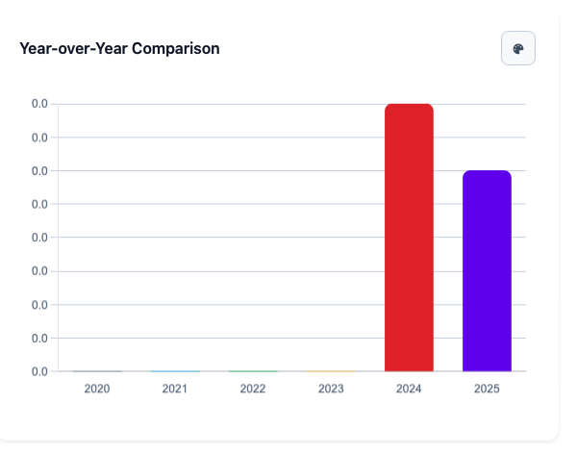

Monthly Emissions Trend (total)
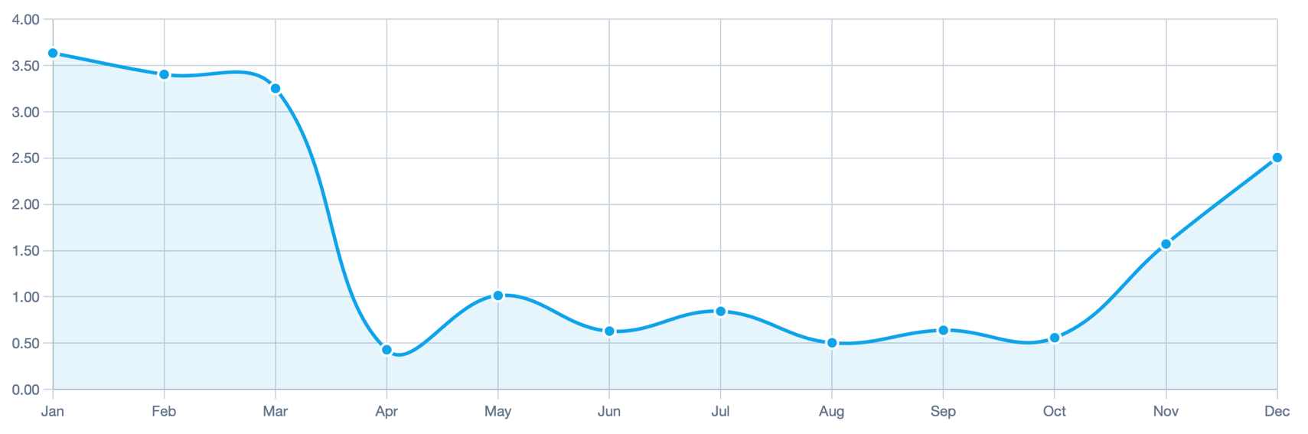

Monthly Trend by Source (All) Monthly Trend by Source (All)

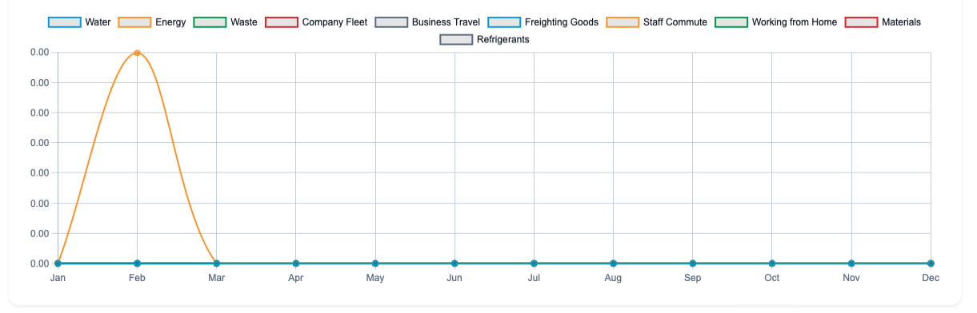

Monthly Emissions Trend — Water
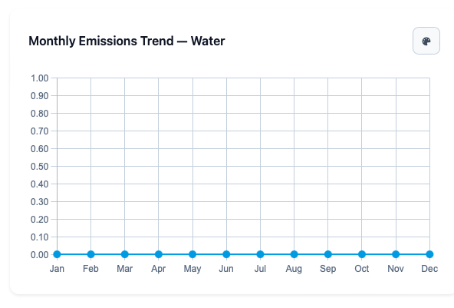\

Monthly Emissions Trend — Waste energy etc

