Doctor License Management System
A full-stack Doctor License Management module built for a Medical SaaS platform technical assessment.

Tech Stack

Backend
- ASP.NET Core 8 Web API
- Clean Architecture
- CQRS with MediatR
- Entity Framework Core
- SQL Server
- Dapper
- FluentValidation
- AutoMapper
- Swagger

Frontend
- Next.js (App Router)
- TypeScript
- Tailwind CSS

Features

Backend Features
- CRUD operations for doctors
- CQRS pattern using MediatR
- Repository Pattern
- Global Exception Middleware
- FluentValidation request validation
- AutoMapper object mapping
- Soft delete support
- Pagination support
- SQL Server stored procedure integration
- Search & filter support

Frontend Features
- Doctor listing table
- Search by name/license
- Filter by status
- Pagination
- Add doctor modal
- Edit doctor modal
- Delete doctor
- Status badges
- Expired doctor highlighting
- Loading states
- Responsive modern UI

Business Rules
- Duplicate license numbers are not allowed
- Expired licenses are automatically marked as Expired
- Soft delete is implemented
- Search supports:
  - Doctor name
  - License number
- Filter supports:
  - Active
  - Expired
  - Suspended

Architecture

Backend Architecture
The backend follows Clean Architecture principles:
DoctorLicenseManagement
│
├── API
├── Application
├── Domain
└── Infrastructure

Design Patterns Used
- CQRS
- Repository Pattern
- Dependency Injection
- Middleware Pattern

Stored Procedure
Doctor listing uses SQL Server stored procedure with:
- Search
- Status filter
- Pagination
- Expiry status logic
Stored Procedure:
sp_GetDoctors

Setup Instructions

Backend Setup

1. Navigate to backend
cd backend

2. Update connection string
Update:
DoctorLicenseManagement.API/appsettings.json

3. Apply database migrations
dotnet ef database update

4. Run API
dotnet run --project DoctorLicenseManagement.API
Swagger:
https://localhost:xxxx/swagger

Frontend Setup

1. Navigate to frontend
cd frontend

2. Install dependencies
npm install

3. Configure environment
Create:
.env.local
Add:
NEXT_PUBLIC_API_BASE_URL=https://localhost:xxxx/api

4. Run frontend
npm run dev
Frontend:
http://localhost:3000

API Endpoints
Method | Endpoint | Description
GET | /api/doctors | Get doctors
GET | /api/doctors/{id} | Get doctor by id
POST | /api/doctors | Create doctor
PUT | /api/doctors/{id} | Update doctor
PATCH | /api/doctors/{id}/status | Update status
DELETE | /api/doctors/{id} | Soft delete doctor

Screenshots

Swagger

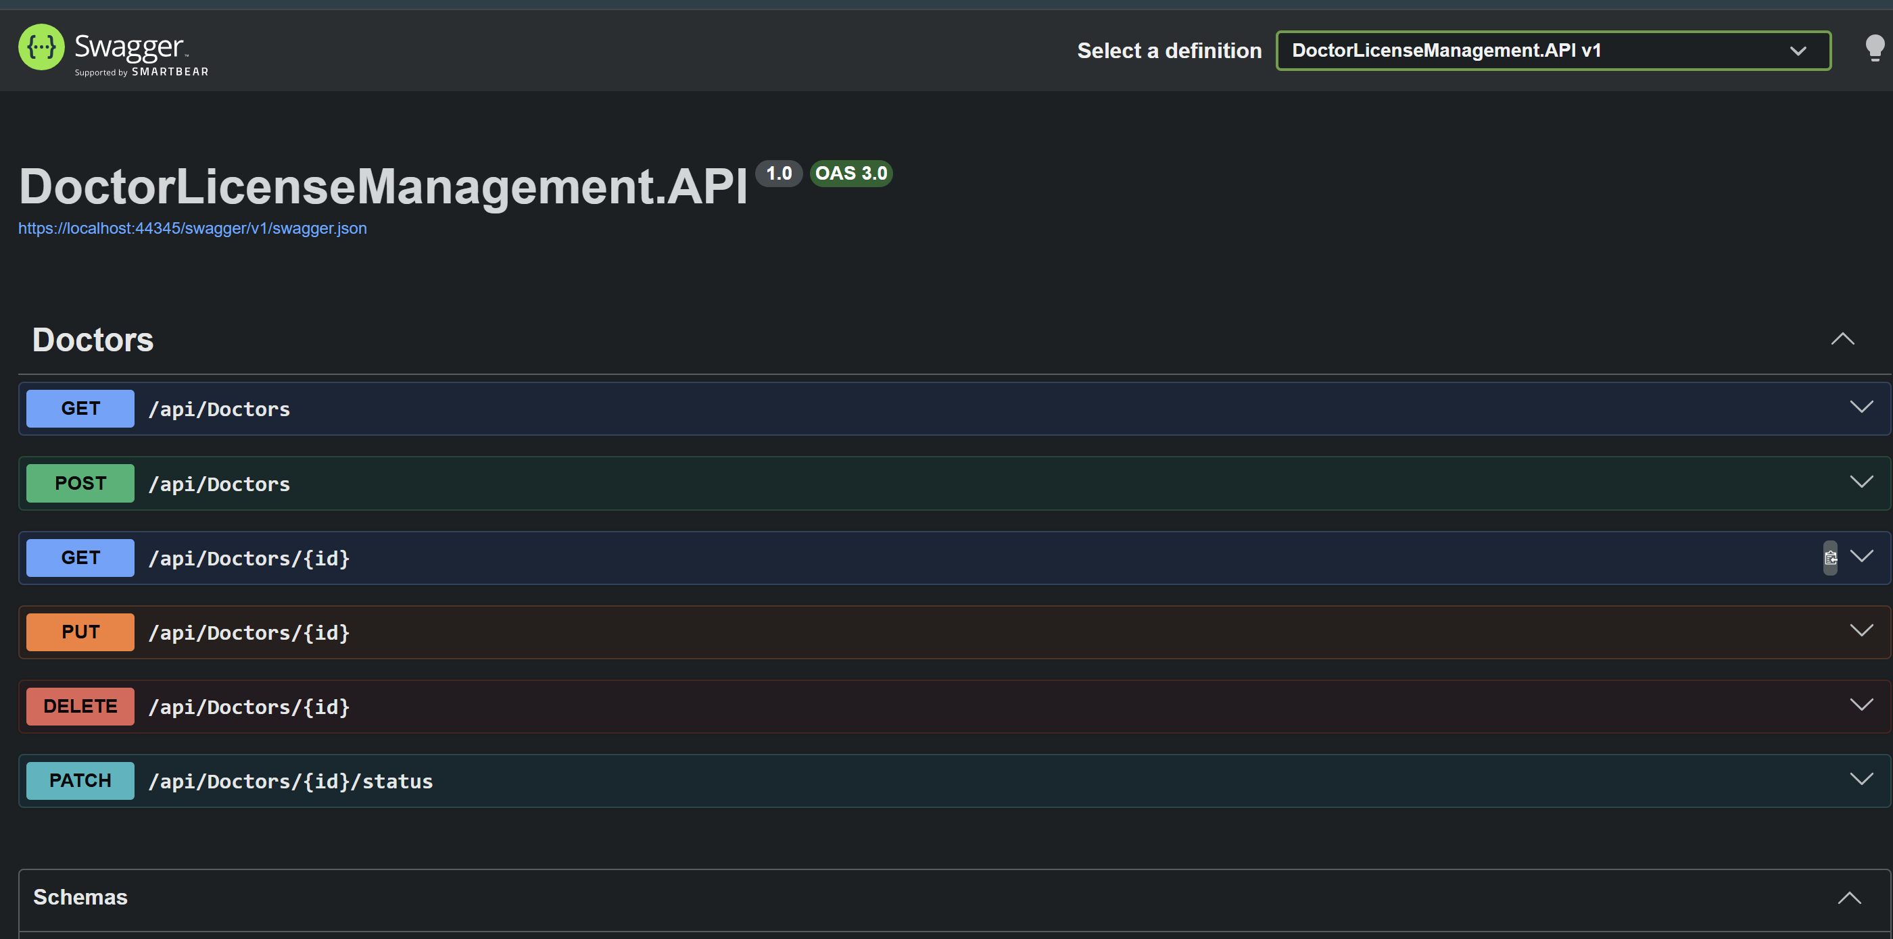

Doctor Listing
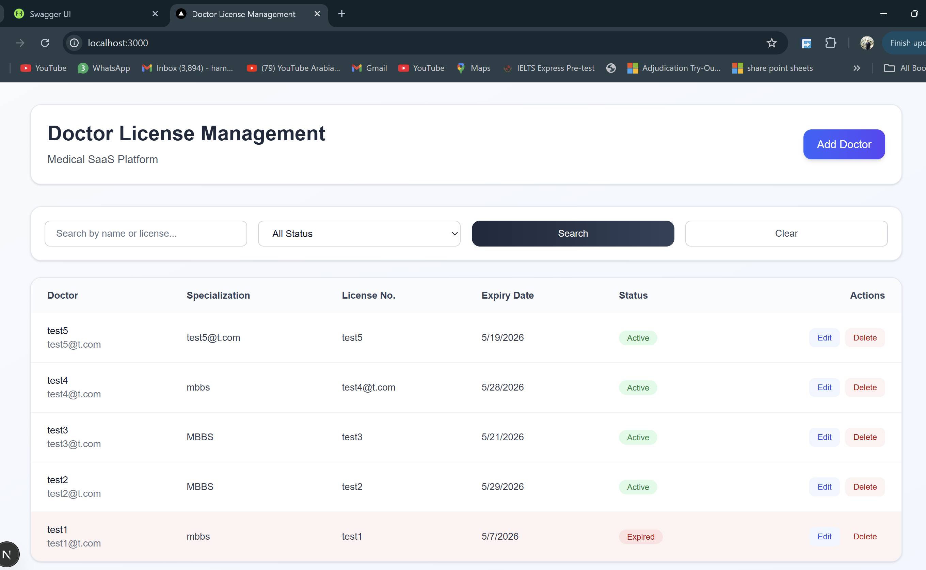

Add/Edit Modal
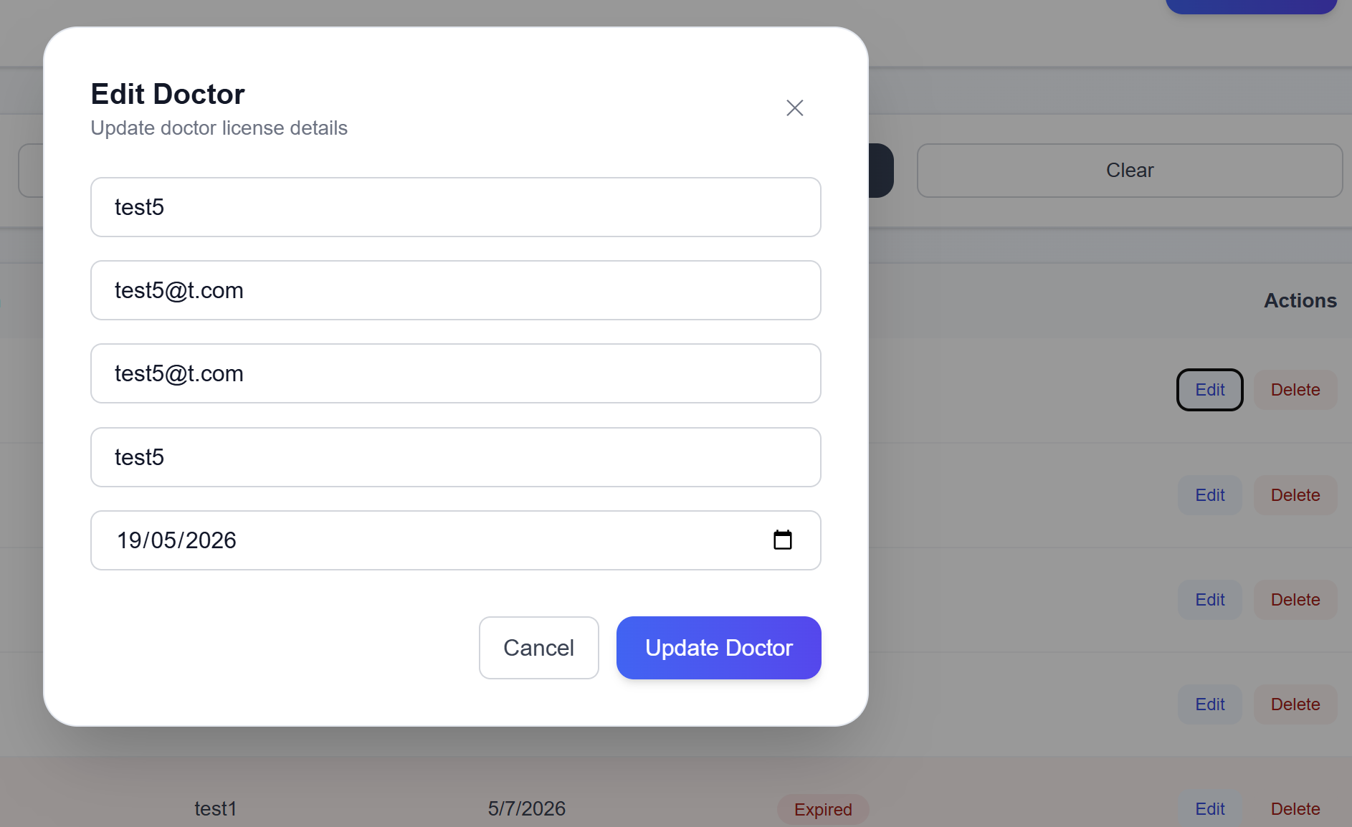

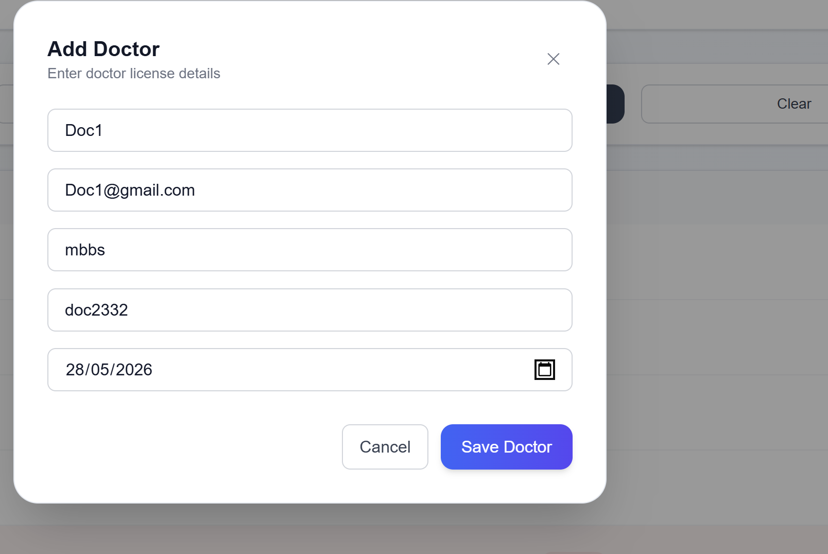

Pagination & Filters

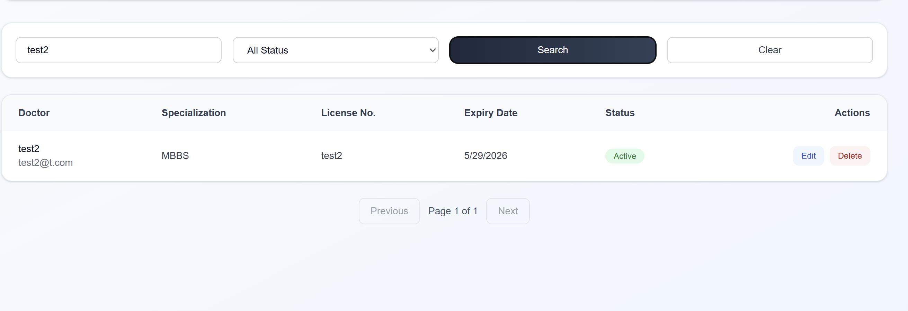

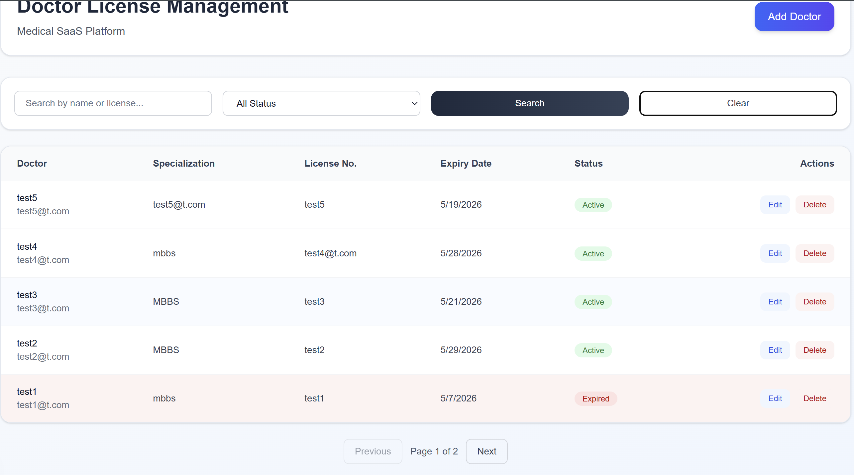

Technical Decisions
- Used CQRS + MediatR for separation of concerns
- Used Dapper for stored procedure execution
- Used EF Core for transactional operations
- Used AutoMapper for clean object mapping
- Used FluentValidation for request validation
- Used Tailwind CSS for fast modern UI development

Author
Hafiz Muhammad Hamza Nawaz Senior .NET Backend Engineer

