Setting up PyQt5 and Qt

* pip install pyqt5
* pip install pyqt5-tools
* pip install pyside2

Signal and Slot

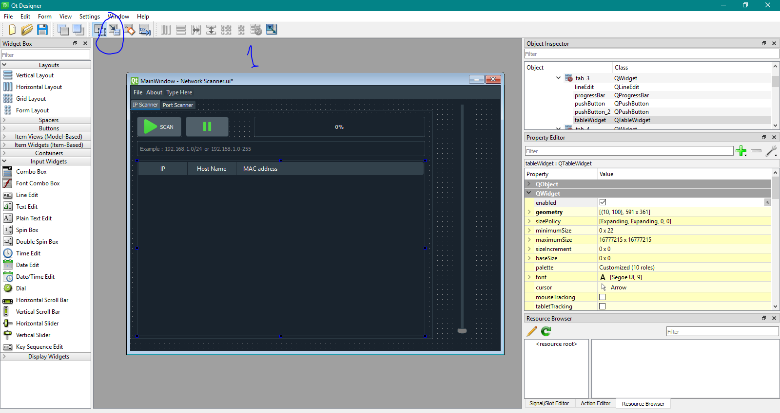

Then choose object(signal) and press ALT and gliss mouse to target(slot) object , then chose ValueChanged(int) => SetValue(int) : if value change in signal put it in slot

PyQT5 & Threading

To use Threading in Pyqt5 we use : QRunnable , QThreadPool , pyqtSlot

1 – in your Ui_MainWindow() Creat a Thread Pool

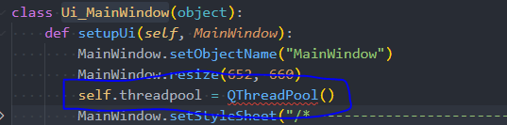

2 – Create a Function That will Start the Function Thread

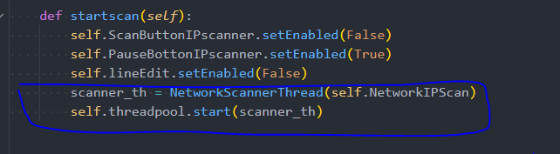

3 – Creat the Function Thread

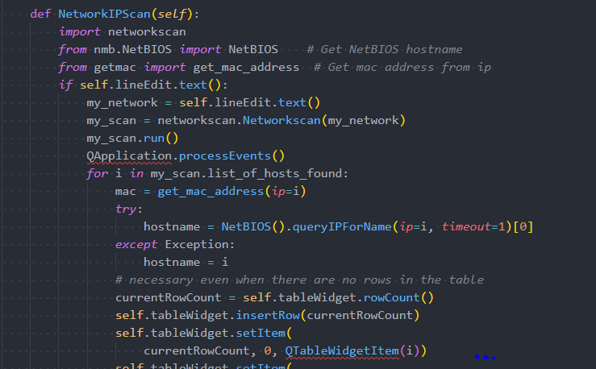

4 – Create The Thread Handler Class :

