With Removing title from the data

Naïve Bayes :

CountVectorizer -> max features = 25000

ngram = 1

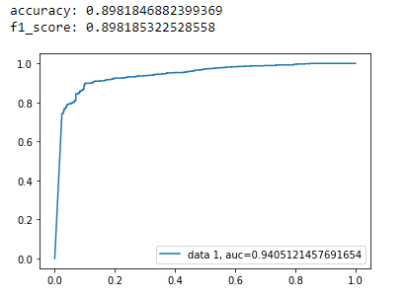

ngram = 1,2

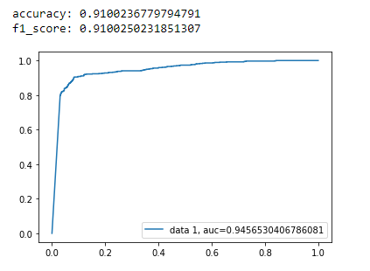

Ngram = 1,3

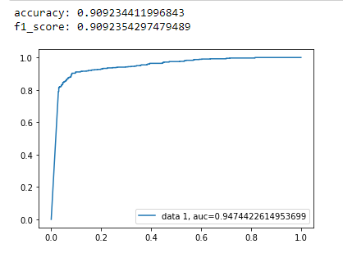

Tf-idf max-features = 25000

Ngram =1

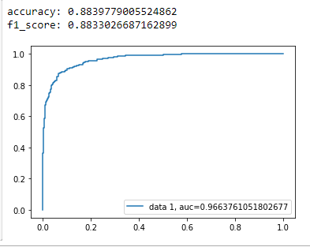

Ngram = 1,2

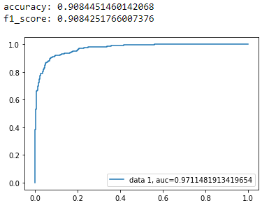

Ngram = 1,3

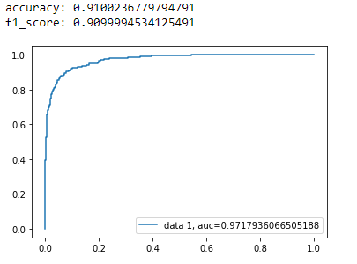

Random Forest n_estimators = 300

CountVectorizer -> max features = 25000

Ngram =1

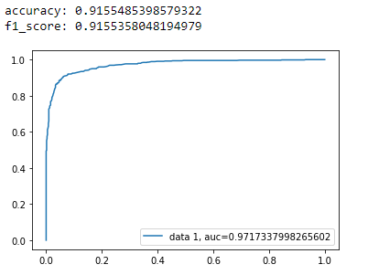

Ngram = 1,2

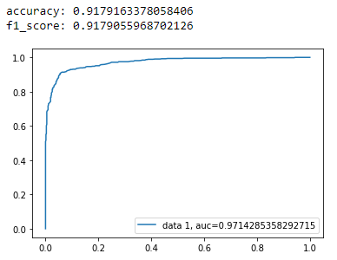

Ngram = 1,3

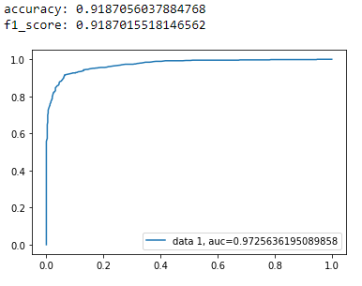

Tf-idf max-features = 25000

Ngram =1

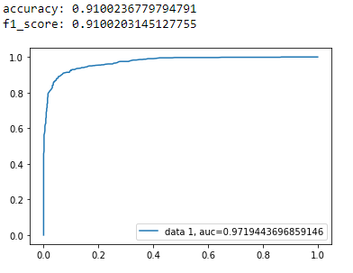

Ngram = 1,2

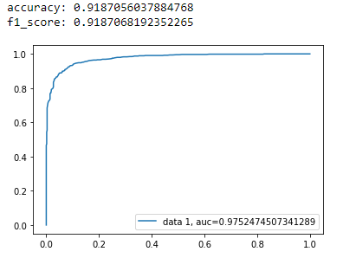

Ngram = 1,3

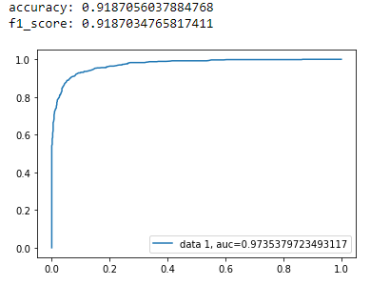

Xtreme Gradient Boosting n_estimators = 200

CountVectorizer -> max features = 25000

Ngram =1

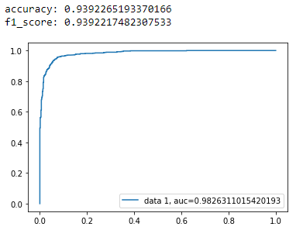

Ngram =2

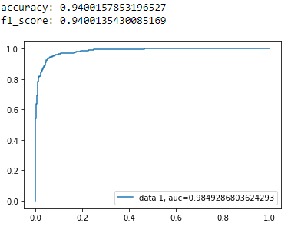

Ngram = 3

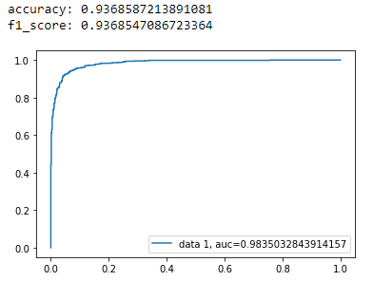

Tf-idf max features = 25000

Ngram =1

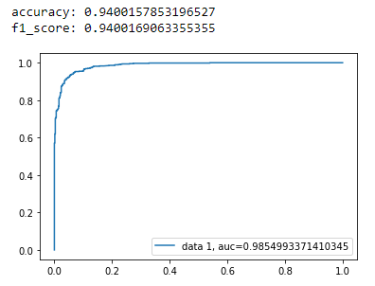

Ngram =1,2

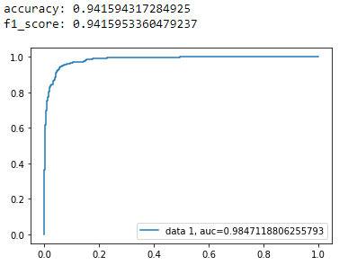

Ngram= 1,3

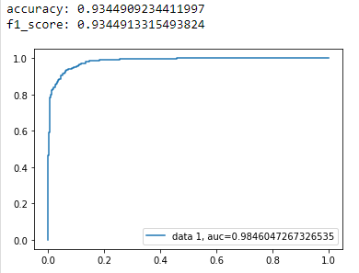

Passive Aggressive Classifier iter = 50

CountVectorizer -> max features = 25000

Ngram =1

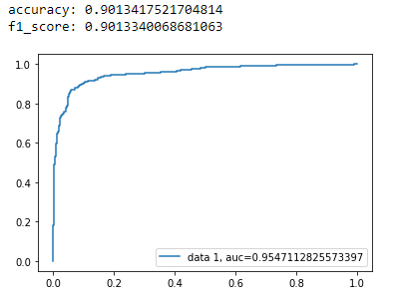

Ngram =2

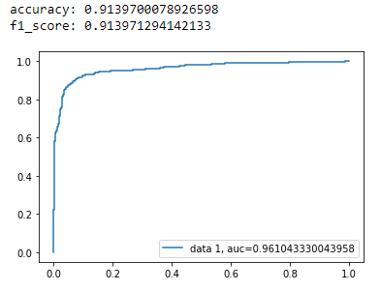

Ngram = 3

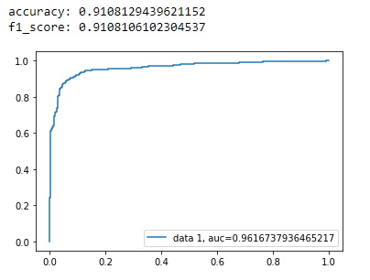

Tf-idf max features = 25000

Ngram =1

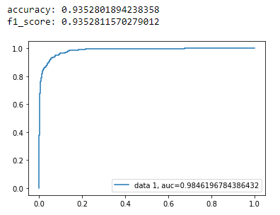

Ngram =1,2

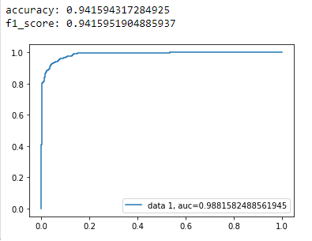

Ngram= 1,3

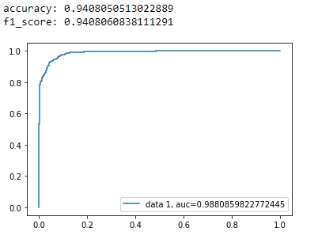

AdaBoostClassifier n_estimators = 100

CountVectorizer -> max features = 25000

Ngram =1

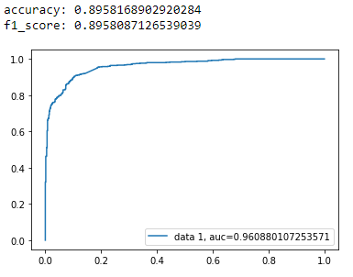

Ngram =2

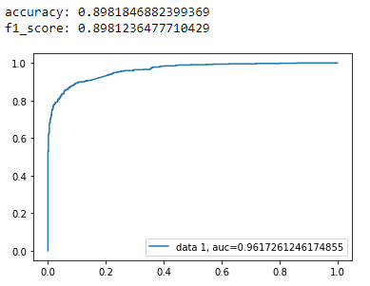

Ngram = 3

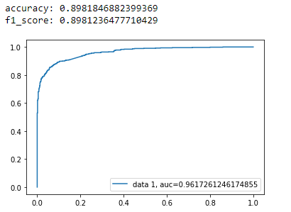

Tf-idf max features = 25000

Ngram =1



Ngram =1,2

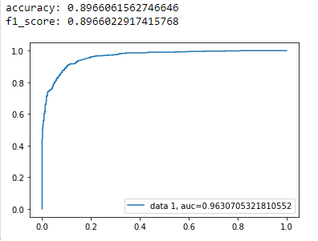

Ngram= 1,3

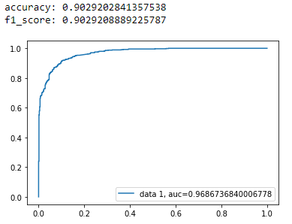

ExtraTreesClassifier n_estimators = 100

CountVectorizer -> max features = 25000

Ngram =1

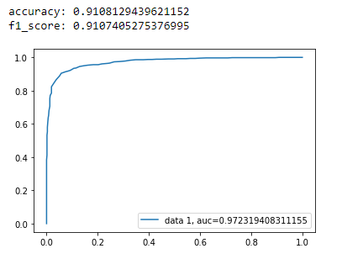

Ngram =2

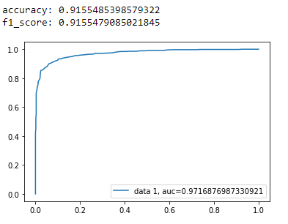

Ngram = 3

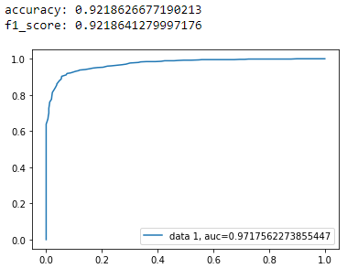

Tf-idf max features = 25000

Ngram =1

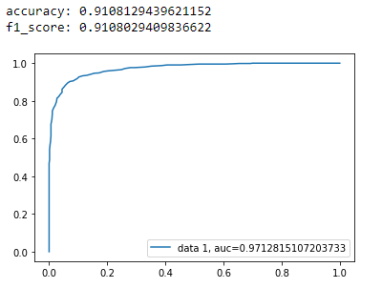

Ngram =1,2

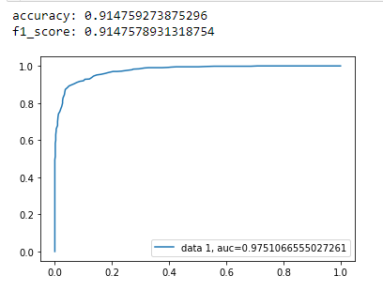

Ngram= 1,3

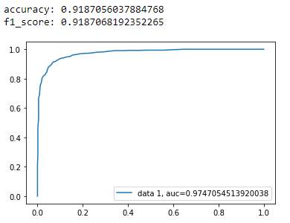

With incorporating the title we selected the best models from the above to use as our ML models

Xtreme Gradient Boosting n_estimators = 200

CountVectorizer -> max features = 25000

Ngram =1

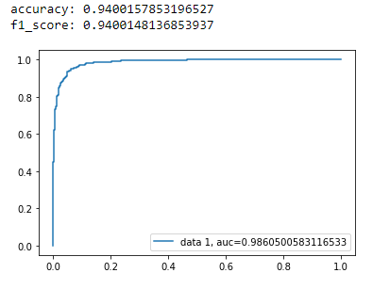

Ngram = 2

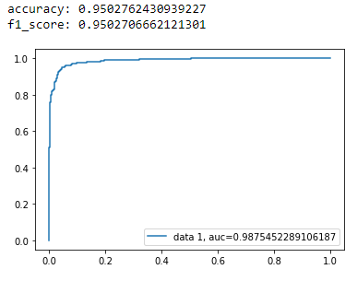

Ngram =3

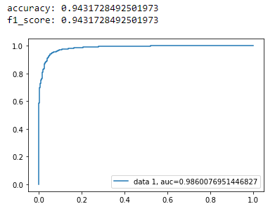

Tf-idf

Ngram = 1

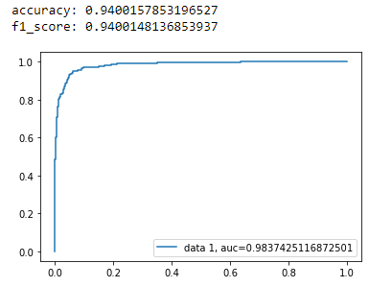

Ngram = 2

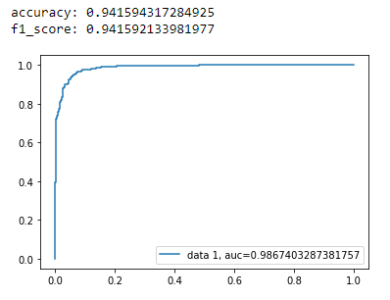

Ngram =3

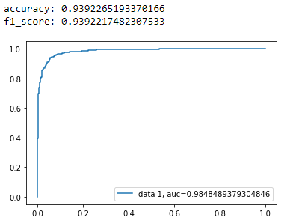

Passive Aggressive Classifier iter = 50

CountVectorizer -> max features = 25000

Ngram =1

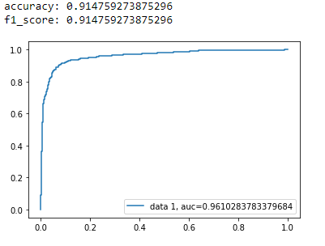

Ngram =1,2

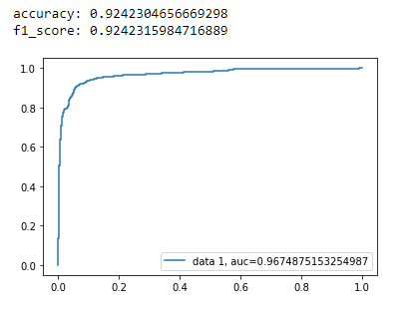

Ngram =1,3

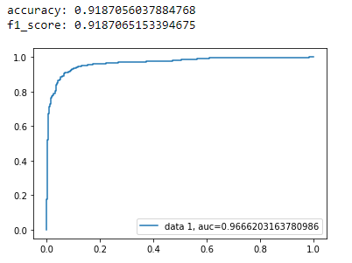

Tf-idf

Ngram =1

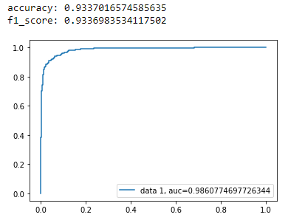

Ngram =1,2

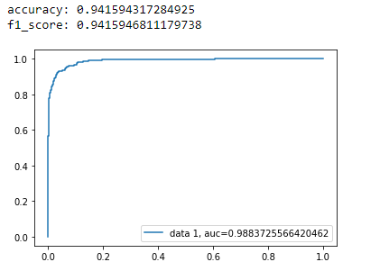

Ngram =1,3

