
ICT Project Report

By: Muhammad Abbas Ali (21i-0773)
&
Hamza Saeed (21i-0671)
Section: D

Welcome to ‘Road-Side Burgers’!
To start things off, when you open our website, the first page that pops up is the login/sign up page.
Here, the user will have to either login or sign up using their email.
Here’s how the login page looks like:

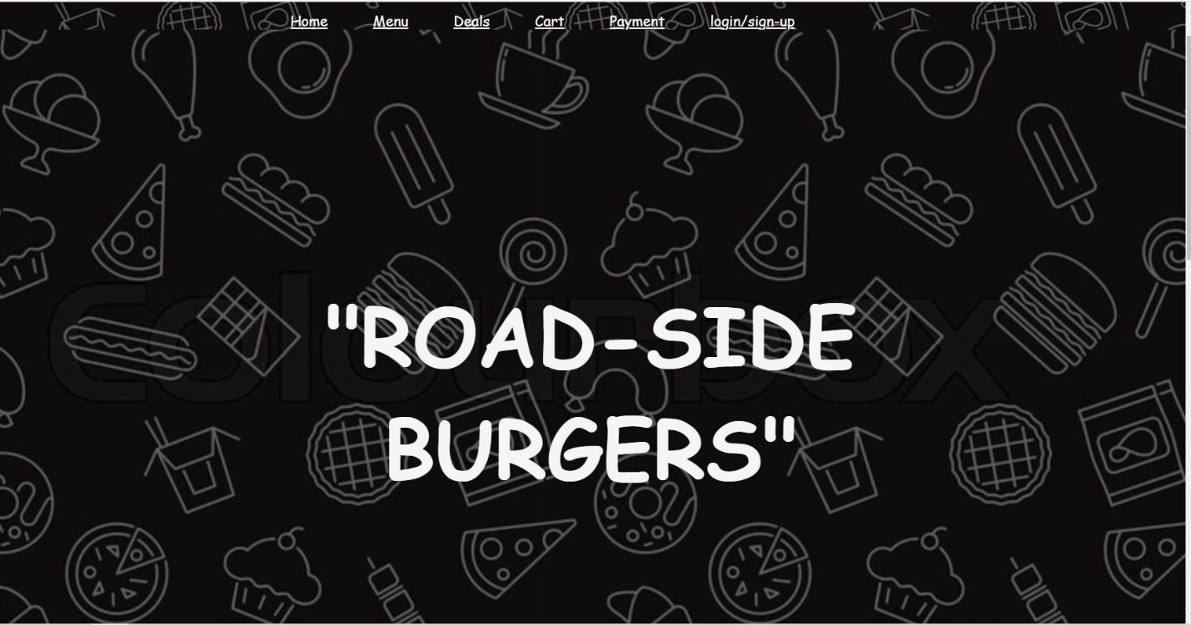

After the login/sign up, the user will then proceed to the home page,

The home page basically gives you a brief description of the joint and gives you an option to proceed the to :
- Menu
- Deals
- Cart
- Payment
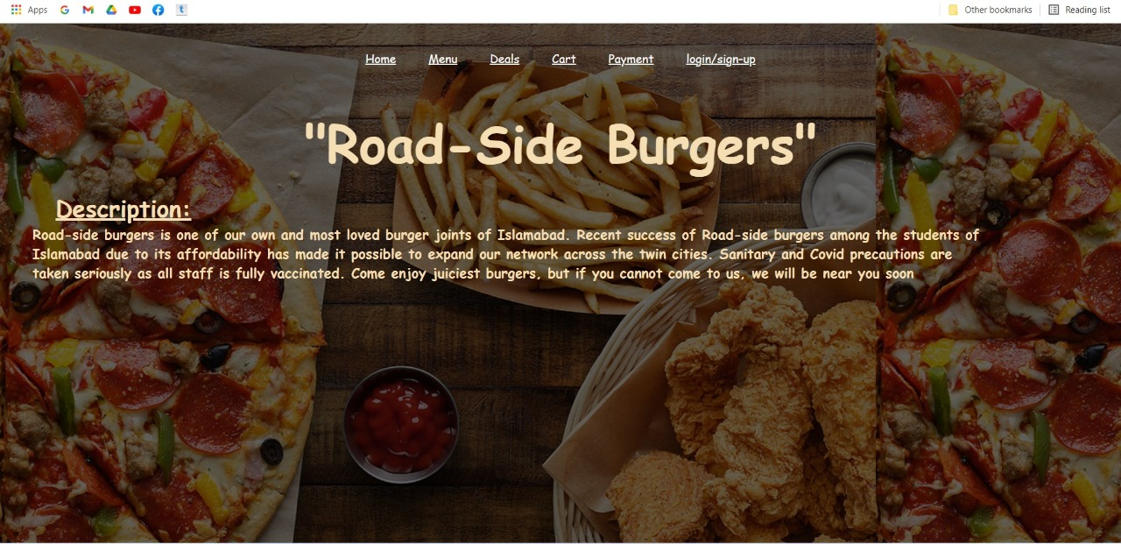

As you can see, all the options are provided on the top of the page to select from.

The Menu page basically shows all the available food items that can be ordered by the customer. It categorically shows a visual representation and the item’s price.
Here’s an example how the menu page might seem to you:
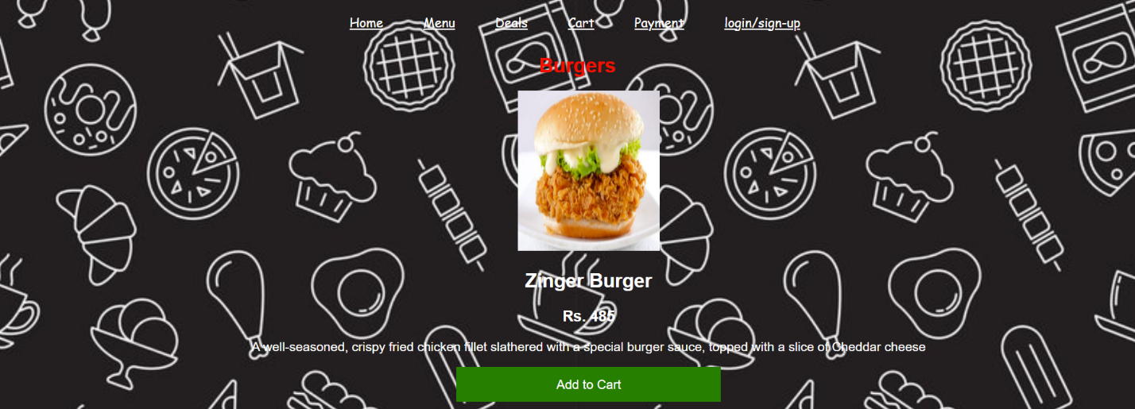
The user will have to scroll down in order view the other items and select from them,

The user also has an option to view the deals section. Here we give combo options to the customer to choose from, if they want to order more in quantity.
A visual representation of a deal in the Deals menu :
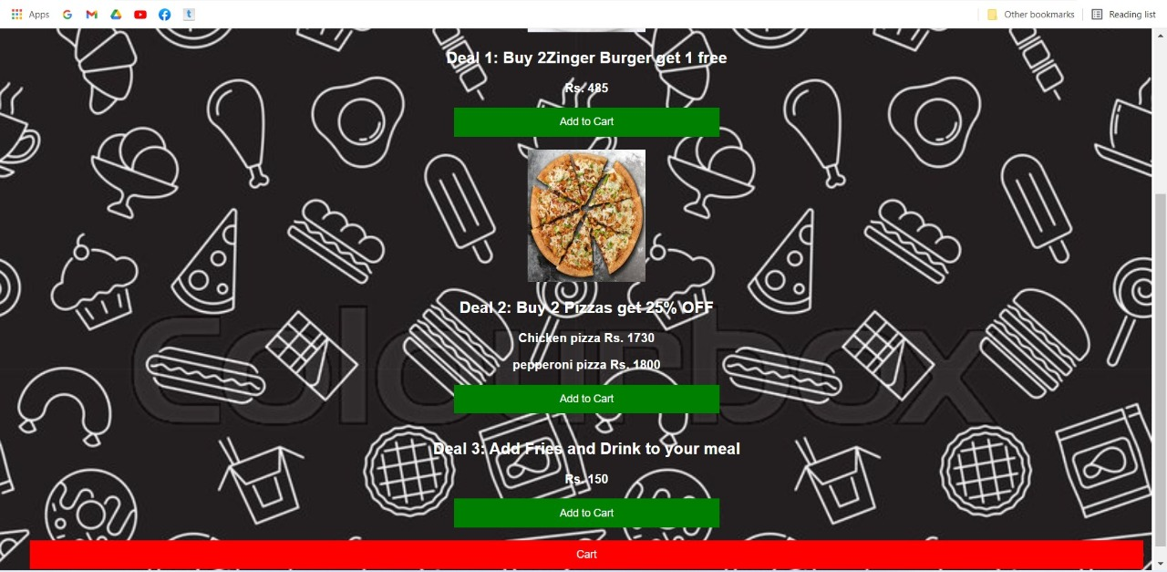

The customer has an option to add the deals to their cart to buy them.

Talking about the cart, the cart basically gives you a summary of the items you have selected and wish to buy.
The cart will let you know the exact name and price of the order and also the total bill.
The cart looks like:
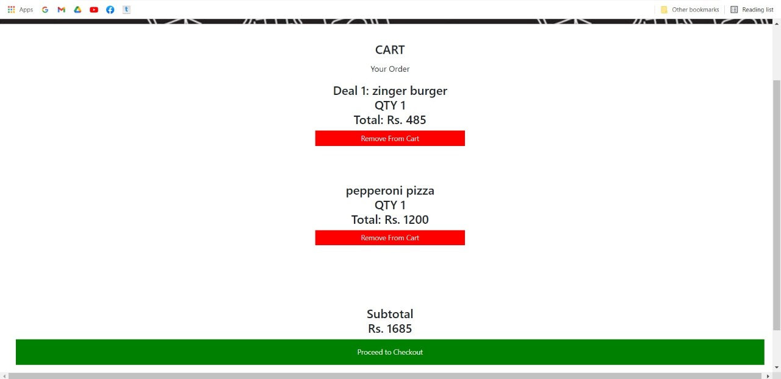

This popup window is the cart, this gives you and idea of your order and leads you to the checkout.

The check out is the final phase of ordering. It asks you to give your:
- Full name
- Mobile number
- Address
- Card information
And then gives you a final overview of you your order.
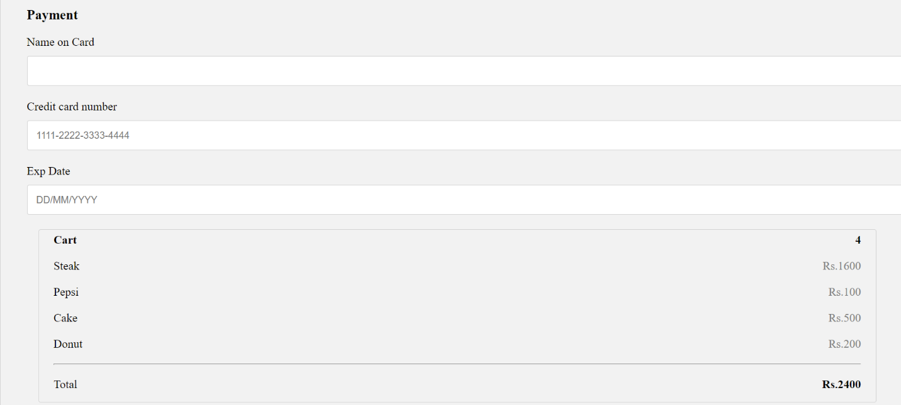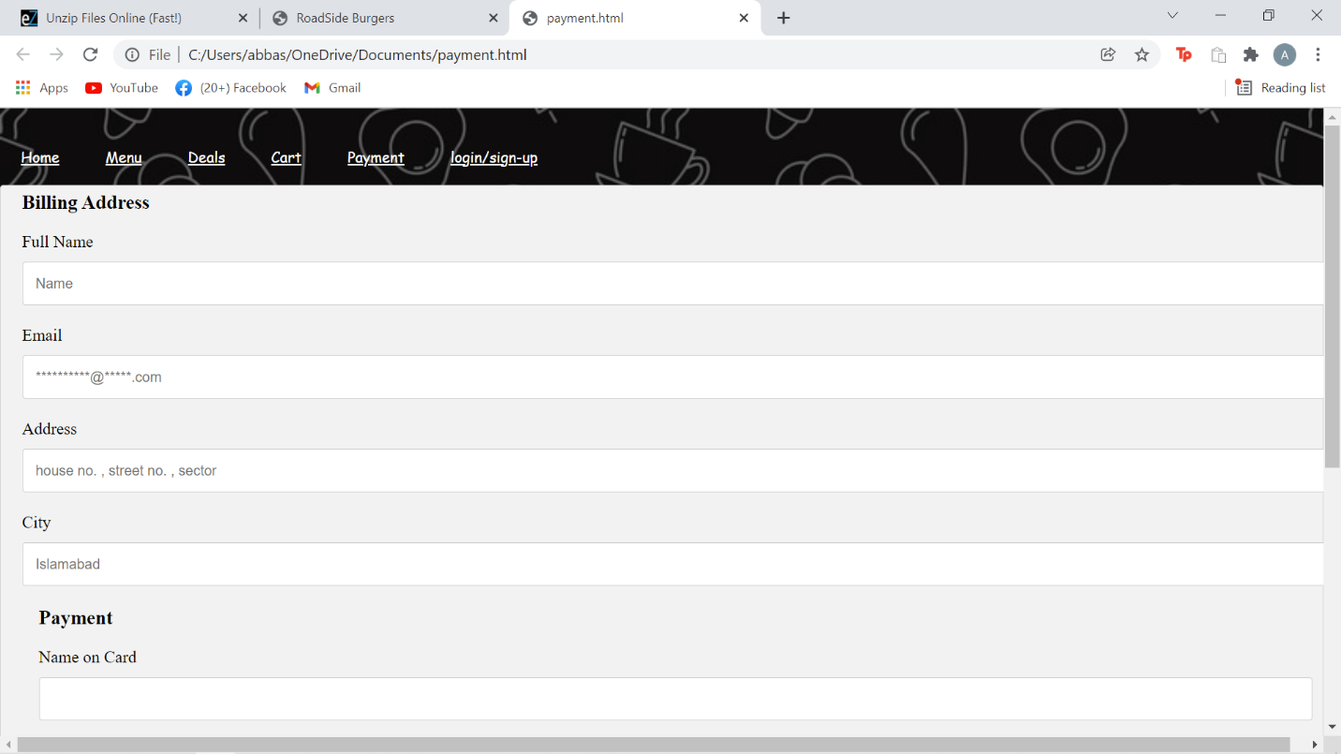

Thank You!

