**Predicting Diabetes Mellitus Using Machine Learning Techniques**

Report Title: Diabetes Prediction and Analysis Report

Summary

This report presents an analysis of a diabetes dataset and the development of machine learning models for predicting diabetes outcomes. The dataset contains information on various health-related features and whether individuals have diabetes. The report covers data preprocessing, exploratory data analysis (EDA), and the implementation of three machine learning models: Decision Trees, Support Vector Machine (SVM), and Random Forest, along with a neural network model.

Introduction

Background

Diabetes is a prevalent health condition that affects a significant portion of the population. Accurate prediction and understanding of the factors influencing diabetes outcomes are crucial for better management and prevention. This report aims to analyze a dataset containing various health-related features and implement machine learning models to predict diabetes outcomes.

Problem Statement

Diabetes is a widespread health condition with serious health implications. Early diagnosis and effective management are crucial to improve patients' quality of life. Predicting diabetes outcomes using machine learning models can assist in early intervention and treatment.

Motivation

The motivation behind this analysis is to develop accurate prediction models for diabetes outcomes. By analyzing a comprehensive dataset, we aim to understand the key factors that influence diabetes and provide healthcare professionals and individuals with a valuable tool for prevention and management.

Literature Review

Diabetes Prediction Models

Several studies have explored the use of machine learning for diabetes prediction. These studies have used various algorithms, including decision trees, support vector machines, and random forests. The use of deep learning techniques, such as neural networks, has also gained attention. These approaches have shown promise in achieving accurate predictions. Additionally, feature engineering and data preprocessing have been key factors in improving model performance.

System Overview

The system is designed to analyze a dataset containing health-related features and predict diabetes outcomes using machine learning models. The key components of the system include:

* Data Preprocessing: Handling missing values and feature selection.
* Exploratory Data Analysis: Visualizing and understanding the dataset.
* Machine Learning Models: Implementing Decision Trees, Support Vector Machine (SVM), Random Forest, and a Neural Network.
* Model Evaluation: Assessing model performance using accuracy, confusion matrices, and ROC curves.

Project Workflow

Import Libraries :

We used very important libraries such as NumPy, Pandas, Matplotlib, Seaborn, Scikit-Learn, TensorFlow, Keras, and Pydotplus  
  
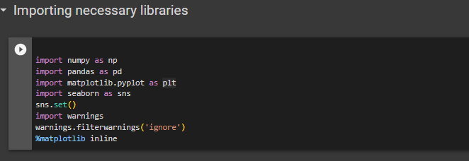

Dataset Overview:

The dataset used for this analysis contains information related to diabetes, including features like Glucose, BloodPressure, SkinThickness, Insulin, BMI, DiabetesPedigreeFunction, and Age. The target variable is "Outcome," indicating whether an individual has diabetes (1) or not (0).

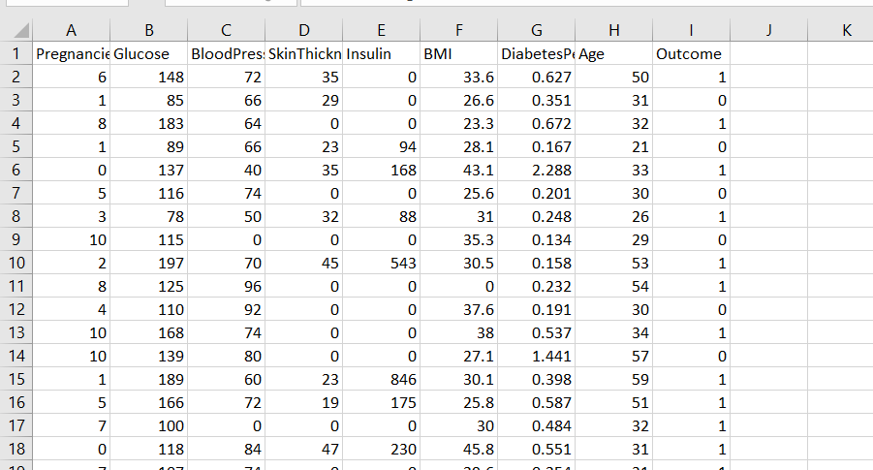

Import Dataset:  
Import the dataset in the system so we can do an analysis on that  
  
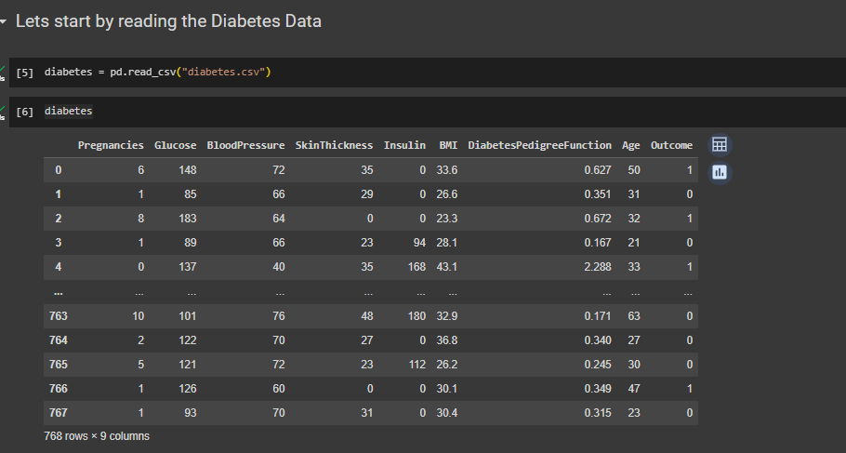

Data Preprocessing:  
The data processing includes the following:

Handling Missing Values

Missing values in the dataset were identified and replaced with appropriate values. Features such as Glucose, BloodPressure, SkinThickness, Insulin, BMI were replaced with the median values.

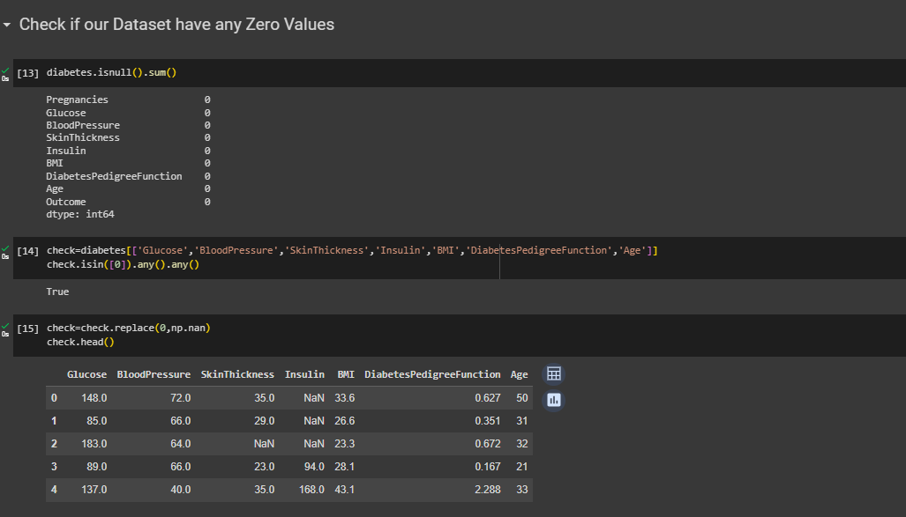

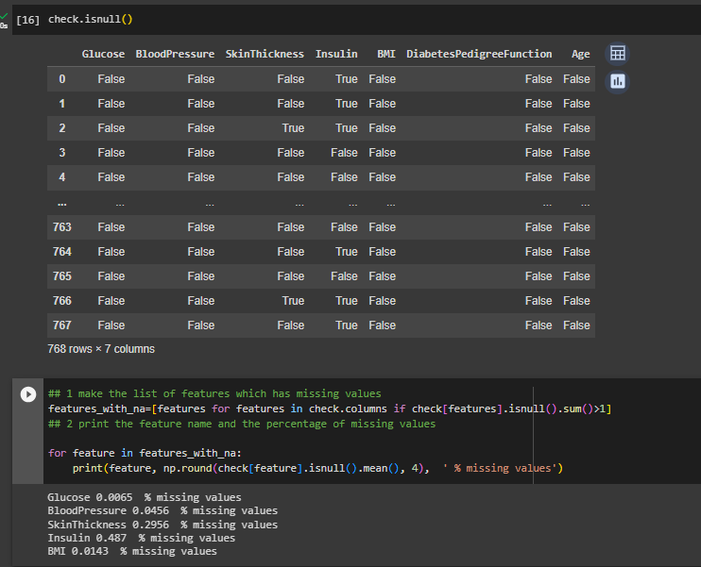  
  
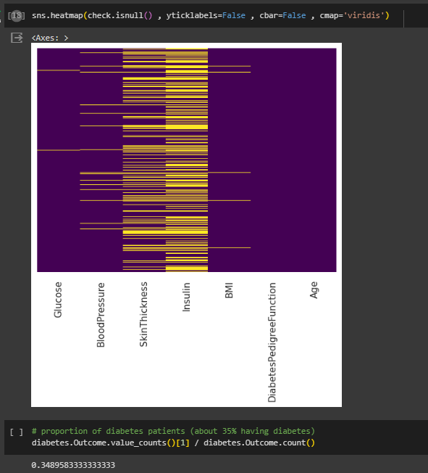  
  
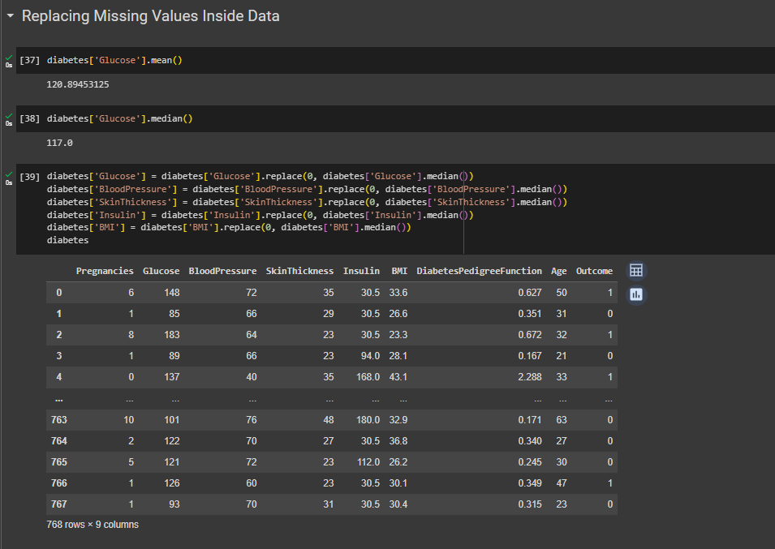  
  
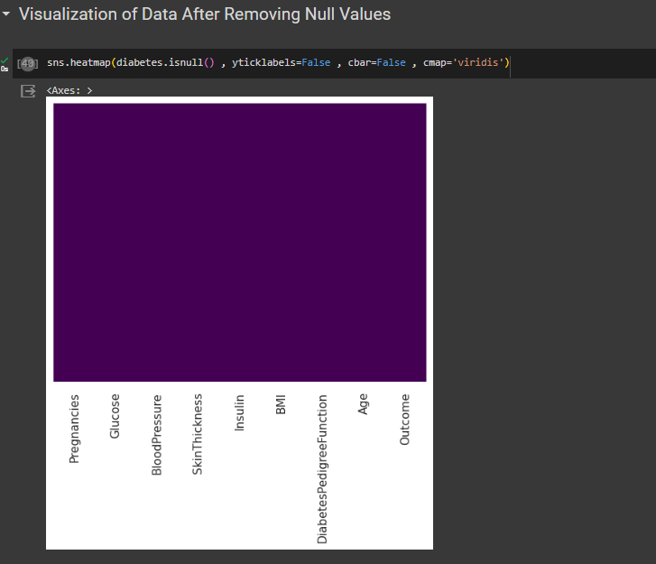

Feature Selection

Feature selection was performed, and the following features were chosen for model development: 'Pregnancies', 'Insulin', 'BMI', 'Age', 'Glucose', 'BloodPressure', 'DiabetesPedigreeFunction'.  
  
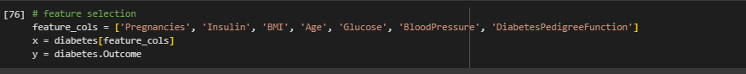

Data Standardization

The data was standardized using the StandardScaler to ensure that features have a mean of 0 and a standard deviation of 1.  
  
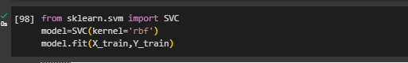

Exploratory Data Analysis (EDA)

Data Visualization

Various data visualizations were generated to gain insights into the dataset. These visualizations included histograms, pair plots, and correlation heatmaps. They helped understand the distribution of features and their relationships.  
  
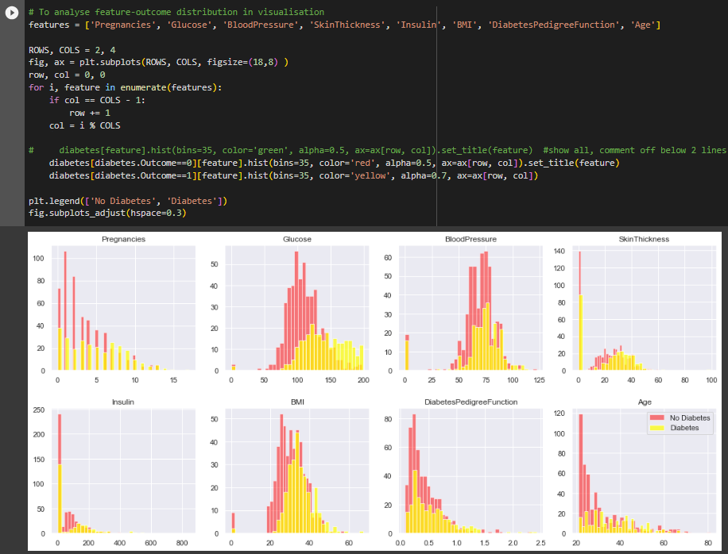  
  
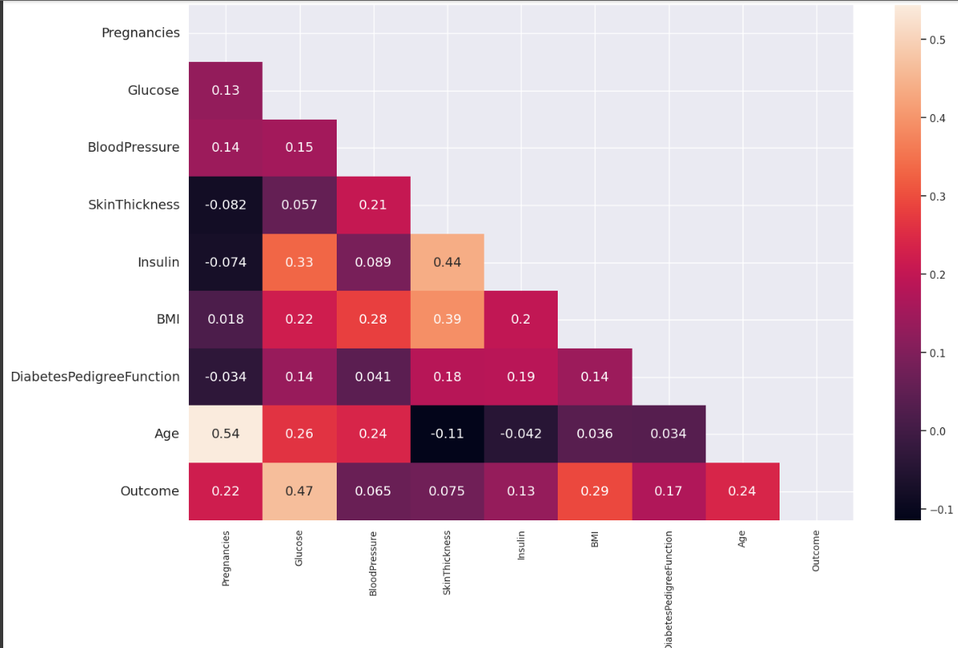

Feature Analysis

The analysis of features showed that certain features had a significant impact on diabetes outcomes. Glucose was found to be strongly correlated with the outcome. The distribution of features for diabetic and non-diabetic patients was also visualized.  
  
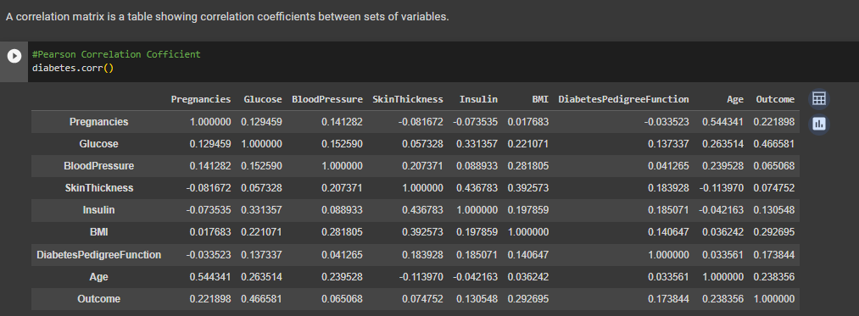  
  
Machine Learning Models

Decision Trees:

A decision tree is a structured, tree-like graphical representation used in decision analysis and machine learning to model decisions and their potential outcomes. It consists of nodes representing decisions, chance events, and end results, along with branches connecting them to illustrate the decision-making process and possible consequences. Decision trees are commonly used for classification and regression tasks in data analysis and predictive modeling.

A Decision Tree classification model was implemented and evaluated for its accuracy in predicting diabetes outcomes. The model was visualized to understand the decision-making process.  
  
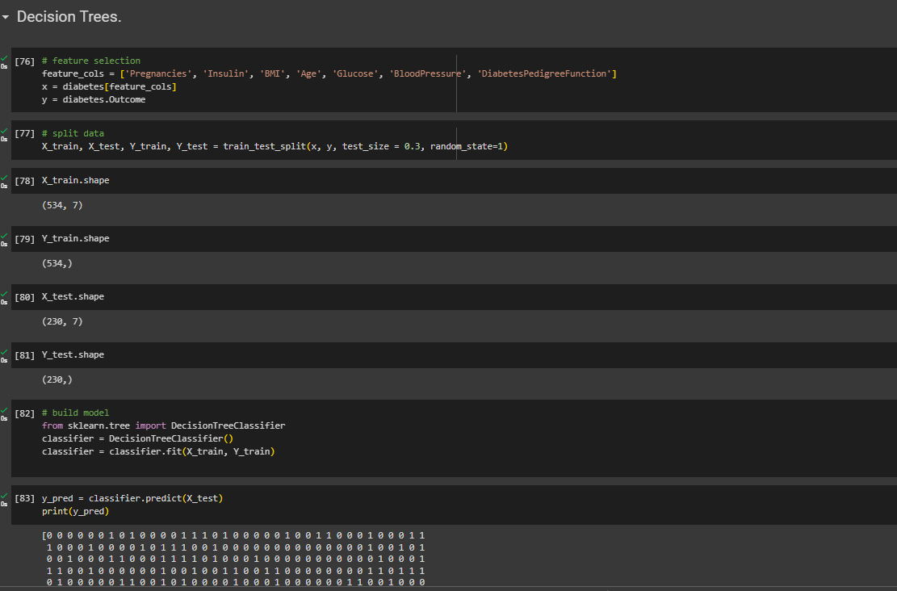

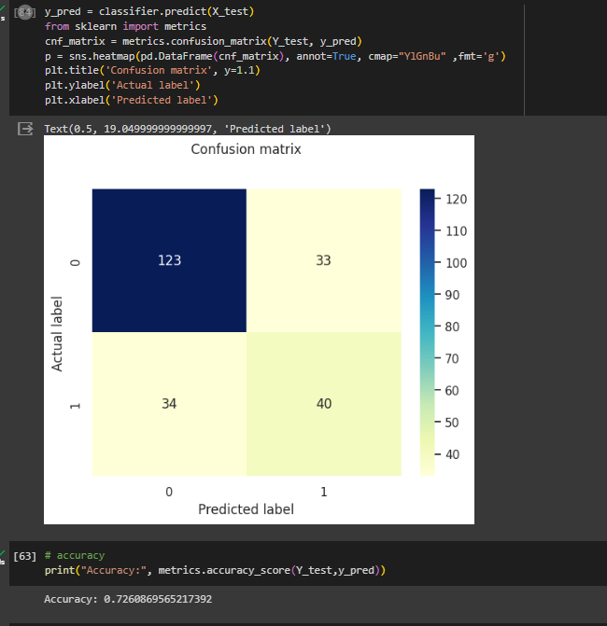  
  
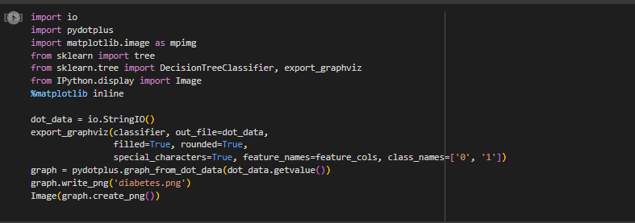  
  
  
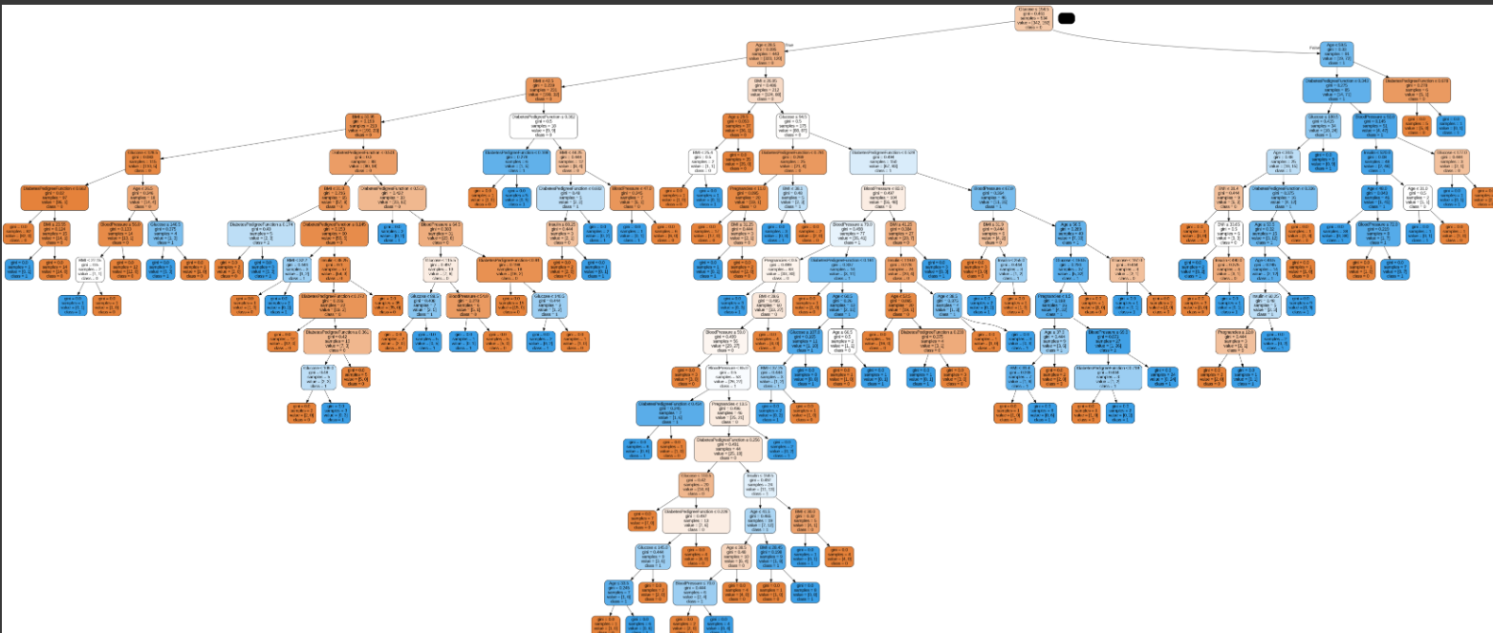

Support Vector Machine (SVM)

A Support Vector Machine (SVM) is a powerful machine learning algorithm used for classification and regression tasks. It finds a decision boundary (hyperplane) that best separates data into distinct classes while maximizing the margin between those classes. SVMs work by identifying support vectors, which are data points closest to the decision boundary, and these support vectors help determine the optimal hyperplane. SVMs are effective in handling complex, high-dimensional data and are known for their ability to generalize well in various applications.  
  
An SVM model with RBF kernel was implemented and evaluated. The model's accuracy and confusion matrix were analyzed. An ROC curve was plotted to assess the model's performance.

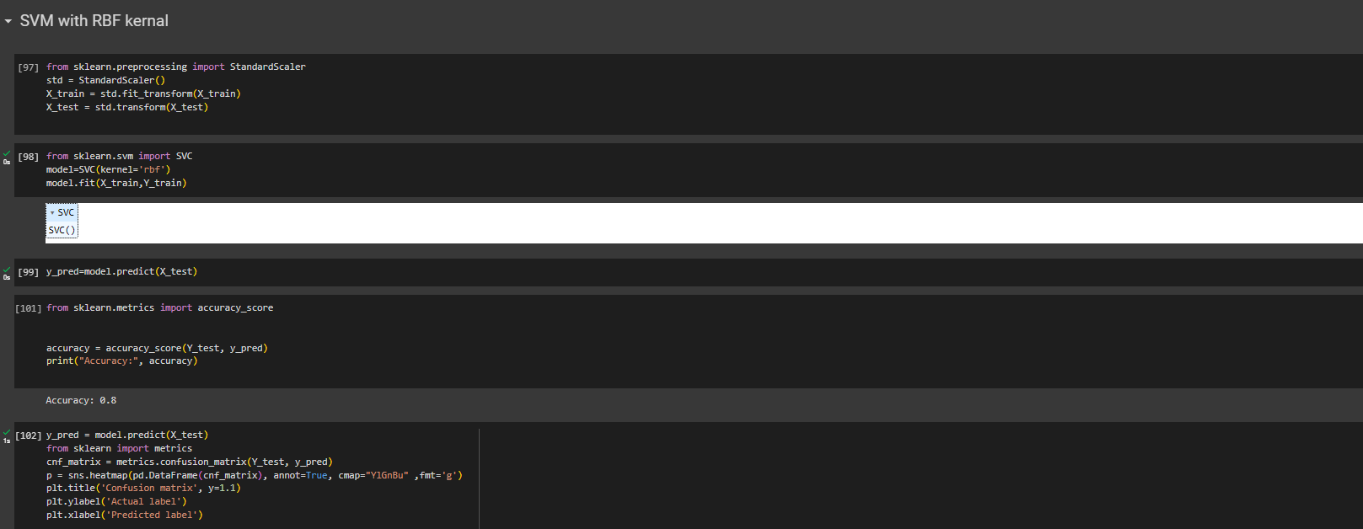  
  
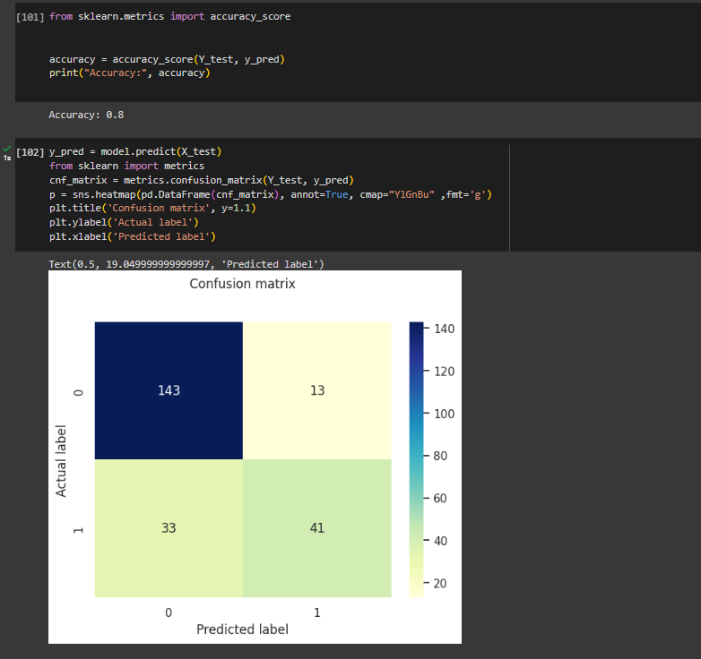  
  
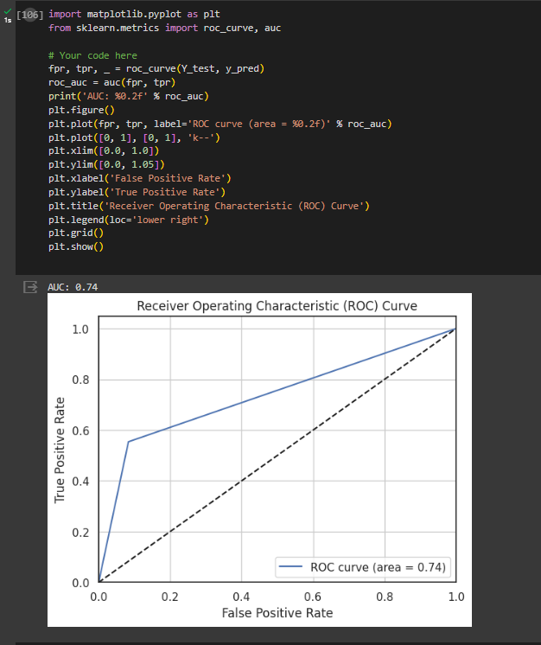  
  
  
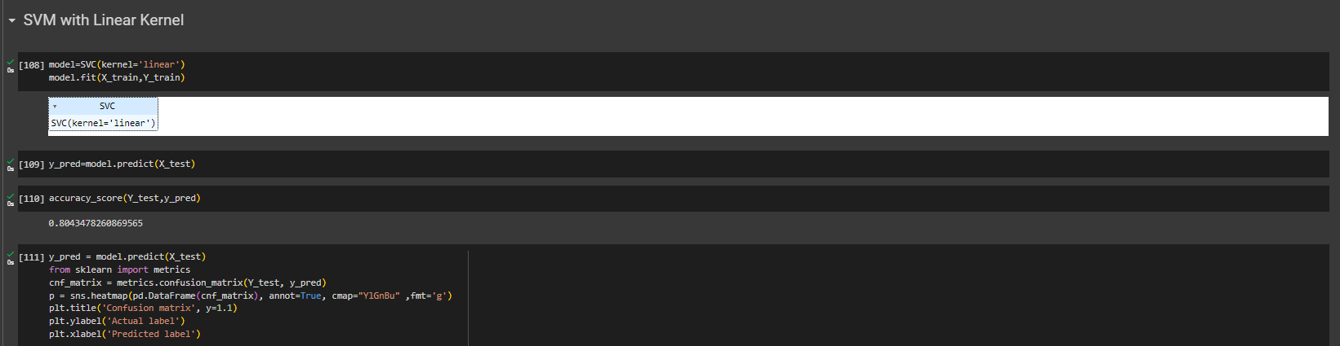  
  
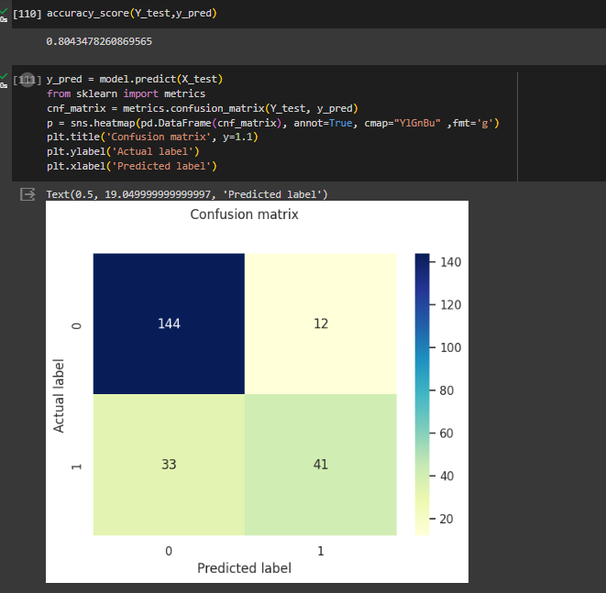  
  
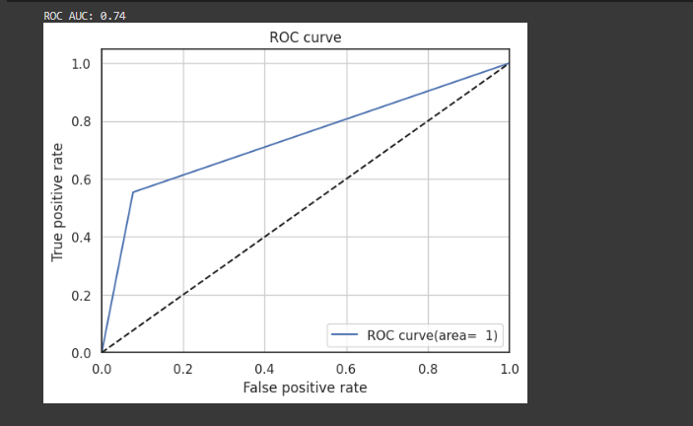

Random Forest

A Random Forest is an ensemble machine learning technique that combines multiple decision trees to improve prediction accuracy and reduce overfitting. It works by creating a "forest" of decision trees, each trained on a random subset of the data and using random feature subsets. The final prediction is determined by aggregating the predictions of all the individual trees. Random Forests are robust, versatile, and effective for both classification and regression tasks, making them a popular choice in many machine learning applications.  
A Random Forest classification model was implemented and evaluated. The model's accuracy, confusion matrix, and ROC curve were analyzed. The decision tree of the Random Forest was visualized.

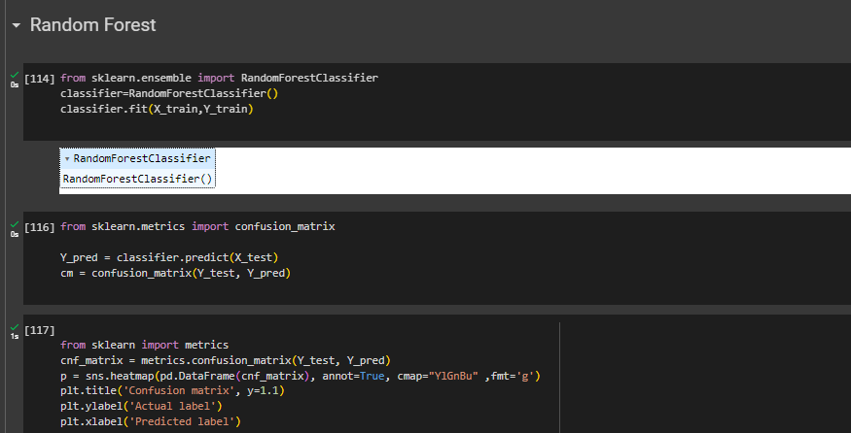  
  
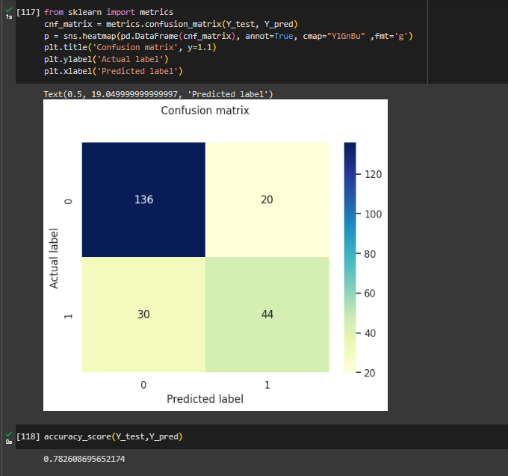  
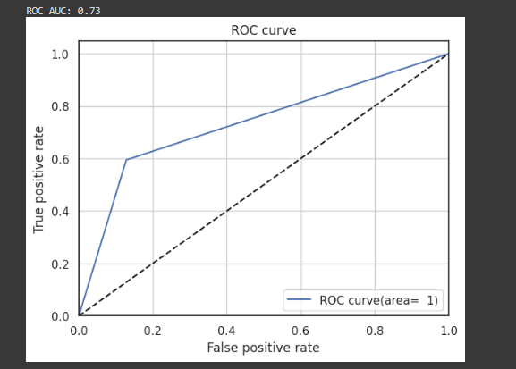  
  
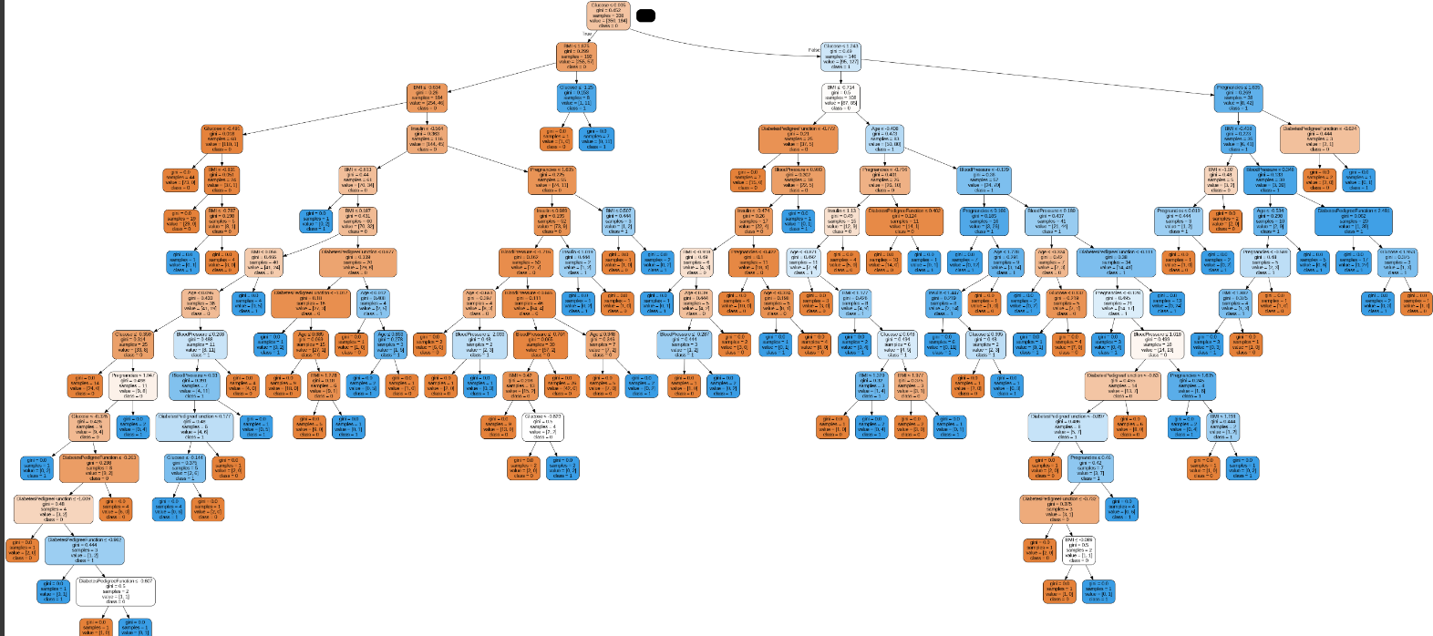

Neural Network

A neural network is a computational model inspired by the structure and function of the human brain. It's composed of layers of interconnected nodes (neurons) that process information.A simple neural network model was developed and trained using the dataset. The training and validation accuracy and loss were visualized.  
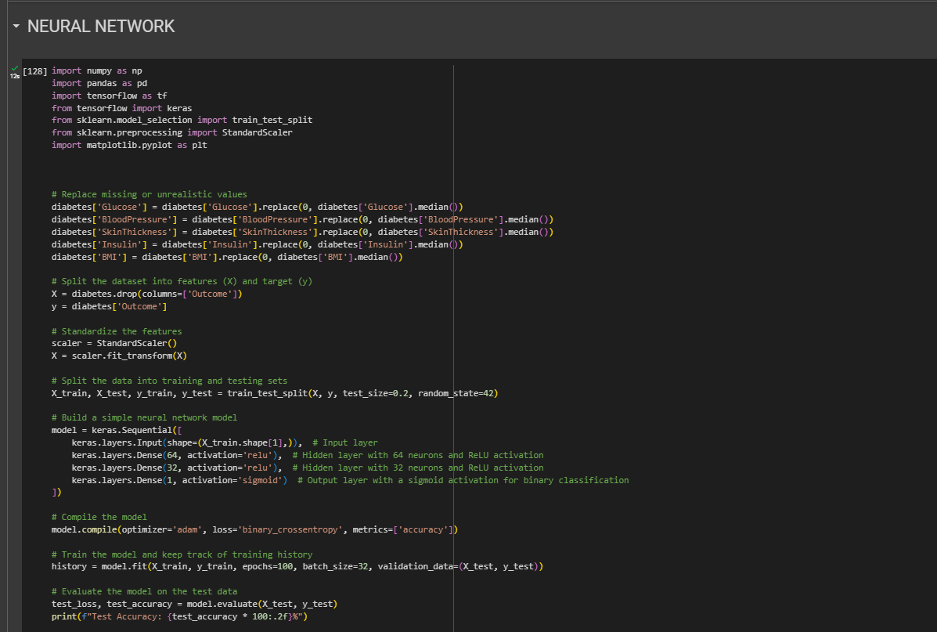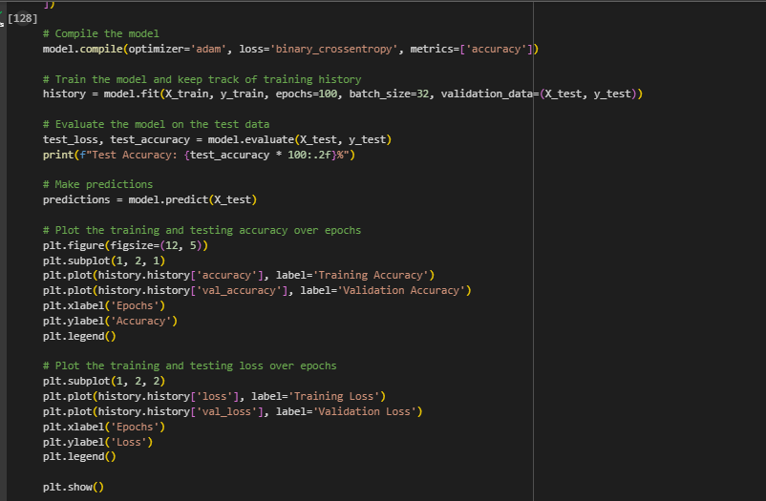



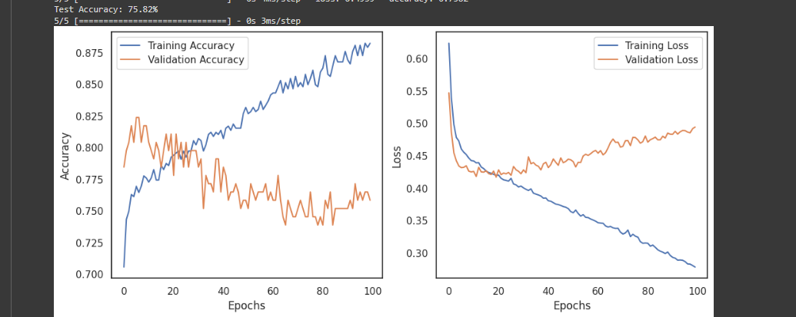  
  
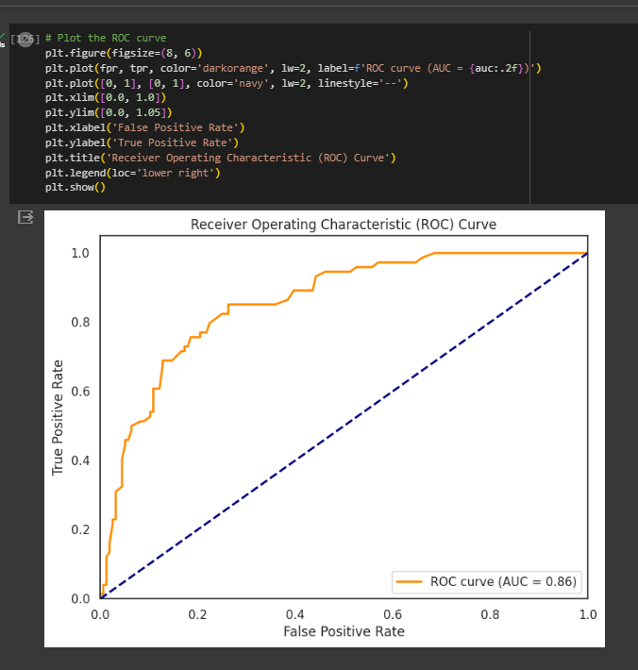

Software and Hardware Tools

Software Tools

* Python: Used for data analysis, model development, and visualization.
* Jupyter Notebook: Used for code development and documentation.

Hardware Tools

* CPU: The analysis can be performed on standard CPUs with sufficient RAM.
* GPU (Optional): For neural network training, a GPU can significantly speed up the process.

Conclusion

Summary of Results

* The Decision Trees model achieved an accuracy of 0.7260869565217392 .
* The SVM model (RBF kernel) achieved an accuracy of 0.8.
* The SVM model (Linear kernel) achieved an accuracy of 0.8043478260869565.
* The Random Forest model achieved an accuracy of 0.782608695652174 .
* The Neural Network model achieved an accuracy of 0.7582.

Recommendations

Based on the analysis and model results, the following recommendations can be made:

* Glucose is a significant factor in predicting diabetes outcomes.
* Further feature engineering and model tuning could improve model performance.
* Regular monitoring and early intervention can help in diabetes management.

References

* *Diabetes Dataset*. (n.d.). Www.kaggle.com.  
  <https://www.kaggle.com/datasets/akshaydattatraykhare/diabetes-dataset>
* Aurélien Géron. (2019). *Hands-On Machine Learning with Scikit-Learn, Keras, and TensorFlow*. “O’Reilly Media, Inc.”
* Bishop, C. (2006). *Pattern recognition and machine learning*. Springer Verlag.
* scikit-learn. (2009). *1.10. Decision Trees — scikit-learn 0.22 documentation*. Scikit-Learn.org. <https://scikit-learn.org/stable/modules/tree.html>
* Gandhi, R. (2018, June 7). *Support Vector Machine — Introduction to Machine Learning Algorithms*. Towards Data Science. https://towardsdatascience.com/support-vector-machine-introduction-to-machine-learning-algorithms-934a444fca47
* *Scikit - Learn Cheat Sheet: Python Machine Learning | Intellipaat*. (n.d.). Intellipaat Blog. https://intellipaat.com/blog/tutorial/python-tutorial/scikit-learn-cheat-sheet/
* Ng, A. (n.d.). *CS229 Lecture notes Support Vector Machines*. https://see.stanford.edu/materials/aimlcs229/cs229-notes3.pdf