**UNIVERSITY OF WAH**



**Department: Artificial Intelligence**

**Name of Assignment: Project**

**Name:** Muhammad Hamza Sajjad

**Subject:** Computer Networks

**Network Implementation Report**

**Topology/Confriguration**

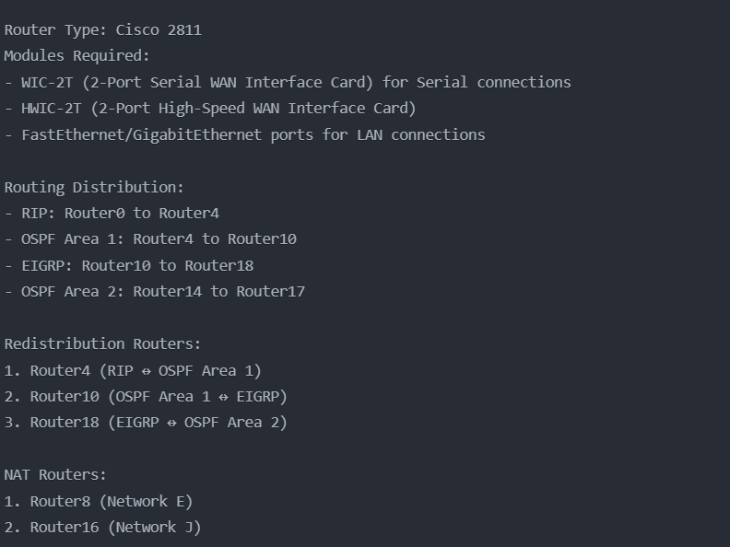

**Total Network Components Summary:**

Total Devices: 34 devices = 19 Routers (Cisco 2811 with WIC-2T modules) + 7 Switches (Cisco 2960-24TT) + 3 Access Points (AP-PT) + 3 Servers (1 DHCP, 1 Mail, 1 Web) + Various End Devices (PCs, Laptops, Smartphones, Tablets)

**1. VLSM Calculations**

**Public IP Addressing (Router-to-Router)**

The network 192.168.1.148/30 has 2 hosts.

Your subnets need 44 hosts.

|  |  |  |  |  |  |  |  |  |
| --- | --- | --- | --- | --- | --- | --- | --- | --- |
| Name | Hosts Needed | Hosts Available | Unused hosts | Network Address | Slash | Mask | Usable Range | Broadcast |
| 0 | 2 | 2 | 0 | 192.168.1.148 | /30 | 255.255.255.252 | 192.168.1.149 - 192.168.1.150 | 192.168.1.151 |
| 1 | 2 | 2 | 0 | 192.168.1.152 | /30 | 255.255.255.252 | 192.168.1.153 - 192.168.1.154 | 192.168.1.155 |
| 2 | 2 | 2 | 0 | 192.168.1.156 | /30 | 255.255.255.252 | 192.168.1.157 - 192.168.1.158 | 192.168.1.159 |
| 3 | 2 | 2 | 0 | 192.168.1.160 | /30 | 255.255.255.252 | 192.168.1.161 - 192.168.1.162 | 192.168.1.163 |
| 4 | 2 | 2 | 0 | 192.168.1.164 | /30 | 255.255.255.252 | 192.168.1.165 - 192.168.1.166 | 192.168.1.167 |
| 5 | 2 | 2 | 0 | 192.168.1.168 | /30 | 255.255.255.252 | 192.168.1.169 - 192.168.1.170 | 192.168.1.171 |
| 6 | 2 | 2 | 0 | 192.168.1.172 | /30 | 255.255.255.252 | 192.168.1.173 - 192.168.1.174 | 192.168.1.175 |
| 7 | 2 | 2 | 0 | 192.168.1.176 | /30 | 255.255.255.252 | 192.168.1.177 - 192.168.1.178 | 192.168.1.179 |
| 8 | 2 | 2 | 0 | 192.168.1.180 | /30 | 255.255.255.252 | 192.168.1.181 - 192.168.1.182 | 192.168.1.183 |
| 9 | 2 | 2 | 0 | 192.168.1.184 | /30 | 255.255.255.252 | 192.168.1.185 - 192.168.1.186 | 192.168.1.187 |
| 10 | 2 | 2 | 0 | 192.168.1.188 | /30 | 255.255.255.252 | 192.168.1.189 - 192.168.1.190 | 192.168.1.191 |
| 11 | 2 | 2 | 0 | 192.168.1.192 | /30 | 255.255.255.252 | 192.168.1.193 - 192.168.1.194 | 192.168.1.195 |
| 12 | 2 | 2 | 0 | 192.168.1.196 | /30 | 255.255.255.252 | 192.168.1.197 - 192.168.1.198 | 192.168.1.199 |
| 13 | 2 | 2 | 0 | 192.168.1.200 | /30 | 255.255.255.252 | 192.168.1.201 - 192.168.1.202 | 192.168.1.203 |
| 14 | 2 | 2 | 0 | 192.168.1.204 | /30 | 255.255.255.252 | 192.168.1.205 - 192.168.1.206 | 192.168.1.207 |
| 15 | 2 | 2 | 0 | 192.168.1.208 | /30 | 255.255.255.252 | 192.168.1.209 - 192.168.1.210 | 192.168.1.211 |
| 16 | 2 | 2 | 0 | 192.168.1.212 | /30 | 255.255.255.252 | 192.168.1.213 - 192.168.1.214 | 192.168.1.215 |
| 17 | 2 | 2 | 0 | 192.168.1.216 | /30 | 255.255.255.252 | 192.168.1.217 - 192.168.1.218 | 192.168.1.219 |
| 18 | 2 | 2 | 0 | 192.168.1.220 | /30 | 255.255.255.252 | 192.168.1.221 - 192.168.1.222 | 192.168.1.223 |
| 19 | 2 | 2 | 0 | 192.168.1.224 | /30 | 255.255.255.252 | 192.168.1.225 - 192.168.1.226 | 192.168.1.227 |
| 20 | 2 | 2 | 0 | 192.168.1.228 | /30 | 255.255.255.252 | 192.168.1.229 - 192.168.1.230 | 192.168.1.231 |
| 21 | 2 | 2 | 0 | 192.168.1.232 | /30 | 255.255.255.252 | 192.168.1.233 - 192.168.1.234 | 192.168.1.235 |
| 22 | 2 | 2 | 0 | 192.168.1.236 | /30 | 255.255.255.252 | 192.168.1.237 - 192.168.1.238 | 192.168.1.239 |

**Private IP Addressing (Networks)**

The network 198.32.0.0/24 has 254 hosts.

Your subnets need 558896 hosts.

|  |  |  |  |  |  |  |  |  |
| --- | --- | --- | --- | --- | --- | --- | --- | --- |
| Name | Hosts Needed | Hosts Available | Unused hosts | Network Address | Slash | Mask | Usable Range | Broadcast |
| Network E | 92345 | 131070 | 38725 | 198.32.0.0 | /15 | 255.254.0.0 | 198.32.0.1 - 198.33.255.254 | 198.33.255.255 |
| Network D | 81234 | 131070 | 49836 | 198.34.0.0 | /15 | 255.254.0.0 | 198.34.0.1 - 198.35.255.254 | 198.35.255.255 |
| Network C | 70123 | 131070 | 60947 | 198.36.0.0 | /15 | 255.254.0.0 | 198.36.0.1 - 198.37.255.254 | 198.37.255.255 |
| Network B | 69012 | 131070 | 62058 | 198.38.0.0 | /15 | 255.254.0.0 | 198.38.0.1 - 198.39.255.254 | 198.39.255.255 |
| Network A | 58901 | 65534 | 6633 | 198.40.0.0 | /16 | 255.255.0.0 | 198.40.0.1 - 198.40.255.254 | 198.40.255.255 |
| Network K | 58901 | 65534 | 6633 | 198.41.0.0 | /16 | 255.255.0.0 | 198.41.0.1 - 198.41.255.254 | 198.41.255.255 |
| Network J | 47890 | 65534 | 17644 | 198.42.0.0 | /16 | 255.255.0.0 | 198.42.0.1 - 198.42.255.254 | 198.42.255.255 |
| Network I | 36789 | 65534 | 28745 | 198.43.0.0 | /16 | 255.255.0.0 | 198.43.0.1 - 198.43.255.254 | 198.43.255.255 |
| Network H | 25678 | 32766 | 7088 | 198.44.0.0 | /17 | 255.255.128.0 | 198.44.0.1 - 198.44.127.254 | 198.44.127.255 |
| Network G | 14567 | 16382 | 1815 | 198.44.128.0 | /18 | 255.255.192.0 | 198.44.128.1 - 198.44.191.254 | 198.44.191.255 |
| Network F | 3456 | 4094 | 638 | 198.44.192.0 | /20 | 255.255.240.0 | 198.44.192.1 - 198.44.207.254 | 198.44.207.255 |

**Network Blocks and Connections (with Redistribution Roles)**

**RIP**

* **Router 0**:
  + Connected to **Switch 0** (Network A).
    - Switch 0 connects to:
      * **Laptop 0**
      * **Laptop 1**
  + Connected to **Router 1** and **Router 2**.
* **Router 1**:
  + Connected to **Switch 1** (Network B).
    - Switch 1 connects to:
      * **Laptop 2**
      * **Laptop 3**
  + Connected to **Switch 2** (Network C).
    - Switch 2 connects to:
      * **PC 2**
      * **PC 3**
      * **Mail Server**
  + Connected to **Router 0**, **Router 3**.
* **Router 2**:
  + Connected to **Router 0** and **Router 3**.
* **Router 3**:
  + Connected to **Router 1** , **Router 2** and **Router 4**.
* **Router 4**:  
  **(Redistribution Router between RIP and OSPF Area 1)**
  + Connected to **Router 3**, and **Router 5**.

**OSPF Area 1**

* **Router 5**:
  + Connected to **Router 4** and **Router 6**.
* **Router 6**:
  + Connected to **Router 5, 7** and **Router 8**.
* **Router 7**:
  + Connected to **Router 6**, **Router 9**, and **Switch 3** (Network D).
    - Switch 3 connects to:
      * **PC 4**
      * **CopyLaptop 1**
* **Router 8 (NAT)** :
  + Connected to **Access Point 2** (Network E).
    - Access Point 2 connects to:
      * **Tablet PC 4**
      * **Tablet PC 5**
      * **Smartphone 2**
  + Connected to **Router 6,9** and **Router 10**.
* **Router 9**:
  + Connected to **Router 7,8** ,10 and **Switch 4** (Network F).
    - Switch 4 connects to:
      * **CopyPC 4**
      * **CopyCopyLaptop 1**
* **Router 10**:  
  **(Redistribution Router between OSPF Area 1 and EIGRP)**
  + Connected to:
    - **Router 8**
    - **Router 9**
    - **Router 11**

**EIGRP**

* **Router 11**:
  + Connected to **Router 10, 12,13** and **Router 18**.
* **Router 12**:
  + Connected to **Access Point 1** (Network G).
    - Access Point 1 connects to:
      * **Smartphone 3**
  + Connected to:
    - **Router 11**
* **Router 13**:
  + Connected to:
    - **Router 11**
    - **Switch 5** (Network H).
      * Switch 5 connects to:
        + **Server 1**
    - **Switch 6** (Network I).
      * Switch 6 connects to:
        + **PC5**
        + **PC6**
* **Router 18**:  
  **(Redistribution Router between EIGRP and OSPF Area 2)**
  + Connected to:
    - **Router 11,17**

**OSPF Area 2**

* **Router 14**:
  + Connected to **Switch 7** (Network K).
    - Switch 7 connects to:
      * **PC 7**
      * **PC 8**
      * **DHCP Server**
  + Connected to:
    - **Router 15**
    - **NAT-Router 16**
* **Router 15**:
  + Connected to:
    - **Router 14**
    - **Nat-Router 16**
    - **Router 17**
* **Router 16**:
  + Acts as **NAT Router**.
  + Connected to:
    - **Router 14**
    - **Router 15**
    - **Router 17**
  + Connected to **Access Point 0** (Network J).
    - Access Point 2 connects to:
      * **Smartphone 5**
      * **Smartphone 4**
* **Router 17**:
  + Connected to:
    - **Router 15**
    - **Router 16**
    - **Router 18**

**Key Devices and Servers**

* **Mail Server**:
  + Connected to **Switch 2** (Network C).
    - Switch 2 also connects to:
      * **PC 2**
      * **PC 3**
* **DHCP Server**:
  + Connected to **Switch 7** (Network K).
* **Web Server**:
  + Connected to **Switch 5** (Network H).
* **NAT Router**:
  + **Router 16** in OSPF Area 2 and Router 8 in OSPF Area 1

**2. Redistribution Configurations**

**Router4 (RIP to OSPF Area 1):**

**Router10 (OSPF Area 1 to EIGRP):**

**Router18 (EIGRP to OSPF Area 2):**

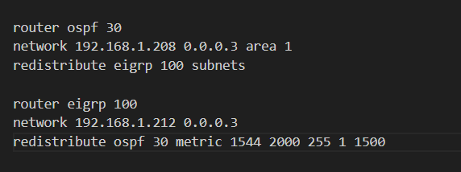

**3. NAT Configurations**

**Router8 (Network E):**

**NAT Verification Commands:**

**4. ACL Configuration:**

**5. DHCP Configuration**

**6. Mail Server Configuration:**

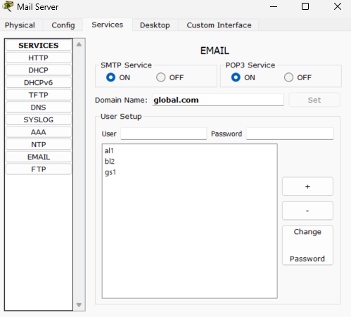

**Routing Table:**

**7. Network Verification Commands:**

**EIGRP:**

**OSPF:**

**RIP:**

**8.Communications (ACL/ALL):**

**ACL:**



**Simple:**

