CURRICULUM VITAE
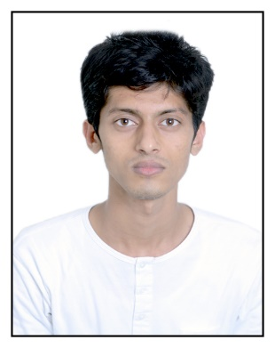

Name : TANDERJAWALA MUHAMMADHASIM MUSTAK
- Computer Science Engineer

Address: Flat No: M3, AL Haadi Building,
Opp. Choitaram SuperMarket,
Al RAS Deira Dubai, UAE.

Contact: 0582715427 (Dubai) , 04-2258327 (Tel), +91-9429529667

E-mail : mail@hasim751.com , hasim751@live.com (alternative), hasim751 (skype id)

Website: http://hasim751.com

OBJECTIVE
To achieve a responsible and challenging position in an organization where I can utilize my knowledge for personal & organizational development.

ACADEMIC QUALIFICATION
Exam | Year | Institute | University | Result
B.E (Computer Science & Engineering.) | 2015 | Shri Sad Vidya Mandal Institute of Technology, Bharuch. | Gujarat Technological University | 5.49/6.27 (CPI/CGPA)
H.S.C | 2010 | M M Memorial High School, Jambusar. | GSHSEB | 59.80%
S.S.C | 2008 | The Dayadara Higher Secondary School, Dayadara. | GSHSEB | 79.38%

EXPERIENCE
- 2 years in Web Developing (Private work).
- 1 year in Web developer & IT admin (at Islamic Welfare Mission).
  - http://islamicwelfaremission.org .

PROJECT SYNOPSIS
- Result:
Project I (7th Sem.): AB, Project II (8th Sem.): AA
- Academic project on 360Education System.
- Project Definition: 360education System is the education management system which made all paper work to digitalize and it can be adopt by any educational institute.

COMPUTER PROFICIENCY
- Familiar with OS : Windows XP/ 7/8/10, Linux, Mac OS and all mobile OS.
- Applications : MS-Office, Basics MATLAB, Sublime, Adobe Tools, Coral, cPanel et-cetra.
- Computer hardware and software (More than 5 years experience).

WORKED ON PROGRAMMING LANGUAGES / Frameworks
- Web Languages: PHP, HTML.
- Frameworks: Codeignitor, Wordpress, Joomla, Bootstrap, Ajax.
- BASICS OF C, C++, JAVA, MATLAB.
- Currently learning SWIFT (introduced by Apple Inc.), Objective-C for iOS Application development, JAVA for Android.

EXTRA CURRICULUM ACTIVITIES
- Participated in UNIVERCITY CRICKET TOURNAMENT.
- Participated in INTERCLASS CRICKET TOURNAMENT held at SVMIT during annual sports week.

EXTRA ACTIVITIES RELATED TO MY PROFESSION
- Running websites (blogs) – http://hasim751.com (own), Developed Village Web site: http://www.pipalia.in
- Running Cydia Repository in Apple Jailbreak – http://repo.hasim751.com.
- Developed monthly magazine & eBooks site for NGO in Dayadara: http://barkatekhwaja.net .
- Enhancing college project named 360education.

ADDITIONAL INFORMATION
    - D.O.B : 13th August, 1992
    - Gender : Male
    - Nationality : Indian
    - Languages Known : English, Urdu, Hindi and Gujarati.
    - Marital Status : Single.
    - Hobbies : Sports.

