# **TASK:**

**(0) Anatomy of spine as you share the links with me**

**(1) How to load a data set?**

**(2) Show and display images from you own application**

**(3) certain pre-processing like image resizing, normalization**

# Ques # 0

**Anatomy of spine as you share the links with me**

The normal **anatomy** of the **spine** is usually described by dividing up the **spine** into three major sections: the cervical, the thoracic, and the lumbar **spine**. (Below the lumbar **spine** is a bone called the sacrum, which is part of the pelvis). Each section is made up of individual bones, called **vertebrae**.

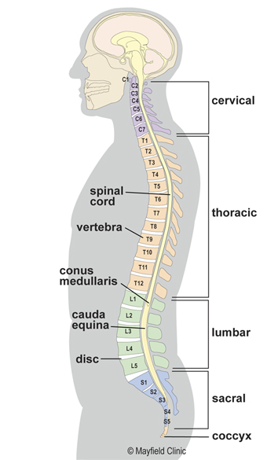

**LUMBAR (LOW BACK)** - the main function of the lumbar spine is to bear the weight of the body. The five lumbar vertebrae are numbered L1 to L5. These vertebrae are much larger in size to absorb the stress of lifting and carrying heavy objects.

**Three types of views in MRI.**

1. Sagittal View
2. Transverse View (Axial view)
3. Coronal View (Frontal view)

For now, we are just working on Sagittal view.

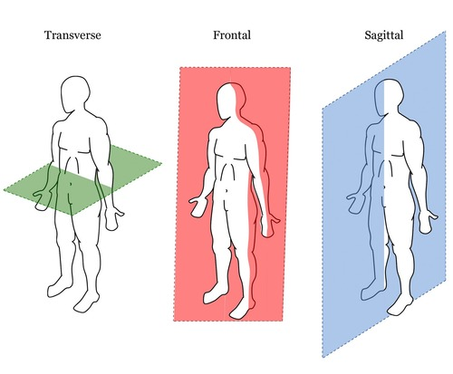

**(This view)**

**SPINAL STENOSIS:**Spinal stenosis is a narrowing of the spaces within your **spine**, which can put pressure on the nerves that travel through the **spine**. **Spinal stenosis** occurs most often in the lower back and the neck. Some people with **spinal stenosis** may not have symptoms. Symptoms can worsen over time.

# Ques # 1 & 2

**How to load a data set?**

**Show and display images from you own application**

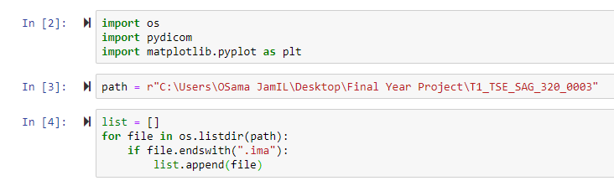

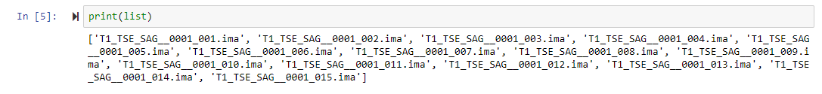

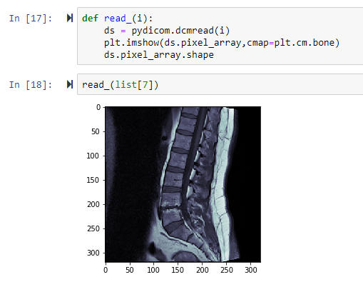

# Ques # 3

**certain pre-processing like image resizing, normalization**

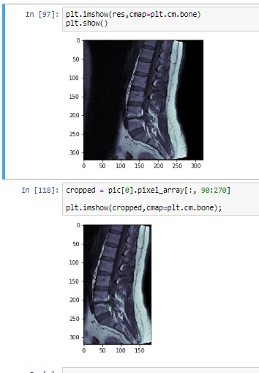

# **REFRENCES:**

<https://mayfieldclinic.com/pe-anatspine.htm>

<https://www.globusmedical.com/patient-education-musculoskeletal-system-conditions/symptoms/anatomy-of-the-spine/>