RESUME

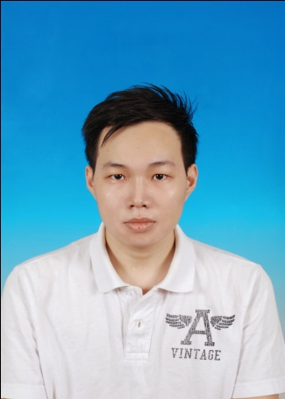

PAN YEE KET

38, Dataran Rapat Baru 13, Taman Sri Berjaya,

31350 Ipoh, Perak.

014-3422056

panyeeket@yahoo.com.my

Expected Salary: RM 2,000

(* I am a fresh graduate and currently seeking my first job.)

________________________________________________________________________

**PERSONAL PARTICULARS:**

Age : 25 Date of Birth : 08 March 1990

Permanent Residence : Malaysian Gender : Male

Race : Chinese I/C Number : 900308-08-5631

Marital Status : Single Religion : Buddha

**EDUCATION BACKGROUND:**

University : **University Tunku Abdul Rahman**

Kampar, Perak, Malaysia.

Bachelor of Commerce (HONS) Accounting

Major: Accountancy

Grade: 2.5974 / 4.0000

(March, 2015)

Secondary : **SMJK Sam Tet**

Ipoh, Perak, Malaysia.

SPM, STPM.

(2003 – 2009)

Primary : **SRJK(C) Sam Tet**

Ipoh, Perak, Malaysia.

(1997 – 2002)

**WORKING EXPERIENCE:**

Oct 2014 – Dec 2014 **J. Y. GOH & CO.**

Ipoh, Perak, Malaysia.

Accounting Intern (3-month Internship)

Scope of Work : - Accounting entry using accounting software.

- Bank reconciliation.

- Creditors reconciliation.

- Assist in finalizing accounts.

**SKILLS:**

* Microsoft Word (Good)
* Microsoft PowerPoint (Good)
* Microsoft Excel (Fair)
* UBS Accounting System (Fair)

**LANGUAGES:**

|  |  |  |
| --- | --- | --- |
| Language | Spoken Proficiency | Written Proficiency |
| 1. Chinese | Good | Good |
| 1. English | Fair | Fair |
| 1. Malay | Fair | Fair |