Contact Info

|  |  |
| --- | --- |
| NAME | TAN CAI HONG |
| IC NO | 921126-08-5342 |
| GENDER | FEMALE |
| AGE | 23 |
| RACES | CHINESE |
| RELIGION | CHRISTIAN |
| HOME ADRESS | NO 21 MARGOSA F/3 SERI MARGOSA  BANDAR SERI BOTANI  31350 IPOH  PERAK |
| HANDPHONE NO. | 019-4186862/05-3126620 |
| E-MAIL ADRESS | rainbow5342@gmail.com |

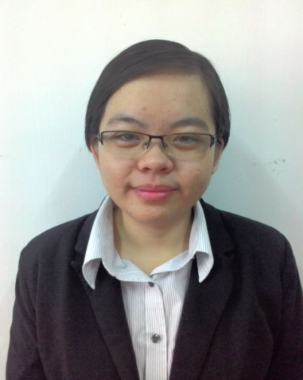

LEVEL OF EDUCATION

2012- Current Bachelor of Public Management Hons (BPM)

University Utara Malaysia (UUM)

**Current CGPA 3.59**

2010- 2011 STPM

Sekolah Menengah Kebangsaan Raja Chulan, Ipoh Perak

CGPA 3.42

Malaysia University English Test **(MUET) – Band 3**

2005-2009 SPM

Sekolah Menengah Kebangsaan Gunung Rapat, Ipoh Perak

**Bahasa Malaysia – Grade B+**

**Bahasa English – Grade B+**

**Bahasa Cina – Grade B**

**Work Experience**

1. Teaching Bahasa Malaysia in Goshen Morning Star (GMS) Kindergarden- 2009 year
2. Internship at Pantai Hospital(Outpatient Billing Department) from July 2015 until November 2015

|  |  |
| --- | --- |
| **Language:**  English ◼◼◼◼◼◼◼◼◼◼  Malay ◼◼◼◼◼◼◼◼◼◼  Mandarin ◼◼◼◼◼◼◼◼◼◼  **Computer:**  Microsoft Office ◼◼◼◼◼◼◼◼◼◼  Keyboard Skill ◼◼◼◼◼◼◼◼◼◼ | **Adaptive Skills:**  Teamwork ◼◼◼◼◼◼◼◼◼◼  Passion For Learning ◼◼◼◼◼◼◼◼◼◼  Problem-solving ◼◼◼◼◼◼◼◼◼◼  Adaptability ◼◼◼◼◼◼◼◼◼◼  Integrity ◼◼◼◼◼◼◼◼◼◼  Leadership ◼◼◼◼◼◼◼◼◼◼ |

Skills

Curriculum Achievements & Activities

|  |  |  |  |
| --- | --- | --- | --- |
| No. | Position | Year | School/University |
| 1. | Secretary Kelab Koir UUM | 2012-2014 | UUM |
| 2. | AJK Bureau Exhibition MPP Hand in Hand | 2012 | UUM |
| 3. | AJK Kachi Fun Run | 2013 | UUM |
| 4. | Ketua Tingkatan | 2010-2011 | SMK Raja Chulan |
| 5. | Library Prefect (Chief Exco) | 2011 | SMK Raja Chulan |
| 6. | Secretary Kelab Ping Pong | 2010-2011 | SMK Raja Chulan |
| 7. | AJK Kelab Bahasa Cina Tingkatan 5 | 2009 | SMK Gunung Rapat |
| 8. | AJK Persatuan Bulan Sabit Malaysia Tingkatan 5 | 2009 | SMK Gunung Rapat |
| 9. | AJK Pertandingan Perbahasan dan Penghasilan Majalah | 2009 | SMK Gunung Rapat |

Extra Achievements

1. Level 2 Certificate in Book-Keeping and Account (Pass With Distinction) of LCCI -2009
2. Participated in International Competition and Assessments for Schools English by University of South Wales – 2009
3. Participated in Program Latihan Khidmat Negara – 2010
4. Participated in Kem Keimpinan & Latihan organized by Bulan Sabit Merah Malaysia (BSMM) – 2008