Proposal

**Site-Build**

"Construction Site Management System"

By Hamza A. Rahman

Advisor: Engr. Abdul Rahman

16-7-2023

**Contents**

1. Overview 3

2. Project Detail 4

2.1 Problem or Challenge 4

2.2 Project Goals 4

2.3 Project Abstract 6

2.4 Project Scope 7

2.5 Existing & Related Work 9

2.6 Proposed solution & Architecture 10

2.7 Use Case Model 10

2.8 Feature List 10

2.9 Software Development Methodology 10

2.10 Proposed infrastructure platform and tools 10

2.11 Project Timeline 10

2.12 Mockups 10

2.13 References 10

# Overview

The Construction Site Management System is a comprehensive software solution designed to streamline and enhance construction project management processes. This overview provides essential information about the system, including its motivation, customer, deliverables, duration, dependencies, and contributions.

**Motivation:**

The motivation behind developing the Construction Site Management System stems from the need to address the complexities and challenges faced in construction project management. Construction projects often involve numerous stakeholders, intricate scheduling, resource allocation, and coordination, making it vital to have a robust system to manage these aspects efficiently. The goal is to improve overall project efficiency, communication, and collaboration, leading to successful project outcomes.

**Customer:**

The primary customer for the Construction Site Management System is construction companies, project managers, and stakeholders involved in overseeing construction projects. These entities seek a reliable and centralized software solution to streamline their construction site management processes, enabling them to effectively plan, execute, and monitor projects.

**Project Deliverables:**

The Construction Site Management System is a new product that offers a comprehensive suite of features and functionalities to support construction project management. It encompasses modules for project planning, scheduling, resource management, communication, document control, progress tracking, and reporting. The system provides a user-friendly interface that allows users to access real-time data, collaborate with team members, and make informed decisions to ensure successful project completion.

**Duration:**

The duration for implementing the Construction Site Management System may vary depending on the scale and complexity of the construction projects it will support. Typically, the implementation process involves requirements gathering, system design, development, testing, and deployment. The duration may range from a few months for smaller projects to a year or more for larger, more intricate construction endeavors.

**Dependencies:**

Several other projects within the construction company's ecosystem may depend on the successful implementation of the Construction Site Management System. These projects could include integrating the system with existing enterprise resource planning (ERP) software, third-party applications, or hardware infrastructure. Additionally, the system's successful adoption may rely on training and change management initiatives to ensure users are familiar with its features and benefits.

**Contributing Projects:**

While the Construction Site Management System is primarily a standalone product, it can integrate and contribute to other related projects within the construction industry. For example, the system can provide valuable data and insights that contribute to business intelligence and analytics initiatives. Furthermore, it can interface with building information modeling (BIM) systems, enabling seamless data exchange and coordination between design and construction phases.

# Project Detail

## Problem or Challenge

## Construction Site Management System (CSMS) faces several challenges in the context of Pakistan's socio-economic conditions. One significant problem is the lack of efficient resource allocation and utilization. Due to limited funds and resources, construction projects often struggle to optimize their use of labor, materials, and equipment. This leads to delays, cost overruns, and substandard quality of work, hindering the overall progress of construction projects and negatively impacting the economy. Additionally, the absence of a streamlined communication system exacerbates the problem, as stakeholders involved in construction projects often face difficulties in effectively coordinating and sharing critical information. This lack of coordination further contributes to delays, misunderstandings, and conflicts among different parties involved in the construction process.

## Another sub-problem related to the CSMS in Pakistan is the absence of standardized safety practices and regulations. The construction industry in Pakistan is prone to accidents and safety hazards due to inadequate safety measures and the non-compliance of workers and contractors. The absence of a robust CSMS exacerbates this issue, as there is no centralized platform to monitor and enforce safety protocols. The lack of safety regulations not only puts the lives of construction workers at risk but also leads to frequent accidents, injuries, and fatalities, resulting in human suffering and financial losses. Addressing these safety concerns and implementing a comprehensive CSMS that emphasizes safety protocols would significantly enhance the well-being of workers and ensure a safer working environment for all construction projects in Pakistan.

## Project Goals

## Functional goals:

## Track and manage construction project progress in real-time.

## Provide a centralized platform for communication and collaboration among project stakeholders.

## Generate automated reports for various project aspects, such as materials, labor, and costs.

## Monitor and control project schedules, deadlines, and milestones.

## Manage resource allocation and optimize workforce efficiency.

## Ensure accurate documentation and version control of project-related data.

## Technological goals:

## Utilize modern web-based technologies for system development.

## Support integration with other construction management software or systems.

## Ensure scalability and flexibility to accommodate future expansion or enhancements.

## Implement data security measures to protect sensitive project information.

## Enable mobile accessibility for on-site personnel.

## Leverage cloud infrastructure for storage and data backup.

## Quality goals:

## Ensure the system is reliable and performs consistently under heavy usage.

## Implement rigorous testing procedures to identify and resolve defects.

## Adhere to industry best practices and coding standards.

## Provide a user-friendly interface with intuitive navigation and clear feedback.

## Deliver a system that meets or exceeds customer expectations.

## Organizational goals:

## Facilitate competence development by providing training and support for system users.

## Encourage the adoption of new construction management methods or techniques.

## Promote collaboration and knowledge sharing among project teams.

## Improve project planning and decision-making processes.

## Foster a culture of continuous improvement in construction site management practices.

## Other goals:

## Ensure high usability by designing a user interface that is intuitive and easy to navigate.

## Support system portability across different devices and platforms.

## Enable customization options to meet specific project requirements.

## Enhance system performance and response times.

## Enable data analytics and reporting capabilities for informed decision-making.

## Constraints:

## Comply with environmental regulations and minimize the project's ecological impact.

## Adhere to application-specific standards and guidelines in the construction industry.

## Meet national standards and legal requirements for data privacy and security.

## Consider cultural relationships and adapt the system to local practices if necessary.

## Work within budgetary constraints and resource limitations.

## Note: The specific goals and constraints for the "Construction Site Management System" should be documented in the Project Requirements Specification or other relevant project documents. The examples provided above are general and should be tailored to the specific needs and context of the project.

## Project Abstract

Site-Build is a comprehensive construction site management system developed to enhance the efficiency and effectiveness of construction projects. This abstract provides a brief summary of the key features and benefits of the Site-Build system.

The construction industry faces numerous challenges, including project delays, cost overruns, and poor communication among stakeholders. Site-Build aims to address these issues by providing a centralized platform for managing all aspects of a construction site. The system integrates various modules and functionalities to streamline project planning, resource allocation, communication, and documentation.

The project planning module in Site-Build enables construction managers to create detailed project schedules, allocate resources, and track progress in real-time. This feature helps to optimize resource utilization, identify potential bottlenecks, and ensure timely completion of tasks. The system also incorporates advanced analytics capabilities to generate insights and support data-driven decision-making.

Effective communication is crucial in construction projects involving multiple stakeholders. Site-Build facilitates seamless communication by providing a centralized platform for exchanging messages, sharing files, and collaborating on project-related documents. Additionally, the system includes notification and alert mechanisms to ensure that all stakeholders are informed about important updates and changes.

One of the key strengths of Site-Build is its ability to manage construction resources efficiently. The system allows users to track and monitor the availability and utilization of construction equipment, materials, and labor. This functionality helps to prevent delays caused by resource shortages and enables proactive planning for future requirements.

Another notable feature of Site-Build is its robust documentation management system. Construction projects generate a vast amount of paperwork, including blueprints, permits, and inspection reports. Site-Build centralizes all project documents, ensuring easy access, version control, and secure storage. The system also supports document sharing and collaboration, improving overall project coordination.

Furthermore, Site-Build prioritizes safety by incorporating modules for monitoring and managing construction site risks. The system enables users to record safety inspections, track incidents, and implement corrective measures promptly. This focus on safety helps to mitigate potential hazards and promotes a culture of workplace well-being.

## Project Scope

Project Objective: The objective of the Construction Site Management System project is to develop and implement a comprehensive software solution that streamlines and enhances the management and coordination of construction sites. The system aims to improve efficiency, communication, and collaboration among various stakeholders involved in construction projects.

**Deliverables:**

1. **User-friendly Interface:** The system will provide an intuitive and user-friendly interface accessible through web and/or mobile applications.
2. **Project Management:** The system will include features for managing project timelines, milestones, tasks, and resources. It will allow project managers to allocate resources effectively and monitor progress.
3. **Document Management:** The system will enable efficient storage, retrieval, and sharing of project-related documents, such as blueprints, permits, contracts, and reports.
4. **Communication and Collaboration:** The system will facilitate real-time communication and collaboration among project team members, contractors, subcontractors, and clients.
5. **Equipment and Inventory Management:** The system will include functionalities to manage equipment, tools, and inventory on construction sites, ensuring proper allocation, tracking, and maintenance.
6. **Safety and Compliance:** The system will incorporate features to monitor and enforce safety protocols, compliance with regulations, and documentation of incidents or accidents.
7. **Reporting and Analytics:** The system will generate comprehensive reports and provide analytical insights to evaluate project performance, identify bottlenecks, and make informed decisions.
8. **Integration and Scalability:** The system will be designed to integrate with other existing construction management tools and have the capability to scale as per the project requirements.

**Exclusions (What the project will not deliver):**

1. **Physical Infrastructure:** The project will not involve the construction or installation of physical infrastructure, such as servers or networking equipment.
2. **Customization for Specific Construction Projects:** The system will provide a generic framework for construction site management and may require customization to suit specific project requirements. However, project-specific customization is not part of the initial scope.
3. **Training and Support:** While the system will be designed with usability in mind, comprehensive training and ongoing support for end-users may be required but are not included in the project scope.
4. **Hardware Procurement:** The project will not cover the procurement of hardware devices, such as computers, smartphones, or tablets, required to access and utilize the system.
5. **Regulatory Compliance:** While the system will assist in managing compliance with regulations, it will not guarantee or take legal responsibility for ensuring compliance. Compliance ultimately relies on the actions and decisions of the stakeholders involved.

## Existing & Related Work

|  |
| --- |
| [1] 8 Features Construction Management System You Must Have:Cost Management & Financial ManagementCustomer Relationship ManagementProject Management & Scheduling ManagementInventory Management & Equipment ManagementDocument Management SystemCommunication SoftwareMobile CapabilityJob Scheduling |
| [2] Top 9 Features of Construction Management Software:Project managementDocument managementCollaboration toolsResource managementCost managementMobile accessSafety managementReal-time reportingAnalytics and insights |
| [3] 7 Must-Have Features for Construction Management Software Project managementBid Management & Financial ManagementCustomer Relationship ManagementProject Management & Scheduling ManagementInventory Management & Equipment ManagementDocument Management SystemCommunications SoftwareMobile CompatibilityAnalytics and insights |
| [4] Construction Management Software: 5 Features to Consider Bid Management & Financial ManagementEstimatingProject information modelingCost management and accountingField ManagementActionable data analytics |

## Proposed solution & Architecture

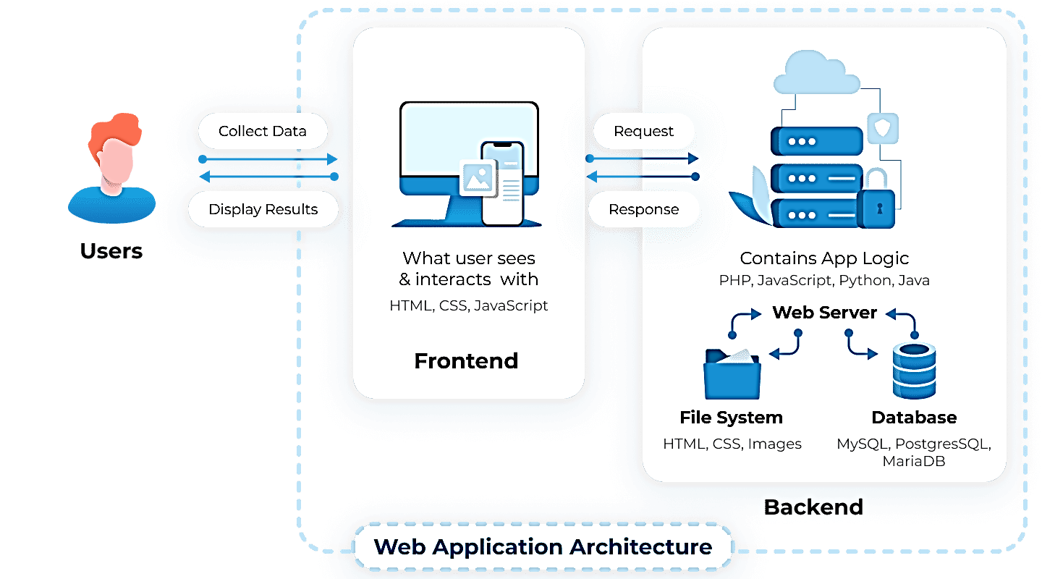

Figure 1: High Level Architecture diagram

+------------------------------------------------------+

| User Interface Layer |

+------------------------------------------------------+

| Presentation Layer |

+------------------------------------------------------+

| Application Layer |

+------------------------------------------------------+

| Data Layer |

+------------------------------------------------------+

| Integration Layer |

+------------------------------------------------------+

| Analytics and Reporting Layer |

+------------------------------------------------------+

| Security Layer |

+------------------------------------------------------+

Figure 2: Layered Architecture

## Use Case Model

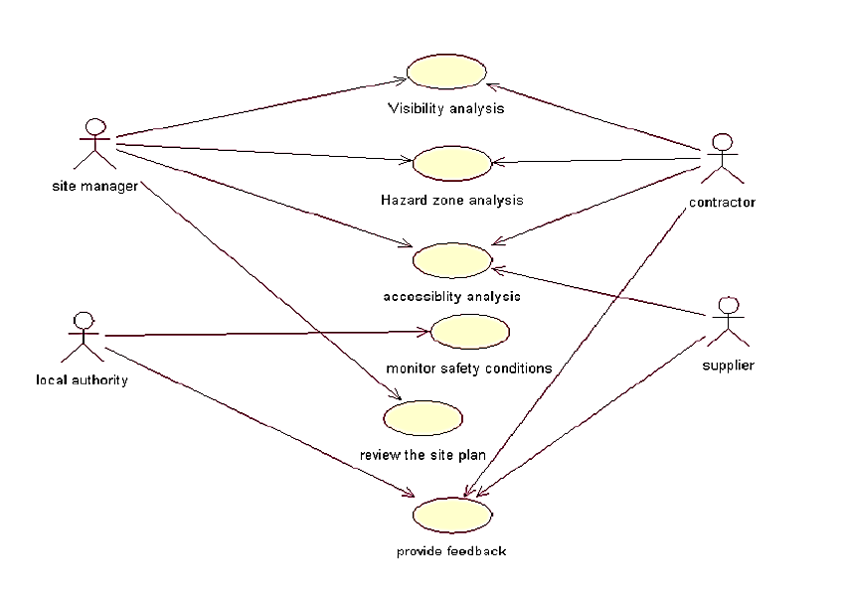

Figure 3: High level Use Case diagram

## Feature List

1. Project Planning: The software should provide tools to create and manage project plans, including defining tasks, assigning resources, and setting timelines.
2. Document Management: It should allow users to store, organize, and access project documents such as contracts, drawings, specifications, and permits.
3. Communication Tools: The software should include features for communication and collaboration among project team members, including messaging, notifications, and file sharing.
4. Task Management: It should enable the creation, assignment, and tracking of tasks, allowing users to prioritize and monitor progress.
5. Resource Management: The software should have functionality to manage and allocate resources such as labor, equipment, and materials efficiently.
6. Cost Estimation and Budgeting: It should provide tools to estimate project costs, create budgets, and track expenses to ensure projects stay within financial constraints.
7. Schedule Management: The software should allow users to create and manage project schedules, track milestones, and monitor progress against timelines.
8. Change Order Management: It should include features to handle change orders, including documenting changes, tracking costs, and obtaining approvals.
9. Quality Assurance and Inspection: The software should support quality control processes, allowing users to schedule inspections, record findings, and track corrective actions.
10. Subcontractor Management: It should facilitate the management of subcontractors, including issuing contracts, tracking progress, and managing payments.
11. Equipment and Asset Tracking: The software should provide features to monitor and manage construction equipment and assets, including tracking location, maintenance schedules, and utilization.
12. Safety and Incident Reporting: It should include tools for recording and reporting safety incidents, maintaining safety documentation, and ensuring compliance with regulations.
13. Reporting and Analytics: The software should generate reports and provide data analytics capabilities to gain insights into project performance, resource utilization, and costs.
14. Mobile Access: It should offer mobile applications or a responsive web interface to enable access to project information and functionality on smartphones and tablets.
15. Integration and Data Exchange: The software should support integration with other construction-related systems, such as accounting software, scheduling tools, or BIM (Building Information Modeling) software, to enable seamless data exchange.

These features form the foundation of Construction Site Management Software and are designed to enhance efficiency, collaboration, and transparency in construction project management.

## Software Development Methodology

Agile Software Development is an iterative and incremental approach to software development that promotes flexibility, collaboration, and rapid delivery of high-quality software solutions. The Agile SDLC incorporates a set of principles and practices that enable cross-functional teams to adapt and respond to changing requirements throughout the development process. Here is a detailed overview of the Agile SDLC methodology:

**Project Initiation:**

1. Identify project goals, objectives, and stakeholders.
2. Define the initial scope of the project and create a high-level product backlog.
3. Form the Agile development team, including product owner, Scrum Master, and development team members.
4. Conduct initial project kickoff and communicate the Agile principles, roles, and responsibilities to the team.

**Requirements Gathering:**

1. Collaborate with stakeholders to identify and prioritize product features and user stories.
2. Create a detailed product backlog with clear acceptance criteria for each user story.
3. Conduct regular meetings with stakeholders to refine and reprioritize the backlog based on feedback and changing requirements.

**Sprint Planning:**

1. Select a set of user stories from the product backlog for the upcoming sprint.
2. Break down the selected user stories into smaller tasks and estimate their effort.
3. Define the sprint goal and create a sprint backlog that includes the tasks to be completed during the sprint.
4. Determine the capacity of the development team and the sprint duration.

**Sprint Execution:**

1. Daily Scrum meetings: The development team meets daily to provide updates on progress, discuss challenges, and plan for the day's work.
2. Development: The team works collaboratively to develop and test the selected user stories within the sprint.
3. Continuous Integration: The development team integrates their work frequently to ensure a working product increment at all times.
4. Testing: The team performs testing throughout the sprint to ensure the quality and functionality of the software.
5. Adaptation: The team embraces changes and adapts the sprint backlog as new information or requirements emerge.

**Sprint Review:**

1. Conduct a sprint review meeting to showcase the completed user stories and demonstrate the working software to stakeholders.
2. Gather feedback and incorporate it into future iterations or sprints.
3. Update the product backlog based on the feedback received.

**Sprint Retrospective:**

1. Hold a retrospective meeting with the development team to reflect on the sprint process and identify areas for improvement.
2. Discuss what went well, what didn't go well, and potential actions to enhance future sprints.
3. Update team practices, tools, or workflows to optimize productivity and collaboration.

**Repeat Sprint Cycle:**

1. Start the next sprint planning, execution, review, and retrospective processes.
2. Continuously refine and reprioritize the product backlog based on feedback, changing requirements, and business needs.
3. Iteratively develop and deliver software increments with high quality throughout the project.

**Conclusion:**

The Agile SDLC methodology emphasizes collaboration, flexibility, and continuous improvement. It enables software development teams to deliver value to stakeholders more frequently while adapting to changing requirements. By following this methodology, teams can embrace uncertainty and complexity, deliver working software, and achieve customer satisfaction through incremental and iterative development practices.

## Proposed infrastructure platform and tools

HTML

CSS

JavaScript

Bootstrap

PHP

MySQL

ES6

Web Services

Visual Studio Code

## Project Timeline

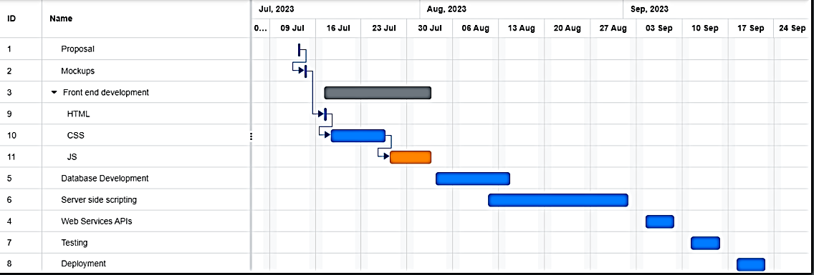

Figure 4: Gantt chart

## Mockups

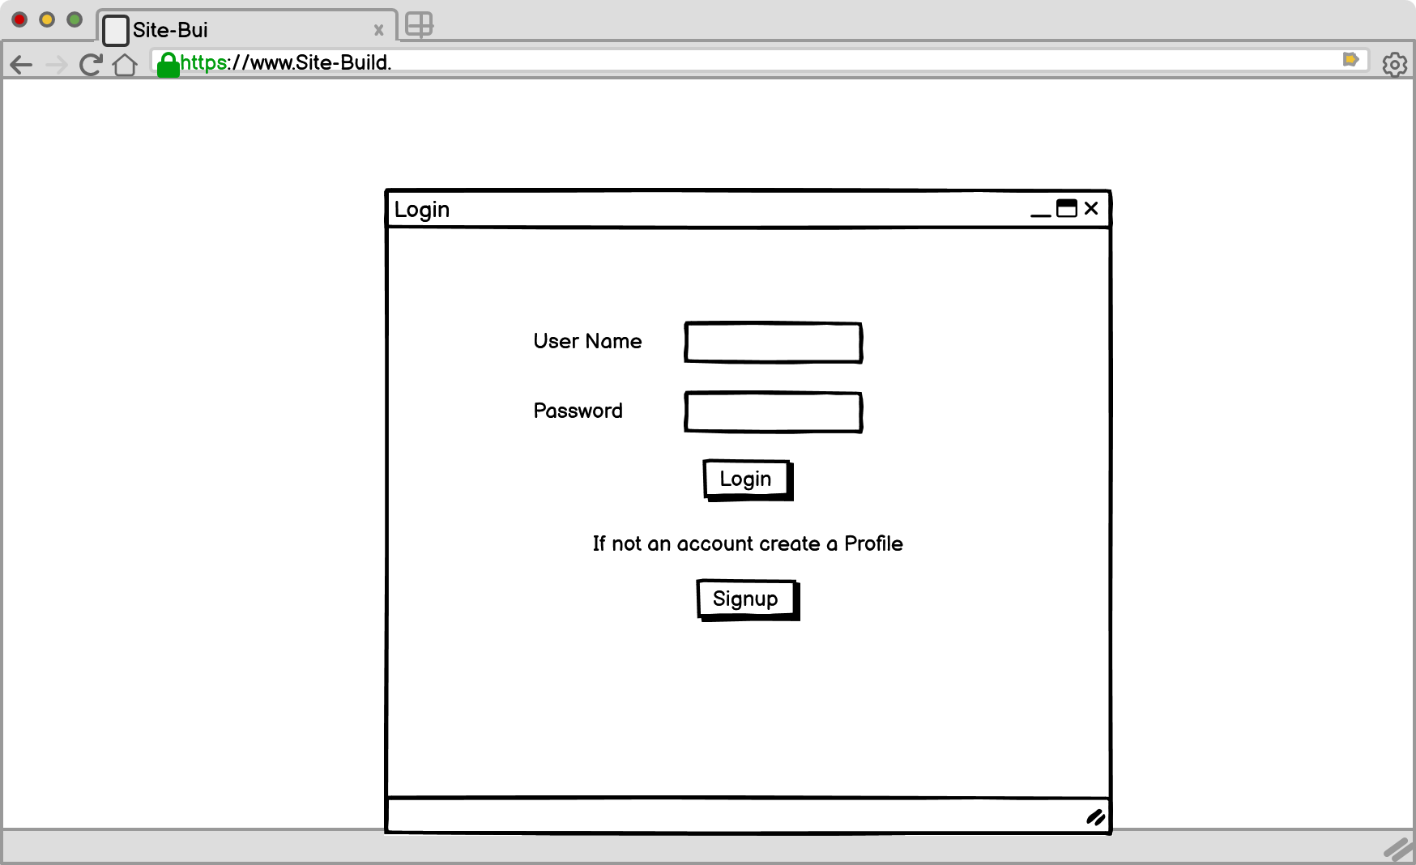

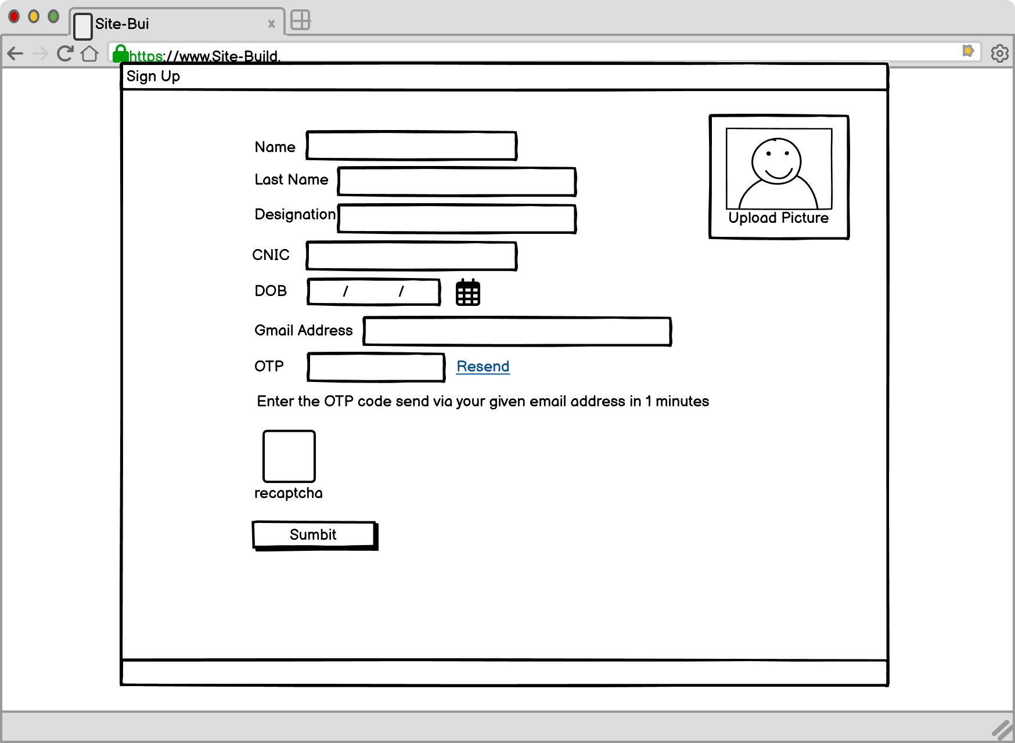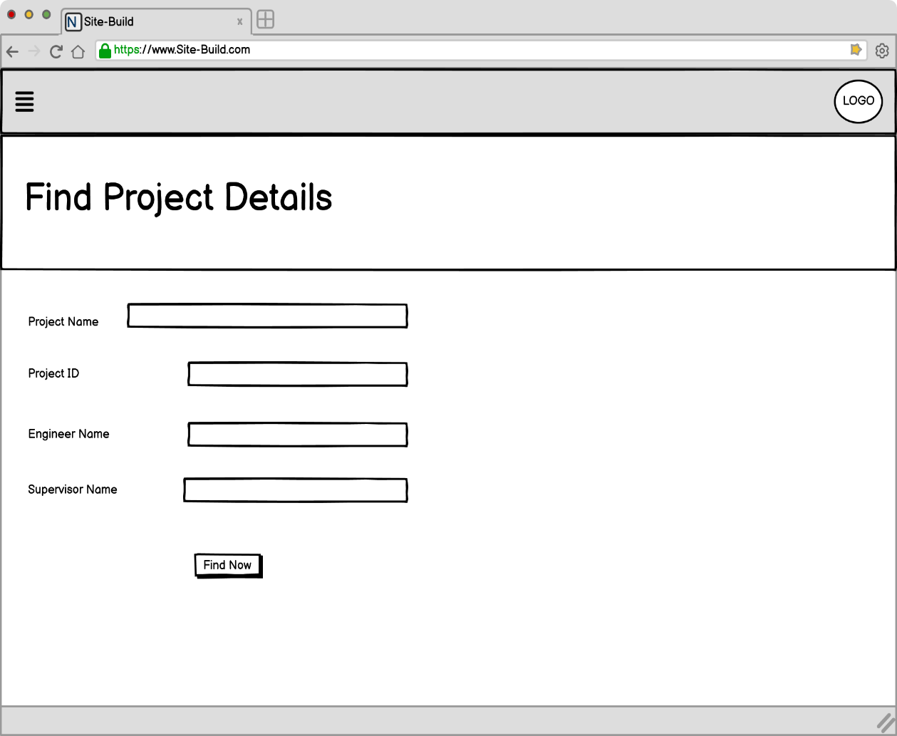

## References

**[1]** C. Natsir, “8 Features construction management system you must have,” BusinessTech, Jul. 2023, [Online]. Available: https://www.hashmicro.com/blog/construction-management-system-features-you-must-have/

**[2]** StrategicERP Business Automation Solutions, “Top 9 features of construction management Software,” www.linkedin.com, [Online]. Available: https://www.linkedin.com/pulse/top-9-features-construction-management

**[3]** “7 Must-Have Features for Construction Management Software | ClikFocus.” https://clikfocus.com/blog/7-must-have-features-construction-management-software

**[4]** G. Contributor, “Construction Management Software: 5 features to consider,” TechnologyAdvice, Apr. 2023, [Online]. Available: https://technologyadvice.com/blog/information-technology/features-to-look-for-in-a-construction-project-management-tool/

## WEBPAGES

