Pediatric Pneumonia Detection using Deep CNNs
Project Link: Kaggle Notebook
Dataset: Chest X-Ray Images (Pneumonia)
1. Introduction & Dataset Overview
This study utilizes a retrospective cohort of pediatric chest X-ray images from patients aged one to five years at Guangzhou Women and Children’s Medical Center. The primary objective is to develop a Convolutional Neural Network (CNN) capable of distinguishing between Normal lungs and those affected by Pneumonia.
- Total Images: 5,863 JPEG images.
- Data Quality: All scans underwent initial screening for quality control.
- Ground Truth: Diagnoses were graded by two expert physicians, with a third expert reviewing the evaluation set to eliminate grading errors.
- Structure: Data is partitioned into three directories: train, test, and val.
2. Methodology
The model was built using the PyTorch Sequential API with a three-block convolutional architecture. To ensure stability and prevent overfitting during the 50-epoch training phase, the following techniques were applied:
- Feature Extraction: Three Convolutional layers with increasing filter depth (32 to 64 to 128).
- Regularization: Dropout layers (0.2 to 0.5) to prevent co-adaptation of neurons.
- Optimization: Adam Optimizer with a starting Learning Rate of 0.001.
- Learning Dynamics: A ReduceLROnPlateau scheduler was implemented to lower the learning rate when validation loss stagnated.
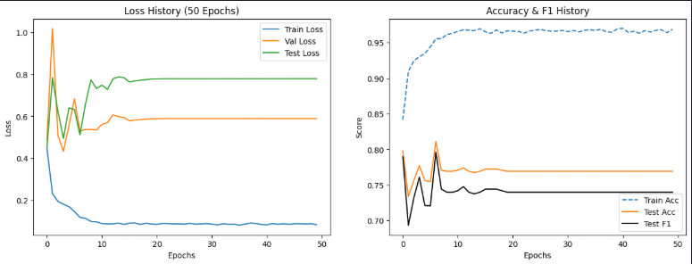
3. Performance Evaluation
3.1 Training Metrics Summary
Over 50 epochs, the model stabilized significantly. While the training loss showed a consistent downward trend, the validation and test accuracies reached a plateau, suggesting the model reached its maximum capacity for this specific architecture.
Metric | Start (Epoch 1) | End (Epoch 50)
Train Loss | 0.4477 | 0.0834
Test Accuracy | 79.81% | 76.92%
3.2 Classification Report (Test Set)
The model achieved a weighted average accuracy of 77%.
Class | Precision | Recall | F1-Score | Support
NORMAL | 0.95 | 0.41 | 0.57 | 234
PNEUMONIA | 0.73 | 0.99 | 0.84 | 390
Weighted Avg | 0.82 | 0.77 | 0.74 | 624

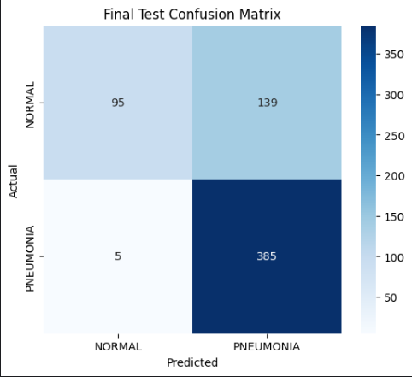
4. Discussion & Key Findings
- Exceptional Sensitivity (Recall): The model achieved a 99% Recall for Pneumonia. In a medical context, this is critical; it means the AI almost never misses a sick patient (near-zero False Negatives).
- Specificity Challenges: The lower recall for "Normal" cases (41%) indicates that the model is "playing it safe" by over-identifying potential pneumonia patterns. This is likely due to the inherent class imbalance in the training data.
- Convergence: The learning rate scheduler effectively managed the plateauing loss in later epochs, keeping the test accuracy stable around 77%.
5. Conclusion
The developed CNN demonstrates high reliability in detecting positive cases of pneumonia, making it a viable screening tool to assist radiologists. Future work will focus on improving the precision for the Normal class through class-weight balancing and deeper architectures like ResNet.

6. Appendix:
Sample Predictions:
