Synthetic Face Generation using DCGANs
Student Roll No: SU92-MSAIW-S25-013
Subject: Advanced Data Analytics
Project Link: Kaggle Notebook
Dataset: CelebFaces Attributes (CelebA)
1. Introduction & Objective
The objective of this project is to implement a Deep Convolutional Generative Adversarial Network (DCGAN) to generate high-fidelity synthetic human faces. Unlike standard CNNs that classify data, DCGANs use an adversarial framework where two models—a Generator (G) and a Discriminator (D)—compete in a zero-sum game to learn the underlying distribution of the CelebA dataset.
2. Dataset Characteristics
The CelebA dataset is a large-scale face attributes dataset with more than 200,000 celebrity images.
- Preprocessing: Images were center-cropped to remove background clutter and resized to 64 times 64 pixels.
- Normalization: Pixel values were scaled to the range [-1, 1] to match the Tanh activation function of the Generator.

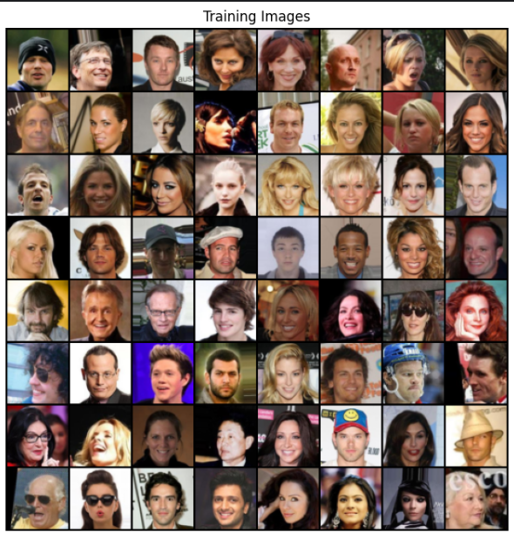
3. Methodology: Adversarial Architecture
3.1 The Generator (netG)
The Generator takes a 100-dimensional latent vector (random noise z) and projects it into a high-dimensional space. Through a series of Strided Fractionally-Convolutions (Transposed Convolutions), it upsamples the noise into a 64 times 64 times 3 image.
- Activation: ReLU is used in hidden layers; Tanh is used for the output.
- Normalization: Batch Normalization is applied after each layer to stabilize training.
3.2 The Discriminator (netD)
The Discriminator is a binary classifier that distinguishes between "Real" images (from CelebA) and "Fake" images (from the Generator). It uses strided convolutions to downsample the image.
- Activation: LeakyReLU (0.2 slope) is used to prevent the "dead neuron" problem during adversarial training.
4. Performance Analysis
4.1 Loss Metrics (The Adversarial Battle)
In a successful DCGAN training run, the losses for G and D do not reach zero but rather fluctuate as they "push" each other to improve.
- Generator Loss: Represents how well G is fooling D.
- Discriminator Loss: Represents how accurately D identifies fakes.
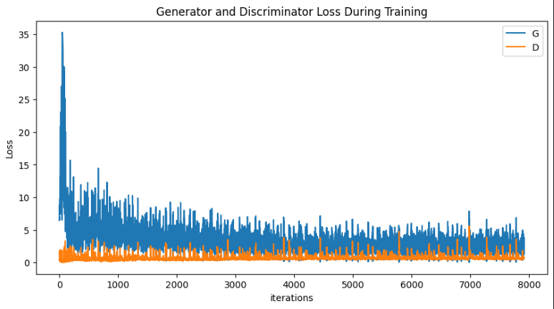
4.2 Visual Evolution
The model's progress is best measured by the quality of the "fixed noise" samples saved at each epoch.
Stage | Visual Description
Initial (Epoch 0) | Pure Gaussian noise; no identifiable structures.
Intermediate | Emergence of "ghost-like" features, skin tones, and rough face boundaries.
Final (Epoch 25+) | Distinct facial features (eyes, nose, hair) and lighting consistency.
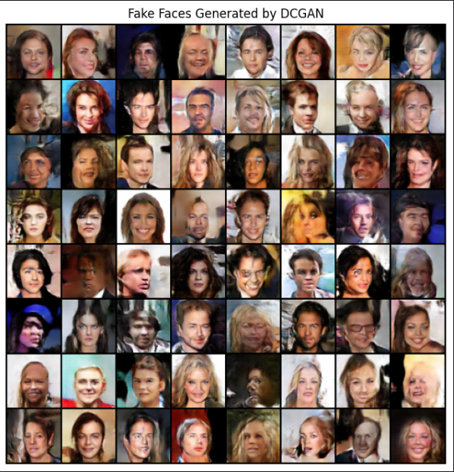
5. Conclusion
The DCGAN successfully learned to replicate the complex features of the CelebA dataset. While some "checkerboard artifacts" (common in Transposed Convolutions) may remain, the high degree of facial symmetry and attribute variety (hair color, gender, expressions) confirms that the model has captured the latent distribution of human faces. This project demonstrates the power of adversarial learning in unsupervised data synthesis.

