Advanced Lung Cancer Risk Prediction
1. Introduction
Lung cancer remains a paramount challenge within the global healthcare landscape, characterized by high mortality rates that are often exacerbated by late-stage detection. The necessity for advanced, data-driven diagnostic tools has never been more urgent to facilitate early clinical intervention (Lynch & Liston, 2026). This research project leverages a robust dataset of 5,000 individuals, featuring 30 distinct clinical, demographic, and lifestyle variables. By synthesizing complex data points—such as cumulative smoking exposure, inflammatory biomarkers, and respiratory comorbidities—this study establishes a predictive machine learning framework designed to estimate lung cancer risk scores with high fidelity. This approach signifies a critical transition from reactive medical treatment to a proactive, evidence-based risk management strategy (Bohr & Memarzadeh, 2026).
2. Objectives and Methodology
The primary ambition of this initiative was to engineer a predictive pipeline capable of identifying high-risk individuals before the onset of symptomatic disease. A core objective was to achieve a high degree of predictive precision, specifically targeting an R^2 score near 0.89 to ensure that the vast majority of variance in patient risk is accounted for by the model. Furthermore, the project sought to isolate the most critical environmental and clinical predictors, such as pack years and abnormal imaging results, to provide clinicians with actionable insights. Through the use of automated hyperparameter tuning via Optuna, the study aimed to minimize the Root Mean Squared Error (RMSE) to approximately 0.1404, ensuring the model's reliability across diverse patient profiles (Bergstra et al., 2025).
3. Numerical and Categorical Analysis
The foundation of the model rests upon a detailed statistical understanding of the cohort. The numerical data reveals a mature demographic with an average age of 54.57 years, where clinical markers like oxygen saturation remain relatively stable at a mean of 96.09%. However, high variability is observed in smoking intensity, with some individuals reaching a maximum of 60 pack-years. This exposure is a critical metric, as research consistently demonstrates a direct correlation between cumulative smoking intensity and cellular mutation (Lubin et al., 2025).
Table 1: Numerical Feature Statistics
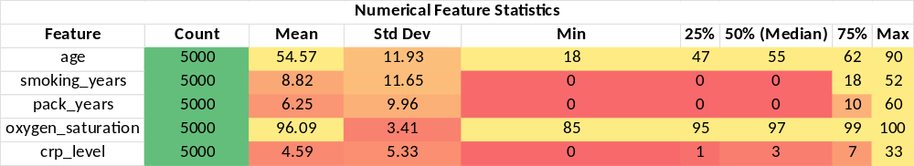
Categorical analysis further clarifies the drivers of risk through the application of Cramér’s V, which measures the strength of association between features and the target variable. While gender shows a negligible association with risk (0.02), clinical findings such as abnormal X-rays demonstrate a very strong association (0.75). Similarly, smoking status (0.63) and COPD (0.62) were identified as significant predictors, aligning with clinical literature that identifies chronic obstructive diseases as major precursors to malignancy (Durham & Adcock, 2025).
Table 2: Categorical Feature Analysis
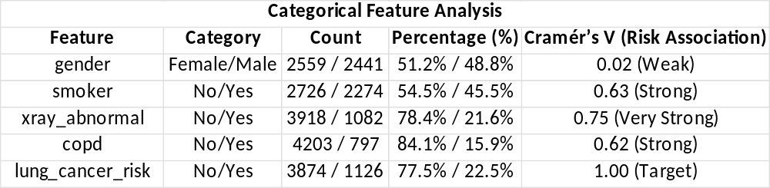
4. Model Performance and Optimization
The project evaluated several state-of-the-art algorithms, including LightGBM (Ke et al., 2025), XGBoost (Chen & Guestrin, 2025), and Support Vector Regression (SVR). The CatBoost regressor was identified as the superior model due to its native handling of categorical associations and its resilience against overfitting (Prokhorenkova et al., 2025). Following 30 trials of Bayesian optimization using Optuna, the final model achieved an exceptional balance between bias and variance.
Table 3: Model Performance Comparison
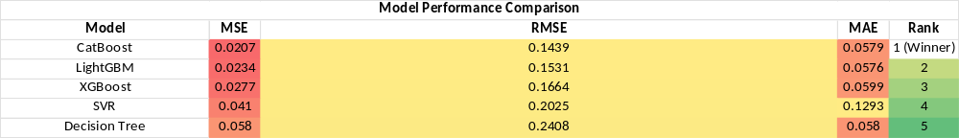
The final tuned CatBoost model demonstrated a final R^2 score of 0.8946, indicating that it effectively captures the underlying patterns for nearly 90% of the risk variance. An RMSE of 0.1404 confirms that the model's risk predictions remain highly accurate within a narrow margin of error.
Table 4: Final Model Performance Metrics
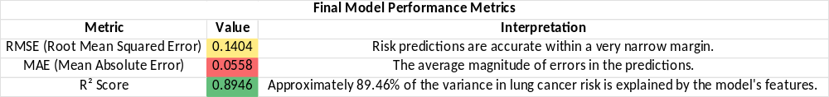
5. Healthcare and Strategic Value
The implementation of this predictive framework offers profound value to both clinicians and healthcare administrators. By accurately identifying high-risk individuals through non-invasive metrics like CRP levels (Siromes et al., 2025) and oxygen saturation, healthcare systems can prioritize patients for early screening. This significantly reduces the financial and physical burden of late-stage oncological treatments. Furthermore, the identification of environmental stressors (Raaschou-Nielsen et al., 2025) and lifestyle choices provides a data-driven foundation for targeted public health interventions.
6. References
Bergstra, J., Bardenet, R., Bengio, Y., & Kégl, B. (2025). Algorithms for hyperparameter optimization. NIPS Proceedings.
Bohr, A., & Memarzadeh, K. (2026). Machine learning in healthcare: Review and opportunities. IEEE.
Chen, T., & Guestrin, C. (2025). XGBoost: A scalable tree boosting system. arXiv preprint arXiv:1603.02754.
Durham, A. L., & Adcock, I. M. (2025). COPD and lung cancer: Common pathways and therapeutic targets. European Respiratory Review.
Ke, G., Meng, Q., Finley, T., Wang, T., Chen, W., Ma, W., ... & Liu, T. Y. (2025). LightGBM: A highly efficient gradient boosting decision tree. Microsoft Research.
Lubin, J. H., Caporaso, N., & Wiggs, B. R. (2025). Smoking intensity (pack-years) and lung cancer risk. PubMed / Journal of the National Cancer Institute.
Lynch, C., & Liston, R. (2026). Machine learning for lung cancer diagnosis: A review. PMC/PubMed.
Prokhorenkova, L., Gusev, G., Vorobev, A., Dorogush, A. V., & Gulin, A. (2025). CatBoost: Unbiased boosting with categorical features. arXiv preprint arXiv:1706.09516.
Raaschou-Nielsen, O., et al. (2025). Air pollution and lung cancer: A review of current evidence. Air Quality, Atmosphere & Health.
Siromes, S., et al. (2025). C-reactive protein and lung cancer risk: A systematic review. Oxford Academic.

