Data-Driven Growth: A Regional and Category-Based Audit of the Superstore Sales Ecosystem

Contents
1. Introduction & Business Context 2
2. Dataset Description 3
3. Methodology 3
4. Key Findings: Interpretation of Insights 4
Dashboard 1: Executive Overview 4
Dashboard 2: Profitability Drivers 4
Dashboard 3: Regional & Product Insights 5
5. Strategic Recommendations 6
6. Limitations 7
7. Conclusion 7

1. Introduction & Business Context
The retail side is focusing more and more on data driven decision making. For Superstore Giant, staying competitive means understanding more than just sales; it means knowing how healthy the profit margins are at granular levels across different products and different locations. This report looks at four years worth of transaction data and aims to pinpoint where the business is doing well and perhaps more crucially where the business is losing profit. We look at the intersection of discounting, regional flow of products and product categories to try and formulate a plan to optimize the bottom line.

2. Dataset Description
The dataset of the analysis is based on the Superstore Dataset, which is the detailed account of about 9,994 retail transactions. These data are recent and include three main groups such as Furniture, Office Supplies, and Technology since 2014-2017. The dataset possessed a solid sample size to analyze the consumer behavior, considering the total revenue footprint of about 1.9 million in 48 U.S. states and four major regions. The major variables are Sales, Profit, Quantity, Discount and Category metadata where a multi dimensional perspective of the company ecosystem can be seen.

3. Methodology
The analysis method was a three step visualization plan. An Executive Overview was created initially to create a level on which total growth and seasonality were to be measured. Second, a Profitability Drivers analysis was performed to isolate the variables which are correlated to negative margins and that is, discount rates and product categories. Lastly, Regional and Product Insights were mapped in order to find geographic deviations. Technical aids like Context Filters and Parameters were employed to make the lists of top n products and regional maps interactive so that they could be drilled down to particular areas of problems.

4. Key Findings: Interpretation of Insights

Dashboard 1: Executive Overview
The financial health of the company can be summed up as high revenue generation (1.9M) and low profit ratio (12.58). The sales pattern is on a positive trend with an increase of the sales on a year-over-year basis, but the profitability lines are more fluctuating. The fourth quarter seasonal peaks indicate that the company heavily depended on holiday spending but the Average Discount of 15.79% indicates that the company is likely to be buying its revenue at the cost of margin. The major learning here is that growth is available, but profitability is yet to be maximized.

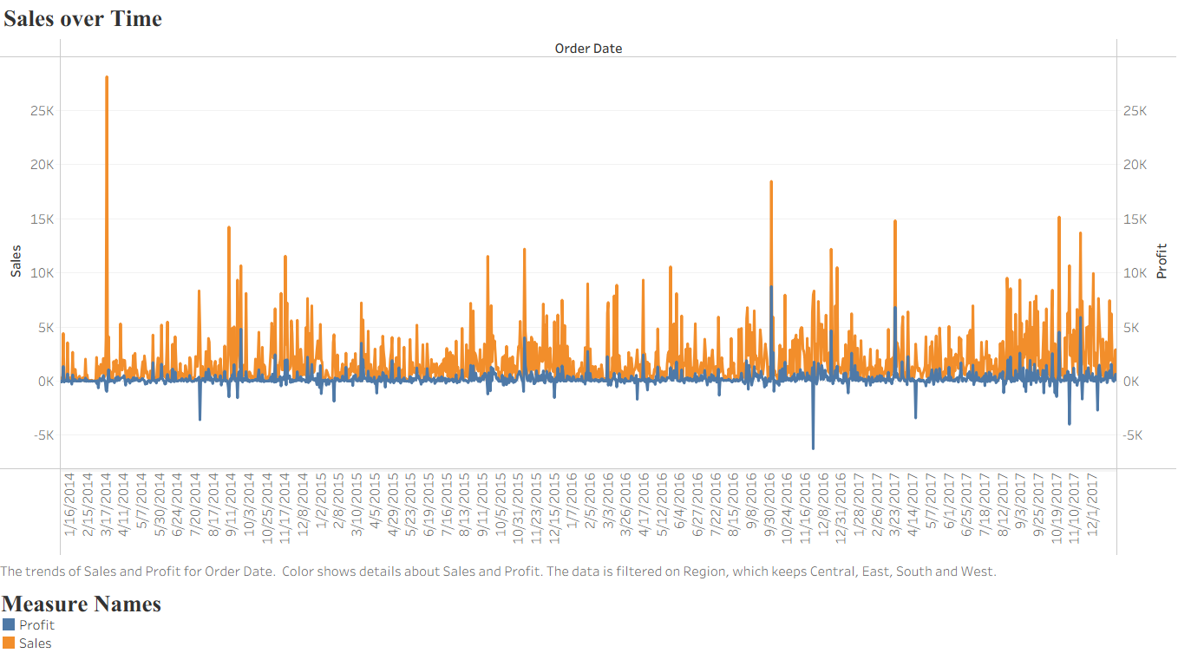

Dashboard 2: Profitability Drivers
As one gets down to the Why behind the numbers, the Furniture category stands as a major issue of concern. Particularly, the Tables sub-category is bleeding profit in the East and Central region and the losses in the East alone are more than 11000 dollars. The Discount Impact analysis shows that there is a distinct point of no return: as the discounts reach 20 or more, the likelihood of a transaction being profitable reduces considerably. On the other hand, the Technology segment is the "Gold Mine" which still has high profit ratios with even slight discounts implemented.
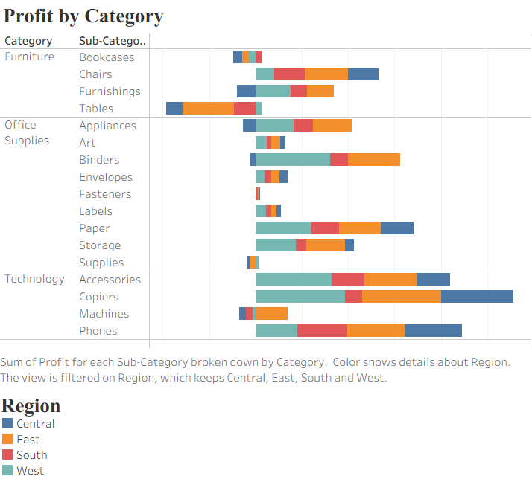

Dashboard 3: Regional & Product Insights
The geographical spread of profit is very skewed. Although New York and California are the most profit-driven states, Texas and Ohio are major Money Pits. Paradoxically, high sales volume is associated with the greatest losses in Texas (25, 729 in the red) and it indicates that aggressive discounting is not paying off in that state. At the product level, the Canon pictureCLASS 2200 Advanced Copier has been the best performer and a row of Binder and Table items is always on the list of the poorest performing in terms of profitability, the Bottom 10 List.
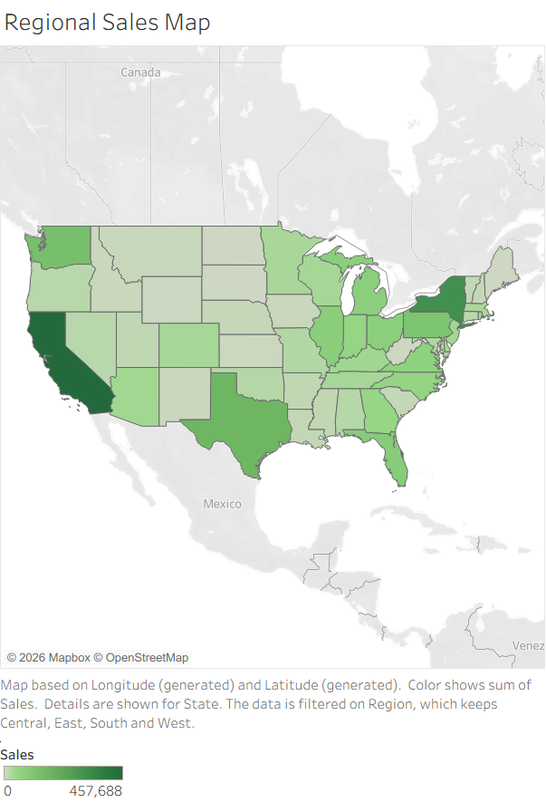

5. Strategic Recommendations
In order to regain the margins, Superstore Giant should adopt Tiered Discounting Policy. We suggest a tough limit of 20 percent on the discounts on the Furniture and Office Supplies sections since according to our data, there is no way to become profitable beyond that limit. Also, the Texas Region Audit is to be carried out on whether it is high shipping rates or local competitive pricing that is compelling these uncontrollable losses. Lastly, the company ought to redirect its marketing efforts to high performing Technology products such as Copiers and Phones which prove to be much more stable to market volatility.

6. Limitations
This report gives a clear picture of transactional success but it is constrained by the fact that it does not have Cost of Goods Sold (COGS) and Shipping Logistics data. We are not told what the cost of such transportation of a heavy Table to the East Region is, but we can only estimate that the loss is caused by discounting. Moreover, the data lacks Customer Lifetime Value (CLV); it may include unprofitable sales, which are Loss Leaders; such purchases attract high-value customer, who purchases profitable products in the future.

7. Conclusion
The Superstore Giant is stable in the market share and revenue. Nevertheless, the way to the long-term sustainability is the "Selective Growth" and not the Volume Growth. With the Tables category profit leaks adjusted and reconsideration of the approach in such states as Texas, the company will be able to transition its profit ratio by 12.5 percentage points to a more significant 20 percent. The data indicates that the company does not necessarily require additional customers seeking it; it requires additional profitable transactions.

