Generate a Private Key

openssl genpkey -algorithm RSA -out private.key  
  
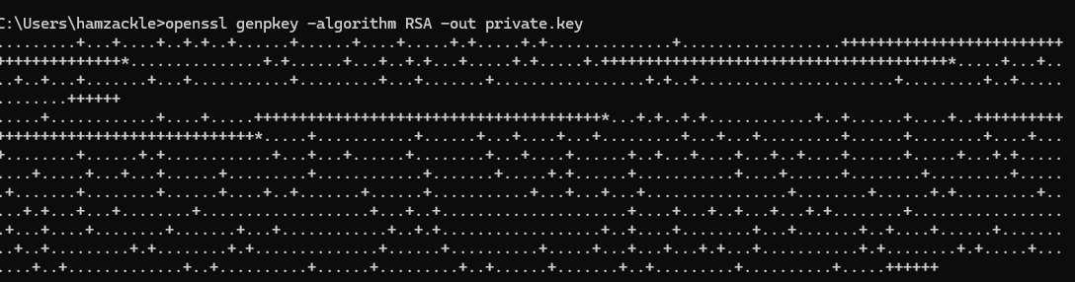

Generate a Public Key

openssl rsa -pubout -in private.key -out public.key



Generate a Certificate Signing Request (CSR)

openssl req -new -key private.key -out request.csr

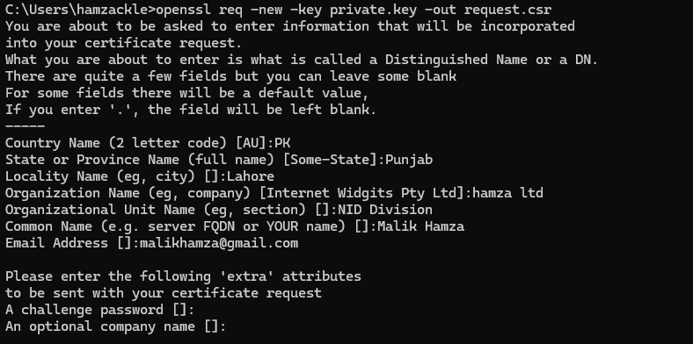

Create a Self-Signed Certificate

openssl req -x509 -key private.key -in request.csr -out selfsigned.crt -days 365



Act as a Certification Authority (CA)

Generate a CA private key and certificate:

openssl genpkey -algorithm RSA -out ca.key

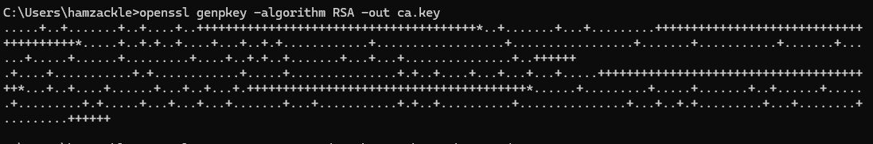

openssl req -x509 -new -nodes -key ca.key -sha256 -days 365 -out ca.crt

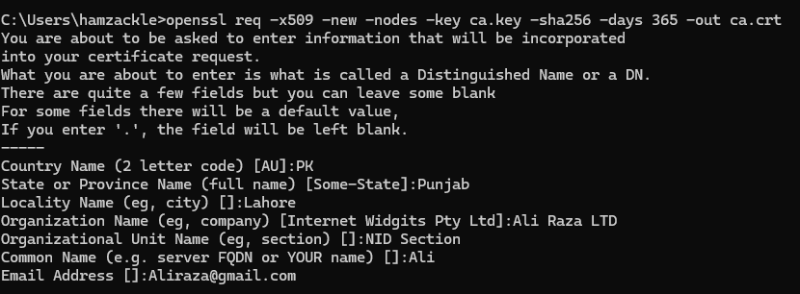

Sign a certificate using the CA:

openssl x509 -req -in request.csr -CA ca.crt -CAkey ca.key -CAcreateserial -out signed_certificate.crt -days 365 -sha256

