­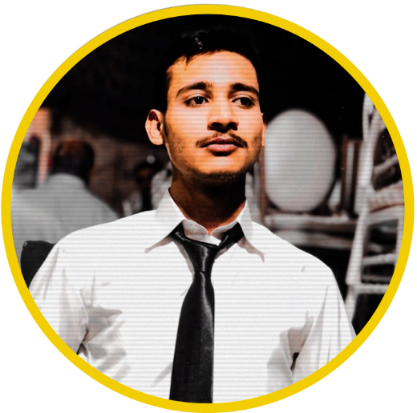

Summary

Presenting an accomplished full stack developer who effortlessly navigates between front-end and back-end realms, weaving together seamless digital experiences. With a fusion of functionality and aesthetics at their fingertips, they craft captivating solutions.

Skills

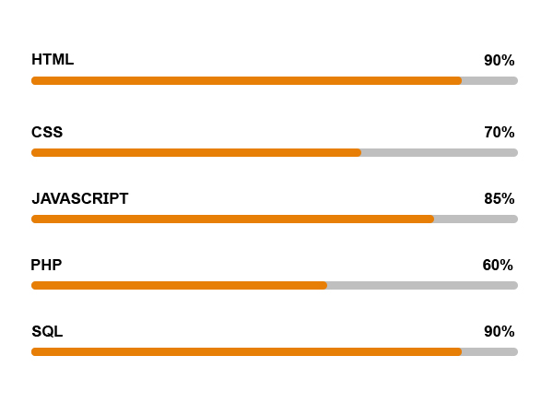

Education

* Matriculation in Computer Science
* [Intermediate Commerce Group (I. Com Part I-II)](https://hadaf.edu.pk/i-com/)
* Accp prime 2.0 (to be continued...)

**Gmail:** Hamzasiddiqui1317@gmail.com

**Linkedin:** **https://www.linkedin.com/in/hamza-siddiqui-code**

**AGE : 21**

HAMZA SIDDIQUI