Tweak the phrase, “Friends who go gluten free for fun?” to an alternate phrase we discussed in our last meeting. Please find those notes and correct this screen. Also, please do a quality control check on the capitalization i.e. do not capitalize every word in the sentence - it should follow regular American English.
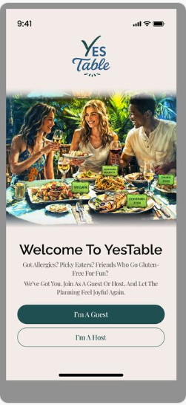
"Done — no need to implement it in Figma; it has been implemented directly in the development build."

Remove the fake language/placeholder Latin. We also discussed this awhile back. Replace it with something like, “Show us that beautiful mug!”
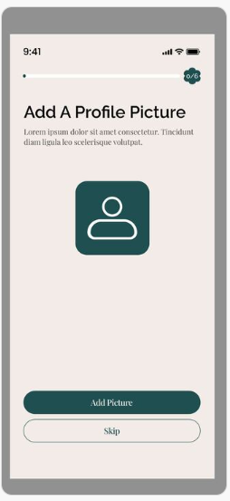
"Done — no need to implement it in Figma; it has been implemented directly in the development build."

Again, replacing the fake Latin
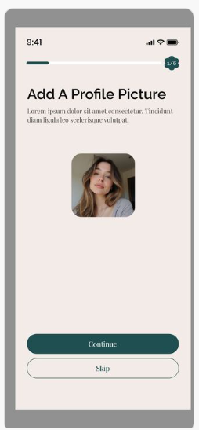
"Done — no need to implement it in Figma; it has been implemented directly in the development build."

Add punctuation after “here” so it reads, “Your seat at the YesTable starts here!”“Set a Place For Someone Else” - no period, every wird is capitalized because it’s like a little title/it’s not a sentence
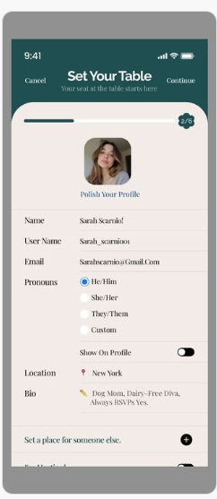
"Done — no need to implement it in Figma; it has been implemented directly in the development build."

The severity toggles should be the lowest on the left (no allergy) and highest at the max on the right (severe). The label should move with the toggle, instead of being fixed on the right.
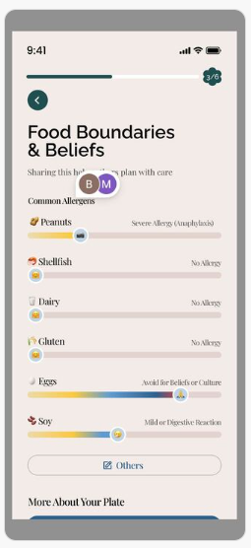
"It can’t be implemented directly in the development build, as the UI isn’t finalized yet. It needs to be designed in the UI first, then implemented in development."

Take out the fake Latin, Instead, put in quotations an example of what a person might say. Write: i.e., “I’m alcohol free!”
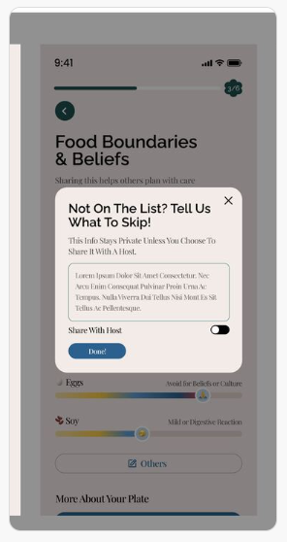

"Done — no need to implement it in Figma; it has been implemented directly in the development build."

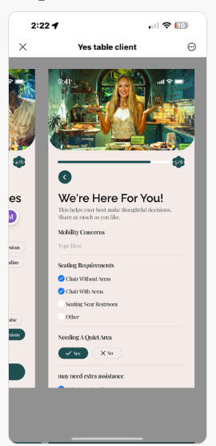

The yum/yuck list is supposed to be expanded to include the extra flavors. There does not need to be this yum/yum list and then an additional page with all the options.
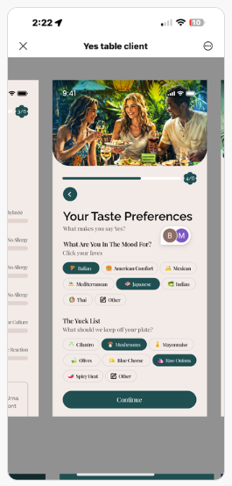
"It can’t be implemented directly in the development build, as the UI isn’t finalized yet. It needs to be designed in the UI first, then implemented in development."

We talked about all the social stuff being locked away for now. I do not want the app to feel empty as user based starts out. If it seems like no one is using it, no one will. We can unlock the social portions later
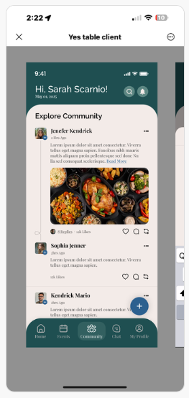

"Done — no need to implement it in Figma; it has been implemented directly in the development build. However, it’s unclear what the 'Community' item in the navigation bar should be replaced with, as there will be four items left after its removal. The replacement is not specified in the UI."

Same for “posting”. This is not Facebook. Down the line when there are 100k users we can introduce this feature.
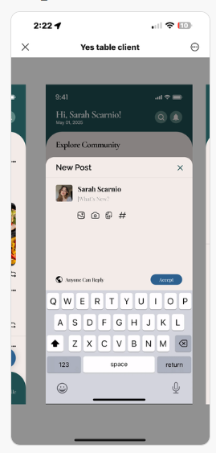

"Done — no need to implement it in Figma; it has been implemented directly in the development build."

We do not want “friends” or lack thereof to be a deterrent to use. Please remove the friends capacity. Please remove the fake Latin and add the user-generated bio. If they haven’t added a bio, use the placeholder, “gluten free diva on Team Blue Cheese”
Also, include liked flavors at the bottom
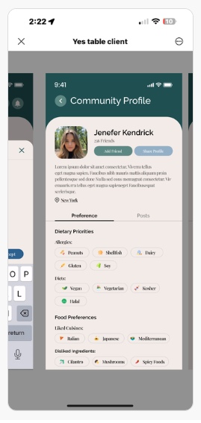
"Done — no need to implement it in Figma; it has been implemented directly in the development build."

Where is the user-prompted ai recipe generation?
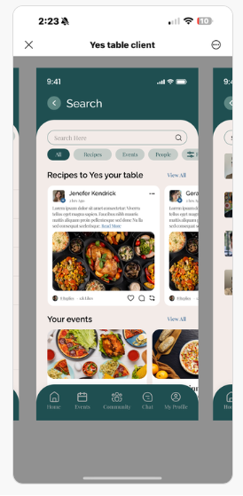

"The User AI prompt has been implemented on page 13 of the Figma. It hasn’t reached the development phase yet due to pending modifications in the Figma design."

Again, we are not ready to roll out a friend/social feature.
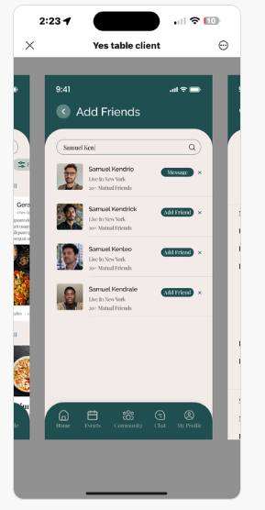
"No need to implement it in Figma; it has been implemented directly in the development build."

Is this the user-prompted ai recipe suggestion area? If so, instead of “search here” it should say in quotes, “suggest a brunch for this group” or “recommend a wine” —— use both suggestions and keep the quotes
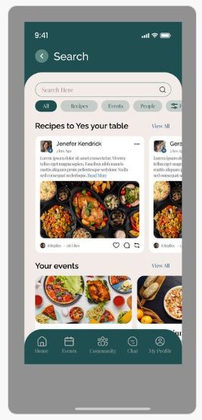
"The User AI prompt has been implemented on page 13 of the Figma. It hasn’t reached the development phase yet due to pending modifications in the Figma design."

I really like what I’m seeing on the Host side! We need to replace the fake Latin with real suggested prompts in quotes such as, “Sam takes his coffee black.”
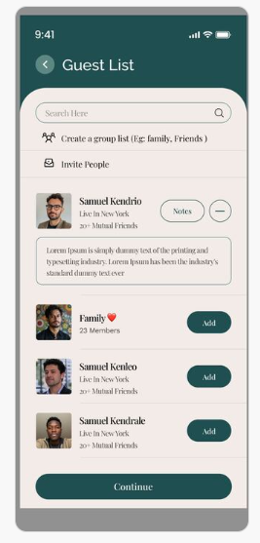
"It has been implemented directly in the development build."

The chat can stay, but the host needs to be able to turn it off. I’m worried about hosts having to moderate a chat.
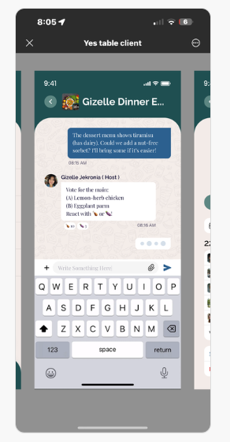

"It can’t be implemented directly in the development build, as the UI isn’t finalized yet. It needs to be designed in the UI first, then implemented in development."

If there’s a way to tweak the chat feature to give visibility & control to the host, that would be amazing.
It would be cooler if the hosts could ask a chat-type question and get answers from guests like, “what size T-shirt do you wear” but the answers just go to the host.
I’m not really getting the dietary compatibility score. What is it compatible with? The other guests, or the hosts recipes?? Please explain it to me, then change the wording to, “Taste Match”
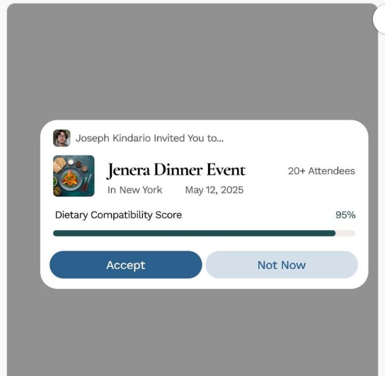
"No need to implement it in Figma; it has been implemented directly in the development build."

Instead of an end date, the event should have an option to add an end time. Please remove the "end date" and add "end time. Also it should be "time" not "timing."
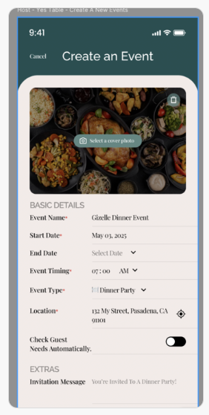
"No need to implement it in Figma; it has already been implemented directly in the development build. The page is outdated because we are currently following Figma page 11, while this one is based on page 13. For now, the full page has been implemented according to page 13, and minor revisions will be made during the development phase of page 13."

