Deutsche Telekom Sustainability Strategy Analysis
Submission version (3-5 pages): enriched introduction, SDG actions by date, charts and animation

Executive Summary
Deutsche Telekom (DT) has developed a mature sustainability strategy with strong governance integration, board-level oversight, and clear climate milestones. The strategic challenge is now implementation speed in Scope 3, where most value-chain emissions and dependencies are concentrated.

Company Profile (Detailed Introduction)
- Headquarters: Bonn, Germany. Founded in 1995 as Deutsche Telekom AG.
- Reporting perimeter: 326 fully consolidated companies (CR reporting scope).
- Commercial scale: 298 million total connections and around 245,000 petabytes of annual network data traffic (GSMA indicators in CR reporting).
- Workforce: about 199,000 employees in 2025 (public market profile referencing annual reporting); CR workforce profile indicates a strong international mix (about 61% international and 39% domestic in 2021 profile).
- Operating structure: Germany, USA, Europe, Systems Solutions; these segments represent roughly 99% of Group sales in ESG KPI governance.
Strategic implication: DT's size and geographic spread make sustainability a portfolio-execution challenge across infrastructure, supply chains, and customer ecosystems.

Emissions and SDG Evolution

Verified Scope Values (Recent Robust Years)
Year | Scope 1 | Scope 2 (market) | Scope 2 (location) | Scope 3
2022 | 212,044 | 21,019 | 4,232,913 | progress vs baseline disclosed
2023 | 239,602 | 17,957 | 3,979,565 | progress vs baseline disclosed
2024 | 236,355 | 16,212 | 4,002,218 | progress vs baseline disclosed
2025 | 223,790 | 16,375 | 3,736,800 | progress vs baseline disclosed
Figure 1. Scope 1 and Scope 2 (market-based) evolution
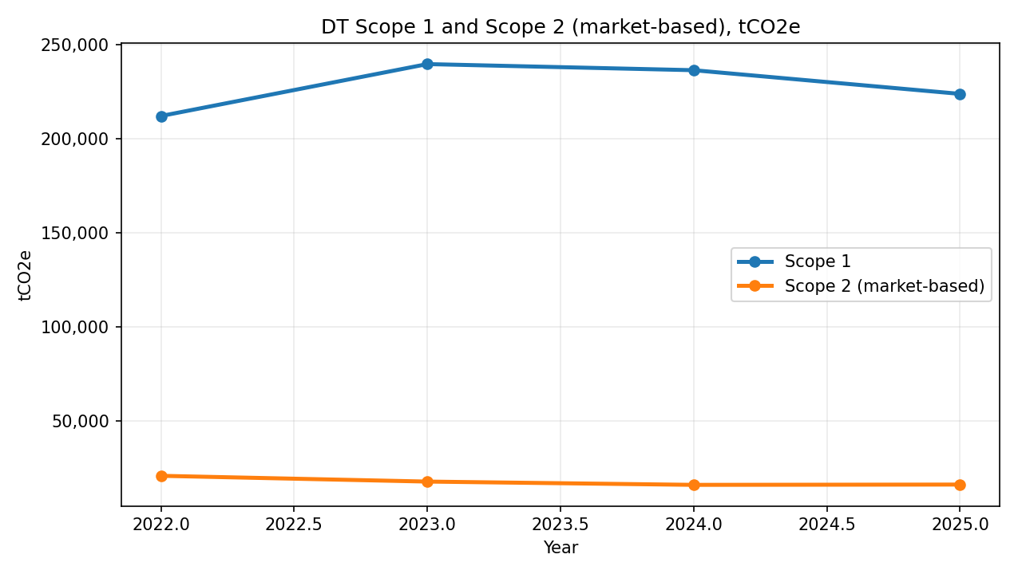
Figure 2. Scope 2 (location-based) evolution
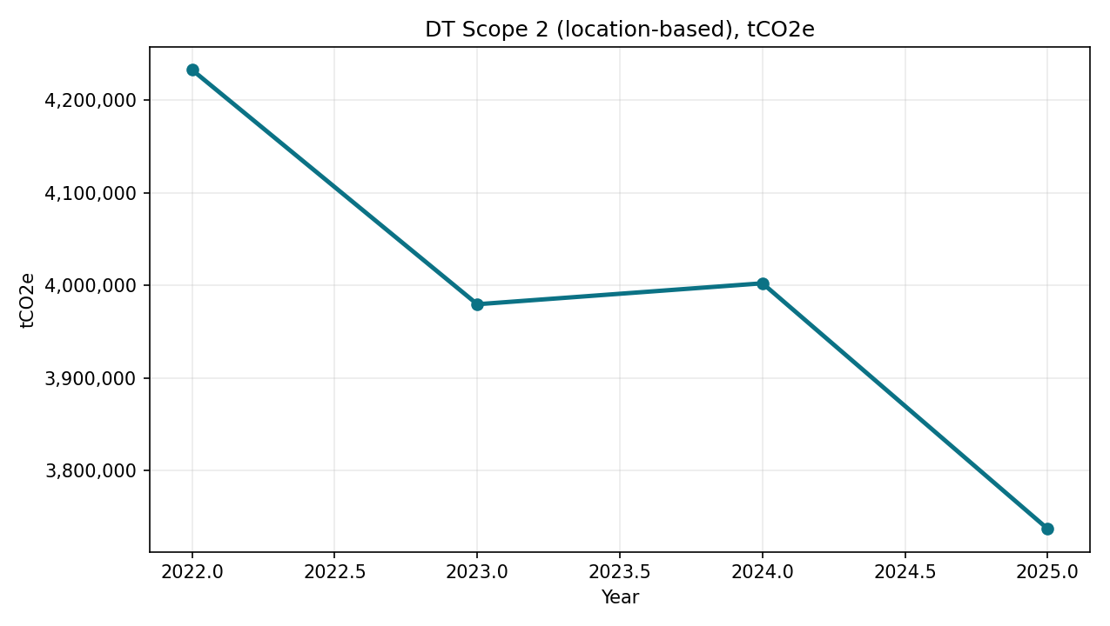
Figure 3. SDG disclosure-intensity trend (2009-2025)
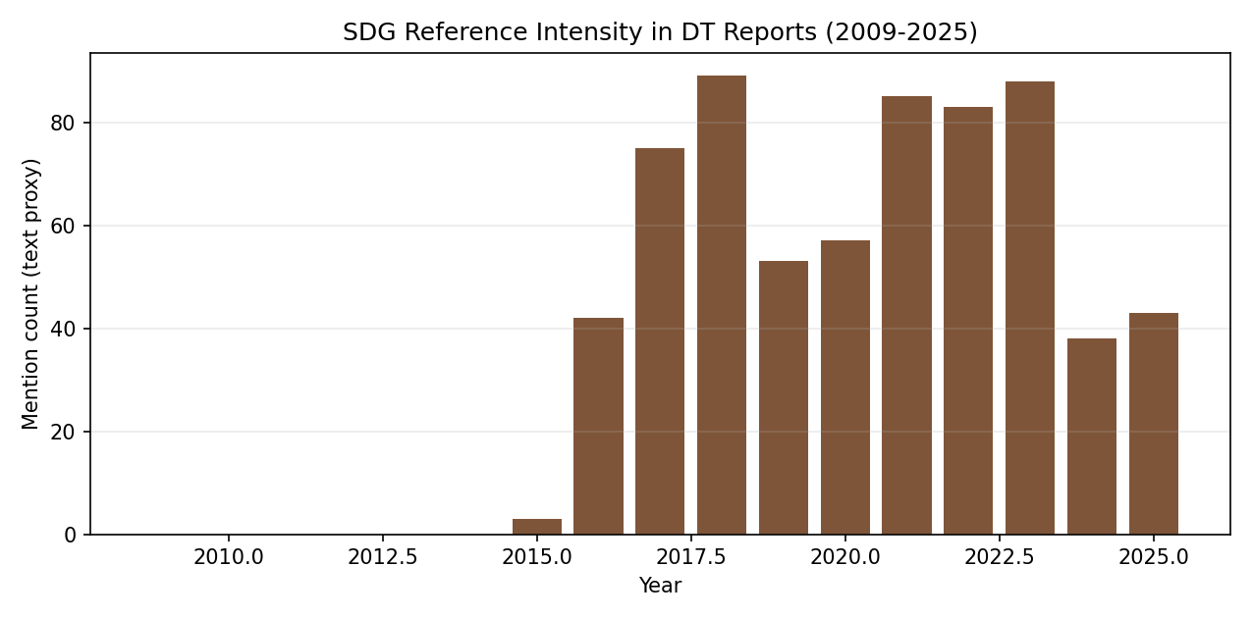
Figure 4. Indexed emissions animation insert (GIF)

Animation note: GIF playback depends on Word version/view mode; in non-animated mode it remains a static key frame.

SDGs Touched: Actions by Date
SDG | Date | Action executed | Effect
SDG 2 | 2022 | 5G precision agriculture positioning solution | Higher yield precision, optimized fertilizer/seeds, indirect contribution to zero hunger
SDG 3 | 2022 | Remote maintenance and mobility solutions | Lower transport-related pollution and health co-benefits
SDG 4 | 2022 | Teachtoday and AwareNessi cyber-literacy content | Improved safe and competent digital use for children/families
SDG 5 | 2022 | Gender-neutral educational design in AwareNessi | Inclusive representation and communication practices
SDG 6 | 2022 | Soy-ink sustainable packaging use case | Reduced environmentally harmful chemicals in packaging
SDG 7 | 2021 | 100% renewable electricity sourcing | Major Scope 2 market-based decarbonization lever
SDG 8 | 2022 | AR service productivity and digital process efficiency | Higher productivity and better employee work conditions
SDG 9 | 2022 | Device-as-a-Service and digital service tools | Resource-efficient device lifecycle and infrastructure innovation
SDG 10 | 2022 | Inclusive multilingual educational access | Broader inclusion across user groups and languages
SDG 11 | 2022-2025 | Remote maintenance, A-CDM, digital society programs | Lower urban emissions and wider digital participation (40m reached in 2025)
SDG 12 | 2022 | Device-as-a-Service (>97% refurbishment) | Longer product life and reduced material throughput
SDG 13 | 2025 | Net zero in own operations (Scope 1+2) | >94% reduction vs 2017 plus residual neutralization
SDG 15 | 2025 | Reforestation/removal projects for residuals | Land-based sequestration and ecosystem co-benefits
SDG 16 | 2022 | Digital safety and human-rights process strengthening | Better institutional safeguards and responsible digital behavior
SDG 17 | 2022-2023 | Partnerships (everphone, airport ecosystem, collaborations) | Faster scaling of sustainability solutions
Reporting note: 2023 CR program explicitly focuses on SDGs 2, 3, 4, 5, 7, 8, 9, 11, 12, 13, 15, 16 and includes structured Measures and KPIs relevant to SDGs.

Recommendations
- Make Scope 3 a growth and margin lever through supplier and customer decarbonization solutions.
- Build an ESG-finance-risk control tower for capital allocation decisions.
- Increase weighting of forward-looking transition KPIs in incentives.
- Scale circularity with explicit unit economics by category.
- Embed climate resilience standards in network capex decisions.

Sources
- Deutsche Telekom CR Report 2025 (scope, segments, milestones, GSMA indicators)
- Deutsche Telekom CR Report 2024 (historical climate tables)
- Deutsche Telekom CR Reports 2022 and 2023 (SDG use cases and SDG focus list)
- Public company profile references (employee scale cross-check)

