

|  |  |  |
| --- | --- | --- |
| **Course Name:** Computer Engineering workshop (CEN 1006) | | |
| **LAB # 4:** Introduction to Computer Aided Design - Part-1 | | |
| **Department** | **Registration Number/Name** | **Semester/Section** |
| BS CEN | F24604018/Muhammad Hamzah Iqbal | 1 |
| **Date** | **Instructor’s Name** | **Instructor’s Signature** |
| 22/10/2024 | Maj Sheryar /Iqra Ashraf |  |

Objective:

* To get familiar with the interface and different tools to effectively use AutoCAD.

# Introduction:

AutoCAD is a widely used computer-aided design (CAD) software developed by Autodesk. It allows users to create precise 2D and 3D designs for various engineering, architectural, and construction projects. Key features include tools for drawing, editing, and annotating, along with layers, blocks, and hatching for organized designs. AutoCAD supports

customization through macros and plugins, enhancing productivity. Its compatibility with numerous file formats ensures smooth collaboration. The software’s interface is user-

friendly, making it suitable for both beginners and professionals.

# Task 1:

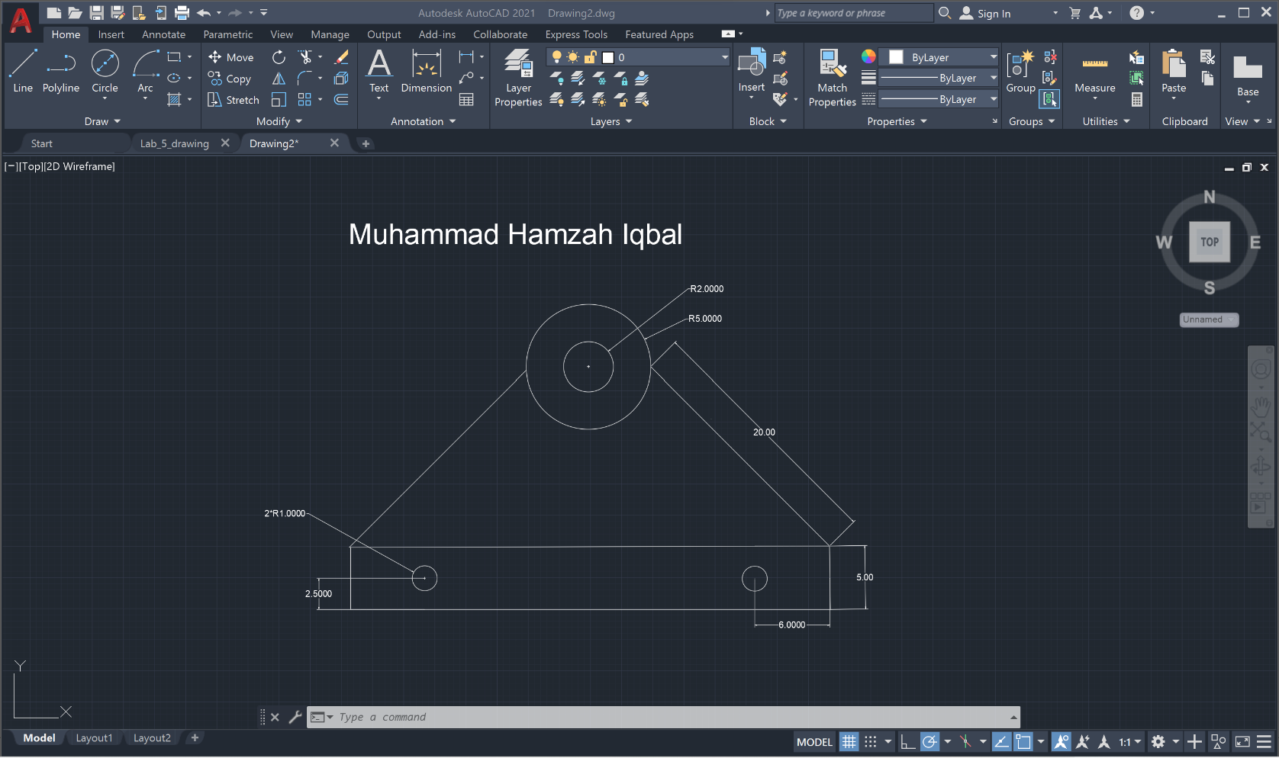

## Method:

1. Begin by creating the two large circles using the Circle tool. Ensure they are positioned according to your design specifications.
2. Use the Circle tool again to draw a smaller circle inside each large circle, ensuring the placement and size are accurate.
3. Then two lines at a 45-degree angle from the large circles using the Line tool and the Angle option for precision.
4. Use the Rectangle tool to create the base box, ensuring the dimensions match the required measurements.
5. Finally, add two smaller circles inside the base box using the Circle tool. Place them precisely, 6 cm away from the sides and 2.50 cm from the bottom edge of the box.

# Task 2:

## Method:

A large circle was made through which small semi circles were trimmed out. Then lines were joined and the shape was made.

## Conclusion:

In conclusion, the tasks demonstrated key AutoCAD techniques such as drawing, trimming, and joining shapes to create precise designs. The first task focused on positioning circles and lines accurately, while the second highlighted shape manipulation using trimming and joining. These exercises reinforced essential skills for precise design in AutoCAD.