Project 1: Static Foundations
Feedback for Hamzah Marie, personal portfolio
Student: Hamzah Marie Course: CSC 436, Fall 2026 Reviewed at: 1fa0296
Repo: github.com/HamzahM03/CSC-436-Project1 Live: starlit-swan-32a6ca.netlify.app

Grade: 88 / 100
Category | Points | Earned | One line
Semantic HTML | 20 | 18 | Valid, one h1, clean outline, every element the brief lists; footer sits inside main, menu button has no aria-expanded
CSS layout | 25 | 22 | Flexbox and Grid, both authored, both purposeful, mobile-first; tokens defined then ignored, an empty stylesheet still linked
Responsive design | 15 | 15 | Seven min-width queries, no horizontal scroll anywhere, hamburger works, grids step 1 to 2 to 4
JavaScript interaction | 15 | 13 | Menu toggle and an IntersectionObserver reveal, both working; the toggle announces nothing, the reveal covers one section
Repository and deployment | 15 | 12 | Fifteen commits over eight days with real messages, deploy matches repo; README has two of the four items
Content and polish | 10 | 8 | Real internships, real projects, real resume; a 553 KB headshot shown at 200 px, and a hero that depends on its animation
Total | 100 | 88 | Tied for the top of the class. The deductions are all small and all fixable in an evening.

How this review was made
Your instructor reviewed this project with Claude (Anthropic's AI) as a second set of eyes. Claude cloned the repo, read every line of the HTML, all eight stylesheets and both scripts, loaded the live site at phone, tablet and desktop widths, ran the W3C validator, opened and closed the hamburger, scrolled to check the About fade-in, downloaded the resume, measured every image, counted how many times each color is typed, and read the commit history. Every note and every point in this document was read and approved by your instructor. Same rubric, same standard, just more time spent looking at your code than one person has in a grading week.

The short version
This is a real portfolio, not an assignment that looks like one. The internships have dates and specific bullets, the projects link to their repos and a live demo, the resume downloads, and the whole thing reads like you. Underneath it the structure is what the brief asked for: header and nav with a list, main with six sections, articles for the cards, one h1, and a validator with nothing to say. All seven media queries are min-width, so you built mobile-first, which most of the class did not. Flexbox handles the nav, hero and project rows; Grid handles experience and skills, and the featured internship spanning both columns with grid-column: 1 / -1 is exactly the kind of Grid move that shows you understand it.
The points came off in four small places. The README is a title and one sentence, so a stranger cannot run it or find it. The footer is inside main. You wrote five custom properties in :root and then typed the same hex colors by hand forty times across eight files. And the menu button opens and closes but never tells assistive tech which state it is in. None of those is a design problem. They are finishing problems, and the fix list at the end is short.

What Claude measured
Check | Result
Horizontal scroll at 375 / 768 / 919 / 1280 px | None at any width
W3C HTML validator | 0 errors, 0 warnings
Heading order | h1 > h2 > h3, no skipped levels
Semantic elements | header, nav (ul of 5), main, 6 section, 5 article, footer (inside main)
Media queries | 7, all min-width (mobile-first)
Experience grid columns at 375 / 768 | 1 / 2, featured card spans both
Skills grid columns at 375 / 600 / 900 | 1 / 2 / 4
Hamburger | Opens and closes; no aria-expanded before or after
About fade-in | Fires on scroll: opacity 0 to 1, is-visible added
Console errors | 0
Stylesheets linked | 9; home.css is empty
Custom properties | 5 defined, used 4 times; #3ecf8e typed 14 times in 8 files, #111a2b 9 times in 8
Images | headshot.jpg is 3024 by 3069 and 553 KB, shown at 160 to 200 px; everything else is small; 0.73 MB total
Resume PDF | Downloads (HTTP 200)
Commits | 15, Sep 8 to Sep 15; 8 of them between 22:55 and 23:51 on the due date; last one at 23:51, on time
README | Title and one sentence; no run instructions, no live URL (2 of 4)

The site at three widths
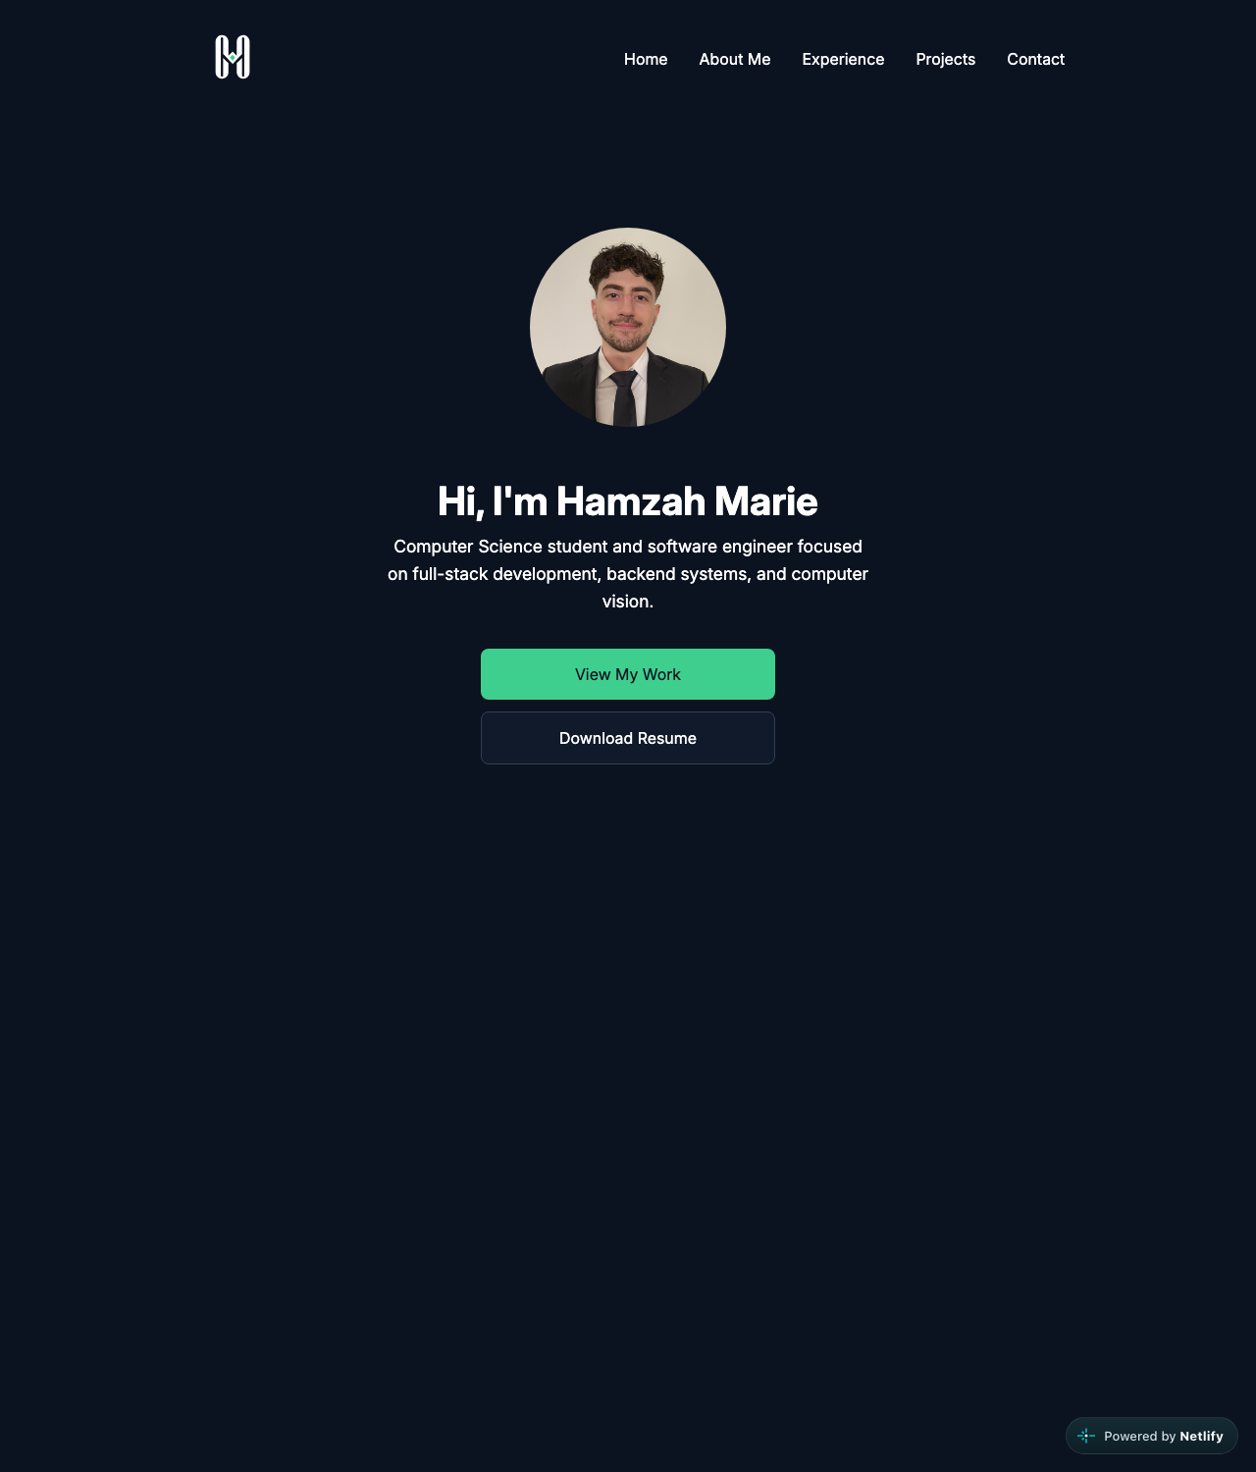
Desktop, 1280px. Centered single-column hero above a two-column experience grid; skills in four columns.
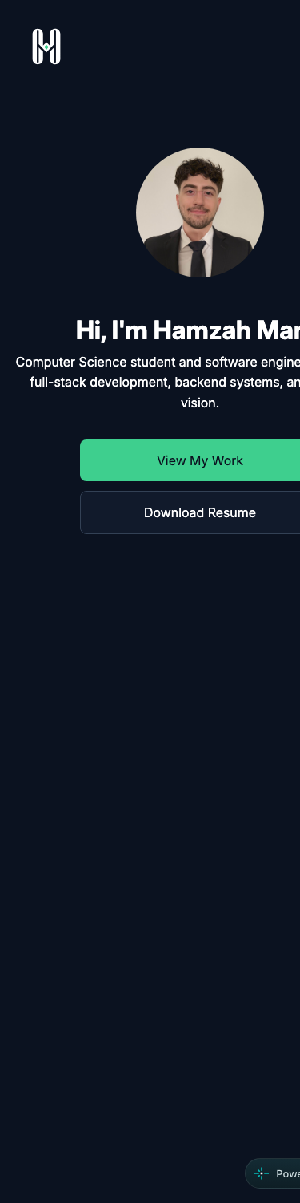  Phone, 375px. Hamburger nav, stacked hero, no horizontal scroll. | 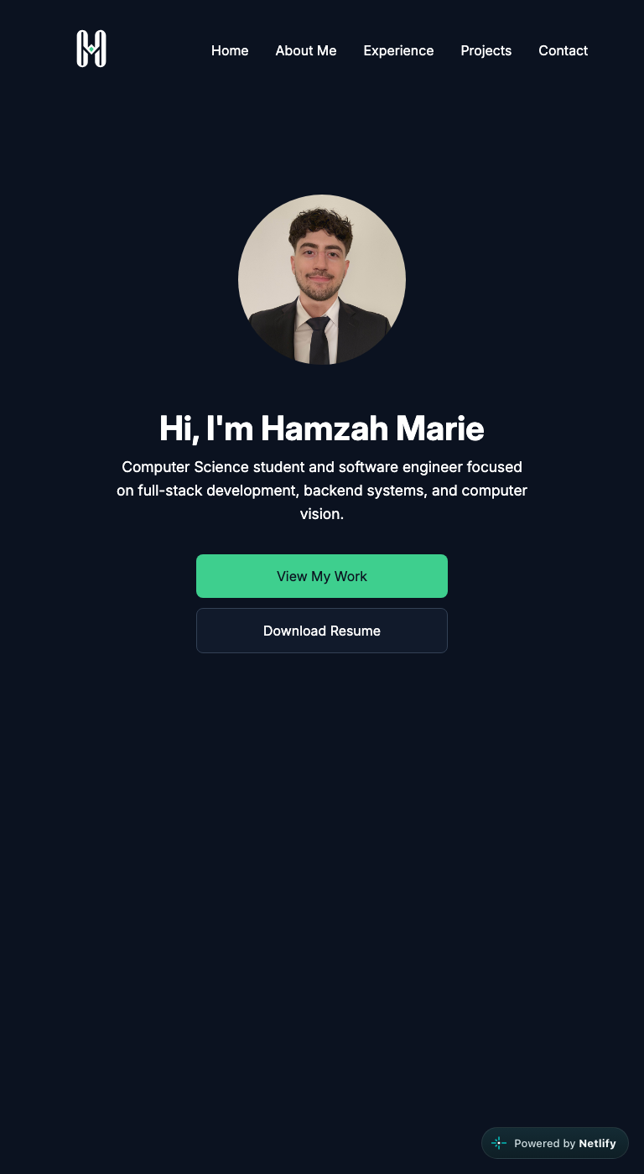  Tablet, 768px. Full nav, two experience columns, featured card spanning both.

Semantic HTML: 18 / 20

What is working
- The skeleton is right. header > nav with a ul of five links, main with six sections, an article per internship and per project, and footer. One h1 in the hero, an h2 per section, h3 per card. The validator returns nothing. Every image has alt text that says what it is; the social icons are decorative (alt="") with an aria-label on the link, which is the correct pattern (index.html lines 105 to 129). The resume button uses the download attribute, and the nav links are real anchors, so the page works with JavaScript off.

What to change
- The footer is inside main (index.html lines 450 to 454). main is the unique content of the page; the footer is site chrome, a sibling of header and main, not a child. Move the closing main tag above line 450. Nothing in your CSS breaks.
- The menu button has no state (lines 39 to 44). aria-label="Toggle navigation" is good, but a screen reader user hears "Toggle navigation, button" and has no idea whether it is open. Add aria-expanded="false" and aria-controls="primary-nav" (and give the .nav-links div that id), then flip aria-expanded in nav.js. Two attributes, one line of JS.
- Small: the skill groups are div.skill-group with an h3 inside (line 259). They would be section or article if you want them in the outline, but div is not wrong here.

CSS layout: 22 / 25

What is working
- Flexbox and Grid, both yours, both used for the right thing. Flex for the nav bar, the hero column, the button row and the project rows (17 flex containers). Grid for the experience cards and the skills grid. Experience goes from one column to two at 768px and the featured card spans both with grid-column: 1 / -1 (experience.css lines 108 to 113). Skills goes 1 to 2 to 4 (skills.css lines 68 to 87).
- Mobile-first. Every one of the seven queries is min-width. The base rules are the phone. That is what the brief asked for and almost nobody did it. One stylesheet per section keeps 800 lines readable. Zero !important.

What to change
- You wrote the tokens and then did not use them (global.css lines 1 to 5). --accent-color: #3ecf8e is defined once and used three times in nav.css. The literal #3ecf8e is typed fourteen more times across all eight files. #111a2b (your --surface-color) is typed nine times. #cbd5e1, #334155 and #1f2a3a have no token at all and appear seventeen times between them. A find-and-replace to var(--accent-color) and friends takes ten minutes and makes the palette one edit instead of forty.
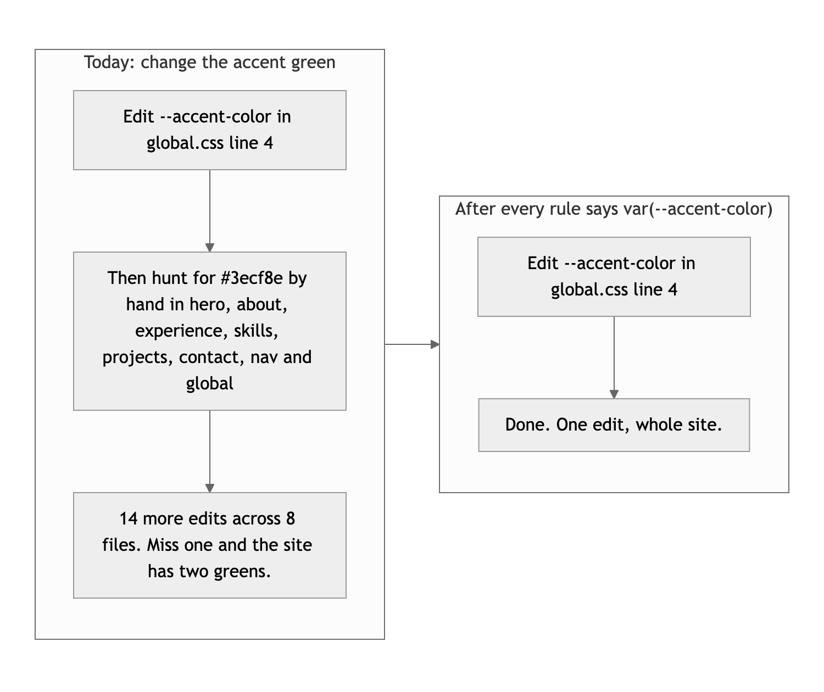
Diagram 1. What changing one color costs today, and after the tokens are used.
- home.css is empty and still linked (index.html line 8). It is left over from the rename. Delete the file and the link. Nine stylesheet requests is also on the high side for a one-page site; fine for a class project, but a build step would concatenate them in Project 2.
- The hero is min-height: 100vh and a single centered column at every width (hero.css line 19). On a phone that is right. On a 1280px desktop the content is a narrow column in the middle of a large navy rectangle, and About always starts below the fold. Either let the hero go two-column at 900px (headshot beside the text, like the project rows already do) or drop to min-height: 70vh.

Responsive design: 15 / 15

What is working
- No horizontal scroll at 375, 768, 919 or 1280. The hamburger appears below 768 and the list appears above it (nav.css lines 104 to 118). Project rows stack on the phone and go image-beside-text on the tablet. Experience goes 1 to 2, skills go 1 to 2 to 4. Every breakpoint does something visible and none of them break anything. Full marks.

What to change
- Nothing that costs points. The hero note above is a desktop layout suggestion, not a responsive bug.

JavaScript interaction: 13 / 15

What is working
- Two scripts, both small, both working. nav.js toggles is-open on the links and the button (lines 5 to 8), and the CSS turns the three spans into an X. scrollEffect.js uses an IntersectionObserver at 20 percent to add is-visible to About (lines 3 to 16), and about.css transitions it in (lines 7 to 16). Claude scrolled to it and watched the class land and the opacity climb. IntersectionObserver instead of a scroll listener is the right choice and most students do not know it exists. Zero console errors.

What to change
- The toggle changes nothing a screen reader can hear. Add menuButton.setAttribute("aria-expanded", navLinks.classList.contains("is-open")) inside the click handler. Then close the menu when a link is clicked (right now on a phone you tap About, the page scrolls, and the open menu is still covering it) and on Escape. About six more lines and the menu is finished.
- The reveal only watches About. querySelector(".about") observes one element. The other four sections just appear. Either observe all of them (querySelectorAll("main > section") and a .reveal class) or take the effect off; one section animating in and the rest not reads as unfinished. Also call observer.unobserve(entry.target) after adding the class so the observer stops doing work it no longer needs.
- Small: menuButton and aboutSection are queried once with no null check. Fine on this page, but the first time you reuse nav.js on a page without a button it will throw on line 5.

Repository and deployment: 12 / 15

What is working
- The history shows the build. Fifteen commits from Sep 8 to Sep 15: navbar first, then mobile nav, then hero, then the reveal, then each section. Messages like "feat: add responsive mobile navigation" and "feat: add experience section with responsive grid" say what changed and why. This is the second-best history in the class. .gitignore covers .env, .DS_Store and editor folders. The live site matches the repo exactly and needs no login.
- One honest note, not a deduction: eight of the fifteen commits landed between 22:55 and 23:51 on the due date. You started a week early, so this is not a last-minute dump, but half the page went in during the last hour. Next time move that burst to the weekend.

What to change
- README is two lines. The brief asks for a title, a description, how to run it locally, and the live URL. You have the first two. Add "Open index.html in a browser, or run npx serve ." and the Netlify link. Five minutes, three points.
- Small: "deleted home.html" and "Rename home page to index" are two commits for one rename. git mv home.html index.html does it in one and keeps the file history attached.

Content and polish: 8 / 10

What is working
- It is a real portfolio. Two internships with dates, specific bullet points and tech tags, a current role, two projects with repo links and a live demo, a resume that downloads, a headshot, and a logo you made. The dark navy and green palette is consistent from the nav to the footer, and the hover states on the cards are tight. If a recruiter landed here they would not know it was a class project.

What to change
- The headshot is 3024 by 3069 pixels and 553 KB, shown at 200px (index.html line 63). It is 75 percent of everything the page downloads. Export it at 400px wide (2x for retina) as JPEG or WebP and it drops under 60 KB.
- The hero depends on its animation to be visible (hero.css lines 27 to 32). Every hero element starts at opacity: 0 and the keyframe brings it to 1. Today nothing stops the keyframe, so it works. But the day you add a prefers-reduced-motion rule (and you should, it is one media query), the hero goes blank for anyone with that setting on. Start at opacity: 1 and put the opacity: 0 plus the animation inside @media (prefers-reduced-motion: no-preference). The effect stays for everyone who wants it and the content is never hostage to it.
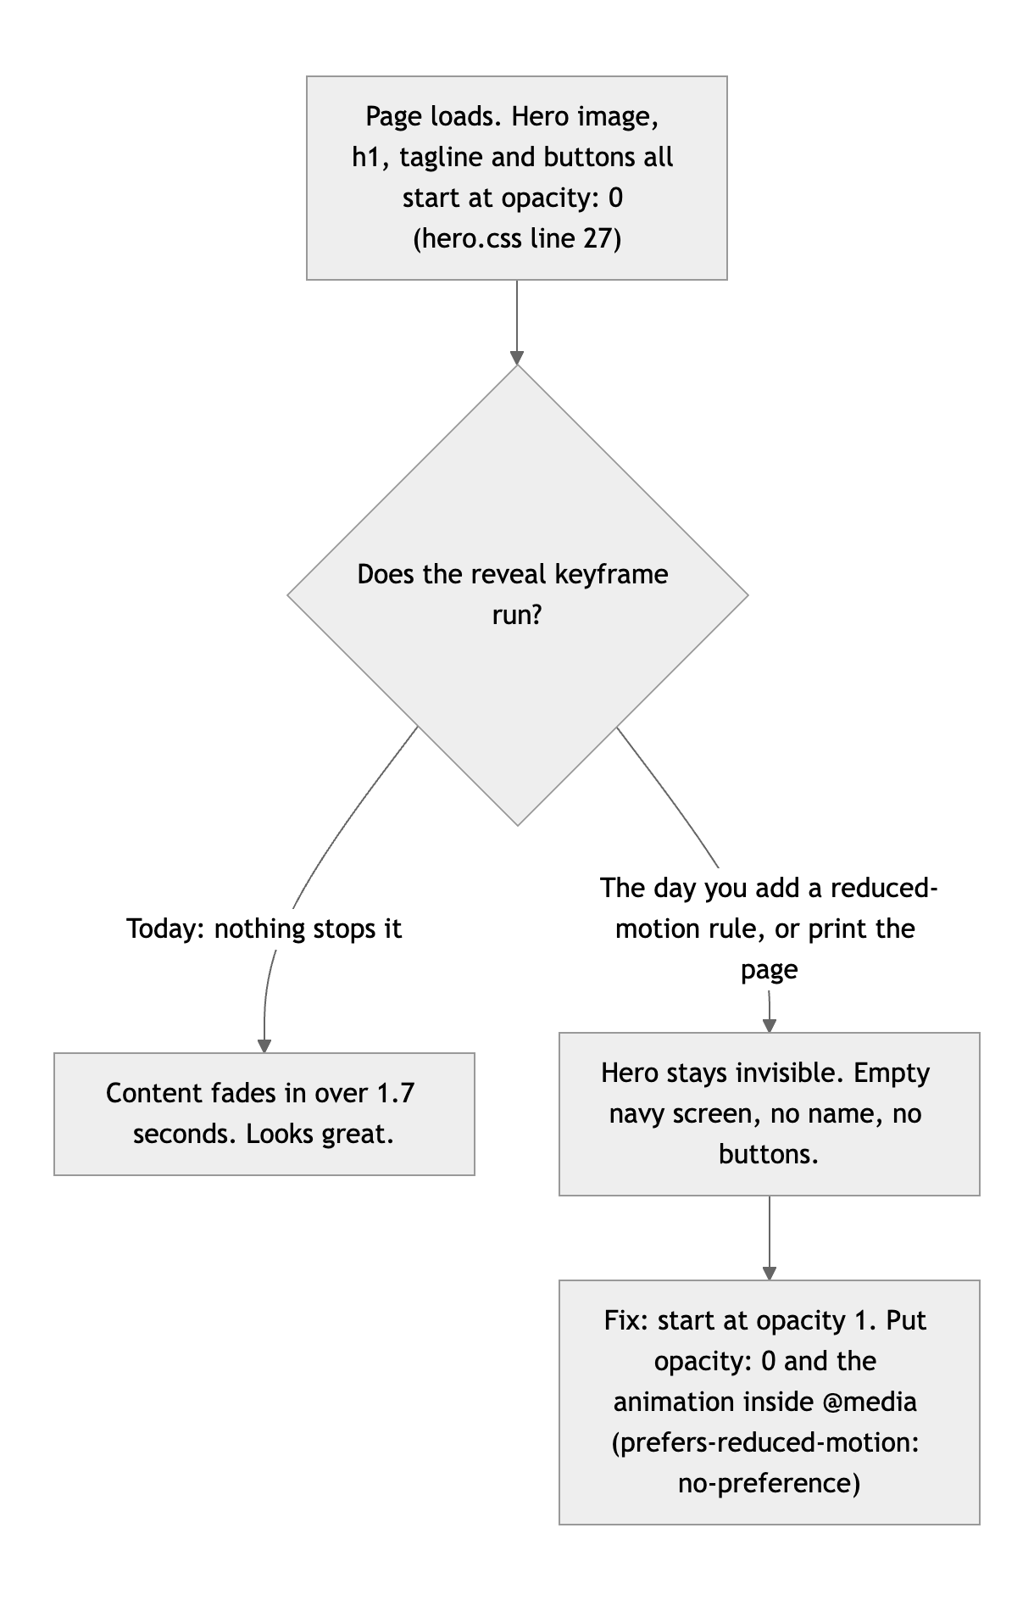
Diagram 2. Why a hero that starts invisible is a risk, and the one-query fix.
- Small: the 1.7 second stagger on the hero is a long time to wait for a name and two buttons. 0.9 seconds total would feel the same and cost less patience.

Your next three moves
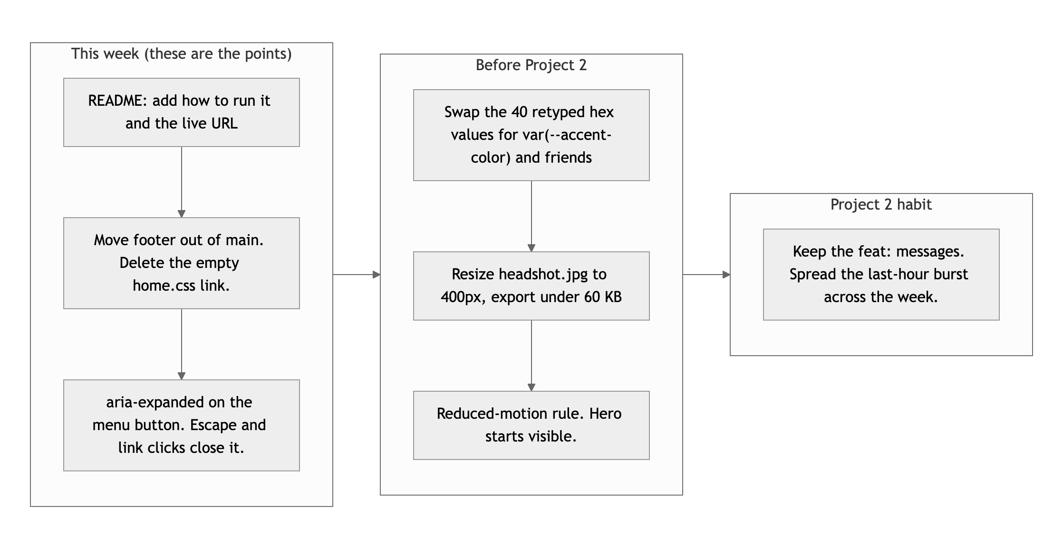
Diagram 3. Priority order. Left column first: it is where the points are.
- Finish the README and move the footer. Two items in the README, one closing tag moved, one dead link deleted. Twenty minutes, and it covers most of what came off.
- Give the menu a state. aria-expanded, close on link click, close on Escape. The menu goes from working to finished.
- Use the tokens you wrote, and shrink the headshot. Find-and-replace the hex values, export the photo at 400px. Then add the reduced-motion query so the hero never depends on its animation.

This is a strong site, Hamzah. Finish the edges and it is a portfolio you can send out.
This review lives in a pull request on your repo. It only adds feedback files and does not touch your code. Merge it, close it, or just read it. Questions go to office hours or the Brightspace board.

