# The First exam

1. How are you?
   1. Good
   2. Bad
   3. Perfect

Answer: Good

1. Hi hamza Work?
   1. Yes
   2. No

Answer: No

1. 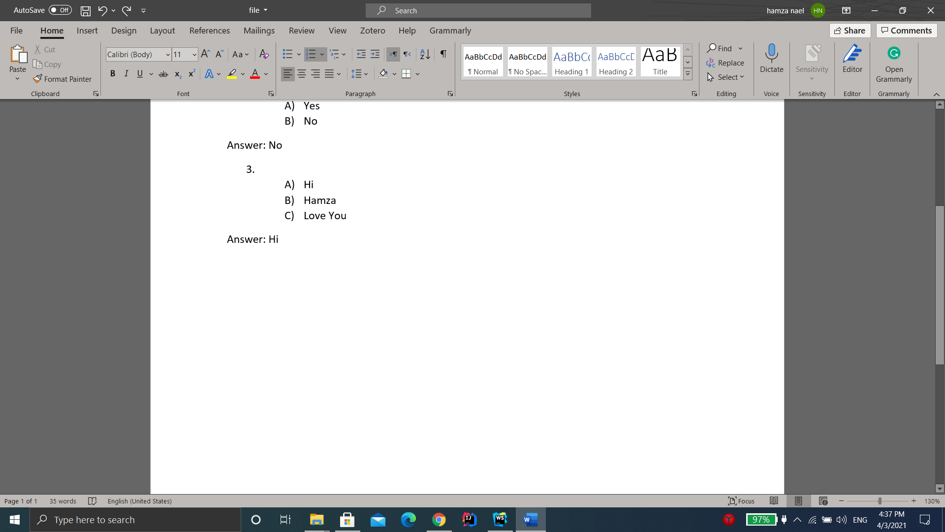?
   1. Hi
   2. Hamza
   3. Love You

Answer: Hi